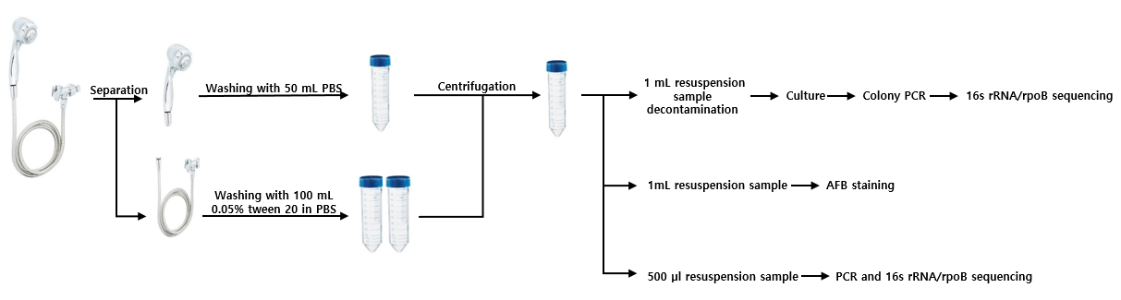
Supplemental Figure 1. Sample collection and processing

