Supplementary Materials For

**A Battery-Powered Soft** **Electromechanical Stimulation Patch for Haptic Human-Machine Interfaces**

Wenying Qiu,1,3,4,5 Junwen Zhong,2,3,4* Tao Jiang,1,3,4,5 Mingze Yao,3,4 Zhichun Shao,3,4 Qilong Cheng,4 Jiaming Liang,1,3,4,5 Dongkai Wang,1,3,4,5 David B. Bogy,4 Min Zhang,5* Xiaohao Wang,5 Liwei Lin1,3,4*

1 Tsinghua-Berkeley Shenzhen Institute, Tsinghua University, Shenzhen, 518055, China.

2 Department of Electromechanical Engineering and Centre for Artificial Intelligence and Robotics, University of Macau, Macao, 999078, China

3 Berkeley Sensor & Actuator Center, University of California Berkeley, Berkeley, CA, 94720, USA.

4 Department of Mechanical Engineering, University of California Berkeley, Berkeley, CA, 94720, USA.

5 Tsinghua Shenzhen International School, Tsinghua University, Shenzhen, 518055, China.

Corresponding Author:

junwenzhong@um.edu.mo

zhang.min@sz.tsinghua.edu.cn

lwlin@berkeley.edu

**Supplementary Figures**

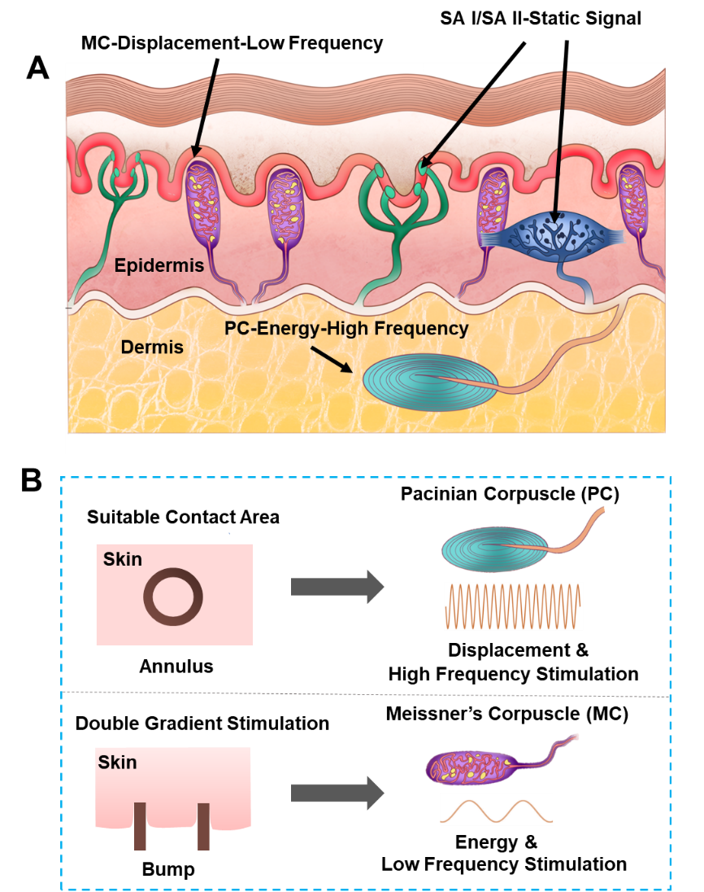

**Figure S1. (A)** Four types of tactile receptors in human skins, which are: (1) the tactile corpuscle (Meissner’s corpuscle, MC); (2) the lamellar corpuscle (Pacinian corpuscle, PC); (3) the bulbous corpuscle (Ruffini ending, SA-I); and (4) the Merkel nerve ending (Merkel disc, SA-II). The soft actuators in this work are designed to activate MC and PC receptors that are sensitive to dynamic actuating stimulations. **(B)** The detailed actuating stimulations for the PC and MC receptors from the annulus bump structure.

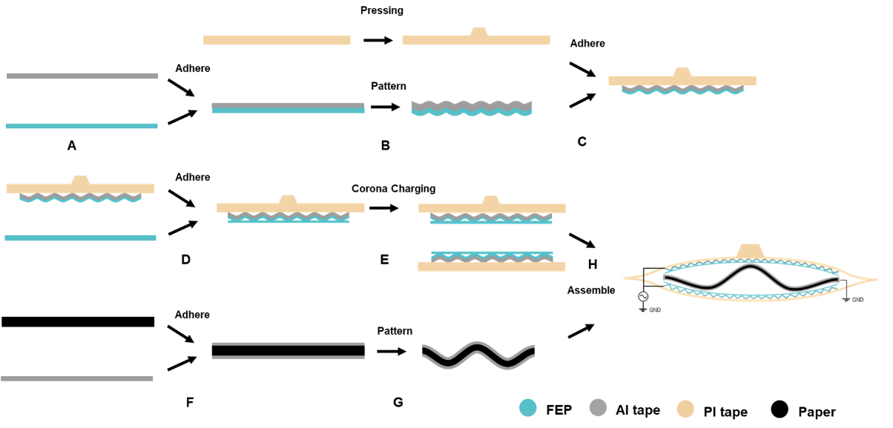

**Figure S2.** The fabrication process for the low voltage soft haptic actuator. **(A)** The Al tape (Detai Inc. with glue on the surface and the thickness of 100 μm) is adhered to an FEP film (DuPont Teflon®, thickness of 12.5 μm). **(B)** The wavy pattern (about 1 mm in length and about 0.2-0.5 mm in height) of the FEP film and the annulus-bump shape of the PI tape (Bertech Inc. with the thickness of 165 μm) are constructed by a pressing method with two different 3D printed mold-inserts. **(C)** The PI tape is adhered to the Al electrode as a supporting and isolating structure. **(D)** Another FEP film is attached to the patterned FEP film to form air bubbles in between. **(E)** After the corona charging process, the two FEP films are bonded together by the electrostatic charges to form the FEP/Air/FEP/Al/PI structure, with air bubbles inside the material. **(F)** Two pieces of Al tapes are adhered to both sides of a paper substrate (Genuine Origami Craze Inc., 70 gsm). **(G)** The wavy-shape patterns (about 5-20 mm in length and about 1-2 mm in height) for the spring structure are formed by using the Al/Paper/Al structure with the assistance of a 3D printed mask. **(H)** The assembly of the FEP/Air/FEP/Al/PI film (with the annulus-bump structure) and a second FEP/Air/FEP/Al/PI film (with flat surface) are assembled with the Al/Paper/Al spring structure in between for the soft actuator with prototype sizes of 2×2, 3×3, and 4×4 cm2, by using the double sided tape (3M, 61 μm in thickness) to fix the boundaries.

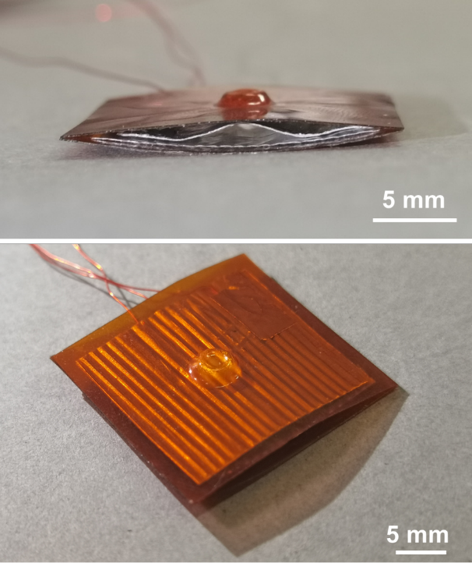

**Figure S3.** The optical images of a fabricated low voltage soft actuator.

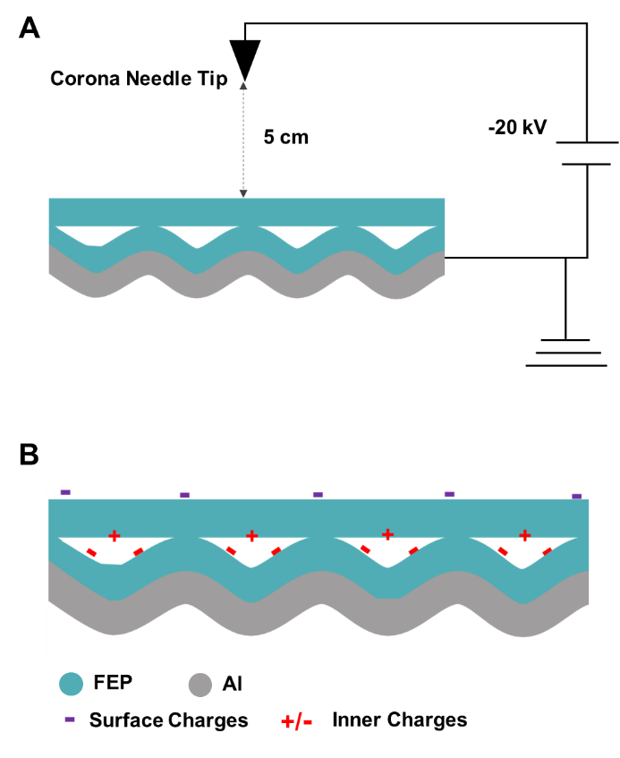

**Figure S4.** **(A)** Schematic diagram for the corona charging process. **(B)** The charge distribution illustrations for the charged FEP/Air/FEP/Al electret structure.

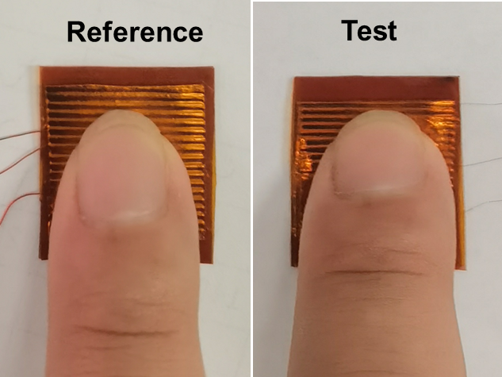

**Figure S5.** The optical images showing the volunteer sensation test for the index fingertip, where the reference actuator is driven under a fixed driving voltage of 20 Volts at 300 Hz for strong sensation and the test actuator is driven by randomly selected voltages (5, 10, 20 Volts) and frequencies (10-500 Hz).



**Figure S6.** Measured optimal values of the preloads to generate the strongest haptic sensations from 20 volunteers, under a driving voltage of 10, and 20 Volts between 50-400 Hz.



**Figure S7.** The measured threshold voltage under various driving frequency from 30 to 400 Hz for a prototype, 2×2 cm2 soft actuator.



**Figure S8.** The “adapting stimulus” testing results by 4 volunteers. The threshold voltage for haptic sensation from 30 to 400 Hz is first measured as the “Basic line” (black symbols). The unit for the threshold voltage in Y-axis is dB, or 20log10(U/U0), where U is the measured threshold voltage and U0 is 1 Volt. The adaption stimulus test is conducted by stimulating the index fingertip with an intensity of 9 dB above the “basic line” condition for a period of 6 mins at 30 Hz and 250 Hz, respectively. Afterwards, the threshold voltage for haptic sensation from 30 to 400 Hz is characterized again. The changes of threshold voltage before and after the adaption at 30 Hz (red symbols) and 250 Hz (blue symbols), respectively, are observed. After the 30 Hz adaption stimulation, the threshold sensation voltage increases for frequencies below 150 Hz with small increments in the high frequency range (200-400 Hz), suggesting MC receptors are more responsive to the low frequency actuation. After the 250 Hz adaption stimulation, the voltage threshold increases more uniformly for all tested frequencies, implying that the threshold sensation for PC and MC receptors are similar for high frequency actuation.

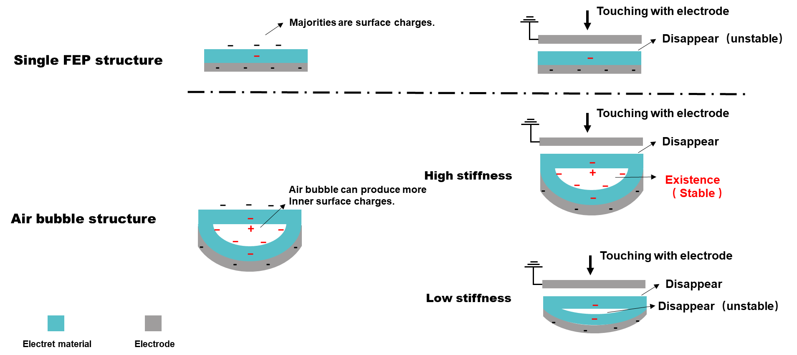

**Figure S9.** Charges distributions in electret materials before and after the contact with an external electrode. For the single FEP structure, most of the electrostatic charges are on the surface which can flow/leak out due to the contact with the external electrode. For the structure with embedded air bubbles, electrostatic charges can be stored on the inner surface of the embedded air bubble. The electrostatic charges inside the air bubble will remain stable if the bubbles can maintain their shapes but the charges could be neutralized if the air bubble collapse under a high external pressure.

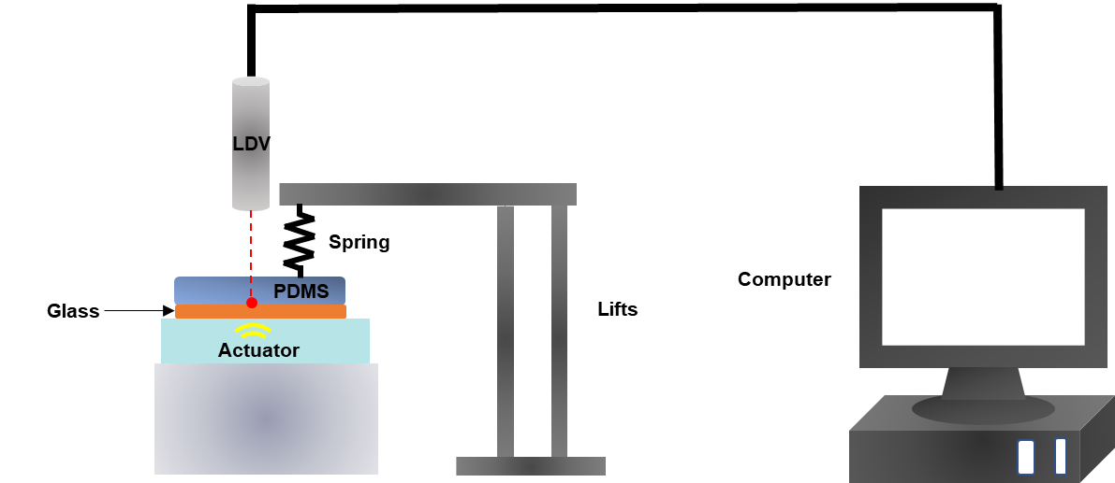

**Figure S10.** Experimental setup to measure the displacement of the actuator. A 4 mm-thick PDMS film mimicking tissues is placed on top of a stiff glass piece and the soft actuator is placed under the glass substrate. The glass substrate is utilized to measure the uniform vertical displacement during the vibration test. The pre-load force (FPreload) is adjusted by a spring. The vibration displacement (Ys-max) for the interface between the PDMS and glass is recorded by a Laser Doppler Velocimetry (LDV).



**Figure S11.** Effect of charging time for the corona charging process of the FEP/Air/FEP/Al electret film.

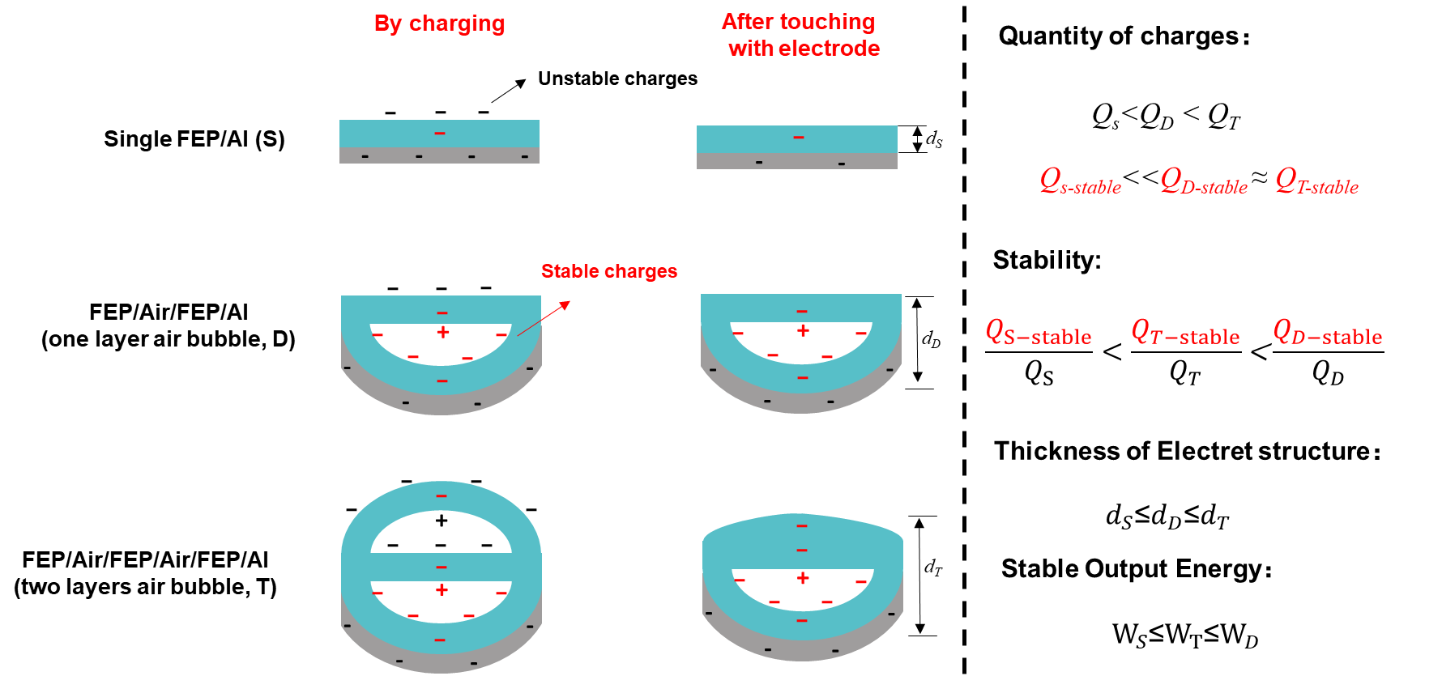

**Figure S12.** The electrostatic charges in the single FEP/Al electret film (S), one-layer air bubble FEP/Air/FEP/Al electret film (D), and two-layer air bubble FEP/Air/FEP/Air/FEP/Al electret film (T). For the single FEP/Al electret film, most electrostatic charges on the surface are leaked out when the surface is in repeated contacts with external electrodes. For the one-layer air bubble FEP/Air/FEP/Al electret film, a good portion of the electrostatic charges are stored inside the air bubbles to be stable when the film is pressed. For the two-layer air bubble FEP/Air/FEP/Air/FEP/Al electret film, the top layer may have collapsed when pressed such that lots of the electrostatic charges inside these air bubbles will be neutralized. As a result, actuators with the single-layer air bubble FEP/Air/FEP/Al electret film has best performances.

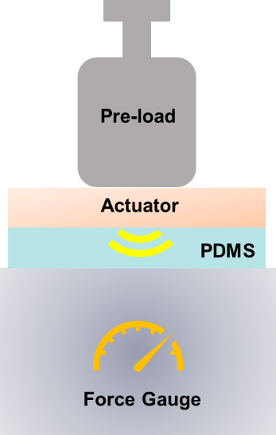

**Figure S13.** The experimental setup to measure the output force of the soft actuators.

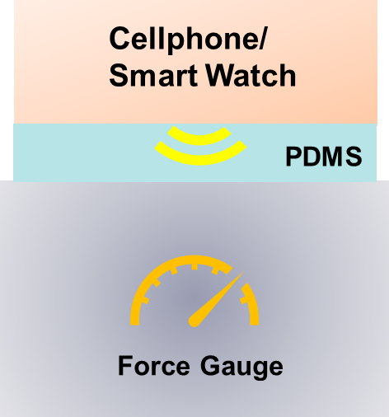

**Figure S14.** The experimental setup to measure the output force of cellphones or smart watches.

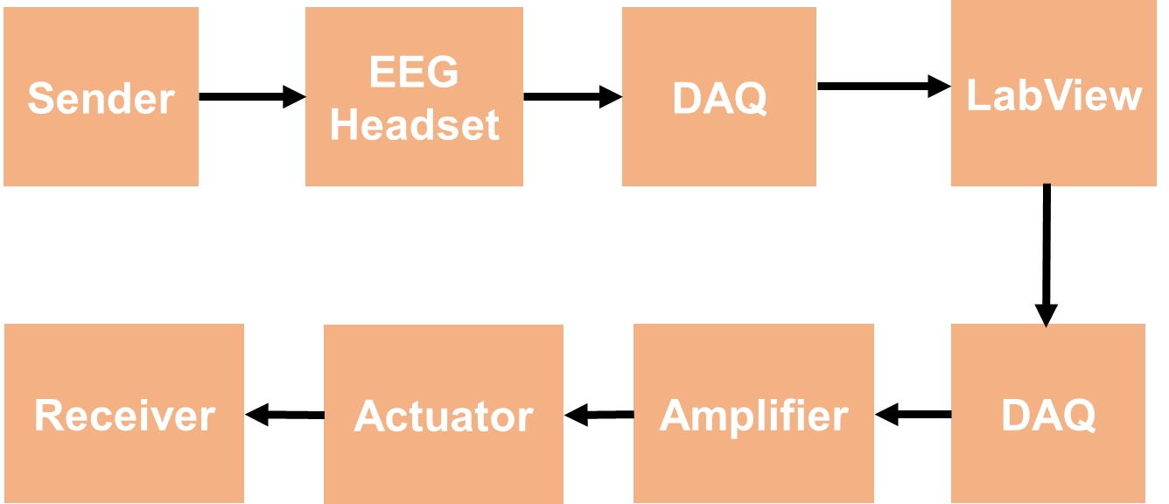

**Figure S15.** The detailed signal flow chart of the wearable silent haptics communication demo.

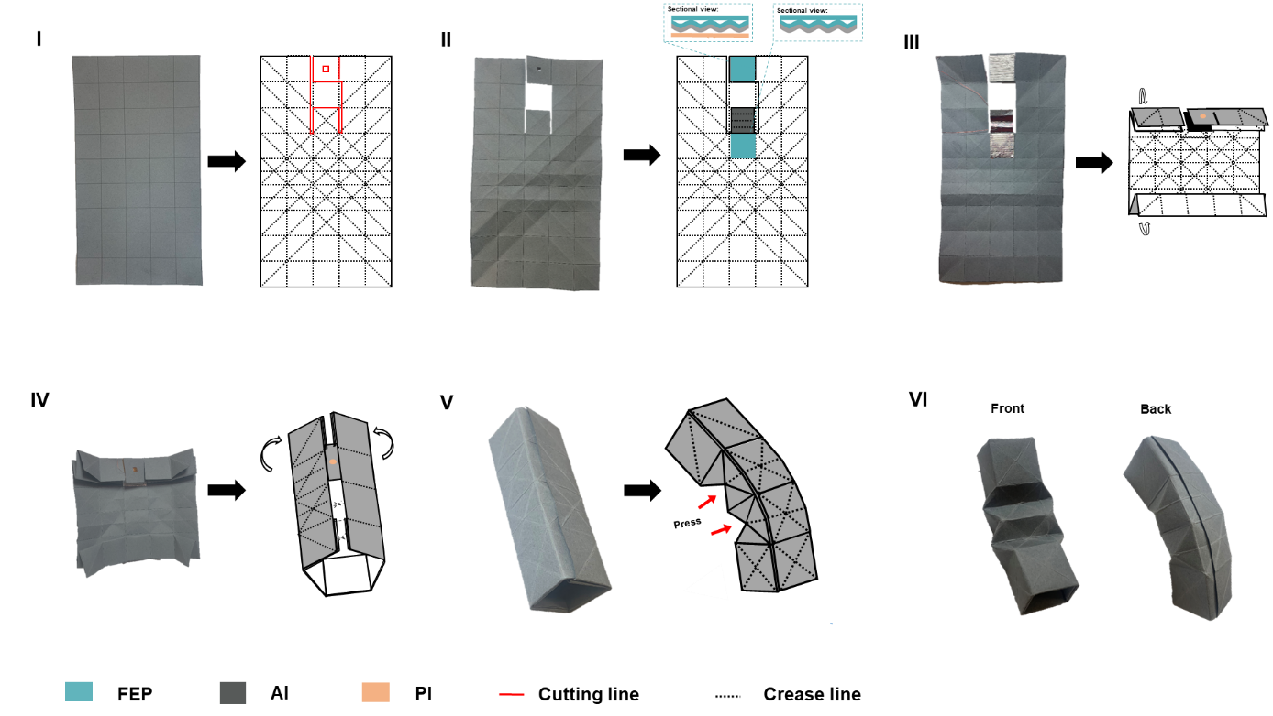

**Figure S16.** The origami fabrication process to assemble a prototype soft actuator with a paper fingerstall-shape as a wearable haptics feedback device. I: Start with a square sheet of paper with the grey side up. II: Fold the paper, unfold it after creasing it well, and then cut off the paper following the cutting line. III: Pasting FEP/Air/FEP/Al /PI film (blue area), FEP/Air/FEP/Al film (blue area) and one Al film (black area) on the paper, corona charging the blue area with -20 kV and folding the black area into a wave shape supporting part. IV: Fold the top and bottom three rows separately. V: Truck the first column of the left and right ends into each other, snugly plugging them in and form a cuboid and the edges are bonded with double side tape. VI: Press the middle 2 rows (as shown by the red arrow in the figure), the fingerstall with haptic feedback function is made.

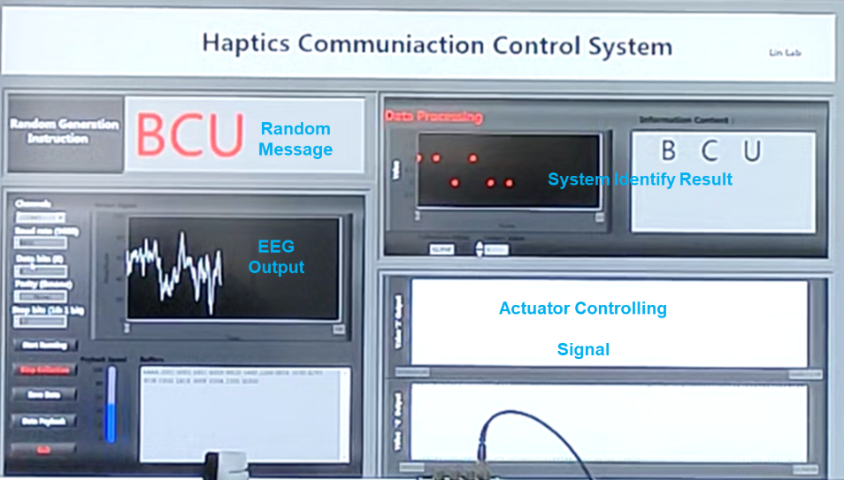

**Figure S17.** The operation interface system composed of “Random Message”, “EEG Output by the Sender”, “System Identify Result”, and “Actuator Controlling Signal for the Receiver”.

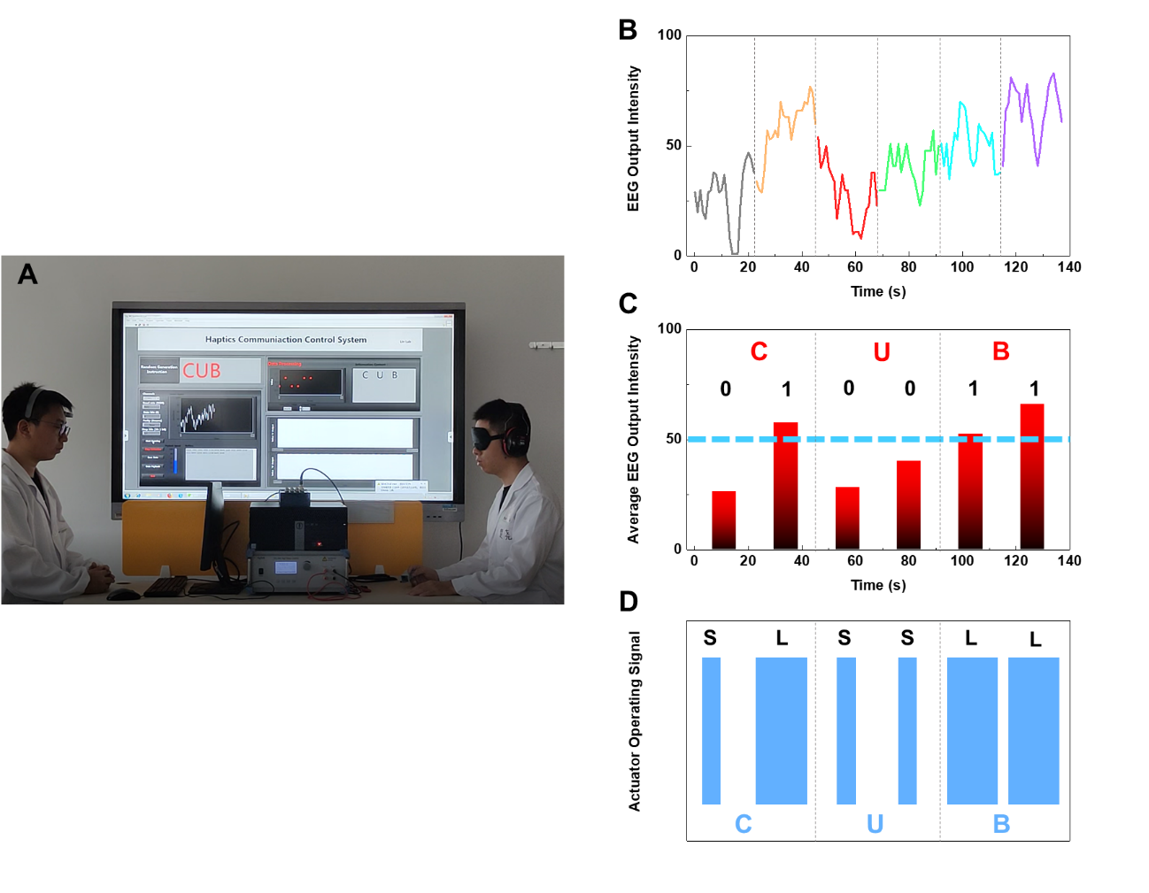

**Figure S18.** **(A)** The silent haptics communication system setup for transmitting “CUB”. **(B)** EEG output intensity from the sender. **(C)** Average EEG output intensity for 6 cycles. **(D)** The corresponding actuator controlling signals for each cycle.



**Figure S19.** Output energy comparison for portable and wired prototypes, under driving voltage and frequency of 7.4 V and 300 Hz.

**Table S1.** Comparison for different types of actuators for haptics feedback in the literature

|  |  |  |  |  |  |  |  |
| --- | --- | --- | --- | --- | --- | --- | --- |
| Ref | **Actuator Type** | **Input Voltage** | **Preload** | **Output** | **Operation**  **Frequency** | **size** | **Note** |
| 1 | electrostatic actuators | 400-1400 V (Threshold: 468 V) | 3 mN | 300 mN  750 µm | 1-320 Hz | 6*6*0.8 mm3 | High Voltage |
| 2 | Dielectric elastomers | 1-4 KV  (Threshold: 2.3 KV) |  | 100 mN  650 µm | 0-500 Hz | Thickness：1.7 mm | High Voltage |
| 3 | Dielectric elastomers | 3000 V |  | > 10 µm | 100-200 Hz | 100mm2 *0.86mm | High Voltage |
| 4 | Dielectric elastomers | Up to 4 KV  (Threshold: 584 V) |  | 12 µm  130 mN | 0-1000 Hz | Thickness:0.6mm | High Voltage |
| 5 | Electret | (Threshold: 500 V) | 1.5 N | 20 mN | 25-500 Hz | 2cm*2cm*150 μm | High Voltage |
| 6 | Dielectric elastomers | Up to 1.4 KV  (Threshold:600-800V) |  | 40-45 µm | 10-1000 Hz | 5cm*5cm*1mm | High Voltage |
| 7 | PVDF | 100-300V  (Threshold: 90-140 V) | <0.6 N | 4.4 µm  6.7 mN | 160 & 250 Hz | 35cm*14cm*2mm | Medium Voltage |
| 8 | Dielectric elastomers | 4-6 KV |  | 155 μm  47 mN | 0-1000 Hz | 10cm*10cm*1mm | High Voltage |
| 9 | Dielectric fluid transducer | 1.5-3.5 KV |  | 1.45 mm  13 mN | 0-200 Hz | Area >4*8mm2  Thickness:6mm | High Voltage |
| 10 | Electrovibration | Up to 225 V  (Threshold: 23 V) |  |  | 30-300 Hz | 55*95*0.125 mm3 | Friction |
| 11 | PVC gel | 100 V-1.9 KV |  | 1 G | 0-300 Hz | 36 *36*0.8 mm3 | High Voltage |
| 12 | Electrostrictive polymer | 400V-1200V |  | 14 mm | 10-300 Hz | 60*10*0.18 mm3 | High Voltage |
| 13 | PVC gel | 100 V-1 KV | 1 N | 0.7 G | 0-300 Hz | 23*23*0.5 mm3 | High Voltage |
| 14 | Dielectric elastomers | Threshold:468 V |  | 300 μm  0.6 N | 0-300 Hz | Thickness:10mm | High Voltage |
| 15 | Dielectric elastomers | 100 V-3.5 KV |  | 430 μm  240 mN | 0.1-150 Hz | 130*90*2 mm3 | High Voltage |
| 16 | PVC gel | 100-1500 V |  | 21.63 μm | 1-300 Hz | 36*36*1 mm3 | High Voltage |
| a | Electret | Up to 200 V  (Threshold: 4.4 V) | 0.4-1.6 N | 3.24μJ, 147.5 mN | 10-500 Hz | 2cm*2cm to 4cm*4cm | An annulus-bump (5.5 mm2, 2.3 mm thick） |
| b | Up to 200V  (Threshold: 5.1 V) | An annulus-bump（12 mm2, 2.1 mm thick） |
| c | Up to 200V  (Threshold:5.1 V) | A cylinder-shape (5.5 mm2, 1.9 mm thick） |
| d | Up to 200 V  (Threshold:7.7V) | Flat (1.3 mm thick) |

1. Leroy E*, et al.* Multimode hydraulically amplified electrostatic actuators for wearable haptics. *Adv. Mate*r. **32**, 2002564 (2020).
2. Mun S, *et al.* Electro-active polymer based soft tactile interface for wearable devices. *IEEE T. Haptics* **11**, 15-21 (2018).
3. Pyo D, *et al.* High-pressure endurable flexible tactile actuator based on microstructured dielectric elastomer. A*ppl. Phys. Lett.* **112**, 061902 (2018).
4. Yun S, *et al.* A Soft and transparent visuo-haptic interface pursuing wearable devices. *IEEE T. Ind. Electron.* **67**, 717-724 (2020).
5. Zhong J, *et al*. A flexible piezoelectret actuator/sensor patch for mechanical Human-machine interfaces. *ACS Nano* **13**, 7107-7116 (2019).
6. Matysek M, et al. Tactile display with dielectric multilayer elastomer actuators. SPIE (2009).
7. Yoon SH, *et al*. HapSense: A soft haptic I/O device with uninterrupted dual functionalities of force sensing and vibrotactile actuation. Proceedings of the 32nd Annual ACM Symposium on User Interface Software and Technology, (2019).
8. Ankit, Tiwari N, *et al.* Highly transparent and integrable surface texture change device for localized tactile feedback. *Small* **14**, 1702312 (2018).
9. Han AK, *et al*. Haptic surface display based on miniature dielectric fluid transducers. *IEEE Robot. Autom. Lett.* **5**, 4021-4027 (2020).
10. Guo X, *et al.* Absolute and discrimination thresholds of a flexible texture display. In: 2017 IEEE World Haptics Conference (WHC) (ed^(eds) (2017).
11. Park W, *et al*. Soft haptic actuator based on knitted PVC gel fabric. *IEEE T. Ind. Electron.* **67**, 677-685 (2020).
12. Ganet F, *et al*. Haptic feedback using an all-organic electroactive polymer composite. *Sensor. Actuat. B-Chem.* **220**, 1120-1130 (2015).
13. Park W-H, *et al*. Development of a flexible and bendable vibrotactile actuator based on wave-shaped poly(vinyl chloride)/acetyl tributyl citrate gels for wearable electronic devices. *Smart Mater. Struct.* **25**, 115020 (2016).
14. Zhao H, *et al.* A Wearable Soft Haptic Communicator Based on Dielectric Elastomer Actuators. *Soft Robot.* **7**, 451-461 (2020).
15. Phung H, *et al*. Interactive haptic display based on soft actuator and soft sensor. In: 2017 IEEE/RSJ International Conference on Intelligent Robots and Systems (IROS) (ed^(eds) (2017).
16. Park W-H, *et al*. A Soft Vibrotactile Actuator with Knitted PVC Gel Fabric. In: Haptics: Science, Technology, and Applications (ed^(eds Prattichizzo D, Shinoda H, Tan HZ, Ruffaldi E, Frisoli A). Springer International Publishing (2018).

**Table S2**. Power consumption for commercial eccentric rotating mass (ERM), linear resonant actuator (LRA), piezo motor (Piezo), and our soft actuator.

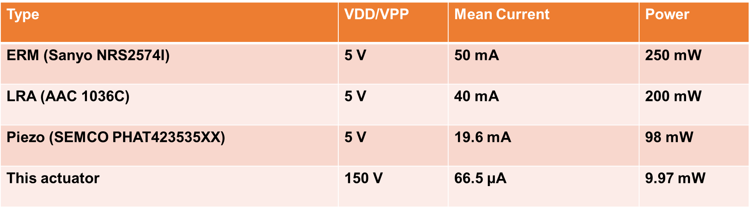

**Supplementary** **Explanation 1:** Working mechanism of the soft actuator.

The electrostatic force generated by the soft actuator is modeled by the three-electrode parallel plate **(Figure S20A)** and simplified to a two-electrode parallel plate actuator **(Figure S20B)**. There are 2 types of electrostatic charges for the actuator. One type of charges is adsorbed on electret material by the corona charging process with a charge density of σFEP. The other type is by the applied driving voltage (*U*) with charge density of σ0. The capacitance (C) of per unit area can be expressed as the following if the distance between two electrode plate is *d*0 and the thickness of the electret membrane is *d*1:

 (1)

where ε0 is vacuum permittivity and εr is relative permittivity. The charge density on the electrode is computed by substitute Eq (1) as:

 (2)

If the length of the electrode, *l*, is much larger than the distance between the two electrodes, the Gauss's law is used to derive the electric field strength as:

 (3)

The electrostatic force, d*F*, can be expressed as:

 (4)

In general, under an applied AC voltage (zero to positive values), this soft electret actuator will contract and recover by the generated alternating electrostatic force (*F*). The electrostatic charges in the electret (*σ0*) provides the extra bias voltage to reduce the required AC driving voltage the soft actuator. Under a low driving voltage (less than10 Volts), the soft actuator is directly driven by square waves from the Agilent 33220A functional generator. Under a high driving voltage (10-150 Volts), the soft actuator is driven by a PI E-463 HVPZT amplifier and the driving voltage and frequency are adjusted by the functional generator.

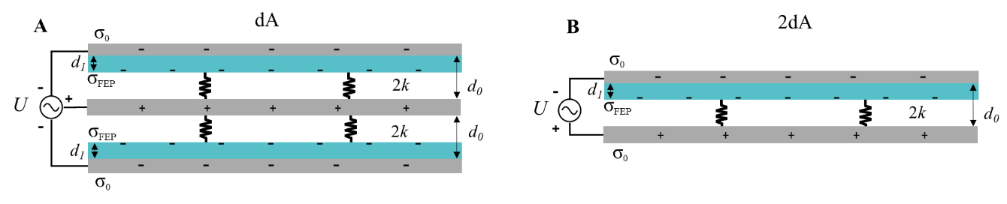

**Figure S20. (A)** An electrical model of three-electrode parallel plate actuator. (**B)**. A simplified electrical model of **(A)**.

**Supplementary Explanation 2:** The output energy of the soft actuator

When the fingertip presses on the top surface of the soft actuator, the force analysis of finger-actuator is as shown in the **Figure S21**.The soft actuator has the dynamic output force (*F*(*t*)), as well as the support force (*F*s) which is considered to be a constant and expressed as:

 (5)

where *F*preload is preload force by the fingertip on the actuator. Because the magnitude of the preload force is much larger than that of the dynamic output force, the output energy (*W*) of the actuator on the fingertip can be derived as:

 (6)

where *y*s isthe displacement of the fingertip-actuator contact surface*.* When the fingertip is actuated from the lowest point to the highest point by the soft actuator, the actuator does the largest energy and transmits the maximum energy to the fingertip in this process. This energy is defined as the peak energy (Δ*Wpeak*):

 (7)

where *Ys-max*is the largest displacement of the fingertip-actuator contact surface.

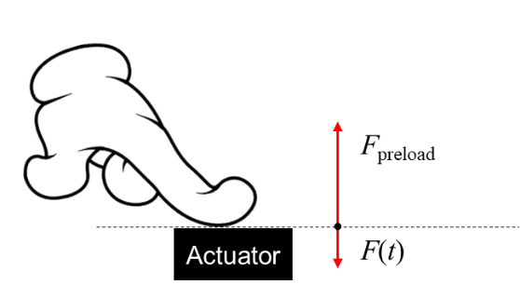

**Figure S20.** Force analysis of fingertip-actuator contact surface.

**Supplementary Explanation 3:** The electromechanical output simulations

**Figure S22** showsthe initial distance between the electret structure and the supporting structure as *D*0 (the initial supporting spring structure thickness). When a preload force (*F*preload) is applied on the soft actuator, the distance decreases to *D*1. When an AC driving voltage is applied, the upper plate of the soft actuator (electret structure and electrode) moves periodically. At the highest point, the distance between the electret structure and the supporting structure is *D*1-up, and at the lowest point, the distance is *D*1-down. Therefore, *D*1 is related to the supporting structure thickness and spring stiffness under a pre-load, and can be expressed as:

 (8)

where 2*k* refers to the spring stiffness of soft actuator. According the basic electric model in **Supplementary Explanation 1** andEq.(4), the electrostatic force (*F*) of the soft actuator can be expressed as:

 (9)

where *x* and *z* represent the coordinates of X, Z on the horizontal coordinate axis. In this work, the vibration of the soft actuator can be approximated as a Stable periodic vibration driven by a Periodic force. Substituting Eqs.(9) &(4) into Eq.(10), the numerical solution of Ys-max (ys-max) can be obtained in Matlab and the ideal output energy can be calculated by Eq.(7).

In general, the displacement of the actuator can be classified into three categories:



For the first case, the distance between the electret and the supporting structure is large such that the electrostatic force is very small to result in a weak vibration. For the second case, the spacing between the plates is appropriate for the actuator to perform periodic movements. The optimal conditions is when the upper plate moves to the lowest point, it may just touches the supporting structure for the best outputs. For the third case, the structure doesn’t have enough space for the upper plate to move as the movements of the electret will be blocked by the materials. In order to achieve the ideal operating condition, *D*1 can be designed to meet the requirements of the second case. According to Eq.(8), under a fixed preload and a supporting structure thickness, *D*1 can be determined by the spring stiffness of the soft actuator as an optimal spring stiffness for generating the best output energy.

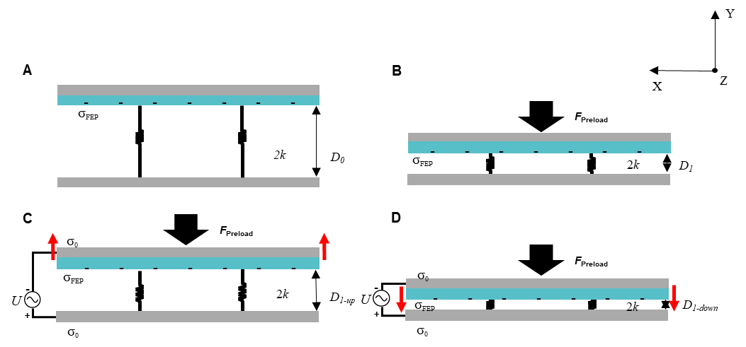

**Figure S23. (A)** Schematic diagram of initial actuator structure between the electret and spring structure. (**B)**. Schematic diagram of the pre-loaded structure. **(C)**. Schematic diagram of movements of the electret structure to the highest point under the preload condition. **(D)**. Schematic diagram of the movement to the lowest point under a preload as the optimal operation condition.

**Supplementary Explanation 4:** Kinetic model of the fingertip-actuator system

A five degree-of-freedom dynamic system is developed to approximate the movement of the actuator and human finger during the haptic actuation test, as shown in **Figure S23.** The system can be expressed by 3 mass blocks: the mass of skin which is in directly contact with the soft actuator (*ms*); the equivalent mass of the finger (*mf*), the equivalent mass of Palm-hand-back-wrist-arm structure (*mp*), and the pairs of stiffness-damping elements. Here, *Ka* and *cac*represent the stiffness and damping of the soft actuator; *Ksf* and *csf*represent the stiffness and damping coefficient of the tissue between the skin (*ms*) and bone of fingertip and *Kfp*, *cfp*, *Krfp* and *crfp* are used to couple m*f* and m*p*. Finaly, *Kpb*, *cpb*, *Krpb* and *crpb*are used to couple *mp* and human body.

When the soft actuator is driven by an AC voltage, the system will generate a periodic force (*F*(t)) on the fingertip. This work only includes the movements of *ms* in the vertical direction as the rotational damping between various parts of the body is very large such that the rotational movement between each part is ignored. The kinetic model can be expressed as:

 (10)

Where

,,

(11)

The parameters in Eq.(11) are assigned in the normal range as shown in **Table S3**. The effect of the actuator spring stiffness changes on the actuator output is shown in **Figure S24**.It’s found that resonant frequencies at around 250 to 300 Hz under various preload values and these results match relatively well with the experimental results in **Figure 3D**.

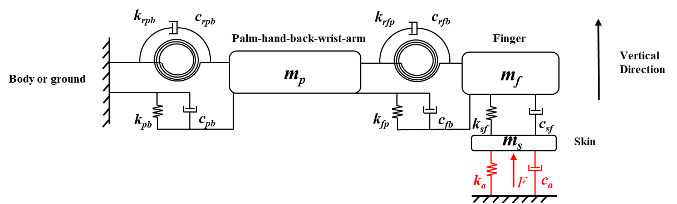

**Figure S23.** Thekinetic model of finger-actuator system.

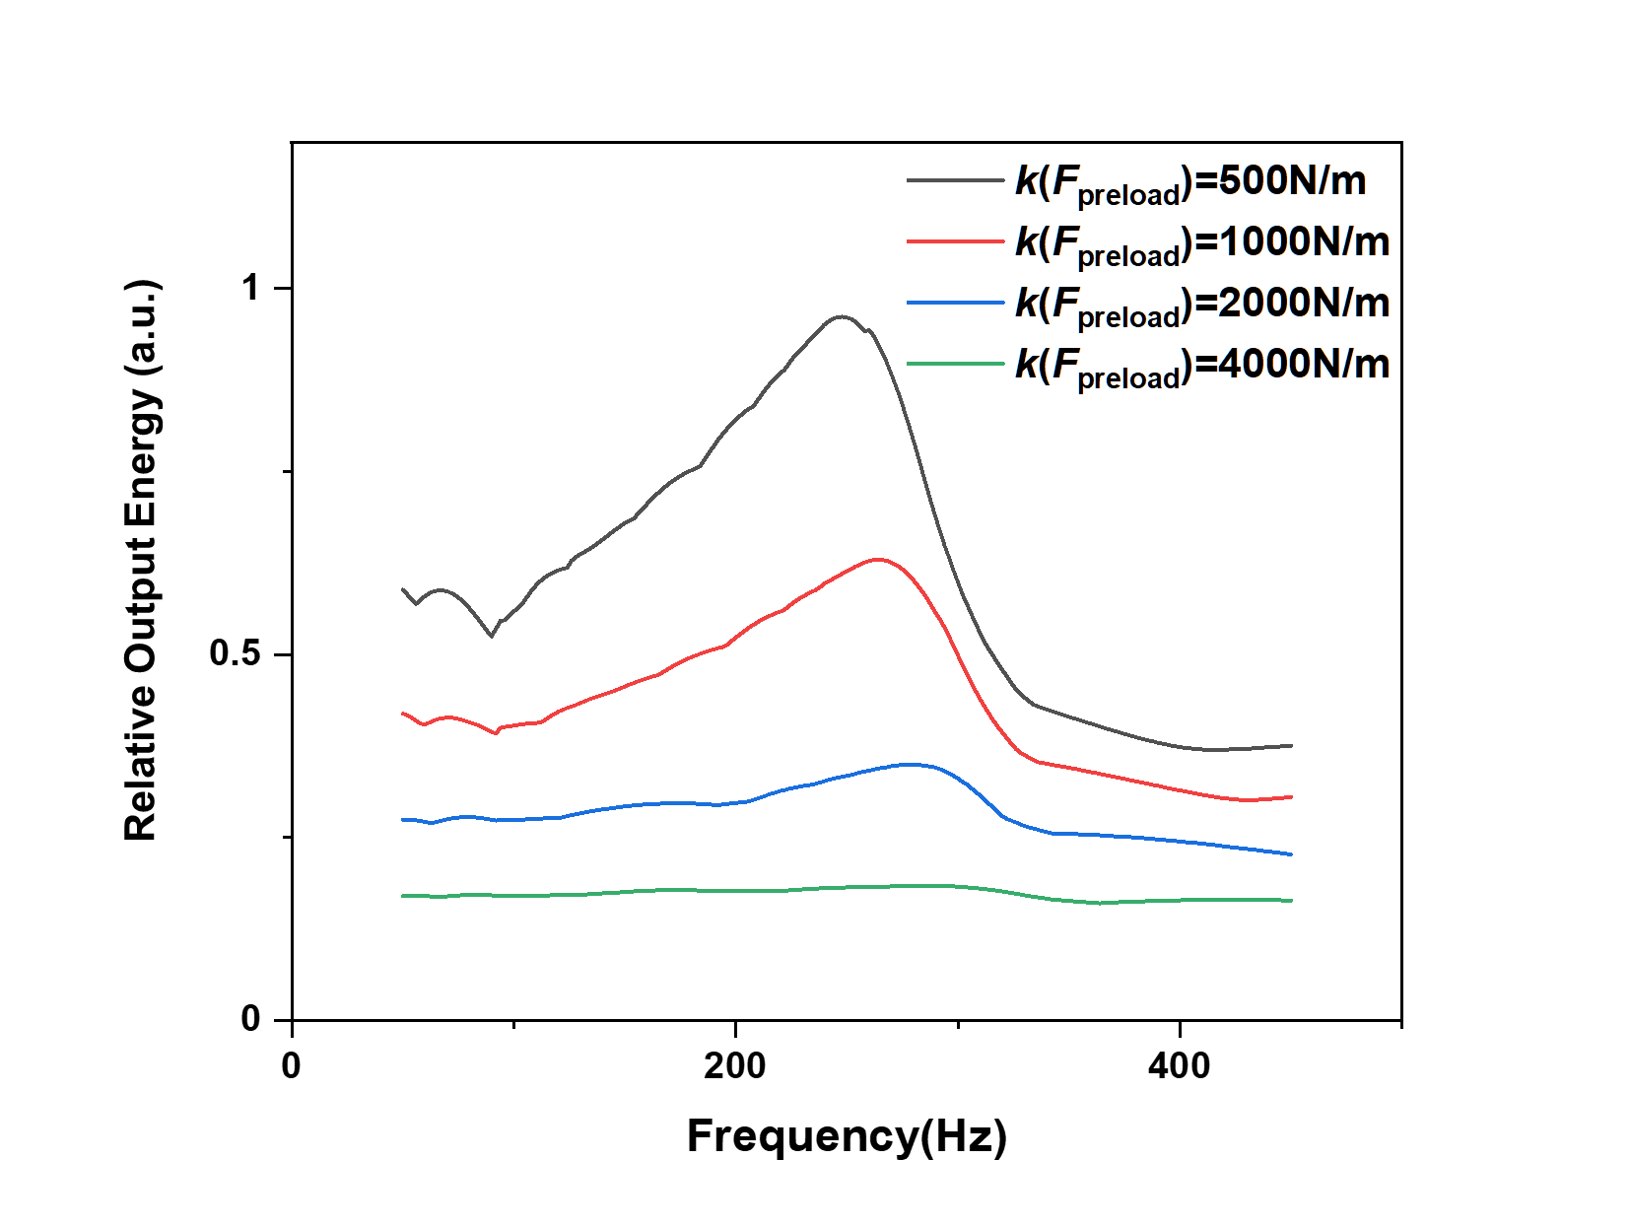

**Figure S24.** A simulation of output energy of soft actuator to the finger under different spring stiffness and the same electrostatic force (Sinusoidal periodic force).

**Table S3:** Parameters of the kinetic model

|  |  |  |
| --- | --- | --- |
| **Parameters** | **Unit** | **Value** |
| *ms* | g | 2 |
| *mf* | 25 |
| *mp* | 1000 |
| *ksf* | N/m | 2000 |
| *kfp* | 1500 |
| *kpb* | 100 |
| *csf* |  | 1 |
| *cfp* | Ns/m | 2 |
| *cpb* |  | 70 |

**Table S4:** Raw data of sensation intensity from 20 volunteers under the driving voltages of 5, 10, 20 Volts and frequency of 10-500 Hz for the soft actuator with the annulus bump structure.

|  |  |  |  |  |  |  |  |  |  |  |  |  |  |  |  |  |  |  |  |  |  |
| --- | --- | --- | --- | --- | --- | --- | --- | --- | --- | --- | --- | --- | --- | --- | --- | --- | --- | --- | --- | --- | --- |
|  | | **Subjects** | | | | | | | | | | | | | | | | | | | |
| **Condition** | | **1** | **2** | **3** | **4** | **5** | **6** | **7** | **8** | **9** | **10** | **11** | **12** | **13** | **14** | **15** | **16** | **17** | **18** | **19** | **20** |
| **5V** | **10Hz** | 0 | 0 | 0 | 0 | 0 | 0 | 0 | 0 | 0 | 0 | 0 | 0 | 0 | 0 | 0 | 0 | 0 | 0 | 0 | 0 |
| **50Hz** | 0 | 0 | 0 | 0 | 0 | 0 | 0 | 0 | 0 | 0 | 0 | 0 | 0 | 0 | 0 | 0 | 0 | 0 | 0 | 0 |
| **100Hz** | 0 | 0 | 0 | 0 | 0 | 0 | 0 | 0 | 0 | 0 | 0 | 0 | 0 | 0 | 0 | 0 | 0 | 0 | 0 | 0 |
| **120Hz** | 0 | 0 | 0 | 0 | 0 | 0 | 0 | 0 | 0 | 0 | 0 | 0 | 0 | 0 | 0 | 0 | 0 | 0 | 0 | 0 |
| **140Hz** | 0 | 0 | 0 | 0 | 0 | 0 | 0 | 0 | 0 | 0 | 0 | 0 | 0 | 0 | 0 | 0 | 0 | 0 | 0 | 0 |
| **170Hz** | 0 | 0 | 0 | 0 | 0 | 0 | 0 | 0 | 0 | 0 | 0 | 0 | 0 | 0 | 0 | 0 | 0 | 0 | 0 | 0 |
| **200Hz** | 1 | 1 | 0 | 0 | 0 | 0 | 0 | 0 | 0 | 0 | 1 | 0 | 0 | 0 | 0 | 1 | 1 | 0 | 0 | 0 |
| **250HZ** | 1 | 1 | 0 | 0 | 0 | 1 | 0 | 1 | 0 | 0 | 1 | 0 | 0 | 0 | 0 | 1 | 1 | 0 | 0 | 1 |
| **300HZ** | 1 | 1 | 1 | 0 | 0 | 1 | 0 | 1 | 0 | 0 | 1 | 0 | 0 | 0 | 0 | 1 | 1 | 1 | 1 | 1 |
| **350Hz** | 1 | 0 | 1 | 0 | 0 | 1 | 0 | 1 | 0 | 0 | 1 | 0 | 0 | 0 | 0 | 1 | 0 | 1 | 0 | 0 |
| **400Hz** | 1 | 0 | 0 | 0 | 0 | 1 | 0 | 0 | 0 | 0 | 0 | 0 | 0 | 0 | 0 | 1 | 0 | 1 | 0 | 0 |
| **500Hz** | 0 | 0 | 0 | 0 | 0 | 0 | 0 | 0 | 0 | 0 | 0 | 0 | 0 | 0 | 0 | 0 | 0 | 0 | 0 | 0 |
| **10V** | **10Hz** | 0 | 0 | 0 | 0 | 0 | 0 | 0 | 1 | 0 | 0 | 0 | 0 | 0 | 0 | 0 | 0 | 0 | 0 | 0 | 0 |
| **50Hz** | 0 | 1 | 0 | 0 | 0 | 1 | 0 | 1 | 0 | 0 | 0 | 0 | 0 | 0 | 0 | 0 | 0 | 0 | 0 | 0 |
| **100Hz** | 1 | 1 | 0 | 0 | 0 | 1 | 0 | 1 | 0 | 0 | 0 | 0 | 0 | 0 | 0 | 0 | 0 | 1 | 0 | 0 |
| **120Hz** | 1 | 1 | 0 | 0 | 1 | 1 | 0 | 1 | 0 | 0 | 0 | 0 | 0 | 0 | 0 | 0 | 0 | 1 | 0 | 0 |
| **140Hz** | 1 | 1 | 0 | 0 | 1 | 1 | 0 | 1 | 0 | 0 | 0 | 0 | 0 | 0 | 0 | 1 | 1 | 1 | 0 | 1 |
| **170Hz** | 1 | 1 | 0 | 0 | 1 | 1 | 0 | 1 | 0 | 0 | 1 | 0 | 0 | 1 | 0 | 1 | 1 | 1 | 0 | 1 |
| **200Hz** | 1 | 1 | 1 | 1 | 1 | 1 | 1 | 1 | 0 | 0 | 1 | 0 | 1 | 1 | 0 | 1 | 1 | 1 | 0 | 1 |
| **250HZ** | 1 | 1 | 1 | 1 | 1 | 2 | 1 | 1 | 0 | 0 | 1 | 0 | 1 | 1 | 1 | 1 | 1 | 1 | 1 | 1 |
| **300HZ** | 1 | 1 | 1 | 1 | 1 | 2 | 1 | 1 | 0 | 0 | 1 | 1 | 1 | 1 | 1 | 1 | 1 | 1 | 1 | 1 |
| **350Hz** | 1 | 1 | 1 | 1 | 1 | 1 | 1 | 1 | 0 | 0 | 1 | 0 | 1 | 1 | 1 | 1 | 1 | 1 | 1 | 1 |
| **400Hz** | 1 | 1 | 1 | 0 | 1 | 1 | 0 | 1 | 0 | 0 | 1 | 0 | 1 | 1 | 1 | 1 | 1 | 1 | 0 | 1 |
| **500Hz** | 0 | 0 | 0 | 0 | 0 | 0 | 0 | 1 | 0 | 0 | 1 | 0 | 0 | 0 | 0 | 0 | 0 | 1 | 0 | 0 |
| **20V** | **10Hz** | 1 | 0 | 1 | 0 | 0 | 0 | 0 | 0 | 0 | 0 | 1 | 0 | 0 | 1 | 1 | 0 | 0 | 1 | 0 | 1 |
| **50Hz** | 1 | 1 | 1 | 1 | 1 | 1 | 1 | 1 | 1 | 1 | 1 | 0 | 1 | 1 | 1 | 1 | 0 | 1 | 0 | 1 |
| **100Hz** | 1 | 1 | 1 | 1 | 1 | 1 | 1 | 1 | 1 | 1 | 1 | 1 | 1 | 1 | 1 | 1 | 1 | 1 | 0 | 1 |
| **120Hz** | 1 | 1 | 1 | 1 | 1 | 1 | 1 | 1 | 1 | 1 | 1 | 1 | 1 | 1 | 1 | 1 | 1 | 1 | 1 | 1 |
| **140Hz** | 1 | 1 | 2 | 1 | 1 | 2 | 1 | 1 | 1 | 1 | 1 | 1 | 2 | 1 | 1 | 1 | 1 | 1 | 1 | 1 |
| **170Hz** | 2 | 2 | 2 | 1 | 2 | 2 | 1 | 2 | 1 | 2 | 1 | 2 | 2 | 2 | 1 | 2 | 1 | 2 | 2 | 2 |
| **200Hz** | 2 | 2 | 3 | 2 | 2 | 2 | 3 | 2 | 3 | 2 | 2 | 3 | 2 | 3 | 2 | 2 | 2 | 2 | 2 | 2 |
| **250HZ** | 2 | 3 | 3 | 3 | 3 | 3 | 2 | 3 | 3 | 3 | 3 | 3 | 3 | 3 | 3 | 2 | 3 | 3 | 3 | 2 |
| **300HZ** | 3 | 3 | 3 | 3 | 3 | 3 | 3 | 3 | 2 | 3 | 3 | 3 | 3 | 3 | 3 | 3 | 3 | 2 | 3 | 3 |
| **350Hz** | 3 | 2 | 3 | 2 | 3 | 3 | 2 | 2 | 2 | 1 | 3 | 2 | 3 | 3 | 2 | 3 | 2 | 2 | 2 | 2 |
| **400Hz** | 3 | 2 | 2 | 2 | 3 | 3 | 2 | 2 | 2 | 1 | 2 | 2 | 1 | 2 | 1 | 2 | 2 | 2 | 2 | 2 |
| **500Hz** | 0 | 0 | 1 | 0 | 1 | 0 | 0 | 1 | 1 | 1 | 1 | 1 | 1 | 1 | 1 | 1 | 1 | 1 | 0 | 1 |

**Table S5:** Raw data of sensation intensity from 20 volunteers under the driving voltages of 5, 10, 20 Volts and frequency of 10-500 Hz for the soft actuator without the annulus bump structure.

|  |  |  |  |  |  |  |  |  |  |  |  |  |  |  |  |  |  |  |  |  |  |
| --- | --- | --- | --- | --- | --- | --- | --- | --- | --- | --- | --- | --- | --- | --- | --- | --- | --- | --- | --- | --- | --- |
|  | | **Subjects** | | | | | | | | | | | | | | | | | | | |
| **Condition** | | **1** | **2** | **3** | **4** | **5** | **6** | **7** | **8** | **9** | **10** | **11** | **12** | **13** | **14** | **15** | **16** | **17** | **18** | **19** | **20** |
| **5V** | **10Hz** | 0 | 0 | 0 | 0 | 0 | 0 | 0 | 0 | 0 | 0 | 0 | 0 | 0 | 0 | 0 | 0 | 0 | 0 | 0 | 0 |
| **50Hz** | 0 | 0 | 0 | 0 | 0 | 0 | 0 | 0 | 0 | 0 | 0 | 0 | 0 | 0 | 0 | 0 | 0 | 0 | 0 | 0 |
| **100Hz** | 0 | 0 | 0 | 0 | 0 | 0 | 0 | 0 | 0 | 0 | 0 | 0 | 0 | 0 | 0 | 0 | 0 | 0 | 0 | 0 |
| **120Hz** | 0 | 0 | 0 | 0 | 0 | 0 | 0 | 0 | 0 | 0 | 0 | 0 | 0 | 0 | 0 | 0 | 0 | 0 | 0 | 0 |
| **140Hz** | 0 | 0 | 0 | 0 | 0 | 0 | 0 | 0 | 0 | 0 | 0 | 0 | 0 | 0 | 0 | 0 | 0 | 0 | 0 | 0 |
| **170Hz** | 0 | 0 | 0 | 0 | 0 | 0 | 0 | 0 | 0 | 0 | 0 | 0 | 0 | 0 | 0 | 0 | 0 | 0 | 0 | 0 |
| **200Hz** | 0 | 0 | 0 | 0 | 0 | 0 | 0 | 0 | 0 | 0 | 0 | 0 | 0 | 0 | 0 | 0 | 0 | 0 | 0 | 0 |
| **250HZ** | 0 | 1 | 1 | 0 | 0 | 0 | 0 | 0 | 0 | 0 | 0 | 0 | 0 | 0 | 0 | 0 | 0 | 1 | 0 | 0 |
| **300HZ** | 0 | 1 | 1 | 0 | 0 | 0 | 0 | 0 | 0 | 0 | 0 | 0 | 0 | 0 | 0 | 0 | 0 | 1 | 0 | 0 |
| **350Hz** | 0 | 1 | 0 | 0 | 0 | 0 | 0 | 0 | 0 | 0 | 0 | 0 | 0 | 0 | 0 | 0 | 0 | 0 | 0 | 0 |
| **400Hz** | 0 | 0 | 0 | 0 | 0 | 0 | 0 | 0 | 0 | 0 | 0 | 0 | 0 | 0 | 0 | 0 | 0 | 0 | 0 | 0 |
| **500Hz** | 0 | 0 | 0 | 0 | 0 | 0 | 0 | 0 | 0 | 0 | 0 | 0 | 0 | 0 | 0 | 0 | 0 | 0 | 0 | 0 |
| **10V** | **10Hz** | 0 | 0 | 0 | 0 | 0 | 0 | 0 | 0 | 0 | 0 | 0 | 0 | 0 | 0 | 0 | 0 | 0 | 0 | 0 | 0 |
| **50Hz** | 0 | 0 | 0 | 0 | 0 | 0 | 0 | 0 | 0 | 0 | 0 | 0 | 0 | 0 | 0 | 0 | 0 | 0 | 0 | 0 |
| **100Hz** | 0 | 0 | 0 | 0 | 0 | 0 | 0 | 0 | 0 | 0 | 0 | 0 | 0 | 0 | 0 | 0 | 0 | 0 | 0 | 0 |
| **120Hz** | 0 | 0 | 0 | 0 | 0 | 0 | 0 | 0 | 0 | 0 | 0 | 0 | 0 | 0 | 0 | 0 | 0 | 0 | 0 | 0 |
| **140Hz** | 0 | 0 | 0 | 0 | 0 | 0 | 0 | 0 | 0 | 0 | 0 | 0 | 0 | 0 | 0 | 0 | 0 | 0 | 0 | 0 |
| **170Hz** | 0 | 0 | 0 | 0 | 0 | 0 | 0 | 0 | 1 | 0 | 0 | 0 | 0 | 0 | 0 | 0 | 0 | 1 | 0 | 0 |
| **200Hz** | 1 | 0 | 0 | 1 | 1 | 1 | 0 | 1 | 1 | 1 | 1 | 0 | 1 | 1 | 0 | 1 | 0 | 1 | 1 | 1 |
| **250HZ** | 1 | 0 | 0 | 1 | 1 | 1 | 0 | 1 | 1 | 1 | 1 | 1 | 1 | 1 | 0 | 1 | 1 | 1 | 1 | 1 |
| **300HZ** | 1 | 1 | 1 | 1 | 1 | 1 | 1 | 0 | 1 | 1 | 1 | 0 | 1 | 1 | 1 | 1 | 1 | 1 | 1 | 1 |
| **350Hz** | 1 | 1 | 1 | 1 | 0 | 1 | 1 | 0 | 1 | 1 | 1 | 0 | 1 | 1 | 0 | 1 | 0 | 1 | 1 | 1 |
| **400Hz** | 1 | 1 | 1 | 1 | 0 | 1 | 1 | 0 | 1 | 1 | 1 | 0 | 1 | 0 | 0 | 1 | 0 | 1 | 1 | 1 |
| **500Hz** | 0 | 0 | 0 | 0 | 0 | 0 | 0 | 0 | 0 | 0 | 0 | 0 | 0 | 0 | 0 | 0 | 0 | 0 | 0 | 0 |
| **20V** | **10Hz** | 0 | 0 | 0 | 1 | 0 | 0 | 0 | 0 | 0 | 0 | 0 | 0 | 0 | 0 | 0 | 0 | 0 | 0 | 1 | 0 |
| **50Hz** | 0 | 0 | 0 | 1 | 0 | 0 | 0 | 0 | 1 | 0 | 0 | 0 | 1 | 1 | 0 | 0 | 0 | 0 | 1 | 1 |
| **100Hz** | 0 | 1 | 1 | 1 | 0 | 1 | 0 | 1 | 1 | 0 | 0 | 1 | 1 | 1 | 1 | 0 | 1 | 0 | 1 | 1 |
| **120Hz** | 1 | 1 | 1 | 1 | 0 | 1 | 0 | 1 | 1 | 1 | 1 | 1 | 1 | 1 | 1 | 1 | 1 | 1 | 1 | 1 |
| **140Hz** | 1 | 1 | 1 | 1 | 1 | 1 | 0 | 1 | 1 | 1 | 1 | 1 | 1 | 1 | 1 | 1 | 1 | 1 | 1 | 1 |
| **170Hz** | 1 | 1 | 2 | 1 | 2 | 1 | 1 | 2 | 1 | 1 | 2 | 1 | 1 | 2 | 1 | 1 | 1 | 1 | 2 | 1 |
| **200Hz** | 2 | 2 | 2 | 2 | 2 | 2 | 2 | 2 | 3 | 2 | 2 | 2 | 2 | 2 | 2 | 1 | 2 | 1 | 2 | 2 |
| **250HZ** | 2 | 3 | 2 | 2 | 3 | 3 | 2 | 3 | 3 | 3 | 3 | 2 | 2 | 3 | 2 | 3 | 3 | 2 | 3 | 3 |
| **300HZ** | 3 | 3 | 3 | 3 | 2 | 3 | 3 | 3 | 2 | 3 | 3 | 3 | 3 | 3 | 3 | 2 | 3 | 2 | 3 | 3 |
| **350Hz** | 2 | 2 | 2 | 2 | 2 | 3 | 2 | 3 | 2 | 2 | 2 | 2 | 3 | 2 | 1 | 2 | 3 | 2 | 3 | 2 |
| **400Hz** | 2 | 2 | 2 | 2 | 1 | 2 | 2 | 2 | 2 | 2 | 1 | 2 | 1 | 2 | 1 | 2 | 2 | 2 | 2 | 1 |
| **500Hz** | 1 | 0 | 0 | 0 | 0 | 1 | 0 | 1 | 1 | 1 | 1 | 1 | 1 | 0 | 0 | 0 | 0 | 1 | 1 | 1 |

**Table S6:** Raw data of threshold voltage for haptic sensations under a fixed driving frequency of 300Hz based on the testing results of 15 volunteers for actuators with flat surface, cone-shape contactor, cylinder-shape and annulus-bump contactors with contact areas of 2.4, 5.5, 9, and 12 mm2, respectively.

|  |  |  |  |  |  |  |  |  |  |  |  |  |  |  |  |  |
| --- | --- | --- | --- | --- | --- | --- | --- | --- | --- | --- | --- | --- | --- | --- | --- | --- |
|  | | **Subjects** | | | | | | | | | | | | | | |
| **Contact Area** | | **1** | **2** | **3** | **4** | **5** | **6** | **7** | **8** | **9** | **10** | **11** | **12** | **13** | **14** | **15** |
| **Flat** | | 10 | 5 | 4 | 10 | 12 | 10 | 7 | 7 | 5 | 10 | 9 | 5 | 6 | 7 | 8 |
| **Cone** | | 16 | 6 | 8 | 12 | 14 | 9 | 7 | 5 | 5 | 10 | 12 | 5 | 6 | 7 | 11 |
| **2.4mm2** | **Annulus** | 9 | 4 | 3 | 10 | 11 | 6 | 5 | 5 | 4 | 5 | 4 | 1 | 5 | 5 | 5 |
| **Cylinder** | 13 | 5 | 3 | 10 | 11 | 6 | 4 | 4 | 4 | 7 | 5 | 1 | 5 | 6 | 4 |
| **5.5mm2** | **Annulus** | 7 | 3 | 2 | 8 | 7 | 5 | 5 | 3 | 2 | 4 | 4 | 3 | 4 | 4 | 5 |
| **Cylinder** | 9 | 4 | 2 | 9 | 8 | 5 | 3 | 3 | 2 | 5 | 4 | 2 | 5 | 6 | 4 |
| **9mm2** | **Annulus** | 7 | 3 | 2 | 8 | 6 | 5 | 4 | 4 | 3 | 5 | 4 | 3 | 4 | 6 | 4 |
| **Cylinder** | 10 | 3 | 3 | 9 | 10 | 6 | 3 | 3 | 1 | 5 | 4 | 1 | 4 | 7 | 4 |
| **12mm2** | **Annulus** | 12 | 6 | 3 | 9 | 7 | 4 | 3 | 5 | 3 | 7 | 4 | 1 | 4 | 6 | 3 |
| **Cylinder** | 13 | 4 | 4 | 12 | 9 | 5 | 3 | 5 | 3 | 7 | 4 | 1 | 4 | 7 | 5 |

**Table S7:** Raw data of lowest frequency for haptic sensations under a fixed driving voltage of 20 Volts based on the testing results of 15 volunteers for actuators with flat surface, cone-shape contactor, cylinder-shape and annulus-bump contactors with contact areas of 2.4, 5.5, 9, and 12 mm2, respectively.

|  |  |  |  |  |  |  |  |  |  |  |  |  |  |  |  |  |
| --- | --- | --- | --- | --- | --- | --- | --- | --- | --- | --- | --- | --- | --- | --- | --- | --- |
|  | | **Subjects** | | | | | | | | | | | | | | |
| **Contact Area** | | **1** | **2** | **3** | **4** | **5** | **6** | **7** | **8** | **9** | **10** | **11** | **12** | **13** | **14** | **15** |
| **Flat** | | 20 | 50 | 120 | 30 | 50 | 130 | 30 | 70 | 30 | 40 | 60 | 100 | 20 | 60 | 70 |
| **Cone** | | 10 | 70 | 80 | 20 | 40 | 80 | 50 | 70 | 10 | 20 | 50 | 80 | 10 | 50 | 30 |
| **2.4mm2** | **Annulus** | 30 | 40 | 40 | 10 | 10 | 30 | 20 | 20 | 5 | 50 | 30 | 30 | 30 | 20 | 20 |
| **Cylinder** | 10 | 70 | 20 | 10 | 10 | 40 | 20 | 20 | 20 | 20 | 30 | 40 | 20 | 40 | 30 |
| **5.5mm2** | **Annulus** | 5 | 5 | 5 | 10 | 5 | 50 | 20 | 20 | 20 | 10 | 5 | 20 | 5 | 5 | 10 |
| **Cylinder** | 20 | 20 | 10 | 5 | 10 | 60 | 50 | 20 | 20 | 20 | 20 | 30 | 10 | 20 | 10 |
| **9mm2** | **Annulus** | 10 | 10 | 20 | 10 | 10 | 30 | 30 | 10 | 30 | 5 | 10 | 20 | 5 | 5 | 10 |
| **Cylinder** | 5 | 5 | 50 | 20 | 5 | 60 | 20 | 10 | 50 | 20 | 20 | 20 | 10 | 5 | 30 |
| **12mm2** | **Annulus** | 20 | 10 | 50 | 10 | 10 | 20 | 10 | 20 | 20 | 30 | 50 | 40 | 10 | 50 | 30 |
| **Cylinder** | 30 | 40 | 50 | 20 | 20 | 50 | 20 | 50 | 20 | 30 | 40 | 50 | 5 | 20 | 40 |

**Table S8:** Raw data of the optimal values of the pre-loads to generate the strongest haptic sensations from 20 volunteers, under a driving voltage of 10, and 20 Volts between 50-400 Hz.

|  |  |  |  |  |  |  |  |  |  |  |  |  |  |  |  |  |  |  |  |  |  |
| --- | --- | --- | --- | --- | --- | --- | --- | --- | --- | --- | --- | --- | --- | --- | --- | --- | --- | --- | --- | --- | --- |
|  | | **Subjects** | | | | | | | | | | | | | | | | | | | |
| **Condition** | | **1** | **2** | **3** | **4** | **5** | **6** | **7** | **8** | **9** | **10** | **11** | **12** | **13** | **14** | **15** | **16** | **17** | **18** | **19** | **20** |
| **10V** | **50Hz** |  |  |  |  |  |  | 0.88 |  | 0.74 |  |  |  |  |  |  |  | 0.59 |  |  | 0.8 |
| **100Hz** |  |  |  | 0.83 |  |  | 0.80 |  | 0.90 |  |  |  |  |  |  |  | 0.67 |  | 0.78 | 0.84 |
| **200Hz** |  | 0.86 | 0.84 | 089 | 0.88 | 0.86 | 0.86 | 0.84 | 0.76 | 0.84 | 0.77 | 0.62 | 0.71 | 0.71 | 0.73 | 0.72 | 0.76 |  | 0.76 | 0.94 |
| **300HZ** | 0.88 | 0.68 | 0.86 | 0.91 | 0.94 | 0.86 | 0.88 | 0.89 | 0.86 | 0.95 | 0.91 | 0.99 | 0.69 | 0.72 | 0.71 | 0.73 | 0.81 | 0.75 | 0.86 | 0.95 |
| **400Hz** | 0.86 | 0.75 | 0.87 | 0.88 | 0.88 | 0.91 | 0.81 | 0.79 | 0.96 | 1.03 | 0.93 | 0.78 | 0.65 | 0.72 | 0.72 | 0.66 | 0.82 | 0.65 | 0.96 | 1.03 |
| **20V** | **50Hz** |  | 0.67 | 0.84 | 0.88 | 0.82 | 0.88 | 0.99 | 0.79 | 0.82 | 0.93 | 0.76 | 0.72 | 0.55 | 0.71 | 0.83 | 0.64 | 0.74 |  | 0.82 | 0.93 |
| **100Hz** | 0.85 | 0.83 | 0.77 | 0.99 | 0.85 | 1.08 | 1.01 | 0.82 | 0.85 | 0.69 | 0.76 | 0.88 | 0.68 | 0.85 | 0.73 | 0.79 | 0.76 |  | 0.85 | 0.99 |
| **200Hz** | 0.98 | 0.70 | 0.75 | 1.02 | 1.05 | 1.19 | 1.10 | 0.98 | 1.03 | 0.98 | 0.65 | 0.74 | 0.59 | 0.66 | 0.89 | 0.68 | 0.89 | 0.75 | 1.03 | 0.98 |
| **300HZ** | 1.00 | 0.67 | 0.69 | 0.99 | 0.79 | 1.10 | 0.88 | 0.98 | 0.88 | 0.92 | 0.85 | 0.65 | 0.92 | 0.72 | 0.75 | 0.75 | 0.83 | 0.72 | 0.88 | 0.92 |
| **400Hz** | 0.95 | 0.73 | 0.99 | 1.07 | 0.99 | 1.03 | 0.91 | 0.78 | 0.84 | 0.86 | 1.05 | 0.61 | 0.71 | 0.65 | 0.72 | 0.78 | 0.95 | 0.65 | 0.84 | 0.86 |

**Table S9:** Raw data of threshold voltage of the “adapting stimulus” testing from 4 volunteers, under a driving frequency between 30-400 Hz.

|  |  |  |  |  |  |  |  |  |  |  |  |  |  |
| --- | --- | --- | --- | --- | --- | --- | --- | --- | --- | --- | --- | --- | --- |
|  |  | **Subjects** | **30Hz** | **50Hz** | **70Hz** | **100Hz** | **120Hz** | **150Hz** | **200Hz** | **250Hz** | **300Hz** | **350Hz** | **400HZ** |
| **30Hz**  **Adaption** | **Before** | 1 | 30 | 24 | 24 | 18 | 18 | 13 | 6 | 3 | 4 | 8 | 10 |
| 2 | 27 | 21 | 21 | 18 | 16 | 17 | 6 | 4 | 4 | 4 | 5 |
| 3 | 21 | 21 | 21 | 18 | 16 | 15 | 6 | 4 | 3 | 4 | 5 |
| 4 | 30 | 21 | 18 | 16 | 14 | 13 | 6 | 4 | 4 | 5 | 6 |
| **After** | 1 | 65 | 53 | 52 | 44 | 43 | 37 | 9 | 7 | 5 | 8 | 11 |
| 2 | 72 | 60 | 60 | 52 | 48 | 33 | 13 | 7 | 6 | 7 | 13 |
| 3 | 55 | 45 | 45 | 40 | 35 | 32 | 13 | 7 | 5 | 7 | 10 |
| 4 | 89 | 70 | 67 | 62 | 54 | 25 | 17 | 13 | 10 | 11 | 17 |
| **250Hz**  **Adaption** | **Before** | 1 | 27 | 24 | 24 | 24 | 20 | 18 | 9 | 8 | 6 | 7 | 8 |
| 2 | 26 | 22 | 21 | 19 | 17 | 19 | 9 | 8 | 6 | 7 | 5 |
| 3 | 36 | 24 | 25 | 19 | 18 | 18 | 14 | 6 | 3 | 11 | 11 |
| 4 | 34 | 33 | 33 | 30 | 31 | 23 | 16 | 8 | 5 | 8 | 7 |
| **After** | 1 | 61 | 57 | 56 | 40 | 46 | 33 | 23 | 19 | 13 | 15 | 18 |
| 2 | 65 | 55 | 54 | 51 | 46 | 38 | 26 | 20 | 14 | 18 | 20 |
| 3 | 67 | 57 | 52 | 37 | 35 | 33 | 17 | 13 | 9 | 15 | 18 |
| 4 | 42 | 38 | 35 | 29 | 28 | 25 | 14 | 12 | 9 | 11 | 14 |