Supplementary Figure 1. Rarefaction curves of rhizosphere soil samples of alfalfa with different fall dormancy.
Bacterial Fungal
A B
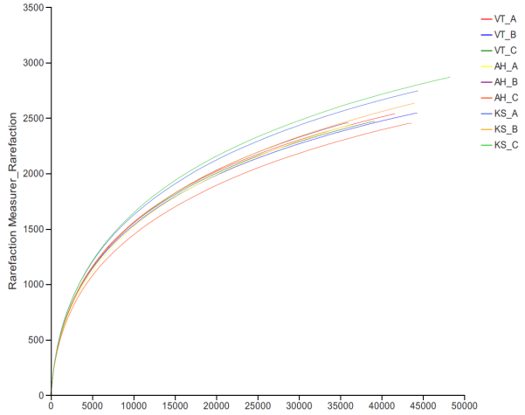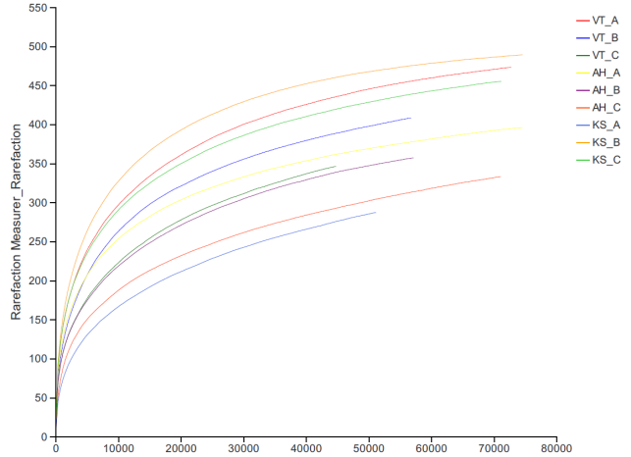
C D

(A, B) show each sample tends to be gentle when the number of sequences reaches 45,000. It reflects the bacterial and fungal microbial communities of soil samples more truly. (C, D) show the curve tended to be gentle. It reflects that the data set from the diversity analysis was large enough to reflect the microbial diversity information of the samples.

