Ancient DNAs and the Neolithic Chinese super-grandfather Y haplotypes

Ye Zhang¹, Xiaoyun Lei¹, Hongyao Chen¹, Hui Zhou² and Shi Huang¹*

Supplementary Materials:

Ancient samples and archaeological sites
S1 was excavated from the Hala Haigou site (42°21'N 11915'E) in 2007 by the archaeology institute of Inner Mongolia. This site is located in Chifeng of Inner Mongolia, and archaeologically performed the Late Neolithic Xiaoheyan culture (5000-4200 BP), which is widely distributed after Hongshan culture (6500-5000 BP) in Northeast China. Five skeletons from four different graves of Hala Haigou site were radiocarbon dated (3920±40 BP, 3850±35 BP, 3925±40 BP, 3860±35 BP, 3780±40 BP) [1].
K2 and K12 belonged to the Dashanqian site (41°54'N 11836'E) in Chifeng, Inner Mongolia. This site was excavated twice by the Institute of Archaeology of Chinese Academy of Social Sciences, the archaeology institute of Inner Mongolia, and Jilin University in 1996 and 1998 [2]. Its uncovered relics showed different period cultures in Dashanqian site, including Xiaoheyan culture, Lower Xiajiadian culture, Upper Xiajiadian culture, and Zhanguo culture. Radiocarbon dates from 10 charcoal specimens from different pits and graves were analyzed by the ¹⁴C Laboratory of the Archaeological Science and Techniques Experiment and Research Center, IA, Chinese Academy of Social Sciences (CASS). The chronological data were 2300±50 BP, 3141±51 BP, 2451±57 BP, 2966±108 BP, 3374±55 BP, 3140±56 BP, 3180±57 BP, 3027±55 BP, 3164±57 BP, and 3184±77 BP. The selected sample K2 and K12 were found in a pit of Upper Xiajiadian culture.
PAB3002 was excavated from the Pinganbao site in 1988 by the archaeology institute of Liaoning and Jilin University. Pingganbao site is situated in Wuzhang, Liaoning province, and was used by ancient people for a very long time. Its six layers of settlements covered the periods from Late Neolithic to Bronze Age. PAB3002 was from a Bronze Age grave of the Gaotaishan culture, and was morphologically identified as a ~35 years old male [3].
ZK was buried in Zhukaigou site (39°6'N 1103'E) in Ordos, Inner Mongolia [4]. This site was excavated four times in 1977, 1980, 1983, and 1984 by the archaeology institute of Inner Mongolia. A complex and characteristic culture ranging from Late Neolithic to Early Bronze Age was found in Zhukaigou site, which dated to 4200-3500 BP. It was associated with both hunting and agriculture people.
FQ17 was excavated from Qiaobei cemetery in Fushan of Shanxi province, by the institute of Qiaobei in 2003. A variety of late Shang and Zhou Dynasties style artifacts were found in all burials of this cemetery [5]. FQ was buried in one of small graves, and was morphologically identified as a male, more than 40 years old.
SG2046 was excavated from Sanguan site in Yuxian, Hebei province by the archaeology institute of Zhangjiakou during 1979-1982 [6]. This site shared aspects of the Lower Xiajiadian culture (2500–1500 BC), and radiocarbon dated to 3435±170 BP. Goods from this site showed successive phases from Neolithic to Early Bronze Age.
ZX167 and ZX107 were excavated from a Neolithic site, the Xishan site during 1993-1996. Xishan site was an old city remains of Miaodigou culture in Zhengzhou, Henan province. Its time period could trace from 6500 to 4800 years ago [7]. ZX167 was a 35-40 years old male by morphological identification. An evidence of Tibia fracture healing was found in XS167.
DZ14 was found in Duzhong site of Mianchi, Henan province. Unearthed relics showed that this site experienced the Neolithic Late Yangshao culture and the Bronze Age Early Longshan culture. DZ14 belonged to Early Longshan culture ~4000 years ago [8]
H69 was from Xuecun, Zhengzhou Henan and from the Early Shang period, 3500 BP [9].

Supplementary methods
The post and pre-PCR labs are located in separate buildings to avoid cross contamination. Sample preparation, DNA extraction, PCR set-up and library preparation were completed in the pre-PCR laboratory. PCR and sequencing were carried out in the post-PCR laboratory. To prevent modern sources of contamination in ancient DNA, researchers in the pre-PCR lab followed a strict workflow protocols when doing the laboratory work [10].
All the samples were randomly selected in this research. ZX167 and DZ14 were stored at the archaeology institute of Henan. Other samples were kept at the State Museum of Research Center for Chinese Frontier Archeology at Jilin University. Sample decontamination, grinding and DNA extraction were performed as described by Zhang et al [10]. The DNA libraries were built using the NEBNext® UltraTM DNA Library Prep Kit for Illumina® in accordance to manufacturer’s instructions. Probes of ~11 Mb targeted regions of the NRY chromosome were designed and used for DNA capture in this study [11]. All the libraries were sequenced on the HiSeq X-Ten platform. Before aligning, Adapterremoval 2.2.1a was used to trim low-quality nucleotides and remove adapter residues [12]. The ancient DNA damage and the distribution of read lengths were calculated using MapDamage2 in this study [13]. The distribution of read lengths of these samples ranged from ~45 to ~100 bp. The damage of ancient DNA was shown in Supplementary Fig. S1.
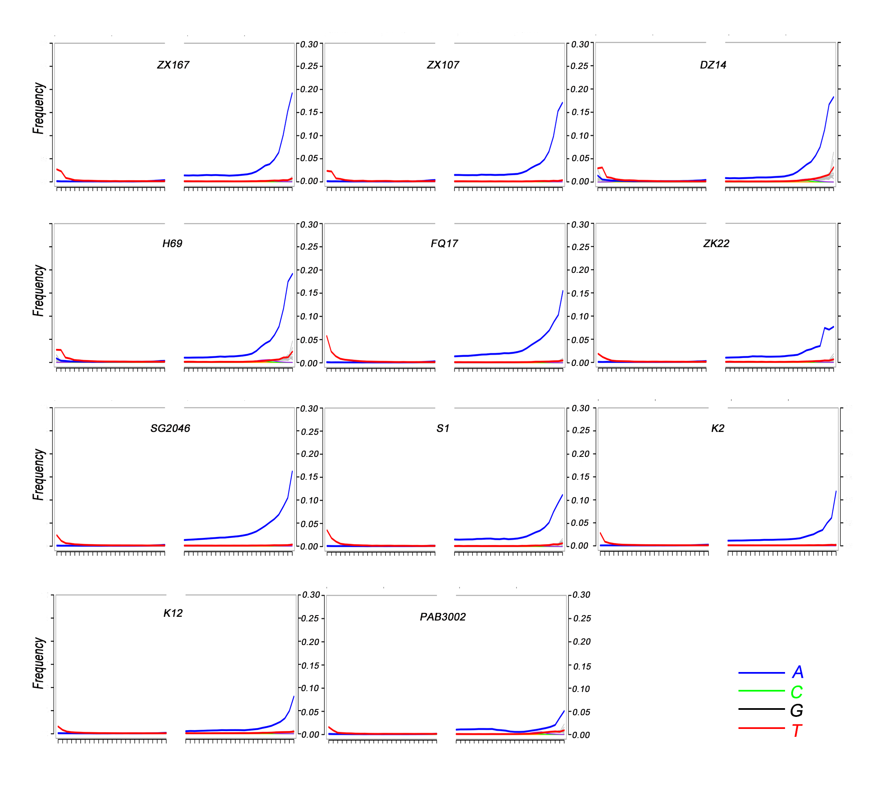
Figure S1. Ancient DNA damage assessment of all samples in this study.

References:
1. Zhang Y: Preliminary report on the excavation to the Neolithic cemetery at Hala Haigou village, Chifeng city, Inner Mongolia. Archaeology 2010, 2:19-35.
2. Peng S, Zhu Y, Guo Z, Wang L: Excavation in 1998 on the Dashanqian site in Harqin Banner, Inner Mongolia. Archaeology 2004, 3:31-39.
3. Zhu H: The report on human bones identification of Pingganbao site. Acta Archaeologica Sinica 1992, 4:473-479.
4. Mongolia T: The Zhukaigou site in Inner Mongolia. Acta Archaeologica Sinica 1988, 3:301-332.
5. Tian J, Fan W, Hou P, Xu X, Wang Y, Li Z: The graves of Shang and Zhou dynasties in Qiaobei, Fushan. J Ancient Civilization 2006, 5:347-394.
6. Chen P: A review of lower Xiajiadian culture. Beijing Cultural Relics and Archaeology 2002, 3:55-64.
7. Yang Z: On the character of the city site of the late Yangshao culture at Xishan, Zhengzhou. Huaxia Archaeology 1997, 1:55-59.
8. Wu Z: Excavation report of 2006 on the Duzhong site, Mianchi, Henan. Huaxia Archaeology 2006, 3:3-18.
9. Sun L, Chu X, Zhu H: Study of the human skulls from the early Shang site at Xuecun, Xingyang, Henan. Huaxia Archaeology 2013, 1:55-64.
10. Zhang Y, Li J, Zhao Y, Wu X, Li H, Yao L, Zhu H, Zhou H: Genetic diversity of two Neolithic populations provides evidence of farming expansions in North China. Journal of human genetics 2017, 62(2):199-204.
11. Li J, Zhang Y, Zhao Y, Chen Y, Ochir A, Sarenbilige, Zhu H, Zhou H: The genome of an ancient Rouran individual reveals an important paternal lineage in the Donghu population. Am J Phys Anthropol 2018, 166(4):895-905.
12. Schubert M, Lindgreen S, Orlando L: AdapterRemoval v2: rapid adapter trimming, identification, and read merging. BMC Res Notes 2016, 9:88.
13. Jonsson H, Ginolhac A, Schubert M, Johnson PL, Orlando L: mapDamage2.0: fast approximate Bayesian estimates of ancient DNA damage parameters. Bioinformatics 2013, 29(13):1682-1684.

