Existence of a single population of Hilsa Shad (Tenualosa ilisha) with low genetic variation in Bangladesh waters revealed by cross-species gene enrichment method
Anirban Sarker^{1,2}, Habibon Naher^{1,2}, Junman Huang¹, Kishor Kumar Sarker¹, Guoxing Yin¹, Mohammad Abdul Baki², and Chenhong Li^{1*}
¹Shanghai Universities Key Laboratory of Marine Animal Taxonomy and Evolution, Shanghai Ocean University, Shanghai 201306, China
²Department of Zoology, Jagannath University, Dhaka-1100, Bangladesh
* Author for Correspondence: Email: chli@shou.edu.cn

Supplementary materials:
Table S1. Taxon sampling, summary of the sequencing result of 139 individuals of Tenualosa ilisha and 5 out-groups.
Table S2. Best K of structure analysis from delivered 14 K (1-14)
Figure S1. Plot of the pc1 and pc2 components of a PCA analysis on polymorphic SNP markers of the four populations. Each point represents an individual colored according to different populations.
Figure S2. Delta K summarized from the results of structure analysis

Voucher number | Collection site | No. raw reads | No. filtered reads | No. unique reads | No. captured loci
CM_CL_1364-1 | Chilmari (CM) | 13811166 | 13770380 | 12378356 | 2223
CM_CL_1364-2 | Chilmari (CM) | 10128048 | 10096894 | 9139470 | 2204
CM_CL_1364-3 | Chilmari (CM) | 8626140 | 8596176 | 7737418 | 2120
CM_CL_1364-4 | Chilmari (CM) | 12706566 | 12664196 | 11515724 | 2215
CM_CL_1364-5 | Chilmari (CM) | 5946254 | 5926902 | 5339712 | 2006
CM_CL_1364-6 | Chilmari (CM) | 9108906 | 9084952 | 8189708 | 2128
CM_CL_1364-7 | Chilmari (CM) | 8011662 | 7988546 | 7135530 | 2076
CM_CL_1364-8 | Chilmari (CM) | 4260856 | 4246092 | 3758114 | 1848
BG_CL_135O_1 | Balashi Ghat (BG) | 3249358 | 3233578 | 3158416 | 797
BG_CL_135O_3 | Balashi Ghat (BG) | 2011698 | 2001866 | 1962534 | 580
BG_CL_135O_4 | Balashi Ghat (BG) | 1715206 | 1706066 | 1672446 | 506
BG_CL_135O_5 | Balashi Ghat (BG) | 2898068 | 2882040 | 2821348 | 717
BG_CL_135O_9 | Balashi Ghat (BG) | 3434456 | 3417984 | 3349224 | 809
BG_CL_135O_10 | Balashi Ghat (BG) | 3658620 | 3646380 | 3563636 | 865
CN_CL_1348_1 | Chapai-Nababganj (CN) | 5460240 | 5433934 | 5173636 | 1576
CN_CL_1348_2 | Chapai-Nababganj (CN) | 7422058 | 7393286 | 7126870 | 1866
CN_CL_1348_3 | Chapai-Nababganj (CN) | 4946970 | 4919700 | 4744886 | 1298
CN_CL_1348_4 | Chapai-Nababganj (CN) | 8158104 | 8112066 | 7829146 | 1788
CN_CL_1348_5 | Chapai-Nababganj (CN) | 7477950 | 7442338 | 7093666 | 1826
CN_CL_1348_6 | Chapai-Nababganj (CN) | 12182784 | 12116040 | 11768762 | 2055
CN_CL_1348_7 | Chapai-Nababganj (CN) | 6998674 | 6972692 | 6671896 | 1820
RS_CL_1349_1 | Rajshahi (RS) | 2593042 | 2579148 | 2523682 | 705
RS_CL_1349_2 | Rajshahi (RS) | 3005774 | 2987772 | 2926326 | 854
RS_CL_1349_3 | Rajshahi (RS) | 4578576 | 4557288 | 4451074 | 1100
RS_CL_1349_4 | Rajshahi (RS) | 1545700 | 1539948 | 1490698 | 505
RS_CL_1349_5 | Rajshahi (RS) | 3743828 | 3726174 | 3640282 | 930
RS_CL_1349_6 | Rajshahi (RS) | 4847444 | 4824676 | 4716432 | 1136
RS_CL_1349_7 | Rajshahi (RS) | 2637034 | 2623702 | 2551530 | 838
RS_CL_1349_8 | Rajshahi (RS) | 3343432 | 3331830 | 3244150 | 933
SS_CL_2318_1 | Someshwari, Durgapur (SS) | 8186078 | 8162586 | 7236474 | 1682
MO_CL_2317_1 | Mohanganj (MO) | 4945970 | 4914700 | 4743886 | 1264
MO_CL_2317_2 | Mohanganj (MO) | 1474100 | 1469150 | 1439132 | 1264
MG_CL_1365_1 | Manikganj (MG) | 4662144 | 4630382 | 4444390 | 1458
MG_CL_1365_2 | Manikganj (MG) | 3044048 | 3024420 | 2916418 | 1417
MG_CL_1365_3 | Manikganj (MG) | 10784194 | 10717416 | 10436148 | 2021
MG_CL_1365_4 | Manikganj (MG) | 3539284 | 3518634 | 3429402 | 1559
MG_CL_1365_5 | Manikganj (MG) | 5156936 | 5120814 | 4963324 | 1582
MG_CL_1365_6 | Manikganj (MG) | 5762632 | 5713332 | 5499352 | 1653
MG_CL_1365_7 | Manikganj (MG) | 2985114 | 2969022 | 2895798 | 1467
MG_CL_1365_8 | Manikganj (MG) | 3146242 | 3129286 | 3042912 | 1475
MG_CL_1365_9 | Manikganj (MG) | 2893892 | 2866712 | 2820774 | 1261
MG_CL_1365_10 | Manikganj (MG) | 4890614 | 4868742 | 4749830 | 1590
BR_CL_1363_1 | Bhairab (BR) | 2237068 | 2230024 | 2160456 | 1463
BR_CL_1363_2 | Bhairab (BR) | 3033758 | 3021946 | 2943490 | 1711
BR_CL_1363_3 | Bhairab (BR) | 4653664 | 4637208 | 4525828 | 1796
BR_CL_1363_4 | Bhairab (BR) | 1925434 | 1917890 | 1863894 | 1466
BR_CL_1363_5 | Bhairab (BR) | 2425418 | 2412754 | 2358956 | 1435

Voucher number | Collection site | No. raw reads | No. filtered reads | No. unique reads | No. captured loci
BR_CL_1363_6 | Bhairab (BR) | 2708144 | 2691764 | 2633914 | 1463
BR_CL_1363_7 | Bhairab (BR) | 3203104 | 3191942 | 3114532 | 1693
BR_CL_1363_8 | Bhairab (BR) | 2281852 | 2274384 | 2214580 | 1568
BR_CL_1363_9 | Bhairab (BR) | 2929778 | 2918956 | 2844996 | 1572
BR_CL_1363_10 | Bhairab (BR) | 1697898 | 1692930 | 1638692 | 1261
CP_CL_2026_1 | Chandpur (CP) | 3913740 | 3904196 | 3626116 | 1237
CP_CL_2026_2 | Chandpur (CP) | 5782332 | 5760684 | 5565320 | 1968
CP_CL_2026_3 | Chandpur (CP) | 6495728 | 6474280 | 6239102 | 2003
CP_CL_2026_4 | Chandpur (CP) | 6997098 | 6973130 | 6755444 | 2042
CP_CL_2026_5 | Chandpur (CP) | 5796862 | 5781770 | 5582250 | 1947
CP_CL_2026_6 | Chandpur (CP) | 8034724 | 8001192 | 7747976 | 2054
CP_CL_2026_7 | Chandpur (CP) | 9924588 | 9895242 | 9555022 | 2120
CP_CL_2026_8 | Chandpur (CP) | 1220266 | 1216046 | 1182070 | 1167
CP_CL_2026_9 | Chandpur (CP) | 3667290 | 3656826 | 3546208 | 1629
CP_CL_2026_10 | Chandpur (CP) | 8573376 | 8543496 | 8265878 | 2059
KN_CL_2002_1 | Khulna (KN) | 2239440 | 2229232 | 2184006 | 770
KN_CL_2002_2 | Khulna (KN) | 1187420 | 1178102 | 1160406 | 563
KN_CL_2002_3 | Khulna (KN) | 2692208 | 2672564 | 2628558 | 917
KN_CL_2002_4 | Khulna (KN) | 1768066 | 1758304 | 1725466 | 614
KN_CL_2002_5 | Khulna (KN) | 1378056 | 1372314 | 1347520 | 504
KN_CL_2002_6 | Khulna (KN) | 1558194 | 1544652 | 1522372 | 594
KN_CL_2002_7 | Khulna (KN) | 1841244 | 1833856 | 1796790 | 642
KN_CL_2002_8 | Khulna (KN) | 2010714 | 2001242 | 1966852 | 735
PP_CL_1355_1 | Pirojpur (PP) | 4446360 | 4427974 | 4249026 | 1568
PP_CL_1355_2 | Pirojpur (PP) | 2260550 | 2254860 | 2156026 | 1424
PP_CL_1355_3 | Pirojpur (PP) | 2832064 | 2821758 | 2682394 | 1425
PP_CL_1355_4 | Pirojpur (PP) | 3538378 | 3528658 | 3315882 | 1549
PP_CL_1355_5 | Pirojpur (PP) | 1975152 | 1968926 | 1867884 | 1389
PP_CL_1355_6 | Pirojpur (PP) | 3436470 | 3426066 | 3280536 | 1454
PP_CL_1355_7 | Pirojpur (PP) | 2739144 | 2731694 | 2595078 | 1424
PP_CL_1355_8 | Pirojpur (PP) | 1443510 | 1438334 | 1380138 | 1141
PP_CL_1355_9 | Pirojpur (PP) | 1980056 | 1972604 | 1877500 | 1125
BL_CL_2036_1 | Bhola (BL) | 9813152 | 9807212 | 7528734 | 867
BL_CL_2036_2 | Bhola (BL) | 12585340 | 12580082 | 9832118 | 1550
BL_CL_2036_3 | Bhola (BL) | 2833670 | 2819978 | 2744640 | 1552
BL_CL_2036_4 | Bhola (BL) | 5801366 | 5782568 | 5618120 | 1859
BL_CL_2036_5 | Bhola (BL) | 2097918 | 2090926 | 2039666 | 1454
BL_CL_2036_6 | Bhola (BL) | 7692470 | 7664554 | 7456214 | 1963
BL_CL_2036_7 | Bhola (BL) | 2935426 | 2924236 | 2850212 | 1619
BL_CL_2036_8 | Bhola (BL) | 4060456 | 4047608 | 3943978 | 1821
BL_CL_2036_9 | Bhola (BL) | 6450196 | 6432626 | 6262420 | 1900
BL_CL_2036_10 | Bhola (BL) | 3697384 | 3682590 | 3575396 | 1660
MP_CL_1356_1 | Mohipur (MP) | 1407318 | 1401536 | 1348842 | 1130
MP_CL_1356_2 | Mohipur (MP) | 507538 | 505120 | 489158 | 801
MP_CL_1356_3 | Mohipur (MP) | 2270012 | 2259446 | 2185978 | 1451
MP_CL_1356_4 | Mohipur (MP) | 1642400 | 1632818 | 1583932 | 1296
MP_CL_1356_5 | Mohipur (MP) | 1945316 | 1937448 | 1868466 | 1321
MP_CL_1356_6 | Mohipur (MP) | 496292 | 493622 | 478444 | 720
MP_CL_1356_7 | Mohipur (MP) | 1894274 | 1886010 | 1819420 | 1427
MP_CL_1356_8 | Mohipur (MP) | 1046048 | 1041428 | 1006812 | 1128
MP_CL_1356_9 | Mohipur (MP) | 1074274 | 1069138 | 1030424 | 1074

Voucher number | Collection site | No. raw reads | No. filtered reads | No. unique reads | No. captured loci
CF_CL_1361_1 | Char Fasson (CF) | 3413278 | 3386882 | 3331840 | 1432
CF_CL_1361_2 | Char Fasson (CF) | 2733738 | 2716490 | 2669010 | 1309
CF_CL_1361_3 | Char Fasson (CF) | 3544142 | 3515262 | 3469008 | 1450
CF_CL_1361_4 | Char Fasson (CF) | 2314308 | 2294618 | 2246672 | 1221
CF_CL_1361_5 | Char Fasson (CF) | 2374252 | 2360006 | 2315864 | 1229
CF_CL_1361_6 | Char Fasson (CF) | 1490532 | 1478274 | 1456748 | 996
CF_CL_1361_7 | Char Fasson (CF) | 2929638 | 2916388 | 2848970 | 1430
CF_CL_1361_8 | Char Fasson (CF) | 2639246 | 2626640 | 2576840 | 1316
PC_CL_1359_1 | Pokhkhir Char (PC) | 3728842 | 3728842 | 3631076 | 1561
PC_CL_1359_2 | Pokhkhir Char (PC) | 4085080 | 4070014 | 3971756 | 1645
PC_CL_1359_3 | Pokhkhir Char (PC) | 1775194 | 1766130 | 1727720 | 1214
PC_CL_1359_4 | Pokhkhir Char (PC) | 4525550 | 4510024 | 4412892 | 1547
PC_CL_1359_5 | Pokhkhir Char (PC) | 2981454 | 2971902 | 2905800 | 1443
PC_CL_1359_6 | Pokhkhir Char (PC) | 2846758 | 2833274 | 2771898 | 1394
PC_CL_1359_7 | Pokhkhir Char (PC) | 4983784 | 4962680 | 4857614 | 1761
PG_CL_1357_1 | Patharghata (PG) | 1412062 | 1404084 | 1379374 | 11175
PG_CL_1357_2 | Patharghata (PG) | 672666 | 668460 | 656732 | 908
PG_CL_1357_3 | Patharghata (PG) | 451486 | 448394 | 440932 | 769
PG_CL_1357_4 | Patharghata (PG) | 1602334 | 1592832 | 1566568 | 1284
PG_CL_1357_5 | Patharghata (PG) | 1593076 | 1586812 | 1551266 | 1335
PG_CL_1357_6 | Patharghata (PG) | 2326576 | 2314410 | 2251116 | 1469
PG_CL_1357_7 | Patharghata (PG) | 2580676 | 2569668 | 2507650 | 1486
PG_CL_1357_8 | Patharghata (PG) | 1611752 | 1604648 | 1570796 | 1349
PG_CL_1357_9 | Patharghata (PG) | 1474100 | 1469150 | 1439132 | 1270
PG_CL_1357_10 | Patharghata (PG) | 4073446 | 4053640 | 3967330 | 1720
CB_CL_2042_1 | Cox’s Bazar (CB) | 7489716 | 7467744 | 6947030 | 1554
CB_CL_2042_2 | Cox’s Bazar (CB) | 3642294 | 3629000 | 3529660 | 1677
CB_CL_2042_3 | Cox’s Bazar (CB) | 5711334 | 5694114 | 5546204 | 1815
CB_CL_2042_4 | Cox’s Bazar (CB) | 3589514 | 3576498 | 3473870 | 1646
CB_CL_2042_5 | Cox’s Bazar (CB) | 5112886 | 5089682 | 4953372 | 1758
CB_CL_2042_7 | Cox’s Bazar (CB) | 2363436 | 2356138 | 2278718 | 1494
CB_CL_2042_8 | Cox’s Bazar (CB) | 4340680 | 4324252 | 4197258 | 1687
CB_CL_2042_9 | Cox’s Bazar (CB) | 6333154 | 6313694 | 6129810 | 1901
CB_CL_2042_10 | Cox’s Bazar (CB) | 5323646 | 5310320 | 5166652 | 1731
MK_CL_1360-2 | Maheshkhali (MK) | 2225932 | 2224932 | 1636310 | 939
MK_CL_1360-3 | Maheshkhali (MK) | 3848084 | 3846434 | 2804746 | 957
MK_CL_1360-4 | Maheshkhali (MK) | 1846242 | 1845834 | 1281676 | 666
MK_CL_1360-5 | Maheshkhali (MK) | 2117768 | 2117292 | 1497366 | 712
MK_CL_1360-6 | Maheshkhali (MK) | 3520342 | 3517148 | 2501302 | 1158
MK_CL_1360-7 | Maheshkhali (MK) | 4682642 | 4680366 | 3209546 | 1131
MK_CL_1360-9 | Maheshkhali (MK) | 1514966 | 1513388 | 1042256 | 601
Outgroup
CL_2312_1 | Out-group | 3905374 | 3887138 | 3795998 | 1104
CL_2312_10 | Out-group | 4222386 | 4196846 | 4104824 | 1104
CL_2312_2 | Out-group | 4192228 | 4171334 | 4070996 | 1104
CL_2312_3 | Out-group | 4850020 | 4827432 | 4689222 | 1104
CL_2312_6 | Out-group | 3918244 | 3896564 | 3818888 | 1104

Table S1. Taxon sampling, summary of the sequencing result of 139 individuals of Tenualosa ilisha and 5 out-groups.

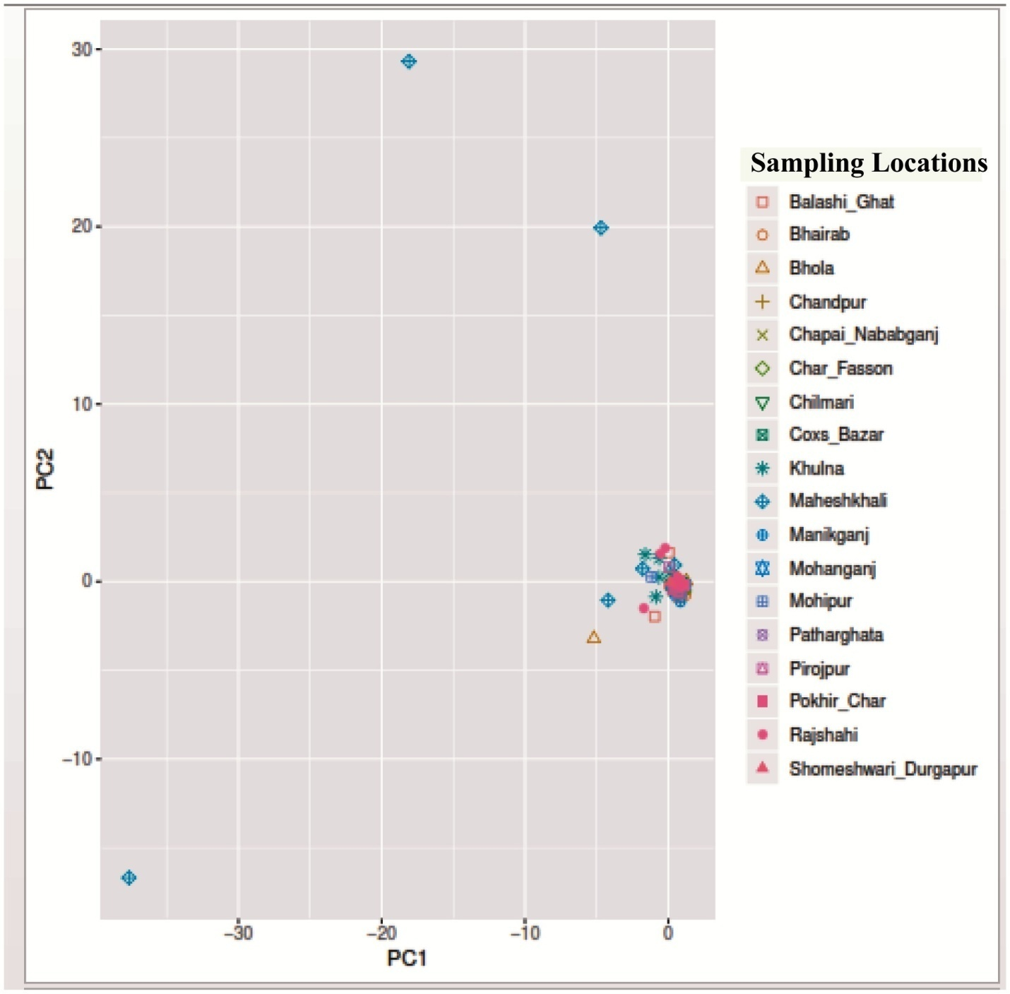
Figure S1. Plot of the pc1 and pc 2 components of a PCA analysis on 512 polymorphic SNP markers of Hilsa shad collected from 18 different locations. Each point represents an individual colored according to different sampling location.

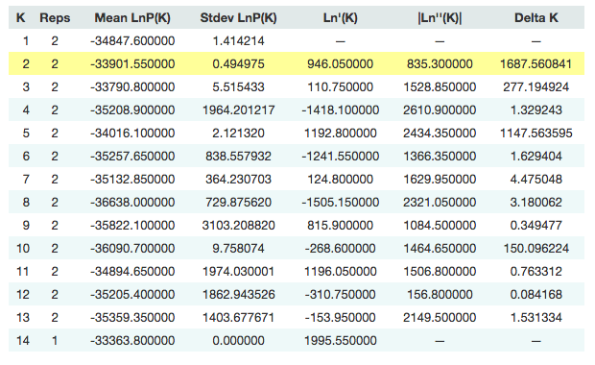
Table S2. Best K of structure analysis from delivered 14 K (1-14)

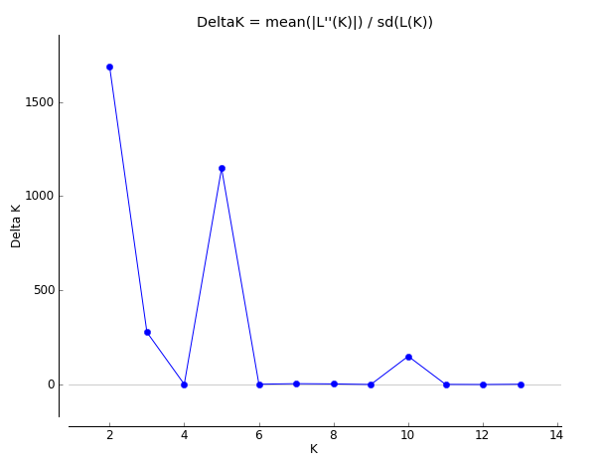
Figure S2. Delta K summarized from the results of structure analysis

