Supplementary information

Large number hexagonal cavities microfluidic digital chip for gene mutation ultrasensitive analysis in lung cancer
Pan Feng ¹, Mingjing Guo ¹, Gang Li ², Tengbao Xie ², Liqun Zhang ^{1 *}, Fei Liu ¹*, Xiaoyun Pu ¹*

¹ Department of Clinical Laboratory, the Second Affiliated Hospital, Army Medical University, Chongqing, 400037, China.
² Key Laboratory of Optoelectronic Technology and Systems, Ministry of Education, Defense Key Disciplines Lab of Novel Micro-Nano Devices and System Technology, Chongqing University, Chongqing, 400044, China.

Supplementary Results

- Optimization of optimum annealing temperature and determination of specificity
The optimal annealing temperature and specificity of EGFR G719S primers and probes were determined by Real-Time PCR. The T_{m} value of primers was calculated to be about 55 ℃ according to primer5. Therefore, in the range of 55-58 ℃, annealing extension temperature was set by adding a 1 ℃ gradient each time to detect the optimal annealing temperature of primers and probes in the digital PCR reagent system.
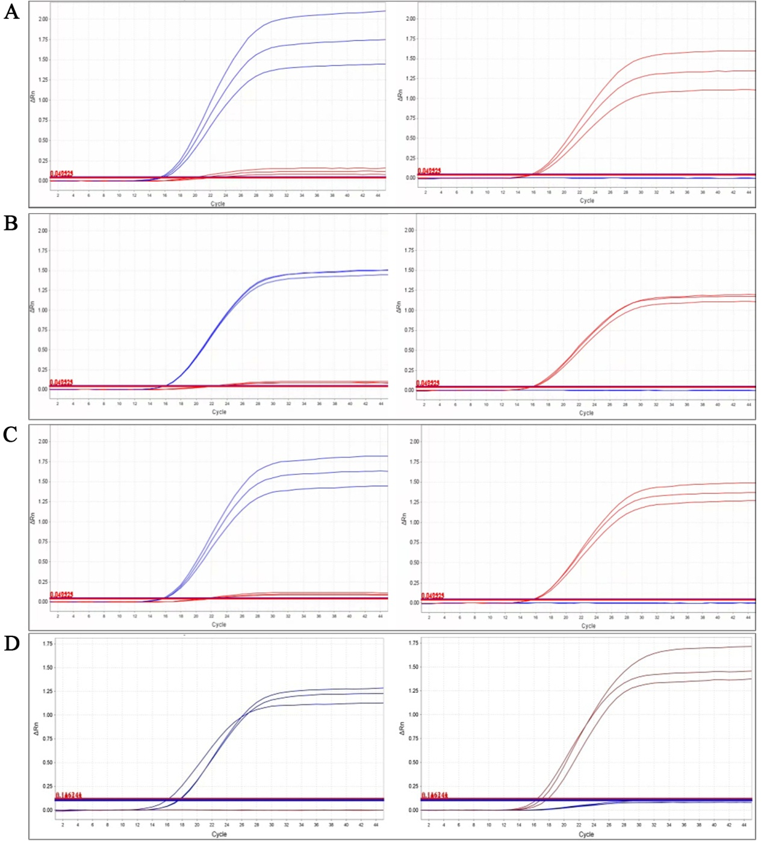
Fig. S1 Optimized annealing temperature of EGFR G719S PCR amplification system (The blue curve represents the wild type and the red curve represents the mutant). A: Amplification curve at 55℃; B: Amplification curve at 56℃; C: Amplification curve at 57℃; D: Amplification curve at 58℃.

- Repeatability experiment
In order to verify the repeatability of the EGFR G719S PCR system, the wild-type and mutant plasmids were used as samples for repeated PCR typing 8 times respectively.
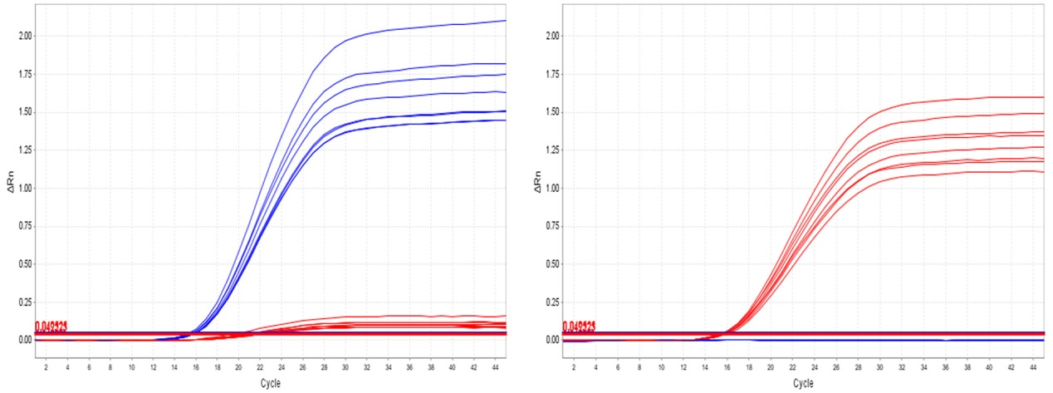
Fig. S2 Reproducibility diagram of 8 wild-type and 8 mutant plasmids (The blue curve represents the wild type and the red curve represents the mutant).

- The detection of FFEP tissue samples in lung cancer by LHMC-dPCR
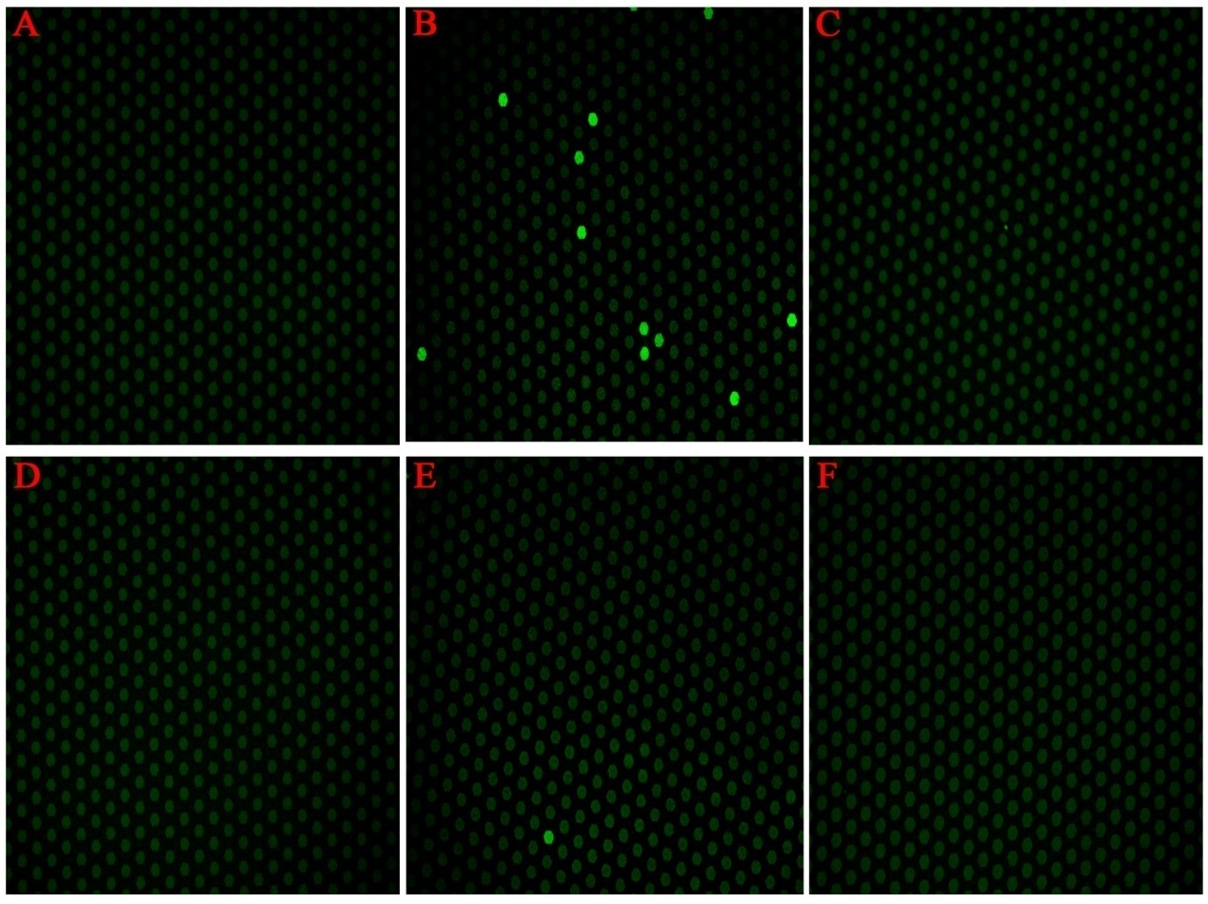
Fig. S3 The results of FFEP tissue samples were determined by LHMC dPCR. A-F: Fluorescence microscope image of tissue samples No. F1-F6.

- The detection of FFEP tissue samples in lung cancer by ddPCR
Tissue samples No. F1-F6 were sent to TargetingOne (Beijing, China) (http://www.targetingone.com/sv.aspx?TypeId=136&FId=t8:136 :8) for ddPCR detection. The results are shown in Fig. S4.
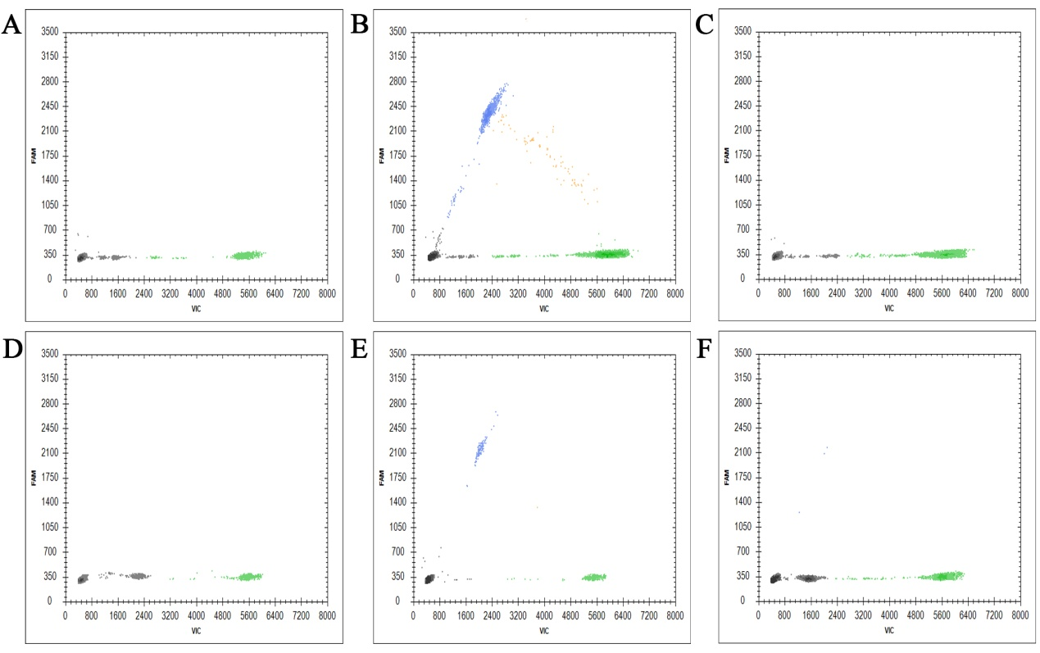
Fig. S4 The results of FFEP tissue samples were determined by ddPCR. A-F: DNA sequencing image of tissue samples No. F1-F6.

- The detection of FFEP tissue samples in lung cancer by DNA sequencing
The PCR amplification products of 6 lung cancer tissue sections were sent to Sangon Biotech (Shanghai) Co. (Shanghai, China) (https://www.sangon.com/services_dnasynthesis.html) for general sequencing. The sequence maps were compared with the standard sequence of the EGFR gene in the NCBI Gene Bank by Chromas software version 2.3 (Technelysium, Queensland, Australia), and the sequencing results were analyzed. The results are shown in Fig. S5.

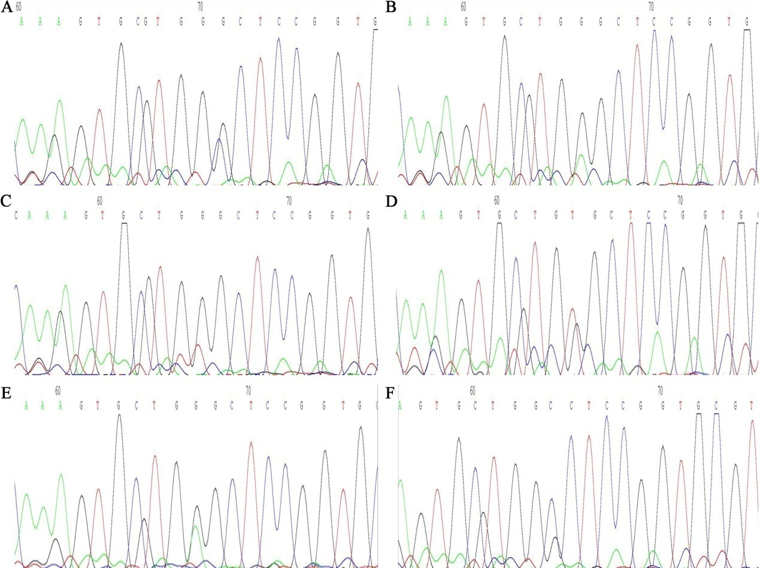
Fig. S5 The results of FFEP tissue samples were determined by DNA sequencing. A-F: DNA sequencing image of tissue samples No. F1-F6.

* Corresponding Author. Tel.: +086-02368763374; Fax: +86-02368755637. E-mail addresses: puxiaoyong63@sina.com(X.Y. Pu); 18289744618@163.com (Pan Feng)

