Supplementary information
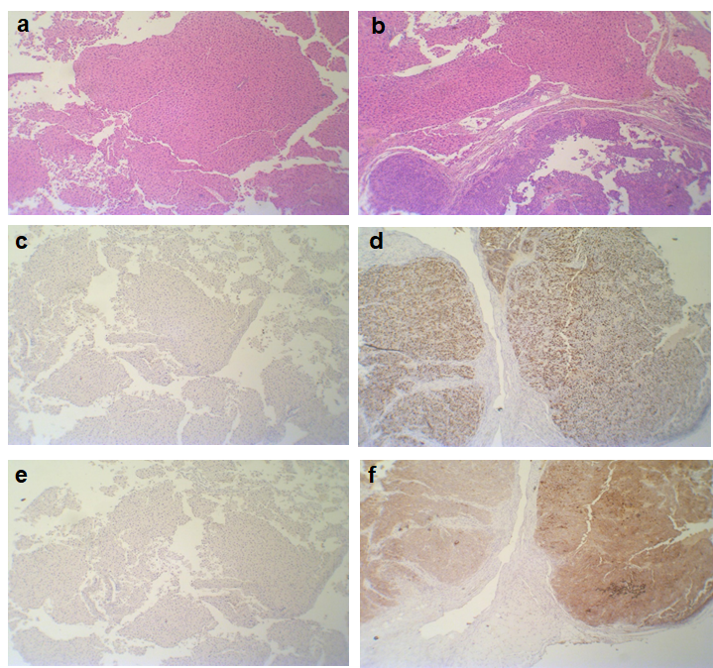
Figure S1. 4T1 breast cancer model. a. Hematoxylin and eosin (H&E) staining of the healthy breast sample b. Hematoxylin and eosin (H&E) staining of the breast tumor sample c. Ki67 expression in the healthy breast section d. Ki67 expression in the breast tumor section e. Glypican3 expression in the healthy breast section f. Glypican3 expression in the breast tumor section

In vivo e-biopsy extraction of proteins yields profiles that strongly correlate with their matching lysis buffer extraction
To investigate whether the in vivo protein extraction by e-biopsy faithfully represents the tumor proteomic profile (i.e., e-biopsy-based proteome is consistent with standard lysis-based proteome), we compared 6 proteomic profiles obtained by e-biopsy in vivo to 3 proteomic profiles obtained by standard lysis in excised tumors in 4 mice (sample from mouse #1 was lost during lysis extractions, therefore the analysis was performed for 4 animals here versus 5 animals in the other sections) (Table S1). In total, 4,511 proteins (with positive LFQ intensity in at least one e-biopsy or lysis sample) out of 4,519 total proteins were considered in this analysis. We found that the expression levels of proteins extracted from all locations strongly correlate between two methods (Pearson R of 0.831-0.934 (Fig. S2); Spearman R of 0.702-0.778; all p-values < 10E-324, (Table S2). This result suggests that in vivo e-biopsy of 4T1 tumors is a reliable method that reflects the proteomics of the sample as obtainable by lysis buffer from excised tissues.
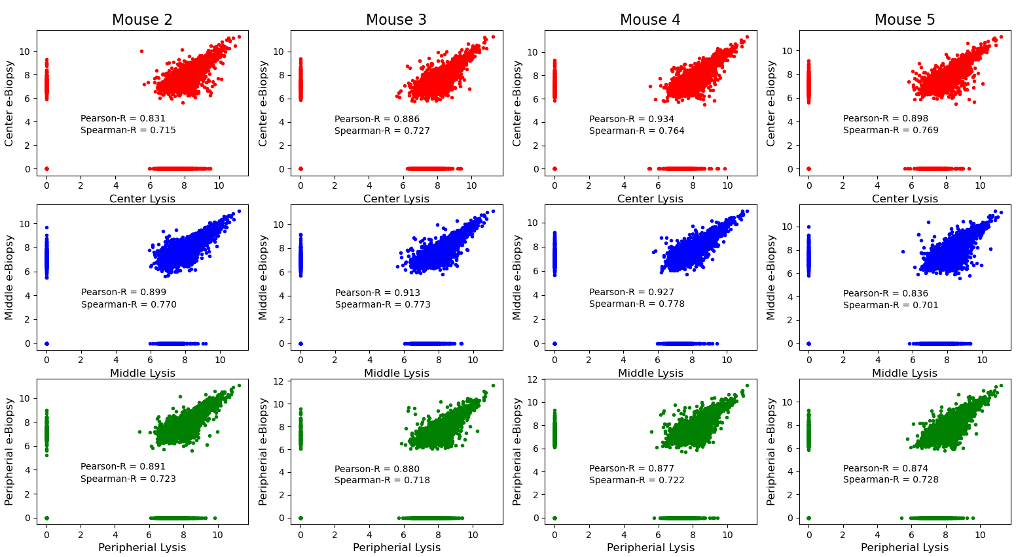
c
b
a
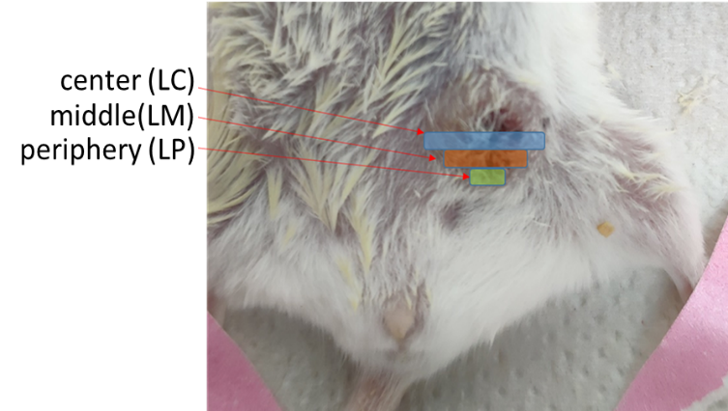
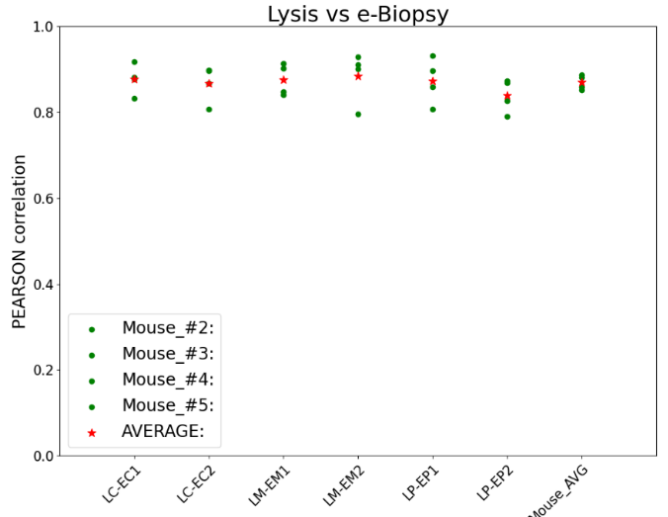

Figure S2. a. Scatter plot of in vivo expression (Log-10 of LFQ intensity of all relevant proteins at matched positions) measured with e-biopsy (average intensity between two reps) vs ex vivo Lysis buffer extraction in peripheral, middle, and center locations of 4T1 tumors in 4 animals. Pearson and Spearman R values are also shown. b. Comparison of protein expression intensity as extracted with e-biopsy in vivo vs tissue lysis buffer ex vivo. Pearson R correlation coefficient of the LFQ intensities of all relevant proteins at matched positions from 4T1 tumor as extracted with e-biopsy and tissue lysis buffer and quantified with LC-MS/MS. 4,511 (out of a total of 4,519) proteins were analyzed in 4 mice, from 6 e-biopsy locations in each mouse: 2 in the center (EC1 and EC2), 2 in the middle (EM1 and EM2), and 2 at the periphery (EP1 and EP2). Tissue lysis was performed from 3 extraction locations in each mouse: 1 in the center (LC), 1 in the middle (LM), and 1 at the periphery (LP). All p-values < 10E-324. c. Image shows the areas from which the control samples were taken for protein extraction using a standard lysis buffer.

In Table S1 and Fig S3 we summarize the comparison between the proteins quantified (with LFQ-intensities) by one extraction method only vs both extraction methods. Table S1 presents our findings on average for all samples (Mouse_Average) and on mixing all mouse samples together (considering all samples together, i.e., union of quantified protein sets Location_MIX), while the detailed per-sample data can be found in Table S3. Two interesting phenomena are observed here. First, there is a significant number of proteins identified by only one method, implying that lysis and e-biopsy technologies may represent complementary extraction methods³⁷. Second, even though at each specific site, standard lysis technique extracted significantly more unique proteins than did e-biopsy (1,366 vs 171 uniquely identified proteins by lysis vs by e-biopsy respectively per each site on average (Mouse_Average)), this difference decreases significantly when considering all locations together (Location_MIX of proteins extracted at 3 lysis sites vs Location_MIX of proteins within 6 e-biopsy sites differ on average by only 572 vs 224 uniquely identified proteins by lysis vs by e-biopsy respectively). This second observation can be explained by the spatial molecular harvesting by e-biopsy together with the inherent heterogeneity of the tumor samples, which is less distinguishable by the standard lysis technique, which averages larger tissue volumes.

Table S1. Summary of the number of unique proteins were captured by each method in each mouse on average and in all locations mixed. A full table describing each extraction site is at Table S3.
Methodology | Site | Mouse_2 | Mouse_3 | Mouse_4 | Mouse_5 | Average
No. of proteins identified by Lysis only | Mouse_Average: | 1,199 | 1,696 | 1,214 | 1,354 | 1,366
 | Location_MIX: | 488 | 744 | 455 | 603 | 572
No. of proteins identified by e-biopsy only | Mouse_Average: | 183 | 108 | 213 | 179 | 171
 | Location_MIX: | 245 | 172 | 269 | 211 | 224
No. of proteins identified by both methods | Mouse_Average: | 2,678 | 2,212 | 2,554 | 2,372 | 2,454
 | Location_MIX: | 3,640 | 3,410 | 3,611 | 3,459 | 3,530

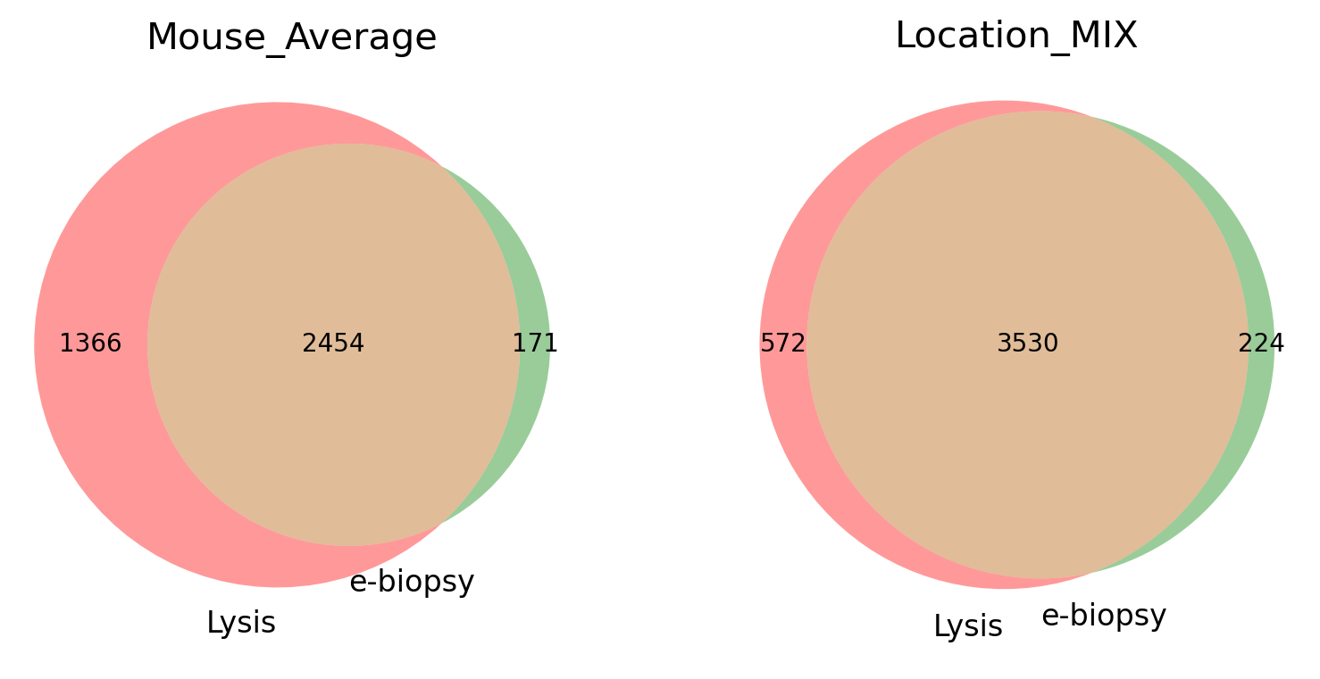
Figure S3. Per-mouse average number of unique proteins captured by each methods on average and in all locations mixed.

These findings are consistent with previous work on electroporation-based extraction of proteins from seaweed biomass. Our previous seaweed work showed that the electroporation-based extraction is selective and extracts proteins not discovered by other standard chemical methods^{37,73}. The implication of these findings for tumor diagnostics may be addressed in further work, as e-biopsy could also serve to complement standard tissue lysis of excised samples.

