Extended data.

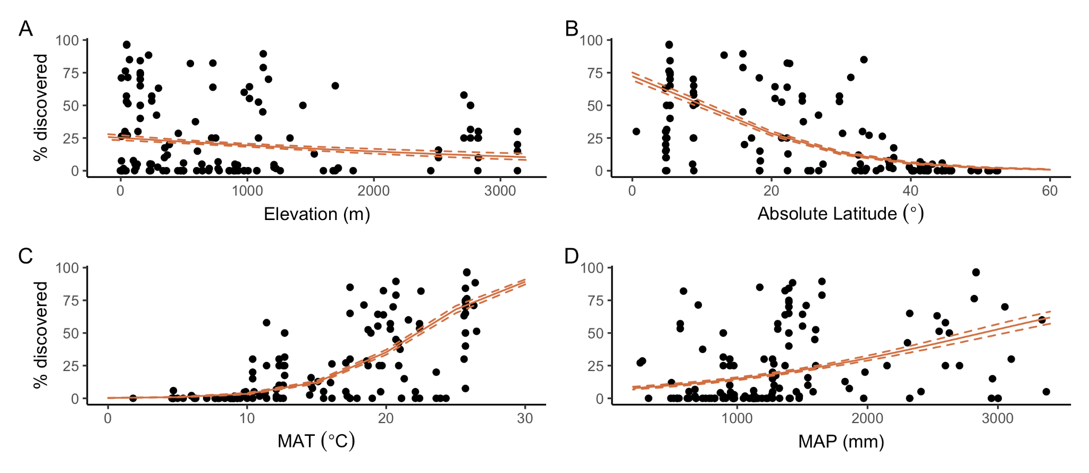
Extended Data Figure 1. Termite discovery versus key spatial and climatic variables: A) Elevation, B) Absolute (Latitude), C) Mean annual temperature (MAT), and D) and Mean annual precipitation (MAP). The solid orange line is the model best fit and dashed line is the 95% CI (Extended Data Table 1). Termite discovery is the percentage of wood blocks with evidence of termites per site and time point. Median termite discovery in two years = 30%; 95th percentile = 99%.

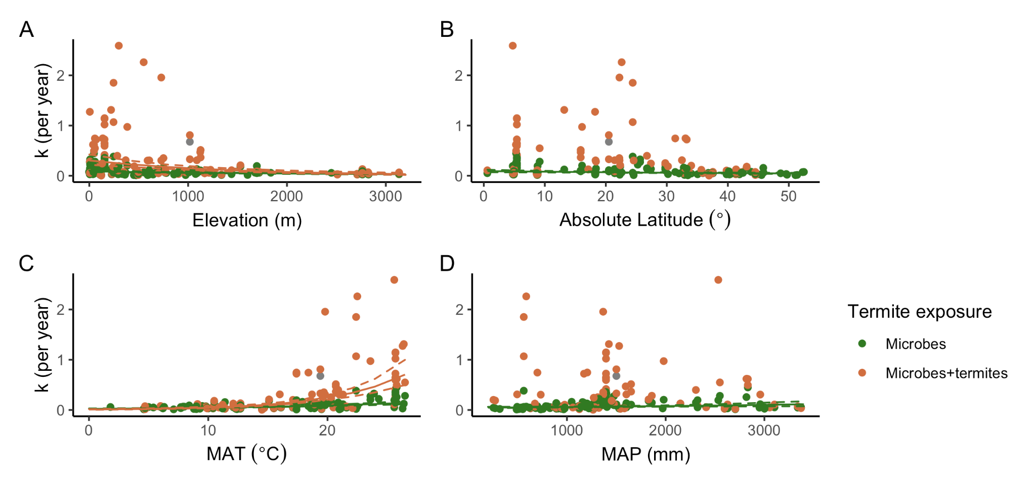
Extended Data Figure 2. Microbial and termite decay (k) versus key spatial and climatic variables: A) Elevation, B) Absolute (Latitude), C) Mean annual temperature (MAT), and D) and Mean annual precipitation (MAP). Green lines denote microbes wood blocks and orange lines denote termite discovered wood blocks. The solid lines are the model best fit and dashed lines are the 95% CI (Extended Data Tables 2-3). Median microbes wood mass loss in two years = 11% (95th percentile = 43%), and median estimated termite discovered wood mass loss in two years = 22% (95th percentile = 92%).

A B
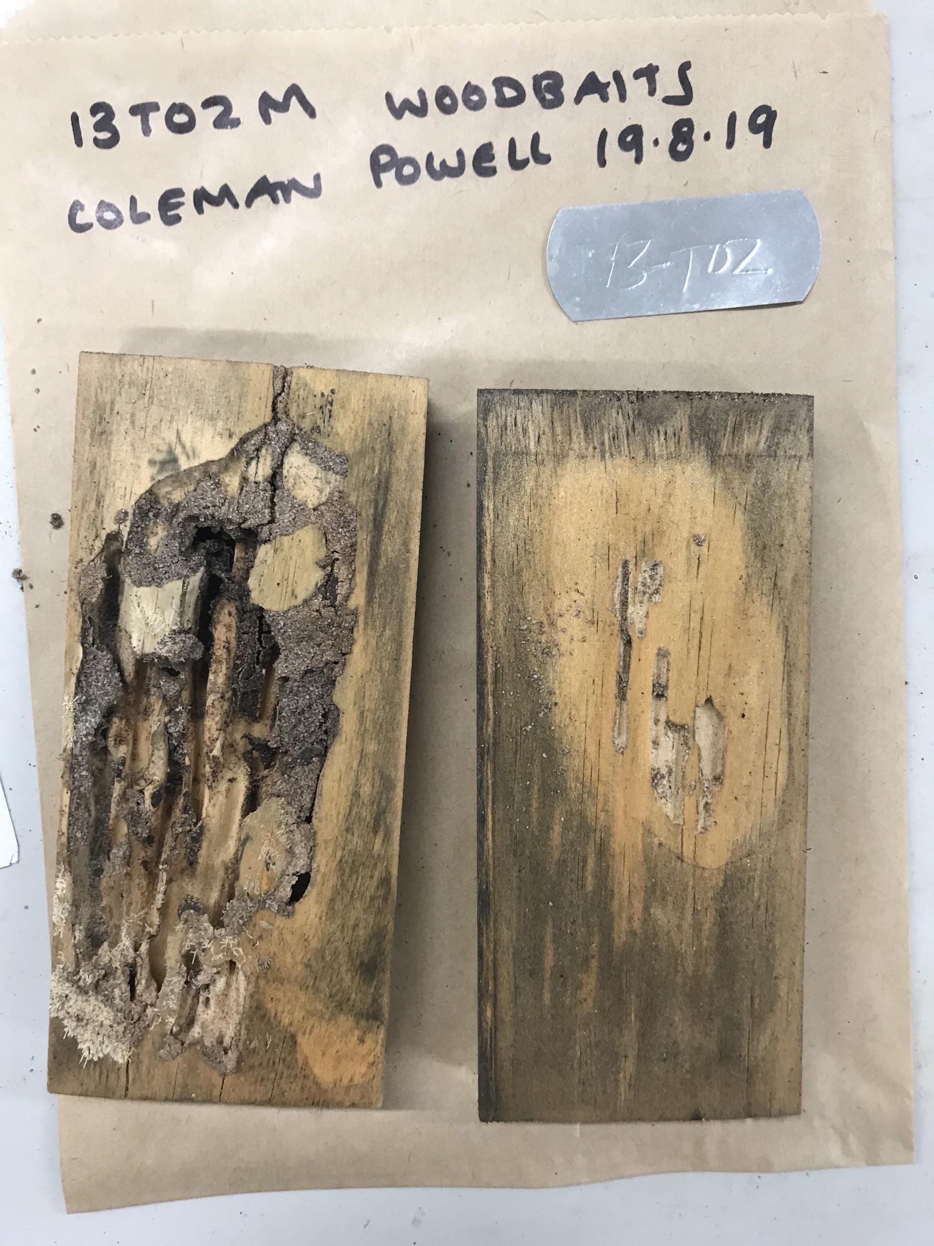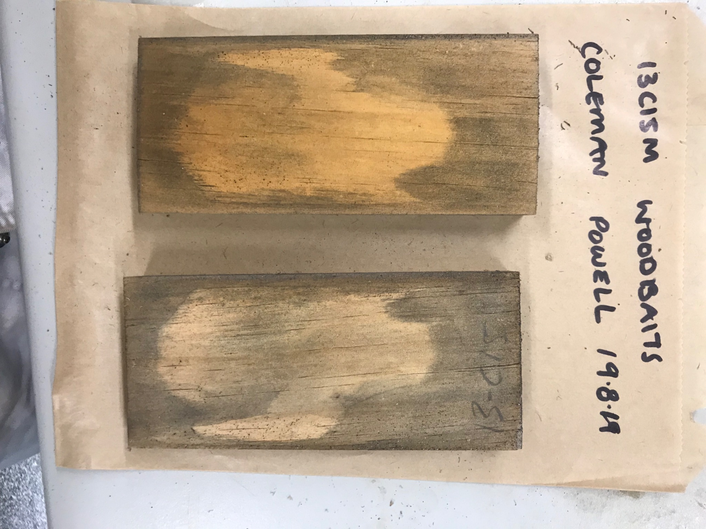
C D
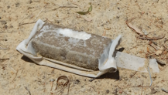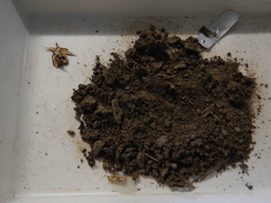
Extended Data Figure 3. Examples of wood blocks discovered by termites. A. Termite discovered wood from ‘Gingin’ (Western Australia) after 488 days of exposure. B. Microbes wood not discovered by termites from the same harvest as the pair of blocks shown in A for comparison. C. Termite discovered wood from Australia savanna from the pilot study after 339 days of exposure. D. The same block shown in C with wood (upper left) and imported soil (right).

Extended Data Table 1. Best fit bivariate models for termite discovery versus key spatial and climatic variables: Elevation, Absolute (Latitude), Mean annual temperature (MAT), and Mean annual precipitation (MAP), including Parameter (Par), Odds Ratio, SE, 95% CI, z-scores, P values and McFadden’s pseudo-R², (DF = 4502, N = 4504). Termite discovery is the percentage of wood blocks with evidence of termites per site and time point. Significant parameters are in bold.
Par | Odds Ratio | SE | 95% CI | z | P | pseudo-R²
Model |  |  |  |  |  | 0.232
Intercept | 0.62 | 0.05 | (0.53, 0.72) | -6.35 | < 0.001
Absolute Latitude | 0.91 | 2.80E-03 | (0.90, 0.92) | -30.57 | < 0.001
Model |  |  |  |  |  | 0.009
Intercept | 0.08 | 4.19E-03 | (0.07, 0.09) | -48.12 | < 0.001
Elevation | 1 | 5.10E-05 | (1.00, 1.00) | -6.51 | < 0.001
Model |  |  |  |  |  | 0.292
Intercept | 5.55E-04 | 9.45E-05 | (3.96E-04, 7.71E-04) | -44.06 | < 0.001
MAT | 1.31 | 0.01 | (1.29, 1.34) | 31.82 | < 0.001
Model |  |  |  |  |  | 0.067
Intercept | 0.02 | 1.39E-03 | (0.01, 0.02) | -48.69 | < 0.001
MAP | 1 | 4.95E-05 | (1.00, 1.00) | 18.72 | < 0.001

Extended Data Table 2. Best fit bivariate models for decay (k) versus key spatial and climatic variables: Elevation, Absolute (Latitude), Mean annual temperature (MAT), and Mean annual precipitation (MAP), including Treatment (Trt; microbes wood blocks (M), Termite discovered wood blocks (MT)), Parameter (Par), Coefficient (Coef), SE, 95% CI, z-score, P values and Adjusted-R2 (DF = 221, N = 225). Decay was estimated as the exponential rate of decay per year and was averaged by site and natural-log transformed prior to analysis. Significant parameters are in bold.
​​
Trt | Par | Coef | SE | 95% CI | t | df | P | R² (Adj)
Model |  |  |  |  |  |  |  | 0.0212
M+T | Intercept | -1.51 | 0.25 | (-1.99, -1.02) | -6.12 | 91 | < 0.001
 | Latitude | -0.02 | 9.87E-03 | (-0.04,  2.53E-03) | -1.73 | 91 | 0.087
Model |  |  |  |  |  |  |  | 0.0941
M | Intercept | -2.38 | 0.14 | (-2.64, -2.11) | -17.48 | 130 | < 0.001
 | Latitude | -0.01 | 4.54E-03 | (-0.02,  -4.94E-03) | -3.07 | 130 | 0.003
Model |  |  |  |  |  |  |  | 0.253
M+T | Intercept | -1.19 | 0.17 | (-1.53, -0.85) | -7.01 | 91 | < 0.001
 | Elevation | -6.99E-04 | 1.23E-04 | (-9.44E-04,  -4.54E-04) | -5.67 | 91 | < 0.001
Model |  |  |  |  |  |  |  | 0.128
M | Intercept | -2.43 | 0.1 | (-2.62, -2.24) | -25.38 | 130 | < 0.001
 | Elevation | -3.35E-04 | 7.46E-05 | (-4.83E-04,  -1.88E-04) | -4.49 | 130 | < 0.001
Model |  |  |  |  |  |  |  | 0.521
M+T | Intercept | -4.7 | 0.3 | (-5.29, -4.10) | -15.7 | 91 | < 0.001
 | MAT | 0.16 | 0.02 | (0.13, 0.20) | 10.06 | 91 | < 0.001
Model |  |  |  |  |  |  |  | 0.31
M | Intercept | -3.84 | 0.16 | (-4.15, -3.53) | -24.72 | 130 | < 0.001
 | MAT | 0.07 | 9.18E-03 | (0.05, 0.09) | 7.75 | 130 | < 0.001
Model |  |  |  |  |  |  |  | -0.0103
M+T | Intercept | -1.93 | 0.33 | (-2.58, -1.28) | -5.86 | 91 | < 0.001
 | MAP | 5.07E-05 | 2.01E-04 | (-3.48E-04, 4.50E-04) | 0.25 | 91 | 0.801
Model |  |  |  |  |  |  |  | 0.0453
M | Intercept | -3.1 | 0.16 | (-3.41, -2.80) | -19.95 | 130 | < 0.001
 | MAP | 2.72E-04 | 1.01E-04 | (7.17E-05,  4.73E-04) | 2.69 | 130 | 0.008

Extended Data Table 3. Best fit multivariate model for probably of termite discovery versus climatic sensitivities: Mean annual temperature (MAT) and Mean annual precipitation (MAP), including Parameter (Par), Odds Ratio, SE, 95% CI, z-scores, P values (​​McFadden’s pseudo-R² = 0.32, DF = 4462, N = 4466). Termite discovery is the percentage of wood blocks with evidence of termites per site and time point. Significant parameters are in bold.
Par | Odds Ratio | SE | 95% CI | z | P
Intercept | 7.53E-06 | 3.44E-06 | (3.05E-06, 1.83E-05) | -25.85 | < 0.001
MAP | 1 | 3.05E-04 | (1.00, 1.00) | 10.51 | < 0.001
MAT | 1.65 | 0.04 | (1.58, 1.73) | 21.26 | < 0.001
MAP x MAT | 1 | 1.47E-05 | (1.00, 1.00) | -10.99 | < 0.001

Extended Data Table 4. Best fit multivariate model for microbes decay (k) versus climatic sensitivities: Mean annual temperature (MAT) and Mean annual precipitation (MAP), including Parameter (Par), Coefficient (Coef), SE, t-values and P values (​​R² = 0.27, DF = 129, N = 133). Significant parameters are in bold.
Par | Coef | SE | t | P
Intercept | -4.496 | 0.47 | -9.57 | < 0.001
MAT | 0.098 | 0.028 | 3.53 | < 0.001
MAP | 0.786 | 0.395 | 1.99 | 0.048
MAT x MAP | -0.037 | 0.02 | -1.81 | 0.072

Extended Data Table 5. Best fit multivariate model for termite discovered decay (k) versus climatic sensitivities: Mean annual temperature (MAT) and Mean annual precipitation (MAP), including Parameter (Par), Coefficient (Coef), SE, t-values and P values (​​R² = 0.70, DF = 90, N = 94) . Significant parameters are in bold.
Par | Coef | SE | t | P
Intercept | -4.938 | 0.767 | -6.44 | < 0.001
MAT | 0.239 | 0.038 | 6.23 | < 0.001
MAP | -0.55 | 0.473 | -1.16 | 0.248
MAT x MAP | -0.007 | 0.02 | -0.32 | 0.751

Extended Data Table 6. Best fit bivariate models for termite discovery versus key spatial and climatic variables and wood chemistry: Mean annual temperature (MAT), Mean annual precipitation (MAP), % nitrogen (%N) and % carbon (%C), including Parameter (Par), Odds Ratio, SE, 95% CI, z-scores, P values and McFadden’s pseudo-R², (DF = 4500, N = 4504). Termite discovery is the percentage of wood blocks with evidence of termites per site and time point. Significant parameters are in bold.
Par | Odds Ratio | SE | 95% CI | z | P | pseudo-R²
Model
Intercept | 1.38E-25 | 4.33E-25 | (2.76E-28, 6.36E-23) | -18.17 | < 0.001 | 0.304
Absolute Latitude | 0.93 | 3.09E-03 | (0.92, 0.94) | -21.9 | < 0.001
%N | 1.37E+08 | 1.85E+08 | (9.82E+06, 1.98E+09) | 13.83 | < 0.001
%C | 2.97 | 0.18 | (2.64, 3.35) | 17.89 | < 0.001
Model
Intercept | 9.14E-40 | 2.89E-39 | (1.76E-42, 4.28E-37) | -28.42 | < 0.001 | 0.206
Elevation | 1 | 5.75E-05 | (1.00, 1.00) | 3.99 | < 0.001
%N | 1.61E+13 | 2.28E+13 | (1.02E+12, 2.65E+14) | 21.45 | < 0.001
%C | 5.35 | 0.33 | (4.75, 6.04) | 27.5 | < 0.001
Model
Intercept | 2.61E-18 | 8.56E-18 | (3.97E-21, 1.52E-15) | -12.34 | < 0.001 | 0.315
MAT | 1.24 | 0.01 | (1.22, 1.26) | 21.9 | < 0.001
%N | 1.22E+05 | 1.78E+05 | (7.2440E+03, 2.20E+06) | 8.03 | < 0.001
%C | 1.93 | 0.13 | (1.70, 2.19) | 10.05 | < 0.001
Model
Intercept | 4.11E-36 | 1.23E-35 | (1.10E-38, 1.43E-33) | -27.15 | < 0.001 | 0.215
MAP | 1 | 6.38E-05 | (1.00, 1.00) | 7.68 | < 0.001
%N | 1.09E+11 | 1.63E+11 | (6.14E+09, 2.07E+12) | 17.12 | < 0.001
%C | 4.54 | 0.26 | (4.05, 5.09) | 26.06 | < 0.001
Extended Data Table 7. Best fit bivariate models for decay (k) versus key spatial versus climatic variables and wood chemistry: Elevation, Absolute (Latitude), Mean annual temperature (MAT), Mean annual precipitation (MAP), % nitrogen (%N) and % carbon (%C), including Treatment (Trt; microbes wood blocks (M), Termite discovered wood blocks (MT)), Parameter (Par), Coefficient (Coef), SE, 95% CI, z-score, P values and Adjusted-R2 (DF = 219, N = 225). Decay was estimated as the exponential rate of decay per year and was averaged by site and natural-log transformed prior to analysis. Significant parameters are in bold.
 | Par | Coef | SE | 95% CI | t | df | P | R² (Adj)
Model
M+T | Intercept | -52.33 | 7.11 | (-66.45, -38.21) | -7.36 | 89 | < 0.001 | 0.368
 | Absolute Latitude | 3.03E-03 | 8.46E-03 | (-0.01, 0.02) | 0.36 | 89 | 0.721
 | %N | 13.51 | 2.93 | (7.68, 19.34) | 4.6 | 89 | < 0.001
 | %C | 0.99 | 0.14 | (0.71, 1.26) | 7.08 | 89 | < 0.001
Model
M | Intercept | -28.51 | 4.51 | (-37.43, -19.59) | -6.32 | 128 | < 0.001 | 0.251
 | Absolute Latitude | -3.17E-03 | 4.45E-03 | (-0.01, 5.63E-03) | -0.71 | 128 | 0.478
 | %N | 9.19 | 1.87 | (5.48, 12.89) | 4.9 | 128 | < 0.001
 | %C | 0.5 | 0.09 | (0.33, 0.67) | 5.71 | 128 | < 0.001
Model
M+T | Intercept | -40.67 | 7.13 | (-54.83, -26.50) | -5.7 | 89 | < 0.001 | 0.435
 | Elevation | -3.94E-04 | 1.20E-04 | (-6.33E-04,  -1.56E-04) | -3.28 | 89 | 0.001
 | %N | 10.47 | 2.78 | (4.95, 15.99) | 3.77 | 89 | < 0.001
 | %C | 0.77 | 0.14 | (0.49, 1.04) | 5.47 | 89 | < 0.001
Model
M | Intercept | -25.71 | 4.24 | (-34.09, -17.33) | -6.07 | 128 | < 0.001 | 0.291
 | Elevation | -1.99E-04 | 7.16E-05 | (-3.41E-04,  -5.77E-05) | -2.78 | 128 | 0.006
 | %N | 8.38 | 1.79 | (4.85, 11.92) | 4.69 | 128 | < 0.001
 | %C | 0.45 | 0.08 | (0.28, 0.61) | 5.4 | 128 | < 0.001
Model
M+T | Intercept | -24.08 | 7.18 | (-38.35, -9.82) | -3.35 | 89 | 0.001 | 0.555
 | MAT | 0.13 | 0.02 | (0.09, 0.17) | 6.12 | 89 | < 0.001
 | %N | 2.76 | 2.91 | (-3.01, 8.54) | 0.95 | 89 | 0.344
 | %C | 0.4 | 0.15 | (0.11, 0.69) | 2.76 | 89 | 0.007
Model
M | Intercept | -17.93 | 4.66 | (-27.15, -8.71) | -3.85 | 128 | < 0.001 | 0.348
 | MAT | 0.05 | 0.01 | (0.03, 0.07) | 4.43 | 128 | < 0.001
 | %N | 5.16 | 1.94 | (1.32, 9.00) | 2.66 | 128 | 0.009
 | %C | 0.28 | 0.09 | (0.09, 0.46) | 2.99 | 128 | 0.003
Model
M+T | Intercept | -52.64 | 6.62 | (-65.80, -39.48) | -7.95 | 89 | < 0.001 | 0.387
 | MAP | -3.52E-04 | 2.06E-04 | (-7.61E-04,  5.74E-05) | -1.71 | 89 | 0.091
 | %N | 17 | 3.55 | (9.96, 24.05) | 4.79 | 89 | < 0.001
 | %C | 0.99 | 0.13 | (0.73, 1.25) | 7.55 | 89 | < 0.001
Model
M | Intercept | -28.92 | 4.18 | (-37.19, -20.64) | -6.92 | 128 | < 0.001 | 0.254
 | MAP | 9.76E-05 | 9.87E-05 | (-9.78E-05,  2.93E-04) | 0.99 | 128 | 0.325
 | %N | 8.79 | 1.96 | (4.92, 12.66) | 4.49 | 128 | < 0.001
 | %C | 0.5 | 0.08 | (0.34, 0.67) | 6.14 | 128 | < 0.001

Extended Data Table 8. Best fit multivariate model for probably of termite discovery versus climatic sensitivities and wood chemistry: Mean annual temperature (MAT), Mean annual precipitation (MAP), % nitrogen (%N) and % carbon (%C) including Parameter (Par), Odds Ratio, SE, 95% CI, z-scores, P values (​​McFadden’s pseudo-R² = 0.34, DF = 4460, N = 4466). Termite discovery is the percentage of wood blocks with evidence of termites per site and time point. Significant parameters are in bold.
Par | Odds Ratio | SE | 95% CI | z | P
Intercept | 9.25E-21 | 2.93E-20 | (1.77E-23, 4.35E-18) | -14.57 | < 0.001
MAP | 1 | 3.14E-04 | (1.00, 1.00) | 10.95 | < 0.001
MAT | 1.59 | 0.04 | (1.51, 1.67) | 18.26 | < 0.001
%N | 1.20E+06 | 1.68E+06 | (7.89E+04, 1.93E+07) | 9.98 | < 0.001
%C | 1.95 | 0.12 | (1.73, 2.21) | 10.58 | < 0.001
MAP x MAT | 1 | 1.55E-05 | (1.00, 1.00) | -11.4 | < 0.001

Extended Data Table 9. Best fit multivariate model for microbes decay (k) versus climatic sensitivities and wood chemistry: Mean annual temperature (MAT), Mean annual precipitation (MAP), % nitrogen (%N) and % carbon (%C), including Parameter (Par), Coefficient (Coef), SE, t-values and P values (​​R² = 0.27, DF = 127, N = 133). Significant parameters are in bold.
Par | Coef | SE | t | P
Intercept | -17.08 | 5.26 | -3.25 | 0.002
MAT | 0.07 | 0.03 | 2.58 | 0.011
MAP | 0.68 | 0.4 | 1.71 | 0.09
%N | 5.84 | 2.2 | 2.65 | 0.009
%C | 0.25 | 0.1 | 2.35 | 0.021
MAT x MAP | -0.03 | 0.02 | -1.5 | 0.136

Extended Data Table 10. Best fit multivariate model for termite discovered decay (k) versus climatic sensitivities and wood chemistry: Mean annual temperature (MAT), Mean annual precipitation (MAP), % nitrogen (%N) and % carbon (%C), including Parameter (Par), Coefficient (Coef), SE, t-values and P values (​​R² = 0.70, DF = 88, N = 94) . Significant parameters are in bold.
Par | Coef | SE | t | P
Intercept | -14.42 | 5.03 | -2.87 | 0.005
MAT | 0.24 | 0.04 | 6.23 | < 0.001
MAP | -0.43 | 0.51 | -0.84 | 0.405
%N | 5.17 | 2.31 | 2.24 | 0.028
%C | 0.18 | 0.1 | 1.8 | 0.075
MAT x MAP | -0.02 | 0.02 | -0.85 | 0.400

Supplementary Information.

Supplementary Table S1. Description of study sites. Site name (Site), deployment date (Date), Latitude (Lat), Longitude (Lon), Wood % nitrogen content (%N), Wood % carbon content (%C), termite presence (Ter) with 0 = absent and 1 = present, and sample size of wood harvested at each deployment date per site with 6 months (6m), 1 year (1 y), 2 years (2y), 3 years (3y) and 4 years (4y).
Site | Date | Lat | Long | %N | %C | Ter | 6m | 1y | 2y | 3y | 4y
ACF_High | 1/4/17 | 29.743642 | -82.218333 | 0.163 | 48.3 | 1 | NA | 32 | NA | NA | NA
ACF_Mod | 1/4/17 | 29.743642 | -82.218333 | 0.163 | 48.3 | 1 | NA | 28 | NA | NA | NA
AliceSprings | 10/7/16 | -22.283702 | 133.251079 | 0.167 | 48.6 | 0 | NA | NA | 18 | NA | NA
Ars | 18/7/17 | 42.471839 | 1.370201 | 0.194 | 47.9 | 0 | NA | 80 | NA | NA | NA
Ars | 19/7/17 | 42.471839 | 1.370201 | 0.194 | 47.9 | 0 | NA | NA | 80 | NA | NA
BCI | 8/2/17 | 9.155 | -79.849 | 0.274 | 46.9 | 1 | NA | 79 | 79 | NA | NA
Boucle Vitex | 5/8/19 | 0.5755 | 9.33461 | 0.170 | 50.2 | 1 | 40 | NA | NA | NA | NA
Boyagin | 14/12/17 | -32.4771 | 116.9386 | 0.167 | 48.6 | 1 | NA | 100 | 100 | NA | NA
BP | 11/4/17 | -43.811603 | 173.016242 | 0.163 | 48.3 | 0 | NA | 60 | 60 | NA | NA
BRUGAROLO | 2/6/17 | 45.854441 | 8.22681 | 0.194 | 47.9 | 0 | NA | 74 | 74 | NA | NA
Brasília grassland | 31/7/17 | -15.878417 | -47.854472 | 0.227 | 48.2 | 1 | NA | 78 | 78 | NA | NA
Brasília woodland | 1/8/17 | -15.875889 | -47.832472 | 0.227 | 48.2 | 1 | NA | 80 | 80 | NA | NA
Brasília savanna | 1/8/17 | -15.881333 | -47.833861 | 0.227 | 48.2 | 1 | NA | 78 | 78 | NA | NA
Calperum | 21/8/17 | -34.0023 | 140.587 | 0.167 | 48.6 | 1 | NA | 119 | 119 | NA | NA
CapeTribulation | 30/1/17 | -16.102302 | 145.446504 | 0.167 | 48.6 | 1 | NA | 120 | 120 | NA | NA
Casita | 12/3/17 | 8.8128 | -82.4994 | 0.274 | 46.9 | 1 | NA | 40 | NA | NA | NA
CCW | 19/1/17 | 41.903505 | -89.334348 | 0.163 | 48.3 | 0 | NA | 40 | NA | NA | NA
Ceiba_dry | 31/7/18 | 18.233061 | -65.599761 | 0.163 | 48.3 | 1 | 77 | 77 | NA | NA | NA
Cerrado Grassland | 7/6/17 | -21.449631 | -44.656219 | 0.263 | 47.4 | 1 | NA | 80 | 80 | NA | NA
ChorroA | 22/2/17 | 8.7494 | -82.2294 | 0.274 | 46.9 | 1 | NA | 80 | 80 | NA | NA
CKYWR_1 | 9/4/17 | 37.546695 | -84.889413 | 0.163 | 48.3 | 1 | NA | 80 | 80 | NA | NA
CKYWR_2 | 9/4/17 | 37.540508 | -84.887468 | 0.163 | 48.3 | 1 | NA | 80 | 80 | NA | NA
CocoaF1 | 9/10/17 | 5.416667 | -1.316667 | 0.170 | 50.2 | 1 | 39 | NA | NA | NA | NA
CocoaF2 | 9/10/17 | 5.416667 | -1.316667 | 0.170 | 50.2 | 1 | 40 | NA | NA | NA | NA
CocoaF4 | 26/11/17 | 5.416667 | -1.316667 | 0.170 | 50.2 | 1 | 40 | NA | NA | NA | NA
CocoaF7 | 12/9/17 | 5.416667 | -1.316667 | 0.170 | 50.2 | 1 | 39 | NA | NA | NA | NA
CocoaF8 | 13/9/17 | 5.416667 | -1.316667 | 0.170 | 50.2 | 1 | 37 | NA | NA | NA | NA
CocoaF9 | 14/9/17 | 5.416667 | -1.316667 | 0.170 | 50.2 | 1 | 40 | NA | NA | NA | NA
Copete | 10/3/17 | 8.8087 | -82.5159 | 0.274 | 46.9 | 1 | NA | 40 | NA | NA | NA
Coweeta | 25/1/17 | 35.04175 | -83.46625 | 0.163 | 48.3 | 0 | NA | 40 | NA | NA | NA
CumberlandPlain | 6/9/16 | -33.615785 | 150.722452 | 0.167 | 48.6 | 1 | NA | 120 | 120 | NA | NA
Deciduous | 11/10/17 | -45.529167 | -72.038056 | 0.083 | 49.3 | 0 | NA | 76 | 76 | NA | NA
Deering | 3/8/17 | 25.616055 | -80.306842 | 0.163 | 48.3 | 0 | NA | 16 | NA | NA | NA
El_verde | 2/8/18 | 18.319453 | -65.816191 | 0.163 | 48.3 | 1 | 80 | 80 | NA | NA | NA
Encenillo_Plot 3 | 6/2/17 | 4.788944 | -73.908722 | 0.146 | 48.5 | 1 | NA | 40 | 40 | NA | NA
Encenillo_Plot 4 | 6/2/17 | 4.791333 | -73.907278 | 0.146 | 48.5 | 1 | NA | 40 | 40 | NA | NA
Encenillo_Plot 5 | 6/2/17 | 4.790139 | -73.908667 | 0.146 | 48.5 | 1 | NA | 40 | 40 | NA | NA
Encenillo_Plot 6 | 6/2/17 | 4.790667 | -73.907139 | 0.146 | 48.5 | 1 | NA | 40 | 40 | NA | NA
EntreRios | 11/10/17 | -32.770972 | -58.451189 | 0.251 | 46.6 | 0 | NA | 76 | 76 | NA | NA
Eucalyptus_plantation | 30/3/17 | 5.29025 | -52.896004 | 0.291 | 49.7 | 1 | NA | NA | 38 | NA | NA
Everglades | 16/8/17 | 25.61556 | -80.583656 | 0.163 | 48.3 | 0 | NA | 32 | 32 | NA | NA
Evergreen | 11/10/17 | -45.527778 | -72.032778 | 0.083 | 49.3 | 0 | NA | 76 | 76 | NA | NA
FORD | 6/11/18 | 18.386732 | -65.880012 | 0.163 | 48.3 | 1 | 80 | 80 | NA | NA | NA
ForestF3 | 10/10/17 | 5.416667 | -1.316667 | 0.170 | 50.2 | 1 | 39 | NA | NA | NA | NA
ForestF5 | 15/9/17 | 5.416667 | -1.316667 | 0.170 | 50.2 | 1 | 38 | NA | NA | NA | NA
ForestF6 | 15/9/17 | 5.416667 | -1.316667 | 0.170 | 50.2 | 1 | 39 | NA | NA | NA | NA
Garraf220Control | 6/3/17 | 41.30255 | 1.81814 | 0.194 | 47.9 | 1 | NA | 124 | 124 | 124 | 124
Garraf220Drought | 6/3/17 | 41.30255 | 1.81814 | 0.194 | 47.9 | 1 | NA | 119 | 119 | 119 | 119
GER_Auwald | 10/5/17 | 51.365686 | 12.307261 | 0.194 | 47.9 | 0 | NA | 80 | 80 | NA | NA
GER_FRANKONIA | 24/5/17 | 49.57735 | 9.921967 | 0.194 | 47.9 | 0 | NA | 79 | 79 | NA | NA
GER_Hainich | 10/5/17 | 51.079236 | 10.452204 | 0.194 | 47.9 | 0 | NA | 79 | 79 | NA | NA
GER_ODENWALD | 25/5/17 | 49.709212 | 8.807432 | 0.194 | 47.9 | 0 | NA | 80 | NA | NA | NA
GER_ODENWALD | 24/5/17 | 49.709212 | 8.807432 | 0.194 | 47.9 | 0 | NA | NA | 80 | NA | NA
Gingin | 2/11/17 | -31.377717 | 115.714322 | 0.167 | 48.6 | 1 | NA | 99 | 99 | NA | NA
GreatWesternWoodlands | 16/9/16 | -30.191963 | 120.655624 | 0.167 | 48.6 | 1 | NA | 100 | 100 | NA | NA
Guatavita_Plot 1 | 1/2/17 | 4.936056 | -73.898361 | 0.146 | 48.5 | 1 | NA | 40 | 40 | NA | NA
Guatavita_Plot 2 | 1/2/17 | 4.936917 | -73.897694 | 0.146 | 48.5 | 0 | NA | 40 | 40 | NA | NA
HH | 4/4/17 | 52.465951 | 5.422382 | 0.194 | 47.9 | 0 | NA | 81 | 81 | NA | NA
Hitchiti | 23/1/17 | 33.057183 | -83.708567 | 0.163 | 48.3 | 1 | NA | 40 | NA | NA | NA
HondaB | 15/1/17 | 8.7566 | -82.2437 | 0.274 | 46.9 | 1 | NA | 39 | NA | NA | NA
HP | 1/2/17 | -36.8 | 174.49 | 0.163 | 48.3 | 1 | NA | 79 | 79 | NA | NA
ISPRA | 13/6/17 | 45.812215 | 8.63308 | 0.194 | 47.9 | 0 | NA | 79 | 79 | NA | NA
Itirapina grassland | 19/8/17 | -22.244972 | -47.889778 | 0.227 | 48.2 | 1 | NA | 72 | 72 | NA | NA
Itirapina woodlands | 20/8/17 | -22.216583 | -47.85525 | 0.227 | 48.2 | 1 | NA | 74 | 74 | NA | NA
Itirapina savanna | 20/8/17 | -22.232306 | -47.894083 | 0.227 | 48.2 | 1 | NA | 73 | 73 | NA | NA
Key Largo | 11/8/17 | 25.232616 | -80.32818 | 0.163 | 48.3 | 0 | NA | 16 | NA | NA | NA
Las Verbenas | 23/1/18 | -32.909694 | -66.108003 | 0.251 | 46.6 | 0 | NA | 80 | 80 | NA | NA
Litchfield | 2/3/17 | -13.1805 | 130.7953 | 0.167 | 48.6 | 1 | NA | 110 | 110 | NA | NA
Llanitos_Plot 21 | 9/2/17 | 4.863787 | -73.697812 | 0.146 | 48.5 | 1 | NA | 40 | 40 | NA | NA
Llanitos_Plot 22 | 9/2/17 | 4.863722 | -73.69846 | 0.146 | 48.5 | 1 | NA | 38 | 38 | NA | NA
Maliau | 22/7/16 | 4.7436 | 116.9698 | 0.277 | 49.0 | 1 | NA | 75 | NA | NA | NA
Gallery forest | 7/6/17 | -21.450322 | -44.655208 | 0.263 | 47.4 | 1 | NA | 79 | 79 | NA | NA
MELIQUINA(PP) | 2/5/17 | -40.441153 | -71.232244 | 0.251 | 46.6 | 0 | NA | 70 | 70 | NA | NA
Meliquina(VN) | 2/5/17 | -40.44575 | -71.228864 | 0.251 | 46.6 | 0 | NA | 70 | 70 | NA | NA
Meranges1800Control | 11/5/17 | 42.452778 | 1.792778 | 0.194 | 47.9 | 1 | NA | 96 | 96 | 96 | 96
Meranges2150Control | 11/5/17 | 42.451944 | 1.798889 | 0.194 | 47.9 | 1 | NA | 109 | 109 | 109 | 109
Meranges2500Control | 11/5/17 | 42.470278 | 1.78 | 0.194 | 47.9 | 0 | NA | 91 | 91 | 91 | 91
Mirador | 2/3/17 | 8.824 | -82.4964 | 0.274 | 46.9 | 0 | NA | 36 | NA | NA | NA
Montseny1200Control | 7/4/17 | 41.781944 | 2.451944 | 0.194 | 47.9 | 1 | NA | 86 | 86 | 86 | 86
Montseny1600Control | 7/4/17 | 41.782778 | 2.436667 | 0.194 | 47.9 | 1 | NA | 80 | 80 | 80 | 80
Montseny800Control | 7/4/17 | 41.753333 | 2.361389 | 0.194 | 47.9 | 1 | NA | 100 | 100 | 100 | 100
Nwanedi | 19/12/18 | -22.596217 | 30.395783 | 0.170 | 50.2 | 1 | 78 | 78 | NA | NA | NA
Ogawa | 2/3/17 | 36.94 | 140.59 | 0.156 | 49.6 | 1 | NA | 80 | 80 | NA | NA
Ombrophilous Atlantic Forest | 10/7/17 | -22.353186 | -44.794172 | 0.263 | 47.4 | 1 | NA | 79 | 79 | NA | NA
OT | 8/2/17 | -36.92 | 174.6 | 0.163 | 48.3 | 1 | NA | 78 | 78 | NA | NA
PaloSeco | 2/2/17 | 8.7786 | -82.1981 | 0.274 | 46.9 | 1 | NA | 40 | NA | NA | NA
PAMPACHI(PP) | 4/5/17 | -40.267122 | -70.802997 | 0.251 | 46.6 | 0 | NA | 69 | 69 | NA | NA
PAMPACHI(VN) | 4/5/17 | -40.267397 | -70.800892 | 0.251 | 46.6 | 0 | NA | 68 | 68 | NA | NA
PE_Colorado | 1/8/18 | 18.294053 | -65.786517 | 0.163 | 48.3 | 0 | 80 | 80 | NA | NA | NA
PE-PALM | 8/11/18 | 18.279948 | -65.770779 | 0.163 | 48.3 | 0 | 80 | 80 | NA | NA | NA
Pinola | 17/1/17 | 8.7542 | -82.2591 | 0.274 | 46.9 | 1 | NA | 80 | 80 | NA | NA
Pinus caribea plantation | 30/3/17 | 5.285835 | -52.912094 | 0.291 | 49.7 | 1 | NA | NA | 40 | NA | NA
PO_CLOUD | 8/11/18 | 18.277552 | -65.764289 | 0.163 | 48.3 | 0 | 80 | 80 | NA | NA | NA
Poblet | 19/7/17 | 41.363196 | 1.046264 | 0.194 | 47.9 | 0 | NA | 80 | 80 | NA | NA
Prades950Control | 21/3/17 | 41.34384 | 1.03325 | 0.194 | 47.9 | 1 | NA | 119 | 119 | 119 | 119
Prades950Drought | 21/3/17 | 41.34384 | 1.03325 | 0.194 | 47.9 | 1 | NA | 124 | 124 | 124 | 124
Quetzal | 10/3/17 | 8.8118 | -82.5097 | 0.274 | 46.9 | 1 | NA | 38 | NA | NA | NA
RobsonCreek | 11/4/17 | -17.120817 | 145.629849 | 0.167 | 48.6 | 1 | NA | 120 | 120 | NA | NA
Sadayama | 7/12/16 | 32.74 | 133 | 0.156 | 49.6 | 1 | NA | 76 | 76 | NA | NA
Samford | 7/2/17 | -27.389281 | 152.880512 | 0.167 | 48.6 | 1 | NA | 120 | 120 | NA | NA
San Bernardo | 25/1/18 | -33.439508 | -66.5382 | 0.251 | 46.6 | 0 | NA | 80 | 80 | NA | NA
SanJavier | 9/8/17 | -32.004722 | -65.006389 | 0.251 | 46.6 | 0 | NA | 79 | 79 | NA | NA
Satara_Burnt & grazed | 1/11/18 | -24.40734 | 31.799414 | 0.170 | 50.2 | 1 | 26 | 26 | NA | NA | NA
Satara_Unburnt | 1/11/18 | -24.40734 | 31.799414 | 0.170 | 50.2 | 1 | 26 | 26 | NA | NA | NA
SavRivSite | 24/1/17 | 33.25985 | -81.714083 | 0.163 | 48.3 | 1 | NA | 39 | NA | NA | NA
Serra Da Canastra grassland | 25/7/17 | -20.494528 | -46.521944 | 0.227 | 48.2 | 1 | NA | 77 | 77 | NA | NA
Serra Da Canastra savanna | 26/7/17 | -20.487861 | -46.533 | 0.227 | 48.2 | 1 | NA | 51 | 51 | NA | NA
Tabio_Plot 10 | 7/2/17 | 4.925472 | -74.108694 | 0.146 | 48.5 | 1 | NA | 40 | 40 | NA | NA
Tabio_Plot 7 | 7/2/17 | 4.928056 | -74.108111 | 0.146 | 48.5 | 1 | NA | 40 | 40 | NA | NA
Tabio_Plot 8 | 7/2/17 | 4.929861 | -74.108611 | 0.146 | 48.5 | 1 | NA | 39 | 39 | NA | NA
Tabio_Plot 9 | 7/2/17 | 4.926056 | -74.113056 | 0.146 | 48.5 | 1 | NA | 40 | 40 | NA | NA
Teshio | 5/11/16 | 44.92 | 142.02 | 0.156 | 49.6 | 0 | NA | 80 | 80 | NA | NA
Torca_Plot 11 | 3/2/17 | 4.813639 | -74.016306 | 0.146 | 48.5 | 1 | NA | 40 | 40 | NA | NA
Torca_Plot 12 | 3/2/17 | 4.813472 | -74.015833 | 0.146 | 48.5 | 1 | NA | 40 | 40 | NA | NA
Torca_Plot 13 | 3/2/17 | 4.808639 | -74.022056 | 0.146 | 48.5 | 1 | NA | 40 | 40 | NA | NA
Torca_Plot 14 | 3/2/17 | 4.812861 | -74.016444 | 0.146 | 48.5 | 1 | NA | 40 | 40 | NA | NA
Tower_North_Carolina | 8/2/17 | 35.910033 | -76.155264 | 0.163 | 48.3 | 1 | NA | 78 | 78 | NA | NA
Tucuman | 11/4/18 | -26.769611 | -65.327472 | 0.251 | 46.6 | 0 | NA | 77 | 77 | NA | NA
Tuixent | 18/7/17 | 42.23223 | 1.609419 | 0.194 | 47.9 | 0 | NA | 79 | NA | NA | NA
Tuixent | 19/7/17 | 42.23223 | 1.609419 | 0.194 | 47.9 | 0 | NA | NA | 79 | NA | NA
Tumbarumba | 19/10/16 | -35.656358 | 148.151181 | 0.167 | 48.6 | 1 | NA | 120 | 120 | NA | NA
Veluwe | 3/4/17 | 52.250546 | 5.640869 | 0.194 | 47.9 | 0 | NA | 80 | 80 | NA | NA
VT2 | 23/5/17 | 44.505833 | -72.84005 | 0.163 | 48.3 | 1 | NA | 28 | 28 | NA | NA
VT3 | 23/5/17 | 44.506417 | -72.837883 | 0.163 | 48.3 | 0 | NA | 20 | NA | NA | NA
VT6 | 23/5/17 | 44.504783 | -72.83565 | 0.163 | 48.3 | 1 | NA | 24 | 24 | NA | NA
VT7 | 23/5/17 | 44.505467 | -72.8337 | 0.163 | 48.3 | 1 | NA | 28 | 28 | NA | NA
Warra | 19/12/16 | -43.095 | 146.654 | 0.167 | 48.6 | 1 | NA | 120 | 120 | NA | NA
White Sand Forest | 30/3/17 | 5.266624 | -52.925014 | 0.291 | 49.7 | 1 | NA | 79 | 79 | NA | NA
Wits Rural Facility | 26/3/18 | -24.56 | 31.09 | 0.170 | 50.2 | 1 | 80 | 80 | NA | NA | NA
Wombat | 19/10/17 | -37.420269 | 144.093926 | 0.167 | 48.6 | 1 | NA | 119 | 119 | NA | NA
Wright State University | 14/4/17 | 39.785253 | -84.05424 | 0.163 | 48.3 | 1 | NA | 149 | 149 | NA | NA
Yona | 7/3/17 | 26.74 | 128.23 | 0.156 | 49.6 | 1 | NA | 79 | 79 | NA | NA
YUCO(PP) | 6/5/17 | -40.160997 | -71.556761 | 0.251 | 46.6 | 0 | NA | 68 | 68 | NA | NA
YUCO(VN) | 6/5/17 | -40.158706 | -71.527944 | 0.251 | 46.6 | 0 | NA | 68 | 68 | NA | NA
Zarceadero | 10/1/17 | 8.6543 | -82.2142 | 0.274 | 46.9 | 1 | NA | 40 | NA | NA | NA
Zofin | 27/6/17 | 48.659667 | 14.704667 | 0.194 | 47.9 | 0 | NA | 80 | 80 | NA | NA

