SUPPLEMENTARY MATERIAL
ENVIRONMENTAL AND SOCIAL CORRELATES, AND ENERGETIC CONSEQUENCES OF FITNESS MAXIMISATION ON DIFFERENT MIGRATORY BEHAVIOURS IN A LONG-LIVED SCAVENGER
Jon Morant^{1,*}, Martina Scacco², Kamran Safi², Jose María Abad Gómez⁴, Toribio Álvarez⁵, Ángel Sánchez⁵, Louis Phipps⁶, Isidoro Carbonell Alanís⁷, Javier García⁷, Javier Prieta⁸, Iñigo Zuberogoitia^{1,9}, Pascual López-López¹⁰
¹ Department of Ornithology, Aranzadi Sciences Society, Zorroagagaina 11, 20014, Donostia-San Sebastián, Spain
² Max Planck Institute of Animal Behavior, Radolfzell Germany
³ Centre for the Advanced Study of Collective Behaviour, University of Konstanz, 78457 Konstanz, Germany
⁴ Conservation Biology Research Group, Department of Anatomy, Cell Biology and Zoology, Faculty of Sciences, University of Extremadura, 06006, Badajoz, Spain
⁵ Servicio de Conservación de la Naturaleza y Áreas Protegidas, Junta de Extremadura, Av/ luis Ramallo s/n, 06800, Mérida, Badajoz, Spain
⁶ Saloro S.L.U., Barruecopardo, Salamanca, Spain
⁷ Department of Biodiversity and Environmental Management, University of León, León, Spain
⁸ SEO-BirdLife, Cáceres, Spain
⁹ Estudios Medioambientales Icarus S.L, C/San Vicente 8, 6 ª Planta, Dpto 8, Edificio Albia I, 48001, Bilbao, Bizkaia, Spain
¹⁰ Movement Ecology Lab, Cavanilles Institute of Biodiversity and Evolutionary Biology, University of Valencia, C/ Catedrático José Beltrán 2, 46980, Paterna, Valencia, Spain

*Corresponding author: jmorant@aranzadi.eus
APPENDIX S1.
STUDY AREA
The study area is located in the western Iberian Peninsula, corresponding to the administrative region of Cáceres (Extremadura, Spain). The climate is typically Mediterranean semi-arid to dry sub-humid with some oceanic influence with mild winter temperatures and autumn rainfall (Felicísimo, 2001). Trends observed in the last fifty years showed slight aridification of the climate (Figure S2A). Similarly, it has been observed an increase in the mean, maximum annual temperature of 1.2 °C, respecting the values observed in 1973 (Agencia Estatal de Meteorología, 2020; Figure S2B). In the same way, similar patterns were observed in mean winter temperatures and non-winter temperatures with 2.97 °C and 1.4 °C increase, respectively (reference value from the year 1973) (Figures S2C and D). Very low human population density, a markedly rural environment, and scarce industrial activity define the region, which is also recognized as one of the major biodiversity hotspots of the Mediterranean region (López-López et al. 2011). Landscapes are mostly characterized by the so-called “dehesas” (sometimes referred to as the “Spanish savannah”), agrosilvopastoral systems composed by holm oak (Quercus ilex) and corn oak (Quercus suber) forests which were progressively thinned until forming wood-pasture used for animal grazing and foraging plus crop production. Most of the region’s land is used for agriculture, combining arable and extensive livestock rearing.

APPENDIX S2.
Breeding information
In some cases, it was not possible to confirm neither the breeding status nor the breeding success of tagged birds in the field (n=14 individuals/breeding events/year). We then used the nestR package (Picardi et al. 2020) to identify 1) nest location when this data was not available for a certain individual/year, 2) breeding status and 3) breeding success. The package uses recursive movement patterns to locate breeding attempts and estimate their fate from GPS-tracking data of central place foragers, such as Egyptian Vultures (e.g., Morant et al. 2020; van Overveld et al. 2018). In case the nest location is known but not the breeding output for a given year, we inspected if individuals used the previous year nest/s by using trajectories with known breeding attempts, by using "find_nest" function to find nests among revisited locations. If no prior information exist, we used "find_nests" function, visualize the data to find trusted nests, select nests/non-nests to compare (e.g., to tell apart roosting sites from nests) and find trustful revisitation patterns by using "get_explodata" and "discriminate_nest" functions, respectively. When a potential nest was identified we visually inspected the area, distance to previous year/s nest/s (if any), the number of visits that it received, the days between the first and the last visit and percentage of the day of maximum attendance to confident that the location represents a true nest. Given that species breeding cycle and duration is well known (see Donázar et al. 1994; Morant et al. 2019), we estimated if an attempt was successful or not according to whether it lasted as long as the duration of a complete nesting cycle for the species. We set 153 days (from 1st April to 31th August) and a minimum of 10 visits into function parameters to differentiate the potential nests. The number of days was estimated so that it covered all species breeding cycle (see Morant et al. 2019). In either, when prior existence or previous nests or not, revisitations histories were formatted to infer whether a nesting attempt was completed or not by using "format_attempts" function. To estimate the breeding output we used “estimate_outcomes” function. This function fits a Bayesian hierarchical model to the histories of nest revisitation and estimates the probability that each nest is still active (i.e., "alive") on the last day of the attempt. The model specification includes two processes: the survival process, which is not directly observable, and the observation process, which is the signal we get in the revisitation data. The reproductive outcome is defined as the probability that the value of z_{nest_cycle}=1, i.e., the probability that the nest was still surviving after nest_cycle days (more details in Picardi et al. 2020). We used the model with p (detection) since the species attendance decreases as the chick energetic demands grow, thus decreasing during the last month (see Picardi et al. 2020 for details on modelling approach). We visually inspected by plotting the survival and detection probability through time at the population level and daily survival estimated individually for each nest. For instance, a nest whose survival remained constant or abruptly decreased before the last month, noting that the pair has bred but failed during the last breeding stages (i.e., when chick demand is higher). We then assigned 0/1 (i.e., breeding failure or success) for each individual/year/breeding season based on the probability assigned by Markov-Chain-Monte-Carlo algorithm implemented in the nestR package, being 1 the probability of success and 0 of failure. We then summed up each breeding year and successful breeding year for each individual, thus obtaining these two parameters for further analysis.

APPENDIX S3.
Death of tagged individuals
We followed three indicators to separate deaths from cases of transmitter failure: (1) stationarity of GPS locations and accelerometry data (when equipped with this sensor type); (2) confirmation or disproof of stationarity by background Doppler data from the E-obs/Ornitrack/Ecotone Systems; and (3) indication of transmitter malfunctioning by low frequencies of GPS-locations preceding signal loss (see details in Rotics et al. 2017 and Sergio et al. 2018). In some individuals, the tags lost signal (e.g., in their African wintering quarters) for long time periods to then started sending data again (e.g., after six months without GPS signalling); we, therefore, set a minimum of six months as time-buffer to be confident that the lack of signal was linked to a plausible death event (see also Rotics et al. 2017). Using the steps mentioned above we were able to successfully classify 100% of all cases of actual deaths (individuals physically recovered as dead) and 100% of actual transmitter failures (see also Sergio et al. 2019). Additionally, some individuals whose transmitter failed were later resighted during breeding season thanks to the alphanumeric ring and therefore confirmed to be alive (n=2).

Table S1. Metada of tagged individuals used in the current study. Age is determined by using EURING ageing system (e.g., age 3 is equivalent to a one calendar year bird). Age class¹ and ² show the age of the id when tagged and at the end of the study period, respectively.
ID | SEX | AGE | AGE CLASS¹ | AGE CLASS² | GPS DATA | ACCELERATION DATA | LOCATIONS | START DATE |  | FINAL DATE |  | FATE | STATUS | TAG MODEL
ARENAL | F | >7 | ADULT | ADULT | 5 min | 3 sec burst (20hz) / 5 min | 2343716 | 2017-01-29 | 2021-02-28 |  | ALIVE |  | RESIDENT | E-obs
ESPIGA | F | 9 | ADULT | ADULT | 5 min | 3 sec burst (20hz) / 5 min | 1550829 | 2016-01-31 | 2021-02-28 |  | ALIVE |  | RESIDENT | E-obs
FRESNEDOSA | F | 5 | SUBADULT | ADULT | 5 min | 3 sec burst (20hz) / 5 min | 250125 | 2015-02-14 | 2021-02-28 |  | ALIVE |  | RESIDENT | E-obs
MACEDONIA | F | 7 | ADULT | ADULT | 5 min | 3 sec burst (20hz) / 5 min | 3042354 | 2015-12-20 | 2021-02-28 |  | ALIVE |  | RESIDENT | E-obs
PANDO | M | 7 | ADULT | ADULT | 5 min | 3 sec burst (20hz) / 5 min | 3846878 | 2017-01-29 | 2021-02-28 |  | ALIVE |  | RESIDENT | E-obs
PRIMAVERA | F | 3 | SUBADULT | ADULT | 5 min | 3 sec burst (20hz) / 5 min | 240816 | 2015-12-20 | 2021-02-28 |  | ALIVE |  | RESIDENT | E-obs
TAIGA | M | >7 | ADULT | ADULT | 5 min | 3 sec burst (20hz) / 5 min | 2369631 | 2017-11-12 | 2021-02-28 |  | DEAD |  | RESIDENT | E-obs
TORRE | M | >7 | ADULT | ADULT | 5 min | 3 sec burst (20hz) / 5 min | 468258 | 2017-01-31 | 2017-06-25 |  | ALIVE |  | RESIDENT | E-obs
VIÑA | F | 5 | SUBADULT | SUBADULT | 5 min | 3 sec burst (20hz) / 5 min | 772174 | 2017-12-02 | 2018-11-02 |  | DEAD |  | RESIDENT | E-obs
VILLA | F | >7 | ADULT | ADULT | 5 min | 3 sec burst (20hz) / 5 min | 2117164 | 2017-12-02 | 2021-02-28 |  | ALIVE |  | RESIDENT | E-obs
JARA | F | >7 | ADULT | ADULT | 5 min | 3 sec burst (20hz) / 5 min | 6219 | 2015-02-14 | 2015-09-09 |  | DEAD |  | MIGRANT | E-obs
LLUVIA | F | >7 | ADULT | ADULT | 5 min | 3 sec burst (20hz) / 5 min | 302895 | 2015-12-20 | 2018-09-09 |  | DEAD |  | RESIDENT/MIGR | E-obs
NIEBLA | F | >7 | ADULT | ADULT | 5 min | 3 sec burst (20hz) / 5 min | 2474508 | 2015-12-20 | 2021-02-28 |  | ALIVE |  | RESIDENT/MIGR | E-obs
TEJO | M | 1 | JUVENILE | ADULT | 5 min | 3 sec burst (20hz) / 5 min | 1713695 | 2015-07-21 | 2021-02-28 |  | ALIVE |  | MIGRANT | E-obs
TIZON | M | 5 | SUBADULT | ADULT | 5 min | 3 sec burst (20hz) / 5 min | 35893 | 2014-09-24 | 2021-02-28 |  | ALIVE |  | MIGRANT | E-obs
BERTO | - | 1 | JUVENILE | JUVENILE | 5 min | 3 sec burst (20hz) / 5 min | 8197 | 2020-07-13 | 2020-09-23 |  | DEAD |  | MIGRANT | Ornitela
CALDILLA | - | 1 | JUVENILE | JUVENILE | 5 min | 3 sec burst (20hz) / 5 min | 35416 | 2020-07-11 | 2021-02-28 |  | ALIVE |  | MIGRANT | Ornitela
SERRADILLA | M | - | ADULT | ADULT | 5 min | 3 sec burst (20hz) / 5 min | 6533 | 2020-09-03 | 2020-09-23 |  | DEAD |  | MIGRANT | Ornitela
TINOCO | - | 3 | JUVENILE | SUBADULT | 5 min | 3 sec burst (20hz) / 5 min | 102238 | 2020-12-23 | 2021-01-22 |  | ALIVE |  | RESIDENT | E-obs
BATUECAS | M | - | ADULT | ADULT | 10 min | - | 75865 | 2017-07-20 | 2018-05-01 |  | DEAD |  | MIGRANT | Ornitela
HUEBRA | M | - | ADULT | ADULT | 10 min | - | 31450 | 2017-06-13 | 2019-05-04 |  | ALIVE |  | MIGRANT | Ornitela
CAMACES | F | 3 | JUVENILE | SUBADULT | 10 min | - | 1225 | 2017-06-13 | 2020-08-26 |  | DEAD |  | MIGRANT | Ornitela
BATUECASP | F | 3 | JUVENILE | SUBADULT | 10 min | - | 86755 | 2017-06-01 | 2018-04-05 |  | ALIVE |  | RESIDENT | Ornitela
BRUCO | M | - | SUBADULT | SUBADULT | 120 min | - | 1505 | 2019-08-10 | 2019-09-02 |  | DEAD |  | MIGRANT | Ecotone
DOURO | M | - | ADULT | ADULT | 120 min | - | 6543 | 2017-06-13 | 2019-05-04 |  | ALIVE |  | MIGRANT | Ecotone
FAIA | F | - | ADULT | ADULT | 120 min | - | 11353 | 2016-07-15 | 2020-09-16 |  | ALIVE |  | MIGRANT | Ecotone
POIARES1 | F | - | ADULT | ADULT | 120 min | - | 1387 | 2017-06-15 | 2020-09-29 |  | DEAD |  | MIGRANT | Ecotone
SENDIM | M | 3 | JUVENILE | SUBADULT | 120 min | - | 509 | 2017-06-15 | 2019-04-16 |  | DEAD |  | MIGRANT | Ecotone
ARRIBAS | - | 3 | JUVENILE | SUBADULT | 10 min | 3 sec burst (20hz) / 5 min | 249242 | 2017-07-31 | 2017-09-09 |  | ALIVE |  | MIGRANT | Ornitela
RUPIS | - | 7 | SUBADULT | SUBADULT | 120 min | - | 10950 | 2017-08-01 | 2021-02-28 |  | ALIVE |  | MIGRANT | Ecotone
IBERIA | - | 3 | JUVENILE | JUVENILE | 10 min | - | 2001 | 2019-10-31 | 2019-11-21 |  | DEAD |  | MIGRANT | Ornitela
FANGUEIRO | - | 3 | JUVENILE | JUVENILE | 10 min | 3 sec burst (20hz) / 5 min | 201001 | 2020-07-14 | 2021-02-28 |  | ALIVE |  | MIGRANT | Ornitela
AZAHAR | F | - | ADULT | ADULT | 120 min | - | 14325 | 2007-08-09 | 2013-11-09 |  | DEAD |  | MIGRANT | Microwave
MOLINA | F | - | ADULT | ADULT | 120 min | - | 6532 | 2008-08-14 | 2011-04-13 |  | UNKNOWN |  | MIGRANT | Microwave
UGE | F | - | JUVENILE | JUVENILE | 120 min | - | 6900 | 2009-07-28 | 2012-04-28 |  | UNKNOWN |  | MIGRANT | Microwave
ZAGAL | M | - | ADULT | ADULT | 120 min | - | 9334 | 2009-07-29 | 2013-08-26 |  | UNKNOWN |  | MIGRANT | Microwave
CALIMERA | F | - | ADULT | ADULT | 120 min | - | 4518 | 2009-07-30 | 2011-07-27 |  | UNKNOWN |  | MIGRANT | Microwave
CALIMERO | M | - | ADULT | ADULT | 120 min | - | 864 | 2009-07-30 | 2012-09-02 |  | UNKNOWN |  | MIGRANT | Microwave
CIRILA | F | - | ADULT | ADULT | 120 min | - | 902 | 2009-07-09 | 2013-05-17 |  | UNKNOWN |  | MIGRANT | Microwave
Table S2. Resume of tagged individuals used in each analysis filled in Blue (see methods section).
ID | SEX | AGE | AGE CLASS | STATUS | GPS | BREEDING | SURVIVAL | ENERGY EXPENDITURE | FLIGHT EFFICIENCY | ACTIVITY DURATION
ARENAL | F | >7 | ADULT | RESIDENT | E-obs
ESPIGA | F | 9 | ADULT | RESIDENT | E-obs
FRESNEDOSA | F | 5 | SUBADULT | RESIDENT | E-obs
MACEDONIA | F | 7 | ADULT | RESIDENT | E-obs
PANDO | M | 7 | ADULT | RESIDENT | E-obs
PRIMAVERA | F | 3 | SUBADULT | RESIDENT | E-obs
TAIGA | M | >7 | ADULT | RESIDENT | E-obs
TORRE | M | >7 | ADULT | NON MIGR | E-obs
VIÑA | F | 5 | SUBADULT | RESIDENT | E-obs
VILLA | F | >7 | ADULT | RESIDENT | E-obs
JARA | F | >7 | ADULT | MIGRANT | E-obs
LLUVIA | F | >7 | ADULT | RESIDENT/MIGR | E-obs
NIEBLA | F | >7 | ADULT | RESIDENT/MIGR | E-obs
TEJO | M | 1 | JUVENILE | MIGRANT | E-obs
TIZON | M | 5 | SUBADULT | MIGRANT | E-obs
BERTO | - | 1 | JUVENILE | MIGRANT | ORNITELA
CALDILLA | - | 1 | JUVENILE | MIGRANT | ORNITELA
SERRADILLA | M |  | ADULT | MIGRANT | ORNITELA
TINOCO | - | 3 | SUBADULT | RESIDENT | E-obs
BATUECAS | M | - | ADULT | MIGRANT | ORNITELA
HUEBRA | M | - | ADULT | MIGRANT | ORNITELA
CAMACES | F | 1 | JUVENILE | MIGRANT | ORNITELA
BATUECASP | F | 1 | JUVENILE | RESIDENT | ORNITELA
BRUCO | M | - | SUBADULT | MIGRANT | ECOTONE
DOURO | M | - | ADULT | MIGRANT | ECOTONE
FAIA | F | - | ADULT | MIGRANT | ECOTONE
POIARES1 | F | - | ADULT | MIGRANT | ECOTONE
SENDIM | M | 1 | JUVENILE | MIGRANT | ECOTONE
ARRIBAS | - | 1 | JUVENILE | MIGRANT | ORNITELA
RUPIS | - | 7 | SUBADULT | MIGRANT | ECOTONE
IBERIA | - | 1 | JUVENILE | MIGRANT | ORNITELA
FANGUEIRO | - | 1 | JUVENILE | MIGRANT | ORNITELA
AZAHAR | F | - | ADULT | MIGRANT | MICROWAVE
MOLINA | F | - | ADULT | MIGRANT | MICROWAVE
UGE | F | - | JUVENILE | MIGRANT | MICROWAVE
ZAGAL | M | - | ADULT | MIGRANT | MICROWAVE
CALIMERA | F | - | ADULT | MIGRANT | MICROWAVE
CALIMERO | M | - | ADULT | MIGRANT | MICROWAVE
CIRILA | F | - | ADULT | MIGRANT | MICROWAVE
Table S3. AIC‐based model selection of each of the computed analyses. Number of estimated parameters (k), AICc values, AICc differences (∆AICc) with the highest-ranked model (i.e., the one with the lowest AICc), Akaike weights (AICcw), and variability of the models explained by the predictors (deviance, D² for GLMs, and R² for random and fixed for GLMMs, respectively) are shown. Selected models are highlighted in bold.
Hypothesis | Model | k | AIC_{c} | ∆AIC_{c} | AIC_{cw} | R² fixed | R² random
Social correlates | Number of adults | 3 | 127.7 | 0.00 | 0.968 | 48.45 % | 16.63 %
 | Null | 2 | 134.5 | 6.85 | 0.032
Hypothesis | Model | k | AIC_{c} | ∆AIC_{c} | AIC_{cw} | D²
Breeding years | Migratory behaviour + Tracking years | 3 | 95.7 | 0.00 | 0.831 | 51.03 %
 | Tracking years | 2 | 98.9 | 3.18 | 0.169
 | Migratory behaviour | 2 | 111.1 | 15.37 | 0.000
Successful breeding years | Migratory behaviour + Tracking years | 3 | 86.2 | 0.00 | 0.574 | 45.81 %
 | Tracking years | 2 | 86.8 | 0.61 | 0.424 | 38.45 %
 | Migratory behaviour | 2 | 97.7 | 11.51 | 0.002
Survival | Migratory behaviour * Age class | 3 | 69.7 | 0.00 | 0.521 | 99.16 %
 | Age class | 2 | 69.9 | 0.20 | 0.475 | 79.53 %
 | Migratory behaviour | 2 | 78.5 | 8.73 | 0.006
 | Null | 1 | 81.7 | 11.98 | 0.001
Hypothesis | Model | k | AIC_{c} | ∆AIC_{c} | AIC_{cw} | R² fixed | R² random
Energy expenditure | Migratory behaviour *Flight type + Migratory behaviour *Season | 5 | 116168.9 | 0.00 | 0.995 | 40.09 % | 3.22 %
 | Migratory behaviour + Flight type + Migratory behaviour *Season | 5 | 116209.2 | 40.31 | 0.005
 | Migratory behaviour + Season + Migratory behaviour *Flight type | 5 | 116404.0 | 235.15 | 0.000
 | Null | 3 | 134017.7 | 17848.82 | 0.000
Flight efficiency | Cumulative daily distance*Migratory behaviour + Cumulative daily distance*Season + Migratory behaviour *Season | 5 | 25100.5 | 0.00 | 0.999 | 7.71 % | 23.54 %
 | Cumulative daily distance*Migratory behaviour + Migratory behaviour *Season | 5 | 25131.8 | 31.30 | 0.001
 | Cumulative daily distance + Migratory behaviour *Season | 4 | 25240.7 | 140.17 | 0.000
 | Null | 2 | 25865.3 | 764.77 | 0.000
Acitivity duration | Day length*Migratory behaviour*Season | 5 | 72846.6 | 0.00 | 0.999 | 21.51 % | 32.28 %
 | Day length*Migratory behaviour+ Day length*Season+ Migratory behaviour*Season | 5 | 72888.4 | 41.80 | 0.001
 | Day length*Migratory behaviour+ Day length*Season | 5 | 72889.1 | 42.54 | 0.000
 | Day length*Season+ Migratory behaviour*Season | 5 | 72961.5 | 114.94 | 0.000

Table S4. Home range areas (km²) based on the monthly 95% Kernell Density Estimation of migrant (n=13) and non-migrant (n=14) tagged birds between non-winter (March-October) and winter (November-February). Average values are provided together with SE.
 | Non-winter |  | Winter
Migrant |  | 1251 ± 2418 | 4101 ± 3031
Non-migrant |  | 1417 ± 2349 | 211 ± 564

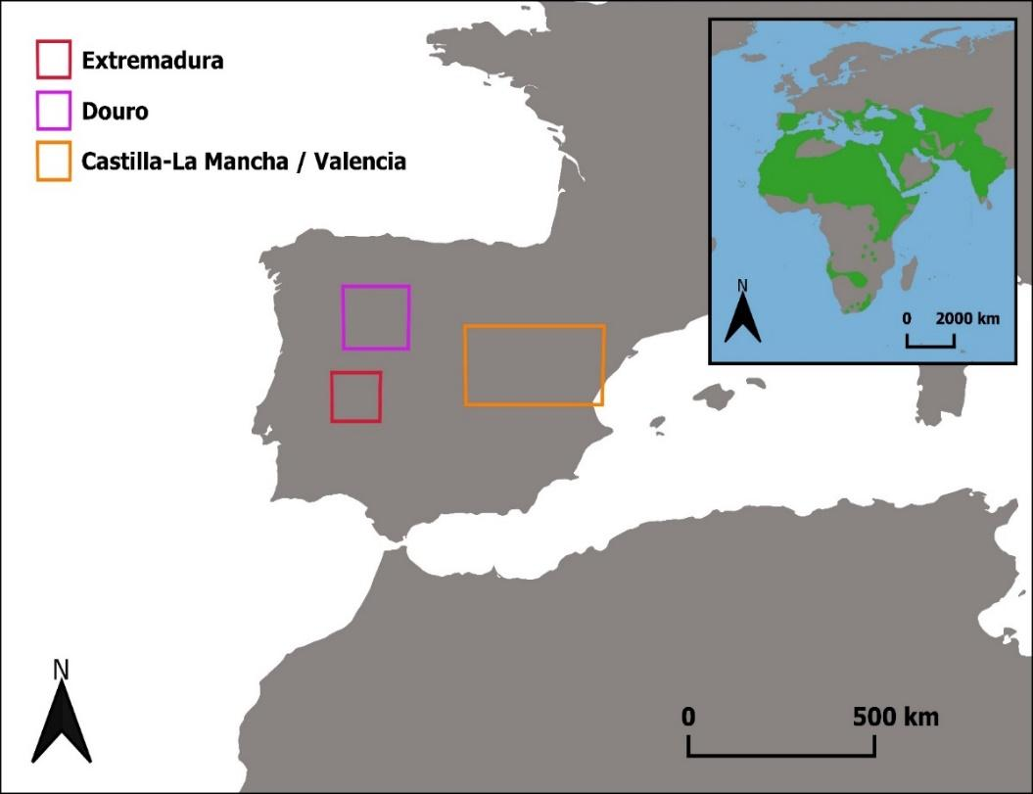
Figure S1. Worldwide distribution of the Egyptian Vulture (Upper right) and the location of the populations from which birds were tagged, including, Extremadura (red), Duero/Douro (pink) and Castilla-La Mancha/ Valencia (yellow).

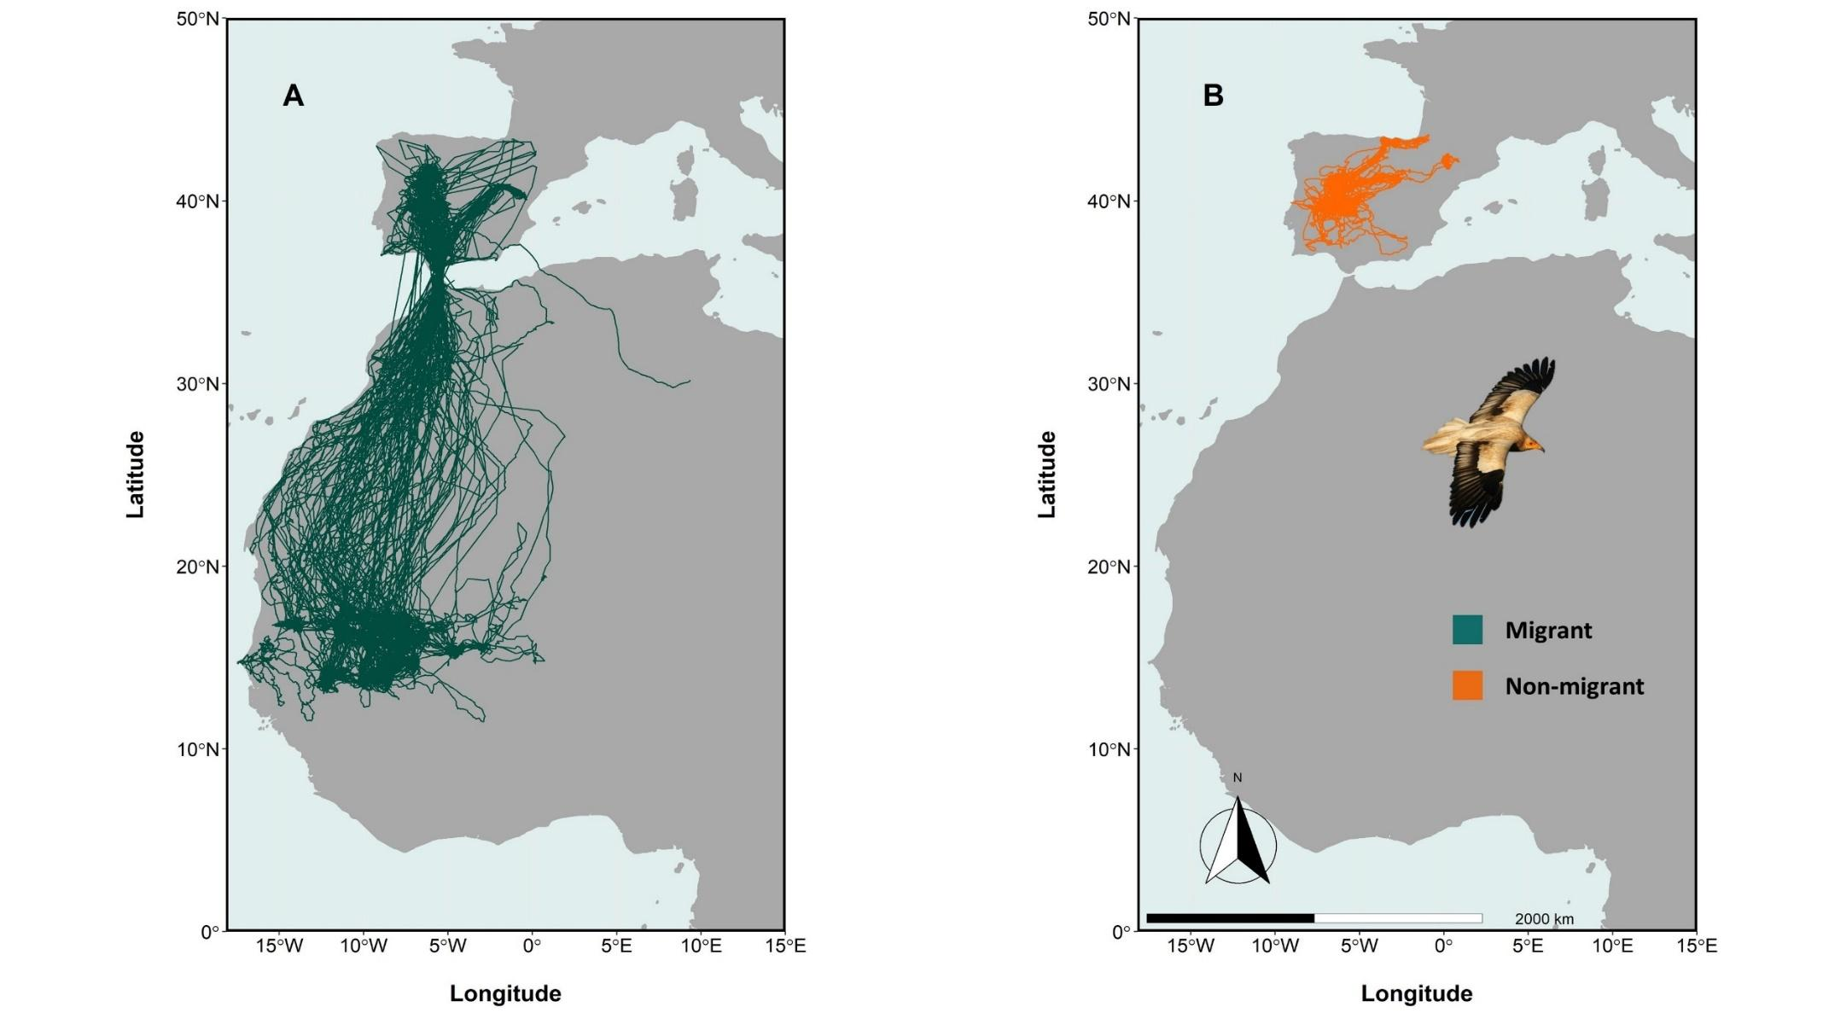Figure S2. Movement tracks of the tagged (A) migrant (n=25) and (B) resident birds (n=14) between 2009 and 2021.
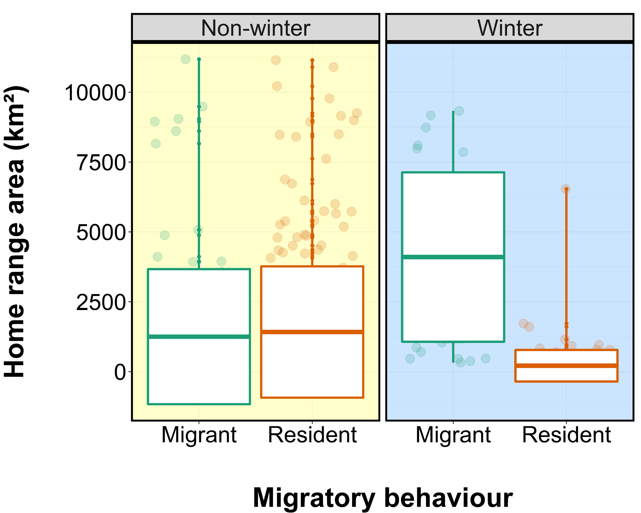

Figure S3. Differences in the home range area (km²) based on the monthly 95% Kernell Density Estimate of migrant (n=13)* and resident (n=14) individuals during non-winter and wintering seasons. Estimates were calculated by using “rhrKDE” and “rhrArea” functions implemented in the “rhr” package (Signer and Bakenhol, 2015). The horizontal line in the box plot represents the mean, whilst the standard deviation is shown as error bars.
*Note that only individuals tagged with E-obs and Ornitela are used for this analysis due to the timeframe differences in location recordings of Ecotone and Microwave tags.

SUPPLEMENTARY REFERENCES
Agencia Estatal de Meteorología (2020). https://opendata.aemet.es/centrodedescargas/productosAEMET?. Accessed: 10 December 2020.
Felicísimo Pérez, Á. M. Elaboración del atlas climático de Extremadura mediante un Sistema de Información Geográfica. GeoFocus 1, 17–23 (2001).
Donazar, J. A., Ceballos, O., & Tella, J. L. (1994). Copulation behaviour in the Egyptian Vulture Neophron percnopterus. Bird study, 41(1), 37-41.
López-López, P., Maiorano, L., Falcucci, A., Barba, E. & Boitani, L. Hotspots of species richness, threat and endemism for terrestrial vertebrates in SW Europe. Acta Oecol. 37, 399–412 (2011).
Morant, J., Abad-Gómez, J. M., Álvarez, T., Sánchez, Á., Zuberogoitia, I., & López-López, P. (2020). Winter movement patterns of a globally endangered avian scavenger in south-western Europe. Scientific reports, 10(1), 1-11.
Picardi, S., Smith, B. J., Boone, M. E., Frederick, P. C., Cecere, J. G., Rubolini, D., ... & Basille, M. (2020). Analysis of movement recursions to detect reproductive events and estimate their fate in central place foragers. Movement Ecology, 8, 1-14.
Signer, J., & Balkenhol, N. (2015). Reproducible home ranges (rhr): A new, user‐friendly R package for analyses of wildlife telemetry data. Wildlife Society Bulletin, 39(2), 358-363.
Traba, J., García De La Morena, E. L., Morales, M. B. & Suárez, F. Determining high value areas for steppe birds in Spain: Hot spots, complementarity and the efficiency of protected areas. Biodivers. Conserv. 16, 3255–3275 (2007).

