Supplementary material
Measurement of femorotibial alignment with the method from Moyer et al.[16]
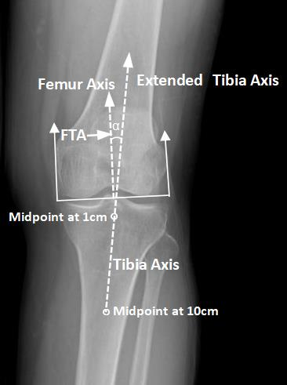
Fig. 1 Measurement of femorotibial alignment with the short knee radiograph. The femoral axis was perpendicular to the line tangent to the base of the femoral condyles; The tibial axis connected the centers of the shaft of tibia at two levels, which were 1 cm and 10 cm distal to the tibial plateau.

