Supplementary Information for

H₂-CO₂ polymer electrolyte fuel cell that generates power while evolving CH₄ at the Pt_{0.8}Ru_{0.2}/C cathode

Shofu Matsuda, Yuuki Niitsuma, Yuta Yoshida, Minoru Umeda *

Department of Materials Science and Technology, Graduate School of Engineering, Nagaoka University of Technology, 1603-1 Kamitomioka, Nagaoka, Niigata 940-2188, Japan

* Corresponding author: mumeda@vos.nagaokaut.ac.jp (M. Umeda)

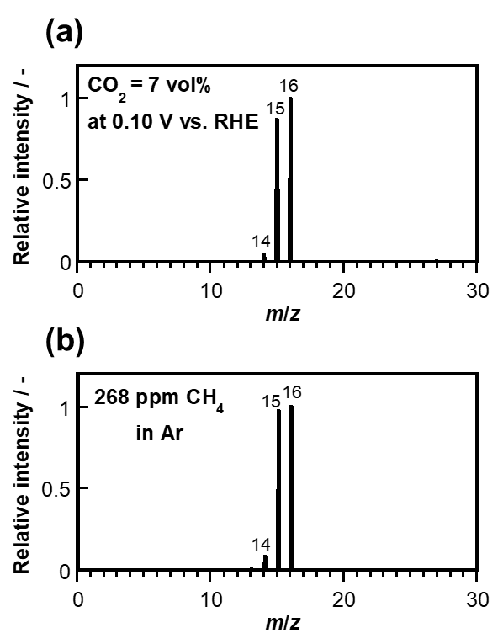
Fig. S1. Mass spectra. Mass spectra of (a) the cathodic output gas from the cell at 0.10 V (vs. RHE) during negative-scan CV in a 7 vol% CO₂ atmosphere (Fig. 2a) and (b) 268 ppm CH₄ standard gas diluted with Ar.

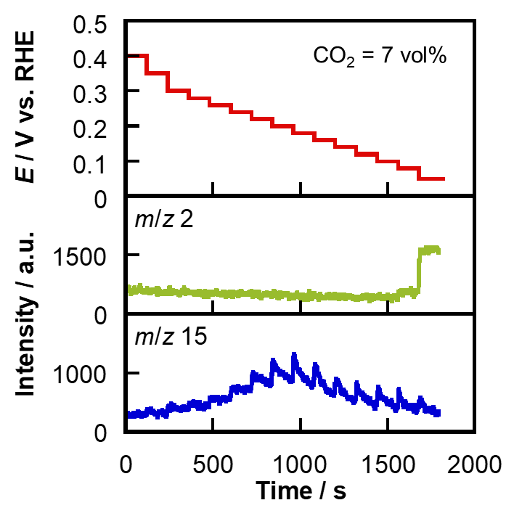
Fig. S2. Potential program and MS-signal responses. Potential program applied to the cathode (upper) and time-dependent in-line m/z 2 and 15 MS signal intensities (lower) in a 7 vol% CO₂ atmosphere.

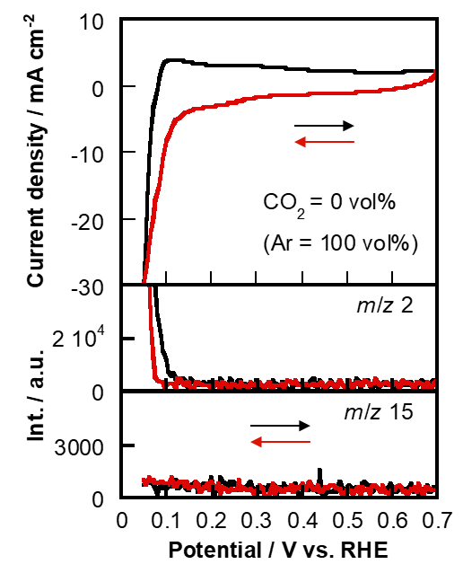
Fig. S3. Product analysis during CV. In-line m/z 2 (for H₂) and 15 (for CH₄) MS signals during cyclic voltammetry at a CO₂ concentration of 0 vol% (100 vol% Ar).

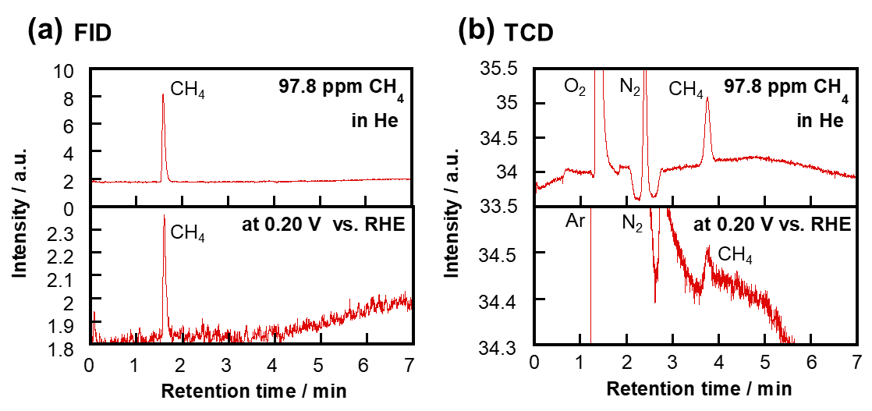
Fig. S4. Gas chromatography. Gas chromatograms of (upper) the 97.8 ppm CH₄ standard gas in He and (lower) the cathodic output gas from the cell during potential holding at 0.20 V (vs. RHE) in a 7 vol% CO₂ atmosphere using (a) a flame ionization detector (FID) and (b) a thermal conductivity detector (TCD). A 6890 series gas chromatograph (Agilent Technology Inc.) and a DB-WAX capillary column (Agilent Technology Inc.) were used in this study.

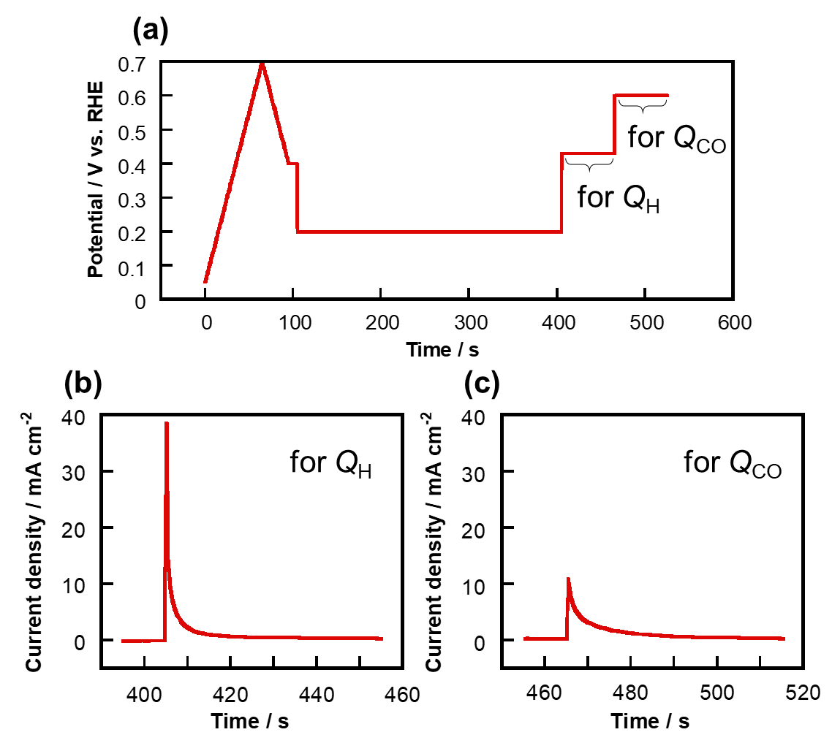
Fig. S5. Potential program and current responses. (a) Potential program applied in this experiment and the corresponding current responses used to determine (b) Q_{H} and (c) Q_{CO}. To determine why CH₄ was continuously generated during CO₂ reduction at 0.20 V (vs. RHE), we evaluated the CO_{ads}-to-H_{ads} ratio after holding for 5 min at 0.20 V (vs. RHE) in a 7 vol% CO₂ atmosphere, after which the potential was stepped to 0.43 V, which is the CO_{ads}-desorption onset potential, which enabled the faradaic charge associated with H desorption (Q_{H}) to be determined. After holding for 50 s hold at 0.43 V (vs. RHE) the potential was then stepped to 0.60 V (vs. RHE) in order to determine the faradaic charge associated with CO desorption (Q_{CO}). Based on the values of Q_{H} and Q_{CO} determined from Figs. S5b and S5c, the CO_{ads}-to-H_{ads} ratio was calculated to be 1:7 using equation (2).

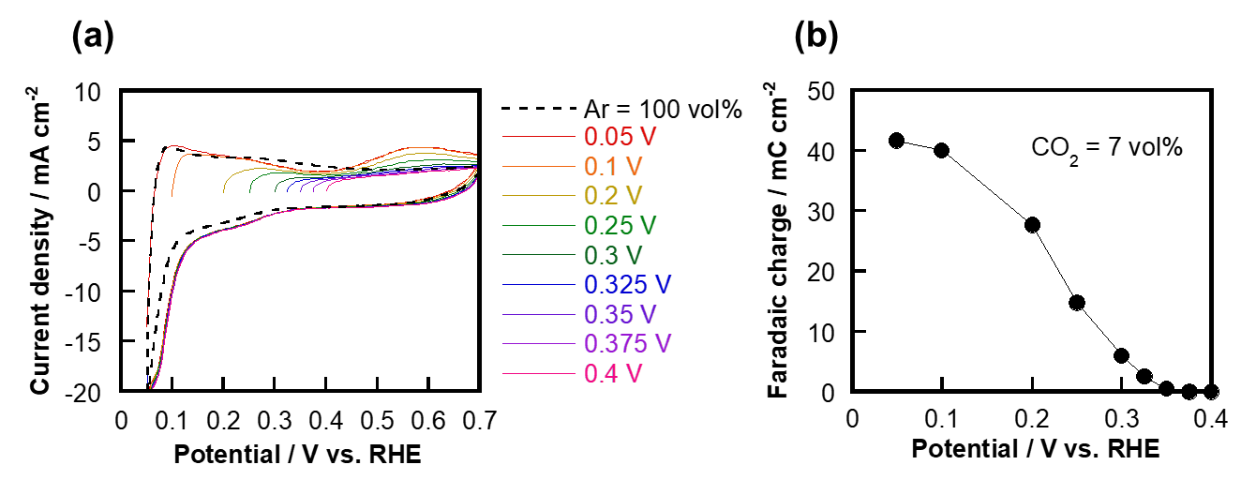
Fig. S6. Cyclic voltammograms and faradaic charges. (a) Cyclic voltammograms acquired after holding at each potential for 5 min and (b) dependence of faradaic charge (0.43–0.70 V vs. RHE in the cyclic voltammograms in (a)) on the hold potential at a CO₂ concentration of 7 vol% and a cell temperature of 40°C using the Pt_{0.8}Ru_{0.2}/C cathode catalyst. The cathodic potential in Fig. S6a was swept in the positive direction at 10 mV·s⁻¹ after being held for 5 min at 0.05–0.40 V (vs. RHE) in 7 vol% CO₂. As a result, the CO desorption peak in the 0.43–0.70 V (vs. RHE) potential range decreased in size as the hold potential moved in the positive direction, and then disappeared at 0.375 V vs. RHE. The calculated faradaic charges derived from the oxidation current for CO desorption shown in Fig. S6a decreased in magnitude as the hold potential was positively shifted, and became 0.0 mC·cm⁻² at 0.375 V vs. RHE, as shown in Fig. S6b. It should be noted that the onset potential for the formation of CO_{ads} through the reduction of CO₂ is defined as the hold potential which the faradaic charge derived from the CO-desorption oxidation disappears. Therefore, the onset potential for the formation of CO_{ads} at the Pt_{0.8}Ru_{0.2}/C electrocatalyst in 7 vol% CO₂ was determined to be 0.375 V (vs. RHE).

