Supplemental appendix
Auxora vs. placebo for the treatment of patients with severe COVID-19 pneumonia: a randomized clinical trial
Table of Contents
Acknowledgements 2
Inclusion Criteria 5
Exclusion Criteria 6
Figure S1. All-Cause Mortality Through Day 60 (Efficacy Set). 8
Figure S2. All-Cause Mortality at Day 60 for Patients Requiring High Flow Supplemental Oxygen at Baseline (Efficacy Set). 9
Figure S3. All-Cause Mortality at Day 60 for Patients with Imputed PaO₂/FiO₂ ≤100 at Baseline (Efficacy Set). 10
Figure S4. Subgroup Analysis of All-Cause Mortality at Day 60 (Efficacy Set). 11
Table S1: Concomitant Medications for COVID-19 (Efficacy Set). 12
Table S2: Baseline Characteristics (All Randomized Patients). 13
Table S3. Primary and Key Secondary Endpoints (All Randomized Patients). 15
Table S4: Number of Hospitalized Days or ICU Days During the First 28 Days of the Study (Efficacy Set). 16

Acknowledgements
We thank the patients who participated in the study and the Investigators and research teams who contributed to the study.
Institution | Investigators and Research Personnel
Aurora Research Institute | Raul Mendoza-Ayala, MD, FCCP; Suraj Arora, MD; Jessica S.Thompson, AG-ACNP, MSN, BS, BSN, RN; Alexander Albers; Lori McElroe
Baton Rouge General Medical Center | Vasudev Tati, MD; Melissa Bunke, MD; Silpita Katragadda, MD; Jeremy Polman, DO, MS, MBA; Stacie S. LaPrarie
Brigham and Women's Hospital | Peter C. Hou, MD; Michelle Chung; Gabrielle Donohoe; Jordyn M. Fofi; Mohammad A. Hasdianda; Alexander B. Hill; Guruprasad Jambaulikar, MBBS, MPH; Lily Johnsky; Jenson J. Kaithamattam; Steven E. Miyawaki; Mayra A. Pinilla; Nikita Umale
Henry Ford Health System | Joseph Miller, MD, MS; Mayur Ramesh, MD; Hashem Nassereddine, MD; Margaret Beyer; Jo-Ann Rammal; Kathleen Wilson, RN, BSN, MS
JPS Health Network | James P. d'Etienne, MD, MBA; Elizabeth Cyril, MD; Stephen Q. Davis, MD, MS FCCP; Robert Peeler, MD; Maximillian Y. Masuda
University of Southern California | James L. Buxbaum, MD; Doug Hutcheon, MD, FHM; Jonathan Sadik, MD, Jessica Serna
Memorial Health Services | Maged Tanios, MD; Fady Youssef, MD; Daniel Blevins, CRC; Laura Macias
MaineHealth | Kathryn Brouillette, MD; David Seder, MD, FCCP, FCCM, FNCS, FAHA; Debra Burris, RN, CCRC
Methodist Hospital and Regions Hospital | Charles A. Bruen, MD; Michael Schnaus, MD Sadia Ali, MD; Sarah Peglow, MD; Omobosola Akinsete, MD; Firas Elmufdi, MD; Dave Niccum, MD; Sandi Wewerka, MPH; Nell Adams; Lois Akintade; Makenna Ash; Sarah Ashton; David Bachman; Ruby Carlson; Kirsten Dalrymple; Alan Denney; Jessica Haines; Miranda Harris; Hans Gil Jeong; Madison Johnson; Jenny Koops; Alana Lemke; Jennifer McKay; Meghan O’Brien; Megan O’Leary; Wiktoria Pasek; Bethany Penna; Marissa Peterson; Kelsey Schnakenberg; Jason Sloan; Zach Stoecker; Anna Swensen; Annika Tureson; Zeling Yu; Sylvia Wong; Hlee Yang; Yeshareg Yismaw
Houston Methodist Hospital, Department of Medicine | Mukhtar Al-Saadi, MD, EdD, FACP; Jihad G. Youssef, MD; Solmaz Afshar, Alejandro De La Torre; Anisha Gupte; Chisom Onwunyi; Caroline Perry; Mellissa Whipple; Marianne Younes
Northwestern University | Richard G. Wunderink, MD; Helen Donnelly, RN, BSN; Alvaro Donayre
Sharp Memorial Hospital | Thomas Lawrie, MD; Roland El Ghazal, MD; Cary Murphy
Wayne State University | James H. Paxton, MD, MBA, FACEP, FAHA; Abe Lovelace; Thomas Mazzocco; James Wooden
National Jewish Health | William J. Janssen, MD; Christine Griesmer, RN
Texas Tech University Health Sciences Center | Edward A. Michelson, MD; Danielle Austin; Lilian Marquez; Susan Watts, PhD
Virginia Commonwealth University | Christopher J. Hogan, MD, FACEP, FCCM; Paula Ferrada, MD, FACS; Stefan W. Leichtle, MD, FACS; Jinfeng Han, CCRP

Senior Research Personnel
Bionical-Emas | Esme Remfry; Katie Simpson, MS; Kimberly Lupejkis, BSN, RN
CalciMedica, Inc. | Deb Jezior; Katherine Randolph; Liisa Tingue
Safety Sphere | Mary Dymond BSN: Ashley Hehr; Ed Parsley, MD

Inclusion Criteria
All of the following must be met for a patient to be randomized into the study:
- Has laboratory-confirmed SARS-CoV-2 infection as determined by polymerase chain reaction (PCR) or other commercial or public health assay in any specimen, as documented by either of the following: o PCR positive in sample collected < 72 hours prior to randomization; or
  - PCR positive in sample collected ≥ 72 hours prior to randomization, with inability to obtain a repeat sample (e.g. due to lack of testing supplies, or limited testing capacity, or results taking >24 hours, etc.) or progressive disease suggestive of ongoing SARS-CoV-2 infection;
- At least 1 of the following symptoms:
  - Fever, cough, sore throat, malaise, headache, muscle pain, dyspnea at rest or with exertion, confusion, or respiratory distress;
- At least 1 of the following signs at Screening or noted in the 24 hours before Screening:
  - PaO₂/FiO₂ ≤200 when receiving supplemental oxygen. The PaO₂/FiO₂ may be estimated from pulse oximetry or determined by arterial blood gas;
  - If SpO2 ≥97%, receiving 10L or more of supplemental oxygen;
- The presence of a respiratory infiltrate or abnormality consistent with pneumonia that is documented by either a CXR or CT scan of the lungs;
- The patient is ≥18 years of age;
- A female patient of childbearing potential must not attempt to become pregnant for 39 months, and if sexually active with a male partner, is willing to practice acceptable methods of birth control for 39 months after the last dose of study drug;
- A male patient who is sexually active with a female partner of childbearing potential is willing to practice acceptable methods of birth control for 39 months after the last dose of study drug. A male patient must not donate sperm for 39 months;
- The patient is willing and able to, or has a legal authorized representative (LAR) who is willing and able to, provide informed consent to participate, and to cooperate with all aspects of the protocol.

Exclusion Criteria
Patients with any of the following conditions or characteristics must be excluded from randomizing:
- Expected survival or time to withdrawal of life-sustaining treatments expected to be <7 days;
- Do Not Intubate order;
- Home mechanical ventilation (noninvasive ventilation or via tracheotomy) except for continuous positive airway pressure or bi-level positive airway pressure (CPAP/BIPAP) used solely for sleep-disordered breathing;
- PaO₂/FiO₂ ≤75 at the time of Screening. The PaO₂/FiO₂ may be estimated from pulse oximetry or determined by arterial blood gas;
- Noninvasive positive pressure ventilation;
- Invasive mechanical ventilation via endotracheal intubation or tracheostomy;
- ECMO;
- Shock defined by the use of vasopressors;
- Multiple organ dysfunction or failure;
- Positive Influenza A or B testing if tested as local standard of care;
- The patient has a history of:
  - Organ or hematologic transplant;
  - HIV
  - Active hepatitis B, or hepatitis C infection;
- Current treatment with:
  - Chemotherapy;
  - Immunosuppressive medications or immunotherapy at the time of consent;
  - Hemodialysis or Peritoneal Dialysis;
- Have a history of venous thromboembolism (VTE) (deep vein thrombosis [DVT] or pulmonary embolism [PE]) within 12 weeks prior to screening or have a history of recurrent (> 1) VTE;
- The patient is known to be pregnant or is nursing;
- Currently participating in another study of an investigational drug or therapeutic medical device at the time of consent;
- Allergy to eggs or any of the excipients in Auxora.

Figure S1. All-Cause Mortality Through Day 60 (Efficacy Set).
The all-cause mortality rate at Day 60 was 0.21 (95% CI 0.15–0.29) for placebo and 0.12 (95% CI 0.08–0.19) for Auxora when estimated by the Kaplan-Meier procedure (P=0.0730). P-value is based on the stratified Kaplan-Meier estimates and standard errors estimated by Greenwood formula using the log-log transformation of the survival function stratified by the baseline imputed PaO₂/FiO₂ of ≤100 vs 101-200.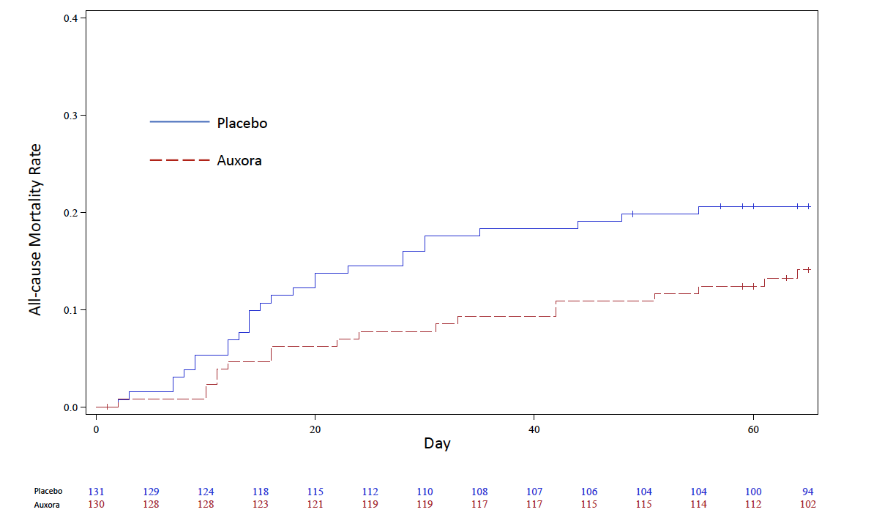

Figure S2. All-Cause Mortality at Day 60 for Patients Requiring High Flow Supplemental Oxygen at Baseline (Efficacy Set).
The all-cause mortality rate at Day 60 was 0.26 (95% CI, 0.18–0.37) for placebo and 0.15 (95% CI, 0.09–0.25) for Auxora when estimated by the Kaplan-Meier procedure (P=0.0980). P-value is based on the Kaplan-Meier estimates and standard errors estimated by Greenwood formula using the log-log transformation of the survival.

Figure S3. All-Cause Mortality at Day 60 for Patients with Imputed PaO₂/FiO₂ ≤100 at Baseline (Efficacy Set).
The all-cause mortality rate at Day 60 was 0.29 (95% CI, 0.19–0.43) for placebo and 0.19 (95% CI, 0.11–0.32) for Auxora when estimated by the Kaplan-Meier procedure (P=0.1958). P-value is based on the Kaplan-Meier estimates and standard errors estimated by Greenwood formula using the log-log transformation of the survival.

Figure S4. Subgroup Analysis of All-Cause Mortality at Day 60 (Efficacy Set).

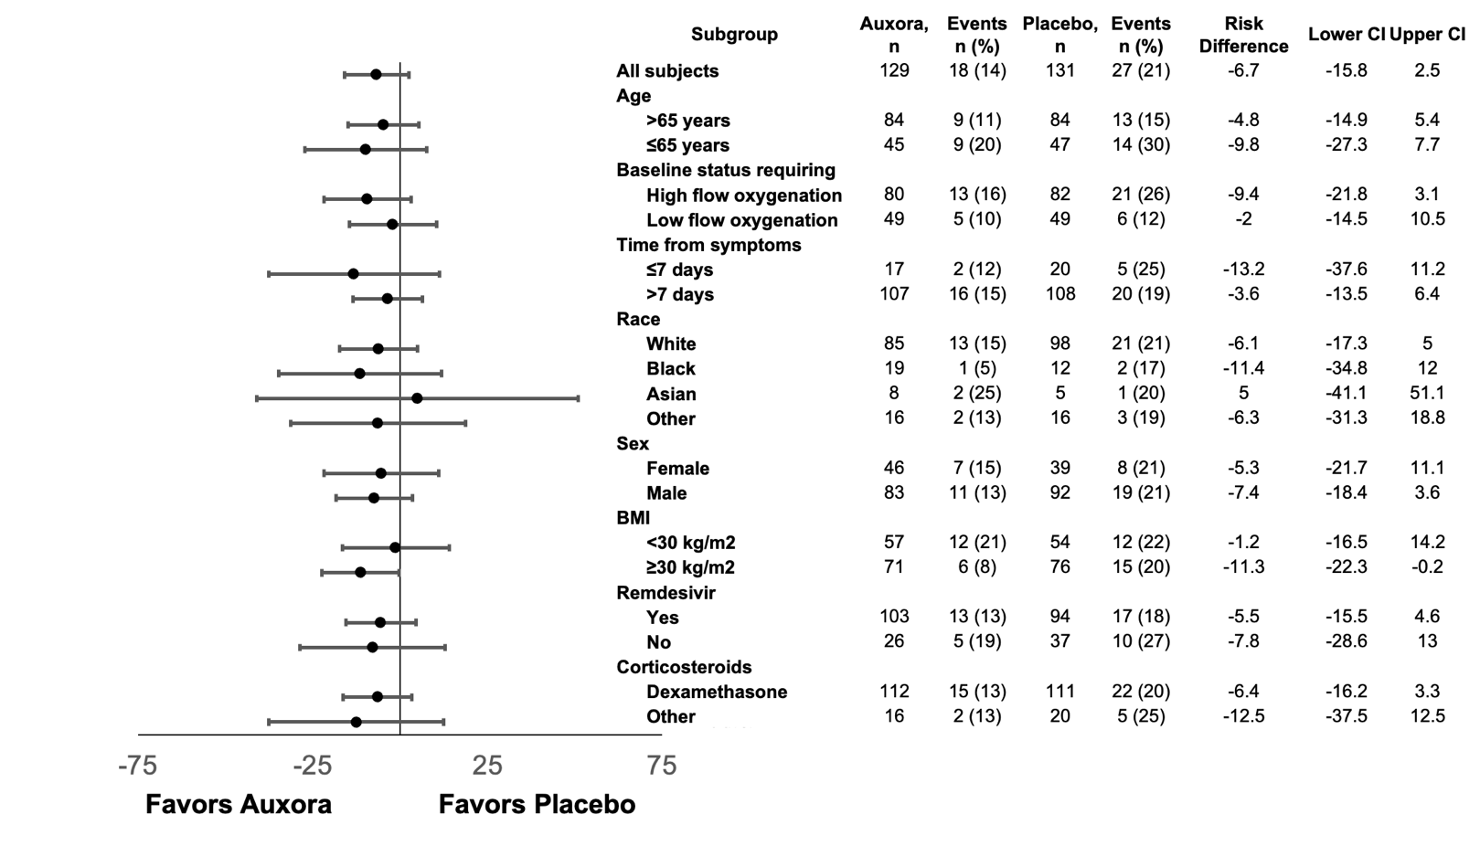

Table S1: Concomitant Medications for COVID-19 (Efficacy Set).
 | Placebo  (n=131) | Auxora  (n=130) | Total  (n=261)
Corticosteroids | 131 (100%) | 130 (100%) | 261 (100%)
Dexamethasone | 111 (84.7%) | 113 (86.9%) | 224 (85.8%)
Methylprednisolone | 43 (32.8%) | 37 (28.5%) | 80 (30.7%)
Prednisone | 17 (13%) | 13 (10%) | 30 (11.5%)
Remdesivir | 94 (71.8%) | 104 (80.0%) | 198 (75.9%)
Anticoagulation | 130 (99.2%) | 130 (100%) | 260 (99.6%)
Enoxaparin | 118 (90.1%) | 125 (96.2%) | 243 (93.1%)
Tocilizumab | 6 (4.6%) | 2 (1.5%) | 8 (3.1%)
Hyperimmune Plasma COVID-19 | 2 (1.5 %) | 1 (0.8%) | 3 (1.1%)

Table S2: Baseline Characteristics (All Randomized Patients).
 | Placebo  (n=141) | Auxora  (n=143) | Total  (N=284)
Male, n (%) | 99 (70.2%) | 91 (63.6%) | 190 (66.9%)
Race
White, n (%) | 104 (73.8%) | 93 (65.0%) | 197 (69.4%)
Black, n (%) | 14 (9.9%) | 22 (15.4%) | 36 (12.7%)
Asian | 5 (3.5 %) | 9 (6.3 %) | 14 (4.9%)
Other/Multiple* | 18 (12.8 %) | 18 (12.6 %) | 36 (12.7%)
Hispanic, n (%) | 59 (41.8%) | 49 (34.3%) | 108 (38.0%)
Median age, years | 60 | 60 | 60
65+ years of age, n (%) | 50 (35.5%) | 48 (33.6%) | 98 (34.5%)
Median BMI, kg/m² | 30.9 | 30.8 | 30.9
Median time from symptom onset, days | 12.0 | 11.0 | 11.0
Median time from hospitalization to randomization, days | 3.0 | 3.0 | 3.0
HFNC use, n (%) | 83 (58.9%) | 81 (56.6%) | 164 (57.7%)
Median baseline imputed PaO₂/FiO₂ value† | 106.8 | 111.7 | 109.8
Imputed PaO₂/FiO₂ ≤100, n (%) | 58 (41.1%) | 59 (41.31%) | 117 (41.2%)
Imputed PaO₂/FiO₂ 101-300, n (%) | 83 (58.9%) | 84 (58.7%) | 167 (58.8%)
Median CRP, mg/L | 74.5 | 73.0 | 74.0
Median ferritin, ng/mL | 775 | 752 | 756.5
Hypertension, n (%) | 86 (61.0%) | 90 (62.9%) | 176 (62.0%)
Diabetes, n (%) | 61 (43.3%) | 60 (42.0%) | 121 (42.6%)
Hyperlipidemia, n (%) | 57 (40.4%) | 56 (39.2%) | 113 (39.8%)
Former smoker, n (%) | 36 (25.5%) | 45 (31.5%) | 81 (28.5%)
*Other include Native Hawaiian or other Pacific Islander. One participant in the Auxora arm was missing race at baseline; †Worst value in the 24 hours prior to Screening. BMI, body mass index; CRP, C-reactive protein; HFNC, high flow nasal cannula

Table S3. Primary and Key Secondary Endpoints (All Randomized Patients).
 | Placebo  (n=141) | Auxora  (n=143) | Difference  (95% CI) | P Value
Patients who recovered, n (%) | 107 (75.9%) | 115 (80.4%)
Median time to recovery, days (95% CI) | 8.0  (7.0, 11.0) | 7.0  (6.0, 8.0) |  | 0.0533
All-Cause Mortality at Day 60, n (%) | 27 (19.1%) | 18 (12.6%) | -6.43  (-14.74, 1.88) | 0.1321
Definition of Recovery by Ordinal Scale: 6 Hospitalized, not requiring supplemental oxygen or ongoing medical care; 7 Discharged, requiring supplemental oxygen; 8 Discharged, not requiring supplemental oxygen. Analysis of time to recovery through Day 60 in the efficacy set used log-rank test stratified by the baseline imputed PaO₂/FiO₂ ≤100 and 101-200; Analysis of all-cause mortality in the efficacy set used Cochran-Mantel-Haenszel test stratified by the baseline imputed PaO₂/FiO₂ ≤100 and 101-200.

Table S4: Number of Hospitalized Days or ICU Days During the First 28 Days of the Study (Efficacy Set).
 |  | Placebo (n=131) | Auxora  (n-130) | Difference (95% CI; P value)
Hospitalized Days | LS Mean | 15.29 | 13.65 | -1.64 (-4.09–0.80; 0.1864)
ICU Days | LS Mean | 8.36 | 6.88 | -1.47 (-4.25–1.30; 0.2970)
ANOVA model includes treatment group as fixed effect in the model. The number of days in the hospital is defined as 28 if the patient died. ICU, intensive care unit.

