Genome mining reveal secondary metabolites of antarctic bacterium Streptomyces albidoflavus ANT_B131 related to antimicrobial and antiproliferative activities.

Paula de França^{1,2,*}, Jonas Henrique Costa³, Taícia Pacheco Fill³, Marcelo Lancelotti⁴, Ana Lucia Tasca Gois Ruiz⁴, Fabiana Fantinatti-Garboggini^{1,*}.
¹ Division of Microbial Resources, Pluridisciplinary Center for Chemical, Biological and Agricultural Research, University of Campinas, Paulínia, SP, Brazil
²Graduate Program in Genetics and Molecular Biology, Institute of Biology, University of Campinas, Campinas, SP, Brazil
³Institute of Chemistry, University of Campinas, CP 6154, 13083-970, Campinas, SP, Brazil.
⁴ Faculty of Pharmaceutical Sciences, University of Campinas, Campinas, SP, Brazil.
*Correspondence:
Paula de França
pauladfranca@gmail.com
Dr. Fabiana Fantinatti-Garboggini
fabianaf@cpqba.unicamp.br

SUPPORT INFORMATION

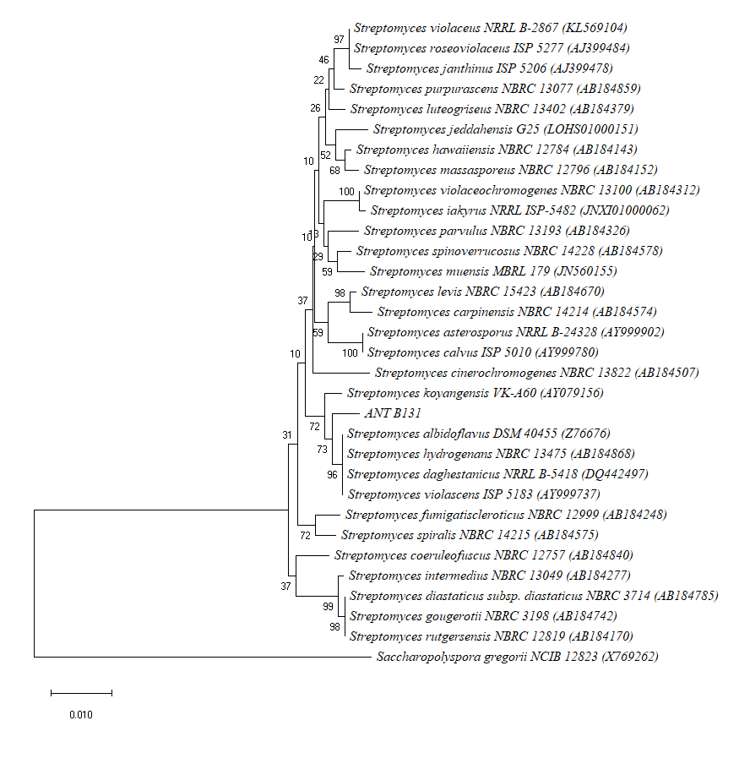
Supplementary Figure. 1. Phylogenetic tree based on the phylogenetic analysis of the 16S ribosomal RNA gene sequence of the ANT_B131 bacteria isolated from Antarctic and related microorganisms. Bootstrap values (1000 repetitions, showed as %) are listed. Scale bar represents 1 nucleotide substitution per 100 nucleotides position. Saccharopolyspora gregorii NCIB 12823 was used as outgroup.

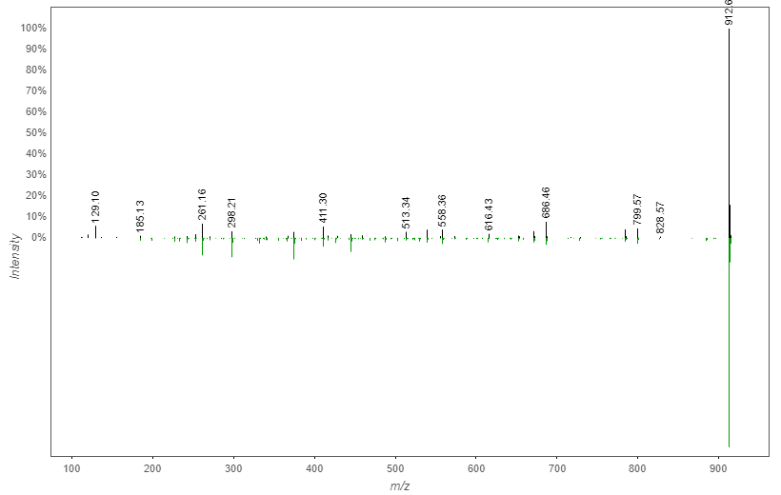
Supplementary Figure 2. MS/MS match for surugamide A between GNPS database (green) and S. albidoflavus ANT_B131 extracts (black).

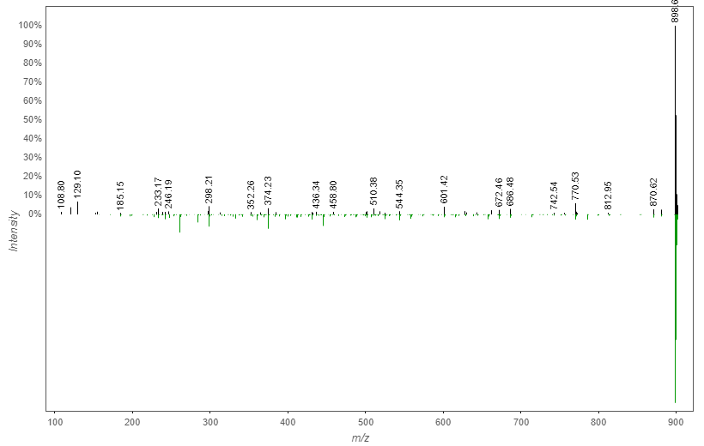
Supplementary Figure 3. MS/MS match for surugamide D between GNPS database (green) and S. albidoflavus ANT_B131 extracts (black).

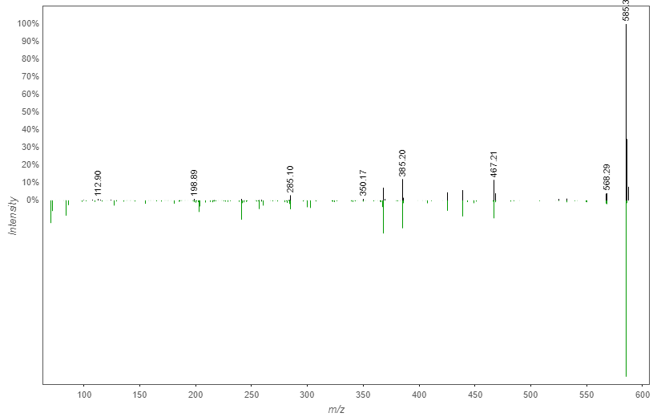
Supplementary Figure 4. MS/MS match for desferrioxamine B between GNPS database (green) and S. albidoflavus ANT_B131 extracts (black).

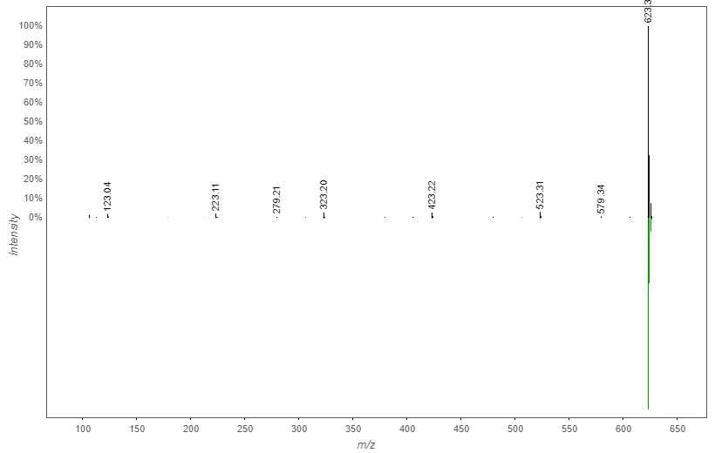
Supplementary Figure 5. MS/MS match for desferrioxamine E between GNPS database (green) and S. albidoflavus ANT_B131 extracts (black).

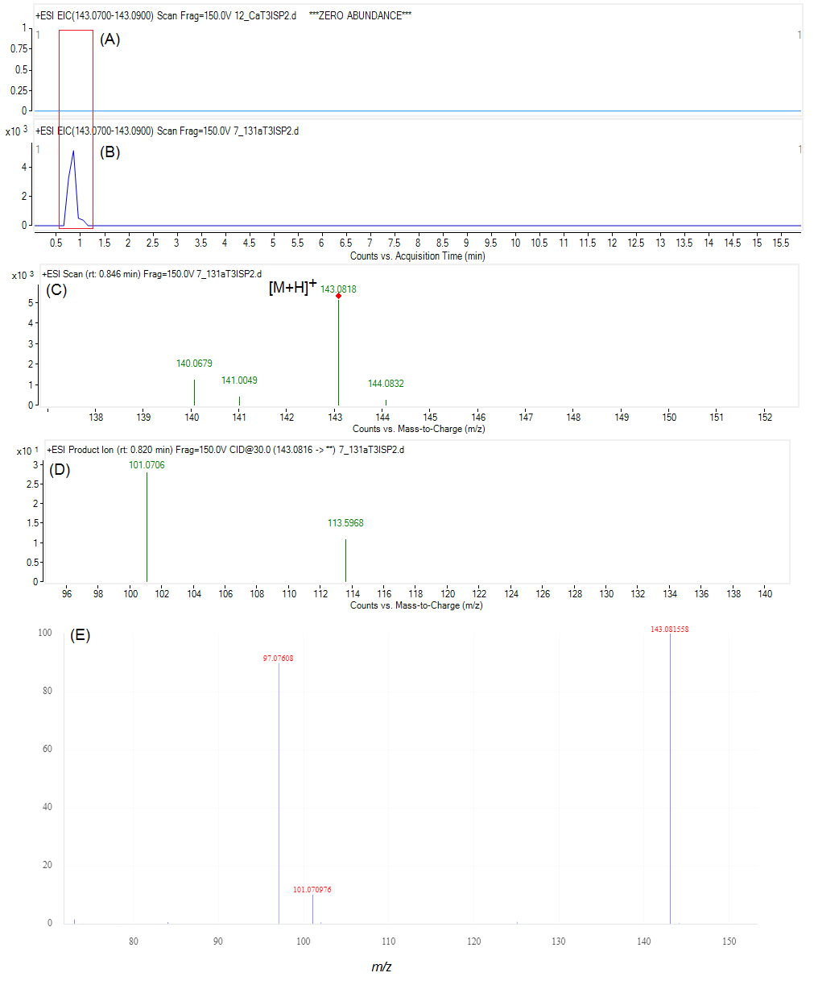
Supplementary Figure 6. Extracted ion chromatograms of m/z 143.08 for extracts of (A) culture media (control) and (B) S. albidoflavus ANT_B131. (C) Mass spectrum obtained for ectoine. (D) MS/MS spectrum of ion [M+H]⁺ m/z 143.0816. (E) MS/MS spectrum of ectoine in Mass MassBank of North America database (adapted from https://mona.fiehnlab.ucdavis.edu/spectra/display/CCMSLIB00005435933 - acessed 18th September of 2020).

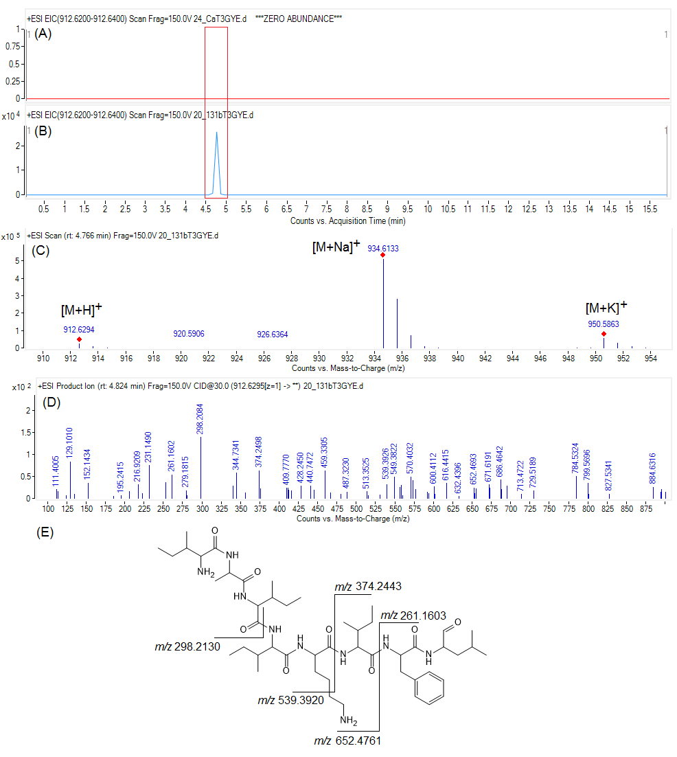
Supplementary Figure 7. Extracted ion chromatograms of m/z 912.62 for (A) culture media (control) and (B) S. albidoflavus ANT_B131. (C) Mass spectrum obtained for surugamide A. (D) MS/MS spectrum of ion [M+H]⁺ m/z 912.6295. (E) Typical mass fragments of surugamide A.

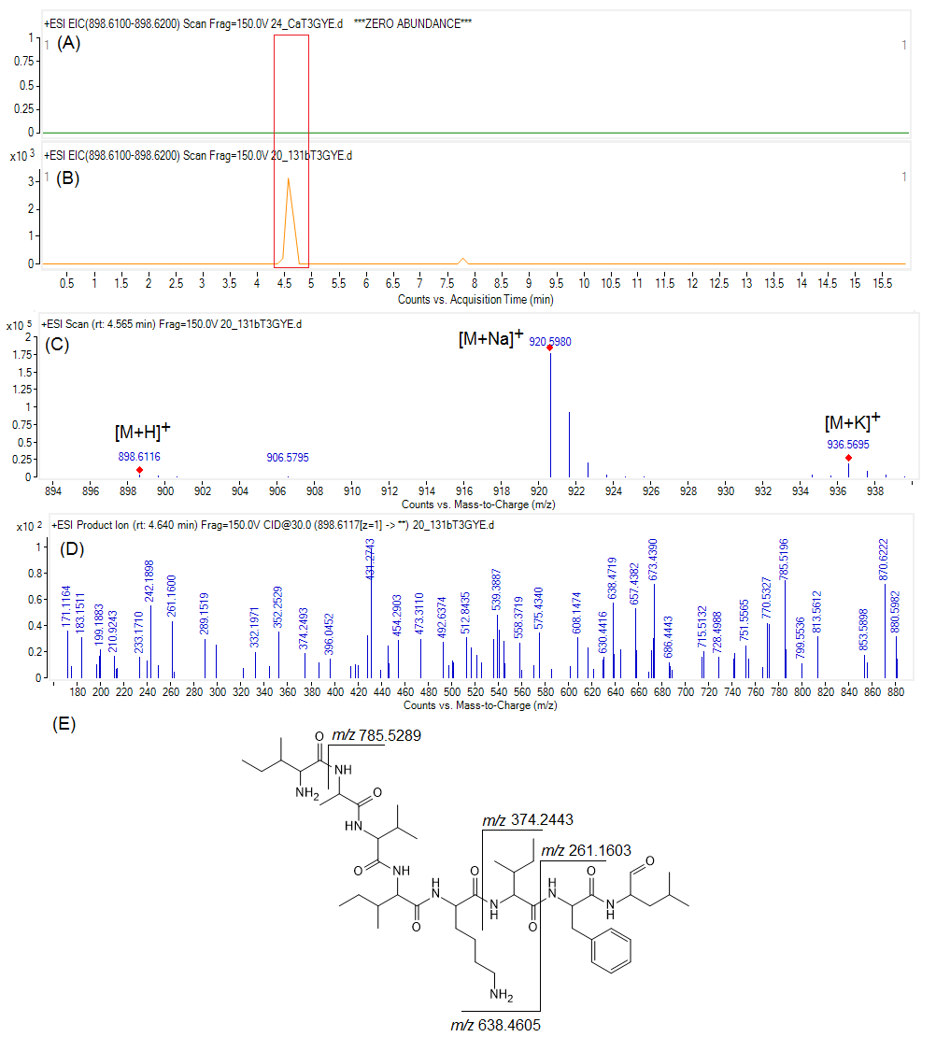
Supplementary Figure 8. Extracted ion chromatograms of m/z 898.61 for (A) culture media (control) and (B) S. albidoflavus ANT_B131. (C) Mass spectrum obtained for surugamide D. (D) MS/MS spectrum of ion [M+H]⁺ m/z 898.6117. (E) Typical mass fragments of surugamide D.

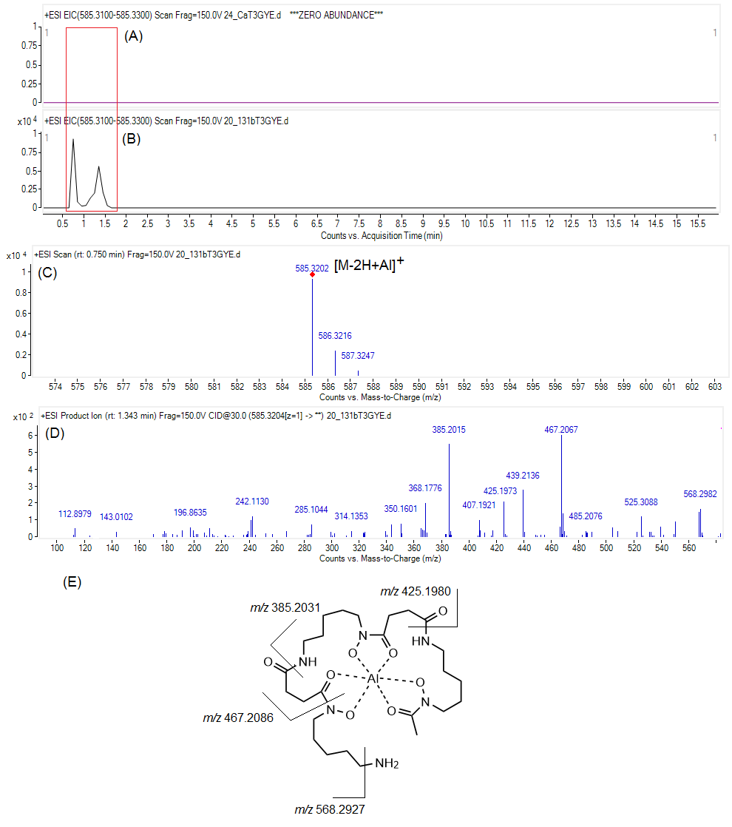
Supplementary Figure 9. Extracted ion chromatograms of m/z 585.32 for (A) culture media (control) and (B) S. albidoflavus ANT_B131. (C) Mass spectrum obtained for desferrioxamine B. (D) MS/MS spectrum of ion [M-2H+Al]⁺ m/z 585.3204. (E) Typical mass fragments of desferrioxamine B + Al.

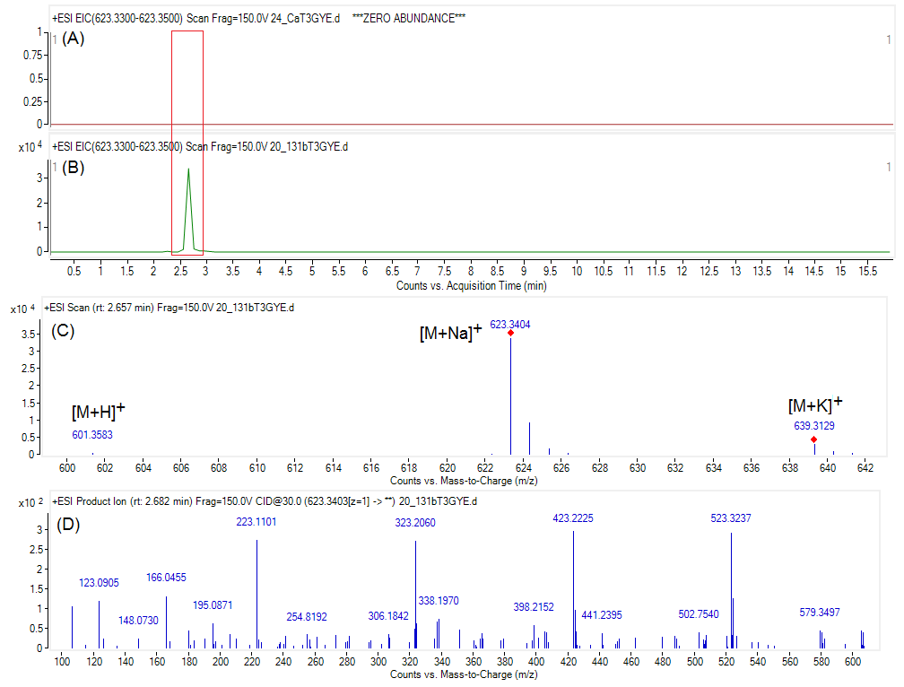
Supplementary Figure 10. Extracted ion chromatograms of m/z 623.34 for (A) culture media (control) and (B) S. albidoflavus ANT_B131. (C) Mass spectrum obtained for desferrioxamine E. (D) MS/MS spectrum of ion [M+Na]⁺ m/z 623.3403.

Supplementary Table 1. Sequence accession number of genes used in Multilocus Sequence Analysis
Name | Strain | Accession number GenBank
 |  | atpD | gyrB | recA | rpoB | trpB
Streptomyces daghestanicus | NRRL B-5418 | KJ137021 | KJ137038 | KJ137055 | KJ137072 | KJ137089
Streptomyces albidoflavus | NRRL B-1271 | KT384451 | KT384800 | KT385148 | KT388770 | KT389120
Streptomyces violascens | NRRL B-2700 | KT384752 | KT385100 | KT385454 | KT389072 | KT389421
Streptomyces violaceochromogenes | NRRL B-5427 | KT384748 | KT385096 | KT385450 | KT389068 | KT389417
Streptomyces purpurascens | NRRL B-12230 | KT384696 | KT385046 | KT385397 | KT389017 | KT389365
Streptomyces luteogriseus | NRRL B-12422 | KT384632 | KT384981 | KT385332 | KT388952 | KT389301
Streptomyces hawaiiensis | NRRL B-1988 | KT384592 | KT384941 | KT385290 | KT388912 | KT389261
Streptomyces levis | NRRL B-16370 | KT384621 | KT384970 | KT385320 | KT388941 | KT389290
Streptomyces violaceus | JCM 4533 | LC381981 | LC381982 | LC381983 | LC381984
Streptomyces iakyrus | NRRL B-3317 | KT384600 | KT384949 | KT385298 | KT388920 | KT389269
Streptomyces massasporeus | NRRL B-3300 | KT384636 | KT384985 | KT385336 | KT388956 | KT389305
Streptomyces roseoviolaceus | NRRL B-12177 | KT384710 | KT385060 | KT385411 | KT389031 | KT389379
Streptomyces janthinus | NRRL B-3365 | KT384604 | KT384953 | KT385303 | KT388924 | KT389273
Streptomyces carpinensis | NRRL B-16921 | KT384503 | KT384852 | KT385200 | KT388822 | KT389172
Streptomyces cinerochromogenes | NRRL B-16928 | KT384514 | KT384863 | KT385211 | KT388833 | KT389183
Streptomyces parvulus | NRRL B-1628 | KJ196367 | KJ196369 | KJ196371 | KJ196373 | KJ196375
Streptomyces muensis | JCM 17576 | KX784758 |  | KX784760 | KX784762 | KX784764
Streptomyces asterosporus | NRRL B-24328 | KT384471 | KT384820 | KT385168 | KT388790 | KT389140

Supplementary Table 2. Pairwise correlation between whole genome of S. albidoflavus ANT_B131 and phylogenetic closest strains S. albidoflavus SM254 and S. albidoflavus J1074.
Pairwise correlation between strains | ANIb (%) | ANIm (%) | TETRA | isDDH | Difference in %G+C
ANT_B131 x SM254 | 97.41 | 97.78 | 0.99961 | 79.50 | 0.17
ANTB_131 x J1074 | 97.02 | 97.80 | 0.99952 | 79.60 | 0.15

