Supplement for

Graviton in condensed photon sea

Jong-hoon Lee

Correspondence to: science@research.re.kr
This PDF file includes:

Materials and Methods

Supplementary Text
Supplemental Section 1. Gravity generator design (Page 3)
Supplemental Section 2. Keysight B2901A manual (Page 7)
Supplemental Section 3. Experiments (A, B, C – Table S1) (Page 10)
Supplemental Section 4. Experiments (D, E, F – Table S2) (Page 13)
Supplemental Section 5. Experiments (Voltage only while rotating) (Page 15)
Supplemental Section 6. Experiments (Voltage only while stationary) (Page 17)
Supplemental Section 7. Experiments (Current, voltage and time while stationary in the vacuum chamber) (Page 19)

Figs. S1 to S6
Figure 1. Composition for a balanced arrangement of gravity and magnetic field
Figure 2. A schematic diagram of gravity that navigates in magnetic sea
Figure 3. Gravity Generator blueprint
Figure 4. Gravity Generator parts and test operation
Figure 5. B2900A Series Manual
Figure 6. Gravity Generator in the Vacuum Chamber

Tables S1 to S6
Table S1. Electricity measured while the generator rotating
Table S1-1 Electricity data rearranged while the generator rotating
Table S2. Electricity measured while the generator stationary
Table S2-1. Electricity data rearranged while the generator stationary
Table S3. Voltage measurement data while Rotating
Table S4. Voltage measurement data while Stationary
Table S5. Voltage measurement in the vacuum chamber
Table S6. Time and voltage measurement in the vacuum chamber

Captions for Movies S1 to S3
Movies S1. 2019.10.04 Discovery of Gravity to Electricity on Gravity Generator
Movies S2. 2019.10.10 Voltage measurement data while Rotating on Gravity Generator
Movies S3. 2019.10.10 Voltage measurement data while stationary on Gravity Generator

Captions for Data S1 to S3
Data S1 2019.10.04. Preparations before experimenting with the air and first simulations.
Data S2 2020.06.18. Experiments with the gravity generator in the vacuum chamber.
Data S3 2020.06.18. Vacuum chamber & gravity generator in a vacuum.

Materials and Methods
Experimental Design
The gravity generator (GG) exhibits electronic properties that are distinctive for the quantum particles described by the Dirac or Schrödinger equation. This system is not only impressive in itself but also allows one to access – in a condensed magnetic-gravity field experiment – the subtle and rich physics of quantum electrodynamics.
In 2018, we designed an experimental device to convert gravity into electricity (Supplemental Section 1). The experimental device was assembled on September 26, 2019. Electricity was measured by a precision source/measurement device (Supplemental Section 2). To prove that the electricity in the electromagnetic (EM) field was caused by gravity, we assembled a generator that cannot generate electricity according to Maxwell's equations. The N poles of the magnets were placed upwards, north, south, east, and west. Coil Ass'Y was placed between two N poles, and the generator was assembled with bearing covers on the top and bottom. The precision source/measurement unit was connected to measure the electricity generated from a Pico ampere (pA) to a microampere (µA).
Sample Preparation and Measurement
- While the generator was rotating (Supplemental Section 3)
The experiments were carried out three times by placing dumbbell A and dumbbell B on the generator while rotating the magnets. The procedure was as follows:
- We measured the amount of electricity generated while rotating without weight.
- To apply the weight in a three-dimensional world, we measured the amount of electricity generated by placing dumbbell A while rotating.
- To apply more weight in the three-dimensional world, we measured the amount of electricity generated by placing dumbbell B on dumbbell A while rotating.
- To reduce the weight in the three-dimensional world, we measured the amount of electricity generated by removing dumbbell B from dumbbell A while rotating.
- To reduce the weight in the three-dimensional world, we measured the amount of electricity generated by removing dumbbell A while rotating.
- We measured the amount of electricity generated while rotating without weight.
The experiments were conducted three times (A, B, C) while the magnets were rotating.
- While the generator was stationary (Supplemental Section 4)
While the generator was stationary, dumbbell A and dumbbell B were placed on the generator in turn and measured three times, and the procedure was as follows:
- We measured the amount of electricity generated while the generator was stationary.
- To apply the weight, we measured the amount of electricity generated by placing dumbbell A while stationary.
- To apply more weight, we measured the amount of electricity generated by placing dumbbell B on dumbbell A while stationary.
- We measured the amount of electricity generated by removing dumbbell B from dumbbell A while stationary to reduce the weight.
- We measured the amount of electricity generated by removing dumbbell A while stationary to reduce the weight.
- We measured the amount of electricity generated while the generator was stationary and free of dumbbells A and B.
These experiments were conducted three times (experiments D, E, F) while the generator was stationary.
- Only voltage measurements (Supplemental Sections 5 and 6)
Experiments were performed to compare only the voltages obtained while the generator was rotating or stationary. We used a TDS 2014 four-channel digital storage oscilloscope voltage metre (100 MHz, 1 GS/s). A video was taken because the voltage metre could not save and output the data.
Calculations with Data
Among experiments D, E, and F, during which the GG was stationary, the data were generated in experiments D1, E1, and F1 and in D6, E6, and F6 without dumbbells. Among those, the Excel data of experiments D1, E1, and F1 were analysed in rows 312 to 412 (7). We did not choose experiments D6, E6, and F6 because of the involved weights after removing the dumbbell. The time was 0.1 seconds, and there were 100 measured points. The x-axis is the time, and the y-axis represents the voltage and current in a radial chart.
Current while Stationary in the Vacuum Chamber
The amounts of electricity and voltage generated in the vacuum chamber were measured. The Korea Institute of Civil Engineering and Building Technology (KICT) has operated at the centre of extreme environmental construction technology (Supplemental Section 7). This experiment was performed in a vacuum chamber and measured points 1 to 100,000 for 10 seconds and all added together, so we compared the increasing and decreasing trends. The change in the amount of current generated as the barometric pressure decreased was observed.

Supplemental Section 1. Gravity Generator Design
If gravity is a particle (1), it was assumed that gravity could interact with magnetic fields and collide to induce changes in the fields. Michael Faraday wrote a paper in 1851 titled "On the possible relation of gravity to electricity" (25). Faraday's experiments could not prove the relationship between gravity and electromagnetic fields.
This study demonstrated that gravity influences magnetic fields by introducing magnetic fields in the direction of the Earth's rotation.

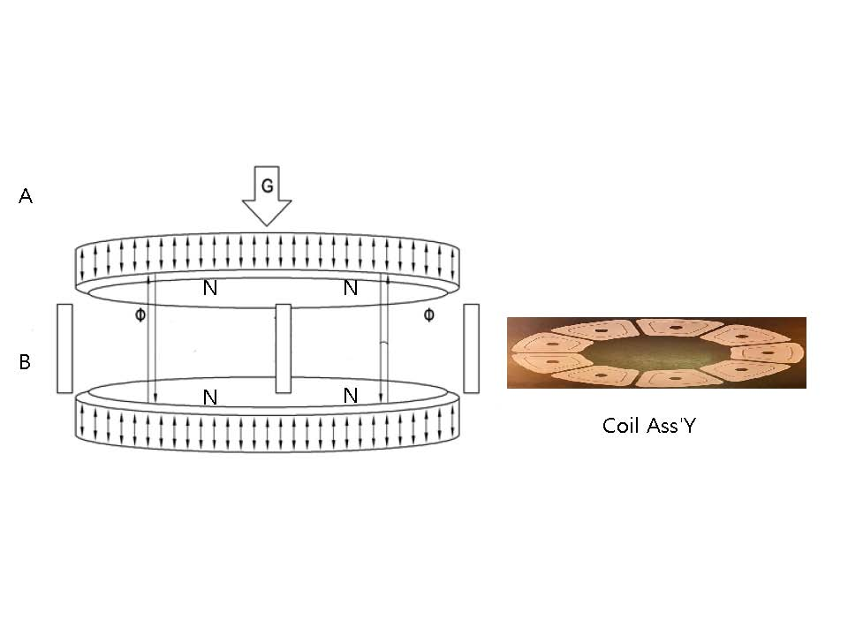
Figure 1. Composition for a balanced arrangement of gravity and magnetic field
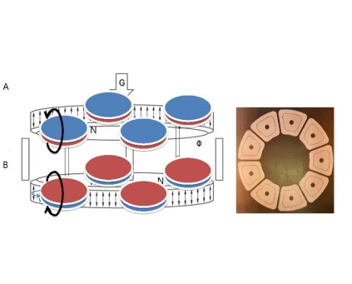 | 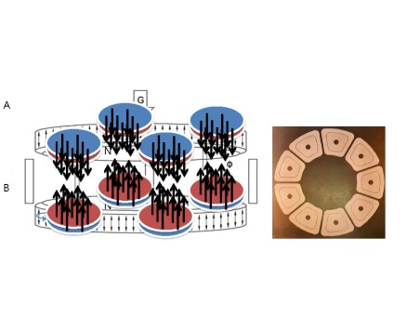 | 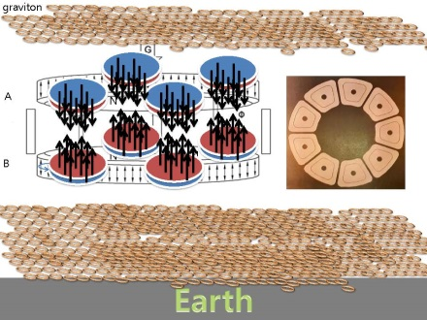
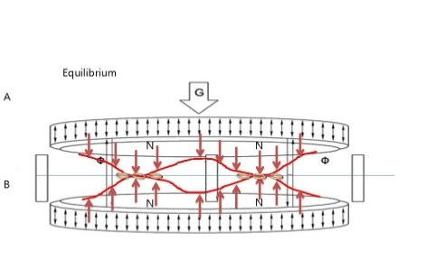 | 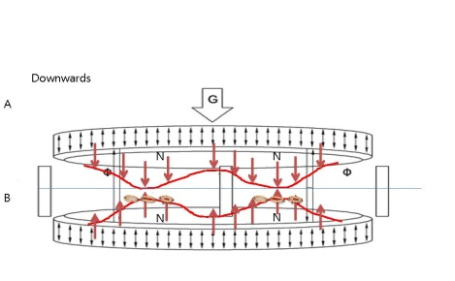 | 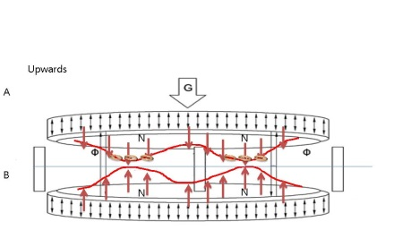
Figure 2. A schematic diagram of gravity that navigates in magnetic sea
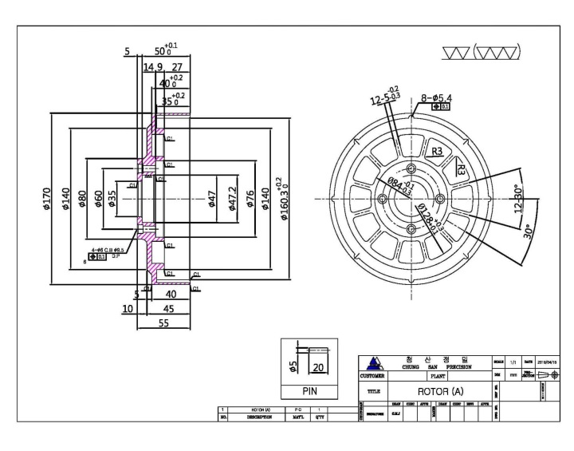
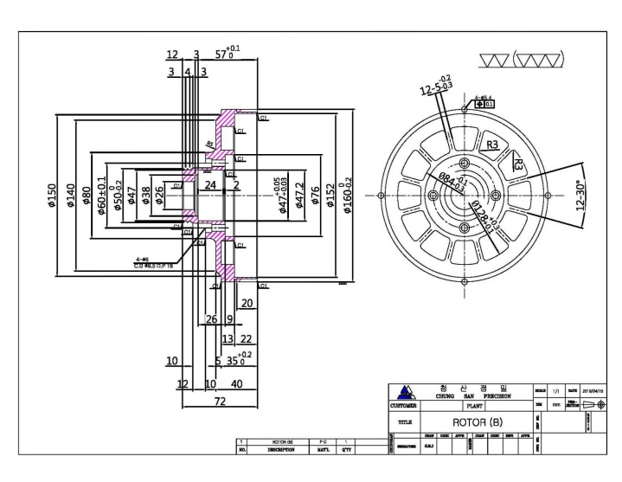
Figure 3. Gravity Generator blueprint
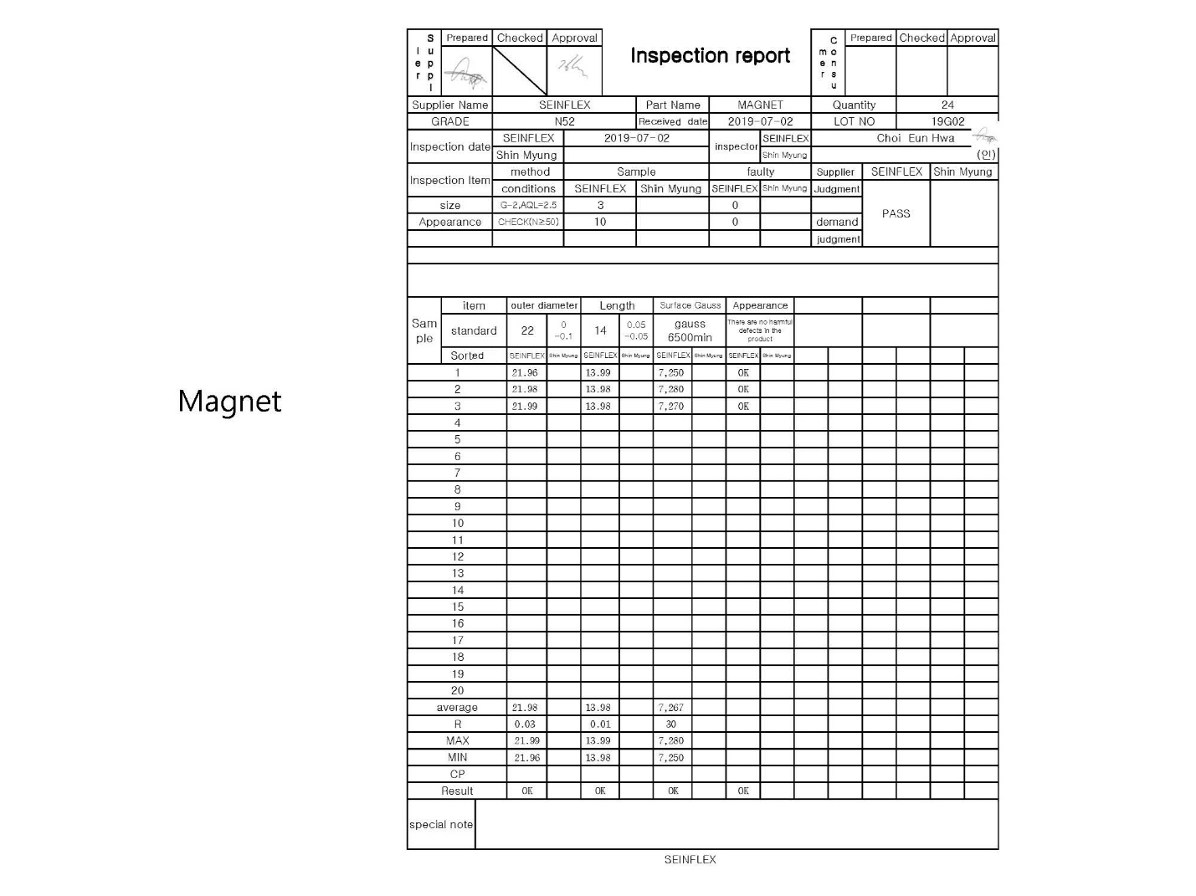
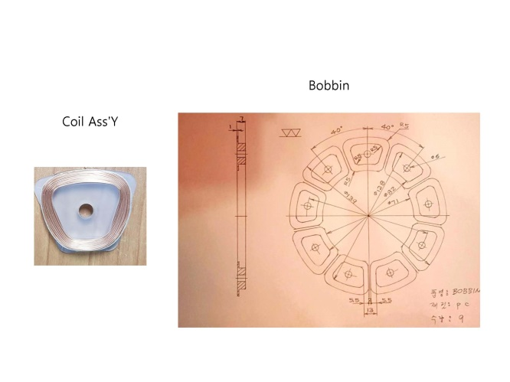
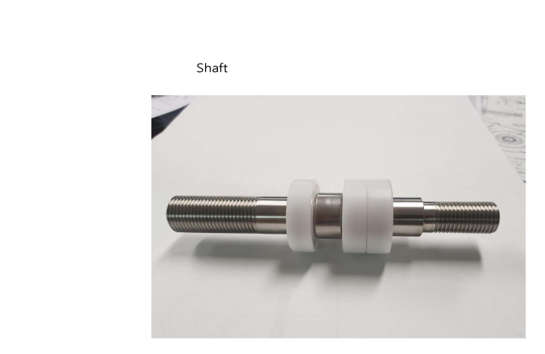
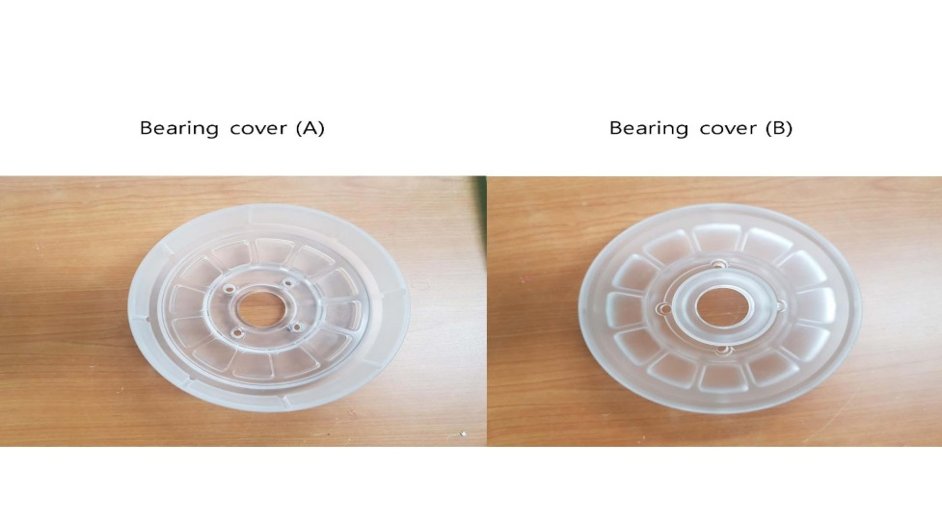
Figure 4. Gravity Generator parts and test operation

Movies S1. 2019.10.04 Discovery of Gravity to Electricity on Gravity Generator
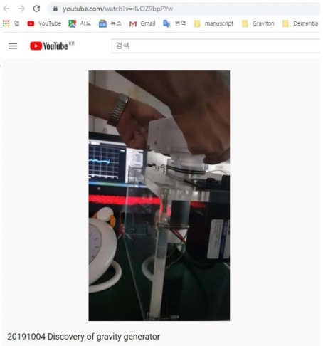
<iframe width="560" height="315" src="https://www.youtube.com/embed/IlvOZ9bpPYw" frameborder="0" allow="accelerometer; autoplay; clipboard-write; encrypted-media; gyroscope; picture-in-picture" allowfullscreen></iframe>

Supplemental Section 2. Keysight B2901A Manual
The GG itself is a device that measures the current and voltage generated by passing a small current in proportion to the resistance of the connected device. Therefore, it was necessary to discriminate whether we were measuring the amount of current generated by the GG or the amount of current generated by gravity. The most effective method is to measure the amount of current generated by the GG with or without air. If there is a difference in the amount of current generated with and without air, the difference in the generated amount is due to gravity.
Figure 5. B2900A Series Manual

Data S1 2019.10.04. Preparations before experimenting with the air and first simulations.
Supplemental Section 2. 20191004_preparation_experiment.zip (Version: 1)
(https://osf.io/ntuda/files/)

Data S2 2020.06.18. Experiments with the gravity generator in the vacuum chamber.
Supplemental Section 2. 20200618_preparation_before_experiment.zip (Version: 1)
(https://osf.io/ntuda/files/)

Supplemental Section 3. Experiments (A, B, C – Table S1)
To apply the weight in the three-dimensional system, dumbbells 1 and 2 were raised in order, and the generator's electricity was measured. Additionally, dumbbell one and dumbbell two were put down in order, and the electricity generated was measured on October 10, 2019. Electricity was measured three times (A, B, C) while the generator rotated and three times (D, E, F) when the generator was stationary. Tables S1 and S2 were rearranged from Tables S1.1 and S2.1 to compare the maximum values. When dumbbell one was placed on the generator while rotating, it generated 745.8 µA (Table S1A2), 883.7 µA (Table S1B2) and 471.4 µA (Table S1C2). When dumbbell two was placed on dumbbell one while the generator was rotating, it generated 1,068.3 µA (Table S1A3), 895.9 µA (Table S1B3) and 2,666.2 µA (Table S1C3).

Table S1. Electricity measured while the generator rotating
 | CH1 Current (A) |  |  | CH1 Voltage (V) |  |  | (0.001 s)
 | Maximum | Minimum | Sum | Maximum | Minimum | Sum
A1  B1  C1 | 0.0004433 | -0.0003803 | -0.0009149 | 0.0000204 | -0.0000172 | -0.0019751 | 10000
 | 0.0005052 | -0.0003646 | 0.0056757 | 0.0000209 | -0.0000189 | 0.0005494 | 10000
 | 0.0004593 | -0.0003969 | 0.033351 | 0.0000198 | -0.0000202 | -0.0034343 | 10000
A2  B2  C2 | 0.0007458 | -0.0016802 | -0.1374131 | 0.0000179 | -0.0000208 | -0.0002372 | 10000
 | 0.0008837 | -0.0021383 | -0.1239456 | 0.0000237 | -0.0000212 | 0.0019692 | 10000
 | 0.0004714 | -0.0012035 | -0.0831234 | 0.0000191 | -0.0000231 | -0.0006971 | 10000
A3  B3  C3 | 0.0010683 | -0.0017568 | -0.1140228 | 0.0000251 | -0.000031 | 0.0017442 | 10000
 | 0.0008959 | -0.0032941 | -0.1080884 | 0.0000406 | -0.0000417 | -0.0024536 | 10000
 | 0.0026662 | -0.0019067 | -0.0950192 | 0.0000236 | -0.0000218 | 0.0001664 | 10000
A4  B4  C4 | 0.0026882 | -0.0011917 | 0.1360524 | 0.0000189 | -0.0000229 | -0.0002788 | 10000
 | 0.0024636 | -0.0011921 | 0.0723971 | 0.000019 | -0.0000214 | -0.0013109 | 10000
 | 0.0029132 | -0.0016932 | 0.118348 | 0.0000194 | -0.0000221 | -0.0022711 | 10000
A5  B5  C5 | 0.0056106 | -0.0047926 | 0.1460264 | 0.0000815 | -0.0000623 | -0.0017428 | 10000
 | The test recorder overwrote the measurement data in the notebook. |  |  |  |  |  | 10000
 | 0.0052364 | -0.0065765 | 0.1328696 | 0.0000721 | -0.0000538 | 0.000513 | 10000
A6  B6  C6 | 0.0004334 | -0.0003605 | 0.0101899 | 0.0000194 | -0.0000186 | -0.0022982 | 10000
 | 0.0004619 | -0.0003687 | -0.0004063 | 0.0000211 | -0.0000182 | 0.0013422 | 10000
 | 0.0004454 | -0.000404 | 0.0400267 | 0.0000224 | -0.0000205 | 0.0011928 | 10000

Table S1-1 Electricity data rearranged while the generator rotating
 | CH1 Current (A) |  |  | CH1 Voltage (V) |  |  | (0.001 s)
 | Maximum | Minimum | Sum | Maximum | Minimum | Sum
A1  A2  A3  A4  A5  A6 | 0.0004433 | -0.0003803 | -0.0009149 | 0.0000204 | -0.0000172 | -0.0019751 | 10000
 | 0.0007458 | -0.0016802 | -0.1374131 | 0.0000179 | -0.0000208 | -0.0002372 | 10000
 | 0.0010683 | -0.0017568 | -0.1140228 | 0.0000251 | -0.000031 | 0.0017442 | 10000
 | 0.0026882 | -0.0011917 | 0.1360524 | 0.0000189 | -0.0000229 | -0.0002788 | 10000
 | 0.0056106 | -0.0047926 | 0.1460264 | 0.0000815 | -0.0000623 | -0.0017428 | 10000
 | 0.0004334 | -0.0003605 | 0.0101899 | 0.0000194 | -0.0000186 | -0.0022982 | 10000
B1  B2  B3  B4  B5  B6 | 0.0005052 | -0.0003646 | 0.0056757 | 0.0000209 | -0.0000189 | 0.0005494 | 10000
 | 0.0008837 | -0.0021383 | -0.1239456 | 0.0000237 | -0.0000212 | 0.0019692 | 10000
 | 0.0008959 | -0.0032941 | -0.1080884 | 0.0000406 | -0.0000417 | -0.0024536 | 10000
 | 0.0024636 | -0.0011921 | 0.0723971 | 0.000019 | -0.0000214 | -0.0013109 | 10000
 | The test recorder overwrote the measurement data in the notebook. |  |  |  |  |  | 10000
 | 0.0004619 | -0.0003687 | -0.0004063 | 0.0000211 | -0.0000182 | 0.0013422 | 10000
C1  C2  C3  C4  C5  C6 | 0.0004593 | -0.0003969 | 0.033351 | 0.0000198 | -0.0000202 | -0.0034343 | 10000
 | 0.0004714 | -0.0012035 | -0.0831234 | 0.0000191 | -0.0000231 | -0.0006971 | 10000
 | 0.0026662 | -0.0019067 | -0.0950192 | 0.0000236 | -0.0000218 | 0.0001664 | 10000
 | 0.0029132 | -0.0016932 | 0.118348 | 0.0000194 | -0.0000221 | -0.0022711 | 10000
 | 0.0052364 | -0.0065765 | 0.1328696 | 0.0000721 | -0.0000538 | 0.000513 | 10000
 | 0.0004454 | -0.000404 | 0.0400267 | 0.0000224 | -0.0000205 | 0.0011928 | 10000

Supplemental Section 4. Experiments (D, E, F – Table 2)
To apply the weight in the system, dumbbells 1 and 2 were raised in order, and the generator's electricity was measured. Additionally, dumbbell one and dumbbell two were put down in order, and the electricity generated was measured on October 10, 2019. When the dumbbell one was placed on while the generator was stationary, it caused 1,041.9 µA (Table S2D2), 1,324.2 µA (Table S2E2), and 482.2 µA (Table S2F2). When dumbbell two was placed on dumbbell one while the generator was stationary, it generated 1,050.6 µA (Table S2D3), 1,018.8 µA (Table S2E3), and 851.7 µA (Table S2F3).

Table S2. Electricity measured while the generator stationary
 | CH1 Current (A) |  |  | CH1 Voltage (V) |  |  | (0.001 s)
 | Maximum | Minimum | Sum | Maximum | Minimum | Sum
D1  E1  F1 | 0.0000047 | -0.000004 | 0.0025892 | 0.0000186 | -0.0000187 | -0.0014627 | 10000
 | 0.0000084 | -0.0000079 | 0.0012128 | 0.0000195 | -0.0000191 | -0.0003436 | 10000
 | 0.0000042 | -0.0000044 | 0.0002018 | 0.0000176 | -0.0000189 | -0.0001177 | 10000
D2  E2  F2 | 0.0010419 | -0.0015249 | -0.1176412 | 0.0000171 | -0.0000197 | -0.003063 | 10000
 | 0.0013242 | -0.002625 | -0.1247941 | 0.0000429 | -0.0000418 | -0.0008347 | 10000
 | 0.0004822 | -0.0015375 | -0.1268739 | 0.0000174 | -0.0000233 | -0.0024814 | 10000
D3  E3  F3 | 0.0010506 | -0.0007511 | -0.0177963 | 0.0000178 | -0.0000204 | -0.001477 | 10000
 | 0.0010188 | -0.0005505 | -0.013439 | 0.0000193 | -0.0000207 | 0.0005212 | 10000
 | 0.0008517 | -0.0004604 | -0.0165925 | 0.0000196 | -0.0000191 | -0.0001067 | 10000
D4  E4  F4 | 0.0004691 | -0.0004882 | 0.0123762 | 0.000017 | -0.0000158 | -0.0009084 | 10000
 | 0.0004207 | -0.0003099 | 0.0131795 | 0.0000188 | -0.0000196 | -0.0018299 | 10000
 | 0.0006965 | -0.0002703 | 0.0236493 | 0.0000186 | -0.0000201 | 0.0014059 | 10000
D5  E5  F5 | 0.0072367 | -0.0075738 | 0.1321999 | 0.0001089 | -0.0000709 | -0.001653 | 10000
 | 0.0049669 | -0.0050688 | 0.1273632 | 0.0000908 | -0.0000666 | 0.0001761 | 10000
 | 0.004052 | -0.0040384 | 0.1180847 | 0.0000597 | -0.0000483 | -0.0016282 | 10000
D6  E6  F6 | 0.0000038 | -0.0000042 | 0.0020211 | 0.000019 | -0.0000218 | 0.0019935 | 10000
 | 0.0000043 | -0.0000044 | 0.0010742 | 0.0000184 | -0.0000191 | 0.0015754 | 10000
 | 0.0000041 | -0.0000042 | 0.0002543 | 0.0000187 | -0.0000202 | 0.0015011 | 10000

Table S2-1. Electricity data rearranged while the generator stationary
 | CH1 Current (A) |  |  | CH1 Voltage (V) |  |  | (0.001 s)
 | Maximum | Minimum | Sum | Maximum | Minimum | Sum
D1  D2  D3  D4  D5  D6 | 0.0000047 | -0.000004 | 0.0025892 | 0.0000186 | -0.0000187 | -0.0014627 | 10000
 | 0.0010419 | -0.0015249 | -0.1176412 | 0.0000171 | -0.0000197 | -0.003063 | 10000
 | 0.0010506 | -0.0007511 | -0.0177963 | 0.0000178 | -0.0000204 | -0.001477 | 10000
 | 0.0004691 | -0.0004882 | 0.0123762 | 0.000017 | -0.0000158 | -0.0009084 | 10000
 | 0.0072367 | -0.0075738 | 0.1321999 | 0.0001089 | -0.0000709 | -0.001653 | 10000
 | 0.0000038 | -0.0000042 | 0.0020211 | 0.000019 | -0.0000218 | 0.0019935 | 10000
E1  E2  E3  E4  E5  E6 | 0.0000084 | -0.0000079 | 0.0012128 | 0.0000195 | -0.0000191 | -0.0003436 | 10000
 | 0.0013242 | -0.002625 | -0.1247941 | 0.0000429 | -0.0000418 | -0.0008347 | 10000
 | 0.0010188 | -0.0005505 | -0.013439 | 0.0000193 | -0.0000207 | 0.0005212 | 10000
 | 0.0004207 | -0.0003099 | 0.0131795 | 0.0000188 | -0.0000196 | -0.0018299 | 10000
 | 0.0049669 | -0.0050688 | 0.1273632 | 0.0000908 | -0.0000666 | 0.0001761 | 10000
 | 0.0000043 | -0.0000044 | 0.0010742 | 0.0000184 | -0.0000191 | 0.0015754 | 10000
F1  F2  F3  F4  F5  F6 | 0.0000042 | -0.0000044 | 0.0002018 | 0.0000176 | -0.0000189 | -0.0001177 | 10000
 | 0.0004822 | -0.0015375 | -0.1268739 | 0.0000174 | -0.0000233 | -0.0024814 | 10000
 | 0.0008517 | -0.0004604 | -0.0165925 | 0.0000196 | -0.0000191 | -0.0001067 | 10000
 | 0.0006965 | -0.0002703 | 0.0236493 | 0.0000186 | -0.0000201 | 0.0014059 | 10000
 | 0.004052 | -0.0040384 | 0.1180847 | 0.0000597 | -0.0000483 | -0.0016282 | 10000
 | 0.0000041 | -0.0000042 | 0.0002543 | 0.0000187 | -0.0000202 | 0.0015011 | 10000

Supplemental Section 5. Experiments (Only Voltage while Rotating)
Experiments were performed to compare the voltages while the generator was rotating and stationary. We used a TDS 2014 four-channel digital storage oscilloscope voltage metre (100 MHz, 1 GS/s). A video was taken because the voltage metre could not save and output the data. We connected the gravity generator to the TDS 2014 in experiments A1 to C6 and measured the voltage in order.
Table S3. Voltage measurement data while Rotating
6.204.8011.010.610.611.09.0011.05.006.6010.48.4011.610.210.68.606.8011.28.609.209.0011.210.48.407.609.0010.67.006.8010.212.610.89.4010.29.2010.07.0011.211.08.408.608.807.8011.49.207.209.007.806.808.809.605.608.8012.09.407.605.6011.08.6011.612.211.611.29.0010.28.209.407.4011.49.6011.46.607.409.409.8010.69.208.2011.89.206.8010.09.008.408.009.009.6010.88.408.809.2012.09.8012.68.409.208.2012.89.208.2010.69.608.206.408.409.4010.814.810.412.011.49.0012.25.8011.211.012.613.09.207.8011.611.08.0013.85.206.6010.29.4011.09.8010.69.6011.010.811.28.008.4010.210.06.207.609.607.609.208.209.209.607.609.608.009.6010.06.6012.010.88.6012.49.805.208.609.8011.810.05.006.606.204.003.003.203.803.203.403.804.003.404.403.204.007.607.6011.610.614.610.412.211.49.8014.413.612.68.8010.27.4013.611.811.013.410.08.408.609.2010.49.607.807.2010.612.48.809.006.805.4010.45.608.009.008.8010.27.0010.29.6010.88.806.0010.28.8010.48.808.2011.67.808.208.8010.47.608.609.0010.89.60 (V) while the generator was rotating.
Movies S2. 2019.10.10 Voltage measurement data while Rotating on Gravity Generator
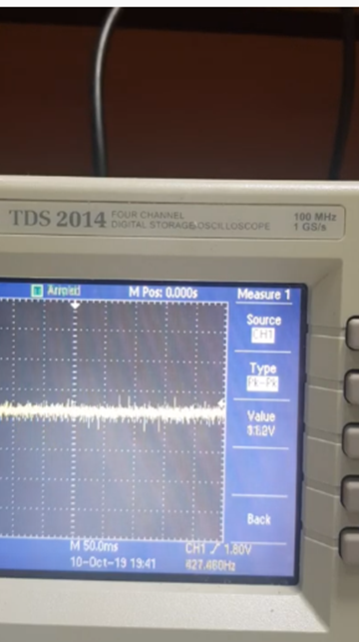
<iframe width="560" height="315" src="https://www.youtube.com/embed/HS6Qbp6i-SU" frameborder="0" allow="accelerometer; autoplay; clipboard-write; encrypted-media; gyroscope; picture-in-picture" allowfullscreen></iframe>

Supplemental Section 6. Experiments (Voltage Only while Stationary)
Experiments were performed to compare the voltages output while the generator was rotating and stationary. We used a TDS 2014 four-channel digital storage oscilloscope voltage metre (100 MHz, 1 GS/s). A video was taken because the voltage metre could not save and output the data. We connected the gravity generator to the TDS 2014 four-channel digital storage oscilloscope (100 MHz, 1 GS/s), and the voltage was measured for experiments D1 to F6.
Table S4. Voltage measurement data while Stationary
3.603.203.403.204.003.603.403.804.005.003.402.803.804.003.404.003.603.404.003.803.404.203.403.803.403.203.404.003.204.203.403.603.003.203.804.203.403.603.404.003.404.003.803.003.804.003.003.203.803.203.403.804.003.404.403.204.007.604.603.604.003.80 (V) while the generator was stationary through the monitor.
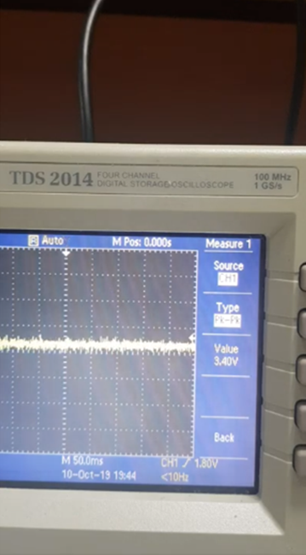
<iframe width="560" height="315" src="https://www.youtube.com/embed/vLRvoBs5924" frameborder="0" allow="accelerometer; autoplay; clipboard-write; encrypted-media; gyroscope; picture-in-picture" allowfullscreen></iframe>

Movies S3. 2019.10.10 Voltage measurement data while stationary on Gravity Generator

Supplemental Section 7. Experiments (Current, Voltage and Time while Stationary in the Vacuum Chamber)
The amounts of electricity generated in the vacuum chamber were measured. The Korea Institute of Civil Engineering and Building Technology (KICT) has operated at the centre of extreme environmental construction technology. The world's largest dusty thermal vacuum chamber (DTVC), a facility simulating the Moon's surface environment, was publicly operated. Nevertheless, other existing vacuum chambers can only be utilised in a complete vacuum state without any impurities. Therefore, this gravity generator (GG) experiment was performed in an absolute vacuum state chamber. In each measurement, the measured currents from 1 to 100000 were all summed. The change in the amount of current generated as the barometric pressure decreased was observed.
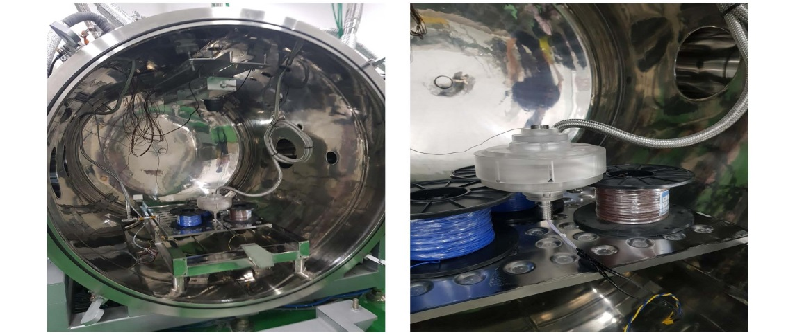
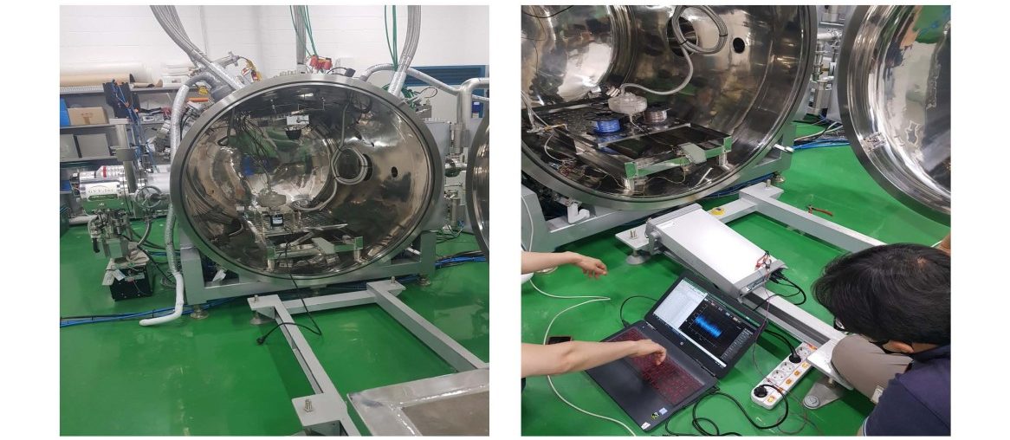
Figure 5. Gravity Generator in the Vacuum Chamber

Data S3 2020.06.18. Vacuum chamber & gravity generator in a vacuum.
Vacuum chamber & GG.zip (Version: 1)
(https://osf.io/ntuda/files/)

Table S5. Voltage measurement in the vacuum chamber
Barometric pressure (mbar) | 1000 | 100 | 10 | 1 | 0.1 | 0.01 | 0.0001
1¹measurement | -5.69E-03 | -5.70E-03 | -5.68E-03 | -5.69E-03 | -5.73E-03 | -5.70E-03 | -5.68E-03
2¹measurement | -5.77E-03 | -5.69E-03 | -6.00E-03 | -5.67E-03 | -5.70E-03 | -5.70E-03 | -5.33E-03
3¹measurement |  | -5.72E-03 | -5.78E-03 | -5.31E-03 | -5.31E-03 | -5.38E-03 | -5.69E-03
4¹Measurement |  |  |  |  |  | -5.74E-03 | -5.66E-03
5¹measurement |  |  |  |  |  | -5.74E-03 | -5.69E-03
6¹measurement |  |  |  |  |  |  | -5.27E-03
7¹measurement |  |  |  |  |  |  | -5.76E-03
8¹measurement |  |  |  |  |  |  | -5.76E-03
9¹measurement |  |  |  |  |  |  | -5.68E-03
10¹  measurement |  |  |  |  |  |  | -5.69E-03
average | -5.73E-03 | -5.70E-03 | -5.82E-03 | -5.56E-03 | -5.58E-03 | -5.65E-03 | -5.62E-03

Supplemental Section 7. DATA
The data were analysed from point 4000 to point 4999, with this interval corresponding to 1 second from the 4th measurement measured in the vacuum chamber. It is a case where the voltage is the same, and the time is different.

