Supplementary material

Materials and methods 28
Data collection overview 28
Population and sample characteristics 29
Vaccine attributes and values 30
Example of a random vaccine profile 31
Psychological variables, measurements 32
Supporting results 34
Supporting figures 34
Average effect of the vaccine context 34
Sensitivity analyses: average attribute effects 35
Effect heterogeneity 37
Supporting regression tables 53
Average attribute effects 53
Attribute effects, by psychological dispositions 54

Materials and methods

Data collection overview

Table S.1. Overview of data collection process (in round 1)
Invitation/reminder | Date
Letter of invitation (E-Boks) | November 27
Reminder 1 (E-Boks) | November 29
Text message | December 1
Telephone | November 30 – December 3

Population and sample characteristics

Table S.2. Population margins, sample margins, and weighted-sample margins
 | Sample | Weighted sample | Population
Education
Low | 40 % | 45 % | 45 %
High | 60 % | 55 % | 55 %
Sex x age
Female 18-34 years | 10 % | 13 % | 13 %
Female 35-50 years | 13 % | 12 % | 12 %
Female 51-65 years | 18 % | 12 % | 12 %
Female 65+ years | 13 % | 13 % | 13 %
Male 18-34 years | 8 % | 14 % | 14 %
Male 35-50 years | 11 % | 12 % | 12 %
Male 51-65 years | 14 % | 12 % | 12 %
Male 65+ years | 13 % | 11 % | 11 %
Region
Capitol | 32 % | 32 % | 32 %
Midtjylland | 22 % | 23 % | 23 %
Nordjylland | 10 % | 10 % | 10 %
Sjælland | 15 % | 14 % | 14 %
Syddanmark | 21 % | 21 % | 21 %

Vaccine attributes and values

Table S.3. Overview of attributes and values
Attributes | Values
Probability that the vaccine protects you against COVID-19 | - 50 %  - 70 %  - 90 %
Risk of serious side-effects, e.g., allergic reaction with swelling and breathlessness | - 1 in 1,000  - 1 in 10,000  - 1 in 100,000
Number of Danes who have already been vaccinated | - 10,000  - 100,000  - 1,000,000
For how long has the vaccine been tested | - 3 months  - 6 months  - 12 months
Country of production | - Denmark  - United Kingdom  - United States of America
Recommended by | - Health authorities  - Own doctor  - The government  - Researcher
Where can you get vaccinated | - A place nearby [regional hospital]  - With your own doctor  - At the pharmacy
When during the day can you get vaccinated | - Weekdays between 6 and 22  - Weekdays between 9 and 16  - Weekdays and weekends between 9 and 16
Appointment | - Health authorities assigns you an appointment  - You show up without having an appointment  - You need to make an appointment

Example of a random vaccine profile

Figure S.1. Random vaccine profile
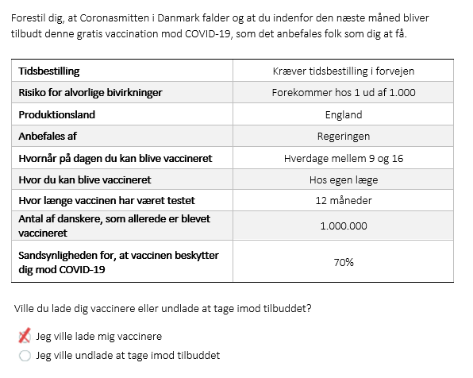
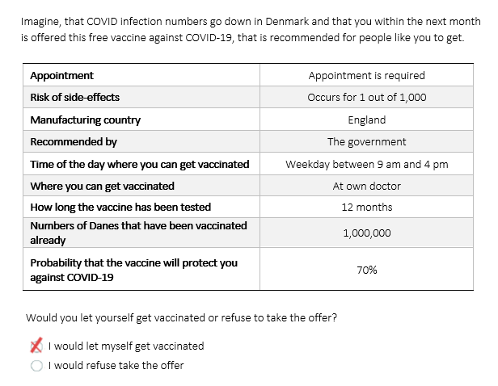

Psychological variables, measurements

Table S.4. Measurement of psychological variables
Concept | Question wordings | Values
Institutional trust | - On a scale from 0 to 10, where 10 is full trust, how much do you personally trust the Danish authorities? | 0 – No trust at all in the authorities  1  2  3  4  5  6  7  8  9  10 – full trust in the authorities
Covid worry | - I am very worried about being infected with COVID-19? | 1 – Completely disagree  2  3  4 – Neither agree nor disagree  5  6  7 – Completely agree
Vaccine motivation  An exploratory PCA shows that the items clearly load on one component. The eigenvalue for the first component is thus 2.85 while the eigenvalue for the second component is .52.  Similarly, there is a high alpha of .86. | - I believe that a vaccine can stop the spread of COVID-19 in Denmark  - Even if you have already been infected, it is still necessary to be vaccinated against COVID-19  - Even if most others are vaccinated against COVID-19, it is still important that I am also vaccinated  - I feel that it is my duty towards the Danish society that I get vaccinated against COVID-19 | 1 – Completely disagree  2  3  4 – Neither agree nor disagree  5  6  7 – Completely agree
Vaccine worry  There is a pearson’s r correlation between the two items of .77. | - I am worried that a vaccine against COVID-19 will have serious side-effects that are yet unknown, when the vaccine is rolled out  - I am very worried that there has been too short time for developing and testing vaccines against COVID-19 | 1 – Completely disagree  2  3  4 – Neither agree nor disagree  5  6  7 – Completely agree

Supporting results

Supporting figures

Average effect of the vaccine context

Figure S.2. Probability of vaccine acceptance across epidemic contexts
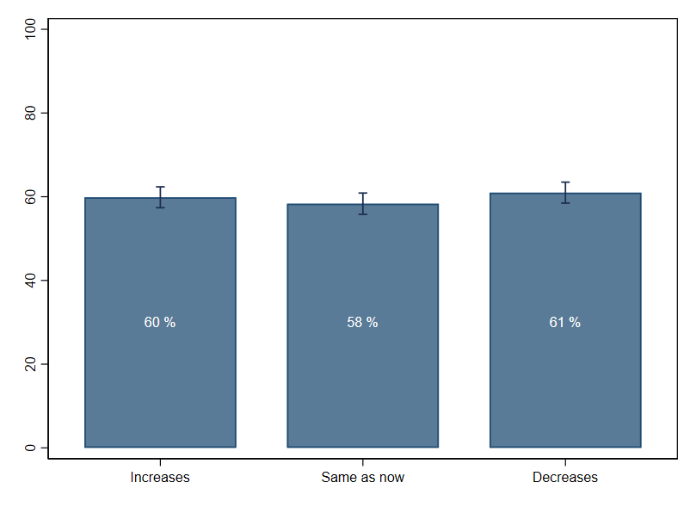 Note: predicted acceptance rates with cluster-robust 95% CI from linear (weighted) least square regression.

Sensitivity analyses: average attribute effects

Figure S.3. Average attribute effects, including covariates
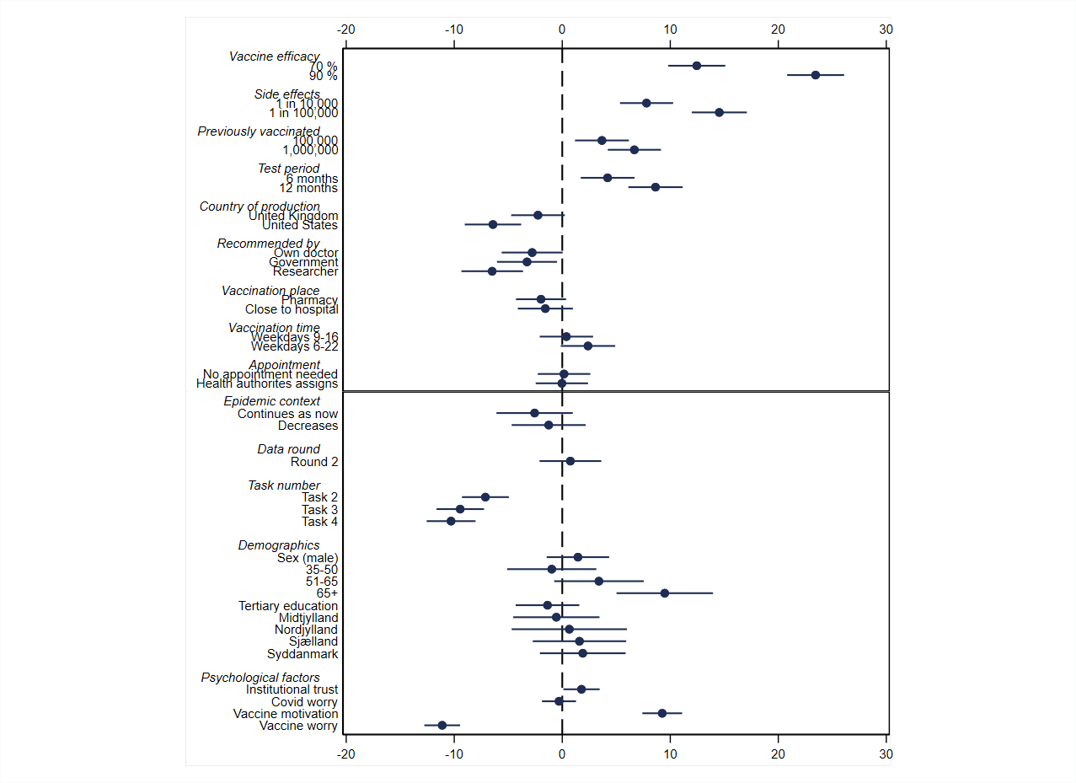
Note: filled circles with horizontal lines indicate point estimates with cluster-robust 95% CI from linear (weighted) least square regression). Upper panel displays the attribute effects. Lower panel displays the correlations between vaccine acceptance and the covariates. For the psychological factors that are continuous variables, the estimated coefficients correspond to a one standard deviation change in each psychological variable.

Figure S.4. Average attribute effects, no post-stratification weights
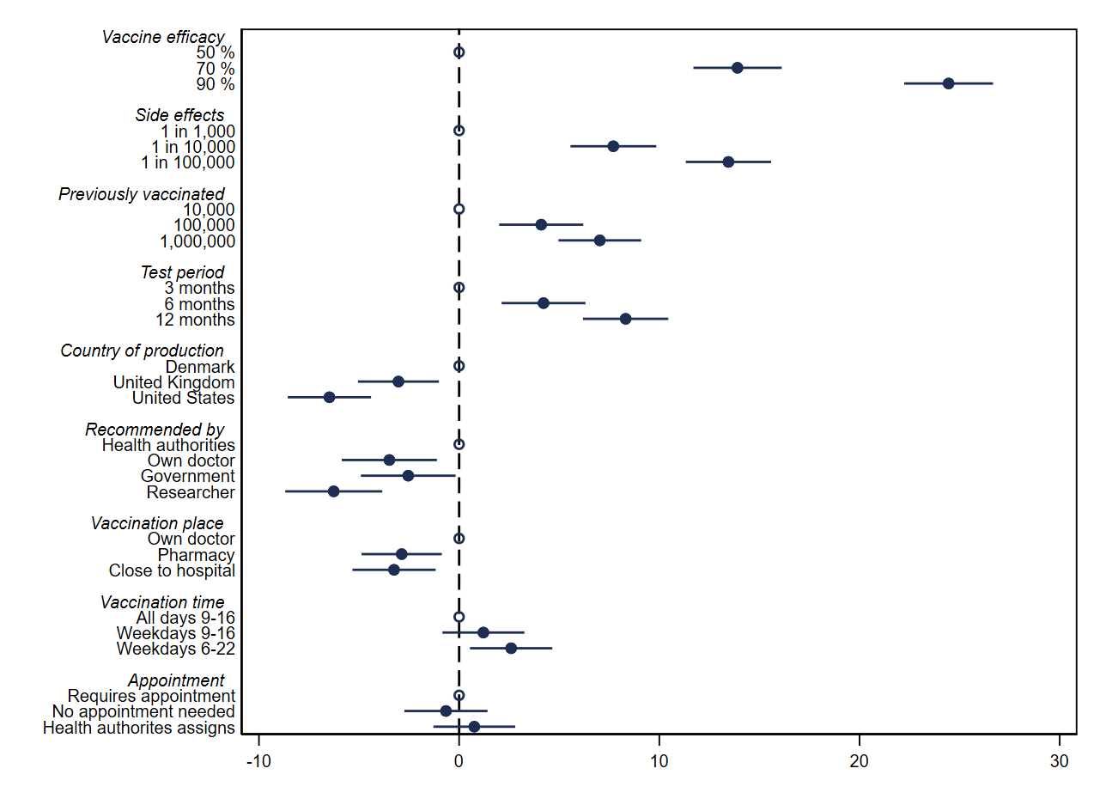
Note: filled circles with horizontal lines indicate point estimates with cluster-robust 95% CI from linear least square regression). No post-stratification weights applied

Effect heterogeneity

More fine-grained interaction analyses

Figure S.5. Effects of vaccine attributes across institutional trust subgroups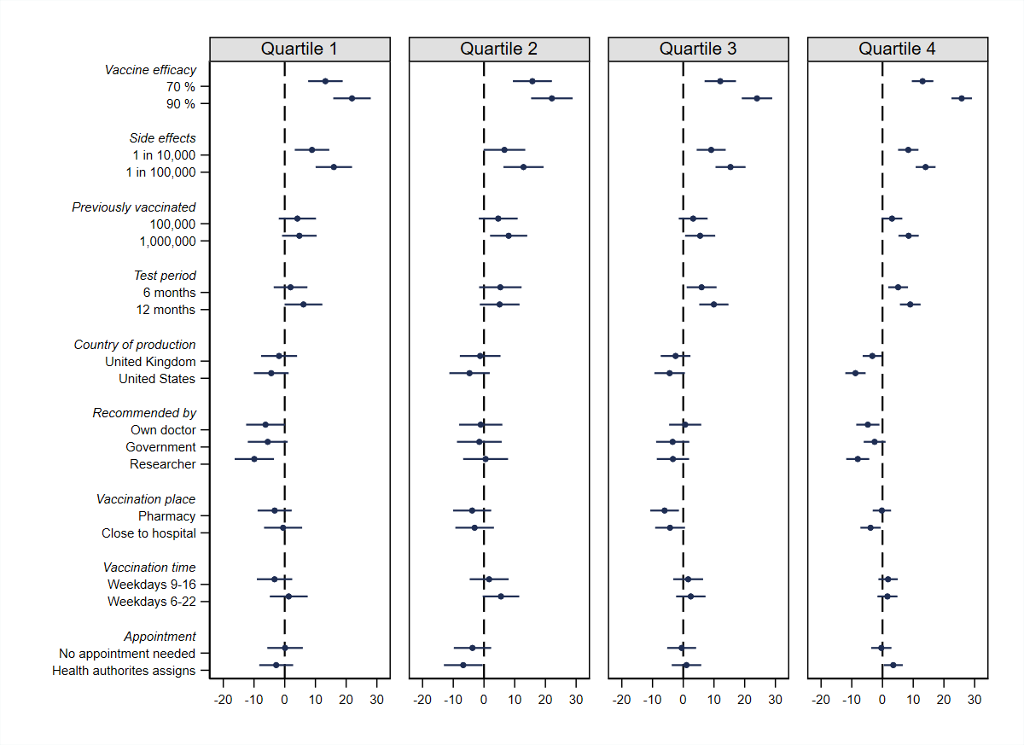
Note: filled circles with horizontal lines indicate point estimates with cluster-robust 95% CI from linear (weighted) least square regression).

Figure S.6. Effects of vaccine attributes across personal COVID worry subgroups
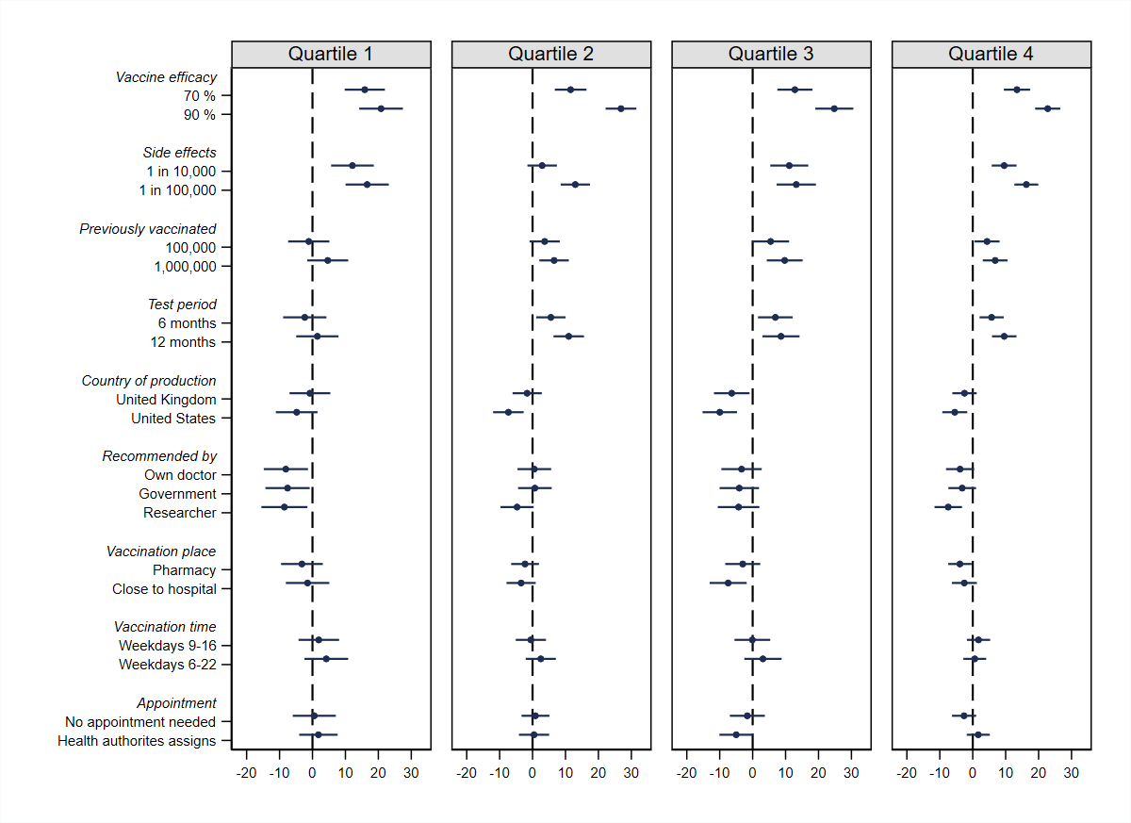
Note: filled circles with horizontal lines indicate point estimates with cluster-robust 95% CI from linear (weighted) least square regression).

Figure S.7. Effects of vaccine attributes across vaccine trust subgroups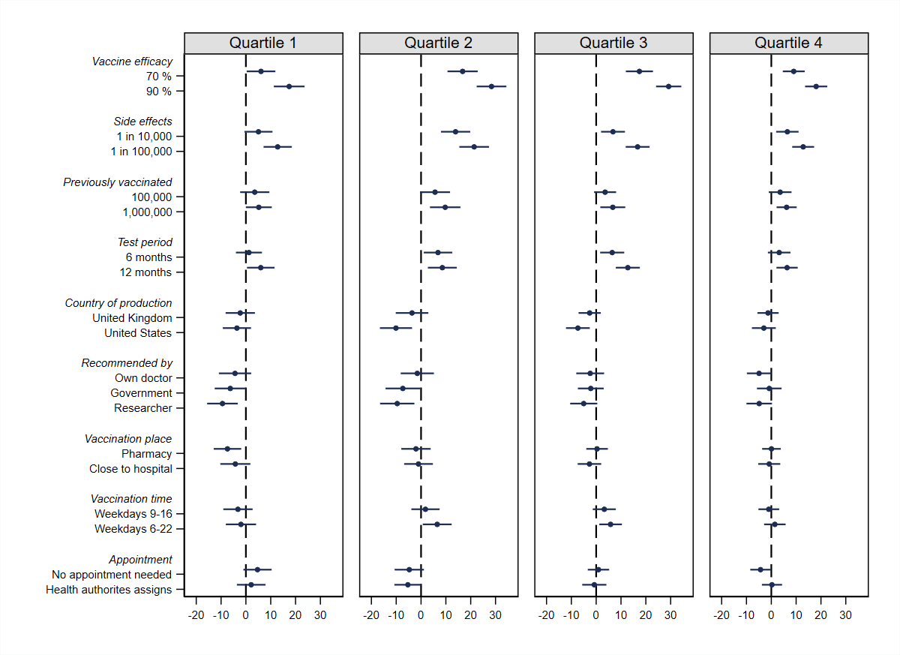
Note: filled circles with horizontal lines indicate point estimates with cluster-robust 95% CI from linear (weighted) least square regression).

Figure S.8. Effects of vaccine attributes across vaccine worry subgroups
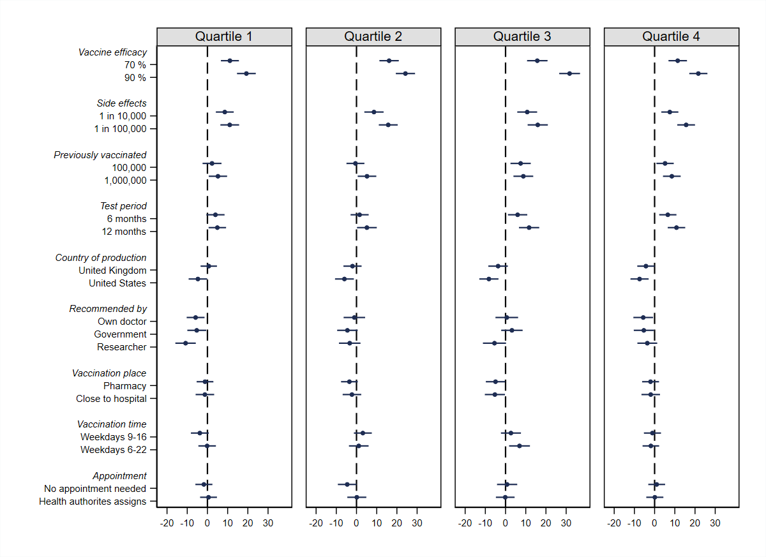
Note: filled circles with horizontal lines indicate point estimates with cluster-robust 95% CI from linear (weighted) least square regression).

Heterogeneity across demographic subgroups

Figure S.9. Effects of vaccine attributes on the probability of vaccine acceptance, by sex, age, and education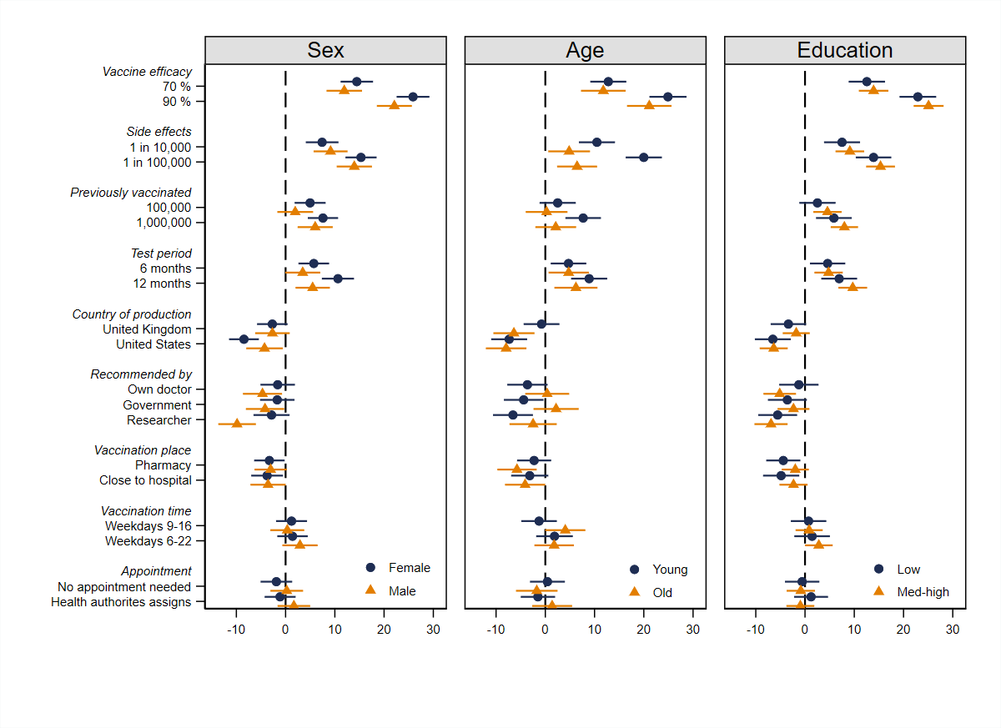
Note: filled circles and triangles with horizontal lines indicate point estimates with cluster-robust 95% CI from linear (weighted) least square regression).

Figure S.10. Effects of vaccine attributes on the probability of vaccine acceptance across regions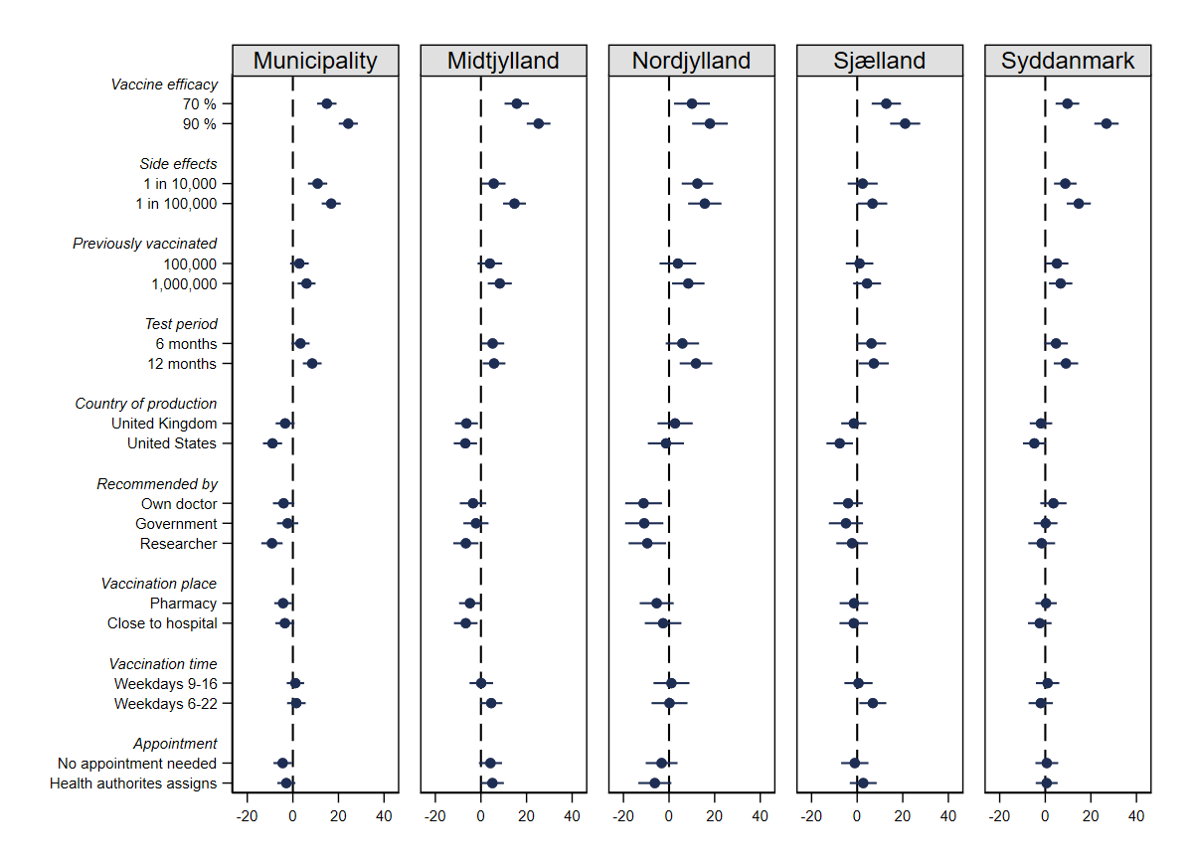
Note: filled circles with horizontal lines indicate point estimates with cluster-robust 95% CI from linear (weighted) least square regression).

Heterogeneity across epidemic contexts

Figure S.11. Effects of vaccine attributes on the probability of vaccine acceptance across varying epidemic contexts
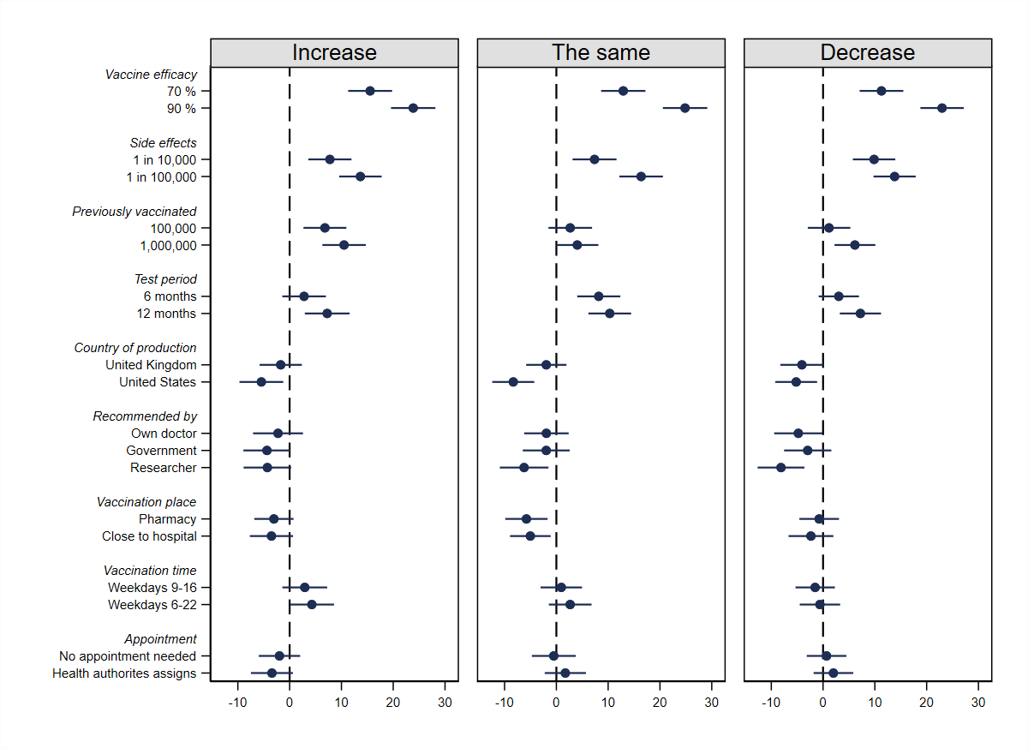
Note: filled circles with horizontal lines indicate point estimates with cluster-robust 95% CI from linear (weighted) least square regression). We varied whether the individual was told to imagine that the epidemic increased, stayed the same, or decreased over the next month and can hence split the sample accordingly.

Interaction between attributes across

Figure S.12. Effects of vaccine attributes on the probability of vaccine acceptance across varying levels of vaccine efficacy
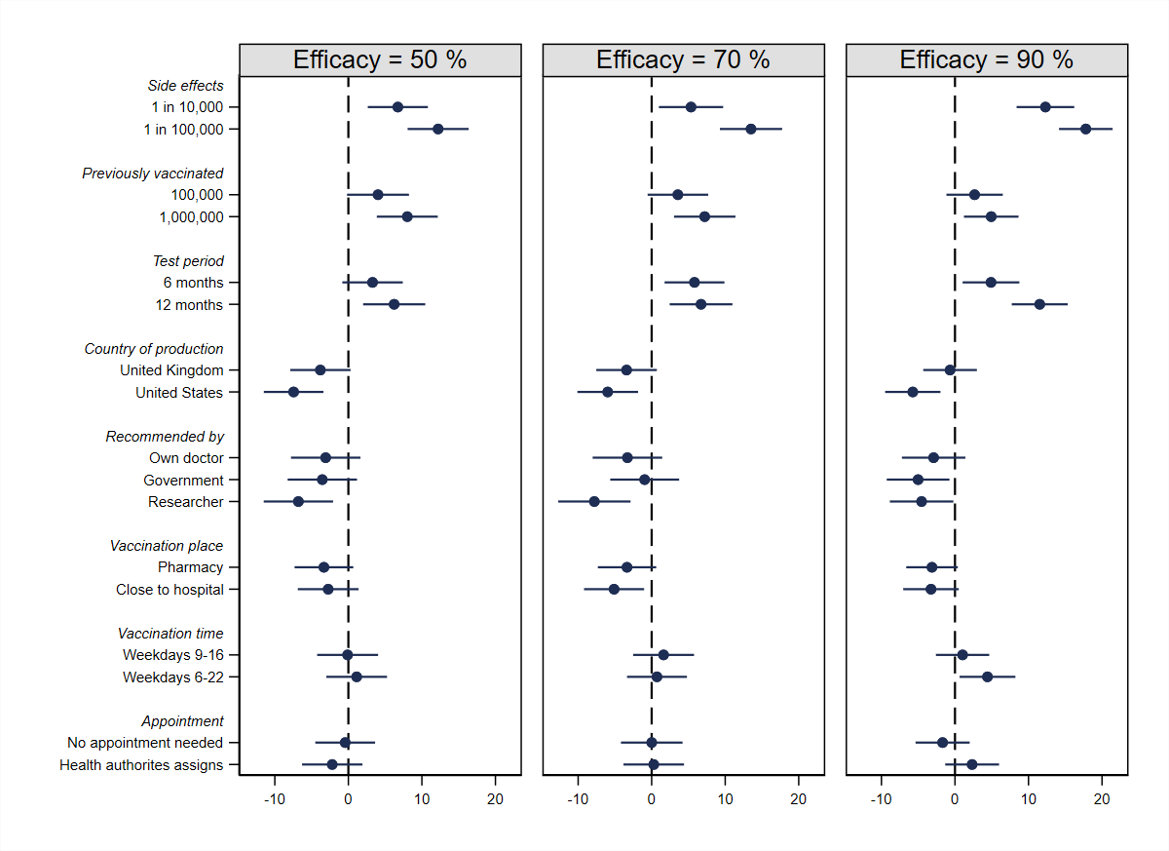
Note: filled circles with horizontal lines indicate point estimates with cluster-robust 95% CI from linear (weighted) least square regression).

Figure S.13. Effects of vaccine attributes on the probability of vaccine acceptance across varying levels of expected side-effects
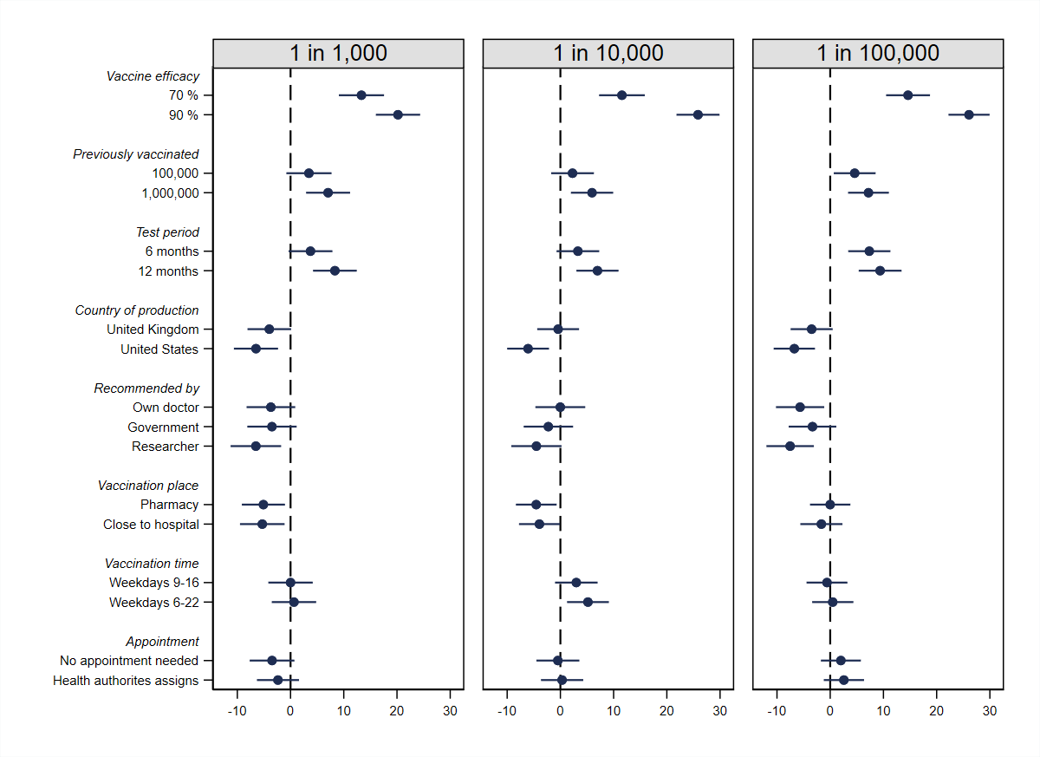
Note: filled circles with horizontal lines indicate point estimates with cluster-robust 95% CI from linear (weighted) least square regression).

Figure S.14. Effects of vaccine attributes on the probability of vaccine acceptance across varying numbers of previously vaccinated
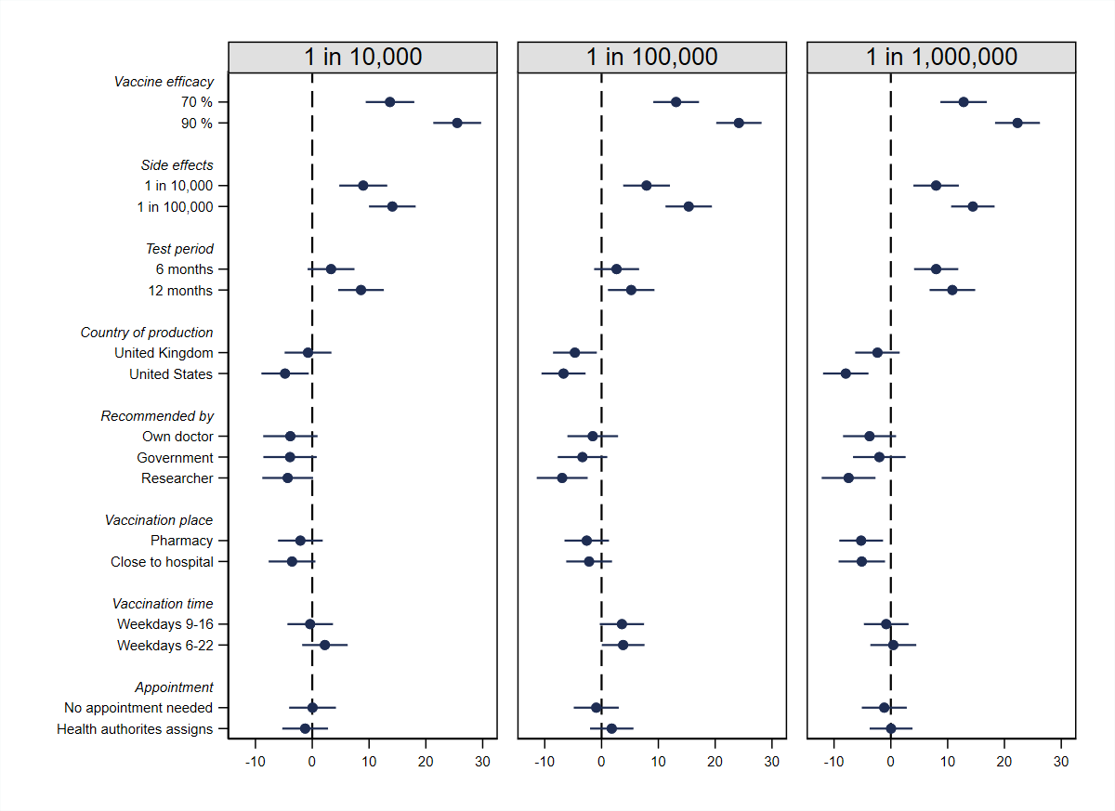
Note: filled circles with horizontal lines indicate point estimates with cluster-robust 95% CI from linear (weighted) least square regression).

Figure S.15. Effects of vaccine attributes on the probability of vaccine acceptance across varying test periods
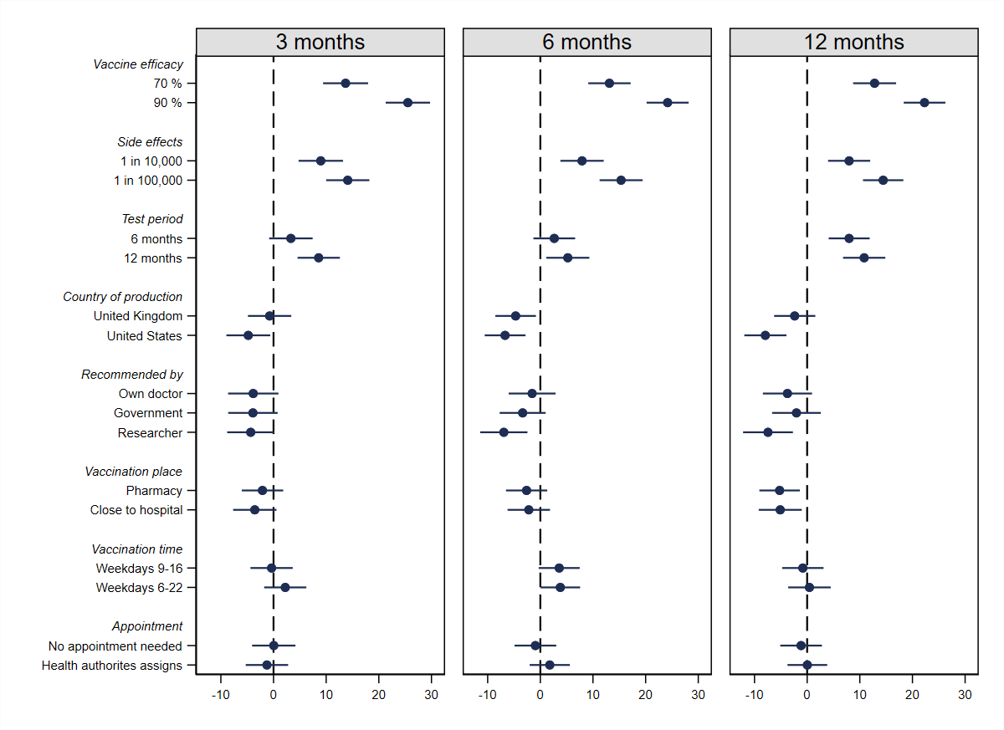
Note: filled circles with horizontal lines indicate point estimates with cluster-robust 95% CI from linear (weighted) least square regression).

Figure S.16. Effects of vaccine attributes on the probability of vaccine acceptance across production countries
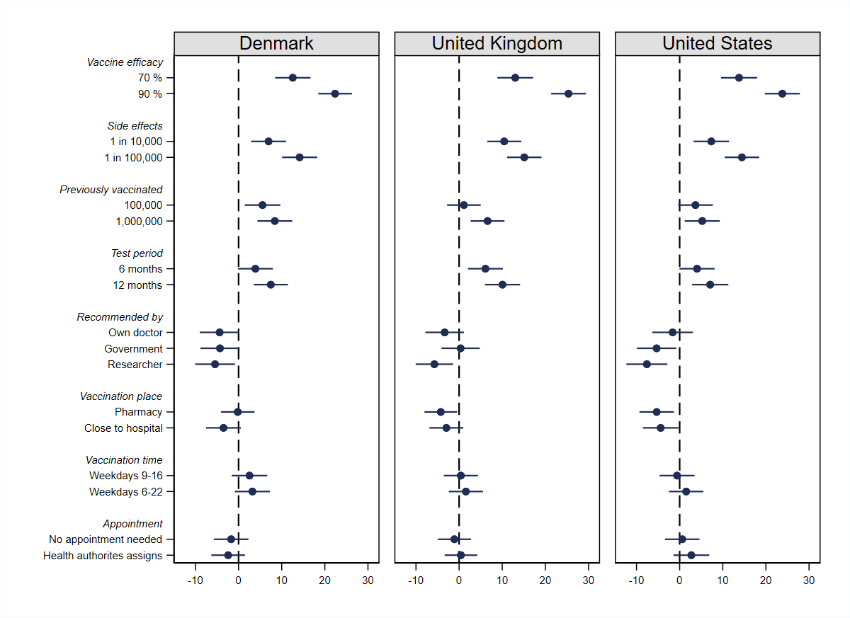
Note: filled circles with horizontal lines indicate point estimates with cluster-robust 95% CI from linear (weighted) least square regression).

Figure S.17. Effects of vaccine attributes on the probability of vaccine acceptance across recommendations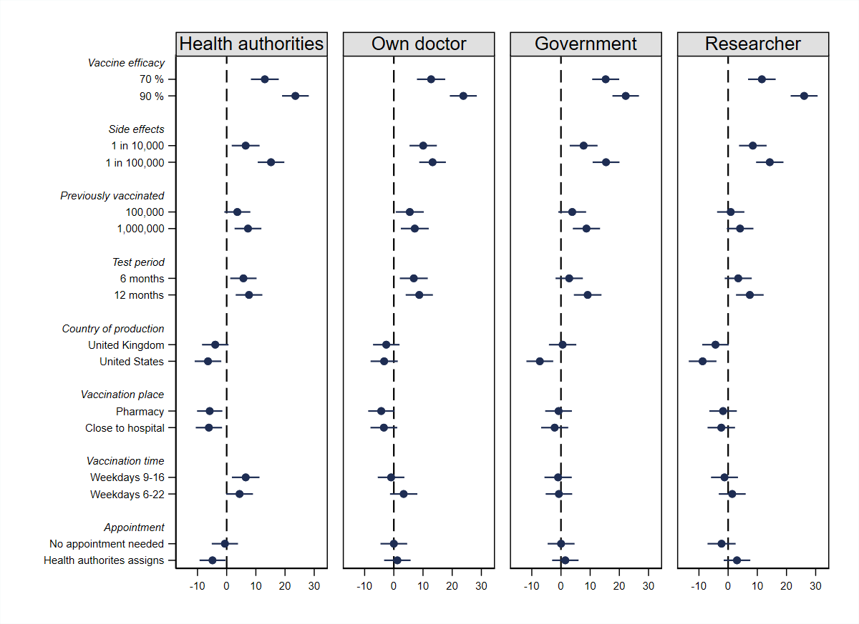
Note: filled circles with horizontal lines indicate point estimates with cluster-robust 95% CI from linear (weighted) least square regression).

Figure S.18. Effects of vaccine attributes on the probability of vaccine acceptance across varying vaccination places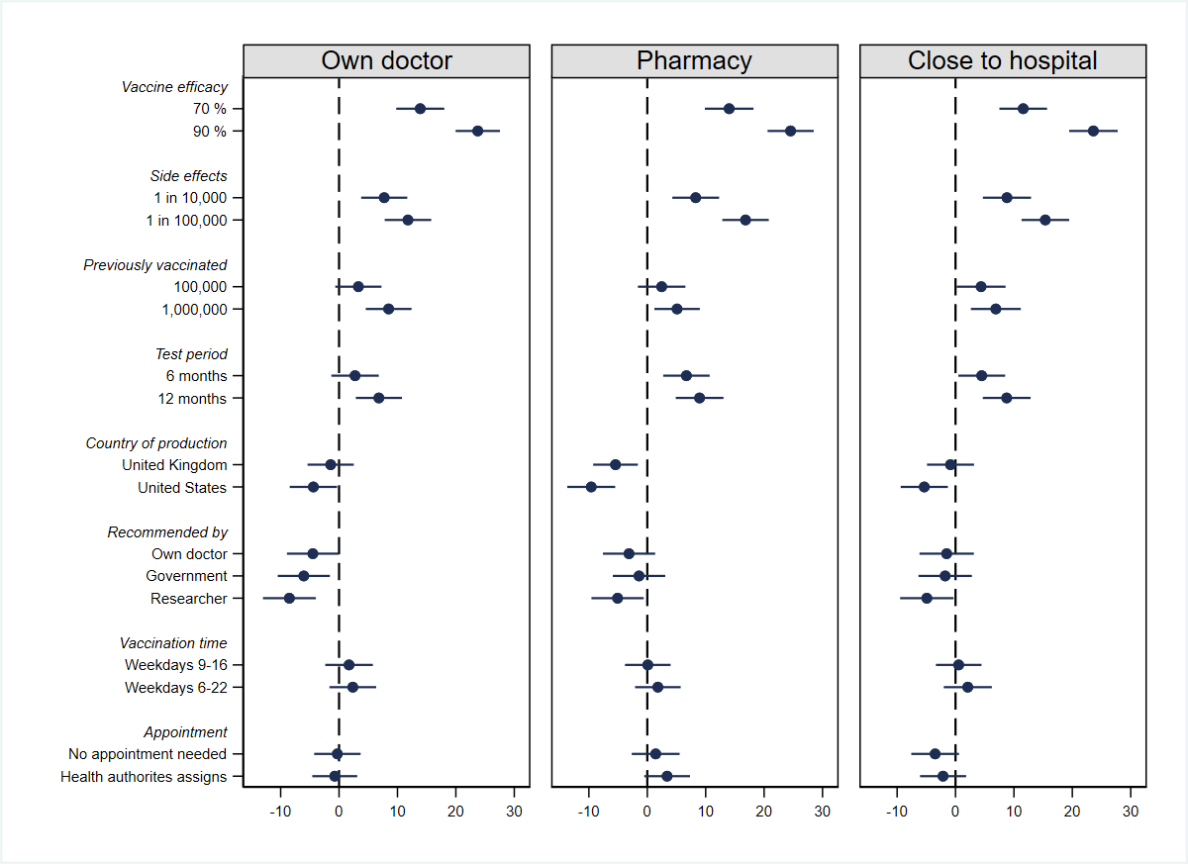
Note: filled circles with horizontal lines indicate point estimates with cluster-robust 95% CI from linear (weighted) least square regression).

Figure S.19. Effects of vaccine attributes on the probability of vaccine acceptance across varying vaccination times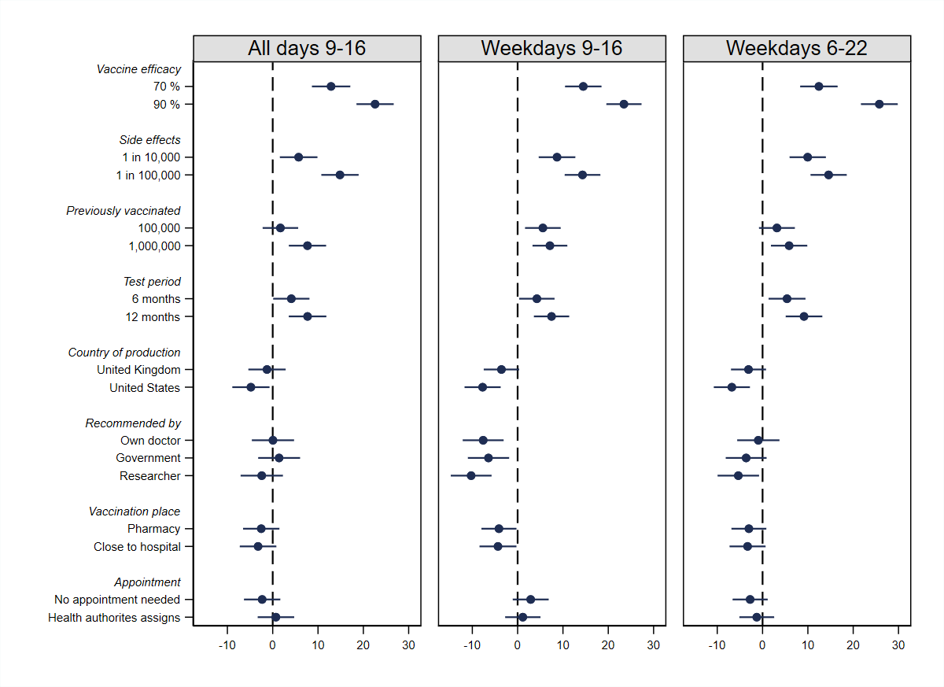
Note: filled circles with horizontal lines indicate point estimates with cluster-robust 95% CI from linear (weighted) least square regression).

Figure S.20. Effects of vaccine attributes on the probability of vaccine acceptance across varying appointment schemes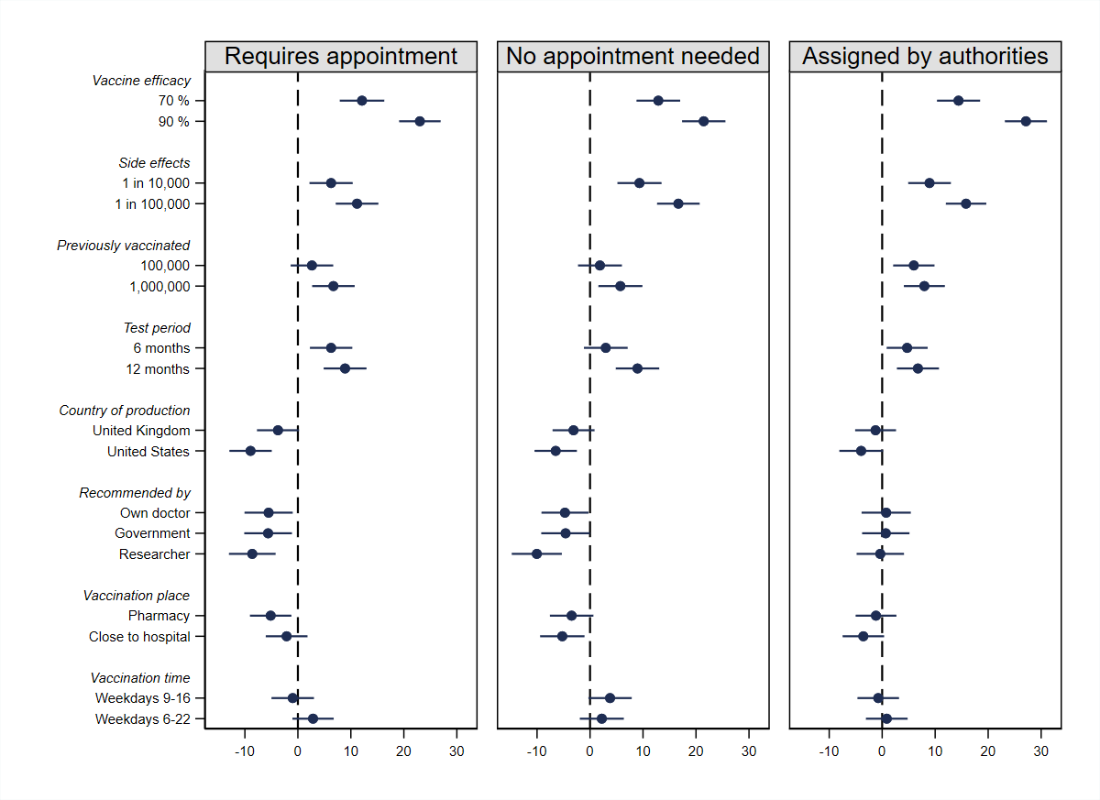
Note: filled circles with horizontal lines indicate point estimates with cluster-robust 95% CI from linear (weighted) least square regression).

Supporting regression tables

Average attribute effects
Table S.5. Effects of vaccine attributes on the probability of vaccine acceptance
Vaccine efficacy
70 % | 13.19***
 | (1.25)
90 % | 23.95***
 | (1.25)
Side effects
1 in 10,000 | 8.21***
 | (1.22)
1 in 100,000 | 14.57***
 | (1.22)
Previously vaccinated
100,000 | 3.46**
 | (1.22)
1,000,000 | 6.80***
 | (1.20)
Test period
6 months | 4.66***
 | (1.20)
12 months | 8.18***
 | (1.22)
Production country
United Kingdom | -2.65*
 | (1.19)
United States | -6.45***
 | (1.21)
Recommended by
Own doctor | -3.04*
 | (1.36)
Government | -3.03*
 | (1.34)
Researcher | -6.14***
 | (1.36)
Vaccination place
Pharmacy | -3.22**
 | (1.15)
Close to hospital | -3.64**
 | (1.23)
Vaccination time
Weekdays 9-16 | 0.75
 | (1.19)
Weekdays 6-22 | 2.09
 | (1.20)
Appointment
No appointment needed | -0.69
 | (1.19)
Health authorites assigns | 0.20
 | (1.16)
Intercept | 39.71***
 | (2.35)
Observations | 12,395
R² | 0.068
Adjusted R² | 0.067
* p < 0.05, ** p < 0.01, *** p < 0.001.

Attribute effects, by psychological dispositions

Table S.6. Vaccine attribute effects, by psychological dispositions

 | Institutional trust |  | Covid worry |  | Vaccine motivations |  | Vaccine worry
 | Below median | Above median | Below median | Above median | Below median | Above median | Below median | Above median
Efficacy
70 % | 13.48*** | 13.05*** | 13.04*** | 13.35*** | 12.02*** | 12.10*** | 13.42*** | 12.60***
 | (1.68) | (1.79) | (1.94) | (1.63) | (1.98) | (1.92) | (1.61) | (1.85)
90 % | 22.58*** | 25.78*** | 24.84*** | 23.41*** | 23.83*** | 22.06*** | 22.68*** | 25.08***
 | (1.73) | (1.70) | (1.95) | (1.63) | (2.02) | (1.89) | (1.61) | (1.90)
Side effects
1 in 10,000 | 8.27*** | 8.39*** | 5.92** | 10.09*** | 8.99*** | 6.75*** | 9.03*** | 8.20***
 | (1.66) | (1.69) | (1.89) | (1.61) | (1.94) | (1.86) | (1.57) | (1.80)
1 in 100,000 | 14.82*** | 14.03*** | 14.17*** | 15.24*** | 16.65*** | 14.27*** | 14.61*** | 14.90***
 | (1.68) | (1.65) | (1.89) | (1.60) | (1.93) | (1.80) | (1.59) | (1.82)
Previously vaccinated
100,000 | 3.92* | 3.09 | 1.89 | 4.73** | 4.84* | 3.98* | 1.34 | 6.56***
 | (1.66) | (1.71) | (1.91) | (1.60) | (1.99) | (1.80) | (1.59) | (1.79)
1,000,000
 | 5.50*** | 8.50*** | 5.83** | 7.80*** | 7.79*** | 6.45*** | 5.52*** | 8.88***
Test period | (1.63) | (1.68) | (1.86) | (1.57) | (1.95) | (1.72) | (1.55) | (1.78)
6 months
 | 4.30** | 5.08** | 2.99 | 6.17*** | 4.61* | 3.79* | 3.56* | 6.52***
12 months | (1.65) | (1.64) | (1.90) | (1.54) | (1.89) | (1.84) | (1.54) | (1.80)
 | 7.28*** | 9.03*** | 7.66*** | 9.29*** | 9.91*** | 7.27*** | 6.03*** | 12.08***
Production country | (1.69) | (1.71) | (1.91) | (1.58) | (1.95) | (1.78) | (1.56) | (1.85)
United Kingdom
 | -2.14 | -3.31* | -1.29 | -3.67* | -3.81 | -1.41 | -2.40 | -2.86
United States | (1.66) | (1.60) | (1.85) | (1.56) | (2.01) | (1.68) | (1.49) | (1.78)
 | -4.65** | -8.80*** | -6.04** | -6.84*** | -6.59*** | -5.37** | -6.30*** | -6.40***
Recommended by | (1.67) | (1.68) | (1.91) | (1.57) | (1.98) | (1.92) | (1.56) | (1.83)
Own doctor
 | -2.55 | -4.77* | -2.47 | -3.48 | -3.00 | -4.21* | -3.31 | -3.38
 | (1.83) | (1.92) | (2.09) | (1.79) | (2.22) | (2.05) | (1.70) | (2.08)
Government | -3.90* | -2.56 | -2.21 | -3.37 | -6.21** | -1.87 | -3.74* | -2.30
 | (1.85) | (1.82) | (2.09) | (1.75) | (2.17) | (2.00) | (1.69) | (2.04)
Researcher | -5.09** | -8.06*** | -6.12** | -6.34*** | -8.58*** | -5.25* | -6.56*** | -4.43*
 | (1.84) | (1.91) | (2.10) | (1.78) | (2.19) | (2.05) | (1.78) | (2.02)
Vaccination place
Pharmacy | -5.17** | -0.20 | -2.72 | -3.46* | -4.11* | 0.08 | -2.69 | -3.36
 | (1.59) | (1.52) | (1.80) | (1.50) | (1.92) | (1.58) | (1.43) | (1.78)
Close to hospital | -3.08 | -3.89* | -3.13 | -3.96* | -3.21 | -1.52 | -1.78 | -3.27
 | (1.70) | (1.69) | (1.89) | (1.61) | (2.02) | (1.85) | (1.58) | (1.87)
Vaccination time
Weekdays 9-16 | -0.23 | 1.82 | 0.17 | 1.12 | 0.21 | -0.51 | -0.69 | 0.61
 | (1.65) | (1.61) | (1.89) | (1.51) | (1.92) | (1.73) | (1.53) | (1.78)
Weekdays 6-22 | 2.94 | 1.61 | 2.77 | 1.44 | 1.95 | 2.67 | 1.28 | 0.78
 | (1.66) | (1.66) | (1.94) | (1.51) | (1.98) | (1.73) | (1.59) | (1.77)
Appointment
No appointment needed | -0.95 | -0.39 | 0.87 | -2.28 | 0.93 | -1.60 | -2.39 | 0.59
 | (1.61) | (1.68) | (1.83) | (1.54) | (1.92) | (1.66) | (1.51) | (1.79)
Health authorites assigns | -1.95 | 3.51* | 1.11 | -0.50 | -0.46 | -0.24 | 0.47 | 0.27
 | (1.62) | (1.57) | (1.84) | (1.49) | (1.90) | (1.77) | (1.52) | (1.75)
Intercept | 35.39*** | 45.90*** | 37.63*** | 41.06*** | 31.92*** | 53.11*** | 55.48*** | 19.96***
 | (3.24) | (3.22) | (3.65) | (3.07) | (3.58) | (3.68) | (3.03) | (3.41)
Observations | 6903 | 5492 | 5316 | 6975 | 4980 | 4451 | 6184 | 5415
R² | 0.060 | 0.092 | 0.067 | 0.074 | 0.076 | 0.073 | 0.075 | 0.077
Adjusted R² | 0.057 | 0.089 | 0.064 | 0.071 | 0.073 | 0.069 | 0.073 | 0.074
* p < 0.05, ** p < 0.01, *** p < 0.001

