Table S1 The sample size and collection phase of industrial wastewater
Industrial Category | CMP* | BPCB1 | EP1 | BPCB2 | FM | FT | MST | EP2 | DS | BPCB1m | EP1m | BPCB2m
Collection Phase | II | I, II | I, II | I, II | I, II | I, II | I | II | II | I, II | I, II | I, II
Sample size | 1 | 2 | 2 | 2 | 2 | 2 | 1 | 1 | 1 | 2 | 2 | 2

*CMP = chemical materials and products; BPCB = bare printed circuit boards; EP = electroplating products; FM = food manufacturing; FT = finishing of textiles; MST = metal surface treatment; DS = domestic sewage. Three manufacturing unit collected from BPCP1, EP1 and BPCP2 are with “m” in front of the category.

Table S2 Mean concentrations, standard deviation, MDL and BDL of 52 elements in the river water samples
Species | Mean | Std | MDL* | BDL | Species | Mean | Std | MDL | BDL
 | (μg L⁻¹) | (μg L⁻¹) | (μg L⁻¹) | (%) |  | (μg L⁻¹) | (μg L⁻¹) | (μg L⁻¹) | (%)
Silver | 0.59 | 1.00 | 0.03 | 1.67 | Niobium | 0.10 | 0.09 | 0.03 | 11.67
Aluminum | 1165.94 | 2279.17 | 1.67 | 0.00 | Neodymium | 0.20 | 0.47 | 0.03 | 11.67
Arsenic | 5.63 | 24.98 | 0.03 | 0.00 | Nickel | 313.44 | 281.25 | 0.03 | 0.00
Gold | 0.31 | 0.46 | 0.03 | 1.67 | Lead | 7.52 | 13.35 | 0.03 | 0.00
Boron | 135.74 | 50.78 | 0.33 | 0.00 | Palladium | 0.05 | 0.09 | 0.03 | 61.67
Barium | 84.85 | 66.34 | 0.03 | 0.00 | Praseodymium | 0.05 | 0.11 | 0.03 | 70.00
Cadmium | 3.13 | 23.66 | 0.03 | 21.67 | Platinum | 0.00 | 0.00 | 0.03 | 100.00
Cerium | 0.54 | 1.00 | 0.03 | 0.00 | Rubidium | 7.44 | 1.93 | 0.03 | 0.00
Cobalt | 10.63 | 9.02 | 0.03 | 0.00 | Ruthenium | 0.00 | 0.00 | 0.03 | 100.00
Chromium | 87.84 | 128.02 | 0.03 | 0.00 | Antimony | 7.27 | 5.33 | 0.03 | 0.00
Caesium | 0.15 | 0.18 | 0.03 | 0.00 | Selenium | 0.21 | 0.17 | 0.17 | 45.00
Copper | 1245.76 | 1200.00 | 0.03 | 0.00 | Samarium | 0.04 | 0.10 | 0.03 | 73.33
Dysprosium | 0.04 | 0.07 | 0.03 | 76.67 | Tin | 62.49 | 113.02 | 0.03 | 0.00
Erbium | 0.02 | 0.03 | 0.03 | 91.67 | Strontium | 171.04 | 28.48 | 0.03 | 0.00
Europium | 0.01 | 0.02 | 0.03 | 93.33 | Tantalum | 0.05 | 0.03 | 0.03 | 30.00
Iron | 2261.06 | 2298.52 | 0.17 | 0.00 | Tellurium | 0.00 | 0.00 | 0.03 | 100.00
Gallium | 2.92 | 19.90 | 0.03 | 0.00 | Thorium | 0.07 | 0.12 | 0.03 | 48.33
Gadolinium | 0.06 | 0.10 | 0.03 | 48.33 | Titanium | 8.14 | 17.39 | 0.17 | 0.00
Hafnium | 0.01 | 0.01 | 0.03 | 95.00 | Thallium | 0.04 | 0.04 | 0.03 | 60.00
Mercury | 0.08 | 0.07 | 0.03 | 13.33 | Thulium | 0.00 | 0.00 | 0.03 | 100.00
Holmium | 0.01 | 0.01 | 0.03 | 96.67 | Uranium | 0.08 | 0.09 | 0.03 | 6.67
Indium | 0.32 | 0.55 | 0.03 | 3.33 | Vanadium | 1.44 | 1.84 | 0.03 | 0.00
Iridium | 0.00 | 0.00 | 0.03 | 100.00 | Tungsten | 26.82 | 45.71 | 0.17 | 0.00
Lanthanum | 0.30 | 0.59 | 0.03 | 0.00 | Ytterbium | 0.02 | 0.03 | 0.03 | 93.33
Manganese | 273.11 | 116.04 | 0.03 | 0.00 | Zinc | 558.49 | 594.72 | 0.17 | 0.00
Molybdenum | 3.53 | 1.85 | 0.03 | 0.00 | Zirconium | 0.23 | 0.30 | 0.67 | 91.67
*MDL = method detection limit; BDL = below detection limit.

Table S3 Two pollution indices, namely MI and total elemental concentrations, for eight sampling sites
Site Code | Metal Index (MI) | The total elemental concentration (μg L⁻¹) | The total elemental concentration without Al and Fe (μg L⁻¹)
S1 | 11.3 | 2289.45 | 1348.55
S2 | 37.8 | 3722.51 | 1715.89
S3 | 7.4 | 1694.94 | 881.87
S4 | 42.8 | 6201.61 | 3598.50
S5 | 4.5 | 1455.72 | 633.21
S6 | 3.6 | 4273.21 | 607.37
S7 | 5.3 | 1730.36 | 1095.63
S8 | 2.5 | 966.65 | 605.33

Table S4 Bootstrapping results for three to eight factors
 | 3 Factors | 4 Factors | 5 Factors | 6 Factors | 7 Factors | 8 Factors
Boot Factor 1 | 99 | 82 | 92 | 98 | 98 | 100
Boot Factor 2 | 100 | 98 | 100 | 77 | 98 | 69
Boot Factor 3 | 74 | 67 | 88 | 100 | 100 | 94
Boot Factor 4 | - | 100 | 95 | 94 | 94 | 76
Boot Factor 5 | - | - | 91 | 98 | 98 | 99
Boot Factor 6 | - | - | - | 97 | 65 | 100
Boot Factor 7 | - | - | - | - | 98 | 100
Boot Factor 8 | - | - | - | - | - | 98

Fig. S1. A fishbone diagram of the sampling locations in the Ta-Liao-Keng River.
Fig. S2. Maximum individual column mean (IM) and maximum individual column standard deviation (IS) for three to eight factors.

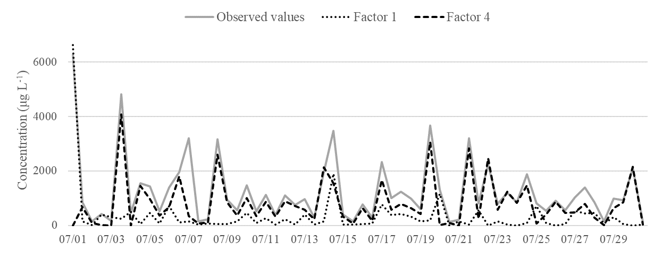

Fig. S3. Monitored concentrations of Cu and the contributions to Cu of Factors 1 and 4 at S4.

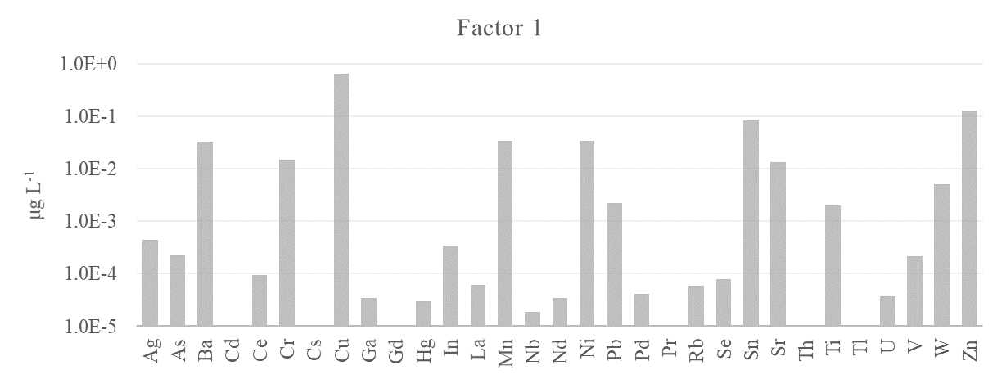
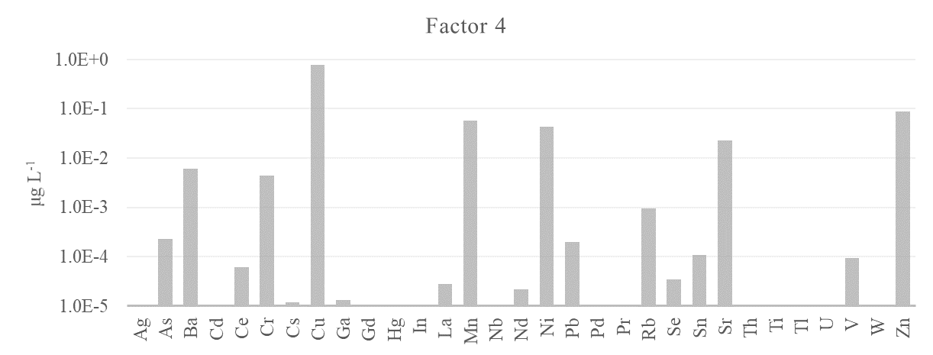
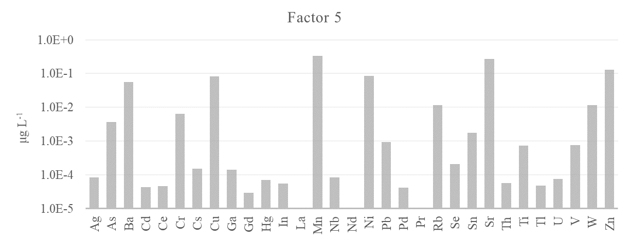
Fig. S4. The source profiles of Factors 1, 4, and 5.

