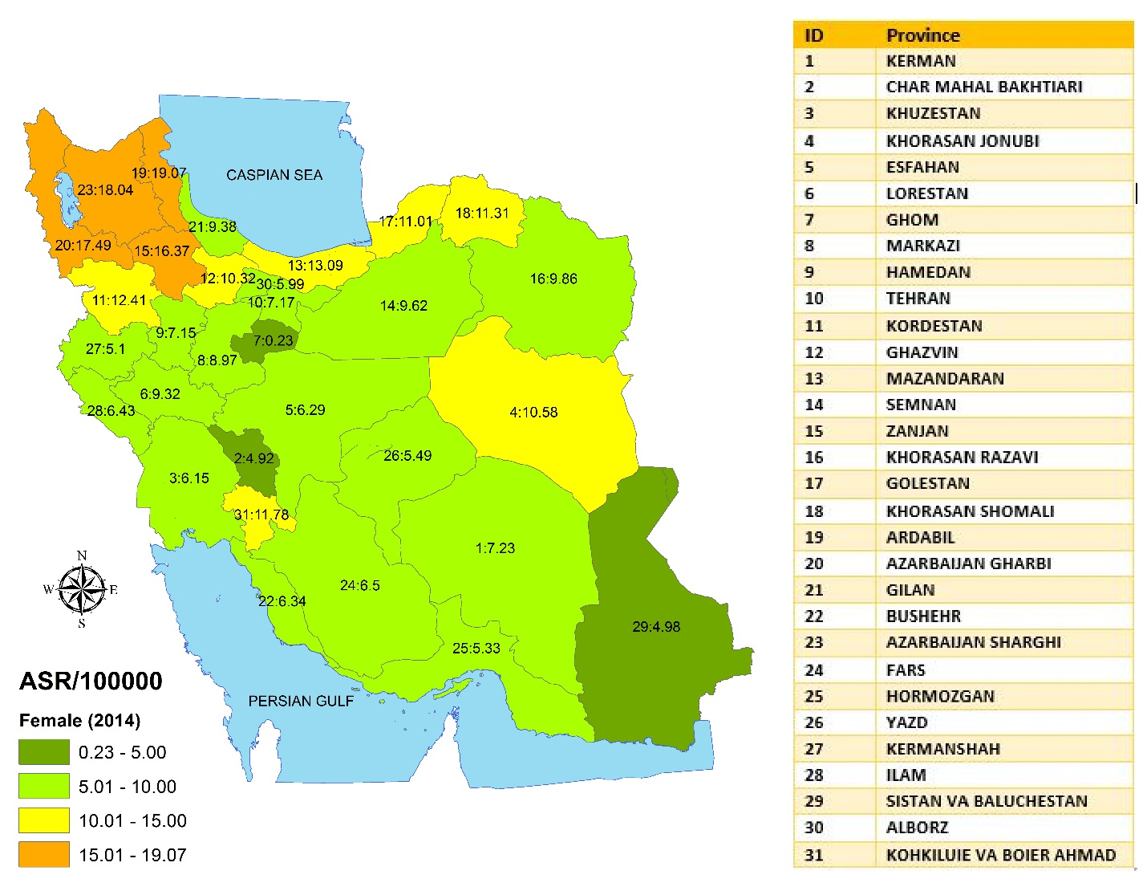

Supplementary Figure S1: distribution of ASR of stomach cancer by sex (female) in Iran in 2014
(GIS map were designed in GIS center, Department of Epidemiology, Shiraz University of Medical Sciences)

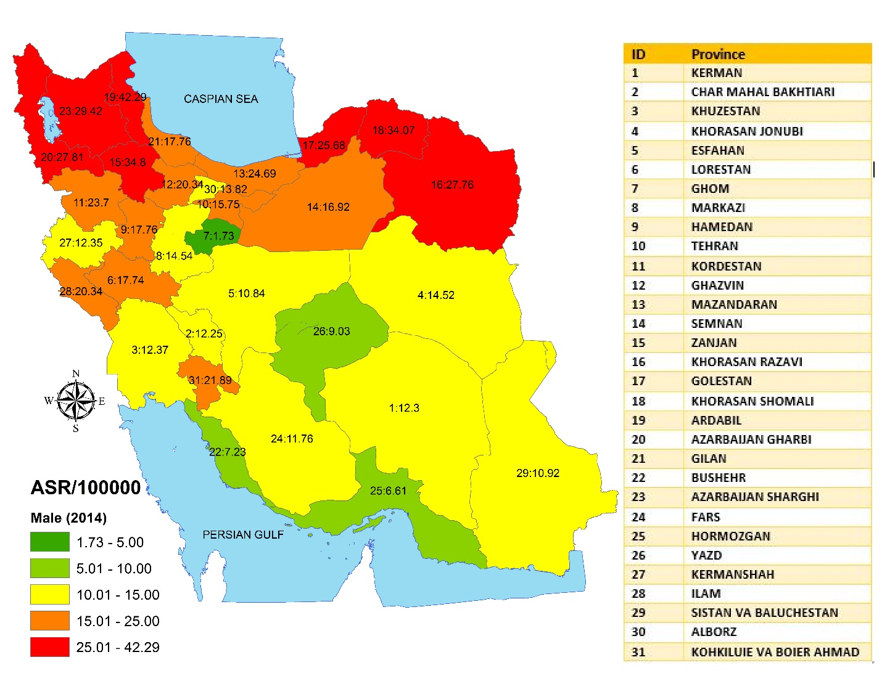

Supplementary Figure S2: distribution of ASR of stomach cancer by sex (men) in Iran in 2014
(GIS map were designed in GIS center, Department of Epidemiology, Shiraz University of Medical Sciences)

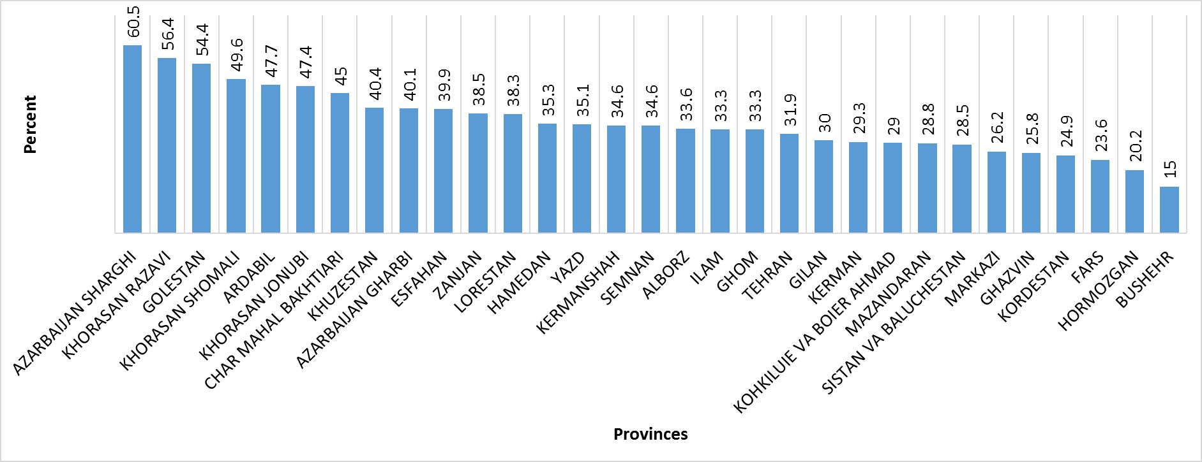
Supplementary Figure S3: Distribution of tumors located in cardia by provinces

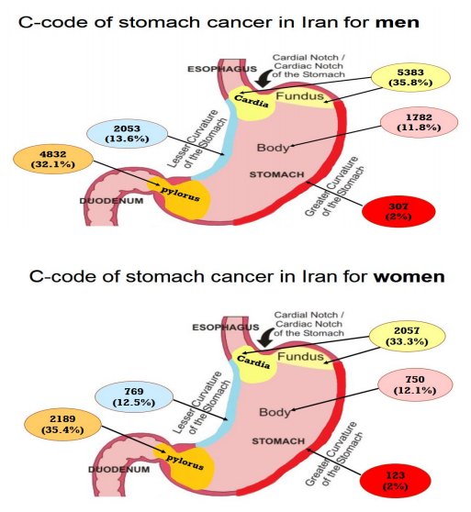
Supplementary Figure S4: distribution of the location of GC tumors in males and females (This figure were designed in GIS center, Department of Epidemiology, Shiraz University of Medical

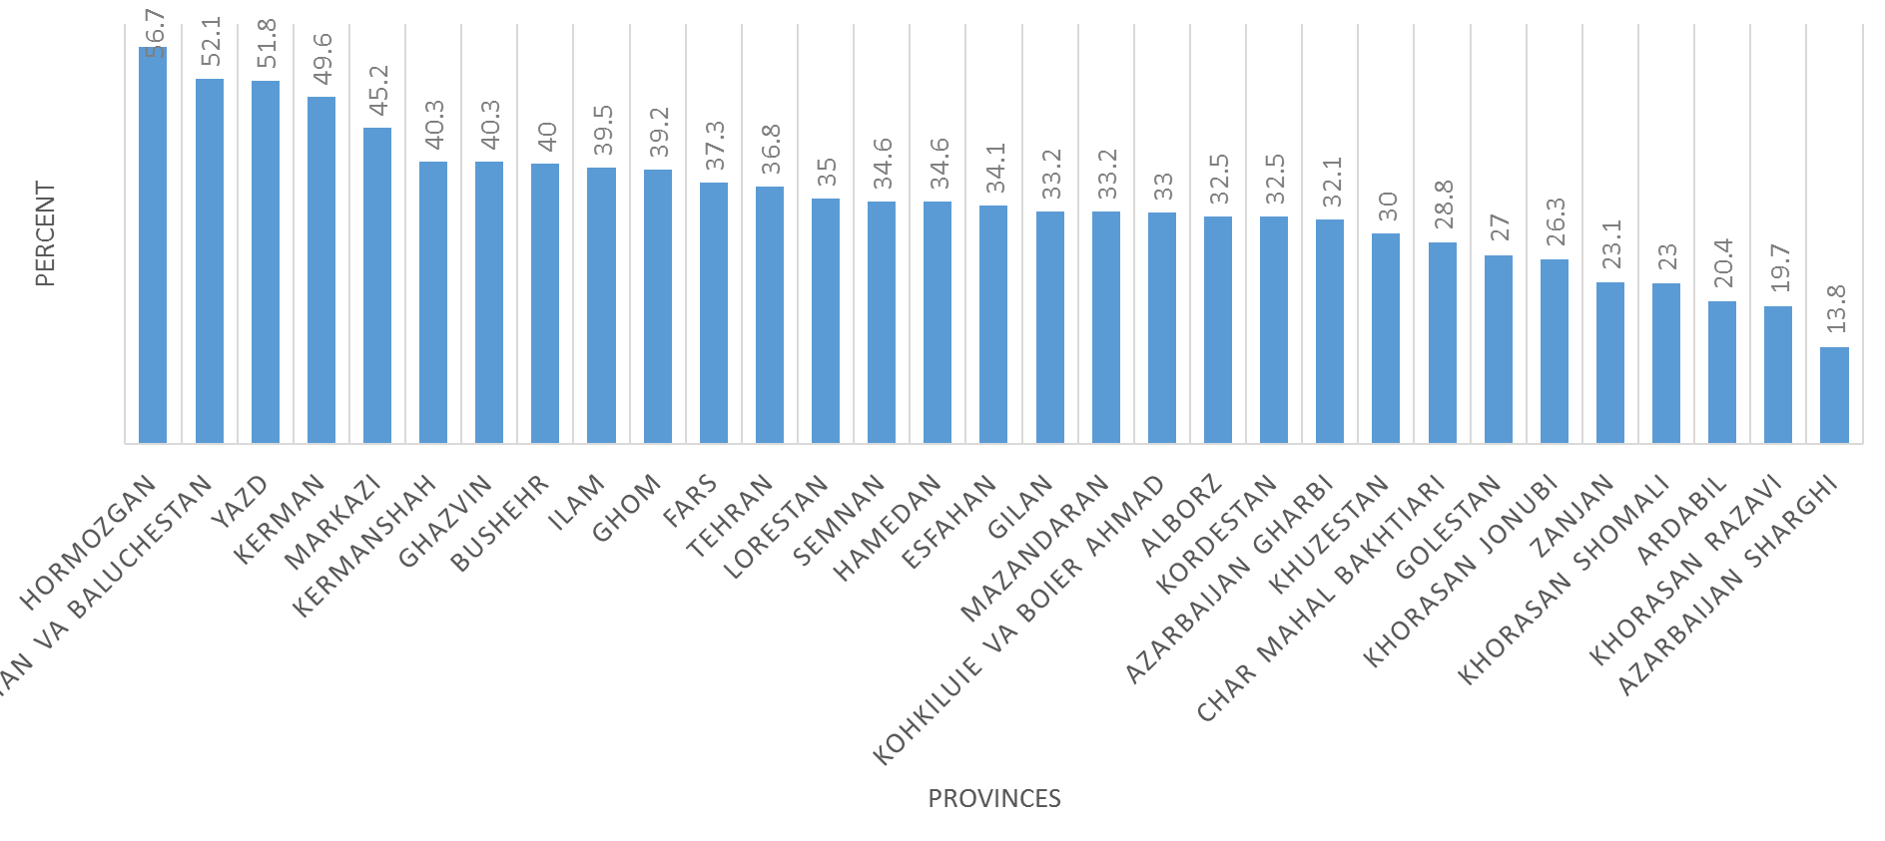
Supplementary Figure S5: distribution of tumour located in pylori by provinces

