Supplementary Information
Figure S1. Typical GC-MS total ion current (TIC) chromatograms of liver samples obtained from control group (a), low-dose group (b), and high-dose group (c), respectively.

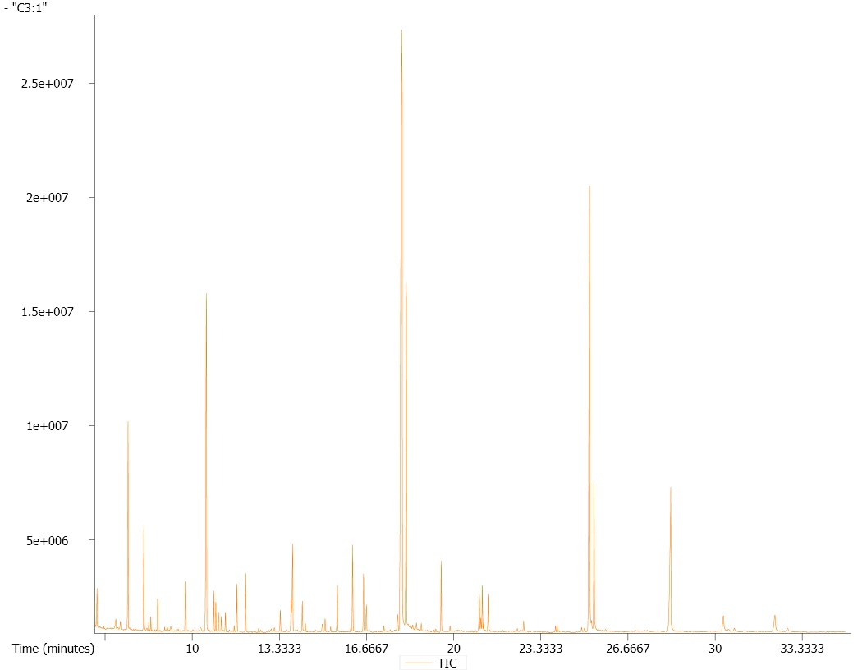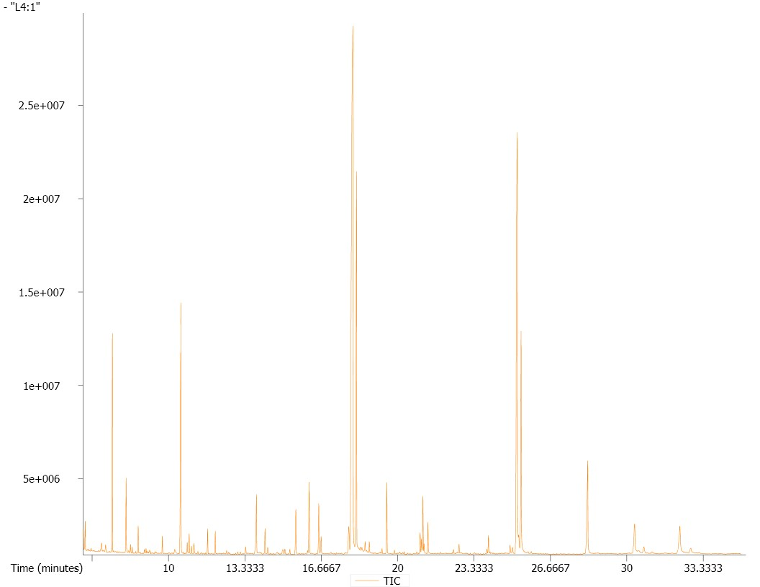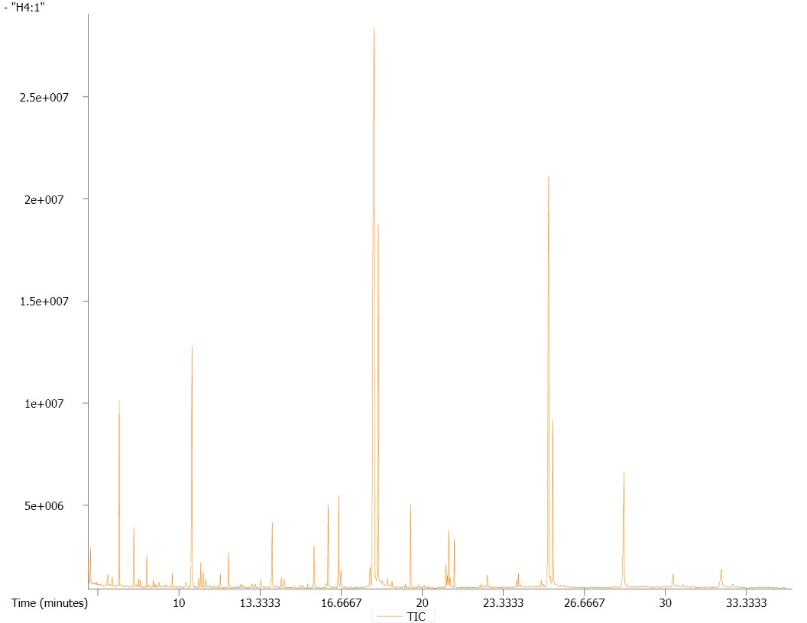
c
b
a
10 20 30
t/min

Supplementary Information
Figure S2. Heatmap analysis combined with hierarchical cluster analysis (HCA) of one hundred and twenty-eight metabolites of zebrafish liver
1. 1-hexadecanol; 2. 1-monopalmitin; 3. 2-Deoxyuridine; 4. 2-hydroxybutanoic acid; 5. 2-oxoadipate; 6. 2-ketobutyric acid; 7. 2-monoolein; 8. 2-monopalmitin; 9. 3,6-anhydro-D-galactose; 10. 3,7,12-trihydroxycoprostane; 11. 3-aminoisobutyric acid; 12. 3-hydroxy-3-methylglutaric acid; 13. 3-hydroxybutyric acid; 14. 3-hydroxypropionic acid; 15. 4-aminobutyric acid; 16. 4-hydroxybutyrate; 17. 4-hydroxypyridine; 18. 5,6-dihydrouracil; 19. 5-dihydrocortisol; 20. 5-hydroxyindole-3-acetic acid; 21. 6-phosphogluconic acid; 22. alanine; 23. D-glucosamine 1-phosphate; 24. ketoleucine; 25. aminomalonic acid; 26. androsterone; 27. arachidic acid; 28. arachidonic acid; 29. asparagine; 30. aspartic acid; 31. benzoic acid; 32. beta-alanine; 33. cellobiose; 34. citraconic acid; 35. citrulline; 36. creatine; 37. cytidine-monophosphate; 38. glycerol 3-phosphate; 39. sphingosine; 40. D-glucoheptose; 41. D-glyceric acid; 42. diglycerol; 43. dihydrosphingosine; 44. elaidic acid; 45. ethanolamine; 46. fructose; 47. fructose-6-phosphate; 48. fumaric acid; 49. galactino; 50. galactonic acid; 51. galactose; 52. glucose-6-phosphate; 53. glutamine; 54. glycine; 55. guanidoacetic acid; 56. glycolic acid; 57. GMP; 58. hippuric acid; 59. hydroxylamine; 60. hypoxanthine; 61. indolelactate; 62. inosine; 63. IMP; 64. isoleucine; 65. isoxanthopterin; 66. lactic acid; 67. lactose; 68. L-glutamic acid; 69. linoleic acid; 70. linoleic acid methyl ester; 71. L-malic acid; 72. L-threose; 73. maleamate; 74. malonic acid; 75. maltose; 76. maltotriose; 77. mannose; 78. methionine; 79. methyl palmitate; 80. methyl stearate; 81. methyl palmitoleate; 82. methylmalonic acid; 83. monostearin; 84. myo-inositol; 85. myristic acid; 86. N,N-dimethylarginine; 87. N-acetyl-beta-D-mannosamine; 88.N-Acetyl-D-galactosamine; 89. N-ethylglycine; 90. nicotinamide; 91. norvaline; 92. oleic acid; 93. O-methylthreonine; 94. O-phosphorylethanolamine; 95. oxalic acid; 96. oxamic acid; 97. oxoproline; 98. palmitic acid; 99. palmitoleic acid; 100. pantothenic acid; 101. phenylacetaldehyde; 102. phenylalanine; 103. proline; 104. putrescine; 105. pyrophosphate; 106. pyruvic acid; 107. raffinose; 108. ribose; 109. ribose-5-phosphate; 110. ribulose-5-phosphate; 111. sarcosine; 112.serine; 113. sorbitol; 114. sorbose; 115. squalene;116. stearic acid; 117. succinic acid; 118. tagatose; 119. taurine; 120. threonine; 121. thymine; 122. tyrosine; 123. uracil; 124. uric acid; 125. uridine; 126. valine; 127. xylitol; 128. zymosterol

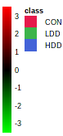
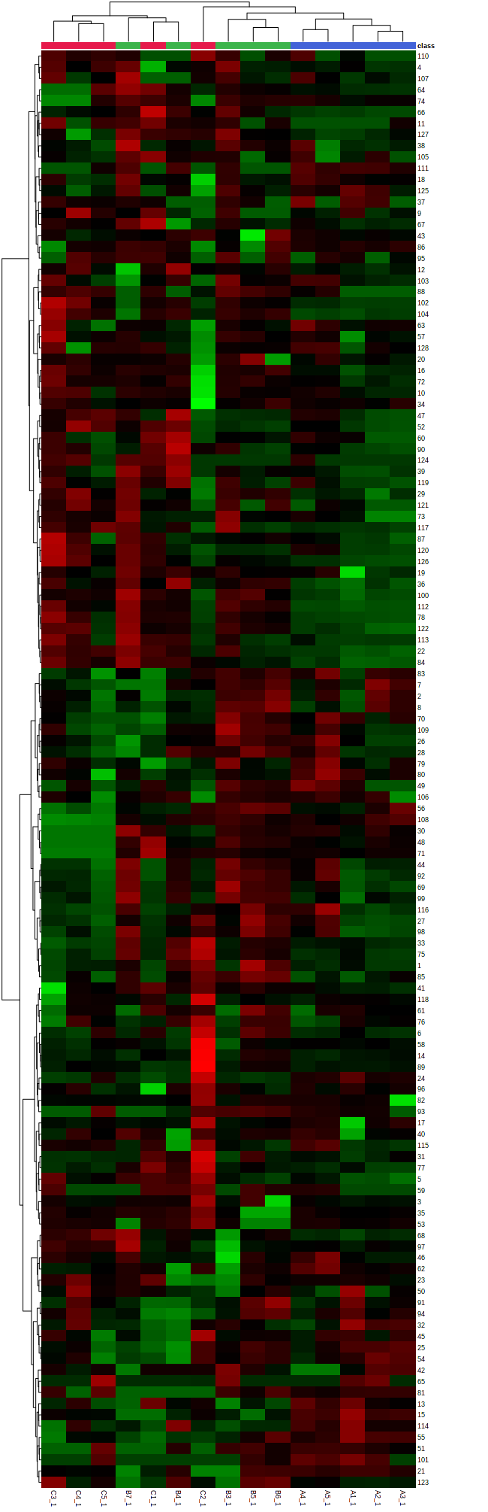

Supplementary Information
Figure S3. PCA-derived metabolite profile score plots of zebrafish exposed on diquat and those of the control
a zebrafish exposed to diquat at doses of 0.34 mg·L⁻¹ versus control; b zebrafish exposed to diquat at doses of 1.69 mg·L⁻¹ versus control.

a b
