Outcomes of hepatic epithelioid hemangioendothelioma with different managements: Retrospective investigation of 50 patients

Running title: Outcomes of HEHE with different managements

Xiaolei Liu, Zhiying Yang
Department of General Surgery, China-Japan Friendship Hospital, Beijing, China

Correspondence to: Zhiying Yang, Department of General Surgery, China-Japan Friendship Hospital, 2 Yinghua Dongjie, Hepingli, Beijing 100029, China
(e-mail: yangzhy@aliyun.com)

Brief profiles of 18 HEHE patients with observation
Patient 1#: Male, 31 years old, length of observation 5 months, progressive disease
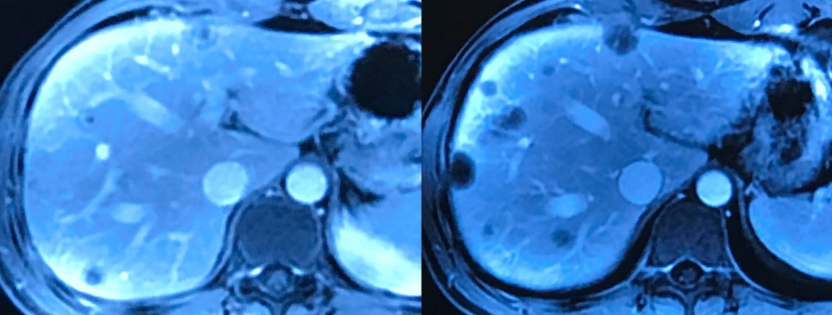

Patient 2#: Male, 32 years old, length of observation 15 months, progressive disease
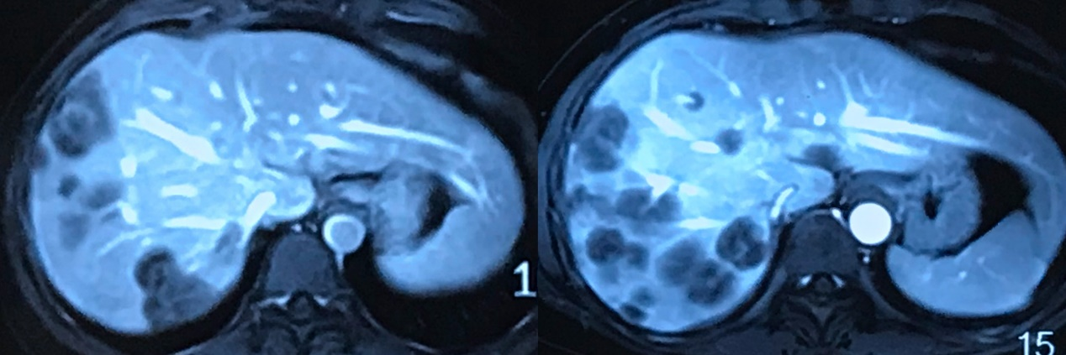

Patient 3#: Female, 42 years old, length of observation 16 months, progressive disease
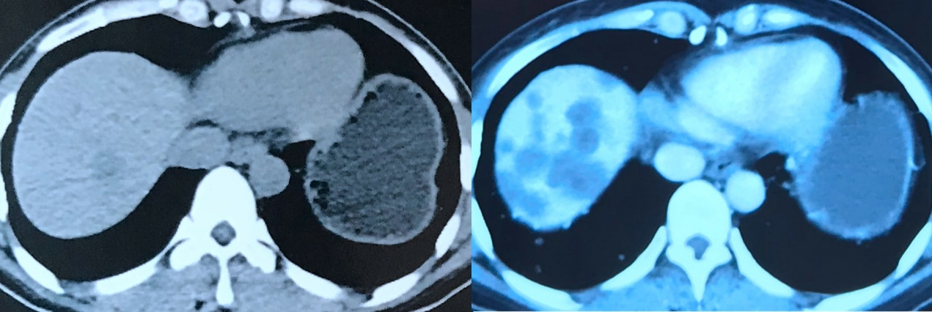

Patient 4#: Female, 46 years old, length of observation 6 months, progressive disease
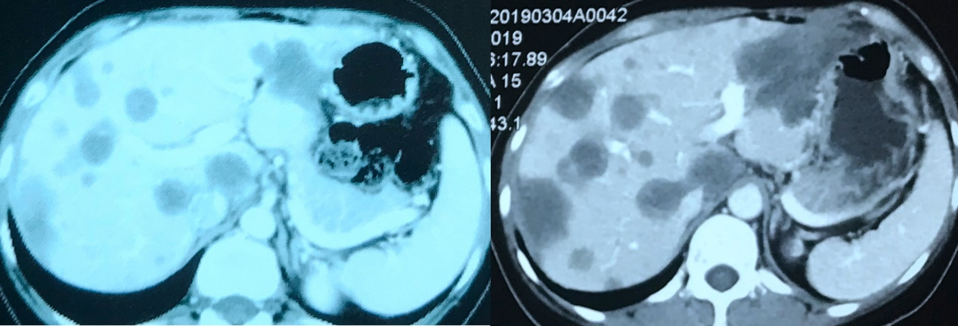

Patient 5#: Female, 30 years old, length of observation 45 months, progressive disease
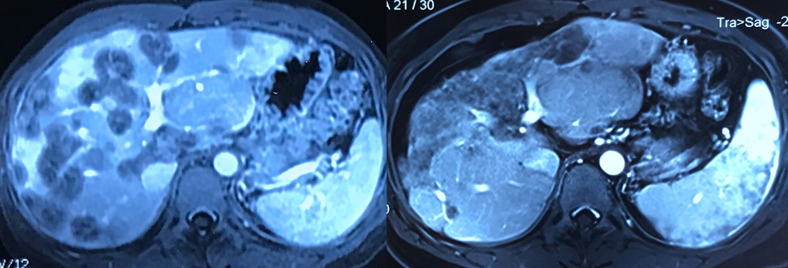

Patient 6#: Male, 22 years old, length of observation 6 months, progressive disease
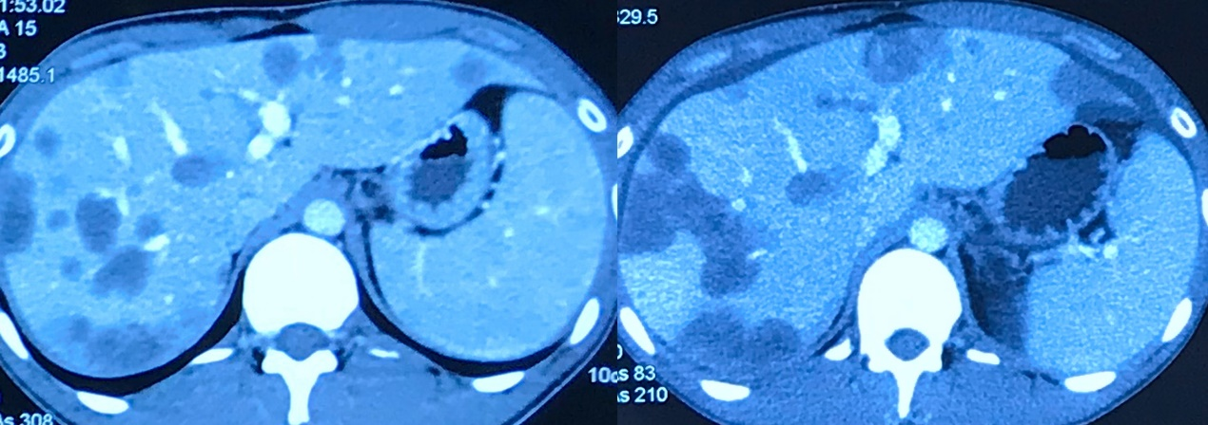

Patient 7#: Female, 35 years old, length of observation 9 months, progressive disease
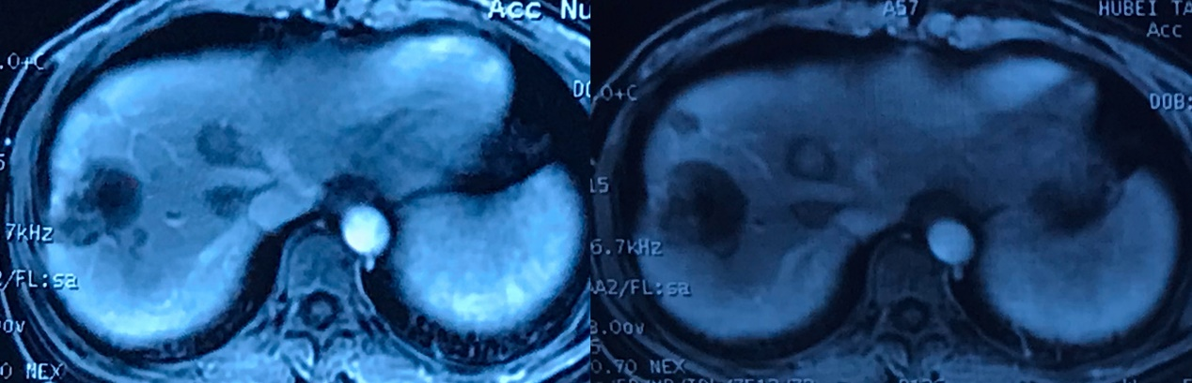

Patient 8#: Male, 44 years old, length of observation 10 months, progressive disease
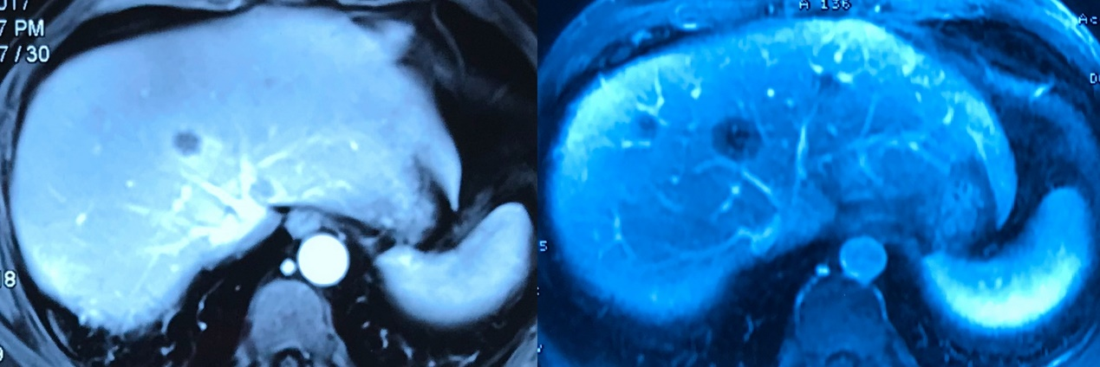

Patient 9#: Female, 27 years old, length of observation 9 months, progressive disease
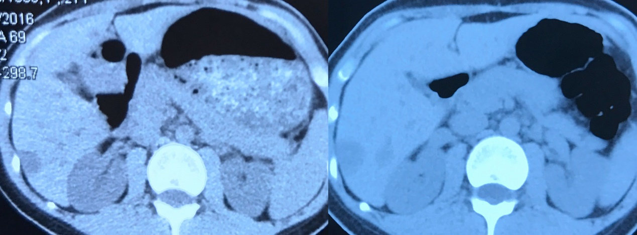

Patient 10#: Male, 53 years old, length of observation 54 months, progressive disease
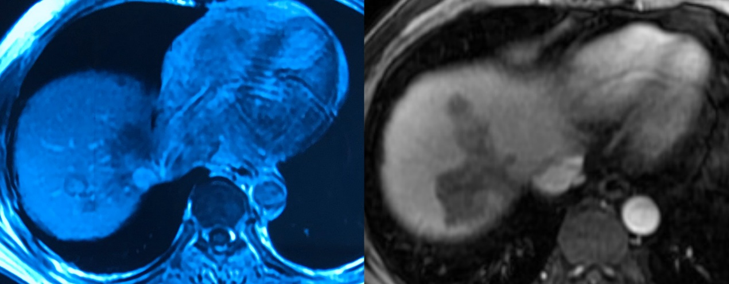

Patient 11#: Female, 36 years old, length of observation 5 months, progressive disease
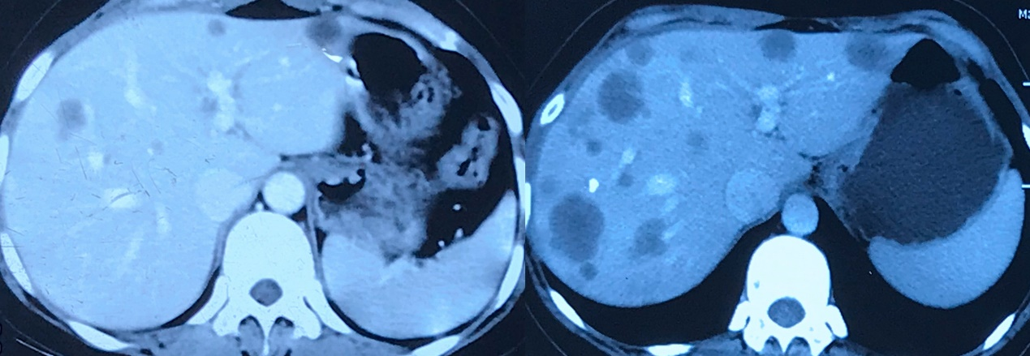

Patient 12#: Female, 29 years old, length of observation 24 months, progressive disease
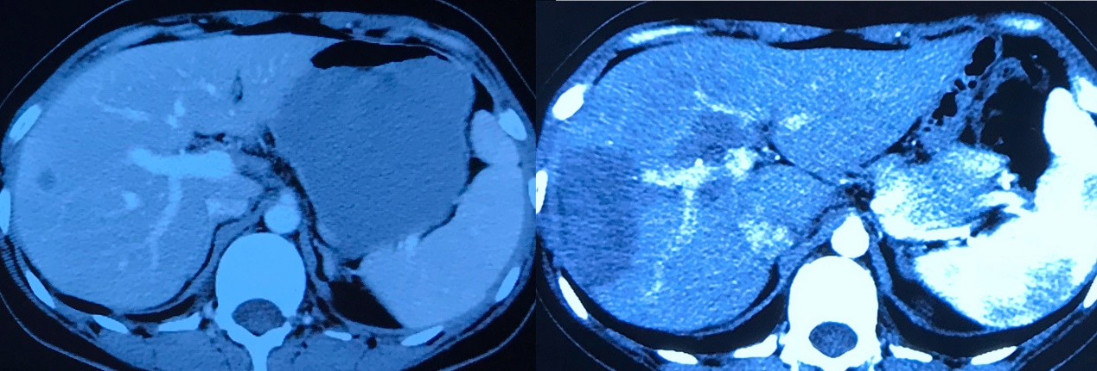

Patient 13#: Male, 38 years old, length of observation 17 months, progressive disease
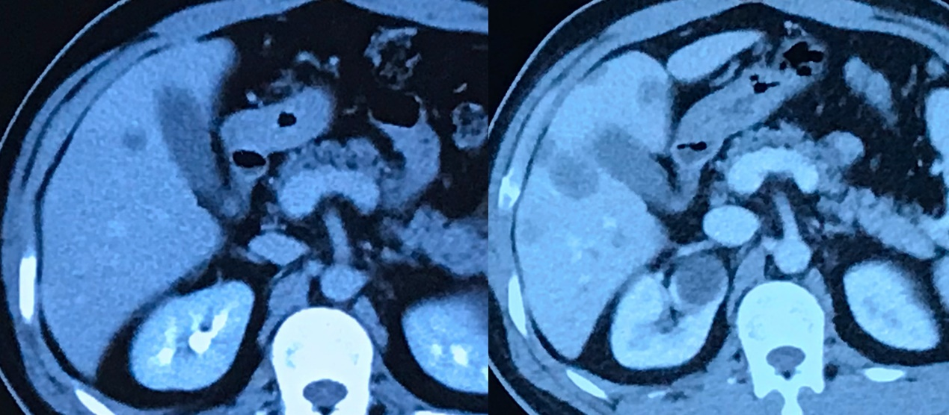

Patient 14#: Male, 26 years old, length of observation 58 months, progressive disease
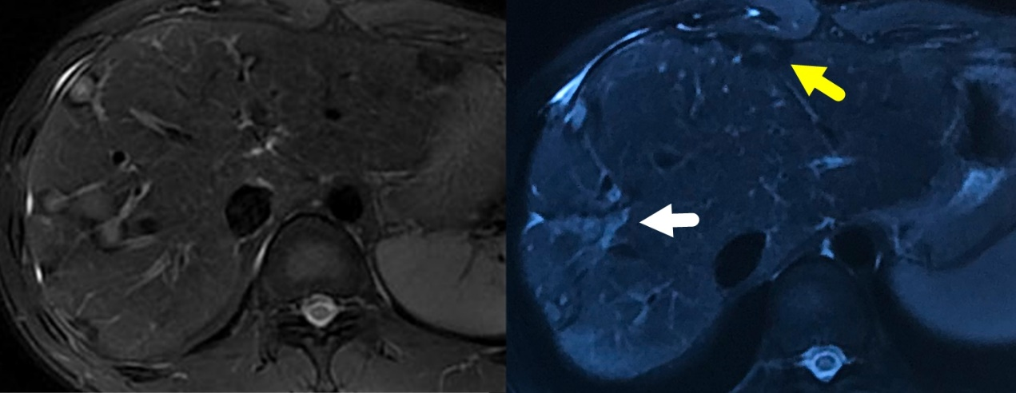

Patient 15#: Male, 36 years old, length of observation 42 months, progressive disease
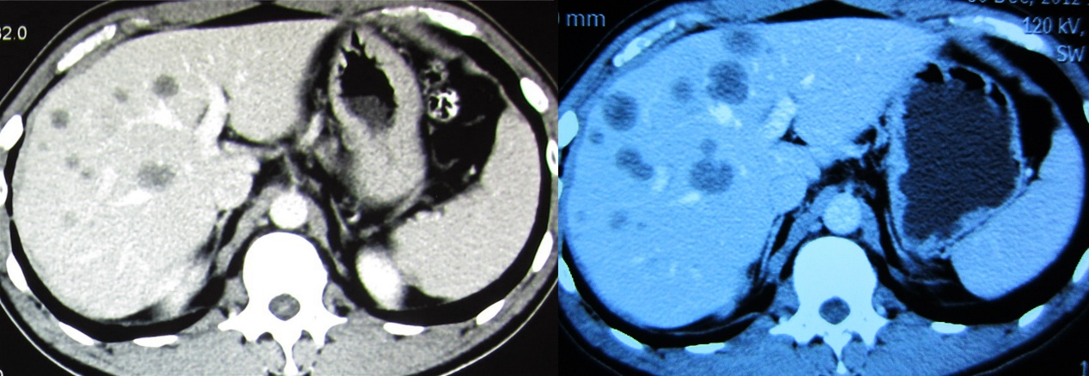

Patient 16#: Female, 42 years old, length of observation 12 months, progressive disease
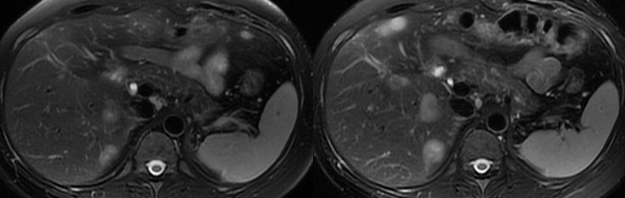

Patient 17#: Male, 43 years old, length of observation 22 months, stable disease
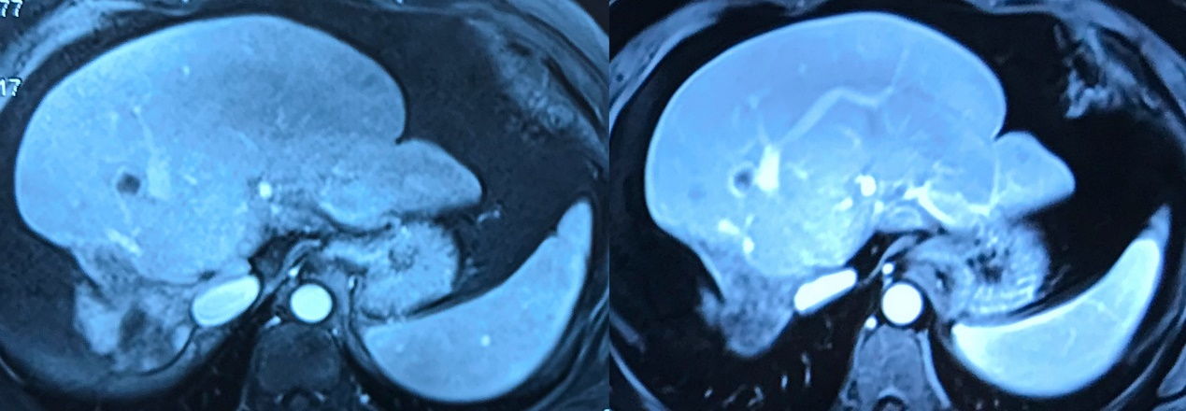

Patient 18#: Female, 49 years old, length of observation 36 months, stable disease
