Detection of glioma infiltration at the tumor margin using quantitative stimulated Raman scattering histology

Melike Pekmezci MD¹, Ramin A. Morshed MD², Pranathi Chunduru MS^{2, 3} , Balaji Pandian BA^{2, 5}, Jacob Young MD², Javier E. Villanueva-Meyer MD⁴, Tarik Tihan MD PhD¹, Emily A. Sloan MD PhD¹, Manish K. Aghi MD PhD², Annette M. Molinaro PhD^{2,3}, Mitchel S. Berger MD², Shawn L. Hervey-Jumper MD²

Supplementary Material

Supplementary Table S1: Detailed Patient Characteristics

Supplementary Figure S1: Cell Counting Quantification Troubleshooting
Supplementary Figure S2: SRH Cellularity

Supplementary Table S1: Detailed Patient Characteristics

Subject # | # of cores | # of margins | Positive margins by SRH | Negative margins by SRH | Sex | Age | Histo-logic WHO grade | IDH-mutant | Oligoden-droglioma, grade 2 or 3 | Astro-cytoma, grade 2 or 3 | Molecular GBM, grade 4 | Location | T1 enhancement | T2 FLAIR only (no  enhancement)
1 | 1 | 4 | 1 | 3 | male | 73 | 4 | no | no | no | no | temporal | yes | no
2 | 1 | 4 | 2 | 2 | male | 22 | 3 | yes | no | yes | no | insula | no | yes
3 | 1 | 2 | 0 | 2 | male | 72 | 4 | no | no | no | no | temporal | yes | no
4 | 1 | 7 | 5 | 2 | male | 44 | 3 | yes | no | yes | no | temporal | no | yes
5 | 1 | 2 | 0 | 2 | male | 53 | 4 | no | no | no | no | frontal | yes | no
6 | 1 | 2 | 0 | 2 | male | 56 | 3 | yes | yes | no | no | frontal | yes | no
7 | 1 | 8* | 6 | 1 | female | 82 | 3 | yes | yes | no | no | frontal | no | yes
8 | 1 | 12 | 1 | 11 | male | 53 | 4 | no | no | no | no | frontal | yes | no
9 | 1 | 2 | 0 | 2 | male | 48 | 4 | no | no | no | no | parietal | yes | no
10 | 1 | 2 | 2 | 0 | female | 70 | 2 | yes | yes | no | no | frontal | no | yes
11 | 1 | 11* | 3 | 7 | female | 63 | 2 | yes | yes | no | no | insula | no | yes
12 | 1 | 1 | 0 | 1 | male | 68 | 4 | no | no | no | no | frontal | yes | no
13 | 1 | 2 | 2 | 0 | male | 55 | 3^ | no | no | no | yes | insula | no | yes
14 | 1 | 6 | 6 | 0 | female | 28 | 4 | no | no | no | no | parietal | no | yes
15 | 1 | 9 | 1 | 8 | female | 61 | 3 | yes | yes | no | no | frontal | yes | no
16 | 1 | 12 | 1 | 11 | female | 30 | 2 | yes | yes | no | no | frontal | no | yes
17 | 1 | 5 | 1 | 4 | male | 75 | 3^ | no | no | no | yes | temporal | yes | no
18 | 1 | 7 | 2 | 5 | female | 73 | 4 | no | no | no | no | temporal | yes | no
19 | 1 | 2 | 1 | 1 | male | 83 | 4 | no | no | no | no | temporal | yes | no
20 | 1 | 11 | 4 | 7 | female | 55 | 3 | yes | yes | no | no | frontal | no | yes
21 | 1 | 6 | 6 | 0 | female | 68 | 4 | yes | no | no | no | frontal | yes | no
22 | 1 | 2 | 2 | 0 | female | 45 | 4 | no | no | no | no | frontal | yes | no
23 | 1 | 2 | 1 | 1 | male | 42 | 2 | yes | yes | no | no | occipital | no | yes
24 | 1 | 4 | 4 | 0 | male | 63 | 4 | yes | no | no | no | insula | yes | no
25 | 1 | 8 | 2 | 6 | male | 77 | 4 | no | no | no | no | parietal | yes | no
26 | 1 | 7 | 6 | 1 | female | 47 | 4 | no | no | no | no | temporal | yes | no
27 | 1 | 11 | 7 | 4 | male | 57 | 4 | no | no | no | no | parietal | yes | no
28 | 1 | 8 | 6 | 2 | female | 60 | 3 | yes | no | yes | no | temporal | yes | no
29 | 1 | 2 | 2 | 0 | male | 68 | 4 | no | no | no | no | frontal | yes | no
30 | 1 | 2 | 2 | 0 | female | 39 | 2 | yes | yes | no | no | frontal | no | yes
31 | 1 | 6 | 6 | 0 | female | 67 | 2 | yes | yes | no | no | parietal | no | yes
* no SRH consensus neuropathology score
^ Astrocytomas with histologic grade of III harboring molecular alterations of glioblastoma, and therefore classified as molecular glioblastoma¹⁰

Supplementary Figure S1: Cell Counting Quantification Troubleshooting
Cell counting quantification troubleshooting includes manual inspection for small samples in which white space covers a portion of the field of view area. Imaging autofocus (A) may result in counter failures therefore manual focus must be applied (B). Tumor margin specimen in which blood impacts imaging quality are manually excluded.

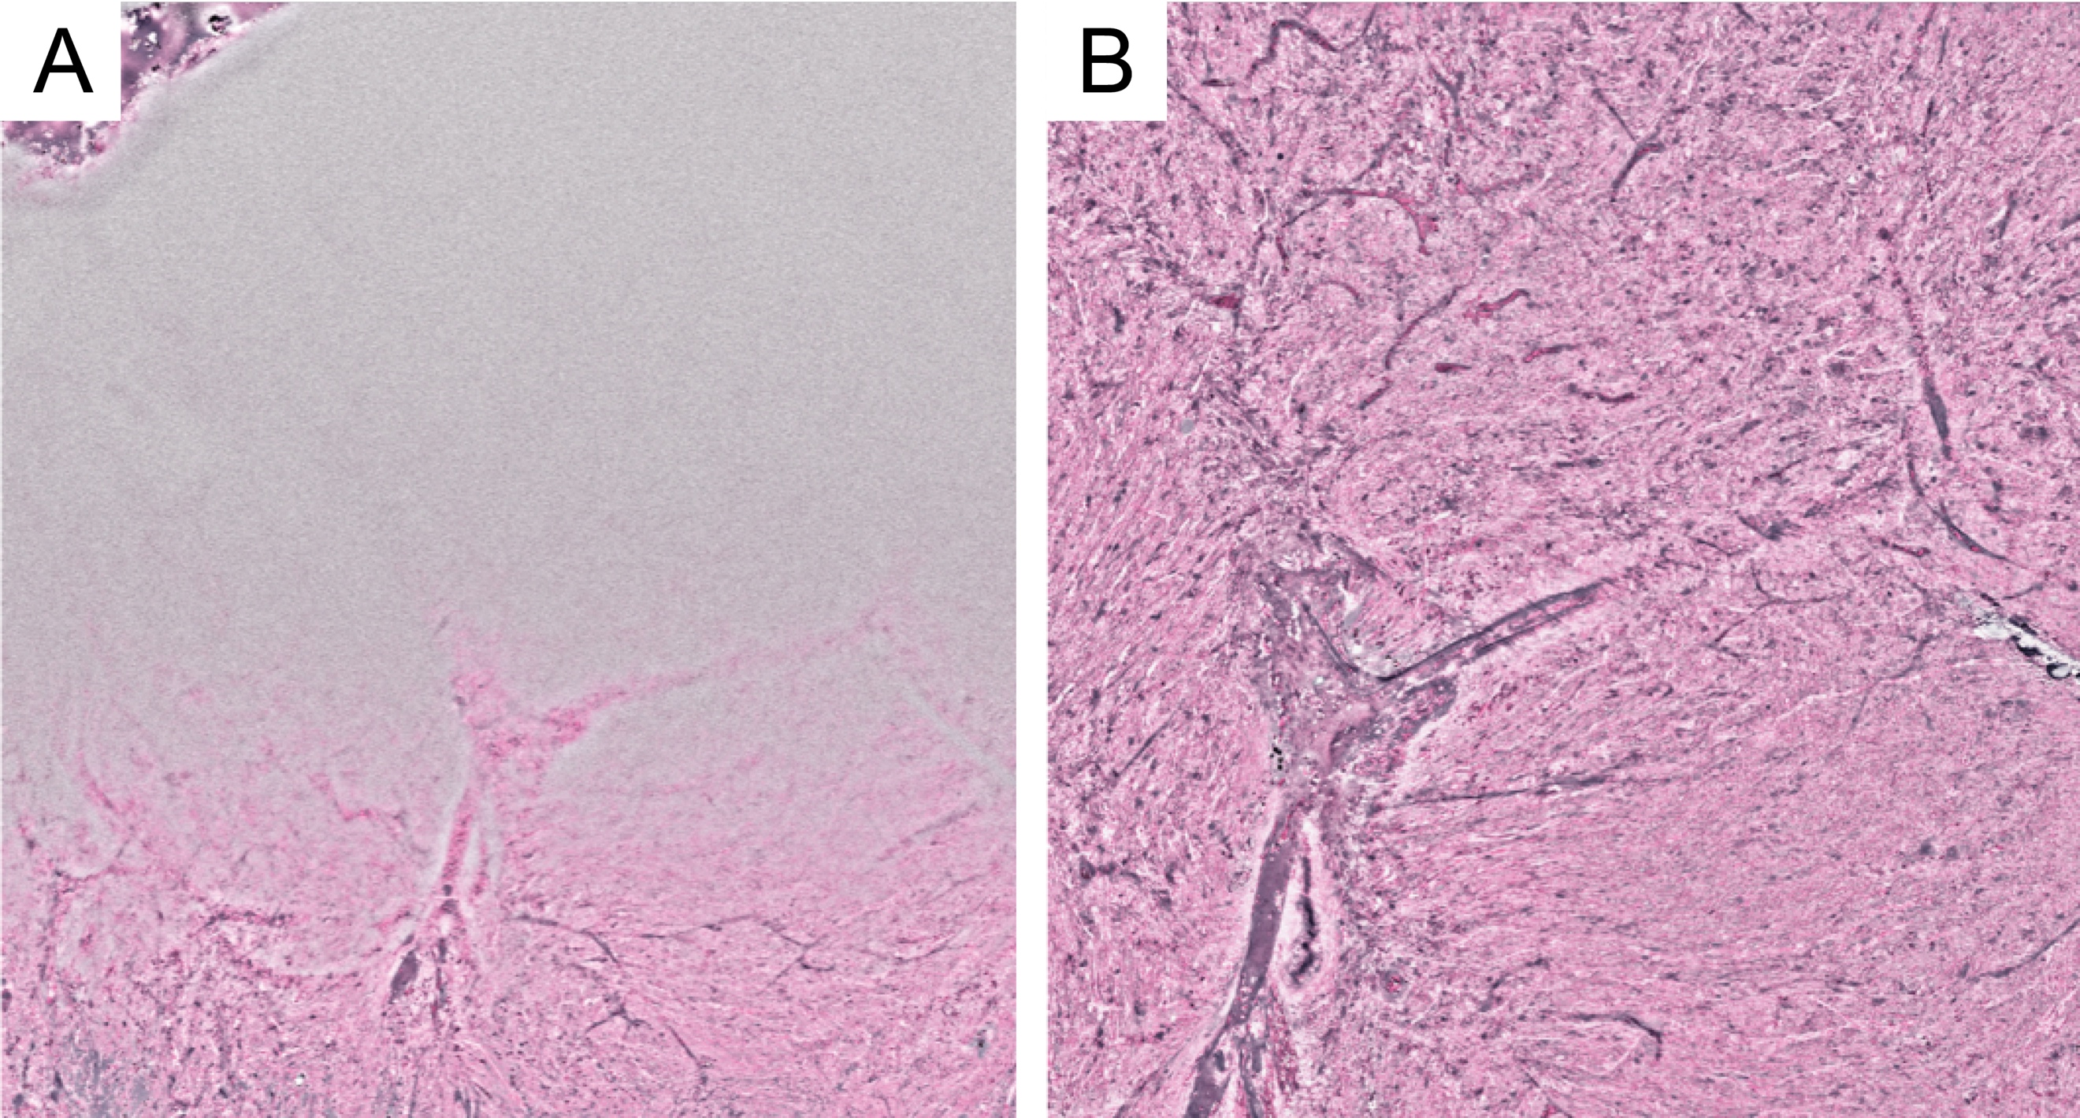

Supplementary Figure S2: SRH Cellularity
(A) Of all images with SRH consensus score n= 164, ROC curve 0-1 vs 2-3 area = 0.84. (B) Duplicates were identified and excluded so that final cell count analysis included n= 155 (9 excluded cases due to poor image quality). ROC and area under the curve was performed with duplicate filtering n = 155, ROC curve 0-1 vs 2-3 area = 0.85 and naïve cell-counts. This resulted in a modest improvement in performance after discarding samples with poor image quality and re-imaging these samples. However poor image samples remained given occasional small tissue samples in which uncovered slide and water make up a percentage of the image. (C) We then applied SRH operator estimates of good tissue percentage as each image was inspected and estimated for percentage of “good” tissue using a 10-point scale of 1-100 (100% = entire image is covered with tissue and 0= entire slide is non-tissue i.e. blood, plastic, water). Adjusting for this percentage, ROC curves improved, n = 155, ROC curve 0-1 vs 2-3 area = 0.86). The above approach is however reliant on human interpretation of percentage of good tissue coverage/ area. (D) In order to avoid potential human error we then applied a machine learning methodology to identify “white-space-areas” by a deterministic threshold (red is considered “excluded”). This approach does not allow the identification of blood which was interpretable using the operator inspection method. Machine leaning area under the curve therefore performed slightly worse than our manual operator inspection method due to the inability to interpret blood (n= 155, ROC curve 0-1 vs 2-3 area = 0.84). The AUC values support this hypothesis because the low-cellularity images would be more sensitive to bloody specimen (0 vs 1-2-3 AUC is worse than manual classification). Furthermore, the very high cellularity images (0-1-2 vs 3) would not be as sensitive to intermittent blood on the image and are actually improved (increased AUC).

