Two-Dimensional Frank-Kasper Z Phase with One Unit-Cell Thickness

Supplementary Information

Hongbo Xieª, Junyuan Baiª, Haiyan Renª, Shanshan Liª,
Hucheng Pan* ^{b}, Yuping Ren* ^{b, c}, Gaowu Qin* ª
ª Key Laboratory for Anisotropy and Texture of Materials (Ministry of Education), School of Materials Science and Engineering, Northeastern University, Shenyang 110819, China
^{b} State Key Laboratory of Rolling and Automation, Northeastern University, Shenyang 110819, China
^{c} Research Center for Metal Wires, Northeastern University, Shenyang 110819, China

* Corresponding author. E-mail: panhc@atm.neu.edu.cn; renyp@atm.neu.edu.cn; qingw@smm.neu.edu.cn.

1. Materials and Methods
1.1 Experimental procedure
The alloy with nominal composition of Mg-4.0wt%Sm-2.0wt%Zn (Mg-0.68at.%Sm-0.78at.%Zn) was prepared by melting the pure Mg (99.9 wt%), pure Zn (99.9 wt%), and Mg-25Sm (wt%) master alloy in the induction furnace with protection of the argon atmosphere. The molten alloy was stirred and kept at 760 ºC for 5 minutes and poured into a steel mold preheated to 300 ºC. The chemical composition of as-cast ingot was measured by OPTIMA 4300 DV composition analyzer, and the actual composition was determined to be Mg-4.12wt% Sm-2.07wt%Zn. The as-cast samples were solution treated at 520 ºC for 12h, followed by water quenching and ageing in oil bath at 200 ºC for different times, and finally continued isothermally aged at 250 ºC for 2 h.
The TEM specimens with a diameter of 3 mm were prepared by twin jet electro-polishing at - 40 ºC in mixture solution of 5.3 g lithium chloride, 11.2 g magnesium perchlorate, 500 ml methanol and 100 ml 2-butoxy ethanol, and subsequently ion milling with low energy electron beam. Finally, Gatan SOLARUS (950) Plasma Cleaning System was used to clean up the sample surfaces. TEM and STEM observation was carried out by using the JEM-ARM200F at an accelerating voltage of 200 kV, equipped with probe Cs corrector and cold field emission gun. The probe convergence is 25 mrad which yields a probe size of less than 0.1 nm, and the camera length was set to 8 cm which yields a collection semi-angle of 48-327 mrad.
Crystal structures were reconstructed by the CrystalMaker.CrystalMaker.v2.2.4 software, and then the electron diffraction patterns of the precipitated phase detected from the [0001], $\left[1\overline{1}00\right]$, and $\left[11\overline{2}0\right]$ directions were simulated by using CrystalMaker.SingleCrystal.v2.0.1.

1.2 Computational methods
The first-principles calculations were conducted using the Vienna ab-initio simulation package (VASP) [1] with projector augmented-wave (PAW) [2, 3] pseudopotentials. The exchange-correlation potential was described by the generalized gradient approximation (GGA) functional of Perdew, Burke and Ernzerhof (PBE) [4]. A high plane-wave cutoff energy of 500eV and dense k-point sampling based Gamma-centered Monkhorst-pack scheme are employed to guarantee high numerical accuracy. The geometry optimization process were performed using a conjugate gradient algorithm until the final force on each atom was less than 0.01 eV/Å.
The formation energy, E_{f}, can approximately characterize the stability of compounds in thermodynamics [5]. And the formation energies in present calculations, $E_{f}$, were calculated as following equation:
$$E_{f}=\frac{E\left({Mg}_{x}{Sm}_{y}{Zn}_{z}\right)-x*E\left({Mg}_{x}\right)-y*E\left({Sm}_{y}\right)-z*E(Zn)}{x+y+z}$$
Here,$E\left({Mg}_{x}{Sm}_{y}{Zn}_{z}\right) , E\left(Mg\right), E\left(Sm\right) and E(Zn)$represent the total energy of the model, the energies of Mg, Sm and Zn unit cell, respectively. The charge distribution and Electron Localized Function (ELF) models were displayed by using the VESTA software.

References
1. Kresse, G. & Furthmüller, J. Efficient iterative schemes for ab initio total-energy calculations using a plane-wave basis set. Phys. Rev. B 54, 11169 (1996).
2. Blöchl, P. E. Projector augmented-wave method. Phys. Rev. B 50, 17953 (1994).
3. Kresse, G. & Joubert, D. From ultrasoft pseudopotentials to the projector augmented-wave method. Phys. Rev. B 59, 1758 (1999).
4. Perdew, J. H., Burke, K. & Ernzerhof, M. Generalized gradient approximation made simple. Phys. Rev. Lett. 77, 3865 (1996).
5. Manzoor, A. et al. Entropy contributions to phase stability in binary random solid solutions. Npj Comput. Mater. 4, 1-10 (2018).

2. Supplementary Figures
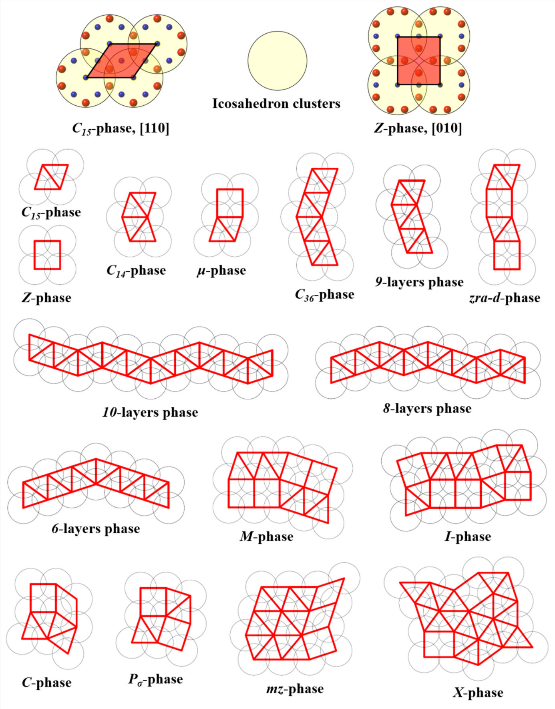
Figure S1. Schematic diagrams of the pentagonal Frank-Kasper phases, which assembled by the C₁₅ and Z plane tiling patterns. And it can be seen that these Frank-Kasper phases are arranged along the pseudo ten-fold axis by the icosahedron columns.

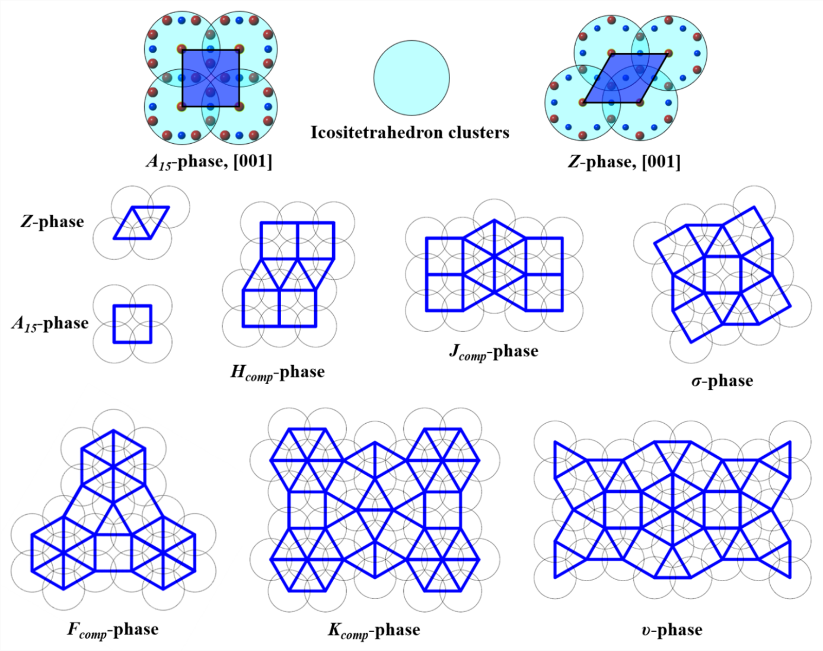
Figure S2. Schematic diagrams of the hexagonal Frank-Kasper phases, which assembled by the A₁₅ and Z plane tiling patterns. And it can be seen that these Frank-Kasper phases are arranged along the pseudo twelve-fold axis by the icositetrahedron columns.

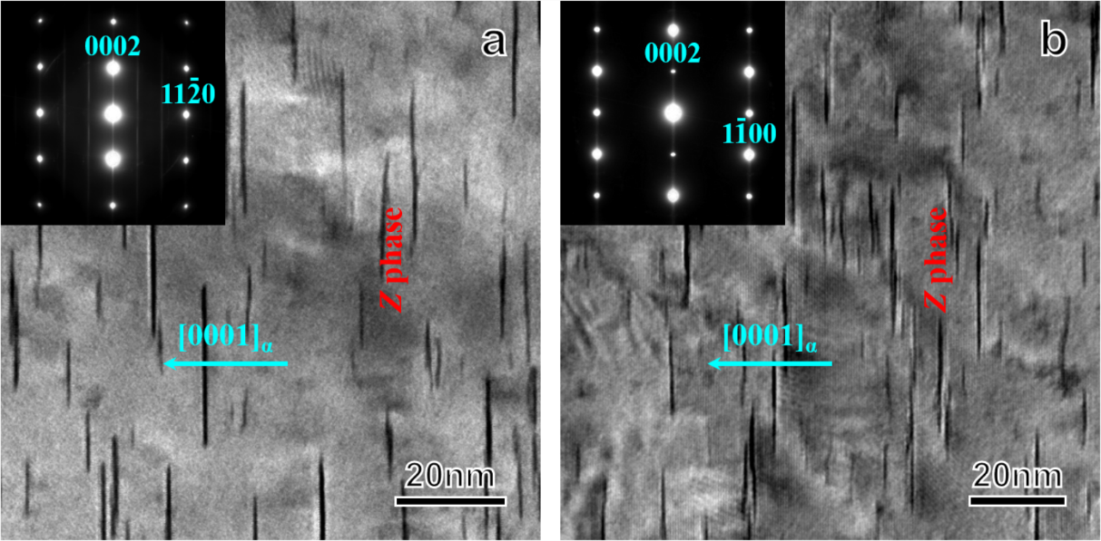
Figure S3. Bright-field images showing the 2D Frank-Kasper Z phase precipitated in the Mg-4Sm-2Zn alloy after aged at 200 ºC for 48 h. The electron beam is parallel to the $\left[1\overline{1}00\right]$_{α} (a) and $\left[11\overline{2}0\right]$_{α} (b). The insets are the corresponding selected-area electron diffraction (SAED) patterns.

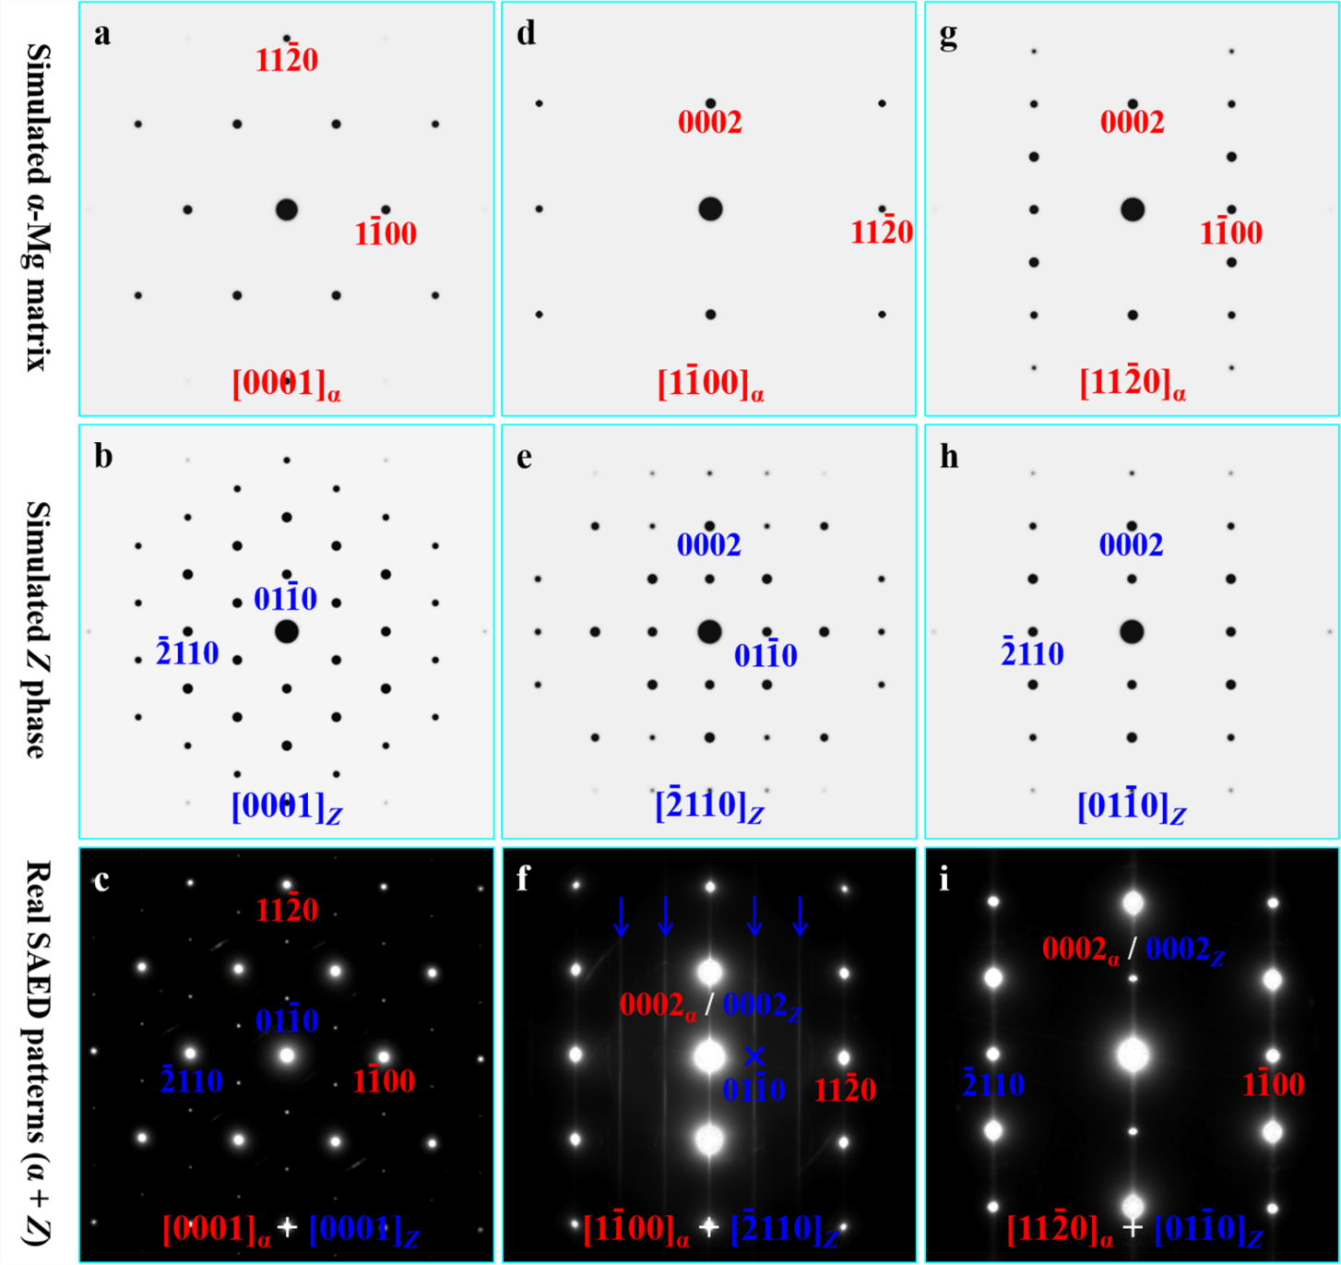
Figure S4. Electron diffraction results. (a, d, and g) Simulated electron diffraction patterns of the α-Mg matrix from [0001]_{α} (a), $\left[1\overline{1}00\right]$_{α} (d), and $\left[11\overline{2}0\right]$_{α} (g). (b, e, and h) Simulated electron diffraction prtterns of the 2D Frank-Kasper Z-Mg₂Sm₂Zn₃ phase from [0001]_{z} (b), $\left[\overline{2}110\right]$_{z} (e), and $\left[01\overline{1}0\right]$_{z} (h). (c, f, and i) Select-area electron diffraction (SAED) patterns of the 2D Frank-Kasper Z-Mg₂Sm₂Zn₃ precipitate in the Mg-Sm-Zn alloy from [0001]_{α+z} (c), $\left[1\overline{1}00\right]$_{α} + $\left[\overline{2}110\right]$_{z} (f), and $\left[11\overline{2}0\right]$_{α} + $\left[01\overline{1}0\right]$_{z} (i). It can be found that the simulation results are consistent with the experimental results, in which without considering the {0001}_{z} basal planes diffraction. Since 2D Frank-Kasper Z-Mg₂Sm₂Zn₃ precipitate only has a single unit-cell height in the [0001]_{z} direction, and it has also no periodicity along the [0001]_{z} direction, the diffraction streaks parallel to the [0001]_{z} direction are observed in the actual electron diffraction patterns.

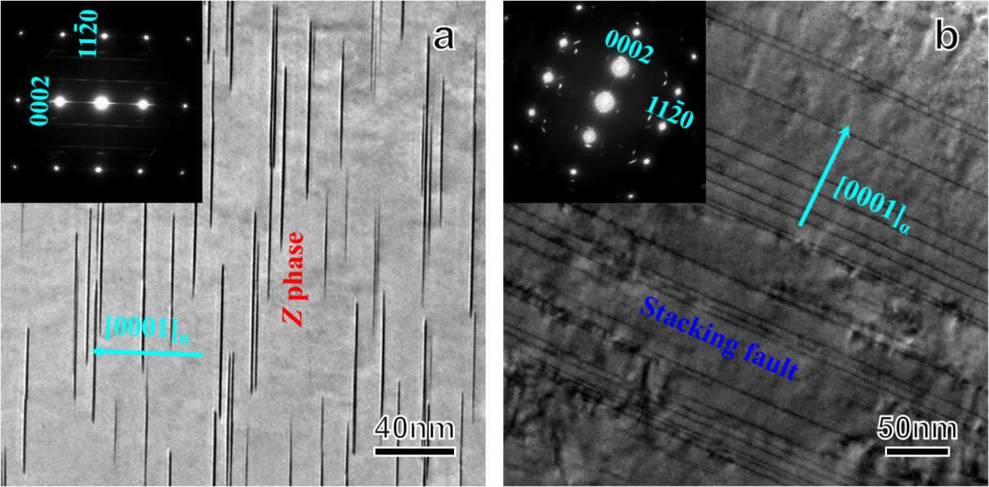
Figure S5. (a) Bright-field image of the Mg-4Sm-2Zn alloy after aged at 200 ºC for 100 h. (b) Bright-field image of the Mg-4Sm-2Zn alloy subjected to continuous isothermal aging at 250 ºC for 2 h. The electron beam is parallel to the $\left[1\overline{1}00\right]$_{α} direction. The insets are the corresponding SAED patterns.

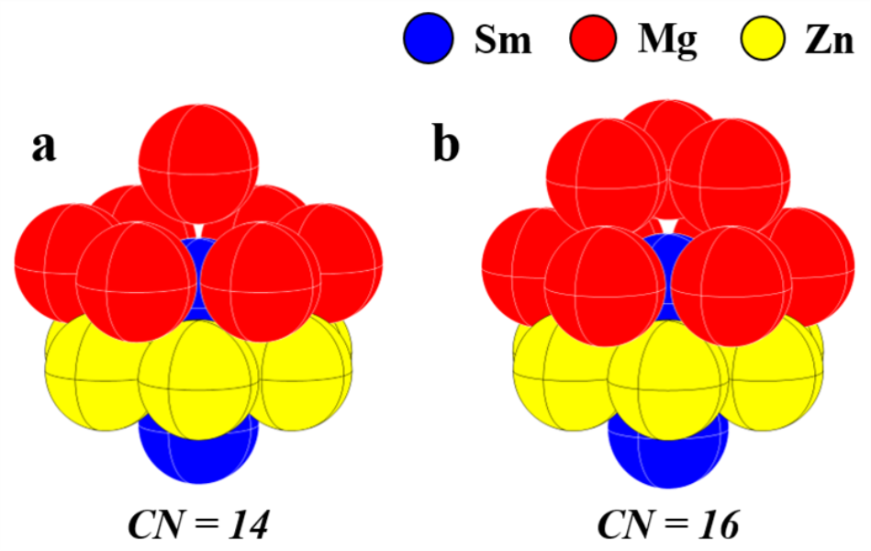
Figure S6. Atomic cluster models: (a) CN = 14, icositetrahedron; (b) CN = 16, irregular polyhedron.

3. Supplementary Tables
Table S1. Crystallographic parameters of the Feank-Kasper phases ^{[1-24]}.
No. | Phase | Representative alloy | Space group | Lattice parameters (Å) |  |  |  | Atomic Number | CN (%) |  |  |  |  | Ref.
 |  |  |  | a | b | c | β (°) |  | 16 | 15 | 14 | 12 | A. V.
1 | A₁₅ | Cr₃Si | Pm$\overline{3}$n | 4.560 | 4.560 | 4.560 |  | 8 | 0 | 0 | 75.0 | 25.0 | 13.50 | [1]
2 | σ | Cr₄₆Fe₅₄ | P4₂/mnm | 8.797 | 8.797 | 4.559 |  | 30 | 0 | 13.3 | 53.4 | 33.3 | 13.47 | [2]
3 | H | Complex | Cmmm | 4.500 | 17.500 | 4.500 |  | 30 | 0 | 13.3 | 53.4 | 33.3 | 13.47 | [3, 4]
4 | K | Complex | Pmmm | 12.500 | 17.100 | 4.500 |  | 82 | 0 | 14.6 | 51.2 | 34.2 | 13.46 | [3, 4]
5 | F | Complex | P6/mmm | 12.500 | 12.500 | 4.500 |  | 52 | 0 | 15.4 | 50.0 | 34.6 | 13.46 | [3, 4]
6 | J | Complex | Pmmm | 4.500 | 12.500 | 4.500 |  | 22 | 0 | 18.2 | 45.5 | 36.3 | 13.46 | [3, 4]
7 | υ | Mn_{81.5}Si_{18.5} | Immm | 16.992 | 28.634 | 4.656 |  | 186 | 6.5 | 10.5 | 43.0 | 40.0 | 13.43 | [5]
8 | Z | Zr₄Al₃ | P6/mmm | 5.433 | 5.433 | 5.390 |  | 7 | 0 | 28.6 | 28.6 | 42.8 | 13.43 | [6]
9 | P | Mo₄₂Cr₁₈Ni₄₀ | Pbnm | 9.07 | 17.01 | 4.74 |  | 56 | 7.1 | 14.3 | 35.7 | 42.9 | 13.43 | [7]
10 | δ | MoNi | P2₁2₁2₁ | 9.108 | 9.108 | 8.852 |  | 56 | 7.1 | 14.3 | 35.7 | 42.9 | 13.43 | [8]
11 | K | Mn₇₇Fe₄Si₁₉ | C2 | 13.362 | 11.645 | 8.734 | 90.5 | 220 | 12.7 | 7.3 | 34.5 | 45.5 | 13.41 | [9]
12 | R | Mo₃₁Cr₅₁Co₁₈ | R$\overline{3}$ | 10.903 | 10.903 | 19.342 |  | 159 | 15.1 | 11.3 | 22.6 | 51.0 | 13.40 | [10]
13 | μ | Mo₆Co₇ | R$\overline{3}$m | 4.762 | 4.762 | 25.615 |  | 39 | 15.4 | 15.4 | 15.4 | 53.8 | 13.39 | [11]
14 | zra-d | K₇Cs₆ | P6₃/mmc | 9.078 | 9.078 | 32.950 |  | 26 | 15.4 | 15.4 | 15.4 | 53.8 | 13.39 | [12]
15 | P_{σ} | W₆(Fe, Si)₇ | Pbam | 9.283 | 7.817 | 4.755 |  | 26 | 15.4 | 15.4 | 15.4 | 53.8 | 13.39 | [13]
16 | M | Nb₄₈Ni₃₉Al₁₃ | Pnma | 9.303 | 4.933 | 16.266 |  | 52 | 15.4 | 15.4 | 15.4 | 53.8 | 13.39 | [14]
17 | I | V₄₁Ni₃₆Si₂₃ | Cc | 13.462 | 23.381 | 8.940 | 100.3 | 228 | 21.1 | 10.5 | 10.5 | 57.9 | 13.37 | [15]
18 | C | V₂(Co, Si)₃ | C2/m | 17.170 | 4.660 | 17.62 | 155 | 50 | 24.0 | 8.0 | 8.0 | 60.0 | 13.36 | [16]
19 | T | Mg₃₂(Zn, Al)₄₉ | Im$\overline{3}$ | 14.160 | 14.160 | 14.160 |  | 162 | 24.7 | 7.4 | 7.4 | 60.5 | 13.36 | [17]
20 | X | Mn₄₅Co₄₀Si₁₅ | Pnnm | 15.500 | 12.470 | 4.760 |  | 74 | 27.0 | 5.4 | 5.4 | 62.2 | 13.35 | [18]
21 | mz | Mg₄Zn₇ | C2/m | 25.960 | 5.240 | 14.280 | 102.5 | 110 | 29.1 | 3.6 | 3.6 | 63.7 | 13.34 | [19]
22 | 6-layers | MgCuNi | P6₃/mmc | 4.917 | 4.917 | 24.040 |  | 36 | 33.3 | 0 | 0 | 66.7 | 13.33 | [20]
23 | 8-layers | MgZn₂+0.03MgAg₂ | P6₃/mmc | 5.210 | 5.210 | 34.400 |  | 48 | 33.3 | 0 | 0 | 66.7 | 13.33 | [21]
24 | 9-layers | MgZn₂+0.07MgAg₂ | R$\overline{3}$m | 5.210 | 5.210 | 38.700 |  | 54 | 33.3 | 0 | 0 | 66.7 | 13.33 | [21]
25 | 10-layers | MgZn₂+0.1MgAg₂ | P6₃/mmc | 5.220 | 5.220 | 43.000 |  | 60 | 33.3 | 0 | 0 | 66.7 | 13.33 | [21]
26 | C₁₄ | MgZn₂ | P6₃/mmc | 5.223 | 5.223 | 8.566 |  | 12 | 33.3 | 0 | 0 | 66.7 | 13.33 | [22]
27 | C₃₆ | MgNi₂ | P6₃/mmc | 4.824 | 4.824 | 15.826 |  | 24 | 33.3 | 0 | 0 | 66.7 | 13.33 | [23]
28 | C₁₅ | MgCu₂ | Fd$\overline{3}$m | 7.061 | 7.061 | 7.061 |  | 24 | 33.3 | 0 | 0 | 66.7 | 13.33 | [24]

References
1. Jauch, W., Schultz, A. J. & Heger, G. Single-crystal time-of-flight neutron diffraction of Cr₃Si and MnF₂: comparison with monochromatic-beam techniques. J Appl. Crystallog. 20, 117-119 (1987).
2. Yakel, H. L. jr. Atom distribution in sigma-phases. I. Fe and Cr distribution in a binary phase equilibrated at 1063, 1013, and 923 K. Acta Crystallog. B 39, 20-28 (1983).
3. Ye, H. Q., Li, D. X. & Guo, K. X. Topologically closed-packed phase in superalloys: New phase and domain structures. Acta Metal. Sin. 22, A1-A43 (1986).
4. Dutour Sikiric, M., Delgado-Friedrichs, O. & Deza, M. Space fullerenes: a computer search for new Frank–Kasper structures. Acta Crystallog. A A66, 602-615 (2010).
5. Brink-Shoemaker, C. & Shoemaker, D. P. The Crystal Structure of the mue Phase, Mn_{81.5}Si_{18.5}. Acta Crystallog. B 27, 227-235 (1971).
6. Wilson, C. G., Thomas, D. K. & Spooner, F. J. The crystal structure of Zr₄Al₃. Acta Crystallog. 13, 56-57 (1960).
7. Shoemaker, C. B. & Shoemaker, D. P. A variation on the sigma-phase structure: the structure of the P phase, Mo-Ni-Cr. Acta Crystallog. 8, 734-735 (1955).
8. Shoemaker, C. B. & Shoemaker, D. P. The crystal structure of the delta phase, Mo-Ni. Acta Crystallog. 16, 997-1009 (1963).
9. Shoemaker, B. & Shoemaker, D. Crystal structure and superstructure of the k phase, Mn₇₇Fe₄Si₁₉. Acta Crystallog. B 33, 743-754 (1977).
10. Komura, Y., Sly, W. G. & Shoemaker, D. P. The crystal structure of the R-phase, Mo-Co-Cr. Acta Crystallog. 13, 575-585 (1960).
11. Forsyth, J. B. & D'Alte da Veiga, L. M. The structure of the mue-phase Co₇Mo₆. Acta Crystallog. 15, 543-546 (1962).
12. Simon, A. et al. Neue Verbindungen zwischen Kalium und Caesium. Zeitschrift fuer Anorganische und Allgemeine Chemie 419, 253-274 (1976).
13. Kripyakevich, P. I. & Yarmolyuk, Ya. P. The crystal structure of W₂FeSi = W₆(W_{0.07}Fe_{0.465}Si_{0.465})₇. Dopovidi Akademii Nauk Ukrains'koi RSR, Seriya A: Fiziko-Matematichni Ta Tekhnichni Nauki 36, 460-463 (1974).
14. Shoemaker, C. B. & Shoemaker, D. P. The crystal structure of the M phase, Nb-Ni-Al. Acta Crystallog. 23, 231-238 (1967).
15. Brink-Shoemaker, C. & Shoemaker, D. P. The structure of the I phase, V₄₁Ni₃₆Si₂₃, a pseudo superstructure. Acta Crystallog. B 37, 1-8 (1981).
16. Kripyakevich, P. I. & Yarmolyuk, Ya. P. Crystal structure of the C-phase V₂(Co_{0.57}Si_{0.43})₃ - new example of the structure of Zr₄Al₃ - MgZn₂ homologous series. Dopovidi Akademii Nauk Ukrains'koi RSR, Seriya A: Fiziko-Tekhnichni ta Matematichni Nauki 32, 948-950 (1970).
17. Bergman, G., Waugh, J. L. T. & Pauling, L. The crystal structure of the metallic phase Mg₃₂(Al, Zn)₄₉ Al-Zn-Mg alloys. Acta Crystallog. 10, 254-259 (1957).
18. Yarmolyuk, Ya. P., Kripyakevich, P. I. & Gladyshevskii, E. I. The crystal structure of the X-phase in the Mn-Co-Si system. Kristallografiya 15, 268-274 (1970).
19. Yarmolyuk, Ya. P., Kripyakevich, P. I. & Mel'nik, E. V. Crystal structure of the compound Mg₄Zn₇. Kristallografiya 20, 538-542 (1975).
20. Komura, Y., Nakaue, A. & Mitarai, M. Crystal structure of a new stacking variant of a Friauf-Laves phase in the system Mg-Cu-Ni. Acta Crystallog. B 28, 727-732 (1972).
21. Komura, Y. & Tokunaga, K. Structural studies of stacking variants in Mg-base Friauf-Laves-phases. Acta Crystallog. B 36, 1548-1554 (1980).
22. Ohba, T., Kitano, Y. & Komura, Y. The charge-density study of the Laves phases, MgZn₂ and MgCu₂. Acta Crystallog. C 40, 1-5 (1984).
23. Komura, Y. & Tokunaga, K. Structural studies of stacking variants in Mg-base Friauf- Laves phases. Acta Crystallog. B 36, 1548-1554 (1980).
24. Braga, M. H. et al. Neutron powder diffraction and first-principles computational studies of CuLi(x)Mg(2-x) (x ~ = 0.08), CuMg₂, and Cu₂Mg. J Solid State Chem. 183, 10-19 (2010).

Table S2. Structure parameters of the 2D Frank-Kasper Z-Mg₂Sm₂Zn₃ phase.
Chemical formula | Atom number in cell | Space group | Lattice parameter | Atom site
Mg₂Sm₂Zn₃ | 7 | P6/mmm | α = β = 90º, γ = 120º;  a = 5.66 Å, c = 4.79 Å | Mg: 2c (0.3333, 0.6667, 0);  Sm: 2e (0, 0, 0.1238);  Zn: 6i (0.500, 0, 0.500)

Table S3. First-principles computations results for the 2D Frank-Kasper Z-Mg₂Sm₂Zn₃ phase.
No. | Stacking model | Formation  energy (meV) | Lattice parameter (Å)
 |  |  | a | c | H_{Sm-Sm}
0+0 | -A’CA’- | 38.54 | 5.50 | 5.18 | 3.31
1+2 | B-A’CA’-BA | -117.85 | 5.58 | 4.85 | 3.52
2+3 | AB-A’CA’-BAB | -88.19 | 5.57 | 4.85 | 3.53
2+3 | BA-A’CA’-ABA | -18.79 | 5.50 | 5.01 | 3.33
3+4 | BAB-A’CA’-BABA | -69.52 | 5.56 | 4.86 | 3.53
4+5 | ABAB-A’CA’-BABAB | -58.09 | 5.55 | 4.88 | 3.52
5+6 | BABAB-A’CA’-BABABA | -50.52 | 5.55 | 4.87 | 3.53
6+7 | ABABAB-A’CA’-BABABAB | -44.26 | 5.56 | 4.87 | 3.50

Acknowledgements
The authors acknowledge the National Key Research and Development Program of China (Grant No. 2016YFB0701202), the National Natural Science Foundation of China (Grant No. 51525101, No. 51971053, No. U1610253), the Fundamental Research Funds for the Central Universities (Grant No. N2002018), the Project of Promoting Talents in Liaoning Province (No. XLYC1808038), and the Project funded by China Postdoctoral Science Foundation (2020M670774). The authors extend their gratitude to Prof. Yonghui Sun and Dr. Yu Dong (Analytical and Testing Center, Northeastern University) for their help with the Cs-corrected HAADF-STEM technique.

