Identification of Biomarkers and Pathogenesis in Severe Asthma by Co-expression Network Analysis

Zeyi Zhang, Jingjing Wang, Ou Chen
Author affiliations: School of Nursing and Rehabilitation, Cheeloo College of Medicine, Shandong University
#44 West Wenhua Road, Jinan250012, China
First author: Zeyi Zhang
Email: Zhzeyi@outlook.com
*Correspondence: Chen Ou
School of Nursing and Rehabilitation, Shandong University, #44 West Wenhua Road, Jinan 250012, China
Tel : 86+15990991181
Fax : 0531-88382201
Email ：chenou@sdu.edu.cn

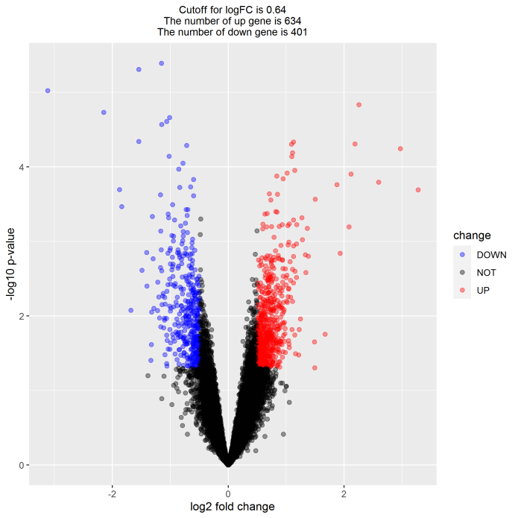Figure S1. Volcano plot of all probesets
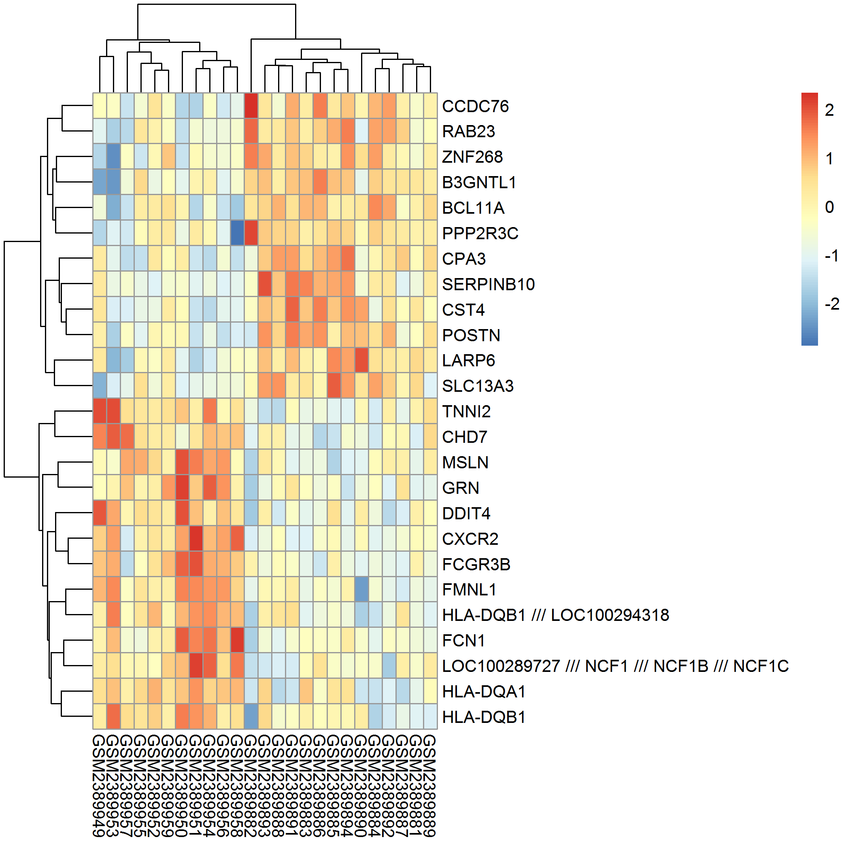Figure S2. Heatmap of the top 25 changed genes
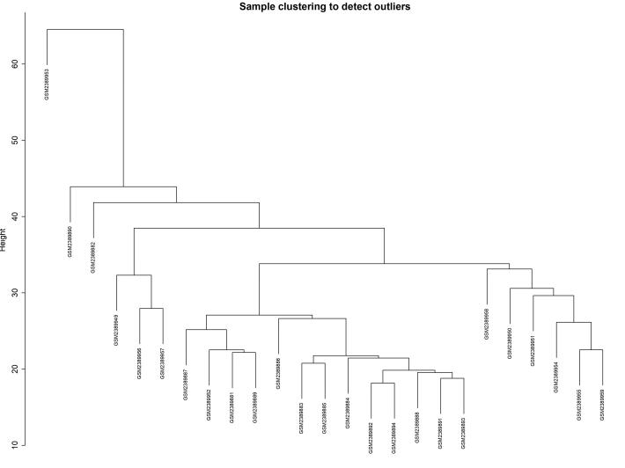Figure S3. Hierarchical clustering analysis
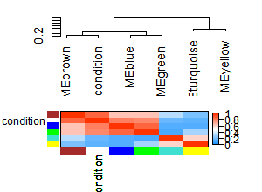Figure S4. The eigengene dendrogram and heatmap
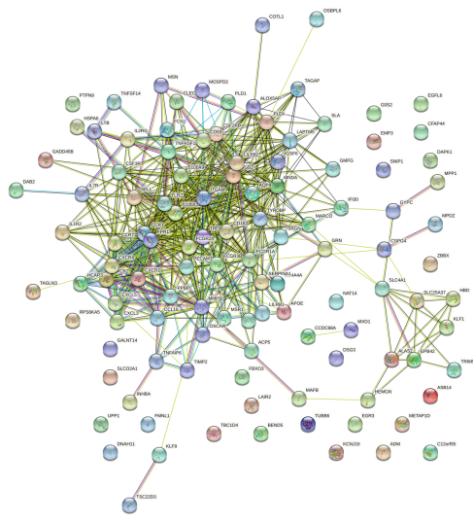Figure S5. Brown module visualized in String database
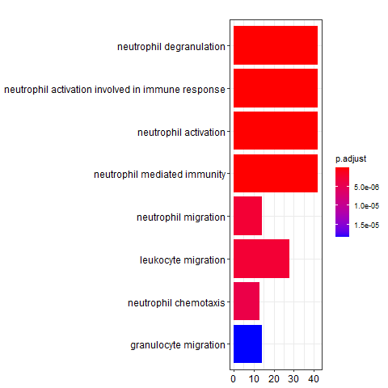Figure S6. GO enrichment analysis of genes in modules positively related to asthma severity
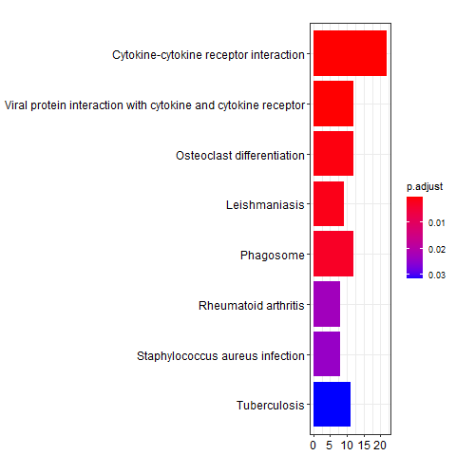Figure S7. KEGG enrichment analysis of genes in modules positively related to asthma severity
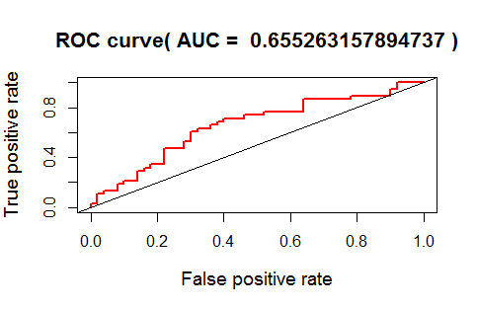Figure S8. Receiver operating characteristics curve analyses of CXCR2
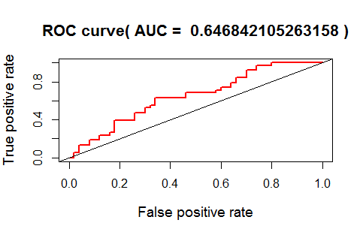Figure S9. Receiver operating characteristics curve analyses of CXCR1
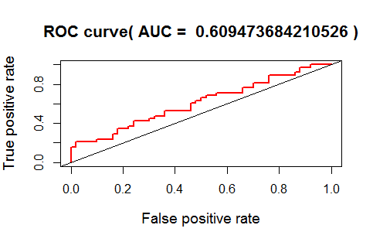Figure S10. Receiver operating characteristics curve analyses of TLR2
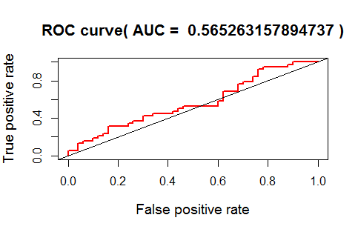Figure S11 Receiver operating characteristics curve analyses of FPR1
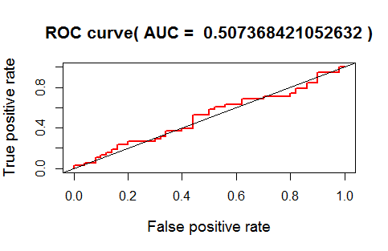Figure S12. Receiver operating characteristics curve analyses of CCR1
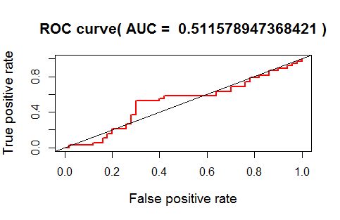Figure S13. Receiver operating characteristics curve analyses of FCGR3B
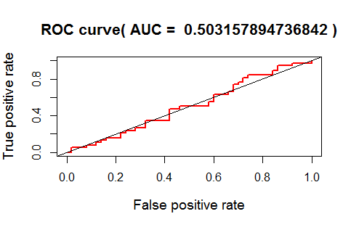Figure S14. Receiver operating characteristics curve analyses of ITGAM
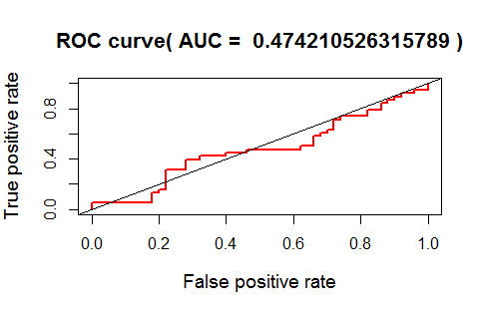Figure S15. Receiver operating characteristics curve analyses of FCGR2A
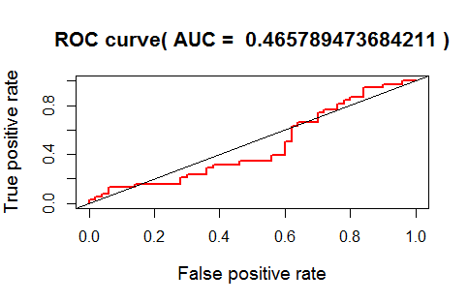Figure S16. Receiver operating characteristics curve analyses of CCR7
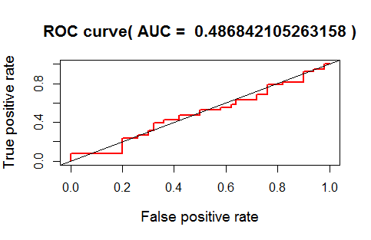Figure S17. Receiver operating characteristics curve analyses of PLEK

