Supplemental Figures:
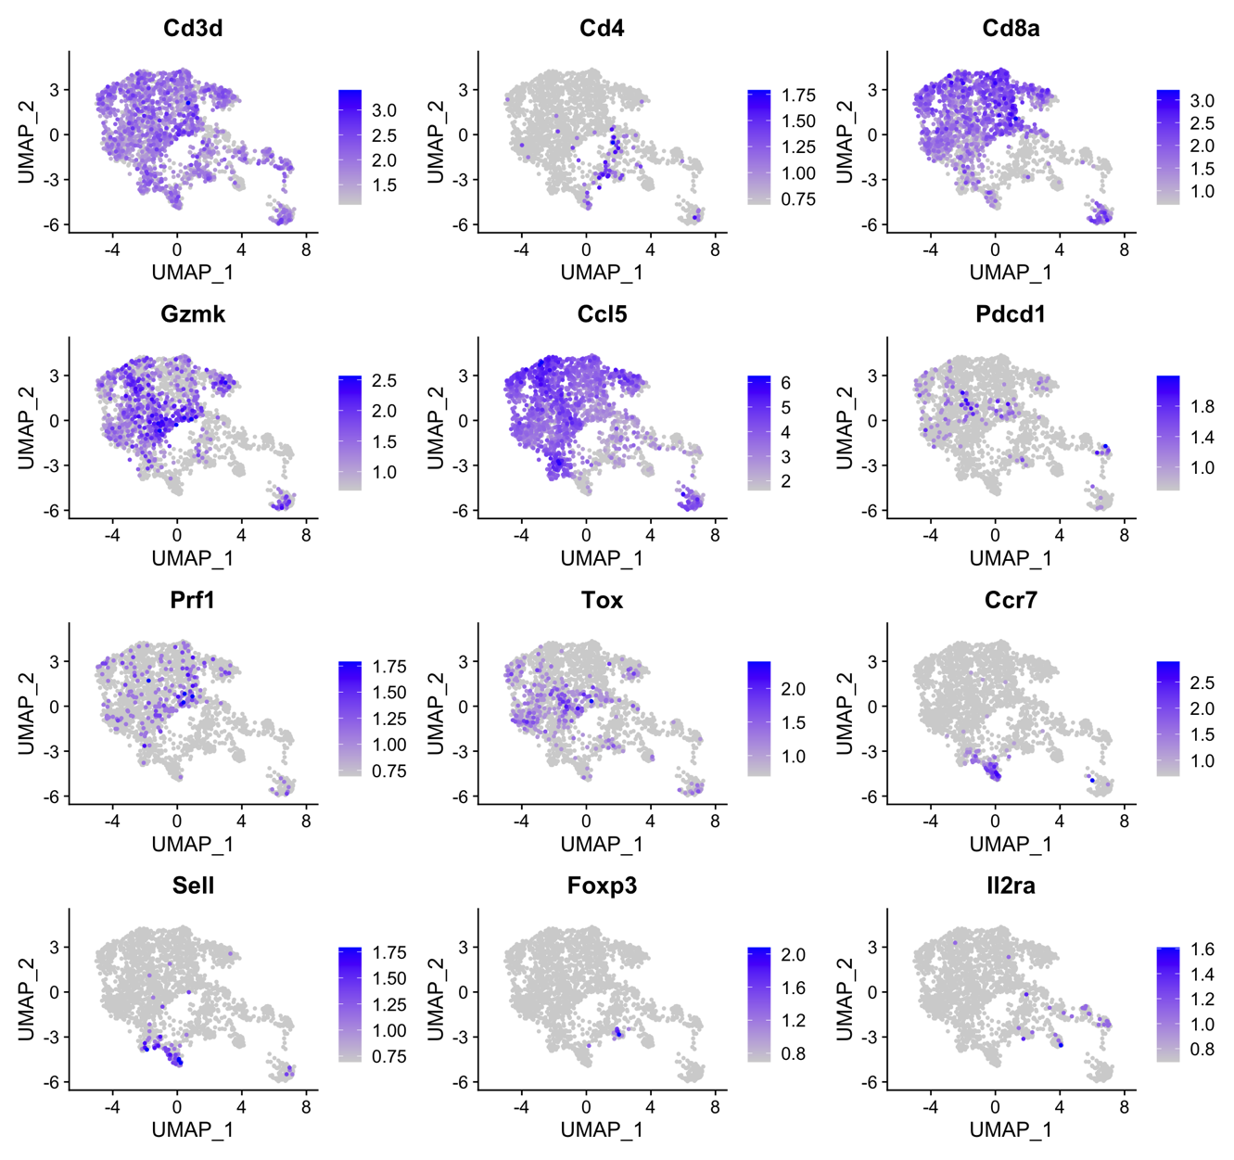

Supplement Figure 1: Feature plots visualizing the expression of markers for different T subtypes on UMAP plots. CD8⁺ effector memory T cells have upregulated expression of cytotoxic molecules (e.g., Gzmk and Prf1) and cytokines and chemokines (e.g., Ccl5). Pdcd1 and Prf1videntified CD8⁺ exhausted cells. Tox marked precursor exhausted CD8⁺ T cells. Sell and Ccr7 are enriched in both CD4⁺ and CD8⁺ naive-like cells. Foxp3 and Il2ra identify Tregs.
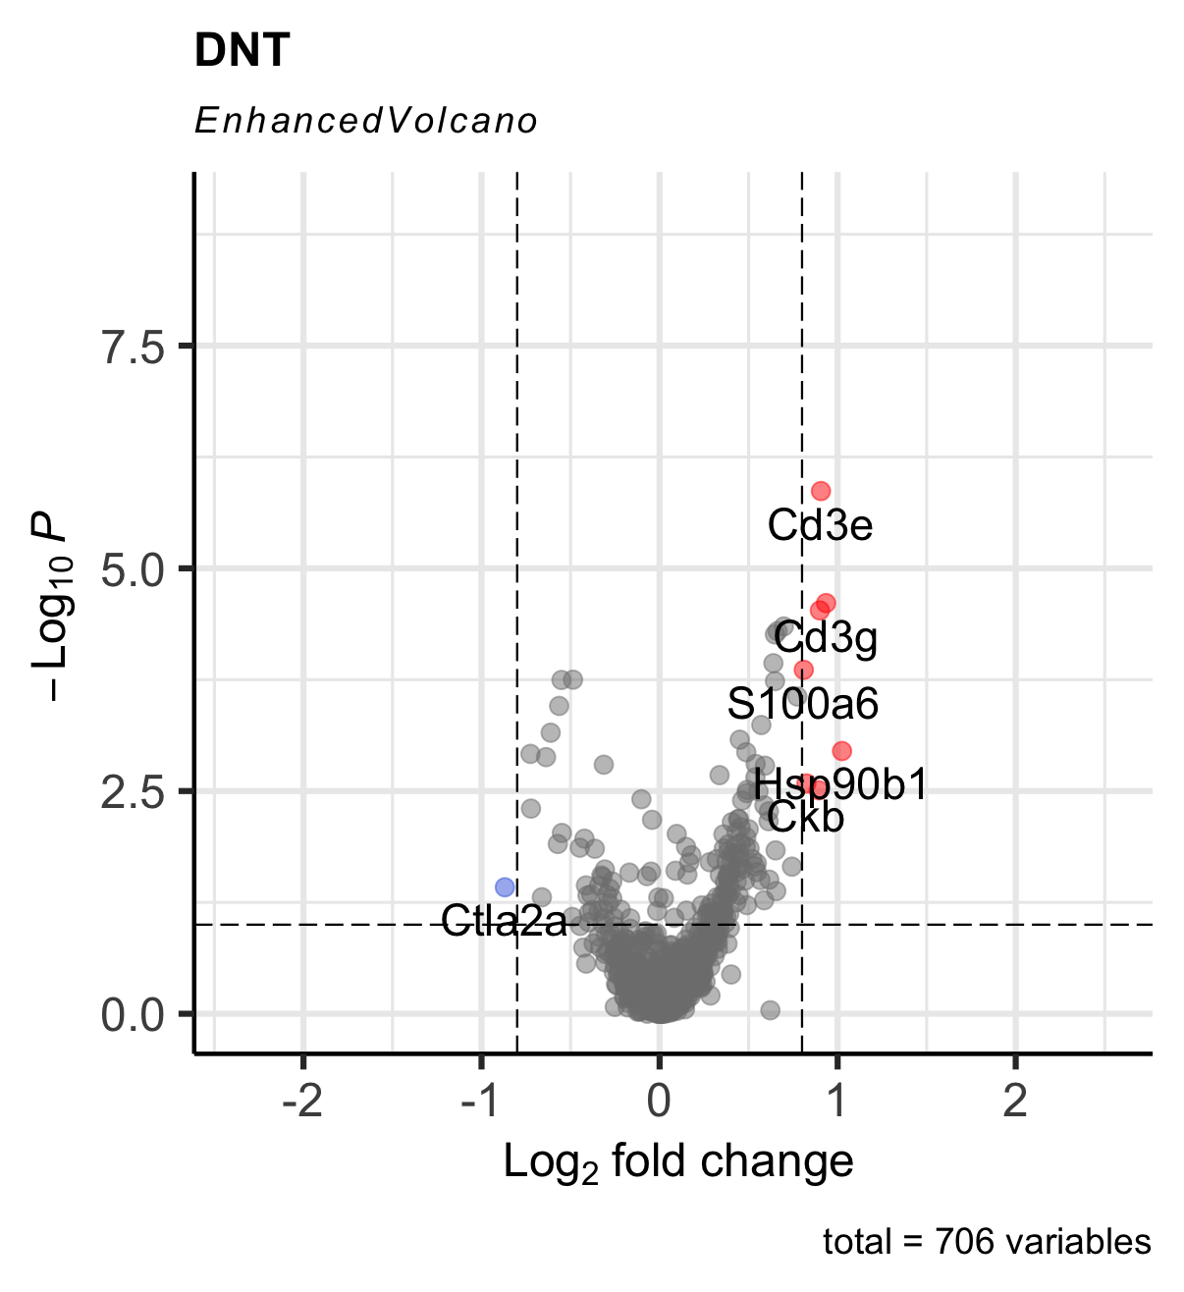
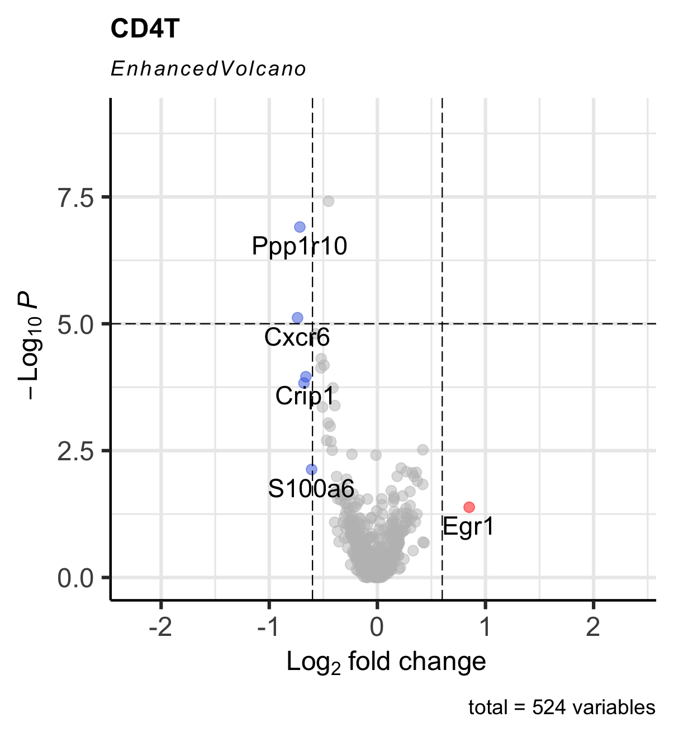
A
B

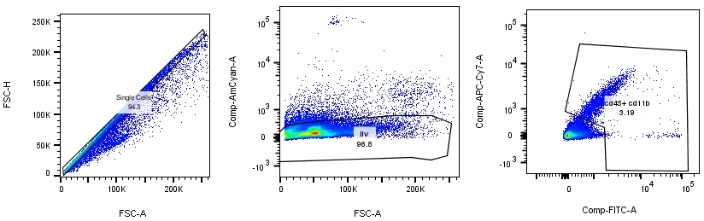
Supplement Figure 2: (A) Volcano plots showing differentially expressed genes of CD4 T, (B) DN T cells from aged mice undergoing TBI versus sham.

Supplement Figure 3: FACS profiles with gating strategy for microglia and infiltrating leukocytes. A forward scatter area (FSC-A) vs forward scatter height (FSC-H) gating identifies singlets. With the singlet gate, live cells can be isolated based on Live/Dead fixable stain, which are further subdivided into Cd45+ Cd11b subpopulations.

Materials and Methods:

Study Design
A 2x2 study design was employed to assess the interaction between age (aged vs. young) and traumatic brain injury (TBI vs. sham injury). All groups were randomly assigned.

Mice
Male C57BL/6 mice were used in all experiments. All mice were purchased from the Jackson Laboratory (Bar Harbor, ME, USA) and housed within a barrier facility at the Northwestern University Center for Comparative Medicine (Chicago, IL, USA). Young adult mice underwent TBI vs. sham injury at 14 weeks of age weighing 25g-30g (n =5-7) and aged mice underwent TBI vs. sham injury at 78-80 weeks of age weighing 35-39g (n=5-7). Animals were housed in ventilated cages under standard conditions at a temperature of 24°C and a 12 h light/dark cycle with ad libitum access to standard food and water. All procedures were approved by the Northwestern University Institutional Animal Care and Use Committee and are reported in accordance with the ARRIVE guidelines on in vivo experimentation.

Controlled Cortical Impact
TBI or sham injury was induced via a controlled cortical impact (CCI) as previously published by our laboratory (Makinde et al, 2017). As previously published in our lab animals were anesthetized with 50mg/kg Kataset Ketamine (Fort Dodge, IA, USA) and 2.5mg/kg Xylazine (Anased, Shenandoah IA) via intraperitoneal injection. All mice underwent a medial 1 cm longitudinal incision exposing the skull. TBI mice underwent a 5mm craniectomy located 2mm left of the sagittal suture and 2mm rostral to the coronal suture. The dura mater was left intact. TBI mice then received a 2mm depth injury delivered by a 3mm impacting tip at 2.5m/s with a 0.1s dwell time. Incisions were closed with VetBond 3M from Santa Cruz Animal Health (Dallas, TX, USA). Sham animals underwent scalp incision only. Post-operative analgesia (0.1mg/kg buprenorphine SR) was given to all mice. Mice were returned to their home cage where they recovered over a warming pad. The animals were observed until they fully recovered. Post TBI, mice were given the same housing environment with ad libitum access to standard food and water. The well-being of each mouse was monitored regularly. Mice were euthanized at 4-months post injury via carbon dioxide inhalation and cervical dislocation per AVMA guidelines.

Tissue Harvesting
After euthanasia peripheral blood was extracted via cardiac puncture and aspiration. The cadavers were then perfused through the apex with 20 mL of 4°C 1x Hank’s Balanced Salt Solution (HBSS). Brains were excised, weighed, and placed in ice-cold HBSS until they were processed.

Histopathology and Immunohistochemistry
Brains (n=3-5/per group) were placed in HBSS followed by being fixed in 4% paraformaldehyde in PBS. After fixation, the brains were paraffin-embedded and 4 μm brain sections were cut. Sections were processed and stained with hematoxylin and eosin (H&E), neuronal nuclei (NeuN), glial fibrillary acidic protein (GFAP), and ionized calcium-binding adaptor molecule 1 (IBA1) at the Northwestern University Mouse Histology and Phenotyping Laboratory. Slides for H&E and NeuN were imaged using an Olympus BX41 microscope equipped with an Olympus DP21 camera at 1.25x and 5x magnification and analyzed by a neuropathologist blinded to the experimental groups. To quantify cerebral edema, the percentage of vessels showing perivascular vacuolation/enlargement was assessed. 5 random 10x microscopic fields per slide were assessed and given scores according to edema level as described (Sobel, 2015). Sections were scored for neuronal degeneration and results were reported as % degenerated neurons. Slides for GFPA and IBA1 were imaged using the by TissueGnostics system (TissueGnostics, Vienna, Austria) and staining was quantified by Histoquest (TissueGnostics, Vienna, Austria).

Tissue Processing for scRNA-seq
Samples were injected with 3mL of digestion buffer [2.5 mg/ml Liberase TL (Roche, Basel, Switzerland), and 1 mg/ml of DNase I in HBSS], morcellated and placed in placed into C-tubes (Miltenyi Biotec, Bergisch Gladbach, North Rhine-Westphalia, Germany) containing 1mL of the digestion buffer. C-tubes were placed on a MACS dissociator (Miltenyi Biotec, Bergisch Gladbach, North Rhine-Westphalia, Germany) and ran using the brain dissociation protocol. Samples were then incubated in a shaker 200 rpm for 30 min at 37˚C. Following incubation, the c-tubes were returned to the MACS dissociator per the manufacturer instructions. The heterogeneous tissue mixture was strained through a 40 μm nylon mesh strainer and washed with 100Ml of autoMACs Running Buffer (Miltenyi Biotec, Bergisch Gladbach, North Rhine-Westphalia, Germany) per brain. Microglia and infiltrating leukocytes were isolated using a 30/70 percoll gradient (Percoll Plus, GE Healthcare, Chicago, IL, USA). Microglia and infiltrating leukocytes were then collected from the interphase of the gradient and washed with HBSS. The cells were courted with a Countess automated cell counter (Invtriogen, Waltham, MA, USA) and tryphan blue was used to identify dead cells. Cells were then stained with Live/dead Aqua (Invtriogen, Waltham, MA, USA) viability dye, Fc-Block (Biosciences, San Jose, CA, USA), and fluorochrome-conjugated antibodies for CD45.1(A-20/BD Biosciences, San Jose, CA, USA) and CD11b (M1/70/BD Biosciences, San Jose, CA, USA). Cells were washed and prepared for sorting.

Fluorescent Activated Cell Sorting
Data were acquired and microglia and infiltrating leukocytes were sorted on a BD FACSAria cell sorter (BD Biosciences, San Jose, CA, USA). Gates were established using “Fluorescence minus one” controls (Supp Fig. 3).

Library Preparation and Sequencing
Concentration and viability (>90%) were confirmed using K2 Cellometer (Nexcelom Bioscience LLC, Lawerence, MA, USA) with AO/PI reagent and ~5,000–10,000 cells were loaded on 10x Genomics Chip A using Chromium Single Cell V3 Reagent Kit and Controller (10x Genomics, Pleasanton, CA, USA). Single-cell 3’ RNA-Seq libraries were prepared were according to manufacturer protocol (10x Genomics, Pleasanton, CA, USA). Libraries were assessed for quality (TapeStation 4200, Agilent Technologies, Santa Carla, CA, USA) and then sequenced on HiSeq 4000 instrument (Illumina, San Diego, CA, USA) generating >25,000 read pairs/cell.

Preprocessing of scRNAseq data
Raw data were processed using the Cell Ranger, version 2.0 pipeline from 10x Genomics (Pleasanton, CA, USA). The reads were mapped to the mm10 mouse reference genome (Ensemble build 98). Individual sample expression matrices were loaded and read into R using the functions Read10x and CreateSeuratObject under the Seurat package (version 4.0.2, Satija Lab). Cells from each sample expressing more than 5000 genes, more than 10,000 unique molecular identifiers (UMIs), and more than 20% mitochondrial genes were excluded. After quality control, the expression matrix for young and aged objects (both sham and TBI) were merged using Merge function respectively followed by regularized negative binomial regression using the SCTransform normalization method to normalize, scale, select variable genes and regress out mitochondrial mapping percentage (Seurat package version 4.0.2, Satija Lab). Integration was performed using Integration function to correct experimental batch effect on datasets normalized with SCTransform. Following PCA, principle components were selected for clustering the cells. Differentially expression analysis was performed using FindAllMarkers function with the Wilcoxon signed-rank test to identify top expressed genes (Seurat package version 4.0.2, Satija Lab). with unsupervised clustering, we annotated clusters using both top expressed genes and known markers for major microglia and infiltrating cell types, retrieved from the Allen Brain Atlas (1), UCSC Cell Browser (2), PanglaoDB (3), Hammondet al, (4), Masuda et al (5), and Ochocka et al (6). These markers were sufficient to define all major cell types. The R package ‘ggplot2’ version 3.3.5 was used to plot proportion of the identified cell types across samples.

Analysis of scRNAseq data
Cluster of T cells and microglia was subset using Subset function in Seurat followed by unsupervised clustering. Unsupervised clustering methods are useful for the discovery of novel cell types (Ranjan, B, et al, 2021). The packages 'UCell', 'scGate', ‘ProjecTIL’, and ‘TILPRED’ downloaded from Carmona Lab (https://github.com/carmonalab) were utilized to assist the annotation of T subtypes (Andreatta M et al, 2021). Differentially expression analysis was performed using FindMarkers function in Seurat with the Model-based Analysis of Sincle Cell Transcriptomics (MAST) algorithm from the R package ‘MAST’ version 1.8.2 (Finak et al, 2015) to identify differentially expressed genes between T cell subtypes from aged TBI mice versus T cell subtypes from aged sham mice. For all comparisons between T cell subtypes, only genes expressed by at least 10 or 50% of cells were included. To identify upregulated genes in microglia from aged TBI mice and young TBI mice, we firstly extracted genes highly upregulated in microglial cells from aged TBI brain (significantly upregulated genes in aged TBI compared to aged sham) as well as genes highly upregulated in microglial cells from young TBI brain (significantly upregulated genes in young TBI compared to young sham). Subsequently, we compared those profiles in aged TBI and young TBI microglia to find genes either common or specific for each sample. Comparison of upregulated genes between aged TBI and young TBI was plotted using ggplot2 packages with selected genes from aged TBI labelled.

For both T cells and microglia, the R package ‘EnhancedVolcano’ version 1.9.5 (Blighe, K et al, 2018) was used to plot the results of the differential expression analysis, showing the average log fold change of each gene and the -log10 of the P value. Mitochondrial and ribosomal genes were filtered for volcano plots. Downstream gene ontology (GO) enrichment analysis was performed using the Gorilla (Eden E, et al, 2007; Eden E, et al, 2009) with all genes within the cell type in the dataset as a background. Enriched ontology terms for biological and functional processes were plotted using ggplot2 packages displaying FDR.q.values and enrichment scores.

