Supporting Information

A single point mutation in the Plasmodium falciparum 3´-5´exonuclease does not alter piperaquine susceptibility

Nonlawat Boonyalai^{1*}, Kirakarn Kirativanich¹, Chatchadaporn Thamnurak¹, Chantida Praditpol¹, Brian A. Vesely¹, Mariusz Wojnarski¹, John S. Greisenbeck¹, Norman C. Waters¹.

¹Department of Bacterial and Parasitic Diseases, Armed Forces Research Institute of Medical Sciences, Bangkok, Thailand.

Short running title: The E145G mutation in the exonuclease gene does not confer piperaquine resistance in Plasmodium falciparum

*Correspondence: Nonlawat Boonyalai, nonlwatb.fsn@afrims.org

Table S1 Oligonucleotide primer sequences used in this study
Primer name | Sequence (5′ - 3′)
Q5SDM_G415E_F | AAGAGGTGAACAACCACTGGGAG
Q5SDM_G415E_R | CCTTGATGGTGATCACCATATTGTTAAAATC
Bsd_NcoI_F | GGATCCATGGCCAAGCCTTTGTCTCAAG
Bsd_SacII_R | AATTCCGCGGCCGCGGTTAGCCCTCCCACACATAAC
sgE415G-1F | ATTGTATGGTTATAACGATAAAAG
sgE415G-1R | AAACCTTTTATCGTTATAACCATA
ExonI_K283_F → | AAGCAGTTGAAAAATACACTCTTTTTATTATTAAACGATATTGAGTG
Screen_WT_Rev_V616 ← | AATCTATTATATATATTTTATTATTTGTTGAAATAGATAGAACACTA
Recodon_F → | ATGGTGATCACCATCAAGGGCG
Recodon_R ← | TTCCAGCAGCCACTTGAAGAATGT
Screen_3’UTR_R ← | CGAGGGGATAAGGTTTATTTTGTAGGGAAAAG
Pfk13_outer_F | CGGAGTGACCAAATCTGGGA
Pfk13_outer_R | GGGAATCTGGTGGTAACAGC
Pfk13_nested_F | GCCAAGCTGCCATTCATTTG
Pfk13_nested_R | GCCTTGTTGAAAGAAGCAGA
Pfexo_E415G_F | GCACCTCCTATCATCAGATGATACC
Pfexo_E415G_R | CAAGAAAAGAGGAAGGAACACCTTC
Pfcrt_93_145_F | TGCTAAAAGAACTTTAAACAAAATTGG
Pfcrt_93_145_R | CAAGAACTACTGGAAATATCCAATC
Pfcrt_218_F | TCTCGGAGCAGTTATTATTGTTG
Pfcrt_218_R | ATTTCCCTTGTCATGTTTGAA
Pfcrt_343_353_F | CGCATTGTTTTCCTTCTTTAAC
Pfcrt_343_353_R | CGGCTAAGAATTTAAAGTAATAAGCAA
Pfpm1_fw | CAATGGTTTCGAACCAGCTT
Pfpm1_rv | GGTAAAAACGGCTTGTTCGAT
Pfpm2_fw | TGGTGATGCAGAAGTTGGAG
Pfpm2_rv | TGGGACCCATAAATTAGCAGA
Pfpm3_fw | CACCTTCATGAAAAATGAAGAATC
Pfpm3_rv | AAGAAAAACCTCCTGCCAAAA
PfB-tub_fw | TGATGTGCGCAAGTGATCC
PfB-tub_rv | TCCTTTGTGGACATTCTTCCTC
AF_for | CCACGATTTATATTGGCAAGTTGATTTAG
AR_rev | CATTTCTACTAAAATTAGCTTTAGCATCATTCACG
BF_for | CGTAGAATCTGCAAGTGTTTTCAAAG
BR_rev | AATGTTATAAATGCAATATAATCAAACGACATCAC

(Coloured arrows in the left-hand column correspond to primer annotation in Fig 1)

PF3D7_Exo_WT ATGACATCACATATTAGTTACAATAAAATAAGAGAAAAAAGGAACATAAGAAGGGTACTG 60
PFB5_Exo_WT ATGACATCACATATTAGTTACAATAAAATAAGAGAAAAAAGGAACATAAGAAGGGTACTG 60
PFB8_Exo_E415G ATGACATCACATATTAGTTACAATAAAATAAGAGAAAAAAGGAACATAAGAAGGGTACTG 60
************************************************************

PF3D7_Exo_WT AGCGTTTATAATTTTTGTTCATTAAATAGATTCTCATGGTACAGACAAGATGTGAGATTA 120
PFB5_Exo_WT AGCGTTTATAATTTTTGTTCATTAAATAGATTCTCATGGTACAGACAAGATGTGAGATTA 120
PFB8_Exo_E415G AGCGTTTATAATTTTTGTTCATTAAATAGATTCTCATGGTACAGACAAGATGTGAGATTA 120
************************************************************

PF3D7_Exo_WT GATAATGTGATATATAGAAAGAATTATGAATATATTTATTATAATTGTATTATAAGAAAA 180
PFB5_Exo_WT GATAATGTGATATATAGAAAGAATTATGAATATATTTATTATAATTGTATTATAAGAAAA 180
PFB8_Exo_E415G GATAATGTGATATATAGAAAGAATTATGAATATATTTATTATAATTGTATTATAAGAAAA 180
************************************************************

PF3D7_Exo_WT TGTAGTAGAAATTATATATCTACACGTAATAATATATATATTAAAAACAAAATATATGAT 240
PFB5_Exo_WT TGTAGTAGAAATTATATATCTACACGTAATAATATATATATTAAAAACAAAATATATGAT 240
PFB8_Exo_E415G TGTAGTAGAAATTATATATCTACACGTAATAATATATATATTAAAAACAAAATATATGAT 240
************************************************************

PF3D7_Exo_WT ATAATACCATATTTATGTAAAGGTAAAGATGTAAAAAATATAACAAGTAATATAATATTT 300
PFB5_Exo_WT ATAATACCATATTTATGTAAAGGTAAAGATGTAAAAAATATAACAAGTAATATAATATTT 300
PFB8_Exo_E415G ATAATACCATATTTATGTAAAGGTAAAGATGTAAAAAATATAACAAGTAATATAATATTT 300
************************************************************

PF3D7_Exo_WT TATATTTTACAACATTTAAGTACAAAAAATGTTGTTAATAGTAATGAATATAAAGATAAT 360
PFB5_Exo_WT TATATTTTACAACATTTAAGTACAAAAAATGTTGTTAATAGTAATGAATATAAAGATAAT 360
PFB8_Exo_E415G TATATTTTACAACATTTAAGTACAAAAAATGTTGTTAATAGTAATGAATATAAAGATAAT 360
************************************************************

PF3D7_Exo_WT ATAAAAAAAATATATTTTAATTTATTGAAATGTTATCATAAAATTTTTGAATATAATAAT 420
PFB5_Exo_WT ATAAAAAAAATATATTTTAATTTATTGAAATGTTATCATAAAATTTTTGAATATAATAAT 420
PFB8_Exo_E415G ATAAAAAAAATATATTTTAATTTATTGAAATGTTATCATAAAATTTTTGAATATAATAAT 420
************************************************************

PF3D7_Exo_WT GAATATGGAGAATATATATTTAGCCTGTTTAATGATGATATAATTATATCTGTTAGTCCG 480
PFB5_Exo_WT GAATATGGAGAATATATATTTAGCCTGTTTAATGATGATATAATTATATCTGTTAGTCCG 480
PFB8_Exo_E415G GAATATGGAGAATATATATTTAGCCTGTTTAATGATGATATAATTATATCTGTTAGTCCG 480
************************************************************

PF3D7_Exo_WT TCTTTAAGAAAGAAACAAAAAAATATTATACAAGATATATTATTGAATAGCTTACATTTT 540
PFB5_Exo_WT TCTTTAAGAAAGAAACAAAAAAATATTATACAAGATATATTATTGAATAGCTTACATTTT 540
PFB8_Exo_E415G TCTTTAAGAAAGAAACAAAAAAATATTATACAAGATATATTATTGAATAGCTTACATTTT 540
************************************************************

PF3D7_Exo_WT TTTTTCCAGAATAATATAACATATAAAAATAAATTAAATATAAATTTGATGTGTGAAATT 600
PFB5_Exo_WT TTTTTCCAGAATAATATAACATATAAAAATAAATTAAATATAAATTTGATGTGTGAAATT 600
PFB8_Exo_E415G TTTTTCCAGAATAATATAACATATAAAAATAAATTAAATATAAATTTGATGTGTGAAATT 600
************************************************************

PF3D7_Exo_WT ATTAATTATCCAAAGTTTTTGTATGTATTACATTCTATTAATTATGATATGAATATATTA 660
PFB5_Exo_WT ATTAATTATCCAAAGTTTTTGTATGTATTACATTCTATTAATTATGATATGAATATATTA 660
PFB8_Exo_E415G ATTAATTATCCAAAGTTTTTGTATGTATTACATTCTATTAATTATGATATGAATATATTA 660
************************************************************

PF3D7_Exo_WT AAACAAAATATAAGTGTACAAAATGTAGATTATTTATTTTCTCAGTATATTAATAAAACA 720
PFB5_Exo_WT AAACAAAATATAAGTGTACAAAATGTAGATTATTTATTTTCTCAGTATATTAATAAAACA 720
PFB8_Exo_E415G AAACAAAATATAAGTGTACAAAATGTAGATTATTTATTTTCTCAGTATATTAATAAAACA 720
************************************************************

PF3D7_Exo_WT AATATATATATTACTACAGCAATTCAATTCGCTTCATTTTTTAAAAATGTCAACATGAAT 780
PFB5_Exo_WT AATATATATATTACTACAGCAATTCAATTCGCTTCATTTTTTAAAAATGTCAACATGAAT 780
PFB8_Exo_E415G AATATATATATTACTACAGCAATTCAATTCGCTTCATTTTTTAAAAATGTCAACATGAAT 780
************************************************************

PF3D7_Exo_WT ATTTTCACACCTTTTAAGAAACACGGTACATTTAATTATTTCTTATTATTAAAACGTATA 840
PFB5_Exo_WT ATTTTCACACCTTTTAAGAAACACGGTACATTTAATTATTTCTTATTATTAAAACGTATA 840
PFB8_Exo_E415G ATTTTCACACCTTTTAAGAAACACGGTACATTTAATTATTTCTTATTATTAAAACGTATA 840
************************************************************

PF3D7_Exo_WT GTAAATAAGCAGTTGAAAAATACACTCTTTTTATTATTAAACGATATTGAGTGTCATCGG 900
PFB5_Exo_WT GTAAATAAGCAGTTGAAAAATACACTCTTTTTATTATTAAACGATATTGAGTGTCATCGG 900
PFB8_Exo_E415G GTAAATAAGCAGTTGAAAAATACACTCTTTTTATTATTAAACGATATTGAGTGTCATCGG 900
************************************************************

PF3D7_Exo_WT TTAAGGCAGGAAATGCTTTTGCACCTCCTATCATCAGATGATACCACAGgtataaaaaaa 960
PFB5_Exo_WT TTAAGGCAGGAAATGCTTTTGCACCTCCTATCATCAGATGATACCACAGgtataaaaaaa 960
PFB8_Exo_E415G TTAAGGCAGGAAATGCTTTTGCACCTCCTATCATCAGATGATACCACAGgtataaaaaaa 960
************************************************************

PF3D7_Exo_WT aaaaaaatatatatatatatatatatatatttatatatgtatatatgtatatatgtatat 1020
PFB5_Exo_WT aaaaaaatatatatatatatatatatatatttatatatgtatatatgtatatatgtatat 1020
PFB8_Exo_E415G aaaaaaatatatatatatatatatatatatttatatatgtatatatgtatatatgtatat 1020
************************************************************

PF3D7_Exo_WT atttattttttatttattatttttttttttttttttttttttccttctgacccctttata 1080
PFB5_Exo_WT atttattttttatttattatttttttttttttttttttttttccttctgacccctttata 1080
PFB8_Exo_E415G atttattttttatttattatttttttttttttttttttttttccttctgacccctttata 1080
************************************************************

PF3D7_Exo_WT gGAATGTGCTTTAACGAATGGAGTCATTTAGCAGCAAAGAAATATTTACTTATGAACAAG 1140
PFB5_Exo_WT gGAATGTGCTTTAACGAATGGAGTCATTTAGCAGCAAAGAAATATTTACTTATGAACAAG 1140
PFB8_Exo_E415G gGAATGTGCTTTAACGAATGGAGTCATTTAGCAGCAAAGAAATATTTACTTATGAACAAG 1140
************************************************************

PF3D7_Exo_WT TATGAAAATGATCTTAAGGAAAATATAAGAGATCAAGAAATAAATGTTAACATTTTGAAA 1200
PFB5_Exo_WT TATGAAAATGATCTTAAGGAAAATATAAGAGATCAAGAAATAAATGTTAACATTTTGAAA 1200
PFB8_Exo_E415G TATGAAAATGATCTTAAGGAAAATATAAGAGATCAAGAAATAAATGTTAACATTTTGAAA 1200
************************************************************

PF3D7_Exo_WT AGATCAATTGATTATGTTAAGGATTACGATGACGATAACGATAAAGTTAACAATAACGAT 1260
PFB5_Exo_WT AGATCAATTGATTATGTTAAGGATTACGATGACGATAACGATAAAGTTAACAATAACGAT 1260
PFB8_Exo_E415G AGATCAATTGATTATGTTAAGGATTACGATGACGATAACGATAAAGTTAACAATAACGAT 1260
************************************************************

PF3D7_Exo_WT AACGATAATGATAACGATTTATATATGGAATATTTTAATTTACCTGAAGACGTTAAAAAT 1320
PFB5_Exo_WT AACGATAATGATAACGATTTATATATGGAATATTTTAATTTACCTGAAGACGTTAAAAAT 1320
PFB8_Exo_E415G AACGATAATGATAACGATTTATATATGGAATATTTTAATTTACCTGAAGACGTTAAAAAT 1320
************************************************************

PF3D7_Exo_WT GTAAAGTACATAAAATGTGTTGATGATTTTAACAATATGGTTATAACGATAAAAGAGGAA 1380
PFB5_Exo_WT GTAAAGTACATAAAATGTGTTGATGATTTTAACAATATGGTTATAACGATAAAAGAGGAA 1380
PFB8_Exo_E415G GTAAAGTACATAAAATGTGTTGATGATTTTAACAATATGGTGATCACCATCAAGGGCGAG 1380
***************************************** ** ** ** ** * **

PF3D7_Exo_WT GTAAACAATCATTGGGAAAATAATATATACAATAAAAAGGATATGGTTAATTATACAAAT 1440
PFB5_Exo_WT GTAAACAATCATTGGGAAAATAATATATACAATAAAAAGGATATGGTTAATTATACAAAT 1440
PFB8_Exo_E415G GTGAACAACCACTGGGAGAACAACATCTACAACAAGAAGGACATGGTCAACTACACCAAT 1440
** ***** ** ***** ** ** ** ***** ** ***** ***** ** ** ** ***

PF3D7_Exo_WT GAAAATTATAATGATAATATATTAACATATGAATATATTAATGAAACACTTAGAAAAGAA 1500
PFB5_Exo_WT GAAAATTATAATGATAATATATTAACATATGAATATATTAATGAAACACTTAGAAAAGAA 1500
PFB8_Exo_E415G GAGAACTACAACGACAACATCCTGACCTACGAGTACATCAACGAGACACTGAGAAAGGAA 1500
** ** ** ** ** ** ** * ** ** ** ** ** ** ** ***** ***** ***

PF3D7_Exo_WT AAAAAAAGATATTATATAGGTATAGATATCGAATGGGATAGTTATAAAAAAAAAAAAAAT 1560
PFB5_Exo_WT AAAAAAAGATATTATATAGGTATAGATATCGAATGGGATAGTTATAAAAAAAAAAAAAAT 1560
PFB8_Exo_E415G AAGAAGCGGTACTACATCGGCATCGACATCGAGTGGGACAGCTACAAGAAAAAGAAAAAC 1560
** ** * ** ** ** ** ** ** ***** ***** ** ** ** ***** *****

PF3D7_Exo_WT ACTGTTAGTGTTCTATCTATTTCAACAAATAATAAAATATATATAATAGATTTATATTAT 1620
PFB5_Exo_WT ACTGTTAGTGTTCTATCTATTTCAACAAATAATAAAATATATATAATAGATTTATATTAT 1620
PFB8_Exo_E415G ACCGTGTCCGTGCTGAGCATCAGCACCAACAACAAGATCTACATCATCGATCTGTACTAC 1620
** ** ** ** ** ** ** ** ** ** ** ** ** *** * ** **

PF3D7_Exo_WT ATTGATTATAATTATAAATTTATGATATATACGTTTTTTAAATGGTTATTAGAAAATCCG 1680
PFB5_Exo_WT ATTGATTATAATTATAAATTTATGATATATACGTTTTTTAAATGGTTATTAGAAAATCCG 1680
PFB8_Exo_E415G ATCGACTACAATTACAAGTTCATGATCTATACATTCTTCAAGTGGCTGCTGGAAAATCCG 1680
** ** ** ***** ** ** ***** ***** ** ** ** *** * * *********

PF3D7_Exo_WT TTTATATATAAATTGTTTTTTAATTTCCCTTCGGATATTAAAATAATGTCTTCATATTTT 1740
PFB5_Exo_WT TTTATATATAAATTGTTTTTTAATTTCCCTTCGGATATTAAAATAATGTCTTCATATTTT 1740
PFB8_Exo_E415G TTTATATATAAATTGTTTTTTAATTTCCCTTCGGATATTAAAATAATGTCTTCATATTTT 1740
************************************************************

PF3D7_Exo_WT CAAAACATATCACATATAAATATATATAACAATATTATAGATTTAAATAATAATATATAT 1800
PFB5_Exo_WT CAAAACATATCACATATAAATATATATAACAATATTATAGATTTAAATAATAATATATAT 1800
PFB8_Exo_E415G CAAAACATATCACATATAAATATATATAACAATATTATAGATTTAAATAATAATATATAT 1800
************************************************************

PF3D7_Exo_WT ATATATACAAGAAAAGAGGAAGGAACACCTTCTTATAAGAATTATAATATTTTATATTTT 1860
PFB5_Exo_WT ATATATACAAGAAAAGAGGAAGGAACACCTTCTTATAAGAATTATAATATTTTATATTTT 1860
PFB8_Exo_E415G ATATATACAAGAAAAGAGGAAGGAACACCTTCTTATAAGAATTATAATATTTTATATTTT 1860
************************************************************

PF3D7_Exo_WT GAAACATTGAATAGAGATATGATTCAATCAAATGATGTACATTTATTCAAAGAATTAGTA 1920
PFB5_Exo_WT GAAACATTGAATAGAGATATGATTCAATCAAATGATGTACATTTATTCAAAGAATTAGTA 1920
PFB8_Exo_E415G GAAACATTGAATAGAGATATGATTCAATCAAATGATGTACATTTATTCAAAGAATTAGTA 1920
************************************************************

PF3D7_Exo_WT CATTCGACACCTTATAATTTTAATAAGAATTTAATGAATAAAATAAAAAAAAAAAATAAT 1980
PFB5_Exo_WT CATTCGACACCTTATAATTTTAATAAGAATTTAATGAATAAAATAAAAAAAAATAATAAT 1980
PFB8_Exo_E415G CATTCGACACCTTATAATTTTAATAAGAATTTAATGAATAAAATAAAAAAAAATAATAAT 1980
***************************************************** ******

PF3D7_Exo_WT AATATTAATATACCAAACAAACAAATGTTCAAATTATATGTTAAAAGTTTAAATGACTTA 2040
PFB5_Exo_WT AATATTAATATACCAAACAAACAAATGTTCAAATTATATGTTAAAAGTTTAAATGACTTA 2040
PFB8_Exo_E415G AATATTAATATACCAAACAAACAAATGTTCAAATTATATGTTAAAAGTTTAAATGACTTA 2040
************************************************************

PF3D7_Exo_WT TGTATAAAGATATTAAATAAAAAGTTAAATAAAAAATTTCAATTAGCTAACTGGAATATA 2100
PFB5_Exo_WT TGTATAAAGATATTAAATAAAAAGTTAAATAAAAAATTTCAATTAGCTAACTGGAATATA 2100
PFB8_Exo_E415G TGTATAAAGATATTAAATAAAAAGTTAAATAAAAAATTTCAATTAGCTAACTGGAATATA 2100
************************************************************

PF3D7_Exo_WT AGACCACTTAACCAAGAACAAATAATATATGCATGTATTGATTCATATGTTTTAATAAAG 2160
PFB5_Exo_WT AGACCACTTAACCAAGAACAAATAATATATGCATGTATTGATTCATATGTTTTAATAAAG 2160
PFB8_Exo_E415G AGACCACTTAACCAAGAACAAATAATATATGCATGTATTGATTCATATGTTTTAATAAAG 2160
************************************************************

PF3D7_Exo_WT ATAGAAGAAATGTTGATAGAAAAAGGTTATATGTCTACATGTGATTCTAACAACAATCAA 2220
PFB5_Exo_WT ATAGAAGAAATGTTGATAGAAAAAGGTTATATGTCTACATGTGATTCTAACAACAATCAA 2220
PFB8_Exo_E415G ATAGAAGAAATGTTGATAGAAAAAGGTTATATGTCTACATGTGATTCTAACAACAATCAA 2220
************************************************************

PF3D7_Exo_WT ATGATGAATTTATTTCTTCAAAAATATAAGTTCAAAGATAGTACATGGGAATGA 2274
PFB5_Exo_WT ATGATGAATTTATTTCTTCAAAAATATAAGTTCAAAGATAGTACATGGGAATGA 2274
PFB8_Exo_E415G ATGATGAATTTATTTCTTCAAAAATATAAGTTCAAAGATAGTACATGGGAATGA 2274
******************************************************

Fig.S1. DNA sequence alignment of exo gene from P. falciparum 3D7, B5 and B5-rexo-E415G-B8 parasites. The exo gene contains 2 exons and one intron. Exon 1 starts from nucleotides 1 to 949, while exon 2 starts from nucleotides 1018 to 2274. The intron is shown in lowercase letters. Grey highlight indicates the recodonized region in B8 line with the amino acid residue 415 change from Glu (codon GAG) to Gly (codon GGC). One single nucleotide mutation at position 1974 from A to T leads to non-synonymous mutation, changing from amino acid Lys to Asn. Guide RNA sequence is shown in yellow highlight while the Protospacer Adjacent Motif (PAM) site is shown in magenta highlight.
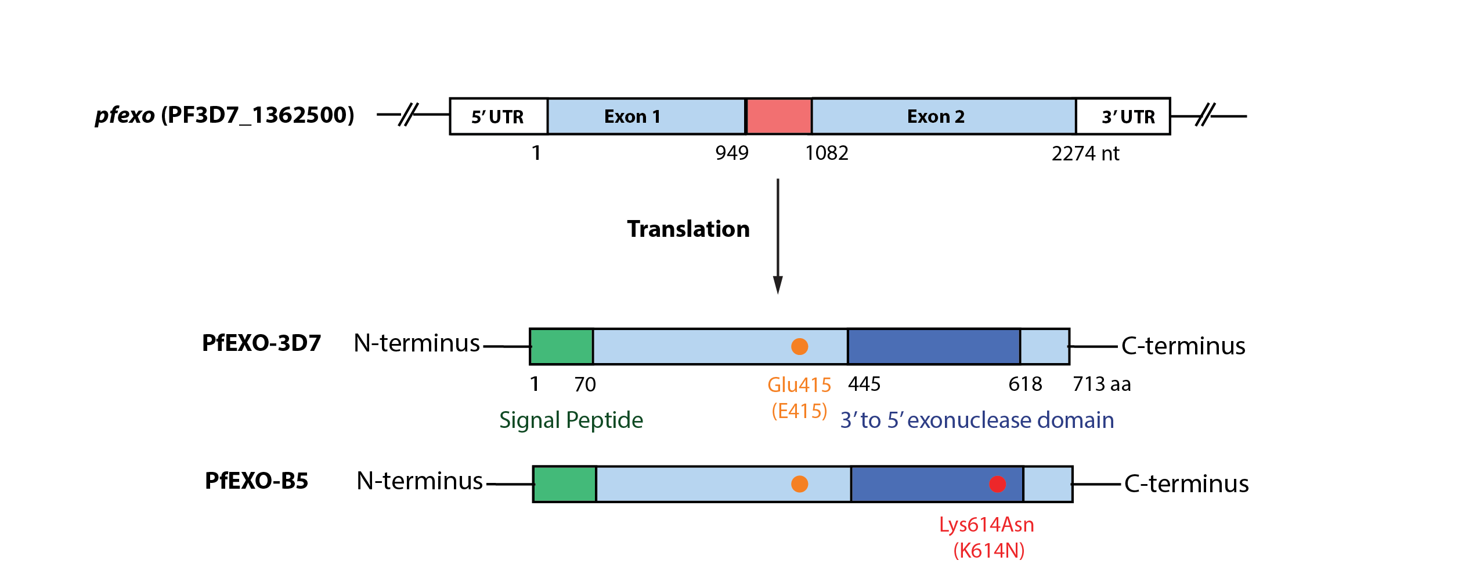
Fig. S2. Gene and amino acid composition of PfEXO. Schematic diagram of pfexo gene and domain structure of PfEXO from 3D7 and B5 lines. pfexo gene contains 2 exons (light blue boxes) and 1 intron (red box). PfEXO contains N-terminal signal peptide (green box) and 3′ to 5′ exonuclease domain (navy blue box). Single amino acid mutation from Lys to Asn at residue 614 found in PfEXO from the B5 line is indicated in red circles. The amino acid Glu at residue 415, focused on in this study, is indicated in orange circles.

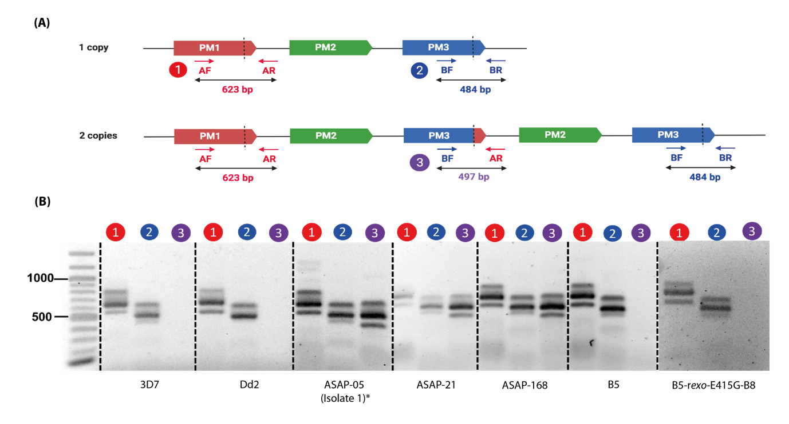
Fig S3. Schematic of P. falciparum plasmepsin 2/3 (pfpm2/3) gene duplication. (A) Gene model showing the pfpm 2/3 breakpoint (dashed lines). Primer positions are labelled in the single copy (top) and multiple copy (bottom) isolates. (B) Amplification primer pairs 1 and 2 are to confirm that regions surrounding the pfpm 2/3 amplification are present in all samples, while primer pair 3 is to detect the pfpm 2/3 amplification and no PCR products are observed in samples with a single copy of pfpm 2/3 amplification. It is noted that ASAP-05 was name isolate 1 in the previous publication¹.

Reference
1 Boonyalai, N. et al. Piperaquine resistant Cambodian Plasmodium falciparum clinical isolates: in vitro genotypic and phenotypic characterization. Malar J 19, 269, doi:10.1186/s12936-020-03339-w (2020).

