Associations of prepregnancy body mass index and gestational weight gain with intelligence in offspring: A systematic review and meta-analysis

Simeng Zhu^{1, 3}, Yichen He^{1, 3}, Chen Zhang², Yanting Wu², Hefeng Huang^{1,2}

¹International Peace Maternal and Child Health Hospital, Shanghai Jiao Tong University, School of medicine, China;
²Hospital of Obstetrics and Gynaecology, Fudan University, Shanghai 200011, China.
³These two authors contribute equally to this work.
Corresponding Author: Hefeng Huang, MD, International Peace Maternal and Child Health Hospital, Shanghai Jiao Tong University, School of medicine, Shanghai 2000030, China and Hospital of Obstetrics and Gynaecology, Fudan University, Shanghai 200011, China. (huanghefg@hotmail.com)
and Yanting Wu, PhD, Hospital of Obstetrics and Gynaecology, Fudan University, Shanghai 200011, People's Republic of China. (yanting_wu@163.com)

Additional file 4: Subgroup meta-analysis of a) pre-pregnancy overweight b) pre-pregnancy obesity c) excessive gestational weight gain group according to age.
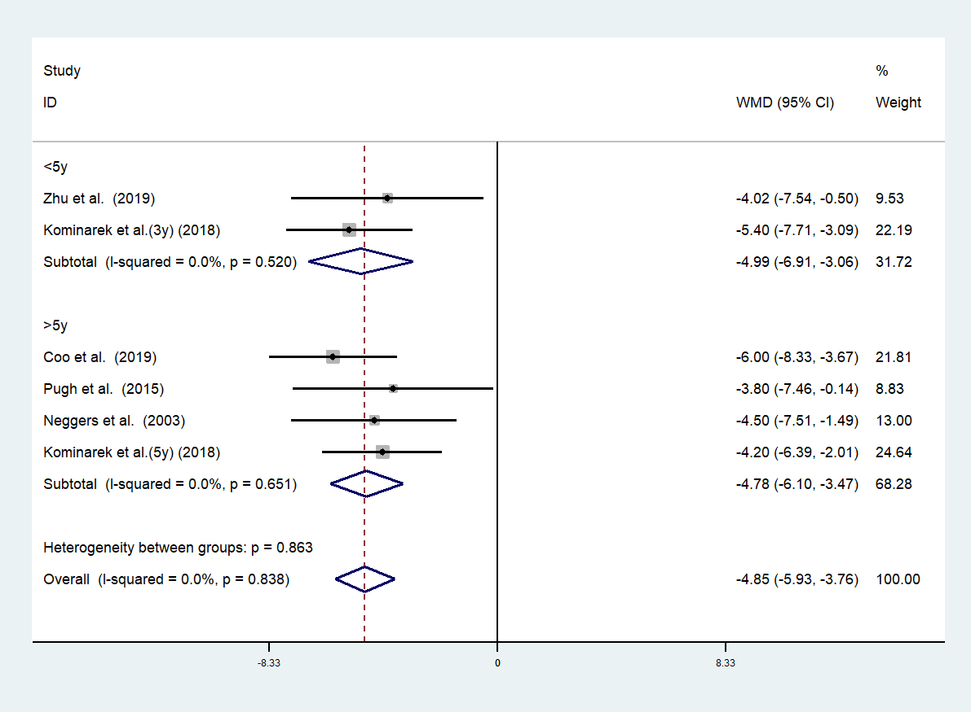a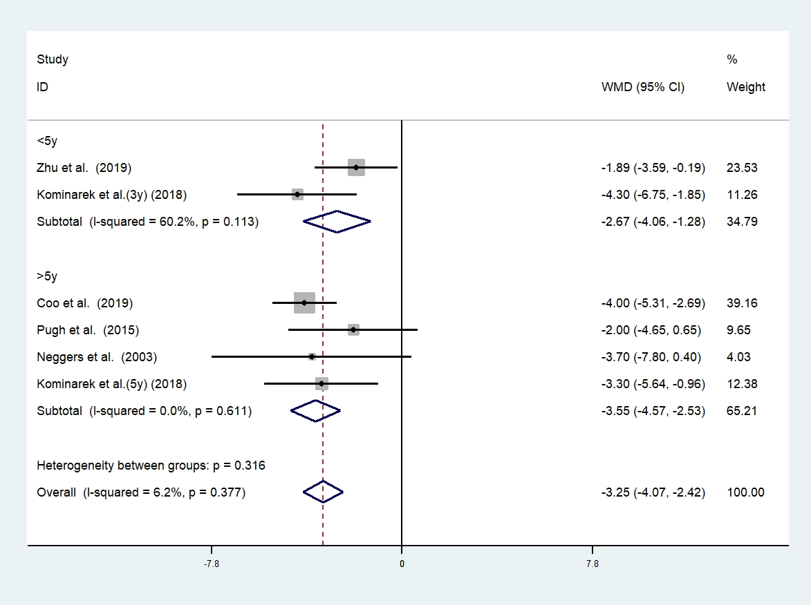b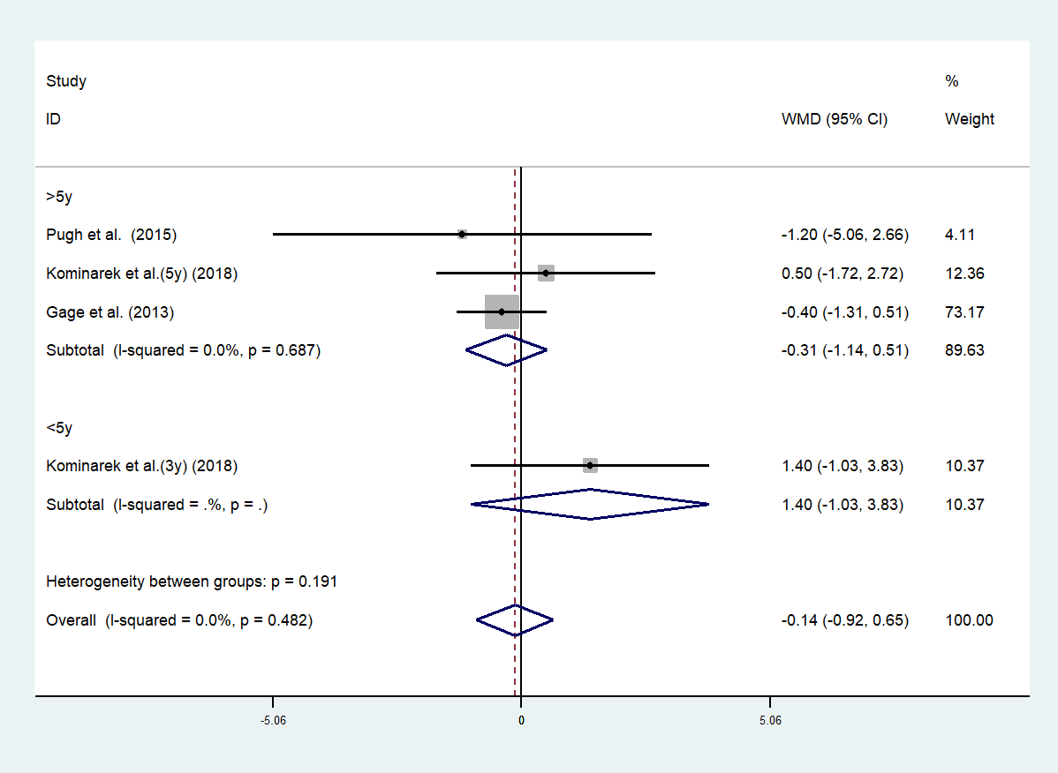c

