Supplement
mTOR inhibitor treats autistic-like behaviors in Tsc2+/- rats but not following developmental status epilepticus

Tomas Petrasek¹, Iveta Vojtechova^{1,2}, Ondrej Klovrza^{1,3}, Klara Tuckova^{1,4}, Cestmir Vejmola¹, Jakub Rak¹, Anna Sulakova¹, Daniel Kaping¹, Nadine Bernhardt⁵, Petrus J de Vries⁶, Jakub Otahal⁷, Robert Waltereit^{8,9}
¹National Institute of Mental Health, Klecany, Czech Republic
²First Faculty of Medicine, Charles University, Prague, Czech Republic
³Second Faculty of Medicine, Charles University, Prague, Czech Republic
⁴Faculty of Science, Charles University, Prague, Czech Republic
⁵Department of Psychiatry, University Hospital and Medical Faculty Carl Gustav Carus, Technical University of Dresden, Germany
⁶Division of Child & Adolescent Psychiatry, University of Cape Town, Cape Town, South Africa
⁷Department of Developmental Epileptology, Institute of Physiology CAS, Prague, Czech Republic
⁸Department of Child and Adolescent Psychiatry, University Hospital and Medical Faculty Carl Gustav Carus, Technical University of Dresden, Germany
⁹Department of Child and Adolescent Psychiatry, University Medical Center Göttingen, Germany

Corresponding Authors:
PD Dr. med. Robert Waltereit
Department of Child and Adolescent Psychiatry
University Medical Center Göttingen
Von-Siebold-Str. 5, 37075 Göttingen
Germany
Telephone: +49 551 39 8958
Email: robert.waltereit@med.uni-goettingen.de

Tomas Petrasek, PhD
National Institute of Mental Health
Topolova 748, 250 67 Klecany
Czech Republic
Telephone: +420 283 088 246
Email: tomas.petrasek@nudz.cz

SUPPLEMENTARY METHODS

Comparison of kainate- and pilocarpine-induced DSE models
In the previous studies [1,2], we have used kainic acid-induced DSE model. However, the pilocarpine-induced DSE model has previously been reported to have similar neurobiological impacts, with the advantage of negligible mortality [3]. Therefore, we decided to compare the two DSE models prior to the main experiment, and choose the better one, in terms of pup mortality and social behavior phenotype. In wild-type Long-Evans rats of both sexes (n = 27) from two different litters, we applied either pilocarpine (n = 7), or kainate (n = 11), or control (saline, n = 9) injection.
Kainic acid (purchased from Sigma Aldrich, Czech Republic, cat. no. K0250-10MG) was injected twice to each pup, at P7 (2 mg/kg) and at P14 (4 mg/kg). This application protocol was employed previously in the studies by [1,2]. However, we used a slightly lower dose at P7 than the previous studies, to avoid risk of mortality. Pilocarpine administration followed the same protocol as described below, which was then used for the main experiment.
Weights of the pups were monitored prior and after the DSE. Following DSE, the pups were tested in open field (40⨯35⨯21 cm box with bedding) at P27. Social interaction test was conducted in the same box, always using two pups from the same treatment group. Social play behavior and ultrasonic vocalizations were noted. For behavioral and ultrasonic observation and subsequent statistical analysis, a pair was taken as a single measurement, because social play involves both animals, and ultrasonic calls cannot be attributed to a specific individual.

Neonatal ultrasonic vocalization
Isolation-induced ultrasonic vocalizations (USV) were recorded as a measure of mother-seeking behavior in pups (n = 55) at P7 (prior to DSE treatment). Each pup was put into a small Plexiglas box (30⨯18⨯14.5 cm) containing fresh bedding and left alone for 45 seconds while vocalizations were recorded using Ultramic 250k microphone (Dodotronic, Italy, cat. no. SKU: UM250K) and Audacity 2.2.0 software. In the analysis, two categories were differentiated: simple neonatal calls and neonatal calls with frequency steps. Number and total duration of calls were evaluated. Duration of bouts (trains of successive vocalizations separated by less than 750 ms gaps) was also measured, and median call duration noted for each individual.

SUPPLEMENTARY RESULTS

Comparison of kainate- and pilocarpine-induced DSE models
Visual observation of the DSE procedure suggested kainate-induced seizures to be less pronounced and more intermittent than pilocarpine-induced seizures. In the open field test at P27, one-way ANOVA didn’t show any differences in locomotion between kainate, pilocarpine and saline groups: F(2) = 0.497, P = 0.615 (Fig. S1c). During social interaction at P27, social play was common in control animals. Ultrasonic recordings showed that low-frequency vocalizations (similar to neonatal calls or adult anxious vocalizations) did not occur, but high-frequency calls were rather common. Although those could be further sub-divided [4], we took them as a single category. Kainate treatment affected neither the duration of social play, nor the number of ultrasonic vocalizations. On the other hand, the pups after pilocarpine-induced DSE exhibited a decrease in both parameters (Fig. S1a, S1b).

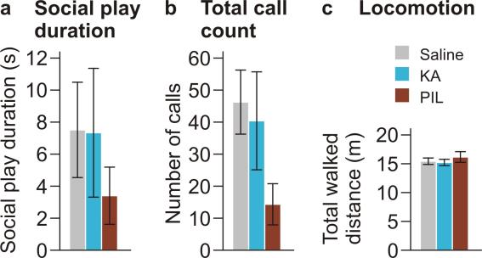
Figure S1: Impact of kainate- and pilocarpine-induced DSE on behavior in P27
During interaction of two age- and treatment-matched pups at the age of P27 (pre-weaning), social play behavior (a) and total number of ultrasonic vocalizations (b) were decreased in the pups which underwent pilocarpine-induced DSE (PIL), but not kainate-induced DSE (KA). Locomotor activity in unfamiliar environment (c) was not affected by the treatment (n = 9 for saline, n = 11 for kainic acid, n = 7 for pilocarpine). Data are shown as means ± SEM.

Alterations in ultrasonic vocalization in Tsc2+/- pups
All 7-day-old pups exhibited isolation-induced vocalizations with the fundamental frequency ranging between 35 and 45 kHz, often with harmonic frequency around 70 – 80 kHz, mostly occurring in series (bouts) of variable duration (Fig. S2d-f). Less common “adult-like” calls with higher fundamental frequencies (up to 70 kHz) were also noted in some individuals, but not included in the analysis. Their abundance didn’t seem linked to genotype. We analyzed the total number of isolation-induced calls, number of isolation-induced calls with frequency steps (stepped calls) and median bout duration. The latter two parameters had non-normal distribution and had to be log-transformed. Analysis by MANOVA didn’t show overall significance. Tests of Between-Subjects Effects showed that Tsc2+/- individuals exhibited lower number of vocalizations with frequency steps (p = 0.026) and decreased median bout duration (p = 0.016). However, these observations have to be interpreted with caution, as the effect size was low (Ƞ_{p}² = 0.094 and 0.109, respectively), and in the latter case the statistical outcome was affected by the presence of an outlier. Nevertheless, the impact of Tsc2 mutation on neonatal vocalization clearly deserves further attention, as it suggests early onset of the behavioral phenotype (Fig. S2a-c).

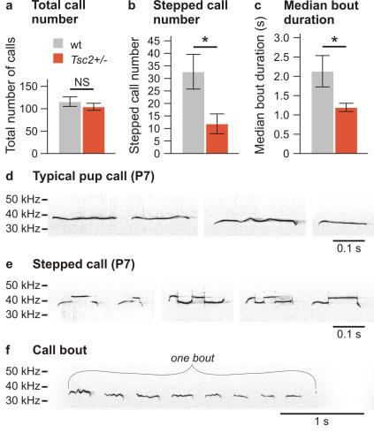
Figure S2: Effect of Tsc2+/- on isolation-induced neonatal vocalization
(a) Tsc2+/- mutation didn’t affect the total number of isolation-induced vocalizations in P7 pups. (b) However, Tsc2+/- mutant individuals exhibited lower number of isolation-induced vocalizations with frequency steps and (c) their vocalization bouts were significantly shorter (n = 33 for wt, n = 22 for Tsc2+/-). (d-f) Typical examples of isolation-induced calls and one bout. Data are shown as means ± SEM. *p < 0.05

Everolimus levels in the brain tissue
In the pilot experiment in intact wild-type rats, everolimus was not detected in the baseline (unmedicated) group. In brains harvested 24 h after the third and 24 h after the sixth injection of everolimus, concentrations of the drug were comparable, suggesting a stable therapeutic level during the T2 behavioral testing (Fig. S3).

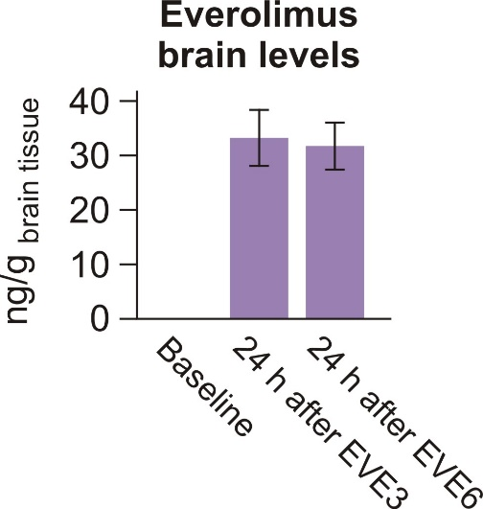
Figure S3: Everolimus levels in the brain during administration
Brain levels of everolimus were stable in the interval between the third (EVE3) and the sixth (EVE6) injection, when the T2 behavioral testing occurred(n = 4 for baseline, n = 6 for EVE3 and n = 6 for EVE6) . Data are shown as means ± SEM.

SUPPLEMENTARY REFFERENCES

1. Waltereit R, Japs B, Schneider M, De Vries PJ, Bartsch D. Epilepsy and Tsc2 haploinsufficiency lead to autistic-like social deficit behaviors in rats. Behav Genet. 2011;41:364–72.
2. Schneider M, de Vries PJ, Schönig K, Rößner V, Waltereit R. mTOR inhibitor reverses autistic-like social deficit behaviours in adult rats with both Tsc2 haploinsufficiency and developmental status epilepticus. Eur Arch Psychiatry Clin Neurosci. 2017;267.
3. Reddy DS, Kuruba R. Experimental models of status epilepticus and neuronal injury for evaluation of therapeutic interventions. Int J Mol Sci. 2013;14:18284–318.
4. Wright JM, Gourdon JC, Clarke PBS. Identification of multiple call categories within the rich repertoire of adult rat 50-kHz ultrasonic vocalizations: effects of amphetamine and social context. Psychopharmacology (Berl). Germany; 2010;211:1–13.

