SRQR Guidelines for good reporting of qualitative research
Short report by M.Barry, N. Scherpbier, W. Kuijer and L. Nieuwenhuis
Title and Abstract
Title | The title is presented on p.1 lines 2-3  “Enabling visibility of the clinician scientists broker role in linking research with clinical practice: A participatory design research in the Dutch nursing-home sector”
Abstract
Intoruduction
Problem formulation | The problem as described in literature is presented on p. 4 line 21 to p. 5 line 3:  “Despite the espoused value of the CS as a knowledge broker, little published information exists about the exact nature of this role at the day-to-day professional level of CSs. The connection between research and practice is frequently assumed to occur by virtue of the CSs professional jurisdiction in both settings(5). The knowledge broker role of CSs is not yet concrete enough to constitute a professionalisable work package that lends itself to the establishment of exclusive professional jurisdiction(1,12).”  The practical problem addressed by the design research is presented on p. 5 line 20- p.6 line 1:  “The managers of the CSs voiced concerns about their limited ability to demonstrate accountability for funding these broker positions. The CSs in turn reported insecurities about role expectations and difficulties in making their broker role visible. The difficulty in clearly defining the CSs broker role presented a practical challenge in this academic network. The managers and CSs were unable to find a tool suitable for making the CS broker role visible.”
Purpose or research question | The purpose of this research is stated on p. 6 lines 6-8:  “In response to this practical difficulty, we conducted a participatory design research aimed at developing a practical method of making the broker role of the CSs visible.”
Methods
Qualitative approach and research paradigm | The approach and paradigm are reported on p. 6 lines 10-13:  “Design research is a genre of research that is collaborative and suitable for design and construction of tools that are required to solve practical problems(15). It contributes to existing theory(15), in this case, the theory on the visibility and professionalisation of the CS broker role. Design research attempts to balance research rigour with practical relevance.”
Researcher characteristics and reflexivity | The researcher was external to the organisation in which this design research was conducted. This is described on p. 6 lines 14-20:  “We invited all CSs and managers from within the academic network to form a design-group together with an external independent researcher (MB).”
Context | The context of this researhc is described on p. 5 lines 21-24 as follows:  “This research was conducted in a Dutch academic network: a collaboration between fifteen nursing-homes and an academic medical research institute. As part of the strategy to link research and clinical practice, the academic network employed twelve master-educated CSs in 2018 and 2019. The CSs were tasked with catalysing both care-informed research and evidence-informed implementation initiatives..”
Sampling strategy | The sampling strategy is described on p. 6 lines 14-17:  “We invited all CSs and managers from within the academic network to form a design-group together with an external independent researcher (MB) with the aim of designing a tool that allows CSs to make their broker role visible.”
Ethical issues pertaining to human subjects | The reserch proposal had received ethical approval, all participants participated voluntarty and the researcher implemented principles of relational ethics during research process. This can be read on p. 12 lines 20-24  “The higher education institution where the researcher is employed granted ethical approval in July 2018 for this research (ref. EACO 113.07/18). Throughout the research, relational ethics ensured that each participant was seen as an equal. The focus remained on the needs of the CSs and their manager.”  p. 8 lines 5-8:  “The design-group consisted of eleven of the twelve CSs and their manager. One CS did not consent to participation. All participants gave written informed consent to participate in the design research.”
Data Collection methods | The data collection as performed in the three phases of design research is described on p. 7 lines 6-16:  “In Phases 1 and 2, data were collected during design-group meetings, individual interviews with CSs, participant observation of supervision meetings between CSs and their manager, questionnaires, walkthroughs, micro-evaluation of elements of the designed tool and try-outs of the tool. Data were in the form of minutes of meetings, sociograms, notes in the researchers log book and member checked notes taken during interviews and conversations. In Phase 3 an anonymous online questionnaire allowed CSs to rate their perception of the SP-tool’ s effect on their ability to make their broker role visible. They rated this on a seven-point Likert scale ranging from ‘a lot worse’ to ‘a lot better'. CSs could also indicate on two multiple choice questions how they planned to use the SP-tool. An individual discussion and reflection was conducted with the manager after the final try-out of the SP-tool.”
Data collection instruments and technology | The independent researcher was the data collection instrument.
Units of study | Individuals (CSs and managers) in the development of the SP-tool.
Data processing | Data was processed in Microsof Excel as indicated on p. 7 line 20.
Data analysis | Data from phases 1 and 2 was analysed using framework analyses as. This is described on p. 7 lines 17-23:  “We analysed data collected in the Phase 1 using framework analysis(16), which is suitable for research that develops new plans and actions. The independent researcher analyzed the raw data following the steps of coding, indexing, charting, mapping and interpretation(16) of all text-fragments in the framework in Microsoft Excel. The codes comprised the inner- and outer context factors necessary for effective CS brokerage as identified in the literature review(5).”  Data in phase 2 was analysed by translating suggesteions into practical changes to the prototype as can be seen on p. 7 line 23 – p.8 line 3:  “During Phase 2 (design and construction), data were collaboratively translated into changes required for the prototypes of the tool during design-group meetings.  Data in phase 3 was analysed as described on p. 8 lines 1-2:  “The answers from the online evaluation questionnaire in Phase 3 were numerically tallied and reported in raw numbers.”
Techniques to enhance trustworthiness | A critical friend p. 7 line 21-22  “A critical friend (AP) oversaw parts of the analysis process to enhance credibility.”
Results
Links to empirical data | Key quotations which had been documented during conversations with participants were used as can be seen on p. 9 lines 1-14:  “One manager (participant 1) said, “We want to be able to assess whether the CSs are doing enough but we don’t know what ‘enough’ is.” The CSs found that documenting their goals for the broker role on a Goal Attainment Scale(17) was too rigid and too specific. It did not assist in showcasing flexibility and sensitivity to the context. “I need to show the activities I do within the broader goals of the CS function” (participant 10). CSs felt it important to showcase all the requests they received and their subsequent decisions in prioritizing certain requests over others. “I receive a tsunami of questions but many are not suitable for a CS, more so for a researcher. I want to communicate more about my (CS) function.” (participant 8). The report did not make the dynamic nature of the CSs network activity visible. Respondent 11 said, “I link people in my network with each other and great things happen but this is not visible anywhere”. “
Discussion
Integration with prior work; implications; transferrability; contribution to the field | In the discussion we link our findings to previous findings on the knowledge broker role of the CS. We also present a conceptual model proposing how visibility of knowledge broker activities can enhance the professionalisation of knowledge-intensive work (figure 3). This conceptual model could guide further research and development of the CS knowledge broker role.:  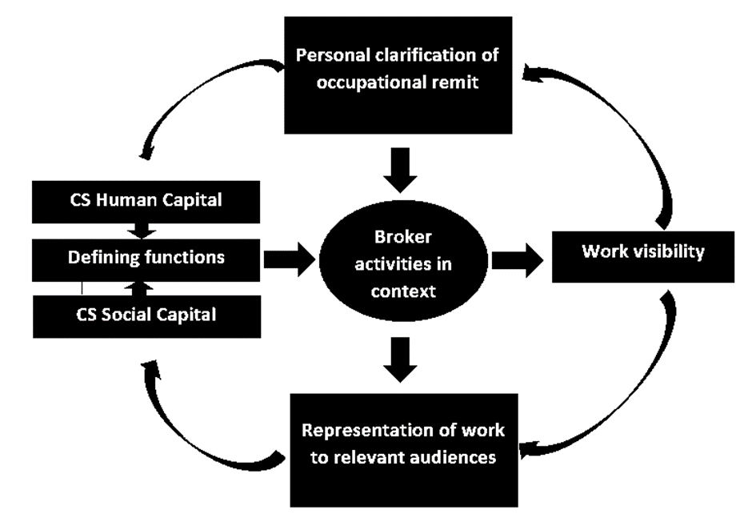
Limitations | The limitations of this design research are page 12, lines 3-9 as follows:  “A limitation of design research is its context specific nature and very limited generalisability. However, the clearly defined design proposition and requirements in this research might be of interest to CSs and managers in other contexts. Furthermore, the SP-tool and the proposed conceptual framework could be of interest in future more fundamental research into the day-to-day professional level of CSs. The small number of participants is a limitation, however, in the academic network all but one CS participated. Their contribution significantly enhanced the practical applicability of the SP-tool.”
Other
Conflict of interest | No conflicts of interest were reported in the Declarations section. P. 13 line 7 “no cometing interest”
Funding | The funding is declared in the declarations section p. 13 lines 9-10 “The first author is receiving support from her higher education institution to complete her PhD of which this project is a part.”

