Supplementary Appendix

This appendix has been provided by the authors to give readers additional information about their work.

Supplement to: Anderson EJ, Jackson LA, Rouphael NG, et al. Safety and Immunogenicity of a Third Dose of SARS-CoV-2 mRNA Vaccine — An Interim Analysis.

Table of Contents
Supplementary Appendix 1
mRNA-1273 Study Group 4
mRNA-1273 Study Team Members 6
Supplemental Methods 8
Supplemental Results 11
Table S1. Toxicity grading scales for solicited systemic and local adverse events* 12
Table S2: Number of All Unsolicited Adverse Events by MedDRA® System Organ Class and Preferred Term, Severity, Relationship, and Vaccination Group – Monovalent Prototype (N=48) 13
Table S3: Number of All Unsolicited Adverse Events by MedDRA® System Organ Class and Preferred Term, Severity, Relationship, and Vaccination Group – Monovalent Variant (N=25) 15
Table S4: Number of All Unsolicited Adverse Events by MedDRA® System Organ Class and Preferred Term, Severity, Relationship, and Vaccination Group – Bivalent (N=23) 17
Table S5: Number and Percentage of Subjects Experiencing Unsolicited Adverse Events MedDRA® System Organ Class and Preferred Term, Severity, Relationship, and Vaccination Group – Monovalent Prototype (N=48) 18
Table S6: Number and Percentage of Subjects Experiencing Unsolicited Adverse Events MedDRA® System Organ Class and Preferred Term, Severity, Relationship, and Vaccination Group – Monovalent Variant (N=25) 20
Table S7: Number and Percentage of Subjects Experiencing Unsolicited Adverse Events MedDRA® System Organ Class and Preferred Term, Severity, Relationship, and Vaccination Group – Bivalent (N=23) 22
Table S8: Serum IgG Binding Assay Area Under the Curve Geometric Mean Titers by Variant and Prime Series Dose at Baseline before a Third Dose of mRNA Vaccination with 95% Confidence Intervals 23
Table S9. Serum IgG Binding Assay Area Under the Curve (AUC) Geometric Means for Variants by Time Point with 95% Confidence Intervals 24
Table S10. Serum IgG Binding Assay Geometric Mean (GM) Results with 95% Confidence Intervals by Time Point and Vaccination Group 27
Table S11. Serum Pseudovirus Neutralization ID₅₀ Assay Geometric Mean (GM) Titers at Baseline before a Third Dose of mRNA Vaccination by Variant with 95% Confidence Intervals 29
Table S12. Serum responses following the booster vaccination assessed by a pseudovirus neutralizing assay – ID₅₀ by Timepoint and Group: A) D614G; B) Beta (B.1.351); C) Alpha (B.1.1.7); D) Delta (B.1.617.2); E) Gamma (P.1). 31
Table S13. Serum Pseudovirus Neutralization ID₈₀ Assay Geometric Mean (GM) Titers at Baseline before a Third Dose of mRNA Vaccination by Variant with 95% Confidence Intervals 34
Table S14. Neutralizing responses following the booster vaccination assessed by a pseudovirus neutralizing assay – ID₈₀ by Timepoint and Group. 36
Table S15. Serum FRNT ID₅₀ Assay Geometric Mean (GM) Titers at Baseline before a Third Dose of mRNA Vaccination by Variant with 95% Confidence Intervals 39
Table S16. Serum FRNT Assay Titers Distribution by Time Point – ID₅₀ – Versus Variants with 95% Confidence Intervals 41
Table S17. Serum FRNT ID₈₀ Assay Geometric Mean (GM) Titers at Baseline before a Third Dose of mRNA Vaccination by Variant with 95% Confidence Intervals 44
Table S18. Serum FRNT Assay Titers Distribution by Time Point – ID₈₀ – Versus Variants with 95% Confidence Intervals 46
Table S19. Mean Percentages of CD4 T Cells Expressing Cytokines with 95% CI 49
Table S20. Mean Percentages of CD8 T Cells Expressing Cytokines with 95% CI 50
Figure S1. Serum IgG Binding Assays Distribution by Time Point and Treatment Group 51
Figure S2. Serum Pseudovirus Neutralization Assay ID₅₀ Titers Distributed by Timepoint for the Gamma Variant (P.1) 57
Figure S3. Serum Pseudovirus Neutralization Assay ID₈₀ Titers Distributed by Timepoint by Variant. a: D614G, b: Beta (B.1.351), c: Alpha (B.1.1.7); d: Delta (B.1.617.2), and e: Gamma (P.1). 59
Figure S4. Serum FRNT₅₀ Titers Distributed by Timepoint and Group. Panel A: D614G, b: Beta (B.1.351), c: Alpha (B.1.1.7); d: Delta (B.1.617.2), and e: Gamma (P.1). 65
Figure S5. Serum FRNT₈₀ Titers Distributed by Timepoint and Group. Panel A: D614G, b: Beta (B.1.351), c: Alpha (B.1.1.7); d: Delta (B.1.617.2), and e: Gamma (P.1). 71
Figure S6. CD4 T Cell TH2 Responses by Group and Timepoint. 77
Figure S7. Memory CD4 TH1 Responses by Group and Timepoint for 614D spike. 79
Figure S8. Memory CD4 TH1 Responses by Group and Timepoint for Beta spike. 83
Figure S9. Memory CD8 T Cell Responses to 614D by Group and Timepoint. 84
Figure S10. Memory CD8 T Cell Responses by Group and Timepoint for Beta. 88
Figure S11. CD4 T Cell TH1 Responses by Group and Timepoint to the Variant Regions. 89
Figure S12. CD8 T Cell TH1 Responses by Group and Timepoint to the Variant Regions. 91
References: 93

mRNA-1273 Study Group

(listed in pubmed, and ordered alphabetically by institutional affiliation)

The following study group members were all closely involved with the design, implementation,
and oversight of the mRNA-1273 clinical trial.

Emory University School of Medicine, Atlanta, GA
Evan J. Anderson MD; Andres Camacho-Gonzalez MD, MSc; Matthew H. Collins MD MPH, Srilatha Edupuganti MD, MPH; Tigisty Girmay, Daniel S Graciaa MD, Cassie Grimsley Ackerley MD, Laila Hussaini MPH, Satoshi Kamidani MD; Colleen F. Kelley MD MPH, Michele P McCullough MPH; Etza Peters RN, Varun K Phadke MD, Paulina A. Rebolledo MD, Christina A. Rostad MD; Nadine Rouphael MD, MS; Kathy Stephens RN, Mehul Suthar PhD, Mehgan Teherani MD, MS

Kaiser Permanente Washington Health Research Institute, Seattle, WA
Lisa A. Jackson, MD, MPH

Seattle Children’s Research Institute, Seattle, WA
Rhea N. Coler, M.Sc., Ph.D., Sasha E. Larsen, Ph.D.

Vaccine Research Center (VRC), National Institute of Allergy and Infectious Diseases (NIAID), NIH, Bethesda, MD Nina M. Berkowitz, M.P.H., Kevin Carlton, M.S., Pamela Costner, R.N., B.S.N., Nicole A. Doria-Rose, Ph.D., Martin Gaudinski, M.D., Ingelise Gordon, R.N., Barney S. Graham, M.D., LaSonji Holman, F.N.P., Julie E. Ledgerwood, D.O., Bob C. Lin, B.S., Mark K. Louder, John R. Mascola, M.D., Adrian B. McDermott, Ph.D., Sijy O’Dell, M.S., Marcelino Padilla, B.S., Amarendra Pegu, Ph.D, Stephen D. Schmidt, B.S., Wei Shi, Phillip A. Swanson II, Ph.D., Lingshu Wang, Ph.D., Alicia T. Widge, M.D., M.S., Eun Sung Yang M.S., Yi Zhang B.S. Sarah E. O’Connell, M.S., Sandeep Narpala, M.S., Mike Castro, M.S., Jennifer Wang, B.S., Obrimpong Amoa-Awua, M.S., Christopher Moore, M.S., Robin Carrol, B.S., Muhammed Naqvi, B.S., Naz Jean-Baptiste, B.S.

Division of Microbiology and Infectious Diseases, National Institute of Allergy and Infectious Diseases (NIAID), National Institutes of Health (NIH), Bethesda, MD
Marina Lee, Ph.D., Mohamed Elsafy, M.D., Rhonda Pikaart-Tautges, B.S. Janice Arega, M.S., Binh Hoang, R. Ph., Dan Curtin, Olivia Sparer, B.A., Ranjodh Gill M.P.H, Hyung Koo, B.S.N., Elisa Sindall, B.S.N., Sonja Crandon, B.S.N., Seema Nayak, M.D., Diane J. Post, Ph. D., Paul C Roberts, Ph.D., John Beigel, M.D.

The Emmes Company, LLC, Rockville, MD:
Mat Makowski, Jim Albert

Cincinnati Children’s Hospital and the University of Cincinnati, Cincinnati, OH:
Paul Spearman MD
Vanderbilt Vaccine Research Program, Department of Pediatrics, Vanderbilt University Medical Center, Nashville, TN
C. Buddy Creech MD; Stephanie L. Rolsma MD PhD; Shannon C. Walker MD; Robert Samuels MBChB, MSCI
Moderna, Inc., Cambridge, MA, USA
Brett Leav, Hamilton Bennett, Rolando Pajon,

Department of Laboratory Medicine and Pathology, University of Washington, Seattle, WA
Christine M. Posavad PhD, John Hural PhD

University of Maryland School of Medicine, Baltimore, MD:
Kathleen M. Neuzil MD

FHI360, Durham, NC.
Kuleni Abebe

Duke Human Vaccine Institute and Department of Surgery, Duke University Medical Center, Durham, NC
David Montefiori PhD, Amanda Eaton

Vaccine and Infectious Disease Division, Fred Hutchinson Cancer Research Center; Department of Medicine and Laboratory Medicine and Pathology, University of Washington, Seattle, WA
Kristen W. Cohen PhD, Stephen C. De Rosa, M. Juliana McElrath PhD

mRNA-1273 Study Team Members

The mRNA-1273 trial was a collective group effort across multiple institutions and locations.
Below is a list of sites and staff that significantly contributed to the implementation and conduct of the mRNA-1273 trial.

Emory University School of Medicine, Atlanta, GA
Alexis Ahonen RN, APRN, NP, Ghina Alaaeddine, BS, MD, Alicarmen Alvarez RN BSN; Amy Anderson BSN, RN, Evan J. Anderson, MD; Larry J. Anderson MD; Mary Atha, MSN, ACNP, APRN, Teresa Ball RN, BBA, Amari Barrett, BA, Julia Bartol, BS, Amer Bechnak, BS, MD, Sara Bechnak BSN; Sydney Biccum BS; Mary Bower BSN, RN,Leisa Bower RN, CDP; Jessica Bowman RN; Laurel Bristow MSc; Andres Camacho-Gonzalez MD, MSc; Erin Carter BS MSW; Clara Caro BS; Laura Clegg RN; Matthew H Collins MD PhD; Carla Cooke BA, MMS, PA-C; Blair Curless MPH; Victoria Curry BSN, RN, CCRN; Rijalda Deovic BA MPH; Cartia Dixon, BS; Ana Drobeniuc BS MPH; Francine Dyer RN; Srilatha Edupuganti MD MPH; Theda Gibson, MS; Tigisty Girmay RN BNS MSN; Felicia Glover, NCMA; Rebecca Gonzalez, PharmD, Daniel Graciaa MD; Natalie Grey; Cassie Grimsley Ackerley MD; Evan Gutter BS, MPH; Lisa Harewood, CCRA; Mari Hart, RN, Lauren Hewitt LPN; Hui-Mien Hsiao BS, MSc; Christopher Huerta, BS, MSc; Amberly Hunter, BS; Laila Hussaini MPH; Sharon Ingram BSN; Brandi Johnson, BS; Inara Jooma, BS; Satoshi Kamidani MD; Colleen F Kelley MD MPH; Peggy Kettle BSN, RN; Alexandra Betzabeth Koumanelis BA; Maranda Leary BS MPH; Tiffany Lee BSN; Marcia Lewis RN; Wensheng Li BS, MSc; Cindy Lubbers BA, ADN, RN; Hollie Macenczak RN, BSN; Lisa Macoy MSc, APN, RN; Michele P McCullough BA, BS, MPH; Nina McNair MD; Juliet Morales BS; Molly Morrison; Amy Muchinsky, BS; Muktha Natrajan PhD MPH; Wendy Nesheim ADN BS MEd PhD; Heather Nurse BSN RN; Tuong-Vy Ngo, PharmD; G Osinski, BS; Julia Paine BS; Amanda Panepento MMSc MPH PA-C; Bernadine Panganiban, BSc; Esther Park, BA, PharmD; Vikash Patel BS, MSPCS; Etza Peters BS, RN, BSN; Varun Phadke MD; Dilshad Rafi Ahmed, BDS; Stephanie Ramer, BS, MPH; Paulina Rebolledo Esteinou MD, MSc MS; Brittany Robinson, BS; Susan Rogers, BS, RPh; Christina A. Rostad MD; Nadine Rouphael MD, MSc, MS; Youssef Saklawi MD; Amber Samuel; Erin Scherer BS, PhD; Robert William Shepard III, RPh, PharmD; Amy Sherman BA MD; Anna Siaw-Anim BS MS; Oliver Smith BS MS; Maya Stagg, BS; Tae Stallworth; Kathleen Stephens RN, MSN; Mehul Suthar PhD; MMegan Taylor BS; Mehgan Teherani MD, MS; Sean Todd BS; Maliya Tolbert, BS; Jessica Traenkner BS, PA-C; Sy Quoc Tran, BS, MPH, PharmD; Kristen Unterberger, BS, MSc, PA-C; Jacob Usher, BS ; Chiamaka Uzuegbunam, BS, MPH; Dongli Wang, BS; Cindy Whitney BS MD MPH; Aaliyah Carron Wilson, BS Juton Winston, BS; Terra Winter, CIP; Grace Xu; Jianguo Xu, BS, MS, PhD, RPh; Yongxian Xu, MD; Kathryn Zaks BS, MSc; Ceclilia Zhang BA MEd MA

Kaiser Permanente Washington Health Research Institute, Seattle, WA
Lee Barr, RN, Jesse Berg, BS, Cassandra Bryant, BS, Rachael Burganowski, MS, Roger Calvert, PA-C, Barbara Carste, MPH, Joe Choe, BS, John Dunn, MD, Maya Dunstan, MS, RN, Roxanne Erolin, MPH, Jana ffitch, LPN, Colin Fields, MD, Lynn Gross, PA-C, Lisa A. Jackson, MD, MPH, Erika Kiniry, MPH, De Vona Lang, Susan Lasicka, RPh, Rebecca Lau, PharmD, Stella Lee, BA, Paula Lins, PA-C, MPH, Amy Mohelnitzky, PA-C, Marilyn Nguyen, BS, Matthew Nguyen, MPH, Jennifer Nielsen, ARNP, Hallie Phillips, MEd, Stephanie Pimienta, BS, Melissa Resendiz Rivas, BA, Melissa Boothe Scheer, PA-C, David Skatula, RPh, Janice Suyehira, MD, Karen Wilkinson, ARNP, Michael Witte, PharmD

Seattle Children’s Research Institute, Seattle, WA
Rhea N. Coler, M.Sc., Ph.D., Sasha E. Larsen, Ph.D., Evan Cross, B.Sc., Tiffany Pecor, B.S., Thomas Smytheman, B.Sc., Emma Johnson, B.S., Valerie A. Reese, M.S., Susan L. Baldwin, Ph.D., Brittany Williams, B.Sc., Suhavi Kaur, B.Sc., Zhiyi Zhu, Ph.D.

Vaccine Research Center (VRC), National Institute of Allergy and Infectious Diseases (NIAID), NIH, Bethesda, MD: Preeti Apte, B.A., Anita Arthur, R.N., B.S.N., Seemal Awan, M.D., Allison Beck, M.P.A.S., P.A.C., Nina M. Berkowitz, M.P.H., Seyhan Boyoglu-Barnum, Ph.D., Eugeania Burch, M.P.H., Kevin Carlton, M.S., Cora Trelles Cartagena, M.P.H., Joe Casazza, M.D., Ph.D., Emily Coates, Ph.D., Pamela Costner, R.N., B.S.N., Jennifer Cunningham, R.N., B.S.N., Nicole A. Doria-Rose, Ph.D., Lesia Dropulic, M.D., Aba Eshun, R.N., B.S.N., Catina Evans, Martin Gaudinski, M.D., Rebecca A. Gillespie, B.S., Ingelise Gordon, R.N., Barney S. Graham, M.D., Carmencita S Graves M.S., M.B.A., Mercy Guech, Ph.D., Renunda Hicks, LaSonji Holman, F.N.P., Kate Houser, Ph.D., Justine Jones, B.S., Priya Kamath, MD., Lam Le, M.B.A., Julie E. Ledgerwood, D.O., Bob C. Lin, B.S., Lauren Lizewski, M.P.H., Mark K. Louder, John R. Mascola, M.D., Adrian B. McDermott, Ph.D., Floreliz Mendoza, R.N., John Misasi, M.D., Patricia Morgan, P.A., M.Sc., Thuy Nguyen, B.A., Laura Novik, R.N., M.A., Mark O’Callahan, B.S., Sijy O’Dell, M.S., Abidemi Ola, M.S.N., F.N.P.-C., Marcelino Padilla, B.S., Karen Parker, D.N.P., C.R.N.P., F.N.P.-B.C., Amarendra Pegu, Ph.D, Iris Pittman, B.A., Sarah Plummer, C.R.N.P., La’Shawn Requilman, Jamie Saunders, R.N., B.S.N., Stephen D. Schmidt, B.S., Ellie Seo, R.Ph., Ph.D., Wei Shi, Sandra Sitar, M.S., Phillip A. Swanson II, Ph.D., Stephanie Taylor, B.A., Shinyi Telscher, Pharm.D., Colin Tran, B.S., Olga Trofymenko, M.D., Olga Vasilenko, M.S., Xiaolin Wang, R.N., William Whalen, R.N., B.S.N., Pernell Williams, B.A., Eun Sung Yang, M.S., Lingshu Wang, Ph.D., Alicia T. Widge, M.D., M.S., Richard Wu, M.D., Galina Yamshchikov, M.S., Eun Sung Yang M.S., Kathy Zephir, R.N., B.S.N., M.S., Yi Zhang, B.S.

Division of Microbiology and Infectious Diseases, National Institute of Allergy and Infectious Diseases, National Institutes of Health, Bethesda, MD.
Marina Lee, Ph.D., Mohamed Elsafy, M.D., Rhonda Pikaart-Tautges, B.S. Janice Arega, M.S., Binh Hoang, R. Ph., Dan Curtin, Olivia Sparer, B.A., Ranjodh Gill M.P.H, Hyung Koo, B.S.N., Elisa Sindall, B.S.N., Sonja Crandon, B.S.N., Seema Nayak, M.D., Diane J. Post, Ph. D., Paul C Roberts, Ph.D., John Beigel, M.D.

FHI360, Durham, NC.
Kuleni Abebe, Janet Archer, Linda McNeil

Supplemental Methods

The Advarra institutional review board functioned as a single board and both studies were overseen by independent safety monitoring committees convened for each trial. All participants provided written informed consent before enrollment in the 20-0003 substudy or the 21-0002 trial. Both were conducted under the original Investigational New Drug application submitted to the US FDA. The boost studies were open to participants starting in March 2021.
Vaccines
The mRNA-1273 vaccine was co-developed by researchers at the National Institute of Allergy and Infectious Diseases (NIAID, the sponsor of both trials) and at Moderna (Cambridge, MA). The mRNA-1273.351 vaccine was developed by researchers at Moderna. The mRNA-1273 vaccine encodes the S-2P antigen for the Wuhan-Hu-1 SARS-CoV-2 isolate, also known as 614D, that has a genome sequence identical to the first United States isolate (USA WA-1). The mRNA-1273.351 vaccine encodes for the S-2P antigen of the Beta variant. Both antigens were stabilized in the prefusion conformation as previously described.^{1,2} The lipid nanoparticle capsule was formulated with a fixed ratio of mRNA and lipid. The vaccines were provided as sterile liquid for injection at a concentration of 0.2 mg per mL for mRNA-1273 and 0.5 mg per mL for mRNA-1273.351. Normal saline was used as a diluent to prepare the 0.5 mL doses administered by injection in the deltoid muscle.

Assessment of SARS-CoV-2 Binding Antibody and Neutralizing Responses
The 4-plex Mesoscale Discovery (MSD) platform that has completed validation testing and is undergoing regulatory review, as previously described,^{3,4} against four SARS-CoV-2 proteins: Wa-1 S-2P, Nucleocapsid, B.1.351 S-2P, and B.1.351 receptor binding domain (RBD).

The DMID 20-0003 substudy participants (monovalent prototype booster group) had pseudovirus neutralization performed using an assay developed at NIH and utilized for the original DMID 20-0003 study.^{1,3,5-7} Samples from the DMID 21-0002 study (monovalent variant and bivalent booster groups) used the same assay that had been further optimized, qualified and validated and was used to assess Phase 3 COVID-19 vaccine study responses and correlates of protection.⁸

T Cell Analyses
The peptides were synthesized by Biosynthesis and provided as individual lyophilized aliquots and reconstituted at 100mg/ml in DMSO.

As a negative control, cells were incubated with DMSO, the diluent for the peptide pools. As a positive control, cells were stimulated with a polyclonal stimulant, staphylococcal enterotoxin B (SEB). There were no replicates except for the negative control, which had two replicates.

Several criteria were used to determine if data from an assay were acceptable and could be statistically analyzed. The blood draw date must have been within the allowable visit window as determined by the protocol. After sample thawing and overnight incubation, the viability of the PBMCs must have been 66% or greater for testing to have proceeded. If it was not, a new specimen for that participant at that timepoint was thawed for testing. If the PBMC viability of the second thawed aliquot was below this threshold, the ICS assay was not performed, and no data were reported to the statistical center for the participant and timepoint.

The total numbers of CD4+ and CD8+ T cells must also have exceeded certain thresholds. If the number of CD8+ T cells was < 5,000 or CD4+ T cells was < 10,000 for any of the SARS-CoV-2-peptide pools or for one of the negative control replicates for a particular sample, data for that stimulation were filtered. If both negative control replicates failed for number of T cells, the sample was retested. If one negative control replicate failed for number of T cells, the negative control replicate with sufficient cells was used.

Individual-level response calls were determined by statistical testing of the number of cytokine positive CD4 T cells after spike peptide stimulation compared to the frequency of cytokine positive T cells in the negative control stimulation. To assess positivity for a peptide pool within a T-cell subset, a two-by-two contingency table was constructed comparing the SARS-CoV-2-peptide stimulated and negative control data. The four entries in each table were the number of cells positive for IFN-γ and/or IL-2 and the number of cells negative for IFN-γ and IL-2, for both the stimulated and the negative control data. If both negative control replicates were included, then the average number of total cells and the average number of positive cells were used. A one-sided Fisher's exact test was applied to the table, testing whether the number of cytokine-producing cells for the stimulated data was equal to that for the negative control data. Since multiple individual tests (for each peptide pool) were conducted simultaneously, a multiplicity adjustment was made to the individual peptide pool p-values using the Bonferroni-Holm adjustment method. If the adjusted p-value for a peptide pool was ≤0.00001, the response to the peptide pool for the T-cell subset was considered positive. Because the sample sizes (i.e., total cell counts for the T-cell subset) were large, e.g., as high as 100,000 cells, the Fisher’s exact test has high power to reject the null hypothesis for very small differences. Therefore, the adjusted p-value significance threshold was chosen stringently (≤ 0.00001). Plots include data from responders in color and non-responders in gray and the y-axis is truncated at 0.025% and any values below this level are set to this value.

Analyses
For both trials, Moderna was involved in discussions of trial design, provided the vaccine candidates, and, as part of the writing group, contributed to drafting this manuscript. The Emmes Company, as a subcontractor to the NIAID, served as the statistical and data coordinating center, developed the statistical analysis plans, and performed the analyses. The manuscript was written entirely by the authors, with the two first authors as the overall lead authors, the last author as the lead and senior NIAID author. The authors had full access to the data reports, which were prepared from the raw data by the statistical and data coordinating center and vouch for the completeness and accuracy of the data and for the fidelity of the trials to their respective protocols.

Supplemental Results

Vaccine Safety and Reactogenicity
Overall, 45 unsolicited adverse events (all mild to moderate in severity) were reported within 28 days, of which 21 were considered related to the monovalent prototype vaccination. Those events included axillary lymphadenopathy, vomiting, chills, fatigue, gait disturbance, thirst, musculoskeletal chest pain, dizziness, headache, anxiety, oropharyngeal pain, night sweats, sensitive skin, and injection site bruising, paresthesia, pruritus, and pain (Supplemental Tables S2 and S5). All events resolved, typically after 1-2 days, though one individual experienced fatigue for 8 days.
Of the 19 unsolicited adverse events occurring in the monovalent variant vaccine group, ten were judged related to the study vaccination that were mild to moderate in severity except for rash and vomiting (detailed in the manuscript). Related events included axillary lymphadenopathy, dyspepsia, vomiting, chills, swelling, jaw pain, nocturia, cough, epistaxis, and rash.
Of the 12 unsolicited adverse events occurring in the bivalent vaccine group, three were judged related to the study vaccination (vomiting, night sweats, axillary lymphadenopathy), but all were mild or moderate in severity (Supplemental Tables S4 and S7).
A single 58-year-old individual with an underlying history of hypertension, alcohol use, seasonal allergies, anxiety, and brain aneurysm who had was taking budesonide, fluoxetine, montelukast, and loratadine had a serious adverse event of paresthesias of the upper extremity beginning 30 days after vaccination with the bivalent vaccine. At the time, the participant had normal platelets and did not have evidence of thrombosis. This was considered unrelated to vaccination, most likely due to a transient ischemic attack.

Table S1. Toxicity grading scales for solicited systemic and local adverse events*
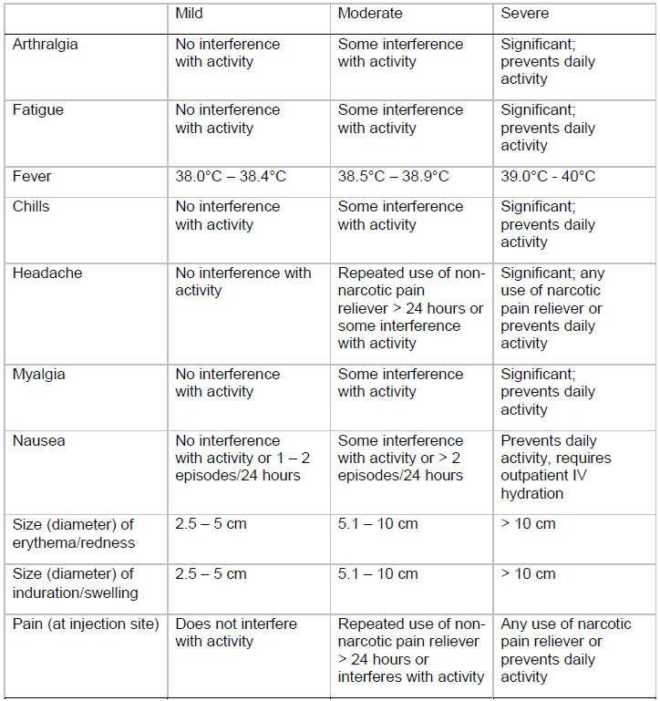
*Obtained from a standard toxicity grading scale⁹

Table S2: Number of All Unsolicited Adverse Events by MedDRA® System Organ Class and Preferred Term, Severity, Relationship, and Vaccination Group – Monovalent Prototype (N=48)
 |  |  | Severity |  |  | Relationship to Study  Vaccination
System Organ Class (SOC) | Preferred Term (PT) | Total  Events  (n) | Mild  (n) | Moderate  (n) | Severe  (n) | Not  Related  (n) | Related  (n)
Any SOC | Any PT | 45 | 28 | 17 | . | 24 | 21
Blood and Lymphatic System Disorders | Any PT | 2 | 2 | . | . | 1 | 1
 | Leukocytosis | 1 | 1 | . | . | 1 | .
 | Lymphadenopathy | 1 | 1 | . | . | . | 1
Cardiac Disorders | Bradycardia | 3 | 3 | . | . | 3 | .
Eye Disorders | Eyelid irritation | 1 | 1 | . | . | 1 | .
Gastrointestinal Disorders | Any PT | 2 | 1 | 1 | . | 1 | 1
 | Umbilical hernia | 1 | 1 | . | . | 1 | .
 | Vomiting | 1 | . | 1 | . | . | 1
General Disorders and  Administration Site Conditions | Any PT | 12 | 9 | 3 | . | 1 | 11
 | Chills | 1 | 1 | . | . | . | 1
 | Fatigue | 2 | 1 | 1 | . | . | 2
 | Gait disturbance | 1 | . | 1 | . | . | 1
 | Injection site bruising | 2 | 2 | . | . | 1 | 1
 | Injection site paraesthesia | 1 | 1 | . | . | . | 1
 | Injection site pruritus | 3 | 3 | . | . | . | 3
 | Pain | 1 | 1 | . | . | . | 1
 | Thirst | 1 | . | 1 | . | . | 1
Infections and Infestations | Any PT | 2 | . | 2 | . | 2 | .
 | Lyme disease | 1 | . | 1 | . | 1 | .
 | Tooth abscess | 1 | . | 1 | . | 1 | .
Injury, Poisoning and Procedural Complications | Any PT | 2 | . | 2 | . | 2 | .
 | Joint dislocation | 1 | . | 1 | . | 1 | .
 | Limb injury | 1 | . | 1 | . | 1 | .
Musculoskeletal and Connective Tissue Disorders | Any PT | 6 | . | 6 | . | 5 | 1
 | Exostosis | 1 | . | 1 | . | 1 | .
 | Musculoskeletal chest pain | 1 | . | 1 | . | . | 1
 | Osteoarthritis | 1 | . | 1 | . | 1 | .
 | Scoliosis | 1 | . | 1 | . | 1 | .
 | Tendonitis | 2 | . | 2 | . | 2 | .
Nervous System Disorders | Any PT | 5 | 4 | 1 | . | 2 | 3
 | Dizziness | 2 | 2 | . | . | . | 2
 | Headache | 2 | 2 | . | . | 1 | 1
 | Tremor | 1 | . | 1 | . | 1 | .
Psychiatric Disorders | Any PT | 2 | 1 | 1 | . | 1 | 1
 | Anxiety | 1 | 1 | . | . | . | 1
 | Generalised anxiety disorder | 1 | . | 1 | . | 1 | .
Renal and Urinary Disorders | Haematuria | 1 | 1 | . | . | 1 | .
Respiratory, Thoracic and  Mediastinal Disorders | Oropharyngeal pain | 1 | 1 | . | . | . | 1
Skin and Subcutaneous Tissue Disorders | Any PT | 2 | 2 | . | . | . | 2
 | Night sweats | 1 | 1 | . | . | . | 1
 | Sensitive skin | 1 | 1 | . | . | . | 1
Surgical and Medical Procedures | Tooth extraction | 1 | . | 1 | . | 1 | .
Vascular Disorders | Any PT | 3 | 3 | . | . | 3 | .
 | Hypertension | 1 | 1 | . | . | 1 | .
 | Systolic hypertension | 2 | 2 | . | . | 2 | .

Table S3: Number of All Unsolicited Adverse Events by MedDRA® System Organ Class and Preferred Term, Severity, Relationship, and Vaccination Group – Monovalent Variant (N=25)
 |  |  | Severity |  |  | Relationship to Study  Vaccination
System Organ Class (SOC) | Preferred Term (PT) | Total  Events  (n) | Mild  (n) | Moderate  (n) | Severe  (n) | Not  Related  (n) | Related  (n)
Any SOC | Any PT | 19 | 12 | 5 | 2 | 9 | 10
Blood and Lymphatic System Disorders | Lymphadenopathy | 1 | 1 | . | . | . | 1
Gastrointestinal Disorders | Any PT | 2 | . | 1 | 1 | . | 2
 | Dyspepsia | 1 | . | 1 | . | . | 1
 | Vomiting | 1 | . | . | 1 | . | 1
General Disorders and  Administration Site Conditions | Any PT | 6 | 6 | . | . | 4 | 2
 | Chest discomfort | 1 | 1 | . | . | 1 | .
 | Chills | 1 | 1 | . | . | . | 1
 | Injection site bruising | 2 | 2 | . | . | 2 | .
 | Swelling | 1 | 1 | . | . | . | 1
 | Vessel puncture site pruritus | 1 | 1 | . | . | 1 | .
Immune System Disorders | Seasonal allergy | 1 | 1 | . | . | 1 | .
Musculoskeletal and Connective Tissue Disorders | Pain in jaw | 1 | 1 | . | . | . | 1
Psychiatric Disorders | Any PT | 3 | . | 3 | . | 3 | .
 | Anxiety | 1 | . | 1 | . | 1 | .
 | Attention deficit  hyperactivity disorder | 1 | . | 1 | . | 1 | .
 | Insomnia | 1 | . | 1 | . | 1 | .
Renal and Urinary Disorders | Nocturia | 1 | . | 1 | . | . | 1
Reproductive System and Breast Disorders | Nipple disorder | 1 | 1 | . | . | 1 | .
Respiratory, Thoracic and  Mediastinal Disorders | Any PT | 2 | 2 | . | . | . | 2
 | Cough | 1 | 1 | . | . | . | 1
 | Epistaxis | 1 | 1 | . | . | . | 1
Skin and Subcutaneous Tissue Disorders | Rash | 1 | . | . | 1 | . | 1

Table S4: Number of All Unsolicited Adverse Events by MedDRA® System Organ Class and Preferred Term, Severity, Relationship, and Vaccination Group – Bivalent (N=23)
 |  |  | Severity |  |  | Relationship to Study  Vaccination
System Organ Class (SOC) | Preferred Term (PT) | Total  Events  (n) | Mild  (n) | Moderate  (n) | Severe  (n) | Not  Related  (n) | Related  (n)
Any SOC | Any PT | 12 | 4 | 7 | 1 | 9 | 3
Blood and Lymphatic System Disorders | Lymphadenopathy | 1 | 1 | . | . | . | 1
Cardiac Disorders | Bradycardia | 1 | . | 1 | . | 1 | .
Gastrointestinal Disorders | Vomiting | 1 | . | 1 | . | . | 1
Injury, Poisoning and Procedural Complications | Limb injury | 1 | . | 1 | . | 1 | .
Investigations | Blood pressure increased | 1 | . | 1 | . | 1 | .
Nervous System Disorders | Paraesthesia | 1 | . | . | 1 | 1 | .
Psychiatric Disorders | Anxiety | 1 | . | 1 | . | 1 | .
Reproductive System and Breast Disorders | Heavy menstrual bleeding | 1 | 1 | . | . | 1 | .
Skin and Subcutaneous Tissue Disorders | Any PT | 3 | 2 | 1 | . | 2 | 1
 | Blister | 1 | 1 | . | . | 1 | .
 | Dermatitis | 1 | 1 | . | . | 1 | .
 | Night sweats | 1 | . | 1 | . | . | 1
Vascular Disorders | Haematoma | 1 | . | 1 | . | 1 | .

Table S5: Number and Percentage of Subjects Experiencing Unsolicited Adverse Events MedDRA® System Organ Class and Preferred Term, Severity, Relationship, and Vaccination Group – Monovalent Prototype (N=48)

 |  |  |  | Severity |  |  |  |  |  | Relationship to Study  Vaccination
 |  | Any  Incidence |  | Mild |  | Moderate |  | Severe |  | Not Related |  | Related
MedDRA System Organ  Class | Preferred  Term | n | % | n | % | n | % | n | % | n | % | n | %
Any SOC | Any PT | 22 | 46 | 17 | 35 | 13 | 27 | . | . | 15 | 31 | 11 | 23
Blood and Lymphatic  System Disorders | Any PT | 2 | 4 | 2 | 4 | . | . | . | . | 1 | 2 | 1 | 2
 | Leukocytosis | 1 | 2 | 1 | 2 | . | . | . | . | 1 | 2 | . | .
 | Lymphadenopathy | 1 | 2 | 1 | 2 | . | . | . | . | . | . | 1 | 2
Cardiac Disorders | Bradycardia | 3 | 6 | 3 | 6 | . | . | . | . | 3 | 6 | . | .
Eye Disorders | Eyelid irritation | 1 | 2 | 1 | 2 | . | . | . | . | 1 | 2 | . | .
Gastrointestinal Disorders | Any PT | 2 | 4 | 1 | 2 | 1 | 2 | . | . | 1 | 2 | 1 | 2
 | Umbilical hernia | 1 | 2 | 1 | 2 | . | . | . | . | 1 | 2 | . | .
 | Vomiting | 1 | 2 | . | . | 1 | 2 | . | . | . | . | 1 | 2
General Disorders and  Administration Site  Conditions | Any PT | 9 | 19 | 8 | 17 | 3 | 6 | . | . | 1 | 2 | 8 | 17
 | Chills | 1 | 2 | 1 | 2 | . | . | . | . | . | . | 1 | 2
 | Fatigue | 2 | 4 | 1 | 2 | 1 | 2 | . | . | . | . | 2 | 4
 | Gait disturbance | 1 | 2 | . | . | 1 | 2 | . | . | . | . | 1 | 2
 | Injection site  bruising | 2 | 4 | 2 | 4 | . | . | . | . | 1 | 2 | 1 | 2
 | Injection site  paraesthesia | 1 | 2 | 1 | 2 | . | . | . | . | . | . | 1 | 2
 | Injection site  pruritus | 3 | 6 | 3 | 6 | . | . | . | . | . | . | 3 | 6
 | Pain | 1 | 2 | 1 | 2 | . | . | . | . | . | . | 1 | 2
 | Thirst | 1 | 2 | . | . | 1 | 2 | . | . | . | . | 1 | 2
Infections and Infestations | Any PT | 2 | 4 | . | . | 2 | 4 | . | . | 2 | 4 | . | .
 | Lyme disease | 1 | 2 | . | . | 1 | 2 | . | . | 1 | 2 | . | .
 | Tooth abscess | 1 | 2 | . | . | 1 | 2 | . | . | 1 | 2 | . | .
Injury, Poisoning and  Procedural Complications | Any PT | 2 | 4 | . | . | 2 | 4 | . | . | 2 | 4 | . | .
 | Joint dislocation | 1 | 2 | . | . | 1 | 2 | . | . | 1 | 2 | . | .
 | Limb injury | 1 | 2 | . | . | 1 | 2 | . | . | 1 | 2 | . | .
Musculoskeletal and  Connective Tissue  Disorders | Any PT | 5 | 10 | . | . | 5 | 10 | . | . | 4 | 8 | 1 | 2
 | Exostosis | 1 | 2 | . | . | 1 | 2 | . | . | 1 | 2 | . | .
 | Musculoskeletal chest  pain | 1 | 2 | . | . | 1 | 2 | . | . | . | . | 1 | 2
 | Osteoarthritis | 1 | 2 | . | . | 1 | 2 | . | . | 1 | 2 | . | .
 | Scoliosis | 1 | 2 | . | . | 1 | 2 | . | . | 1 | 2 | . | .
 | Tendonitis | 2 | 4 | . | . | 2 | 4 | . | . | 2 | 4 | . | .
Nervous System Disorders | Any PT | 4 | 8 | 4 | 8 | 1 | 2 | . | . | 1 | 2 | 3 | 6
 | Dizziness | 2 | 4 | 2 | 4 | . | . | . | . | . | . | 2 | 4
 | Headache | 2 | 4 | 2 | 4 | . | . | . | . | 1 | 2 | 1 | 2
 | Tremor | 1 | 2 | . | . | 1 | 2 | . | . | 1 | 2 | . | .
Psychiatric Disorders | Any PT | 2 | 4 | 1 | 2 | 1 | 2 | . | . | 1 | 2 | 1 | 2
 | Anxiety | 1 | 2 | 1 | 2 | . | . | . | . | . | . | 1 | 2
 | Generalised anxiety disorder | 1 | 2 | . | . | 1 | 2 | . | . | 1 | 2 | . | .
Renal and Urinary  Disorders | Haematuria | 1 | 2 | 1 | 2 | . | . | . | . | 1 | 2 | . | .
Respiratory, Thoracic and Mediastinal Disorders | Oropharyngeal pain | 1 | 2 | 1 | 2 | . | . | . | . | . | . | 1 | 2
Skin and Subcutaneous  Tissue Disorders | Any PT | 2 | 4 | 2 | 4 | . | . | . | . | . | . | 2 | 4
 | Night sweats | 1 | 2 | 1 | 2 | . | . | . | . | . | . | 1 | 2
 | Sensitive skin | 1 | 2 | 1 | 2 | . | . | . | . | . | . | 1 | 2
Surgical and Medical  Procedures | Tooth extraction | 1 | 2 | . | . | 1 | 2 | . | . | 1 | 2 | . | .
Vascular Disorders | Any PT | 3 | 6 | 3 | 6 | . | . | . | . | 3 | 6 | . | .
 | Hypertension | 1 | 2 | 1 | 2 | . | . | . | . | 1 | 2 | . | .
 | Systolic hypertension | 2 | 4 | 2 | 4 | . | . | . | . | 2 | 4 | . | .
Note: This table presents number and percentage of subjects. A subject is only counted once per PT and is summarized according to their highest severity and closest relationship.

Table S6: Number and Percentage of Subjects Experiencing Unsolicited Adverse Events MedDRA® System Organ Class and Preferred Term, Severity, Relationship, and Vaccination Group – Monovalent Variant (N=25)

 |  |  |  | Severity |  |  |  |  |  | Relationship to Study  Vaccination
 |  | Any  Incidence |  | Mild |  | Moderate |  | Severe |  | Not Related |  | Related
MedDRA System Organ Class | Preferred  Term | n | % | n | % | n | % | n | % | n | % | n | %
Any SOC | Any PT | 14 | 56 | 10 | 40 | 4 | 16 | 2 | 8 | 6 | 24 | 10 | 40
Blood and Lymphatic  System Disorders | Lymphadenopathy | 1 | 4 | 1 | 4 | . | . | . | . | . | . | 1 | 4
Gastrointestinal  Disorders | Any PT | 2 | 8 | . | . | 1 | 4 | 1 | 4 | . | . | 2 | 8
 | Dyspepsia | 1 | 4 | . | . | 1 | 4 | . | . | . | . | 1 | 4
 | Vomiting | 1 | 4 | . | . | . | . | 1 | 4 | . | . | 1 | 4
General Disorders and  Administration Site  Conditions | Any PT | 6 | 24 | 6 | 24 | . | . | . | . | 4 | 16 | 2 | 8
 | Chest discomfort | 1 | 4 | 1 | 4 | . | . | . | . | 1 | 4 | . | .
 | Chills | 1 | 4 | 1 | 4 | . | . | . | . | . | . | 1 | 4
 | Injection site bruising | 2 | 8 | 2 | 8 | . | . | . | . | 2 | 8 | . | .
 | Swelling | 1 | 4 | 1 | 4 | . | . | . | . | . | . | 1 | 4
 | Vessel puncture site  pruritus | 1 | 4 | 1 | 4 | . | . | . | . | 1 | 4 | . | .
Immune System  Disorders | Seasonal allergy | 1 | 4 | 1 | 4 | . | . | . | . | 1 | 4 | . | .
Musculoskeletal and  Connective Tissue  Disorders | Pain in jaw | 1 | 4 | 1 | 4 | . | . | . | . | . | . | 1 | 4
Psychiatric Disorders | Any PT | 2 | 8 | . | . | 2 | 8 | . | . | 2 | 8 | . | .
 | Anxiety | 1 | 4 | . | . | 1 | 4 | . | . | 1 | 4 | . | .
 | Attention deficit  hyperactivity disorder | 1 | 4 | . | . | 1 | 4 | . | . | 1 | 4 | . | .
 | Insomnia | 1 | 4 | . | . | 1 | 4 | . | . | 1 | 4 | . | .
Renal and Urinary  Disorders | Nocturia | 1 | 4 | . | . | 1 | 4 | . | . | . | . | 1 | 4
Reproductive System and  Breast Disorders | Nipple disorder | 1 | 4 | 1 | 4 | . | . | . | . | 1 | 4 | . | .
Respiratory, Thoracic  and Mediastinal  Disorders | Any PT | 2 | 8 | 2 | 8 | . | . | . | . | . | . | 2 | 8
 | Cough | 1 | 4 | 1 | 4 | . | . | . | . | . | . | 1 | 4
 | Epistaxis | 1 | 4 | 1 | 4 | . | . | . | . | . | . | 1 | 4
Skin and Subcutaneous  Tissue Disorders | Rash | 1 | 4 | . | . | . | . | 1 | 4 | . | . | 1 | 4
Note: This table presents number and percentage of subjects. A subject is only counted once per PT and is summarized according to their highest severity and closest relationship.

Table S7: Number and Percentage of Subjects Experiencing Unsolicited Adverse Events MedDRA® System Organ Class and Preferred Term, Severity, Relationship, and Vaccination Group – Bivalent (N=23)

 |  |  |  | Severity |  |  |  |  |  | Relationship to Study  Vaccination
 |  | Any  Incidence |  | Mild |  | Moderate |  | Severe |  | Not Related |  | Related
MedDRA System Organ Class | Preferred  Term | n | % | n | % | n | % | n | % | n | % | n | %
Any SOC | Any PT | 8 | 35 | 4 | 17 | 6 | 26 | 1 | 4 | 7 | 30 | 3 | 13
Blood and Lymphatic  System Disorders | Lymphadenopathy | 1 | 4 | 1 | 4 | . | . | . | . | . | . | 1 | 4
Cardiac Disorders | Bradycardia | 1 | 4 | . | . | 1 | 4 | . | . | 1 | 4 | . | .
Gastrointestinal  Disorders | Vomiting | 1 | 4 | . | . | 1 | 4 | . | . | . | . | 1 | 4
Injury, Poisoning and  Procedural Complications | Limb injury | 1 | 4 | . | . | 1 | 4 | . | . | 1 | 4 | . | .
Investigations | Blood pressure  increased | 1 | 4 | . | . | 1 | 4 | . | . | 1 | 4 | . | .
Nervous System  Disorders | Paraesthesia | 1 | 4 | . | . | . | . | 1 | 4 | 1 | 4 | . | .
Psychiatric Disorders | Anxiety | 1 | 4 | . | . | 1 | 4 | . | . | 1 | 4 | . | .
Reproductive System and Breast Disorders | Heavy menstrual  bleeding | 1 | 4 | 1 | 4 | . | . | . | . | 1 | 4 | . | .
Skin and Subcutaneous  Tissue Disorders | Any PT | 3 | 13 | 2 | 9 | 1 | 4 | . | . | 2 | 9 | 1 | 4
 | Blister | 1 | 4 | 1 | 4 | . | . | . | . | 1 | 4 | . | .
 | Dermatitis | 1 | 4 | 1 | 4 | . | . | . | . | 1 | 4 | . | .
 | Night sweats | 1 | 4 | . | . | 1 | 4 | . | . | . | . | 1 | 4
Vascular Disorders | Haematoma | 1 | 4 | . | . | 1 | 4 | . | . | 1 | 4 | . | .
Note: This table presents number and percentage of subjects. A subject is only counted once per PT and is summarized according to their highest severity and closest relationship.

Table S8: Serum IgG Binding Assay Area Under the Curve Geometric Mean Titers by Variant and Prime Series Dose at Baseline before a Third Dose of mRNA Vaccination with 95% Confidence Intervals
Variants | Statistic | 25 μg  (N=29) | 50 μg  (N=23) | 100 μg  (N=31) | 250 μg  (N=13)
614D (Wa-1) | n | 28 | 21 | 27 | 12
 | GM | 4948 | 9268 | 12861 | 14409
 | 95% CI | 3742, 6543 | 7327, 11724 | 10004, 16534 | 10578, 19627
Beta (B.1.351) | n | 28 | 21 | 27 | 12
 | GM | 1953 | 3723 | 5100 | 5777
 | 95% CI | 1513, 2522 | 3001, 4618 | 3952, 6581 | 4407, 7574
Delta (B.1.617.2) | n | 28 | 21 | 27 | 12
 | GM | 2354 | 4724 | 6686 | 7553
 | 95% CI | 1798, 3083 | 3852, 5792 | 5249, 8516 | 5603, 10183
Alpha (B.1.1.7) | n | 28 | 21 | 27 | 12
 | GM | 3509 | 6309 | 8972 | 9539
 | 95% CI | 2578, 4776 | 4954, 8034 | 6898, 11670 | 7074, 12862
Gamma (P.1) | n | 28 | 21 | 27 | 12
 | GM | 1577 | 3419 | 4531 | 5340
 | 95% CI | 1169, 2128 | 2614, 4472 | 3457, 5938 | 3886, 7337
Note: N=Number of Subjects
n=Number of subjects with results available at time point
Confidence intervals of the geometric means were calculated with the Student’s t distribution on log-transformed data

Table S9. Serum IgG Binding Assay Area Under the Curve (AUC) Geometric Means for Variants by Time Point with 95% Confidence Intervals

- IgG Binding Assay Area Under the Curve GM by Time Point - 614D

Time Point | Statistic | Monovalent prototype | Monovalent variant | Bivalent | P201
Booster  Dose,  Day 1 | n | 41 | 25 | 22 | 30
 | GM | 5865 | 13412 | 12225 | 14066
 | 95% CI | 4711, 7303 | 10064, 17872 | 10049, 14873 | 11813, 16747
Day 15 | n | 41 | 25 | 22 | 30
 | GM | 62272 | 61373 | 62025 | 61650
 | 95% CI | 59973, 64659 | 58622, 64254 | 59468, 64691 | 59609, 63762
Confidence intervals of the geometric means were calculated with the student’s t distribution on log-transformed data

- Serum IgG Binding Assay Area Under the Curve GM by Time Point – Beta (B.1.351)
Time Point | Statistic | Monovalent prototype | Monovalent variant | Bivalent | P201
Booster  Dose,  Day 1 | n | 41 | 25 | 22 | 30
 | GM | 2362 | 5438 | 4649 | 5608
 | 95% CI | 1926, 2898 | 4117, 7183 | 3761, 5748 | 4713, 6675
Day 15 | n | 41 | 25 | 22 | 30
 | GM | 47733 | 49768 | 48126 | 43097
 | 95% CI | 44932, 50710 | 46282, 53517 | 44728, 51781 | 40878, 45437
Confidence intervals of the geometric means were calculated with the student’s t distribution on log-transformed data

- Serum IgG Binding Assay Area Under the Curve GM by Time Point - Alpha (B.1.1.7)
Time Point | Statistic | Monovalent prototype | Monovalent variant | Bivalent | P201
Booster  Dose,  Day 1 | n | 41 | 25 | 22 | 30
 | GM | 4151 | 9406 | 7999 | 9780
 | 95% CI | 3281, 5252 | 6990, 12657 | 6495, 9851 | 8115, 11787
Day 15 | n | 41 | 25 | 22 | 30
 | GM | 59512 | 58549 | 58930 | 56993
 | 95% CI | 56677, 62490 | 55031, 62292 | 55613, 62446 | 54362, 59751
Confidence intervals of the geometric means were calculated with the student’s t distribution on log-transformed data

- Serum IgG Binding Assay Area Under the Curve GM by Time Point – Delta (B.1.617.2)
Time Point | Statistic | Monovalent prototype | Monovalent variant | Bivalent | P201
Booster  Dose,  Day 1 | n | 41 | 25 | 22 | 30
 | GM | 2857 | 6978 | 6310 | 6982
 | 95% CI | 2311, 3533 | 5347, 9106 | 5125, 7767 | 5836, 8353
Day 15 | N | 41 | 25 | 22 | 30
 | GM | 51698 | 50352 | 50377 | 46313
 | 95% CI | 48378, 55247 | 46399, 54641 | 46889, 54124 | 43760, 49016
Confidence intervals of the geometric means were calculated with the student’s t distribution on log-transformed data

- Serum IgG Binding Assay Area Under the Curve GM by Time Point – Gamma (P.1)
Time Point | Statistic | Monovalent prototype | Monovalent variant | Bivalent | P201
Booster  Dose,  Day 1 | n | 41 | 25 | 22 | 30
 | GM | 1982 | 4840 | 4281 | 4968
 | 95% CI | 1549, 2536 | 3594, 6519 | 3373, 5434 | 4005, 6163
Day 15 | n | 41 | 25 | 22 | 30
 | GM | 47496 | 49096 | 48283 | 43370
 | 95% CI | 44002, 51267 | 45048, 53508 | 44330, 52588 | 40735, 46175
Confidence intervals of the geometric means were calculated with the student’s t distribution on log-transformed data

Table S10. Serum IgG Binding Assay Geometric Mean (GM) Results with 95% Confidence Intervals by Time Point and Vaccination Group
- Serum IgG Binding Antibody Units/mL Geometric Mean (GM) Results with 95% Confidence Intervals by Time Point and Vaccination Group - S2P-614D
Time Point | Statistic | Monovalent Prototype  (N=48) | Monovalent Variant  (N=25) | Bivalent  (N=23) | P201 50 μg mRNA-1273
Day 1  (Pre-Vaccination 1) | n | 41 | 25 | 22 | 30
 | GM | 118 | 365 | 319 | 409
 | 95% CI | 92, 151 | 265, 502 | 249, 407 | 329, 509
Day 15  (14 Days Post Vaccination 1) | n | 41 | 25 | 22 | 30
 | GM | 8396 | 9591 | 9046 | 7477
 | 95% CI | 6912, 10199 | 7485, 12289 | 7299, 11212 | 6416, 8713
Day 29 Post Vaccination 1  (28 Days Post Vaccination 1) | n | 41 | 25 | 22 | 30
 | GM | 8197 | 11487 | 10588 | 6399
 | 95% CI | 6534, 10284 | 8970, 14711 | 8375, 13386 | 5486, 7465
Note: N=Number of Subjects
n=Number of subjects with results available at time point
Confidence intervals of the geometric means were calculated with the Student’s t distribution on log-transformed data
P201=Subjects from Moderna Phase 2 study that received a 2 dose regimen of 100 ug mRNA-1273 followed by a booster of 50 ug mRNA-1273

- Serum IgG Binding Assay Arbitrary Units/mL Geometric Mean (GM) Results with 95% Confidence Intervals by Time Point and Vaccination Group - S2P-614D (Wa-1)
Time Point | Statistic | Monovalent Prototype  (N=48) | Monovalent Variant  (N=25) | Bivalent  (N=23) | P201 50 μg mRNA-1273
Day 1  (Pre-Vaccination 1) | n | 41 | 25 | 22 | 30
 | GM | 13085 | 40556 | 35394 | 45466
 | 95% CI | 10173, 16831 | 29458, 55833 | 27704, 45219 | 36581, 56509
Day 15  (14 Days Post Vaccination 1) | n | 41 | 25 | 22 | 30
 | GM | 932918 | 1065643 | 1005139 | 830765
 | 95% CI | 767982, 1133277 | 831652, 1365469 | 811001, 1245749 | 712901, 968115
Day 29 Post Vaccination 1  (28 Days Post Vaccination 1) | n | 41 | 25 | 22 | 30
 | GM | 910785 | 1276348 | 1176460 | 711048
 | 95% CI | 725953, 1142677 | 996653, 1634535 | 930536, 1487377 | 609587, 829396
Note: N=Number of Subjects
n=Number of subjects with results available at time point
Confidence intervals of the geometric means were calculated with the Student’s t distribution on log-transformed data
P201=Subjects from Moderna Phase 2 study that received a 2 dose regimen of 100 ug mRNA-1273 followed by a booster of 50 ug mRNA-1273
- IgG Binding Assay Arbitrary Units/mL Geometric Mean (GM) Results with 95% Confidence Intervals by Time Point and Vaccination Group - S2P-Beta (B.1.351)
Time Point | Statistic | Monovalent Prototype  (N=48) | Monovalent Variant  (N=25) | Bivalent  (N=23) | P201 50 μg mRNA-1273
Day 1  (Pre-Vaccination 1) | n | 41 | 25 | 22 | 30
 | GM | 5381 | 16714 | 14462 | 17287
 | 95% CI | 4282, 6763 | 12487, 22373 | 11244, 18603 | 13839, 21594
Day 15  (14 Days Post Vaccination 1) | n | 41 | 25 | 22 | 30
 | GM | 437626 | 598972 | 475346 | 341216
 | 95% CI | 360968, 530564 | 463183, 774570 | 383415, 589319 | 292176, 398488
Day 29 Post Vaccination 1  (28 Days Post Vaccination 1) | n | 41 | 25 | 22 | 30
 | GM | 426872 | 633385 | 502900 | 287748
 | 95% CI | 344255, 529318 | 495342, 809897 | 401635, 629698 | 245603, 337126
Note: N=Number of Subjects
n=Number of subjects with results available at time point
Confidence intervals of the geometric means were calculated with the Student’s t distribution on log-transformed data
P201=Subjects from Moderna Phase 2 study that received a 2 dose regimen of 100 ug mRNA-1273 followed by a booster of 50 ug mRNA-1273

- Serum IgG Binding Assay Arbitrary Units/mL Geometric Mean (GM) Results with 95% Confidence Intervals by Time Point and Vaccination Group - RBD-Beta (B.1.351)
Time Point | Statistic | Monovalent Prototype  (N=48) | Monovalent Variant  (N=25) | Bivalent  (N=23) | P201 50 μg mRNA-1273
Day 1  (Pre-Vaccination 1) | n | 41 | 25 | 22 | 30
 | GM | 1566 | 4860 | 3956 | 4678
 | 95% CI | 1195, 2052 | 3567, 6622 | 3131, 4997 | 3544, 6176
Day 15  (14 Days Post Vaccination 1) | n | 41 | 25 | 22 | 30
 | GM | 131242 | 213451 | 164860 | 111025
 | 95% CI | 104905, 164192 | 165067, 276019 | 132745, 204745 | 89227, 138148
Day 29 Post Vaccination 1  (28 Days Post Vaccination 1) | n | 41 | 25 | 22 | 30
 | GM | 123658 | 209466 | 161428 | 94756
 | 95% CI | 96261, 158853 | 161815, 271148 | 126982, 205218 | 76166, 117883
Note: N=Number of Subjects
n=Number of subjects with results available at time point
Confidence intervals of the geometric means were calculated with the Student’s t distribution on log-transformed data
P201=Subjects from Moderna Phase 2 study that received a 2 dose regimen of 100 ug mRNA-1273 followed by a booster of 50 ug mRNA-1273

Table S11. Serum Pseudovirus Neutralization ID₅₀ Assay Geometric Mean (GM) Titers at Baseline before a Third Dose of mRNA Vaccination by Variant with 95% Confidence Intervals
Variants | Statistic | 25 μg  (N=29) | 50 μg  (N=23) | 100 μg  (N=31) | 250 μg  (N=13)
D614G | n | 28 | 21 | 27 | 12
 | GM | 32 | 70 | 129 | 117
 | 95% CI | 21, 47 | 44, 110 | 102, 163 | 83, 167
 | Seropositive | 17/28 (60.7%) | 19/21 (90.5%) | 27/27 (100%) | 12/12 (100%)
 | 95% CI | 40.6%, 78.5% | 69.6%, 98.8% | 87.2%, 100% | 73.5%, 100%
Beta (B.1.351) | n | 28 | 21 | 27 | 12
 | GM | 12 | 17 | 22 | 28
 | 95% CI | 10, 14 | 12, 22 | 16, 31 | 19, 43
 | Seropositive | 3/28 (10.7%) | 7/21 (33.3%) | 18/27 (66.7%) | 9/12 (75%)
 | 95% CI | 2.3%, 28.2% | 14.6%, 57% | 46%, 83.5% | 42.8%, 94.5%
Delta (B.1.617.2) | n | 15 | 10 | 22
 | GM | 10 | 14 | 83
 | 95% CI | 10, 11 | 10, 21 | 53, 128
 | Seropositive | 0/15 (0%) | 3/10 (30%) | 22/22 (100%)
 | 95% CI | 0%, 21.8% | 6.7%, 65.2% | 84.6%, 100%
Alpha (B.1.1.7) | n | 15 | 10 | 22
 | GM | 34 | 38 | 89
 | 95% CI | 18, 64 | 17, 86 | 64, 126
 | Seropositive | 9/15 (60%) | 6/10 (60%) | 21/22 (95.5%)
 | 95% CI | 32.3%, 83.7% | 26.2%, 87.8% | 77.2%, 99.9%
Gamma (P.1) | n | 15 | 10 | 22
 | GM | 17 | 22 | 44
 | 95% CI | 11, 26 | 11, 44 | 29, 67
 | Seropositive | 4/15 (26.7%) | 4/10 (40%) | 19/22 (86.4%)
 | 95% CI | 7.8%, 55.1% | 12.2%, 73.8% | 65.1%, 97.1%
Note: N=Number of Subjects
n=Number of subjects with results available at time point
Confidence intervals of the geometric means were calculated with the Student’s t distribution on log-transformed data

Table S12. Serum responses following the booster vaccination assessed by a pseudovirus neutralizing assay – ID₅₀ by Timepoint and Group: A) D614G; B) Beta (B.1.351); C) Alpha (B.1.1.7); D) Delta (B.1.617.2); E) Gamma (P.1).
- Pseudovirus Neutralization Assay ID₅₀ - D614G Geometric Mean (GM) Results with 95% Confidence Intervals by Time Point and Vaccination Group
Time Point | Statistic | Monovalent prototype | Monovalent variant | Bivalent | P201 | Peak Neutralization  (100 μg) | Peak Neutralization  (25/50 μg)
Booster  Dose,  Day 1 | n | 41 | 25 | 22 | 30 | 20 | 41
 | GM | 39 | 127 | 110 | 190 | 1399 | 645
 | 95% CI | 28, 54 | 96, 168 | 84, 143 | 147, 244 | 1111, 1762 | 504, 826
Day 15,  +/- 2 | n | 41 | 25 | 22 | 30
 | GM | 2842 | 2111 | 2435 | 2321
 | 95% CI | 2270, 3560 | 1615, 2760 | 1912, 3102 | 1890, 2851
Peak Neutralization = Neutralization 2 weeks post second dose of 100 ug mRNA-1273 in DMID Protocol 20-0003
Confidence intervals of the geometric means were calculated with the student’s t distribution on log-transformed data

- Pseudovirus Neutralization Assay ID₅₀ - Beta (B.1.351) Geometric Mean (GM) Results with 95% Confidence Intervals by Time Point and Vaccination Group
Time Point | Statistic | Monovalent prototype | Monovalent variant | Bivalent | P201 | Peak Neutralization  (100 μg) | Peak Neutralization  (25/50 μg)
Booster  Dose,  Day 1 | n | 41 | 25 | 22 | 30 | 20 | 41
 | GM | 13 | 23 | 23 | 28 | 165 | 48
 | 95% CI | 11, 15 | 16, 33 | 16, 32 | 20, 39 | 105, 259 | 35, 64
Day 15,  +/- 2 | n | 41 | 25 | 22 | 30
 | GM | 865 | 1100 | 866 | 539
 | 95% CI | 672, 1113 | 867, 1395 | 659, 1139 | 428, 680
Peak Neutralization = Neutralization 2 weeks post second dose of 100 ug mRNA-1273 in DMID Protocol 20-0003
Confidence intervals of the geometric means were calculated with the student’s t distribution on log-transformed data

- Pseudovirus Neutralization Assay ID₅₀ - Alpha (B.1.1.7) Geometric Mean (GM) Results with 95% Confidence Intervals by Time Point and Vaccination Group
Time Point | Statistic | Monovalent prototype | Monovalent variant | Bivalent | P201 | Peak Neutralization  (100 μg)
Booster  Dose,  Day 1 | n | 25 | 12 | 10 | 16 | 17
 | GM | 36 | 110 | 70 | 77 | 925
 | 95% CI | 23, 56 | 69, 176 | 40, 121 | 50, 118 | 662, 1292
Day 15,  +/- 2 | n | 25 | 12 | 10 | 16
 | GM | 3425 | 3278 | 2882 | 1539
 | 95% CI | 2543, 4613 | 2549, 4215 | 2005, 4143 | 1082, 2188
Peak Neutralization = Neutralization 2 weeks post second dose of 100 ug mRNA-1273 in DMID Protocol 20-0003
Confidence intervals of the geometric means were calculated with the student’s t distribution on log-transformed data

- Pseudovirus Neutralization Assay ID₅₀ - Delta (B.1.617.2) Geometric Mean (GM) Results with 95% Confidence Intervals by Time Point and Vaccination Group
Time Point | Statistic | Monovalent prototype | Monovalent variant | Bivalent | P201 | Peak Neutralization  (100 μg) | Peak Neutralization  (25/50 μg)
Booster  Dose,  Day 1 | n | 25 | 12 | 10 | 16 | 17 | 25
 | GM | 12 | 119 | 53 | 69 | 592 | 260
 | 95% CI | 10, 14 | 58, 242 | 35, 82 | 41, 115 | 413, 849 | 197, 342
Day 15,  +/- 2 | n | 25 | 12 | 10 | 16
 | GM | 517 | 2045 | 1509 | 951
 | 95% CI | 361, 740 | 1379, 3034 | 885, 2571 | 618, 1463
Peak Neutralization = Neutralization 2 weeks post second dose of 100 ug mRNA-1273 in DMID Protocol 20-0003
Confidence intervals of the geometric means were calculated with the student’s t distribution on log-transformed data

d

3ddd

- Pseudovirus Neutralization Assay ID₅₀ - Gamma (P.1) Geometric Mean (GM) Results with 95% Confidence Intervals by Time Point and Vaccination Group
Time Point | Statistic | Monovalent prototype | Monovalent variant | Bivalent | P201 | Peak Neutralization  (100 μg)
Booster  Dose,  Day 1 | n | 25 | 12 | 10 | 16 | 16
 | GM | 19 | 45 | 43 | 33 | 485
 | 95% CI | 13, 27 | 23, 90 | 24, 75 | 21, 53 | 321, 733
Day 15,  +/- 2 | n | 25 | 12 | 10 | 16
 | GM | 2197 | 4609 | 3055 | 1157
 | 95% CI | 1595, 3028 | 3054, 6956 | 1809, 5161 | 783, 1710
Peak Neutralization = Neutralization 2 weeks post second dose of 100 ug mRNA-1273 in DMID Protocol 20-0003
Confidence intervals of the geometric means were calculated with the student’s t distribution on log-transformed data

Table S13. Serum Pseudovirus Neutralization ID₈₀ Assay Geometric Mean (GM) Titers at Baseline before a Third Dose of mRNA Vaccination by Variant with 95% Confidence Intervals
Variants | Statistic | 25 μg  (N=29) | 50 μg  (N=23) | 100 μg  (N=31) | 250 μg  (N=13)
D614G | n | 28 | 21 | 27 | 12
 | GM | 18 | 28 | 47 | 47
 | 95% CI | 13, 24 | 20, 41 | 38, 60 | 32, 68
 | Seropositive | 10/28 (35.7%) | 12/21 (57.1%) | 24/27 (88.9%) | 10/12 (83.3%)
 | 95% CI | 18.6%, 55.9% | 34%, 78.2% | 70.8%, 97.6% | 51.6%, 97.9%
Beta (B.1.351) | n | 28 | 21 | 27 | 12
 | GM | 11 | 11 | 10 | 11
 | 95% CI | 10, 11 | 8, 13 | 8, 13 | 8, 15
 | Seropositive | 1/28 (3.6%) | 2/21 (9.5%) | 3/27 (11.1%) | 1/12 (8.3%)
 | 95% CI | 0.1%, 18.3% | 1.2%, 30.4% | 2.4%, 29.2% | 0.2%, 38.5%
Delta (B.1.617.2) | n | 15 | 10 | 22
 | GM | 10 | 10 | 21
 | 95% CI | NE | 10, 11 | 15, 28
 | Seropositive | 0/15 (0%) | 0/10 (0%) | 11/22 (50%)
 | 95% CI | 0%, 21.8% | 0%, 30.8% | 28.2%, 71.8%
Alpha (B.1.1.7) | n | 15 | 10 | 22
 | GM | 20 | 18 | 27
 | 95% CI | 14, 29 | 10, 31 | 19, 39
 | Seropositive | 8/15 (53.3%) | 4/10 (40%) | 15/22 (68.2%)
 | 95% CI | 26.6%, 78.7% | 12.2%, 73.8% | 45.1%, 86.1%
Gamma (P.1) | n | 15 | 10 | 22
 | GM | 12 | 14 | 18
 | 95% CI | 10, 15 | 9, 20 | 13, 25
 | Seropositive | 2/15 (13.3%) | 2/10 (20%) | 8/22 (36.4%)
 | 95% CI | 1.7%, 40.5% | 2.5%, 55.6% | 17.2%, 59.3%
Note: N=Number of Subjects
n=Number of subjects with results available at time point
Confidence intervals of the geometric means were calculated with the Student’s t distribution on log-transformed data

Table S14. Neutralizing responses following the booster vaccination assessed by a pseudovirus neutralizing assay – ID₈₀ by Timepoint and Group.
- Pseudovirus Neutralization Assay ID₈₀ - D614G Geometric Mean (GM) Results with 95% Confidence Intervals by Time Point and Vaccination Group
Time Point | Statistic | Monovalent prototype | Monovalent variant | Bivalent | P201
Booster  Dose,  Day 1 | n | 41 | 25 | 22 | 30
 | GM | 20 | 47 | 43 | 63
 | 95% CI | 15, 25 | 36, 62 | 33, 55 | 50, 79
Day 15,  +/- 2 | n | 41 | 25 | 22 | 30
 | GM | 1315 | 758 | 886 | 768
 | 95% CI | 1049, 1648 | 588, 979 | 688, 1142 | 625, 944
Peak Neutralization = Neutralization 2 weeks post second dose of 100 ug mRNA-1273 in DMID Protocol 20-0003
Confidence intervals of the geometric means were calculated with the student’s t distribution on log-transformed data

- Pseudovirus Neutralization Assay ID₈₀ - Beta (B.1.351) Geometric Mean (GM) Results with 95% Confidence Intervals by Time Point and Vaccination Group
Time Point | Statistic | Monovalent prototype | Monovalent variant | Bivalent | P201
Booster  Dose,  Day 1 | n | 41 | 25 | 22 | 30
 | GM | 11 | 10 | 10 | 12
 | 95% CI | 10, 12 | 8, 13 | 7, 12 | 9, 16
Day 15,  +/- 2 | n | 41 | 25 | 22 | 30
 | GM | 422 | 392 | 311 | 221
 | 95% CI | 321, 553 | 323, 477 | 233, 415 | 173, 283
Peak Neutralization = Neutralization 2 weeks post second dose of 100 ug mRNA-1273 in DMID Protocol 20-0003
Confidence intervals of the geometric means were calculated with the student’s t distribution on log-transformed data

- Pseudovirus Neutralization Assay ID₈₀ - Alpha (B.1.1.7) Geometric Mean (GM) Results with 95% Confidence Intervals by Time Point and Vaccination Group
Time Point | Statistic | Monovalent prototype | Monovalent variant | Bivalent | P201
Booster  Dose,  Day 1 | n | 25 | 12 | 10 | 16
 | GM | 19 | 31 | 24 | 28
 | 95% CI | 14, 25 | 19, 51 | 13, 42 | 19, 42
Day 15,  +/- 2 | n | 25 | 12 | 10 | 16
 | GM | 1485 | 1224 | 1106 | 575
 | 95% CI | 1076, 2051 | 885, 1693 | 733, 1669 | 402, 822
Peak Neutralization = Neutralization 2 weeks post second dose of 100 ug mRNA-1273 in DMID Protocol 20-0003
Confidence intervals of the geometric means were calculated with the student’s t distribution on log-transformed data

- Pseudovirus Neutralization Assay ID₈₀ - Delta (B.1.617.2) Geometric Mean (GM) Results with 95% Confidence Intervals by Time Point and Vaccination Group
Time Point | Statistic | Monovalent prototype | Monovalent variant | Bivalent | P201
Booster  Dose,  Day 1 | n | 25 | 12 | 10 | 16
 | GM | 10 | 25 | 16 | 18
 | 95% CI | 10, 10 | 15, 43 | 11, 24 | 12, 28
Day 15,  +/- 2 | n | 25 | 12 | 10 | 16
 | GM | 309 | 681 | 485 | 339
 | 95% CI | 212, 450 | 493, 940 | 299, 788 | 246, 465
Peak Neutralization = Neutralization 2 weeks post second dose of 100 ug mRNA-1273 in DMID Protocol 20-0003
Confidence intervals of the geometric means were calculated with the student’s t distribution on log-transformed data

- Pseudovirus Neutralization Assay ID₈₀ - Gamma (P.1) Geometric Mean (GM) Results with 95% Confidence Intervals by Time Point and Vaccination Group
Time Point | Statistic | Monovalent prototype | Monovalent variant | Bivalent | P201
Booster  Dose,  Day 1 | n | 25 | 12 | 10 | 16
 | GM | 13 | 18 | 17 | 16
 | 95% CI | 11, 15 | 11, 31 | 10, 27 | 11, 22
Day 15,  +/- 2 | n | 25 | 12 | 10 | 16
 | GM | 817 | 1322 | 972 | 399
 | 95% CI | 598, 1118 | 887, 1971 | 597, 1585 | 294, 541
Peak Neutralization = Neutralization 2 weeks post second dose of 100 ug mRNA-1273 in DMID Protocol 20-0003
Confidence intervals of the geometric means were calculated with the student’s t distribution on log-transformed data

Table S15. Serum FRNT ID₅₀ Assay Geometric Mean (GM) Titers at Baseline before a Third Dose of mRNA Vaccination by Variant with 95% Confidence Intervals
Variants | Statistic | 25 μg  (N=29) | 50 μg  (N=23) | 100 μg  (N=31)
D614G | n | 15 | 10 | 22
 | GM | 34 | 63 | 95
 | 95% CI | 22, 54 | 31, 127 | 65, 139
 | Seropositive | 11/15 (73.3%) | 9/10 (90%) | 20/22 (90.9%)
 | 95% CI | 44.9%, 92.2% | 55.5%, 99.7% | 70.8%, 98.9%
Beta (B.1.351) | n | 15 | 10 | 22
 | GM | 14 | 12 | 27
 | 95% CI | 9, 20 | 9, 17 | 18, 39
 | Seropositive | 3/15 (20%) | 1/10 (10%) | 14/22 (63.6%)
 | 95% CI | 4.3%, 48.1% | 0.3%, 44.5% | 40.7%, 82.8%
Delta (B.1.617.2) | n | 15 | 10 | 22
 | GM | 15 | 57 | 43
 | 95% CI | 10, 22 | 25, 130 | 31, 61
 | Seropositive | 4/15 (26.7%) | 7/10 (70%) | 18/22 (81.8%)
 | 95% CI | 7.8%, 55.1% | 34.8%, 93.3% | 59.7%, 94.8%
Alpha (B.1.1.7) | n | 15 | 10 | 22
 | GM | 31 | 58 | 102
 | 95% CI | 16, 59 | 26, 129 | 71, 146
 | Seropositive | 8/15 (53.3%) | 8/10 (80%) | 22/22 (100%)
 | 95% CI | 26.6%, 78.7% | 44.4%, 97.5% | 84.6%, 100%
Gamma (P.1) | n | 15 | 10 | 22
 | GM | 11 | 13 | 33
 | 95% CI | 9, 13 | 9, 20 | 20, 55
 | Seropositive | 2/15 (13.3%) | 2/10 (20%) | 14/22 (63.6%)
 | 95% CI | 1.7%, 40.5% | 2.5%, 55.6% | 40.7%, 82.8%
Note: N=Number of Subjects
n=Number of subjects with results available at time point
Confidence intervals of the geometric means were calculated with the Student’s t distribution on log-transformed data

Table S16. Serum FRNT Assay Titers Distribution by Time Point – ID₅₀ – Versus Variants with 95% Confidence Intervals
- FRNT Assay Geometric Mean (GM) Results with 95% Confidence Intervals by Time Point and Vaccination Group - ID₅₀ - D614G
Time Point | Statistic | Monovalent prototype | Monovalent variant | Bivalent | P201 | Peak Neutralization
Day 1 | n | 25 | 12 | 10 | 16 | 18
 | GM | 44 | 97 | 93 | 79 | 750
 | 95% CI | 30, 64 | 58, 161 | 46, 187 | 53, 117 | 549, 1024
Day 15,  +/- 2 | n | 25 | 12 | 11 | 16
 | GM | 3375 | 2829 | 2392 | 2084
 | 95% CI | 2374, 4796 | 2139, 3740 | 1664, 3438 | 1564, 2777
NE=Not Estimable
Peak Neutralization = Neutralization 2 weeks post second dose of 100 ug mRNA-1273 in DMID Protocol 20-0003
Confidence intervals of the geometric means were calculated with the student’s t distribution on log-transformed data

- FRNT Assay Geometric Mean (GM) Results with 95% Confidence Intervals by Time Point and Vaccination Group - ID₅₀ - Beta (B.1.351)
Time Point | Statistic | Monovalent prototype | Monovalent variant | Bivalent | P201 | Peak Neutralization
Day 1 | n | 25 | 12 | 10 | 16 | 17
 | GM | 13 | 28 | 25 | 29 | 163
 | 95% CI | 10, 17 | 17, 48 | 13, 48 | 20, 42 | 93, 286
Day 15,  +/- 2 | n | 25 | 12 | 10 | 16
 | GM | 1063 | 2020 | 969 | 533
 | 95% CI | 717, 1575 | 1222, 3339 | 609, 1540 | 360, 788
NE=Not Estimable
Peak Neutralization = Neutralization 2 weeks post second dose of 100 ug mRNA-1273 in DMID Protocol 20-0003
Confidence intervals of the geometric means were calculated with the student’s t distribution on log-transformed data

- FRNT Assay Geometric Mean (GM) Results with 95% Confidence Intervals by Time Point and Vaccination Group - ID₅₀ - Alpha (B.1.1.7)
Time Point | Statistic | Monovalent prototype | Monovalent variant | Bivalent | P201 | Peak Neutralization
Day 1 | n | 25 | 12 | 10 | 16 | 18
 | GM | 40 | 135 | 73 | 87 | 624
 | 95% CI | 25, 64 | 81, 224 | 43, 123 | 44, 172 | 452, 861
Day 15,  +/- 2 | n | 25 | 12 | 11 | 16
 | GM | 2527 | 3196 | 2230 | 1600
 | 95% CI | 1780, 3587 | 2351, 4344 | 1236, 4023 | 1078, 2375
NE=Not Estimable
Peak Neutralization = Neutralization 2 weeks post second dose of 100 ug mRNA-1273 in DMID Protocol 20-0003
Confidence intervals of the geometric means were calculated with the student’s t distribution on log-transformed data

- FRNT Assay Geometric Mean (GM) Results with 95% Confidence Intervals by Time Point and Vaccination Group - ID₅₀ - Delta (B.1.617.2)
Time Point | Statistic | Monovalent prototype | Monovalent variant | Bivalent | P201 | Peak Neutralization
Day 1 | n | 25 | 12 | 10 | 16
 | GM | 26 | 45 | 41 | 31
 | 95% CI | 16, 41 | 26, 78 | 25, 68 | 19, 52
Day 15,  +/- 2 | n | 25 | 12 | 11 | 16
 | GM | 1756 | 1712 | 1139 | 807
 | 95% CI | 1262, 2443 | 1251, 2343 | 671, 1932 | 507, 1284
NE=Not Estimable
Peak Neutralization = Neutralization 2 weeks post second dose of 100 ug mRNA-1273 in DMID Protocol 20-0003
Confidence intervals of the geometric means were calculated with the student’s t distribution on log-transformed data

- FRNT Assay Geometric Mean (GM) Results with 95% Confidence Intervals by Time Point and Vaccination Group - ID₅₀ - Gamma (P.1)
Time Point | Statistic | Monovalent prototype | Monovalent variant | Bivalent | P201 | Peak Neutralization
Day 1 | n | 25 | 12 | 10 | 16
 | GM | 12 | 38 | 28 | 25
 | 95% CI | 10, 14 | 19, 79 | 12, 65 | 14, 45
Day 15,  +/- 2 | n | 25 | 12 | 11 | 16
 | GM | 1348 | 1796 | 1113 | 742
 | 95% CI | 903, 2011 | 1221, 2643 | 494, 2510 | 468, 1178
NE=Not Estimable
Peak Neutralization = Neutralization 2 weeks post second dose of 100 ug mRNA-1273 in DMID Protocol 20-0003
Confidence intervals of the geometric means were calculated with the student’s t distribution on log-transformed data

Table S17. Serum FRNT ID₈₀ Assay Geometric Mean (GM) Titers at Baseline before a Third Dose of mRNA Vaccination by Variant with 95% Confidence Intervals

Variants | Statistic | 25 μg  (N=29) | 50 μg  (N=23) | 100 μg  (N=31)
D614G | n | 15 | 10 | 22
 | GM | 15 | 21 | 32
 | 95% CI | 11, 21 | 11, 39 | 23, 43
 | Seropositive | 4/15 (26.7%) | 5/10 (50%) | 16/22 (72.7%)
 | 95% CI | 7.8%, 55.1% | 18.7%, 81.3% | 49.8%, 89.3%
Beta (B.1.351) | n | 15 | 10 | 22
 | GM | 10 | 10 | 11
 | 95% CI | NE | 9, 12 | 10, 13
 | Seropositive | 0/15 (0%) | 0/10 (0%) | 1/22 (4.5%)
 | 95% CI | 0%, 21.8% | 0%, 30.8% | 0.1%, 22.8%
Delta (B.1.617.2) | n | 15 | 10 | 22
 | GM | 10 | 11 | 15
 | 95% CI | NE | 9, 15 | 11, 19
 | Seropositive | 0/15 (0%) | 1/10 (10%) | 6/22 (27.3%)
 | 95% CI | 0%, 21.8% | 0.3%, 44.5% | 10.7%, 50.2%
Alpha (B.1.1.7) | n | 15 | 10 | 22
 | GM | 11 | 17 | 25
 | 95% CI | 10, 13 | 10, 27 | 16, 37
 | Seropositive | 1/15 (6.7%) | 4/10 (40%) | 12/22 (54.5%)
 | 95% CI | 0.2%, 31.9% | 12.2%, 73.8% | 32.2%, 75.6%
Gamma (P.1) | n | 15 | 10 | 22
 | GM | 10 | 11 | 14
 | 95% CI | NE | 9, 13 | 11, 18
 | Seropositive | 0/15 (0%) | 1/10 (10%) | 6/22 (27.3%)
 | 95% CI | 0%, 21.8% | 0.3%, 44.5% | 10.7%, 50.2%
Note: N=Number of Subjects
n=Number of subjects with results available at time point
Confidence intervals of the geometric means were calculated with the Student’s t distribution on log-transformed data

Table S18. Serum FRNT Assay Titers Distribution by Time Point – ID₈₀ – Versus Variants with 95% Confidence Intervals
- FRNT Assay Geometric Mean (GM) Results with 95% Confidence Intervals by Time Point and Vaccination Group - ID₈₀ - D614G
Time Point | Statistic | Monovalent prototype | Monovalent variant | Bivalent | P201 | Peak Neutralization
Day 1 | n | 25 | 12 | 10 | 16
 | GM | 17 | 33 | 30 | 30
 | 95% CI | 13, 23 | 21, 54 | 19, 49 | 19, 46
Day 15,  +/- 2 | n | 25 | 12 | 11 | 16
 | GM | 757 | 1067 | 1075 | 653
 | 95% CI | 512, 1121 | 798, 1427 | 734, 1574 | 461, 924
NE=Not Estimable
Peak Neutralization = Neutralization 2 weeks post second dose of 100 ug mRNA-1273 in DMID Protocol 20-0003
Confidence intervals of the geometric means were calculated with the student’s t distribution on log-transformed data

- FRNT Assay Geometric Mean (GM) Results with 95% Confidence Intervals by Time Point and Vaccination Group - ID₈₀ - Beta (B.1.351)
Time Point | Statistic | Monovalent prototype | Monovalent variant | Bivalent | P201 | Peak Neutralization
Day 1 | n | 25 | 12 | 10 | 16
 | GM | 10 | 11 | 12 | 11
 | 95% CI | 10, 11 | 10, 11 | 8, 16 | 10, 13
Day 15,  +/- 2 | n | 25 | 12 | 10 | 16
 | GM | 220 | 570 | 234 | 154
 | 95% CI | 156, 311 | 332, 980 | 121, 449 | 102, 232
NE=Not Estimable
Peak Neutralization = Neutralization 2 weeks post second dose of 100 ug mRNA-1273 in DMID Protocol 20-0003
Confidence intervals of the geometric means were calculated with the student’s t distribution on log-transformed data

- FRNT Assay Geometric Mean (GM) Results with 95% Confidence Intervals by Time Point and Vaccination Group - ID₈₀ - Alpha (B.1.1.7)
Time Point | Statistic | Monovalent prototype | Monovalent variant | Bivalent | P201 | Peak Neutralization
Day 1 | n | 25 | 12 | 10 | 16
 | GM | 13 | 27 | 22 | 25
 | 95% CI | 11, 16 | 15, 51 | 11, 41 | 16, 41
Day 15,  +/- 2 | n | 25 | 12 | 11 | 16
 | GM | 732 | 1230 | 942 | 543
 | 95% CI | 533, 1006 | 945, 1601 | 464, 1914 | 348, 847
NE=Not Estimable
Peak Neutralization = Neutralization 2 weeks post second dose of 100 ug mRNA-1273 in DMID Protocol 20-0003
Confidence intervals of the geometric means were calculated with the student’s t distribution on log-transformed data

- FRNT Assay Geometric Mean (GM) Results with 95% Confidence Intervals by Time Point and Vaccination Group - ID₈₀ - Delta (B.1.617.2)
Time Point | Statistic | Monovalent prototype | Monovalent variant | Bivalent | P201 | Peak Neutralization
Day 1 | n | 25 | 12 | 10 | 16
 | GM | 11 | 16 | 13 | 11
 | 95% CI | 9, 12 | 11, 24 | 9, 20 | 9, 14
Day 15,  +/- 2 | n | 25 | 12 | 11 | 16
 | GM | 479 | 521 | 459 | 147
 | 95% CI | 335, 684 | 362, 751 | 236, 894 | 73, 295
NE=Not Estimable
Peak Neutralization = Neutralization 2 weeks post second dose of 100 ug mRNA-1273 in DMID Protocol 20-0003
Confidence intervals of the geometric means were calculated with the student’s t distribution on log-transformed data

- FRNT Assay Geometric Mean (GM) Results with 95% Confidence Intervals by Time Point and Vaccination Group - ID₈₀ - Gamma (P.1)
Time Point | Statistic | Monovalent prototype | Monovalent variant | Bivalent | P201 | Peak Neutralization
Day 1 | n | 25 | 12 | 10 | 16
 | GM | 10 | 14 | 14 | 12
 | 95% CI | 10, 11 | 10, 20 | 9, 21 | 10, 16
Day 15,  +/- 2 | n | 25 | 12 | 11 | 16
 | GM | 334 | 634 | 345 | 183
 | 95% CI | 227, 490 | 403, 998 | 132, 903 | 106, 317
NE=Not Estimable
Peak Neutralization = Neutralization 2 weeks post second dose of 100 ug mRNA-1273 in DMID Protocol 20-0003
Confidence intervals of the geometric means were calculated with the student’s t distribution on log-transformed data

Table S19. Mean Percentages of CD4 T Cells Expressing Cytokines with 95% CI

See separate table.

Table S20. Mean Percentages of CD8 T Cells Expressing Cytokines with 95% CI

See separate table.

Figure S1. Serum IgG Binding Assays Distribution by Time Point and Treatment Group
IgG S-2P antibodies were low in many participants at baseline, particularly in those who had received 25 or 50 mcg doses of mRNA-1273 for their primary 2 dose series (monovalent prototype group) and against the Beta and Delta variants. All participants had robust increases in S-2P IgG antibody titers by 2 weeks after receipt of vaccine across all the variants.
Boxes and horizontal bars denote interquartile range (IQR) and median AU, respectively. Whisker endpoints are equal to the maximum and minimum values below or above the median +/- 1.5 x IQR. Titers for participants that had received 100 mcg for their initial two doses in the Phase I study are highlighted with red triangles. All other participants that had received other initial doses (25, 50, 250 mcg) are denoted by black circles.

- Serum IgG S-2P Binding Assay Binding Antibody Units/mL Distribution by Time Point and Treatment Group – 614D
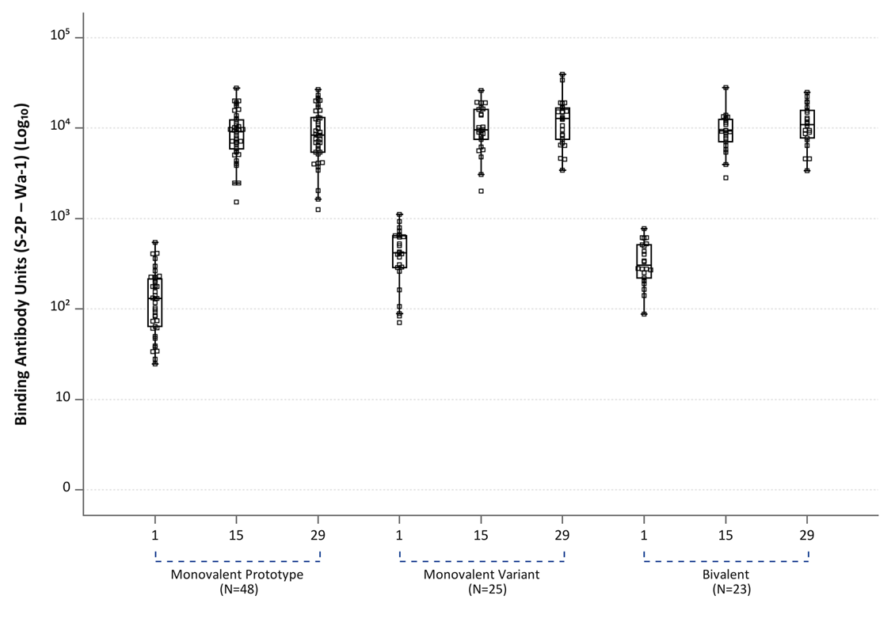

- Serum IgG S-2P Binding Assay Arbitrary Units/mL Distribution by Time Point and Treatment Group – 614D
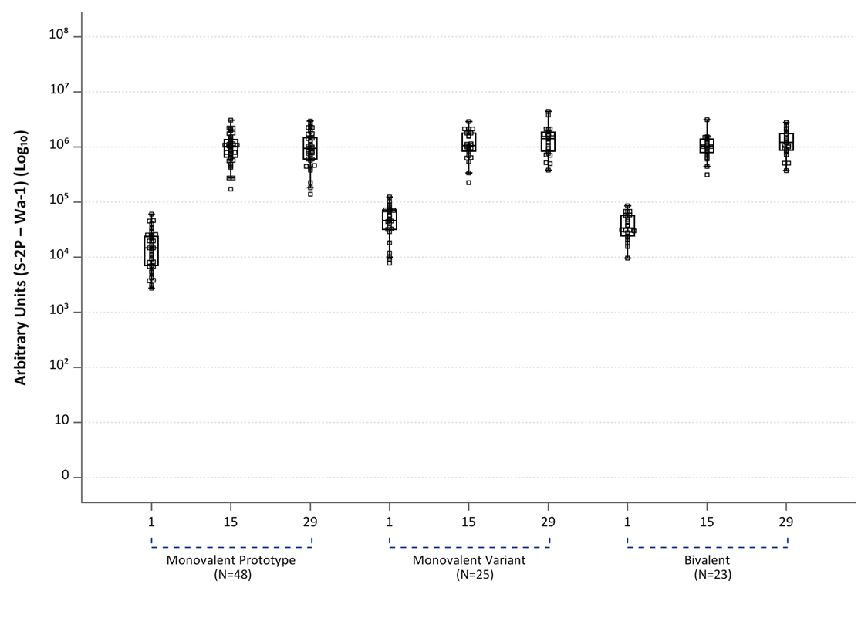

- Serum IgG RBD Binding Assay Arbitrary Units/mL Distribution by Time Point and Treatment Group – Beta (B.1.351)
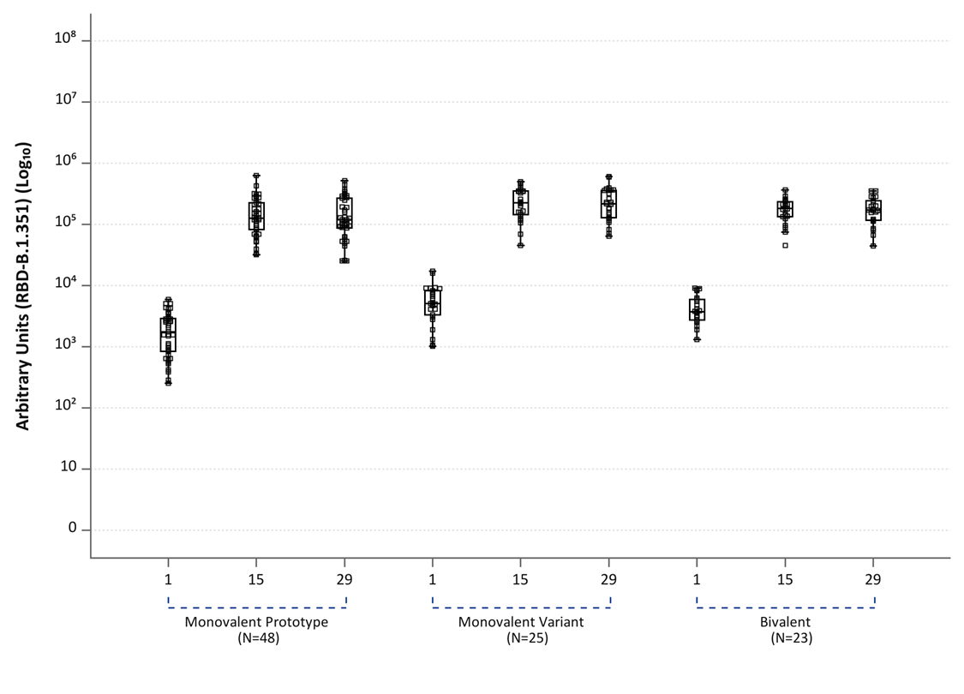
- Serum IgG S-2P Binding Assay Arbitrary Units/mL Distribution by Time Point and Treatment Group - Beta (B.1.351)
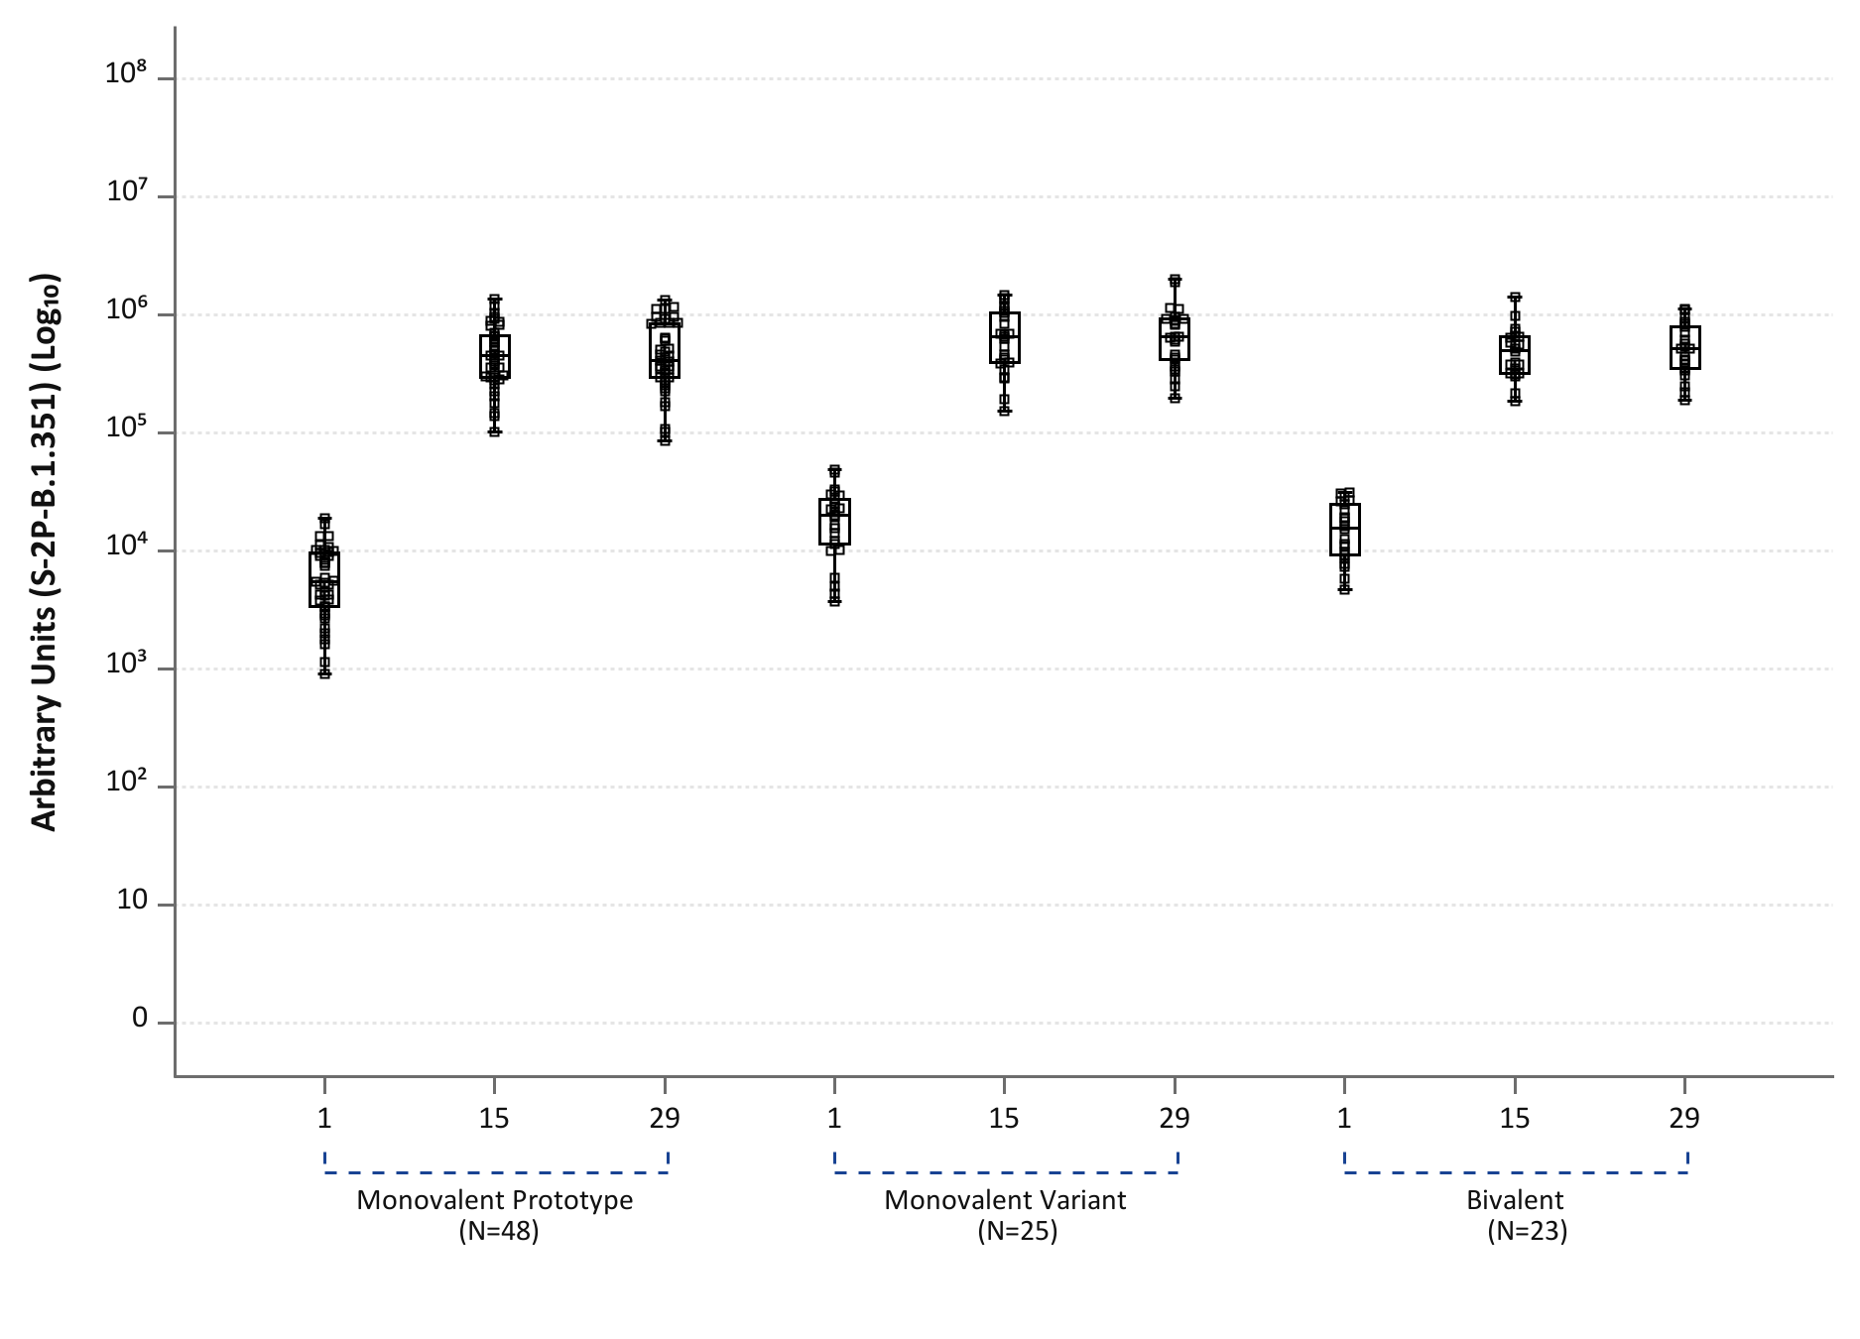

- Serum IgG Binding Area Under the Curve (AUC) Titers Distributed by Timepoint for Gamma (P.1)
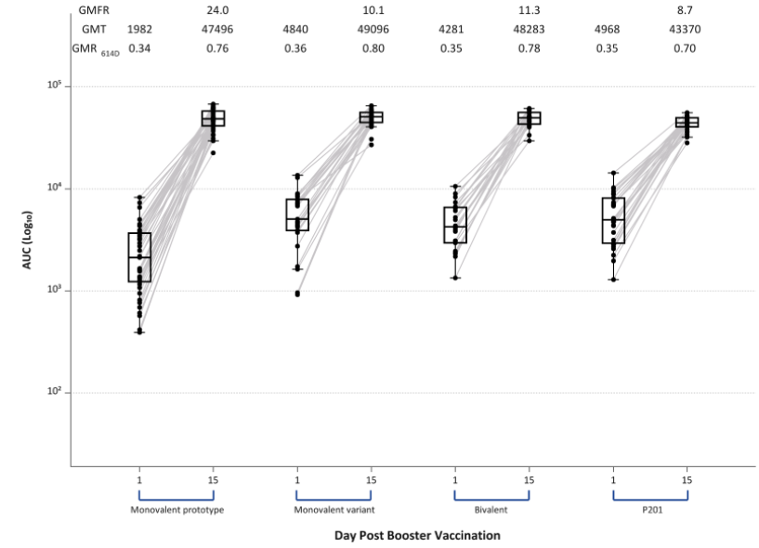
GMT (geometric mean titer), GMFR (geometric mean fold rise), GMR_{614D} (the ratio of GMTs for the variant of concern divided by the GMT of 614D strain). Boxes and horizontal bars denote interquartile range (IQR) and median respectively. Whisker endpoints are equal to the maximum and minimum values below or above the median +/- 1.5 x IQR.

Figure S2. Serum Pseudovirus Neutralization Assay ID₅₀ Titers Distributed by Timepoint for the Gamma Variant (P.1)
Serum Pseudovirus Neutralization Assay ID₅₀ Titers were low to undetectable in many participants at baseline, particularly in those who had received 25 or 50 mcg doses of mRNA-1273 for their primary 2 dose series (blue squares in monovalent prototype group) for the Gamma Variant (P.1). All participants had robust increases in Pseudovirus Neutralization Assay ID₅₀ antibody titers by 2 weeks after receipt of vaccine. Red triangles denote those that had received an initial 2 dose series of 100 mcg of mRNA-1273. For comparison, pseudovirus neutralization assay ID₅₀ titers were similar or greater than those of 30 adults that had received an initial 100 mcg of mRNA-1273 in the Phase 2 study followed by a 50 mcg third dose (P201). Peak pseudovirus neutralization titers observed (at 2 or 4 weeks) after the second dose in 100 mcg recipients in the Phase 1 mRNA-1273 participants at provided as a comparator (Peak Neutralization 100 mcg).
Boxes and horizontal bars denote interquartile range (IQR) and median AU, respectively. Whisker endpoints are equal to the maximum and minimum values below or above the median +/- 1.5 x IQR. LLOD is the lower limit of detection of the assay.

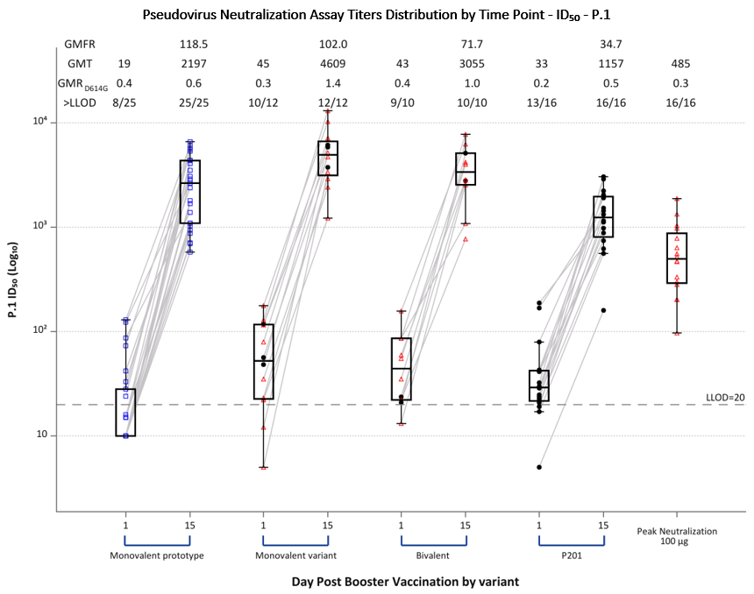

Figure S3. Serum Pseudovirus Neutralization Assay ID₈₀ Titers Distributed by Timepoint by Variant. a: D614G, b: Beta (B.1.351), c: Alpha (B.1.1.7); d: Delta (B.1.617.2), and e: Gamma (P.1).
Serum Pseudovirus Neutralization Assay ID₈₀ Titers before and at 14 days after receiving a third dose of mRNA by study group: Monovalent prototype (100 mcg of mRNA-1273), Monovalent variant (50 mcg of mRNA-1273.351), and Bivalent (25 mcg of mRNA-1273, 25 mcg of mRNA-1273.351). Serum Pseudovirus Neutralization Assay ID₈₀ Titers were low to undetectable in many participants at baseline, particularly in those who had received 25 or 50 mcg doses of mRNA-1273 for their primary 2 dose series (blue squares in monovalent prototype group), particularly for Beta, Delta, and Gamma variants. All participants had robust increases in Pseudovirus Neutralization Assay ID₈₀ antibody titers by 2 weeks after receipt of vaccine across all the variants. For comparison, titers were similar or greater than those of 30 adults that had received an initial 100 mcg of mRNA-1273 in the Phase 2 study followed by a 50 mcg third dose (P201). Peak pseudovirus neutralization titers observed (at 2 or 4 weeks) after the second dose in 100 mcg recipients in the Phase 1 mRNA-1273 participants at provided as a comparator (Peak Neutralization 100 mcg).

Boxes and horizontal bars denote interquartile range (IQR) and median AU, respectively. Whisker endpoints are equal to the maximum and minimum values below or above the median +/- 1.5 x IQR. LLOD is the lower limit of detection of the assay.

- Serum Pseudovirus Neutralization Assay ID₈₀ Titers Distributed by Timepoint by Variant – D614G
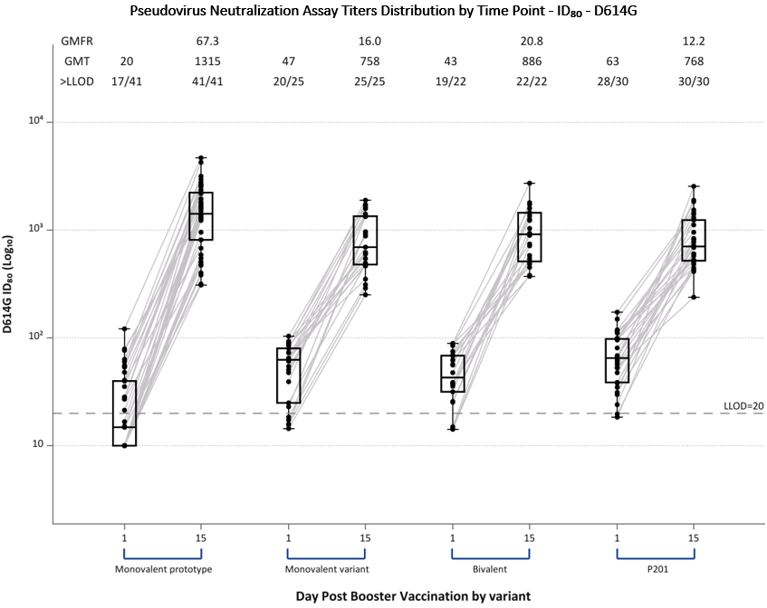
- Serum Pseudovirus Neutralization Assay ID₈₀ Titers Distributed by Timepoint by Variant – Beta Variant (B.1.351)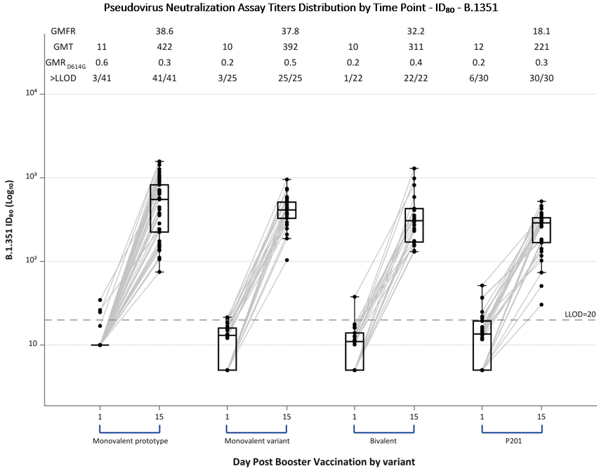

C) Serum Pseudovirus Neutralization Assay ID₈₀ Titers Distributed by Timepoint – Alpha Variant (B.1.1.7)
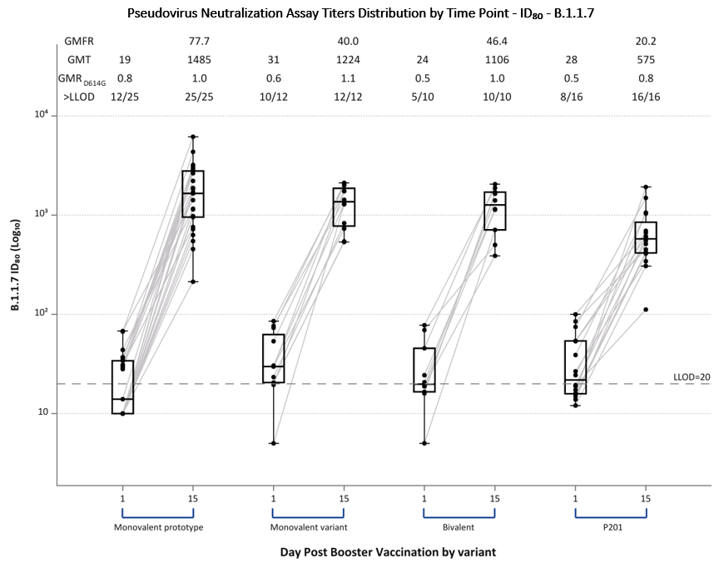

D) Serum Pseudovirus Neutralization Assay ID₈₀ Titers Distributed by Timepoint – Delta Variant (B.1.617.2)
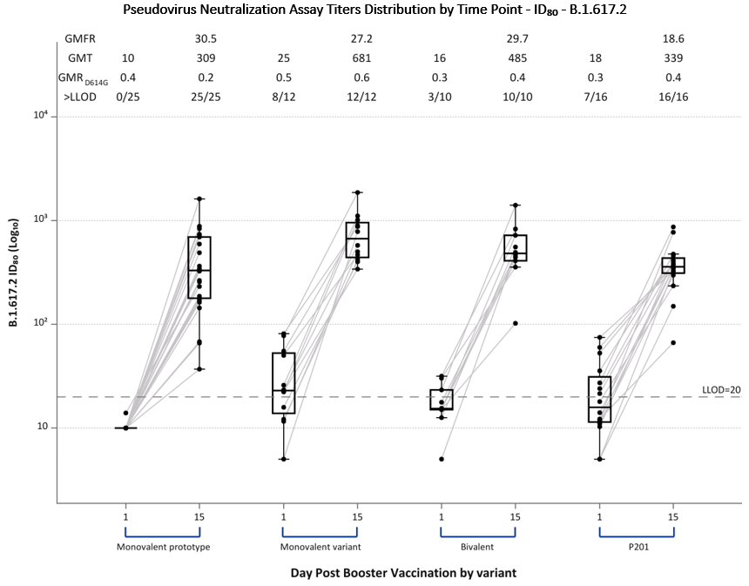
E) Serum Pseudovirus Neutralization Assay ID₈₀ Titers Distributed by Timepoint – Gamma Variant (P.1) 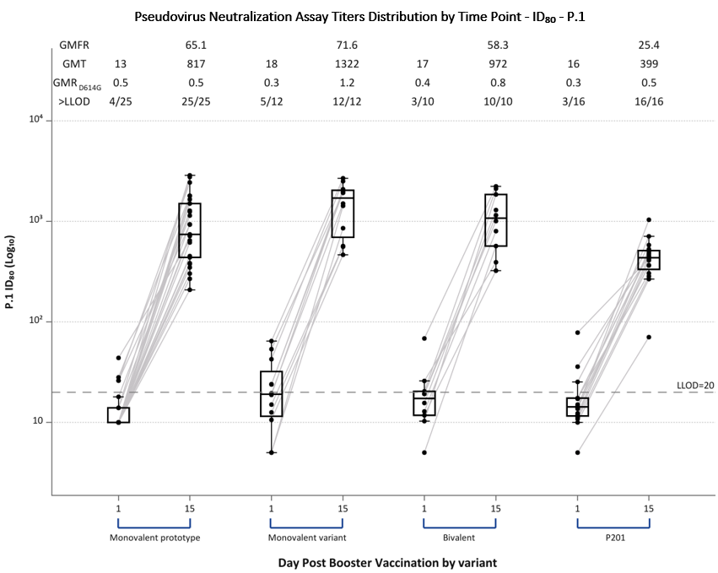

Figure S4. Serum FRNT₅₀ Titers Distributed by Timepoint and Group. Panel A: D614G, b: Beta (B.1.351), c: Alpha (B.1.1.7); d: Delta (B.1.617.2), and e: Gamma (P.1).
Serum FRNT₅₀ antibody titers area under the curve before and at 14 days after receiving a third dose of mRNA by study group: Monovalent prototype (100 mcg of mRNA-1273), Monovalent variant (50 mcg of mRNA-1273.351), and Bivalent (25 mcg of mRNA-1273, 25 mcg of mRNA-1273.351). FRNT₅₀ antibodies were low to undetectable in many participants at baseline, particularly in those who had received 25 or 50 mcg doses of mRNA-1273 for their primary 2 dose series (monovalent prototype group) and against the Beta, Delta, and Gamma variants. All participants had robust increases in FRNT₅₀ antibody titers by 2 weeks after receipt of vaccine across all the variants. For comparison, FRNT₅₀ titers were similar to those of 30 adults that had received an initial 100 mcg of mRNA-1273 in the Phase 2 study followed by a 50 mcg third dose were included (P201). FRNT₅₀ titers were generally greater than the peak responses observed at 2 or 4 weeks after a second 100 mcg dose of mRNA-1273 in those that had enrolled in the original Phase I study that were used for comparison. FRNT ID₅₀ titers after a third dose are generally greater than those observed (at 2 or 4 weeks) after the second dose in 100 mcg recipients in the Phase 1 mRNA-1273 participants (Peak Neutralization 100 mcg).
GMT (geometric mean titer), GMFR (geometric mean fold rise), GMR_{614D} is the ratio of GMTs for the variant of concern divided by the GMT of 614D strain, >LLOD is the number of subjects with titers greater than the lower limit of detection at that timepoint. Boxes and horizontal bars denote interquartile range (IQR) and median respectively. Whisker endpoints are equal to the maximum and minimum values below or above the median +/- 1.5 x IQR. Titers for participants that had received 100 mcg for their initial two doses in the Phase I study are highlighted with red triangles. All other participants that had received other initial doses (25, 50, 250 mcg) are denoted by black circles.

- FRNT Assay Titers Distribution by Time Point - ID₅₀ - D614G
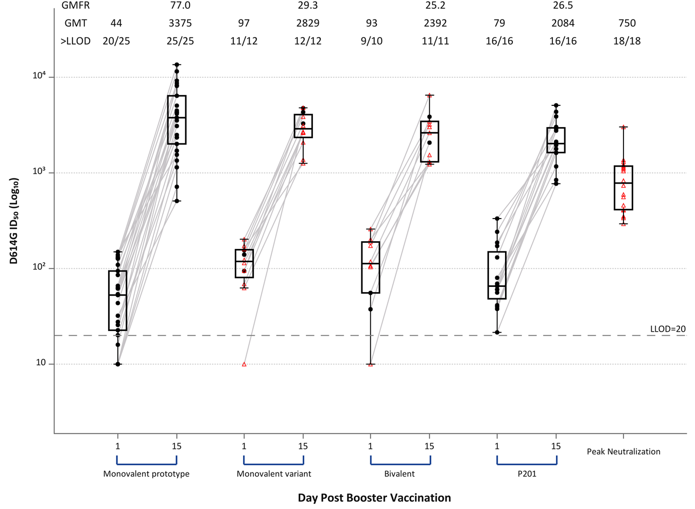

- FRNT Assay Titers Distribution by Time Point - ID₅₀ - Beta (B.1.351)
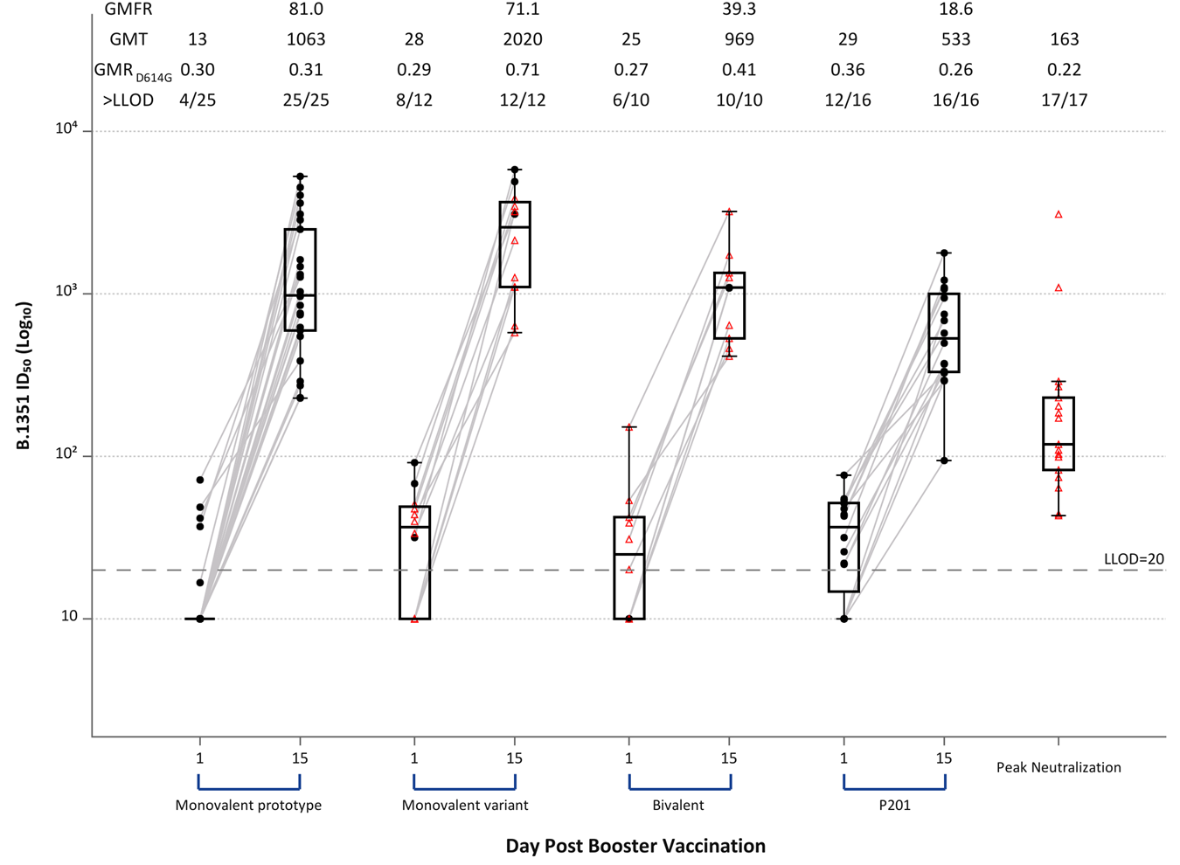

- FRNT Assay Titers Distribution by Time Point - ID₅₀ - Alpha (B.1.1.7)
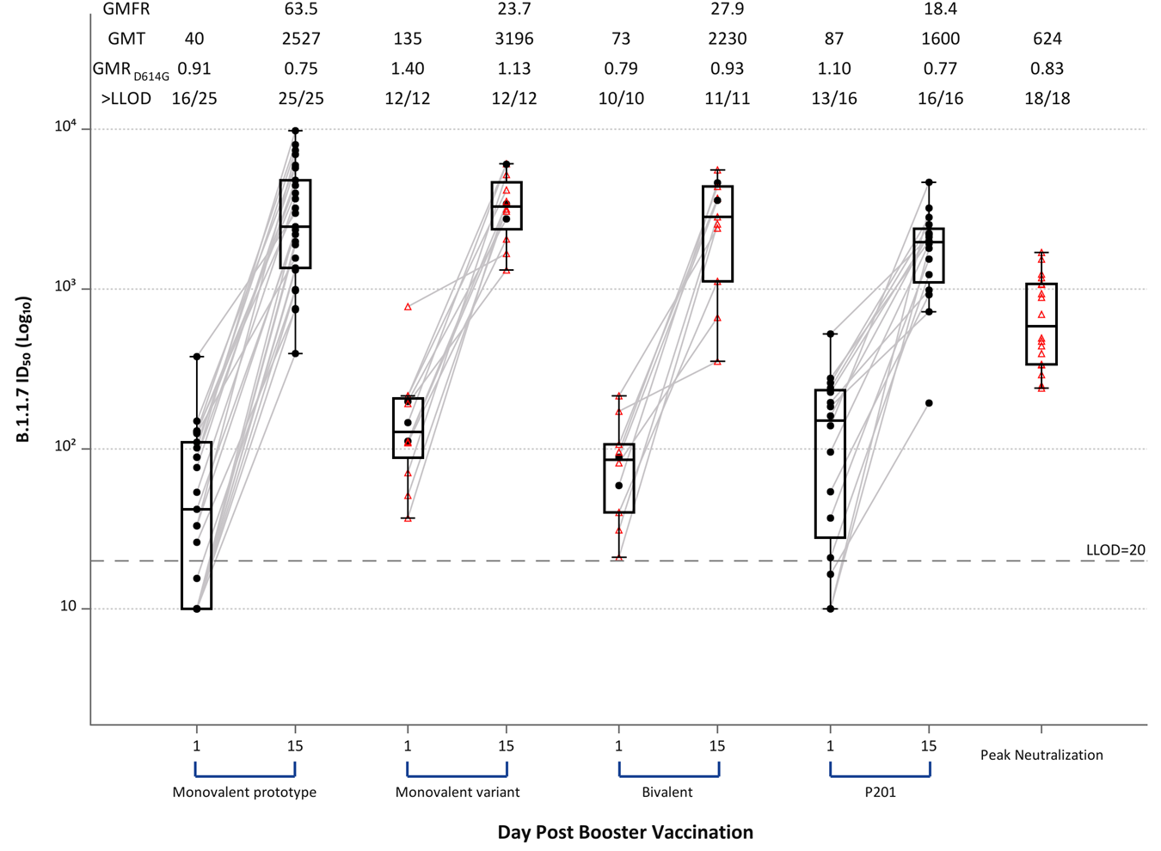
- FRNT Assay Titers Distribution by Time Point - ID₅₀ - Delta (B.1.617.2)
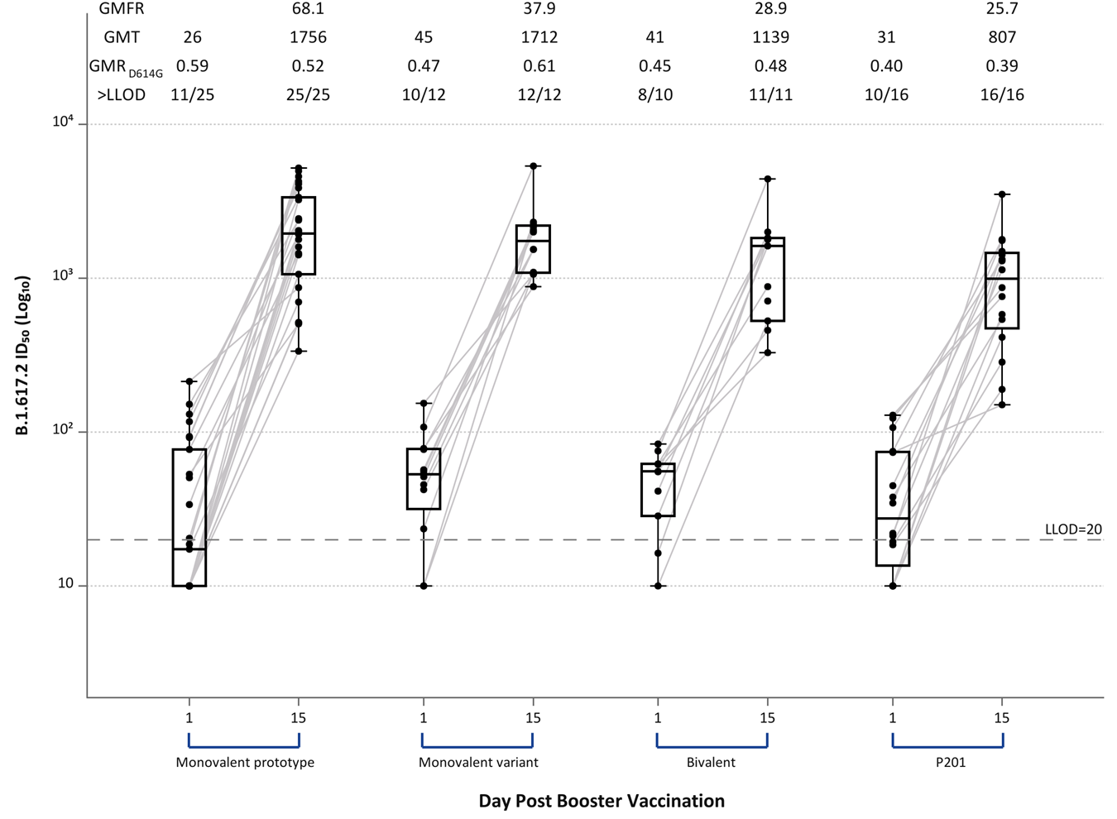

- FRNT Assay Titers Distribution by Time Point - ID₅₀ - Gamma (P.1)
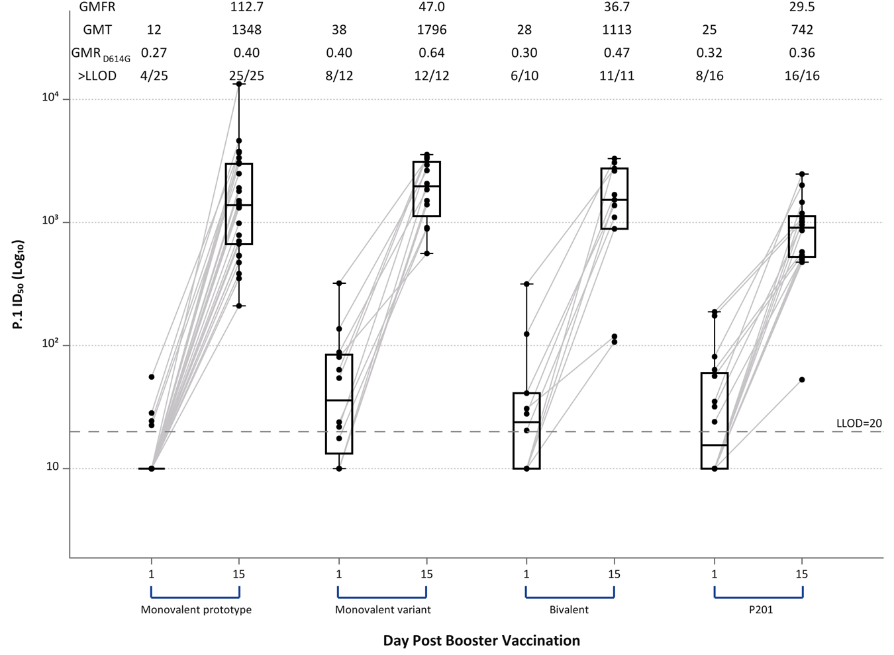

Figure S5. Serum FRNT₈₀ Titers Distributed by Timepoint and Group. Panel A: D614G, b: Beta (B.1.351), c: Alpha (B.1.1.7); d: Delta (B.1.617.2), and e: Gamma (P.1).
Serum FRNT₈₀ antibody titers area under the curve before and at 14 days after receiving a third dose of mRNA by study group: Monovalent prototype (100 mcg of mRNA-1273), Monovalent variant (50 mcg of mRNA-1273.351), and Bivalent (25 mcg of mRNA-1273, 25 mcg of mRNA-1273.351). FRNT₈₀ antibodies were low to undetectable in many participants at baseline, particularly in those who had received 25 or 50 mcg doses of mRNA-1273 for their primary 2 dose series (monovalent prototype group) and against the Beta, Delta, and Gamma variants. All participants had robust increases in FRNT₈₀ antibody titers by 2 weeks after receipt of vaccine across all the variants. For comparison, FRNT₈₀ titers were similar to those of 30 adults that had received an initial 100 mcg of mRNA-1273 in the Phase 2 study followed by a 50 mcg third dose were included (P201). FRNT₈₀ titers were generally greater than the peak responses observed at 2 or 4 weeks after a second 100 mcg dose of mRNA-1273 in those that had enrolled in the original Phase I study that were used for comparison. FRNT ID₈₀ titers after a third dose are generally greater than those observed (at 2 or 4 weeks) after the second dose in 100 mcg recipients in the Phase 1 mRNA-1273 participants (Peak Neutralization 100 mcg).
GMT (geometric mean titer), GMFR (geometric mean fold rise), GMR_{614D} is the ratio of GMTs for the variant of concern divided by the GMT of 614D strain, >LLOD is the number of subjects with titers greater than the lower limit of detection at that timepoint. Boxes and horizontal bars denote interquartile range (IQR) and median respectively. Whisker endpoints are equal to the maximum and minimum values below or above the median +/- 1.5 x IQR. Titers for participants that had received 100 mcg for their initial two doses in the Phase I study are highlighted with red triangles. All other participants that had received other initial doses (25, 50, 250 mcg) are denoted by black circles. LLOD is the lower limit of detection of the assay.

- FRNT Assay Titers Distribution by Time Point - ID₈₀ - D614G
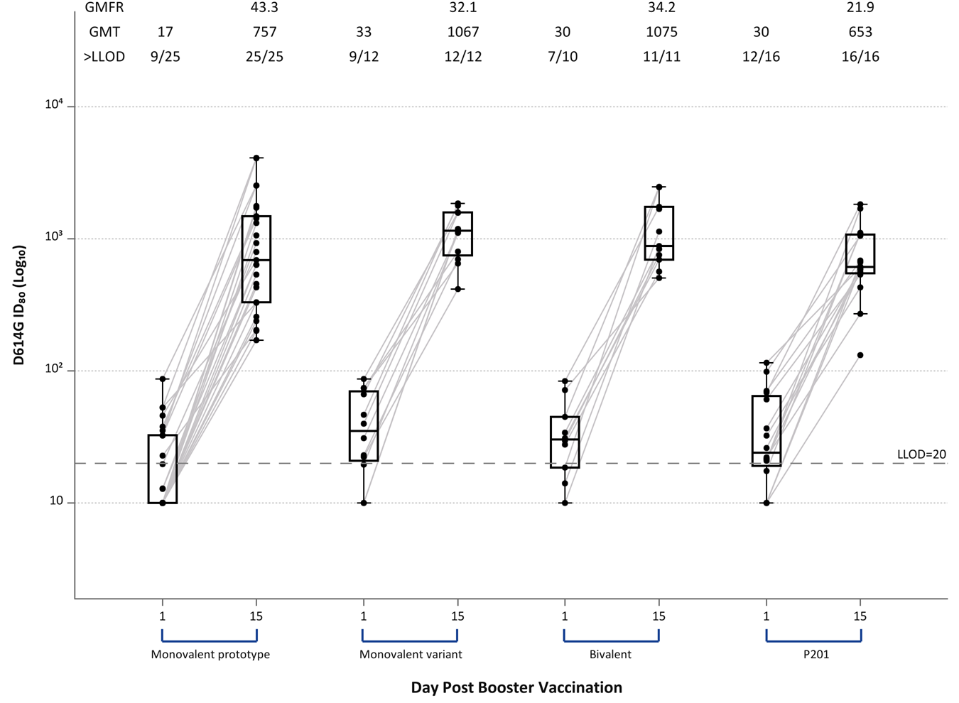

- FRNT Assay Titers Distribution by Time Point - ID₈₀ - Beta (B.1.351)
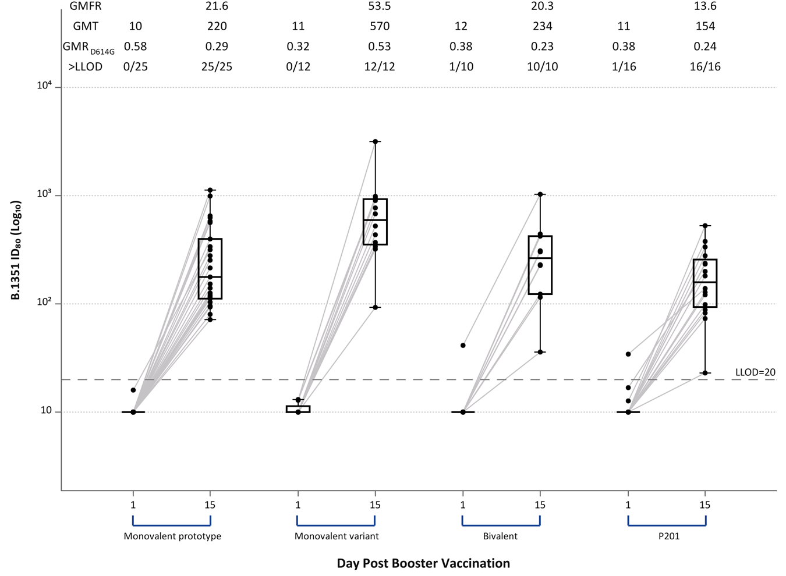

- FRNT Assay Titers Distribution by Time Point - ID₈₀ - Alpha (B.1.1.7)
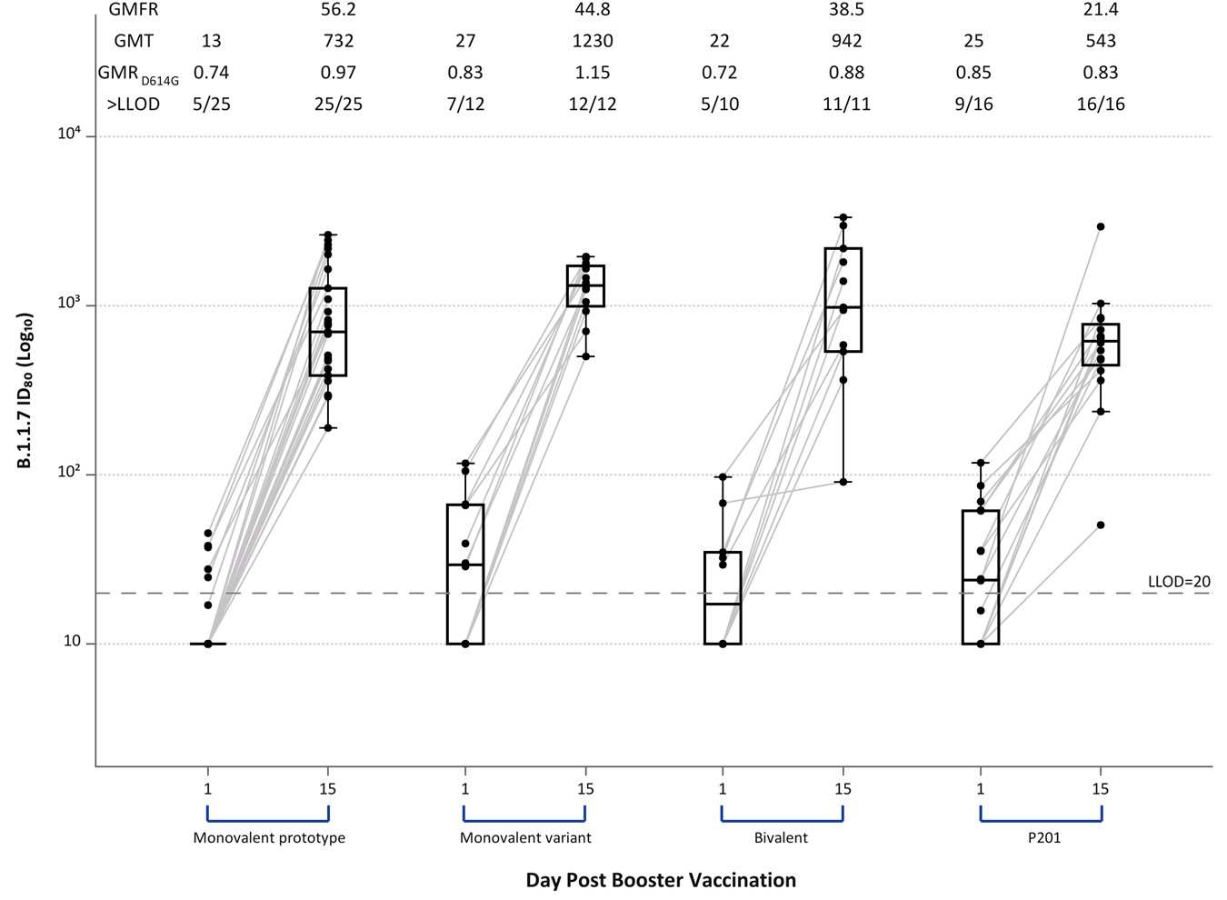

- Assay Titers Distribution by Time Point - ID₈₀ - Delta (B.1.617.2)
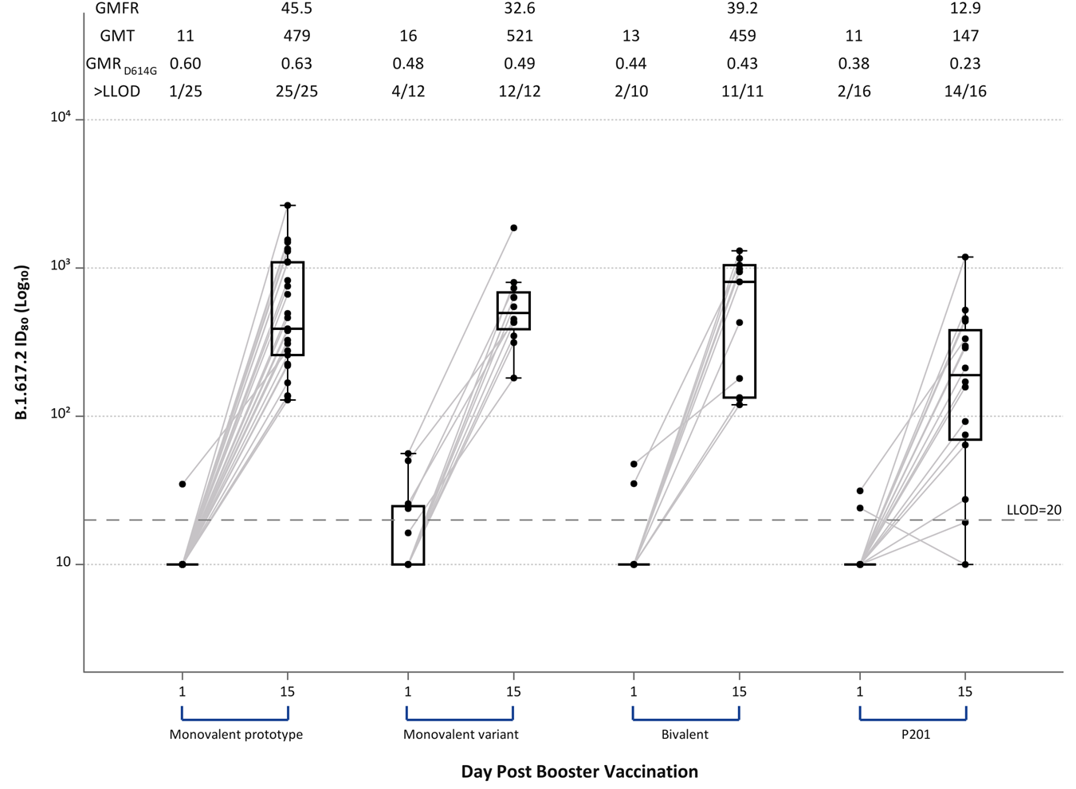

- FRNT Assay Titers Distribution by Time Point - ID₈₀ - P.1
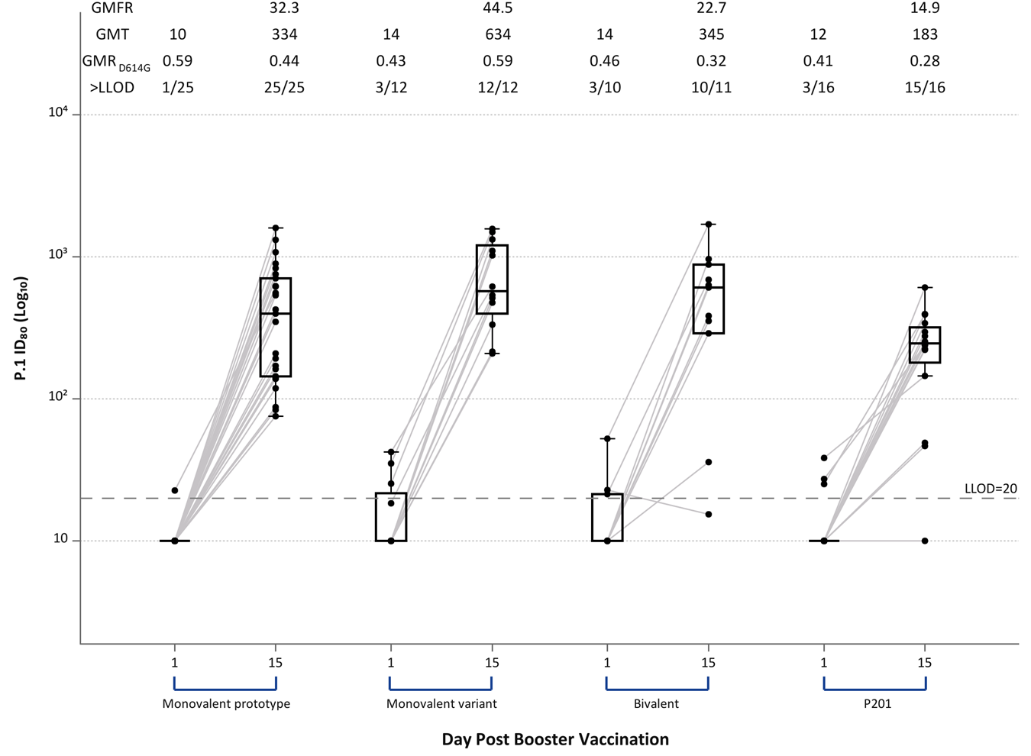

Figure S6. CD4 T Cell TH2 Responses by Group and Timepoint.
Background adjusted % of CD4 T cells expressing IL-4 in response to peptides from the A) 614D spike and B) the beta variant spike, respectively. Data was thresholded at 0.025%. Data points below 0.025% are displayed at 0.025%. Closed circles indicate positive spike-specific IL-4 responses and open circles indicate negative spike-specific IL-4 responses by Fisher’s exact test. The numbers on the graph indicate the number of positive responders over the total number tested for each group and timepoint.
- 614D Spike-Specific TH2 CD4 T Cells
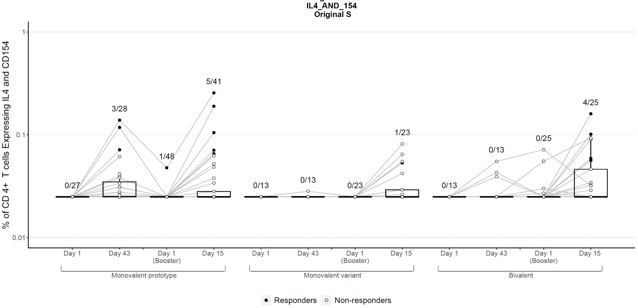

- Beta Spike-Specific TH2 CD4 T Cells
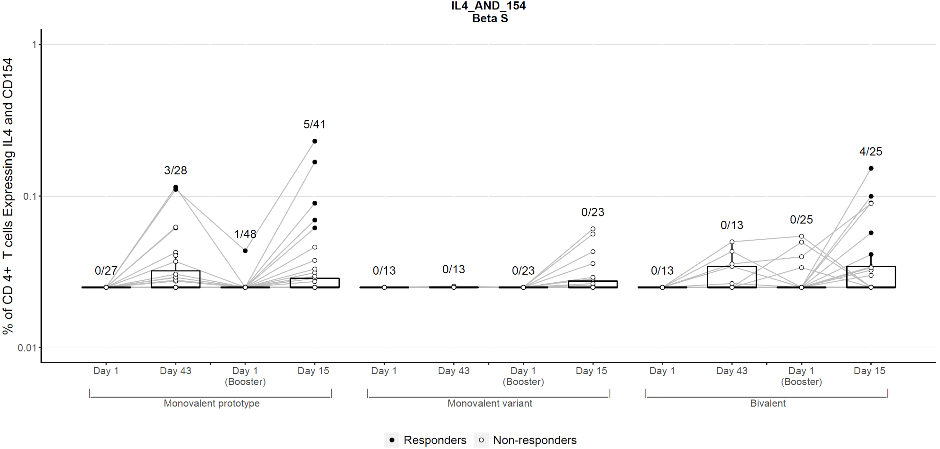

Figure S7. Memory CD4 TH1 Responses by Group and Timepoint for 614D spike.
Background adjusted % of CD4 T cells that are A) effector memory (EM), B) central memory (CM), C) TEMRA and D) overlay of EM, CM, and TEMRA, and express IFN-γ and/or IL-2 in response to peptides from the 614D spike, respectively, out of total CD4 T cells. Data was thresholded at 0.025%. Data points below 0.025% are displayed at 0.025%. Closed circles indicate positive spike-specific responses and open circles indicate negative spike-specific responses by Fisher’s exact test. The numbers on the graph indicate the number of positive responders over the total number tested for each group and timepoint.
  - Spike-Specific Effector Memory CD4 T Cells
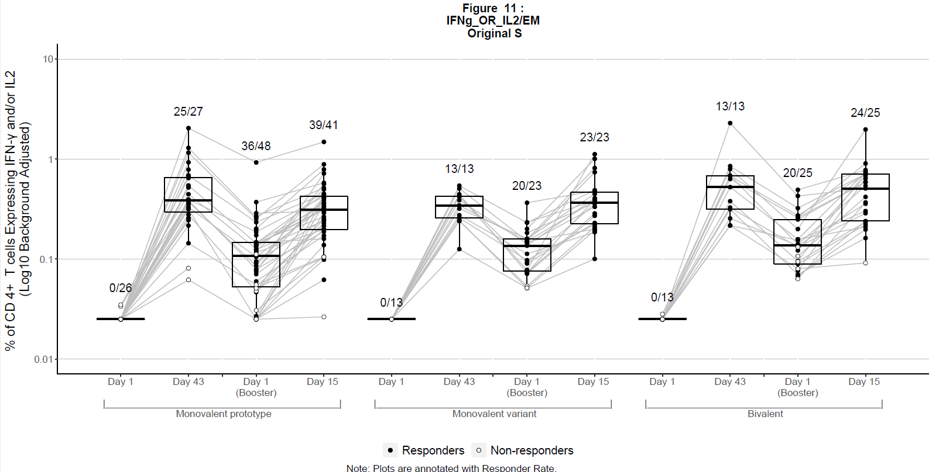:

  - Spike-Specific Central Memory CD4 T Cells
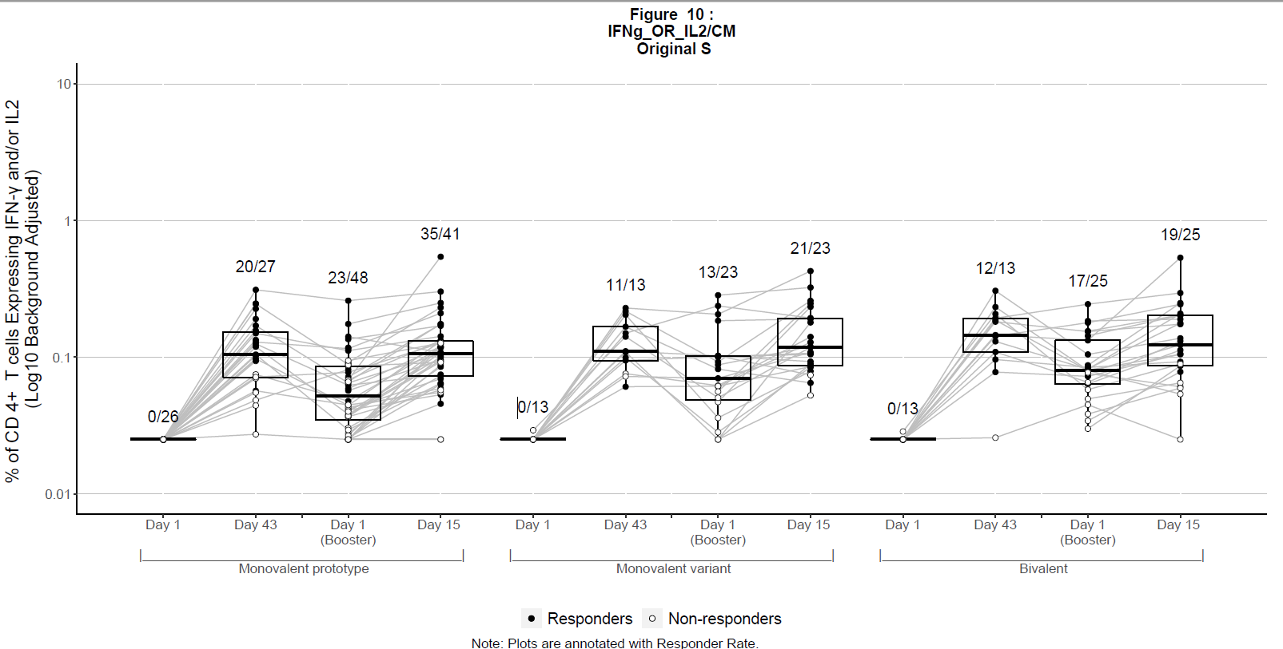

  - Spike-Specific TEMRA Memory CD4 T Cells
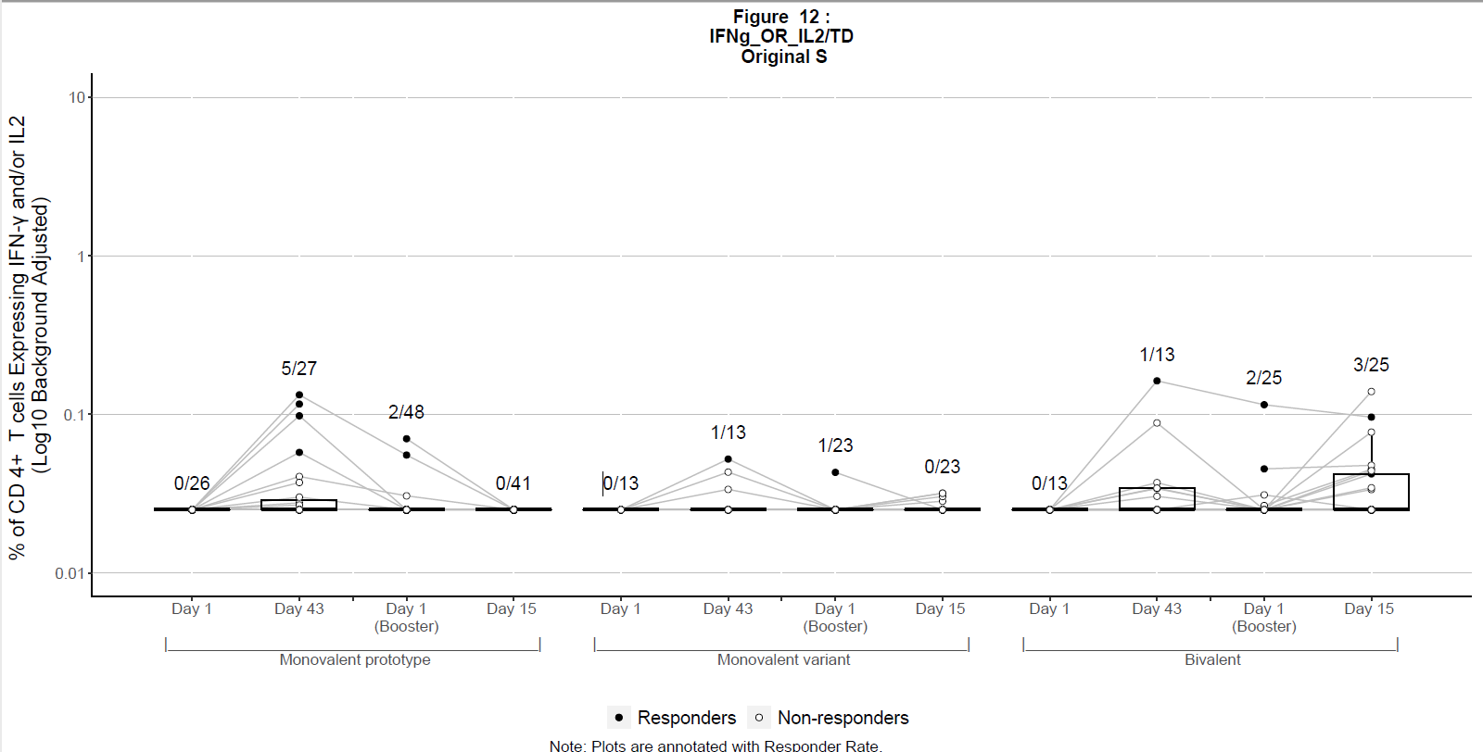

  - Overlay of Spike-specific CD4 effector memory (EM), central memory (CM), and TEMRA for 614D
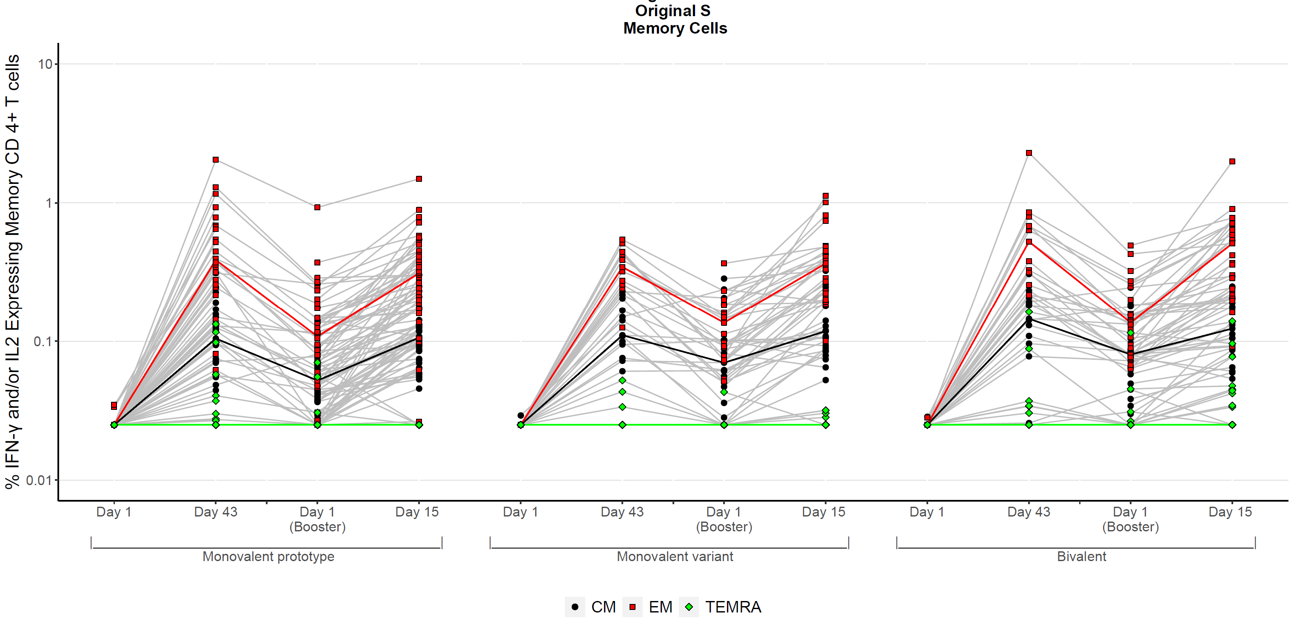

Figure S8. Memory CD4 TH1 Responses by Group and Timepoint for Beta spike.
Background adjusted % of CD4 T cells that are the overlay of EM, CM, and TEMRA, and express IFN-γ and/or IL-2 in response to peptides from the Beta spike, respectively, out of total CD4 T cells. Data was thresholded at 0.025%. Data points below 0.025% are displayed at 0.025%. Closed circles indicate positive spike-specific responses and open circles indicate negative spike-specific responses by Fisher’s exact test. The numbers on the graph indicate the number of positive responders over the total number tested for each group and timepoint.
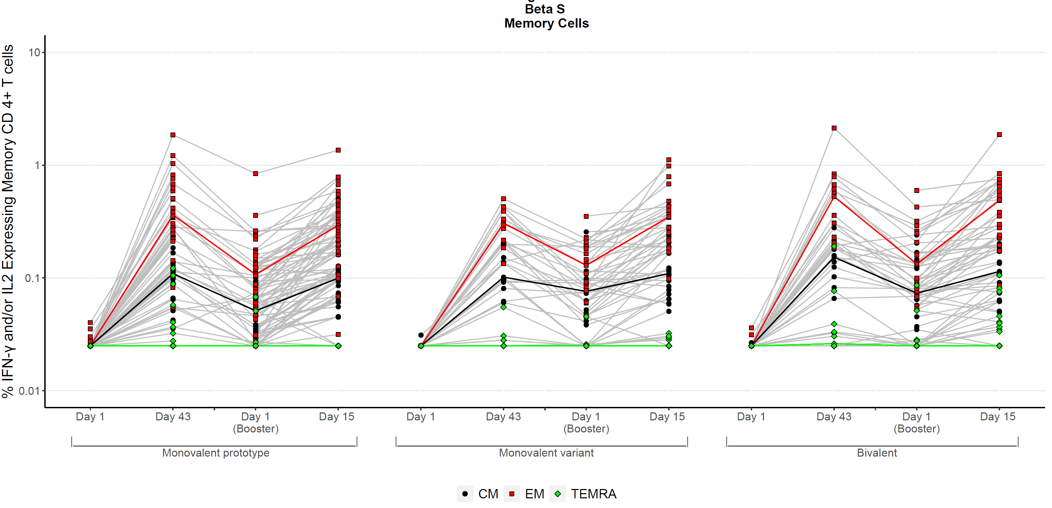

Figure S9. Memory CD8 T Cell Responses to 614D by Group and Timepoint.
Background adjusted % of CD8 T cells that are A) effector memory (EM), B) central memory (CM), C) TEMRA, and D) Overlay of Spike-specific CD8 effector memory (EM), central memory (CM), and TEMRA and express IFN-γ and/or IL-2 in response to peptides from the 614D spike out of total CD8 T cells. Data was thresholded at 0.025%. Data points below 0.025% are displayed at 0.025%. Closed circles indicate positive spike-specific responses and open circles indicate negative spike-specific responses by Fisher’s exact test. The numbers on the graph indicate the number of positive responders over the total number tested for each group and timepoint.
- Spike-Specific Effector Memory CD8 T Cells
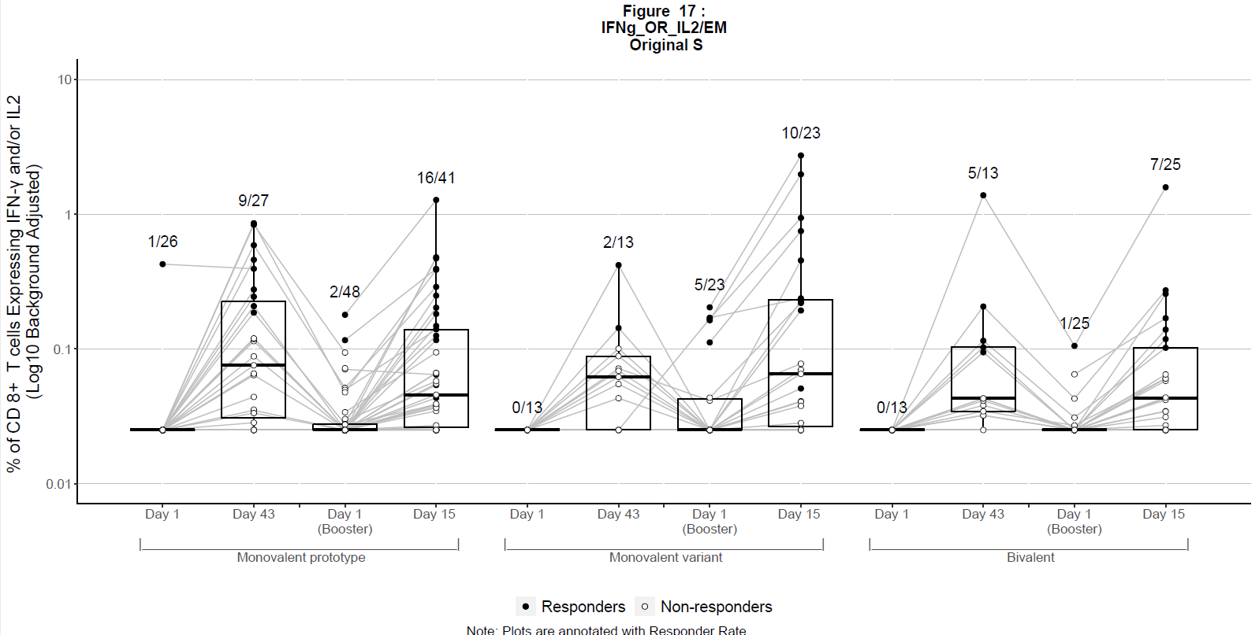

- Spike-Specific Central Memory CD8 T Cells
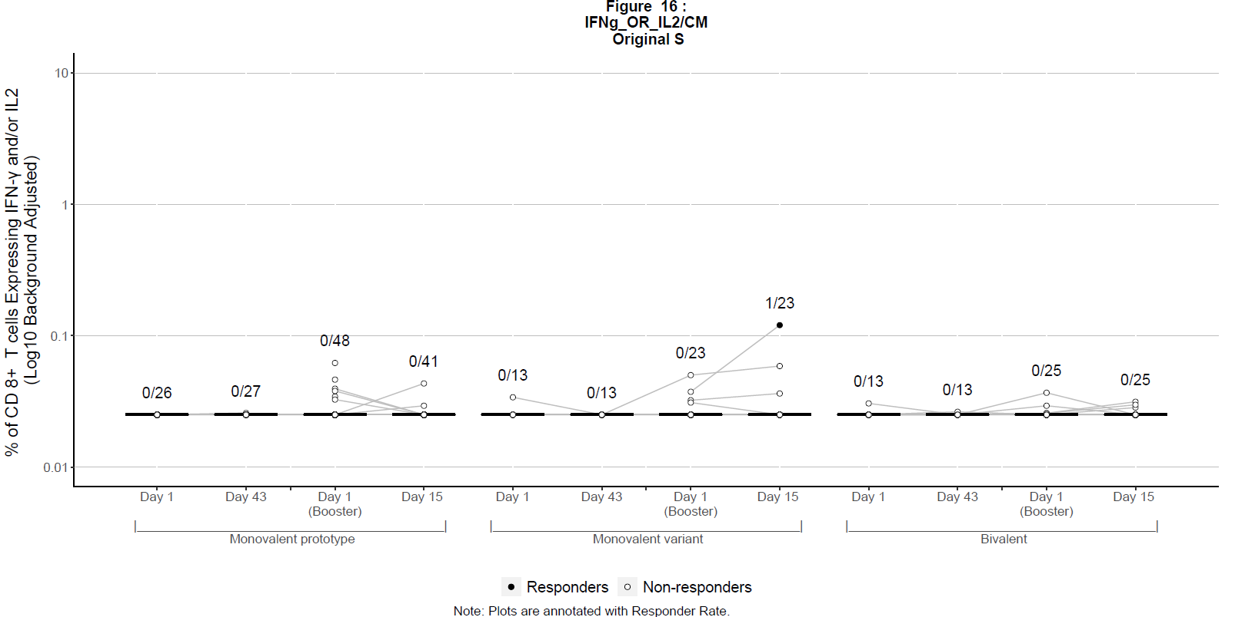

- Spike-Specific TEMRA Memory CD8 T Cells
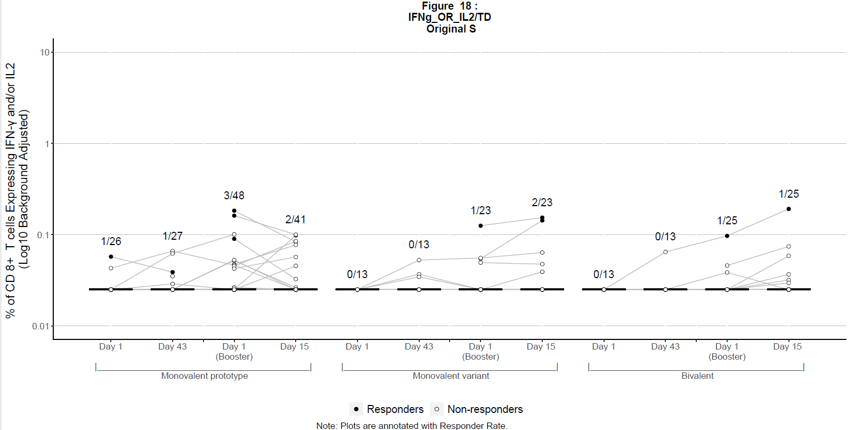

- Overlay of Spike-specific CD8 effector memory (EM), central memory (CM), and TEMRA for 614D
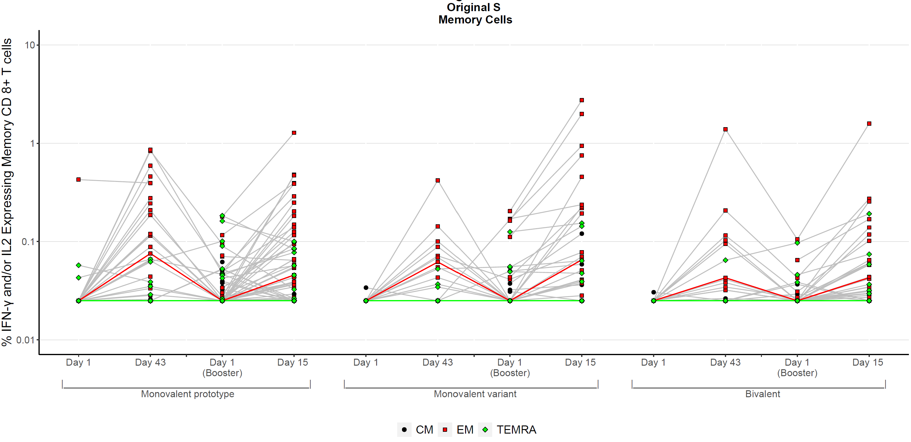

Figure S10. Memory CD8 T Cell Responses by Group and Timepoint for Beta.
Background adjusted % of CD8 T cells that are the Overlay of Spike-specific CD8 effector memory (EM), central memory (CM), and TEMRA and express IFN-γ and/or IL-2 in response to peptides from Beta, respectively, out of total CD8 T cells. Data was thresholded at 0.025%. Data points below 0.025% are displayed at 0.025%. Closed circles indicate positive spike-specific responses and open circles indicate negative spike-specific responses by Fisher’s exact test. The numbers on the graph indicate the number of positive responders over the total number tested for each group and timepoint.
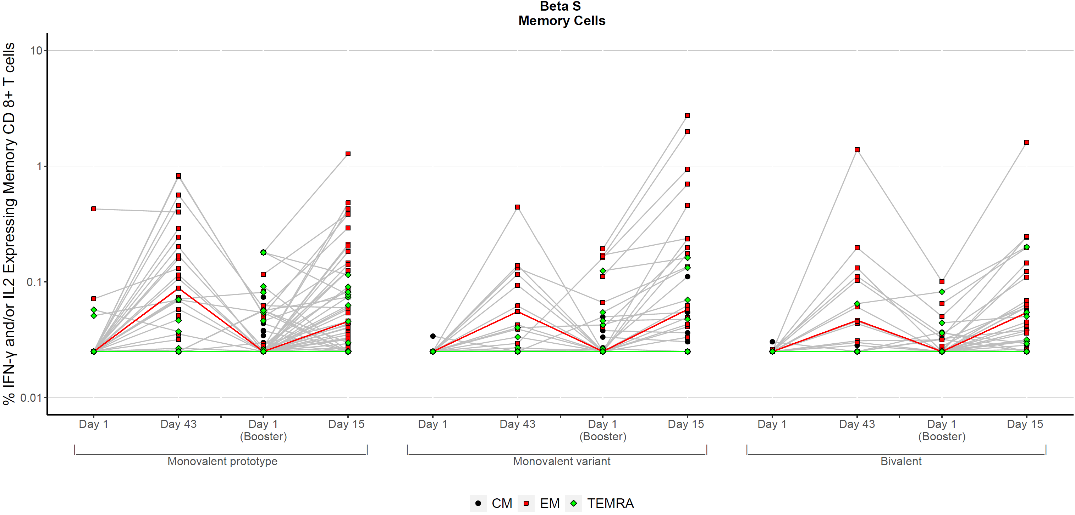

Figure S11. CD4 T Cell TH1 Responses by Group and Timepoint to the Variant Regions.
Background adjusted % of CD4 T cells expressing IFN-γ and/or IL-2 in response to the subset of peptides which contain mutations in the Beta spike A) and a matching set of peptides covering the same regions in the B) 614D spike, respectively. Data was thresholded at 0.025%. Data points below 0.025% are displayed at 0.025%. Closed circles indicate positive responses and open circles indicate negative responses by Fisher’s exact test. The numbers on the graph indicate the number of positive responders over the total number tested for each group and timepoint.
- Beta variant regions
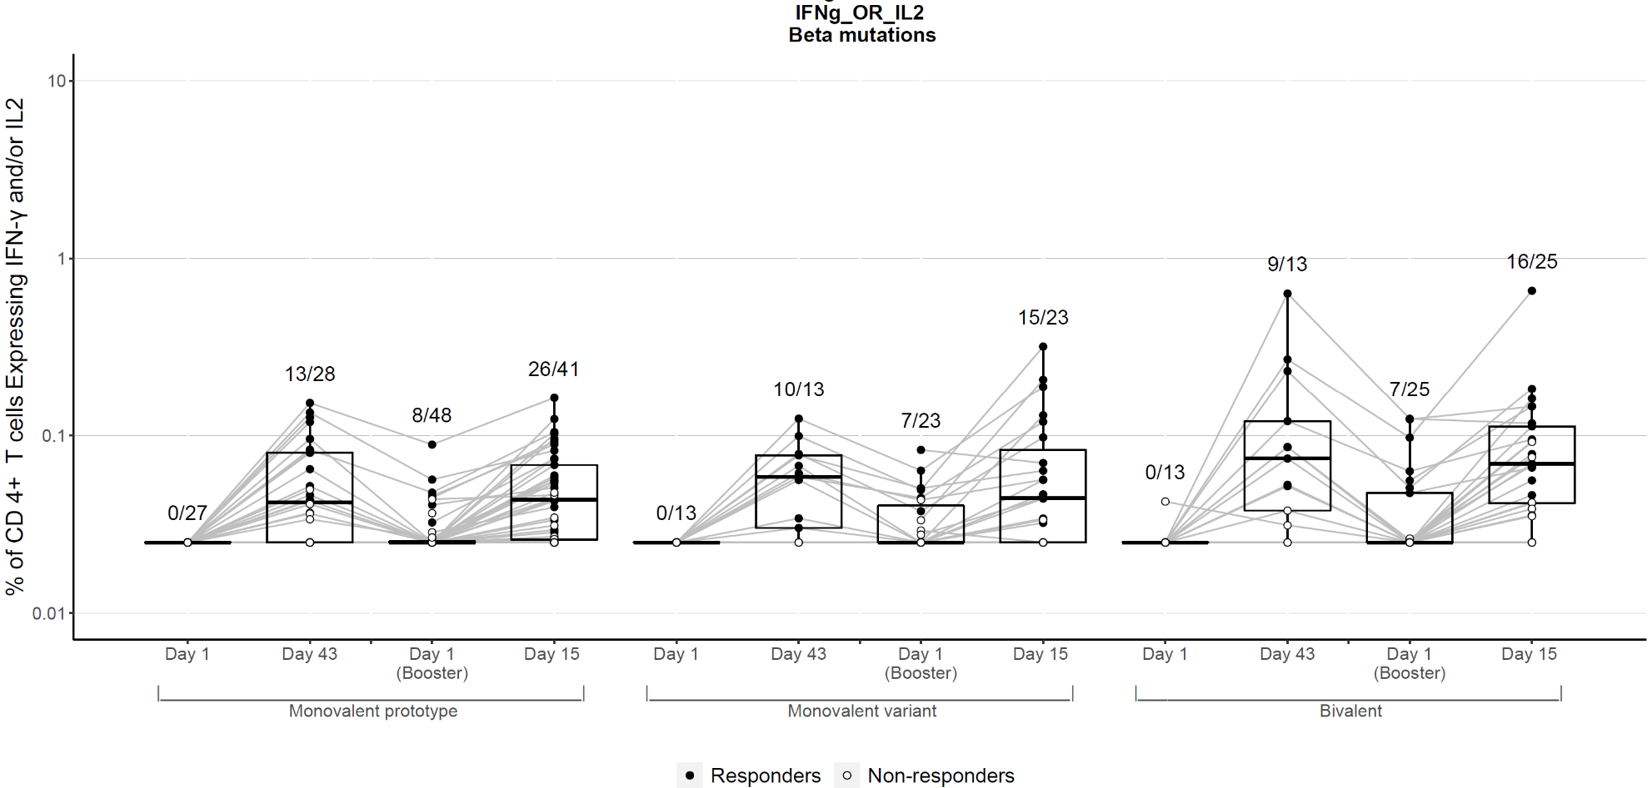

- 614D matched peptides corresponding to the variant regions

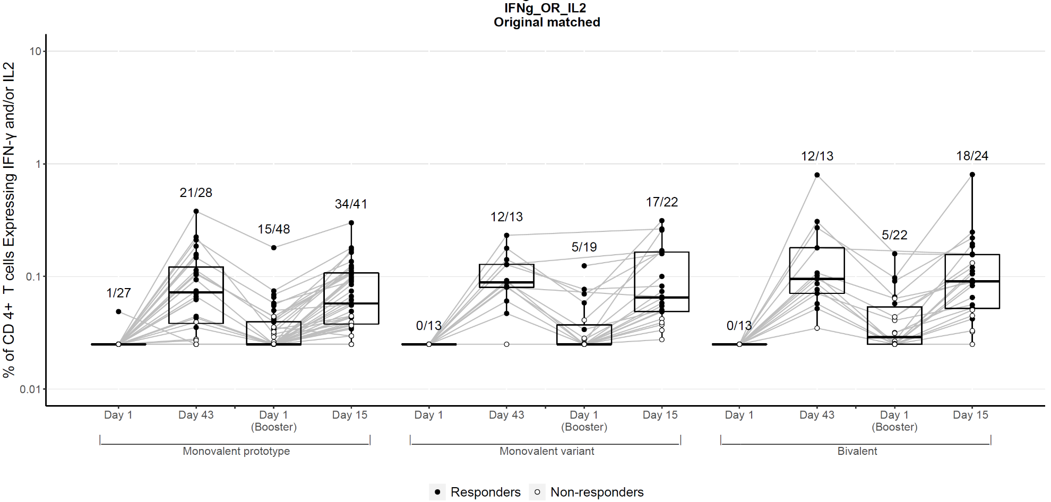

Figure S12. CD8 T Cell TH1 Responses by Group and Timepoint to the Variant Regions.
Background adjusted % of CD8 T cells expressing IFN-γ and/or IL-2 in response to the subset of peptides which contain mutations in the Beta spike A) and a matching set of peptides covering the same regions in the B) 614D spike, respectively. Data was thresholded at 0.025%. Data points below 0.025% are displayed at 0.025%. Closed circles indicate positive responses and open circles indicate negative responses by Fisher’s exact test. The numbers on the graph indicate the number of positive responders over the total number tested for each group and timepoint.
- Beta variant regions
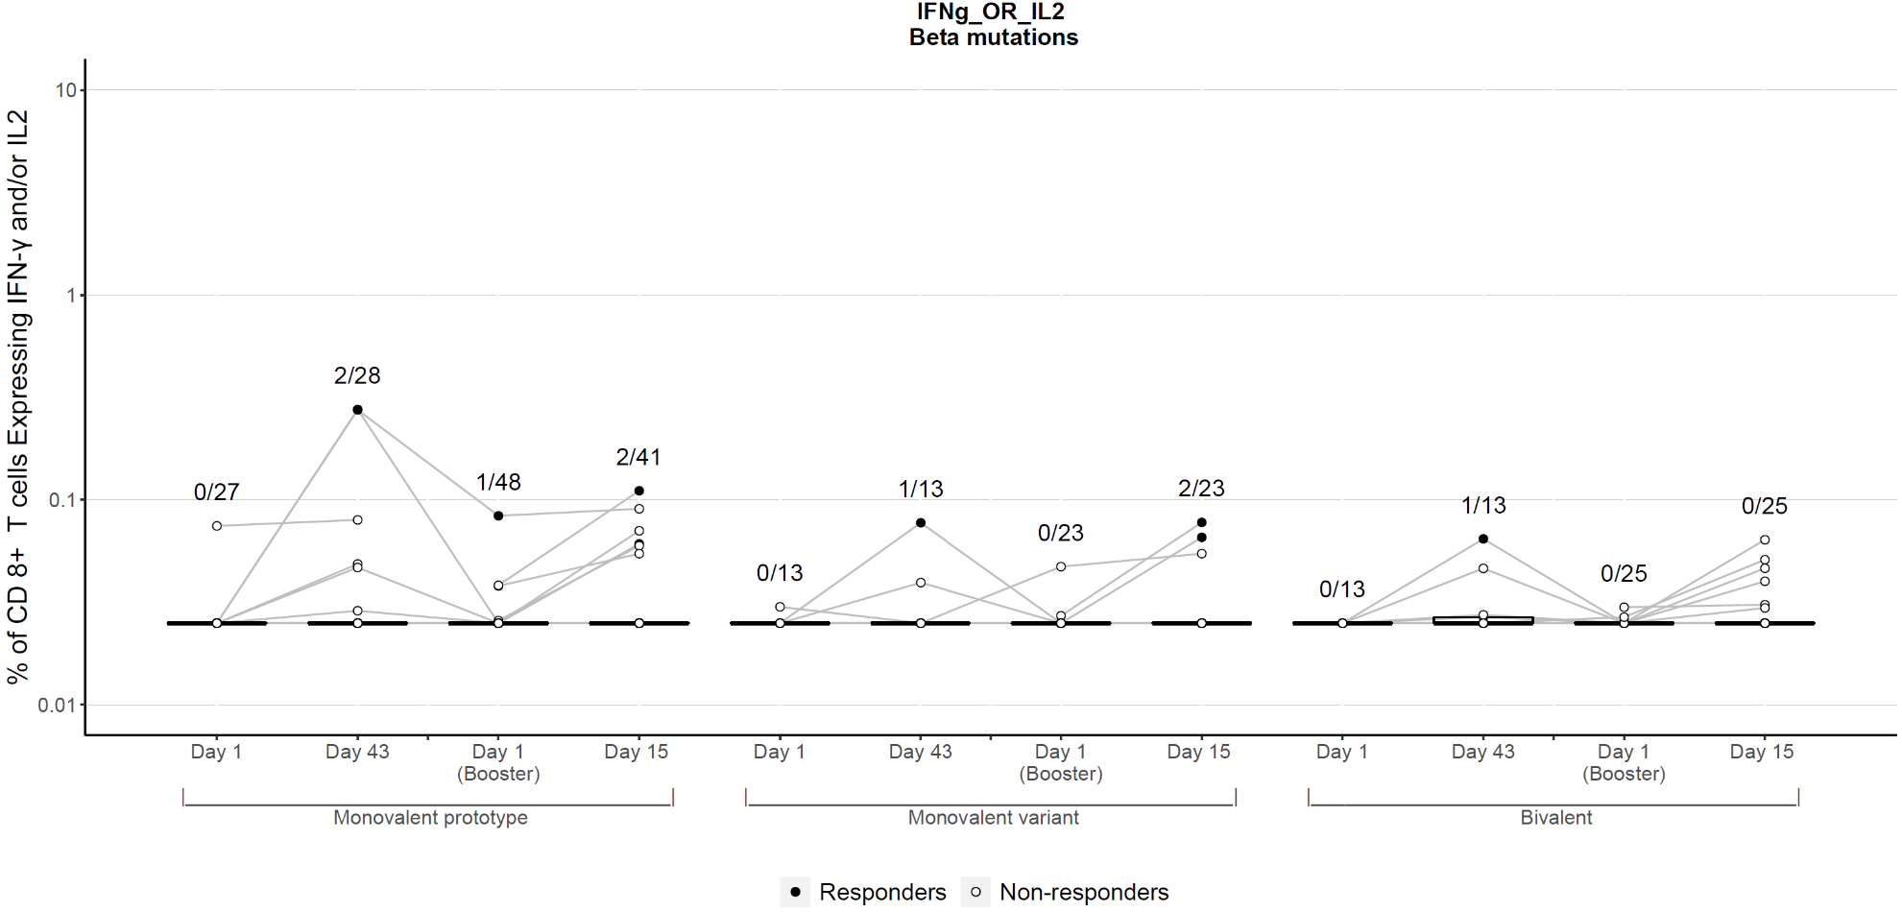
- 614D matched peptides corresponding to the variant regions
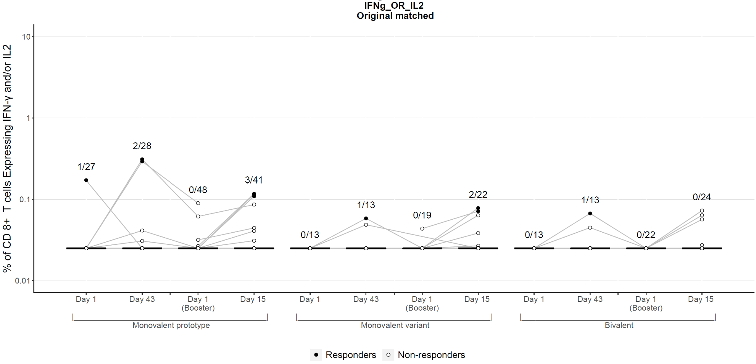

References:
1 Jackson, L. A. et al. An mRNA Vaccine against SARS-CoV-2 - Preliminary Report. N Engl J Med 383, 1920-1931, doi:10.1056/NEJMoa2022483 (2020).
2 Wrapp, D. et al. Cryo-EM structure of the 2019-nCoV spike in the prefusion conformation. Science (New York, N.Y 367, 1260-1263, doi:10.1126/science.abb2507 (2020).
3 Pegu, A. et al. Durability of mRNA-1273 vaccine-induced antibodies against SARS-CoV-2 variants. Science (New York, N.Y 373, 1372-1377, doi:10.1126/science.abj4176 (2021).
4 Atmar, R. L. et al. Heterologous SARS-CoV-2 Booster Vaccinations - Preliminary Report. medRxiv, doi:10.1101/2021.10.10.21264827 (2021).
5 Anderson, E. J. et al. Safety and Immunogenicity of SARS-CoV-2 mRNA-1273 Vaccine in Older Adults. N Engl J Med 383, 2427-2438, doi:10.1056/NEJMoa2028436 (2020).
6 Doria-Rose, N. et al. Antibody Persistence through 6 Months after the Second Dose of mRNA-1273 Vaccine for Covid-19. N Engl J Med 384, 2259-2261, doi:10.1056/NEJMc2103916 (2021).
7 Widge, A. T. et al. Durability of Responses after SARS-CoV-2 mRNA-1273 Vaccination. N Engl J Med 384, 80-82, doi:10.1056/NEJMc2032195 (2021).
8 Shen, X. et al. SARS-CoV-2 variant B.1.1.7 is susceptible to neutralizing antibodies elicited by ancestral spike vaccines. Cell Host Microbe 29, 529-539 e523, doi:10.1016/j.chom.2021.03.002 (2021).
9 Guidance for industry: toxicity grading scale for healthy adult and adolescent volunteers enrolled in preventive vaccine clinical trials. Food and Drug Administration., <https://www.fda.gov/regulatory-information/search-fda-guidance-documents/toxicity-grading-scale-healthy-adult-and-adolescent-volunteers-enrolled-preventive-vaccine-clinical> (

