Table S1 Primers used for quantitative real-time RT-PCR (qRT-PCR)

Gene name | Primer name | Primers sequences (5’-3’)
β-actin | Forw  Rev | CACCATTGGCAATGAGCGGTTCC  GTAGTTTCGTGGATGCCACAGG
CT45A | Forw  Rev | TCGAAATGCTTGAAGGAGTG  TACATCTTGCTGCTTCCTTGA
UEV1A | Forw  Rev | GAGAGGTTCAAGCGTCTTACCTGAA  ACTGTGCCATCTCCTACTCCTTTCT
TWIST1 | Forw  Rev | CATCCTCACACCTCTGCATT  TTCCTTTCAGTGGCTGATTG
ALDH1A1 | Forw  Rev | GATCCAGGGCCGTACAATAC  CAAATGAGCATAACCAACGG
KIT | Forw  Rev | ACAAAGAGCAAATCCATCCC  CAATAATGCACATCATGCCA
MAGED4B | Forw  Rev | GGAGAGGGCAAATAAGTTGG  CGTTGCTCGTTCAATGATCT
HOXB6 | Forw  Rev | CCAGCTACCGCTCTATTCGT  GCGGGTAATAGGAGGAAGTG
HOXD13 | Forw  Rev | ATACGAGCCCTTACCAGCAC  GTGCAGTACACCTGGCTGTT
RASGEF1A | Forw  Rev | CCATCATCTCTGGCATGAAC  GGCTGTACGGTAGTTGCAGA
SULF2 | Forw  Rev | GACACATCGGTGCTACATCC  AGGGTTTCAATCTCGTGGTC
CXCR4 | Forw  Rev | GCCCTAGCTTTCTTCCACTG  TTGGAGAGGATCTTGAGGCT
N-cadherin | Forw  Rev | AGCCAACCTTAACTGAGGAGT  GGCAAGTTGATTGGAGGGATG
E-cadherin | Forw  Rev | CCCATCAGCTGCCCAGAAAATGAA  CTGTCACCTTCAGCCATCCTGTTT
Vimentin | Forw  Rev | GACAATGCGTCTCTGGCACGTCTT  TCCTCCGCCTCCTGCAGGTTCTT

Table S2 Upregulated genes in UEV1A-overexpressed MDA-MB-231 breast cancer cells (fold change > 5)
Gene ID | Fold Change | Gene Description
541465 | 224.6806 | cancer/testis antigen CT45-6
441521 | 131.8982 | cancer/testis antigen CT45-5
441519 | 107.5529 | cancer/testis antigen CT45-3
7032 | 86.1545 | trefoil factor 2 (spasmolytic protein 1) (TFF2)
114798 | 47.0413 | SLIT and NTRK-like family, member 1 (SLITRK1)
728911 | 40.7197 | cancer/testis antigen CT45-2
8722 | 35.0693 | cathepsin F (CTSF)
90737 | 30.2083 | P antigen family, member 5 (prostate associated) (PAGE5)
6035 | 29.5467 | ribonuclease, RNase A family, 1 (pancreatic) (RNASE1)
9840 | 29.4148 | thymocyte expressed, positive selection associated 1 (TESPA1)
56143 | 29.0436 | protocadherin alpha 5 (PCDHA5)
2577 | 28.2247 | G antigen 5 (GAGE5)
3887 | 27.9001 | keratin, hair, basic, 1 (KRTHB1)
53826 | 26.7176 | FXYD domain containing ion transport regulator 6 (FXYD6)
2576 | 26.147 | G antigen 4 (GAGE4)
8477 | 24.2815 | G protein-coupled receptor 65 (GPR65)
4102 | 23.1769 | melanoma antigen family A, 3 (MAGEA3)
4105 | 22.627 | melanoma antigen family A, 6 (MAGEA6)
2574 | 21.1109 | G antigen 2 (GAGE2)
26749 | 20.8572 | G antigen 2E (GAGE2E)
2578 | 18.1914 | G antigen 6 (GAGE6)
6347 | 16.6346 | chemokine (C-C motif) ligand 2 (CCL2)
2543 | 16.5282 | G antigen 1 (GAGE1)
4642 | 15.9014 | myosin ID (MYO1D)
3889 | 15.615 | keratin, hair, basic, 3 (KRTHB3)
196051 | 13.2882 | phosphatidic acid phosphatase type 2 domain containing 1A (PPAPDC1A)
3641 | 12.7966 | insulin-like 4 (placenta) (INSL4)
57447 | 11.5288 | NDRG family member 2 (NDRG2)
2556 | 11.3839 | gamma-aminobutyric acid (GABA) A receptor, alpha 3 (GABRA3)

3294 | 9.7785 | hydroxysteroid (17-beta) dehydrogenase 2  (HSD17B2)
623 | 9.6186 | bradykinin receptor B1 (BDKRB1)
945 | 9.1698 | CD33 molecule (CD33)
2331 | 8.8503 | fibromodulin (FMOD)
9535 | 8.3232 | glia maturation factor, gamma (GMFG)
84707 | 8.1616 | brain expressed X-linked 2 (BEX2)
7433 | 8.1194 | vasoactive intestinal peptide receptor 1 (VIRP1)
57407 | 7.8678 | HSCARG protein (HSCARG)
57451 | 7.4394 | odz, odd Oz/ten-m homolog 2 (Drosophila) (ODZ2)
3119 | 7.2527 | major histocompatibility complex, class II, DQ beta 1 (HLA-DQB1)
7078 | 7.0654 | TIMP metallopeptidase inhibitor 3 (Sorsby fundus dystrophy, pseudoinflammatory) (TIMP3)
7745 | 6.9846 | zinc finger protein 192 (ZNF192)
389860 | 6.8923 | P antigen family, member 2B (PAGE2B)
203569 | 6.2991 | P antigen family member 2 (PAGE2)
794 | 6.1328 | calbindin 2, 29kDa (calretinin) (CALB2)
55799 | 5.7369 | calcium channel, voltage-dependent, alpha 2/delta 3 subunit (CACNA2D3)
6695 | 5.4644 | sparc/osteonectin, cwcv and kazal-like domains proteoglycan (testican) 1 (SPOCK1)
8862 | 5.2982 | apelin, AGTRL1 ligand

Supplemental figure legends
Figure S1 Cancer/testis antigen family CT45A identity and their expression in UEV1A-transfected MDA-MB-231 cells. (A) The altered expression of genes encoding cancer/testis antigens in UEV1A-overexpressed MDA-MB-231 cells extracted from microarray data. The red line indicates 25-fold induction threshold. (B) The amino acid sequence alignment of 10 CT45A family genes.

Figure S2 The ectopic expression of UEV1A and UEV1A-F38E in (A) MDA-MB-231 and (B) MCF7 cells as detected by western blot using an HA-tag antibody.

Figure S3 Efficacy of depleting UEV1A and CT45A in MDA-MB-231 and MCF7 breast cancer cells. (A, B) MDA-MB-231 (A) and MCF7 (B) cells were transfected with shRNA against UEV1A (shUEV1A) and non-specific target (shCK). The transcript levels of UEV1A were determined by qRT-PCR. (C, D) MDA-MB-231 (C) and MCF7 (D) cells were transfected with siRNA against CT45A (siCT45A) and non-specific target (siCK). The transcript levels of CT45A were determined by qRT-PCR. All experiments were performed in at least triplicate and the results are the average with standard deviation. **, P<0.01.

Figure S4 Relative UEV1A and CT45A mRNA levels in HCT116 colorectal cells. (A) HCT116 cells were transfected with shRNA against UEV1A (shUEV1A) and non-specific target (shCK). The UEV1A transcript levels were determined by qRT-PCR. (B,C) The expression levels of CT45A (B) and UEV1A (C) in HCT116 cells overexpressing UEV1A and depleting CT45A were monitored by qRT-PCR. All experiments were performed in at least triplicate and the results are the average with standard deviation. **, P<0.01.

Figure S5 Inhibition of the NF-κB pathway by Bay11-7082 treatment. (A,C) MDA-MB-231 (A) and HCT116 (C) cells transiently transfected with UEV1A were treated with or without 40 μM Bay11-7082 for 4 hours. The nuclear fraction (N) was then prepared for western blot analysis using an anti-p65 antibody to assess the nuclear translocation of p65, while the whole cell extract (WCE) was prepared to monitor Uev1A levels by western blot against an HA-tag antibody. (B,D) The CT45A mRNA levels in MDA-MB-231 (B) and HCT116 (D) cells transiently transfected with UEV1A were treated with or without 40 μM Bay11-7082 followed by qRT-PCR. All experiments were performed in at least triplicate and the results are the average with standard deviation. **, P<0.01.

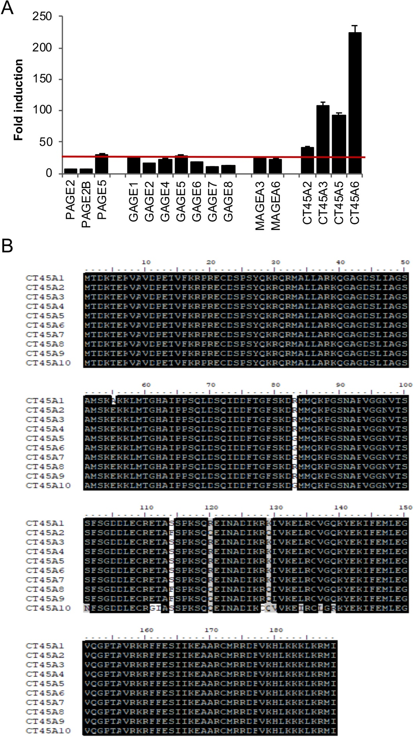
Figure S1
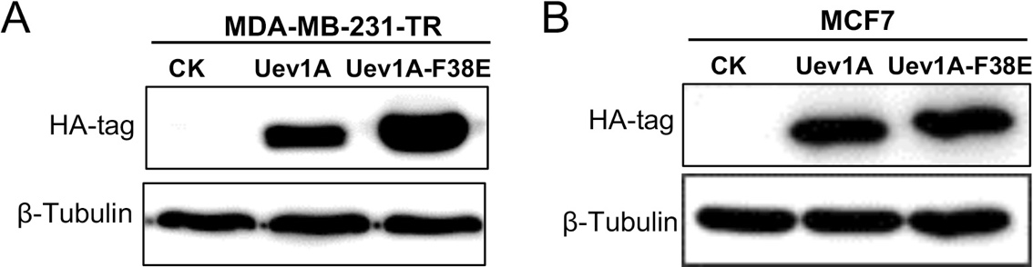
Figure S2
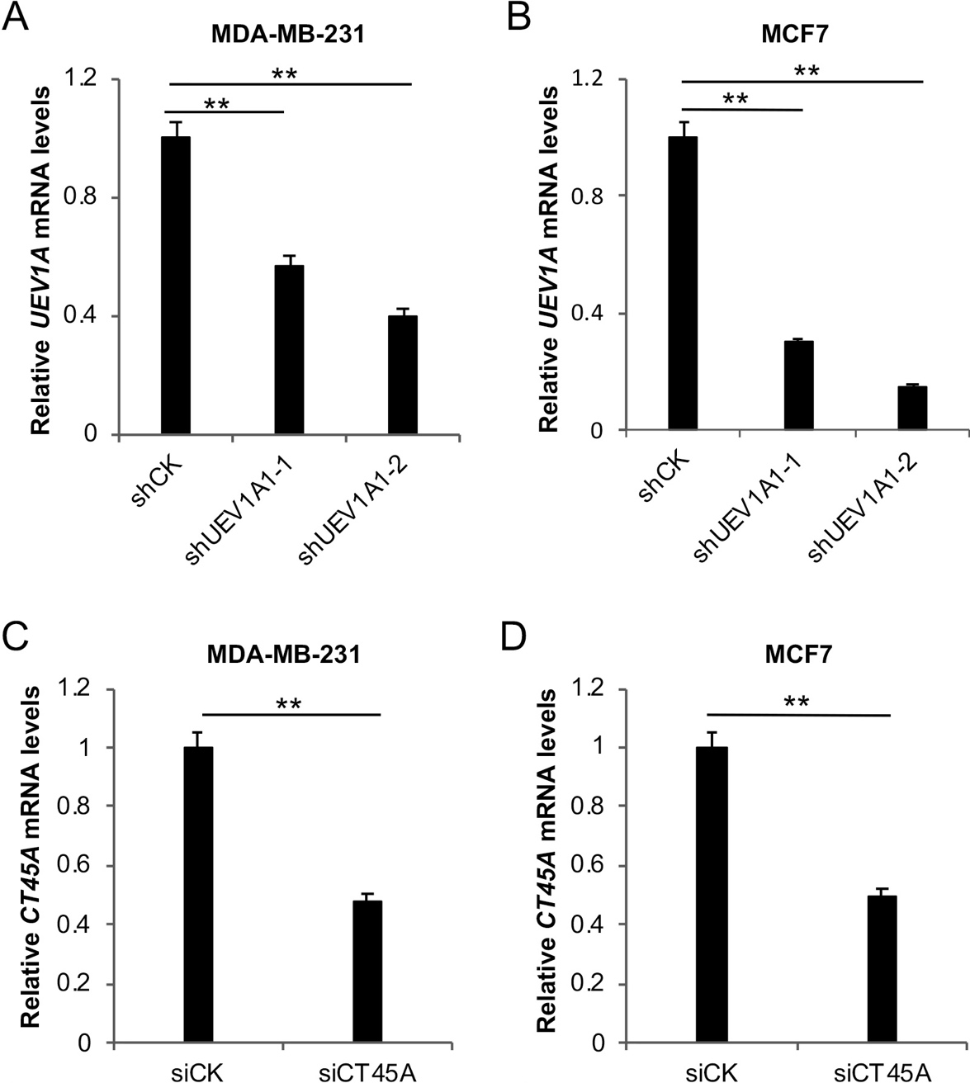
Figure S3
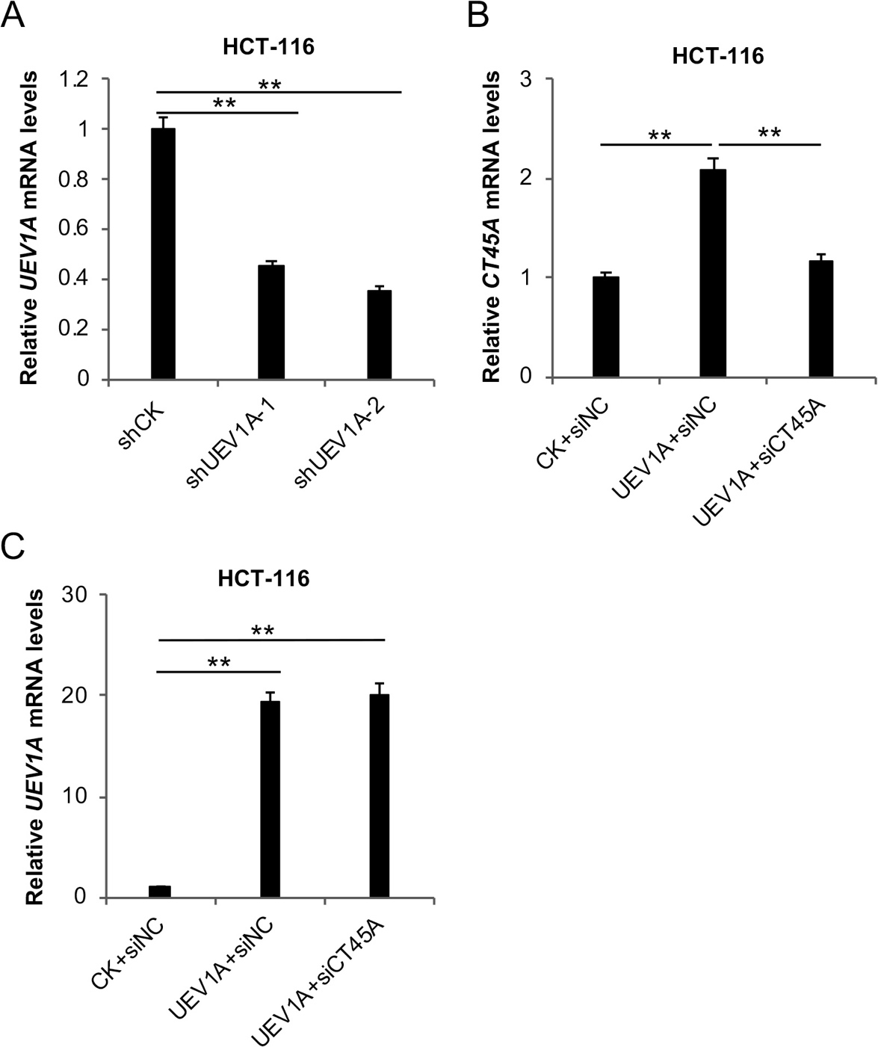
Figure S4

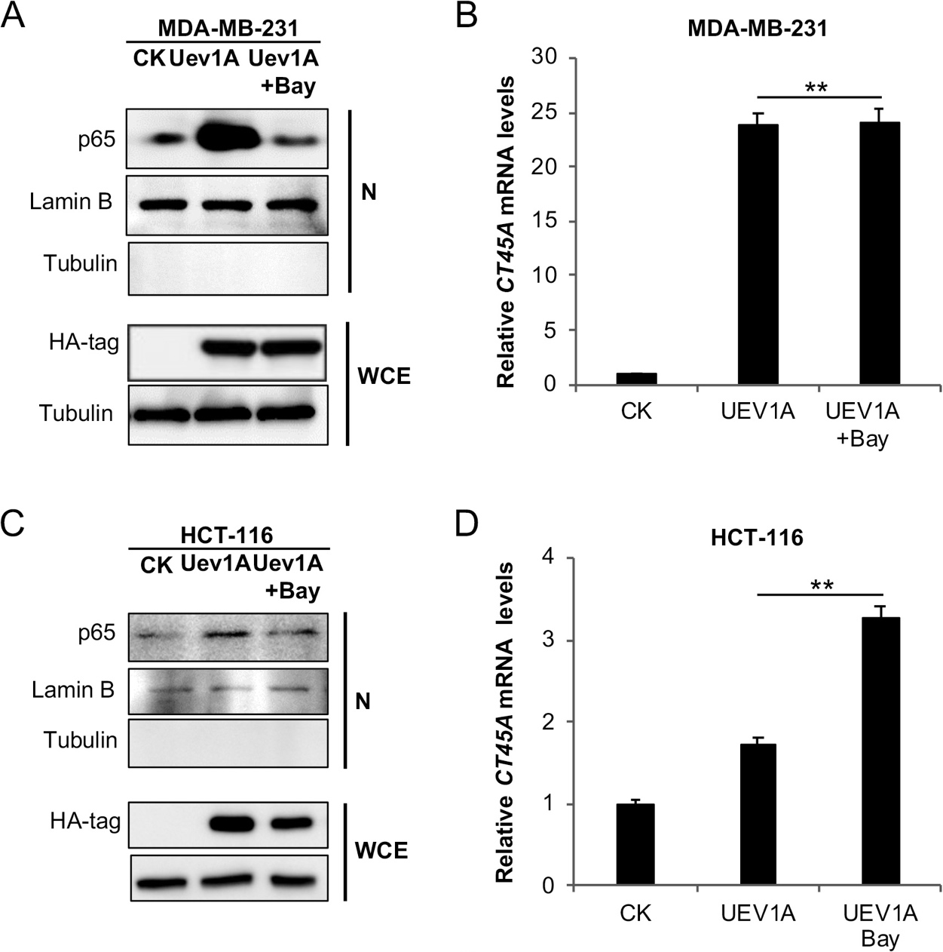
Figure S5

