Supplementary Figures

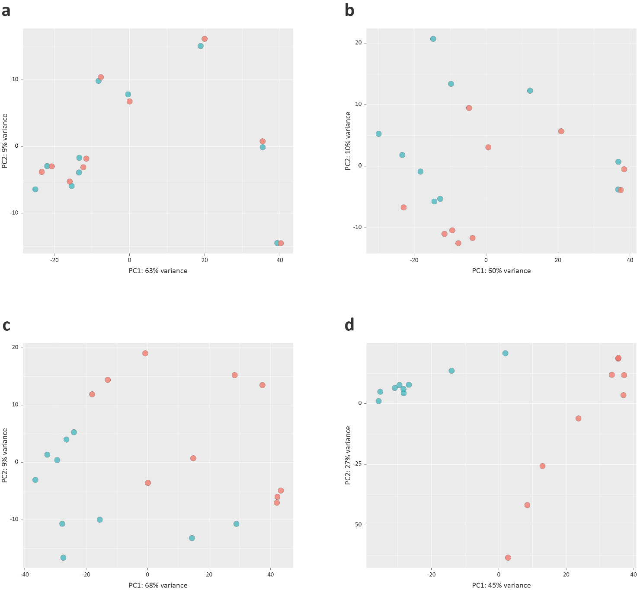
S1 Fig. Principal component analysis (PCA) plots for individual animal bAM gene expression data at a 2 hpi, b 6 hpi, c 24 hpi, and d 48 hpi. Red indicates M. bovis-infected animals and blue indicates non-infected control animals.

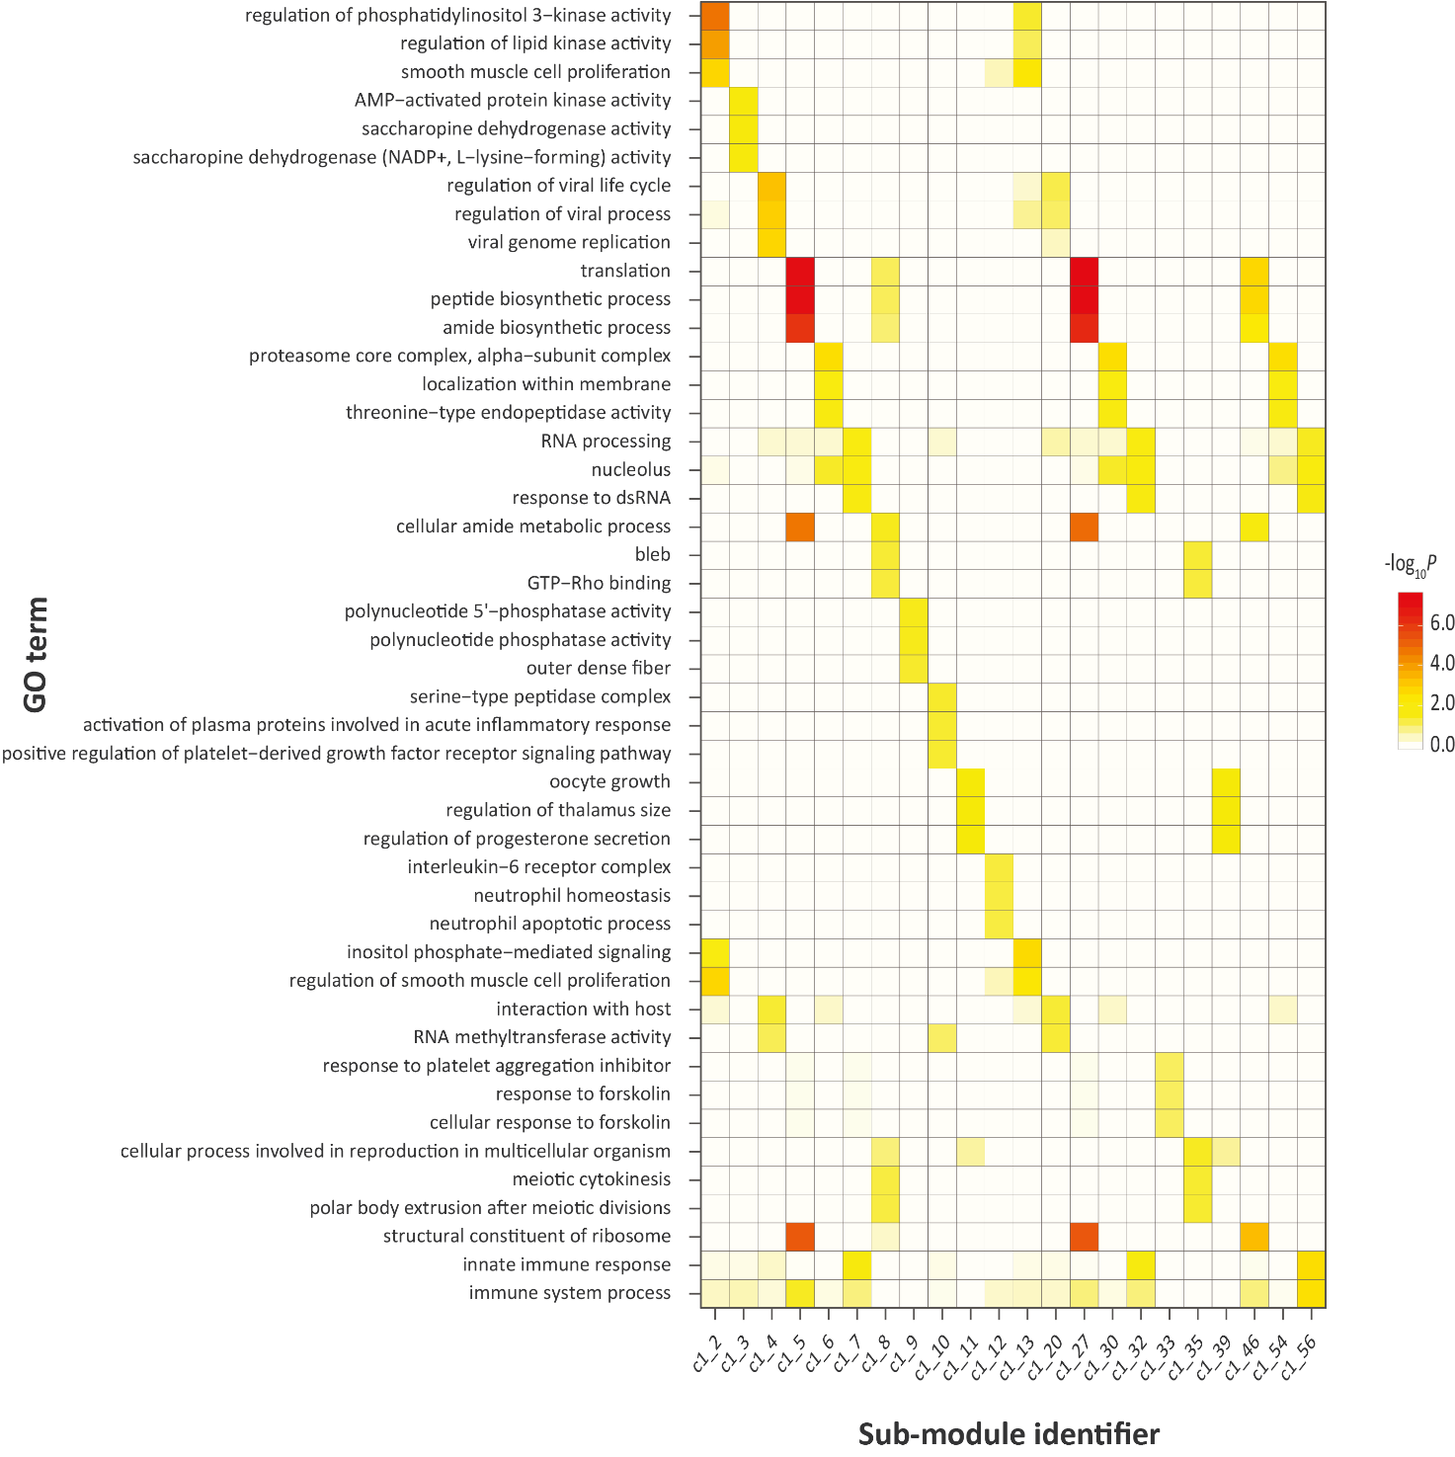
S2 Fig. Gene ontology (GO) enrichment for functional modules identified from the differential co-expression correlation network generated from M. bovis-infected bAM gene expression at 24 hpi.

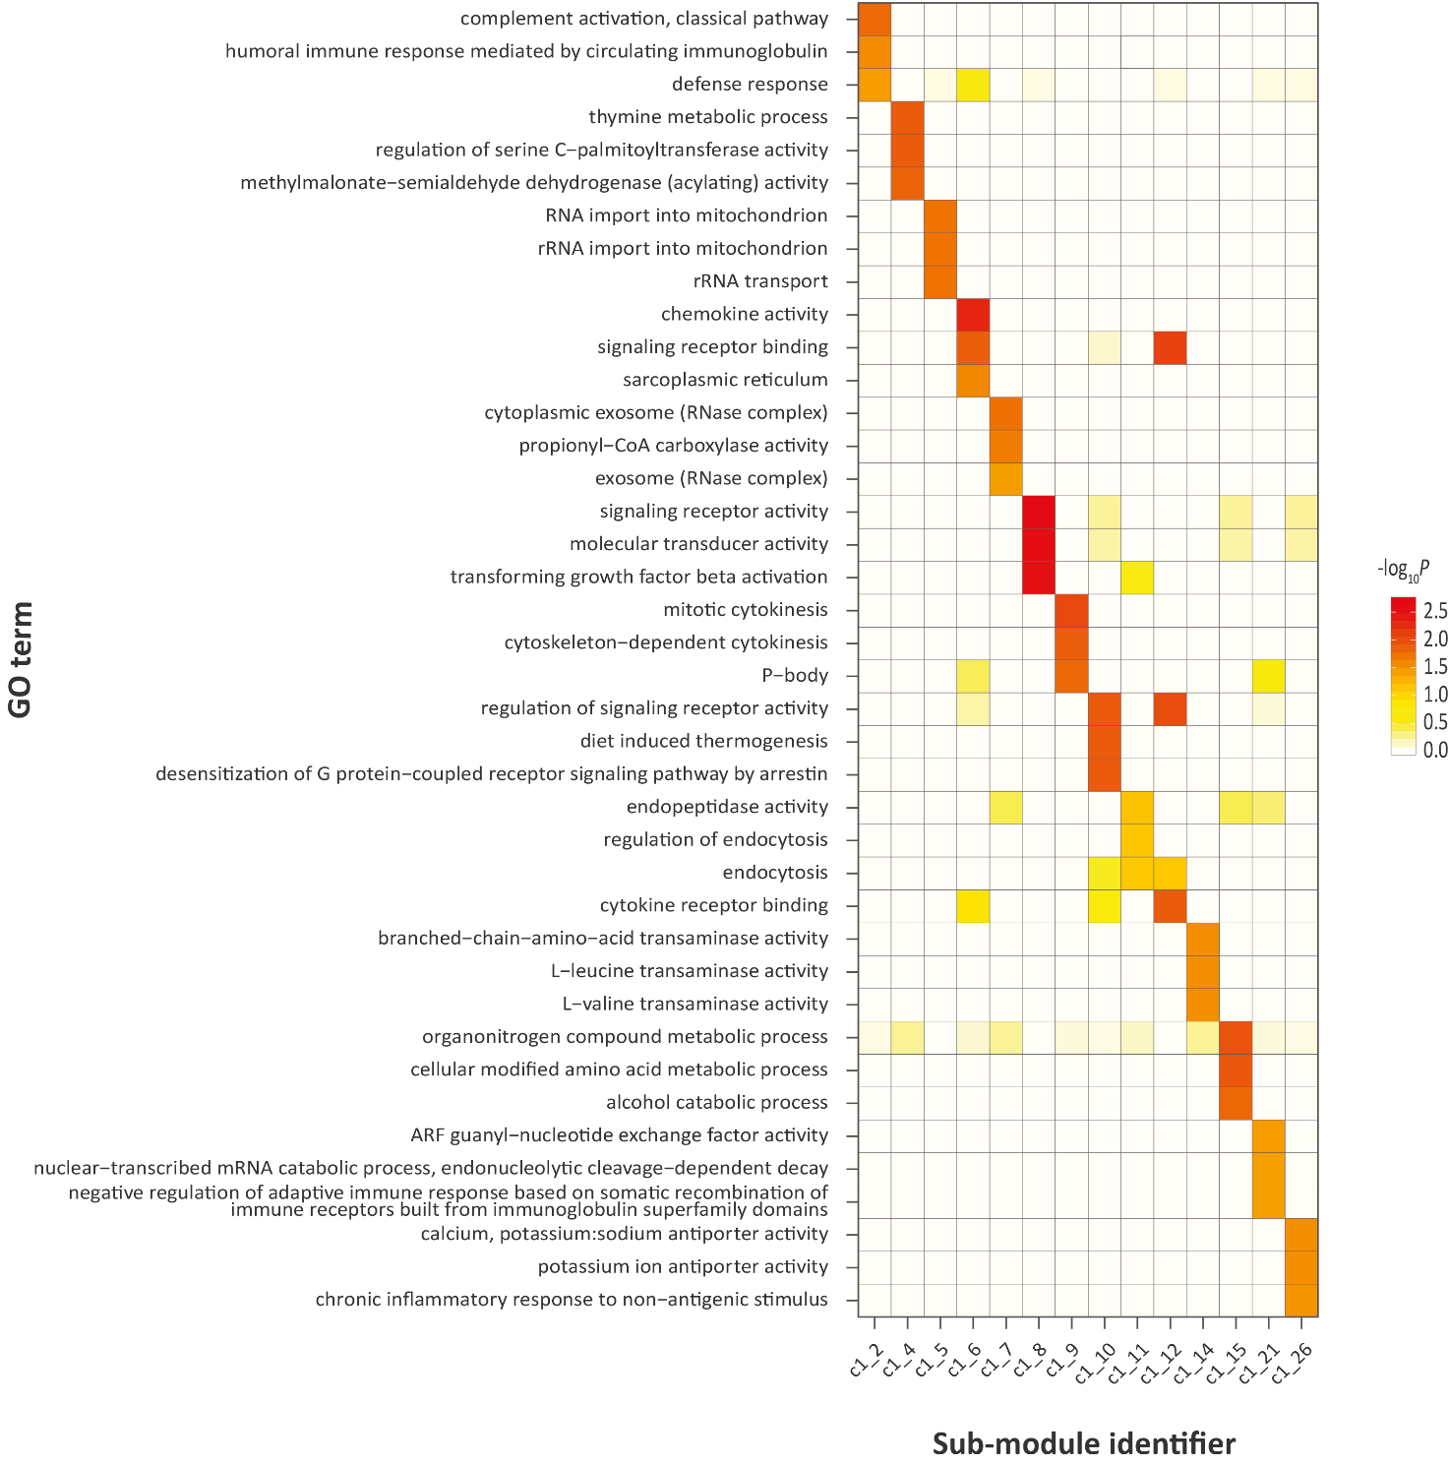
S3 Fig. Gene ontology (GO) enrichment for functional modules identified from the differential co-expression correlation network generated from M. bovis-infected bAM gene expression at 48 hpi.

