**Thermodynamics parameters**

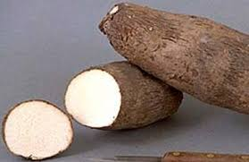

**Partial**

**purification**

**Immobilization**

***Dioscorea alata* (water yam)**

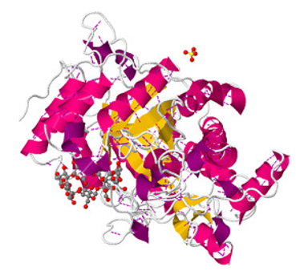

**Catalysis**

**Characterization**

**Inactivation**

**Amino acid composition**

**C**

**Floresencing**

**β-amylase**