Appendix
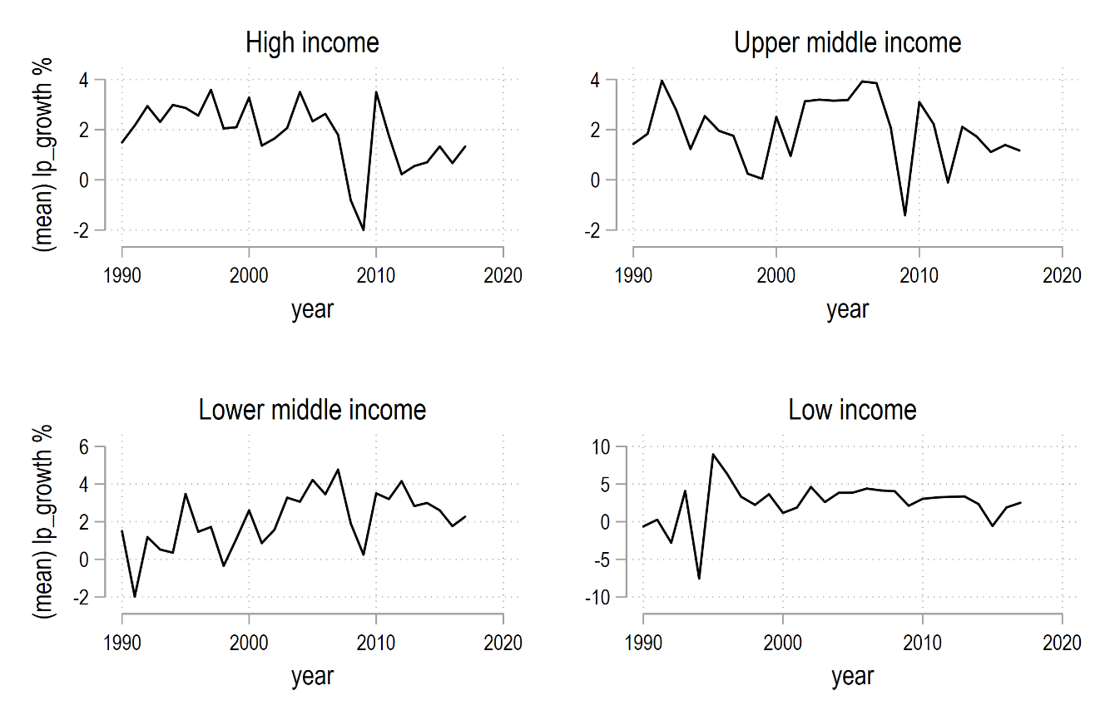
Figure A 1. Trends of average labour productivity growth rates by income group
Source: Author’s calculations based on (Dieppe, 2021).
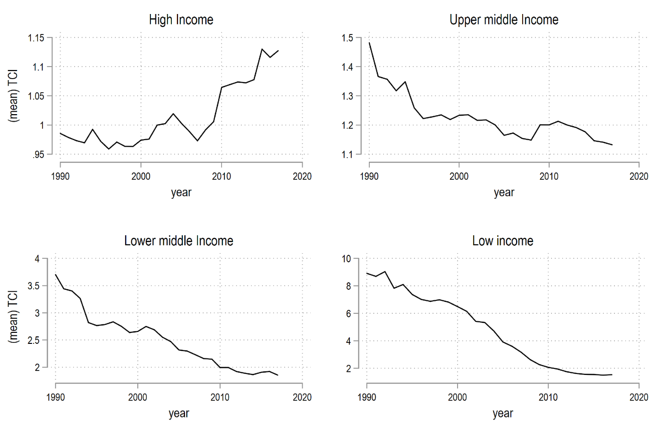
Figure A 2. Trends of average TCI by income group 1990-2017
Source: Author’s calculations based on data from global productivity report 2020, World Bank Development indicators.

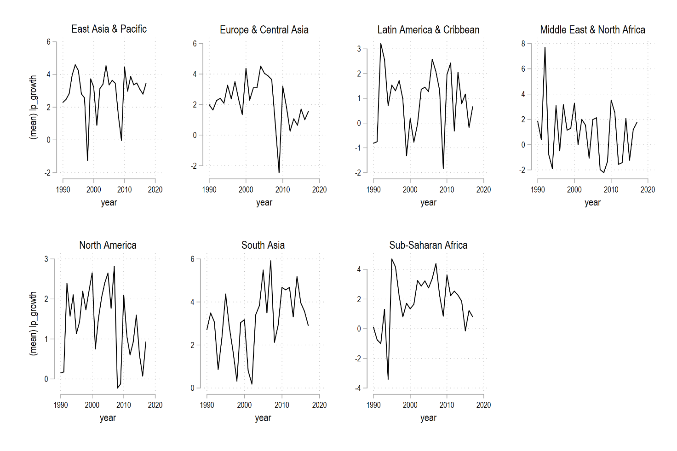
Figure A 3. Trends of labour productivity growth rates by regions 1990-2017
Source: Author’s calculations based on (Dieppe, 2021).
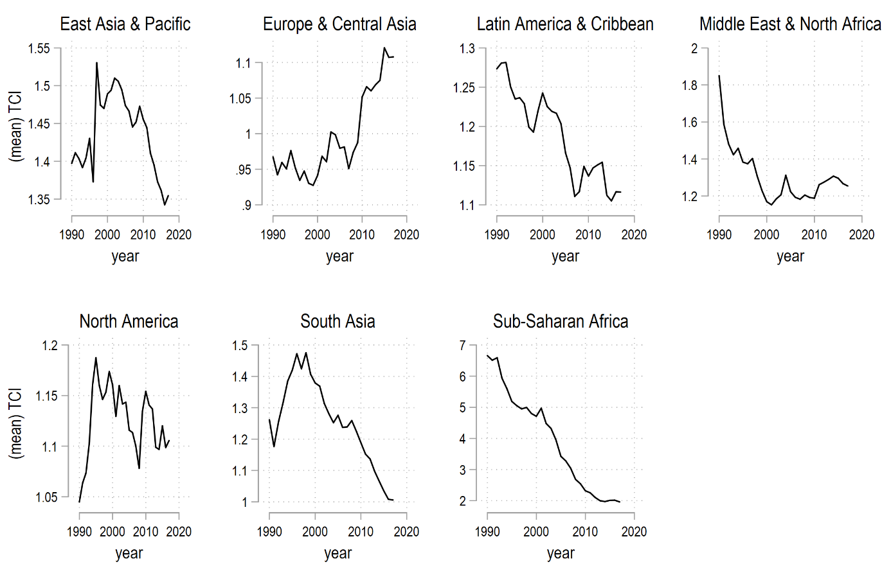
Figure A 4. Trends of average TCI by regions 1990-2017
Source: Author’s calculations based on data from global productivity report 2020, World Bank Development indicator
Table A 1. Estimation of the quadratic relationship between labour productivity growth and economic development
VARIABLES | Dependent variable: labour productivity growth rate (%)
 | (1) | (2) | (3) | (4) | (5) | (6) | (7) | (8) | (9) | (10)
Arable land (% of land area) | 0.012 | 0.019 | 0.019 | 0.022 | 0.022 | -0.090* | -0.103** | -0.103** | -0.099** | -0.098**
 | (0.042) | (0.044) | (0.044) | (0.044) | (0.044) | (0.048) | (0.050) | (0.050) | (0.050) | (0.050)
Institution | 0.016 | 0.048 | 0.048 | 0.039 | 0.039 | -0.008 | -0.004 | -0.004 | -0.010 | -0.011
 | (0.037) | (0.038) | (0.038) | (0.038) | (0.038) | (0.040) | (0.041) | (0.041) | (0.040) | (0.040)
Domestic credit to private sector by banks (% of GDP) | -0.020*** | -0.020*** | -0.020*** | -0.019*** | -0.019*** | -0.022*** | -0.026*** | -0.026*** | -0.026*** | -0.026***
 | (0.005) | (0.005) | (0.005) | (0.005) | (0.005) | (0.006) | (0.006) | (0.006) | (0.006) | (0.006)
Population growth (annual %) | -0.280*** | -0.315*** | -0.315*** | -0.302*** | -0.303*** | -0.021 | -0.037 | -0.037 | -0.038 | -0.038
 | (0.099) | (0.103) | (0.103) | (0.103) | (0.103) | (0.108) | (0.111) | (0.111) | (0.111) | (0.111)
Trade Openness | -0.685 | 0.057 | 0.057 | -0.034 | -0.027 | -0.509 | 0.100 | 0.100 | 0.052 | 0.061
 | (0.594) | (0.605) | (0.605) | (0.602) | (0.602) | (0.642) | (0.656) | (0.656) | (0.653) | (0.653)
Foreign direct investment, net inflows (%GDP) | 0.016* | 0.013 | 0.013 | 0.015* | 0.015* | 0.022*** | 0.019** | 0.019** | 0.020** | 0.020**
 | (0.008) | (0.008) | (0.008) | (0.008) | (0.008) | (0.008) | (0.009) | (0.009) | (0.009) | (0.009)
Gdpc (log) |  |  |  |  |  | 12.446*** | 13.203*** | 13.203*** | 13.278*** | 13.293***
 |  |  |  |  |  | (2.278) | (2.348) | (2.348) | (2.339) | (2.338)
Gdpc² (log) |  |  |  |  |  | -0.647*** | -0.706*** | -0.706*** | -0.712*** | -0.713***
 |  |  |  |  |  | (0.133) | (0.134) | (0.134) | (0.133) | (0.133)
Human capital index | -2.536*** | -0.196 | -0.196 | -0.165 | -0.179
 | (0.976) | (0.566) | (0.566) | (0.565) | (0.565)
Constant | 9.784*** | 3.147** | 3.147** | 3.108** | 3.140** | -53.691*** | -55.692*** | -55.692*** | -55.879*** | -55.911***
 | (2.565) | (1.442) | (1.442) | (1.440) | (1.442) | (10.406) | (10.011) | (10.011) | (9.971) | (9.970)
Observations | 2,101 | 2,101 | 2,101 | 2,101 | 2,101 | 2,036 | 2,036 | 2,036 | 2,036 | 2,036
R-squared | 0.232 | 0.173 | 0.173 | 0.162 | 0.163 | 0.267 | 0.212 | 0.212 | 0.202 | 0.202
Country FE | Yes | Yes | Yes | Yes | Yes | Yes | Yes | Yes | Yes | Yes
Country Year FE | Yes | No | No | No | No | Yes | No | No | No | No
Time trend | No | Yes | No | No | No | No | Yes | No | No | No
Time2 trend | No | No | Yes | No | No | No | No | Yes | No | No
Region-specific time trend | No | No | No | Yes | No | No | No | No | Yes | No
Region-specific time2 trend | No | No | No | No | Yes | No | No | No | No | Yes
Note: The variables lprx (lag), TCI are presented in log. Robust standard errors in parentheses. Significance level at *** p<0.01, ** p<0.05, * p<0.1. Source: Author’s calculation
Table A 2. GMM-system estimation of TCI effect on labour productivity growth 2007-2012
VARIABLES | Dependent variable: labour productivity growth rate (%)
 | (1) | (2) | (3) | (4) | (5) | (6) | (7)
Lpxr (lag) | -1.528*** | -1.528*** | -1.283** | -1.137** | -1.141** | -1.100* | -1.256
 | (0.558) | (0.562) | (0.531) | (0.490) | (0.493) | (0.590) | (0.789)
TCI | -0.557 | -0.976 | 0.708 | 0.501 | 0.938 | 0.539 | 0.349
 | (1.081) | (2.202) | (2.039) | (1.861) | (1.973) | (2.023) | (2.278)
TCI² |  | 0.152 | -0.226 | -0.068 | -0.190 | -0.018 | -0.049
 |  | (0.585) | (0.575) | (0.532) | (0.582) | (0.579) | (0.579)
Institution |  |  | 0.071* | 0.004 | -0.003 | -0.009 | 0.006
 |  |  | (0.042) | (0.053) | (0.055) | (0.060) | (0.072)
Population growth (annual %) |  |  |  | -0.286** | -0.292* | -0.307* | -0.284
 |  |  |  | (0.141) | (0.152) | (0.158) | (0.176)
FDI |  |  |  |  | 0.024 | 0.028 | 0.028
 |  |  |  |  | (0.026) | (0.029) | (0.028)
Trade Openness |  |  |  |  |  | -0.397 | -0.292
 |  |  |  |  |  | (0.542) | (0.645)
Arable land (% of land area) |  |  |  |  |  |  | 0.006
 |  |  |  |  |  |  | (0.022)
Constant | 18.185** | 18.444** | 14.545** | 13.807** | 13.468** | 13.642** | 15.150
 | (6.960) | (7.210) | (6.467) | (5.829) | (5.861) | (6.628) | (9.188)
Observations | 612 | 612 | 582 | 582 | 580 | 574 | 574
Number of countries | 102 | 102 | 97 | 97 | 97 | 97 | 97
Year FE | Yes | Yes | Yes | Yes | Yes | Yes | Yes
AR(1) | 0.000 | 0.000 | 0.000 | 0.000 | 0.000 | 0.000 | 0.000
AR(2) | 0.413 | 0.414 | 0.497 | 0.534 | 0.507 | 0.505 | 0.495
Hansen | 0.485 | 0.486 | 0.475 | 0.452 | 0.506 | 0.559 | 0.623
Number of Instruments | 33.000 | 34.000 | 35.000 | 36.000 | 37.000 | 38.000 | 39.000
Note: The variables lprx (lag), TCI are presented in log. Robust standard errors in parentheses. Significance level at *** p<0.01, ** p<0.05, * p<0.1. Source: Author’s calculation
Table A 3. Extension Analysis estimating the TCI effect and labour productivity growth rates 1990-2017, regional level
VARIABLES | lp_growth
 | (1) | (2)
lprx (lag) | -7.353*** | -6.414***
 | (1.981) | (1.706)
TCI*East Asia & Pacific | -3.878* | 17.288**
 | (2.175) | (8.512)
TCI*Europe & Central Asia | 4.532* | 21.253**
 | (2.484) | (8.308)
TCI*Latin America & Caribbean | -6.595** | 6.545
 | (2.674) | (7.126)
TCI*Middle East & North Africa | -1.007 | 24.205
 | (2.145) | (15.271)
TCI*North America | 7.162** | 33.259***
 | (3.013) | (10.767)
TCI*South Asia | -10.340*** | -2.605
 | (3.848) | (8.729)
TCI*Sub-Saharan Africa | -6.670*** | -2.105
 | (2.218) | (3.119)
TCI²*East Asia & Pacific |  | -11.869**
 |  | (5.303)
TCI²*Europe & Central Asia |  | -10.814**
 |  | (5.013)
TCI²*Latin America & Caribbean |  | -6.025
 |  | (4.647)
TCI²*Middle East & North Africa |  | -16.579
 |  | (10.687)
TCI²*North America |  | -21.172***
 |  | (6.938)
TCI²*South Asia |  | -1.099
 |  | (5.285)
TCI²*Sub-Saharan Africa |  | -0.376
 |  | (0.633)
Institution | 0.437** | 0.376**
 | (0.178) | (0.168)
Population growth (annual %) | -0.382 | -0.194
 | (0.453) | (0.373)
FDI | -0.006 | 0.002
 | (0.012) | (0.017)
Trade Openness | 2.305* | 1.815*
 | (1.245) | (1.029)
Arable land (% of land area) | -0.132** | -0.098*
 | (0.061) | (0.053)
Constant | 79.618*** | 63.169***
 | (21.063) | (16.973)
Observations | 2,235 | 2,235
Number of countries | 97 | 97
Year FE | Yes | Yes
AR(1) | 0.000 | 0.000
AR(2) | 0.345 | 0.354
Hansen | 0.604 | 0.543
Number of Instruments | 44.000 | 51.000
Note: The variables lprx (lag), TCI are presented in log. Robust standard errors in parentheses. Significance level at *** p<0.01, ** p<0.05, * p<0.1. The reference point for the regional dummy variable is East Asia & Pacific. Source: Author’s calculation
Table A 4. Extension Analysis estimating the TCI effect and labour productivity growth rates 1990-2017, income level
VARIABLES | lp_growth
 | (1) | (2)
lpxr (lag) | -8.101*** | -4.754***
 | (2.277) | (1.311)
TCI*High income | 13.473*** | 25.119***
 | (4.134) | (7.558)
TCI²*High income |  | -12.281***
 |  | (4.151)
TCI*Low income | -6.421*** | -2.232
 | (2.284) | (2.441)
TCI²*Low income |  | 0.223
 |  | (0.444)
TCI*Lower middle income | -4.307** | 2.796
 | (1.901) | (3.042)
TCI²*Lower middle income |  | -1.310
 |  | (0.839)
TCI*Upper middle income | 1.720 | 12.611**
 | (1.754) | (5.942)
TCI²*Upper middle income |  | -6.102*
 |  | (3.197)
Institution | 0.174 | 0.041
 | (0.118) | (0.065)
Population growth (annual %) | -0.540 | -0.324
 | (0.404) | (0.257)
FDI | 0.019 | 0.017
 | (0.017) | (0.033)
Trade Openness | 1.430 | 0.645
 | (0.867) | (0.483)
Arable land (% of land area) | -0.071 | -0.030
 | (0.050) | (0.028)
Constant | 82.567*** | 44.699***
 | (22.781) | (12.474)
Observations | 2,235 | 2,235
Number of countries | 97 | 97
Year FE | Yes | Yes
AR(1) | 0.000 | 0.000
AR(2) | 0.297 | 0.279
Hansen | 0.504 | 0.100
Number of Instruments | 41.000 | 45.000

Note: The variables lprx (lag), TCI are presented in log. Robust standard errors in parentheses. Significance level at *** p<0.01, ** p<0.05, * p<0.1. The reference point for the income dummy variable is High income. Source: Author’s calculation

Table A 5. Variable description and sources
No. | Variables | Label | Definition | Sources
1 | Labor productivity growth aggregate | lp_growth | Labor productivity measured as real GDP in US dollars measured in 2010 prices and exchange rates, divided by employment. | Word Bank Global Productivity report 2020 (Dieppe et al., 2020).
2 | Labor productivity level | lprx | Labor productivity (2011 international PPP exchange rate), divided by sectoral employment | Word Bank Global Productivity report 2020 (Dieppe et al., 2020).
3 | Technology Choice Index | TCI | Computed based on the formula in methods section. | Authors based on WDI
4 | Foreign Direct Investment | FDI | Foreign direct investment net inflows (BoP current US$) | WDI 2020
5 | Institution | Institution | The Quality of Government measured by the revised combined Polity Score | Basic Dataset, University of Gothenburg
6 | Trade Openness | openness | Export plus imports divided by total GDP (all in current US$) | Computed based on WDI
7 | Human Capital | HCI | Human capital index, based on years of schooling (Barro & Lee, 205. and assumed returns, based on Mincer equation estimates around the world. | Robert J. Barro and Jong-Wha Lee: http://www.barrolee.com/ (WDI)
8 | Arable land | A_land | Defined by FAO as land under temporary crops or also known as cultivable land (% of land area). | WDI 2020
9 | Population growth (annual %) | pop | Annual population growth rates. Population is based on the facto definition, which count all residents regardless of legal status or citizenship. | WDI 2020
10 | GDP per capita | gdpc | GDP per Capita, PPP (current international US$) | WDI 2020
11 | Financial Development | Findev_1 | Domestic credit to private sector by banks (% of GDP) | WDI 2020

Table A 6. Descriptive statistics and correlation matrix of variables
Variables | Mean | S.D. | Min | Max | lp_growth | lpxr (log) | TCI (log) | A_land | FINDEV_1 | institution | HCI | pop | openness | FDI | gdpc (log)
lp_growth | 1.99 | 3.94 | -48.84 | 35.54 | 1
lpxr (log) | 10.33 | 1.45 | 6.46 | 12.76 | -0.108* | 1
TCI (log) | 1.13 | 0.52 | 0.29 | 4.22 | 0.017 | -0.586* | 1
A_land | 16.64 | 14 | 0.32 | 72.1 | 0.105* | -0.088* | -0.094* | 1
FINDEV_1 | 53.68 | 44.69 | 0 | 308.98 | -0.051 | 0.628* | -0.360* | -0.059 | 1
institution | 5.34 | 5.88 | -10 | 10 | -0.074* | 0.498* | -0.351* | 0.161* | 0.298* | 1
HCI | 2.52 | 0.69 | 1.03 | 3.97 | -0.047 | 0.811* | -0.525* | 0.008 | 0.591* | 0.581* | 1
pop | 1.29 | 1.4 | -9.08 | 17.51 | -0.107* | -0.356* | 0.320* | -0.225* | -0.262* | -0.429* | -0.502* | 1
openness | 0.83 | 0.57 | 0.13 | 4.43 | 0.012 | 0.291* | -0.177* | -0.124* | 0.342* | 0.017 | 0.260* | -0.049 | 1
FDI | 4.84 | 12.29 | -58.32 | 280.13 | 0.028 | 0.132* | -0.106* | -0.05 | 0.301* | 0.062 | 0.098* | -0.047 | 0.317* | 1
gdpc (log) | 9.07 | 1.19 | 5.65 | 11.86 | -0.082* | 0.958* | -0.658* | -0.067 | 0.653* | 0.478* | 0.835* | -0.334* | 0.358* | 0.162* | 1

Table A 7. List of countries contained in the full sample
List of countries in the study
East Asia & Pacific |  |  |  | Europe & Central Asia |  |  |  | North America
No | country |  |  | No | country |  |  | No | country
1 | Australia | High income |  | 39 | Slovenia | High income |  | 75 | Canada | High income
2 | China, Hong Kong SAR |  |  | 40 | Spain |  |  | 76 | United States
3 | Japan |  |  | 41 | Sweden
4 | New Zealand |  |  | 42 | Switzerland |  |  | South Asia
5 | Republic of Korea |  |  | 43 | United Kingdom |  |  | No | country
6 | Singapore |  |  | 44 | Azerbaijan | Upper middle income |  | 77 | Bangladesh | Lower middle income
7 | China | Upper middle income |  | 45 | Bulgaria |  |  | 78 | India
8 | Fiji |  |  | 46 | Montenegro |  |  | 79 | Pakistan
9 | Malaysia |  |  | 47 | Romania |  |  | 80 | Sri Lanka
10 | Thailand |  |  | 48 | Russian Federation |  |  | 81 | Nepal | Low income
11 | Indonesia | Lower middle income |  | 49 | Serbia
12 | Lao People's Dem Rep |  |  | 50 | Turkey |  |  | Sub-Saharan Africa
13 | Mongolia |  |  | 51 | Georgia | Lower |  | No | country
14 | Philippines |  |  |  |  |  |  | 82 | Botswana | Upper middle income
15 | Viet Nam |  |  | Latin America & Caribbean |  |  |  | 83 | Mauritius
 |  |  |  | No | country |  |  | 84 | Namibia
Europe & Central Asia |  |  |  | 52 | Argentina | High income |  | 85 | South Africa
No | country |  |  | 53 | Chile |  |  | 86 | Angola | Lower middle
16 | Austria | High income |  | 54 | Uruguay |  |  | 87 | Cameroon
17 | Belgium |  |  | 55 | Belize | Upper middle income |  | 88 | Eswatini
18 | Croatia |  |  | 56 | Brazil |  |  | 89 | Ghana
19 | Cyprus |  |  | 57 | Colombia |  |  | 90 | Kenya
20 | Czech Republic |  |  | 58 | Costa Rica |  |  | 91 | Lesotho
21 | Denmark |  |  | 59 | Dominican Republic |  |  | 92 | Nigeria
22 | Estonia |  |  | 60 | Ecuador |  |  | 93 | Zambia
23 | Finland |  |  | 61 | Guatemala |  |  | 94 | Burkina Faso | Low income
24 | France |  |  | 62 | Jamaica |  |  | 95 | Ethiopia
25 | Germany |  |  | 63 | Mexico |  |  | 96 | Malawi
26 | Greece |  |  | 64 | Paraguay |  |  | 97 | Mozambique
27 | Hungary |  |  | 65 | Saint Lucia |  |  | 98 | Rwanda
28 | Iceland |  |  | 66 | St. Vincent and the Grenadines |  |  | 99 | Senegal
29 | Ireland |  |  | 67 | Bolivia | Lower middle income |  | 100 | Sierra Leone
30 | Italy |  |  | 68 | Honduras |  |  | 101 | Uganda
31 | Latvia |  |  |  |  |  |  | 102 | Republic of Tanzania
32 | Lithuania |  |  | Middle East & North Africa
33 | Luxembourg |  |  | No | country
34 | Netherlands |  |  | 69 | Qatar | High income
35 | Norway |  |  | 70 | Algeria | Upper middle income
36 | Poland |  |  | 71 | Iran
37 | Portugal |  |  | 72 | Jordan
38 | Slovakia |  |  | 73 | Egypt | Lower middle income
 |  |  |  | 74 | Morocco

Note: Income group classification is base

