An AI-enabled predictive analytics dashboard for acute neurosurgical referrals

Supplementary Document

Software Demonstration

A trial dashboard using synthetic data can be accessed on: https://referralsdash.herokuapp.com/ via a desktop web browser. Please note it can take up to a minute for the dashboard to load on some internet browsers.

A video demonstrating the functionality of the dashboard presenting the data outlined in this manuscript is available on https://youtu.be/Th2vsCpLHbI

Supplementary Methods

Python libraries and dependencies

The following dependencies were used in the creation of this dashboard (see code snippet below)

<CODE>
'pandas', 1.2.3
'numpy', 1.19.5
'matplotlib.pyplot', 3.4.1
'scipy', 1.6.2
'plotly', 5.3.1
'dash', 1.20.0
'dash_core_components', 1.16.0
'dash_html_components', 1.1.3
'requests', 2.25.1
'statsmodels', 0.11.0
'prophet', 1.0.1
'pmdarima' 1.81
'tensorflow' 2.4.1

Data pre-processing

Following anonymisation, referral data was uploaded as a pandas data-frame. Redundant columns, duplicates and erroneous entries were removed, and all dates and times were transformed to python date-time data-types for further manipulation. Specialist working diagnoses are designated by the on-call neurosurgical registrar when receiving the referral and include a total of 138 different options. The diagnosis is based on the information received at the point of the referral and may be modified as further information is shared or after senior review. Specialist diagnoses were aggregated into 13 primary diagnostic categories: brain tumour, cauda equina syndrome, congenital, subdural haematoma, cranial trauma, degenerative spine, hydrocephalus, infection, spinal trauma, stroke, neurovascular and ‘not neurosurgical’ (Supplementary Appendix).

<CODE>
#Upload anonymised file - either saved as .csv or .pkl
df_all = pd.read_pickle(filename)
#Drop duplicates
df_all.drop_duplicates(inplace=True)
#Drop redundant columns
df_all.drop(columns = ['Referring Doctor Name','Bleep or Telephone No','MobileNo','Subsequent Doctor Grade Name','Subsequent Bleep Number','Subsequent Mobile No','Subsequent Dr Email Address','Subsequent Consultant Email Address'], inplace = True)
#Transform date-time entries to datetime datatype
df_all = transform_to_datetime(df_all, 'Referral Time')
#Convert specialist working diagnosis into primary diagnostic classification based on diagnosis table - see Appendix table
diagnosis_table = pd.read_csv('diagnoses_table.csv', low_memory=False)
df_all = add_classification_level(df_all, diagnosis_table,
'Primary Classification')
## RELEVANT PROCESSING FUNCTIONS
def match_classification(diagnosis_table, classification_level,
diagnosis):
diagnosis_level = diagnosis_table[
diagnosis_table['Specialist working diagnosis'] ==
diagnosis][classification_level]
if (len(diagnosis_level.values) > 0):
return diagnosis_level.values[0]
return 'no_match'
def add_classification(input_df, diagnosis_table, classification_level):
df_copy = copy.deepcopy(input_df)
partial_func = partial(match_classification, diagnosis_table,
classification_level)
df_copy[classification_level] = df_copy[
'Specialist Working Diagnosis'].apply(partial_func)
return df_copy
def transform_to_datetime(df, time_col):
copy = df.copy()
copy[time_col] = pd.to_datetime(copy[time_col], dayfirst=True)
return copy

Geographical information

Using the name of the referring site, an application programming interface (API) request is made to openstreetmap.org to derive the latitude and longitude of referral site locations. This location data is then cached and parsed to a geographical plotting function.

<CODE>
##API REQUEST TO GENERATE LATITUDE AND LONGITUDE CO-ORDINATES
def placemaker(df_all):
#Parse and sort dataframe
geocount = df_all
geocount = geocount.groupby(by=['Primary Classification','Referring Hospital'])[['Age']].count().unstack(level=0)
geocount.columns = geocount.columns.droplevel()
geocount.fillna(value=0,inplace=True)
geocount['total'] = geocount.sum(axis=1)
geocount.reset_index(inplace = True)
#Generate empty columns to fill location data in
geocount['add'] = 0
geocount['lon'] = 0
geocount['lat'] = 0
geocount = geocount.sort_values(by = 'total', ascending = False)
geocount.reset_index(drop=True, inplace=True)
#Generate list of unique hospitals from dataframe
hosplist = geocount['Referring Hospital'].unique()
hosplist = hosplist.tolist()
#For each unique hospital, perform an API request
for i,v in enumerate(hosplist):
address = v
url = 'https://nominatim.openstreetmap.org/search/' + urllib.parse.quote(address)+'?format=json'
response = requests.get(url).json()
geocount.loc[i,['add', 'lon', 'lat']] = [address,response[0]["lon"],response[0]["lat"]]
#Create seperate dataframe to save location data to cache
locmatch = pd.DataFrame()
locmatch['Referring Hospital'] = geocount['add']
locmatch['lon'] = geocount.lon
locmatch['lat'] = geocount.lat
locmatch.to_csv('locmatch2.csv')
return geocount, hosplist, locmatch
##GENERATE GEOGRAPHICAL FIGURE
def geospatial(df, date1, date2,classification):
#select data by time
geocount = single_period(df, date1, date2)
#filter df by primary classification and sort
if classification != "all":
geocount = geocount[geocount['Primary Classification'] == classification]
geocount = geocount.groupby(by=['Primary Classification','Referring Hospital'])[['Age']].count().unstack(level=0)
geocount.columns = geocount.columns.droplevel()
geocount.fillna(value=0,inplace=True)
geocount['total'] = geocount.sum(axis=1)
geocount.reset_index(inplace = True)
geocount = geocount.sort_values(by='total', ascending=False)
geocount.reset_index(drop=True, inplace=True)
geocount = geocount.merge(locmatch, on='Referring Hospital')
#create figure, can be scaled by color or size. Center is the receiving hospital
fig5 = px.scatter_mapbox(geocount,
lat="lat",
lon="lon",
hover_name="Referring Hospital",
hover_data=["total"],
zoom=9,
height=300,
size=geocount.total,
size_max=40,
color="total",
center={
'lat': 51.6,
'lon': -0.26
},
opacity=0.7)
#update layouts
fig5.update_layout(mapbox_style='carto-positron')
fig5['data'][0]['showlegend'] = False
fig5['data'][0]['name'] = 'Referring Site'
fig5.update_layout(margin={"r": 0, "t": 0, "l": 0, "b": 0})
fig5.update_layout(autosize=True, width=800, height=800)
return fig5
## RELEVANT PROCESSING FUNCTIONS
def single_period(df, date1, date2):
return df[(df['Referral Time'] >= date1) & (df['Referral Time'] < date2)]

Implementation of time-series forecasting models

Three forecasting algorithms were trialled in this work: an automated pipeline which combined Seasonal and Trend decomposition using Loess (STL) with an automatic Autoregressive Integrated Moving Average (Auto-ARIMA) model, a Convolutional Neural Network - Long Short-Term Memory (CNN-LSTM) network and Prophet. In this section we describe how each model was implemented.
In preparation for time-series analysis, the referral volumes first were sorted into weekly brackets, rather than taking daily volumes. This was to compensate for an observed ‘weekend’ effect seen in the daily referral data (Figure 5A, Supplementary Table 1).

Supplementary Table 1. Median weekday and weekend volumes.
All referrals and four highest referring categories are shown. p values shown are Bonferroni multiple comparison corrected following univariate Mann-Whitney U tests. (NS = not significant)

Diagnostic Classification | Median weekday volume | Median weekend volume | p
All | 34.0 | 17.5 | <0.0001
Brain tumour | 6.8 | 3.5 | <0.0001
Degenerative spine | 4.6 | 2.0 | <0.0001
Neurovascular | 2.4 | 2.0 | 0.06
Stroke | 2.2 | 2.0 | NS

We performed an exploratory analysis of the time-series using auto-correlation and partial auto-correlation plots in combination with augmented Dickey-Fuller testing to determine the degree of stationarity in the data and assist in defining initial parameters for seasonal decomposition and upper and lower parameter limits for the auto-ARIMA grid search.
ARIMA models are often considered a benchmark model in fields such as econometrics ¹. Here, two adjustments were made to enable automatic hyperparameter tuning and make the model robust to time-series of uncertain length, frame and degree of seasonality. First, a Seasonal and Trend decomposition using Loess (STL) was applied which separates the raw data into seasonal, trend and residual components. Each component is fed into an automated grid search to determine p, d and q parameters which describe the lag order, degree of differencing and order of moving average respectively. Here, models with various combinations of parameter values were compared using the Akaike Information Criterion (AIC). Approximately 25 models are tested in this way, of which the parameters with the lowest AIC were determined to be the optimal set. In this way if the seasonal and trend decomposition fails to enforce stationarity in the trend data (if for example there are multiple layers of seasonality), the auto-ARIMA step can separately model the trend, seasonality and residual before recomposing the data to forecast.
<CODE>
### STL/Auto-ARIMA model
#Run EDA on weekly time-series first to manually check seasonality
#Set variables
res = []
#STL period corresponds to expected seasonality. 4 chosen to reflect monthly seasonal changes.
##Also can use 52 for yearly or 26 for 6-monthly seasonality
period = 4
#How long into future/out-of-sample to make forecast
future = 0
#95% Confidence interval
confidence = 0.05
#STL decomposition with default parameters and period - can be further tuned using grid search
res = STL(df, period = period, robust = False).fit()
#Seasonal auto-ARIMA, stepwise can be changed to True for more thorough grid search. Upper and lower limits regarding p, q, d determined by initial exploratory analysis of data set
smodel = pm.auto_arima(res.seasonal,
start_p=0, max_p=5,
start_q=0, max_q=5,
seasonal=False,
stepwise = False,
start_d=0, max_d=5,
trace=False, error_action='ignore');
#Trend auto-ARIMA
tmodel = pm.auto_arima(res.trend,
start_p=0, max_p=5,
start_q=0, max_q=5,
seasonal=False,
stepwise = False,
start_d=0, max_d=5,
trace=False, error_action='ignore');
#Residual auto-ARIMA
rmodel = pm.auto_arima(res.resid,
start_p=0, max_p=5,
start_q=0, max_q=5,
seasonal=False,
stepwise = False,
start_d=0, max_d=5,
trace=False, error_action='ignore');
#Modelling seasonality
modelsea = SARIMAX(res.seasonal, order = smodel.order, seasonal_order= smodel.seasonal_order).fit()
#If Auto-ARIMA fails then use simple differenced d=1 model for trend
try:
modeltrend = ARIMA(res.trend, order = tmodel.order, freq=interval).fit()
except:
modeltrend = ARIMA(res.trend, order = (0,1,0), freq=interval).fit()
#Modelling residual
modelres = ARIMA(res.resid, order = rmodel.order, freq=interval).fit()
#Forecasting and recomposition
forecast_season = modelsea.forecast(future, alpha=confidence)
forecast_trend, std_err_trend, confidence_int_trend = modeltrend.forecast(future, alpha=confidence)
forecast_resid, std_err_resid, confidence_int_resid = modelres.forecast(future, alpha=confidence)
forecast_final = forecast_season + forecast_trend + forecast_resid
conf = confidence_int_trend + confidence_int_resid

Deep learning methods such as CNN and LSTM neural networks are able to discover and model hidden complexity within data and extract features of interest automatically. LSTM is a sub-type of recurrent neural network which is able to model long temporal data. A CNN model can be used in a hybrid model with a LSTM network. Here the one-dimensional CNN is used to learn discriminative features by applying a non-linear transformation on the time-series data, which are then fed to the LSTM layers .
We split the time-series into sub-sequences with 52 “steps” (i.e. one-year) as the input and one output. This is then split into two sub-samples, each with two targets. This is passed into the convolutional layer which transforms the subsamples before down-sampling, flattening and passing to a single LSTM layer with 64 neurons. Dropout proportion was set to 30%, in order to reduce overfitting. The number of filters in the convolutional layer, neurons and dropout proportion were selected following a hyperparameter grid search (~30 minutes). For out-of-sample predictions longer than one week, the predicted value was used to iteratively increase the training set; thus the test set is used to progressively fit the model.
<CODE>
###CNN-LSTM implementation
#Relevant imports
from tensorflow.keras.models import Sequential
from tensorflow.keras.layers import LSTM, Dense, Flatten, TimeDistributed, Conv1D, MaxPooling1D
# define input sequence from dataframe
sequence = df['all'].to_list()
# Set number of steps, keep even
n_steps = 52
# split into an array of subsequences, X = input
X, y = sequence_split(sequence, n_steps)
features = 1
n_seq = 2
# divided subsequence into 2 subsamples
n_steps_2 = n_steps/2
# reshape input data for CNN layer
X = X.reshape((X.shape[0], n_seq, n_steps2, features))
# set up sequential stack model
model = Sequential()
#CNN layer with 64 output filters, kernel size corresponds to length of convolutional window
model.add(TimeDistributed(Conv1D(filters=64, kernel_size=1, activation='relu'), input_shape=(None, n_steps2, n_features)))
# Down samples by pool size
model.add(TimeDistributed(MaxPooling1D(pool_size=2)))
#Flatten to single 1D vector
model.add(TimeDistributed(Flatten()))
#Single LSTM layer with 64 neurons
model.add(LSTM(64, activation='relu'))
#NN dense layer
model.add(Dense(1))
#ADAM optimisation using mse as a cost function
model.compile(optimizer='adam', loss='rmse')
model.fit(X, y, epochs=500, verbose=0)
## RELEVANT PROCESSING FUNCTIONS
def sequence_split(sequence, n_steps):
#Prepare list variables
X, y = list(), list()
for i in range(len(sequence)):
# find index at sequence end
end_index = i + n_steps
# stop code if has gone past total length of sequence
if end_index > len(sequence)-1:
break
# divide sequence into subsamples
seq_x, seq_y = sequence[i:end_index], sequence[end_index]
X.append(seq_x)
y.append(seq_y)
return np.array(X), np.array(y)

Prophet is an open-source library provided by Facebook (https://facebook.github.io/prophet/). Prophet decomposes a time series into four components: growth, yearly and weekly seasonality and holidays, then fits an additive regression model ². Growth is modelled as a piecewise linear or logistic growth trend, yearly seasonality is modelled using Fourier series, weekly seasonality is modelled using dummy variables, and holidays are inputted by the user. When modelling, Prophet automatically detects ‘changepoints’ in the trend. In applying this model, we performed a grid search hyperparameter tuning to identify the changepoint and seasonality prior scale (~ 20 minutes) and specified the lockdown period as a custom ‘holiday’.
<CODE>

### Prophet implementation
#Specify dataframe and convert to prophet input
prophetdf = df.reset_index()
prophetdf.columns = ['ds', 'y']
#Specify weeks to predict
prediction = 1
#Specify lockdown period
lockdown = pd.DataFrame({
'holiday': 'lockdown',
'ds': pd.to_datetime(['2020-03-23']),
'lower_window': 0,
'upper_window': 84,
})
#Set model parameters. Note data is already in weekly format.
model = Prophet(yearly_seasonality=True,
weekly_seasonality=False,
daily_seasonality = True,
seasonality_mode='additive',
interval_width=0.95,
changepoint_prior_scale= 0.05,
seasonality_prior_scale= 0.1,
holidays = lockdown)
#Fit model
model.fit(prophetdf)
future = model.make_future_dataframe(periods=prediction,freq='W')
#Make predictions
forecast = model.predict(future)

Usability, acceptability and feasibility

This study employed a mixed-method design to assess dashboard usability, acceptability and feasibility. Participants were recruited from the local neurosurgical centre through mailing lists and were included if they had an adequate experience of using the electronic referral system (> 6 months). Participants were excluded if they were aware of the development of the dashboard.
In each testing session, a demonstration of the dashboard’s capabilities were shown (~ 10-minutes). As an example which would simulate a typical service evaluation, participants were shown how to use features to audit a particular diagnostic category or time-period. Using a think-aloud protocol, participants were invited to explore the functions of the dashboard independently, after which they completed an electronic questionnaire that incorporated three validated instruments: the System Usability Scale (SUS), Acceptability of Intervention Measure (AIM) and Feasibility of Intervention Measure (FIM) adapted for use. The SUS asks participants to respond to a set of 10 statements using a 5 point Likert scale, with a composite score above 70 defined as “good” usability.
In each of the AIM and FIM scales, participants were presented with 4 statements in reference to the ‘intervention’ (dashboard) and asked to rate these according to a 5-point Likert Scale. These statements have been previously assessed for substantive and discriminant content validity ³. Two white-box questions were also incorporated into the questionnaire: “Which aspects or features of the dashboard did you find useful?” and “Do you have any suggestions for improving the dashboard?”. The questionnaire has been outlined in full in the Supplementary Appendix.

Web application and synthetic data set

A trial version of the dashboard was hosted using Heroku (www.heroku.com), an online service allowing developers to deploy, manage and scale applications. A synthetic data set was created by taking the original anonymised data set and scrambling demographic and clinical variables, while keeping frequency of aggregate diagnostic classes and outcomes the same. Referral locations were shuffled and replaced with names and locations of English Premier League football stadiums to preserve referral site anonymity.

Supplementary Results

Supplementary Figure 1.

Out-of-sample one-year referral projections using all three forecasting algorithms trained on all available data.

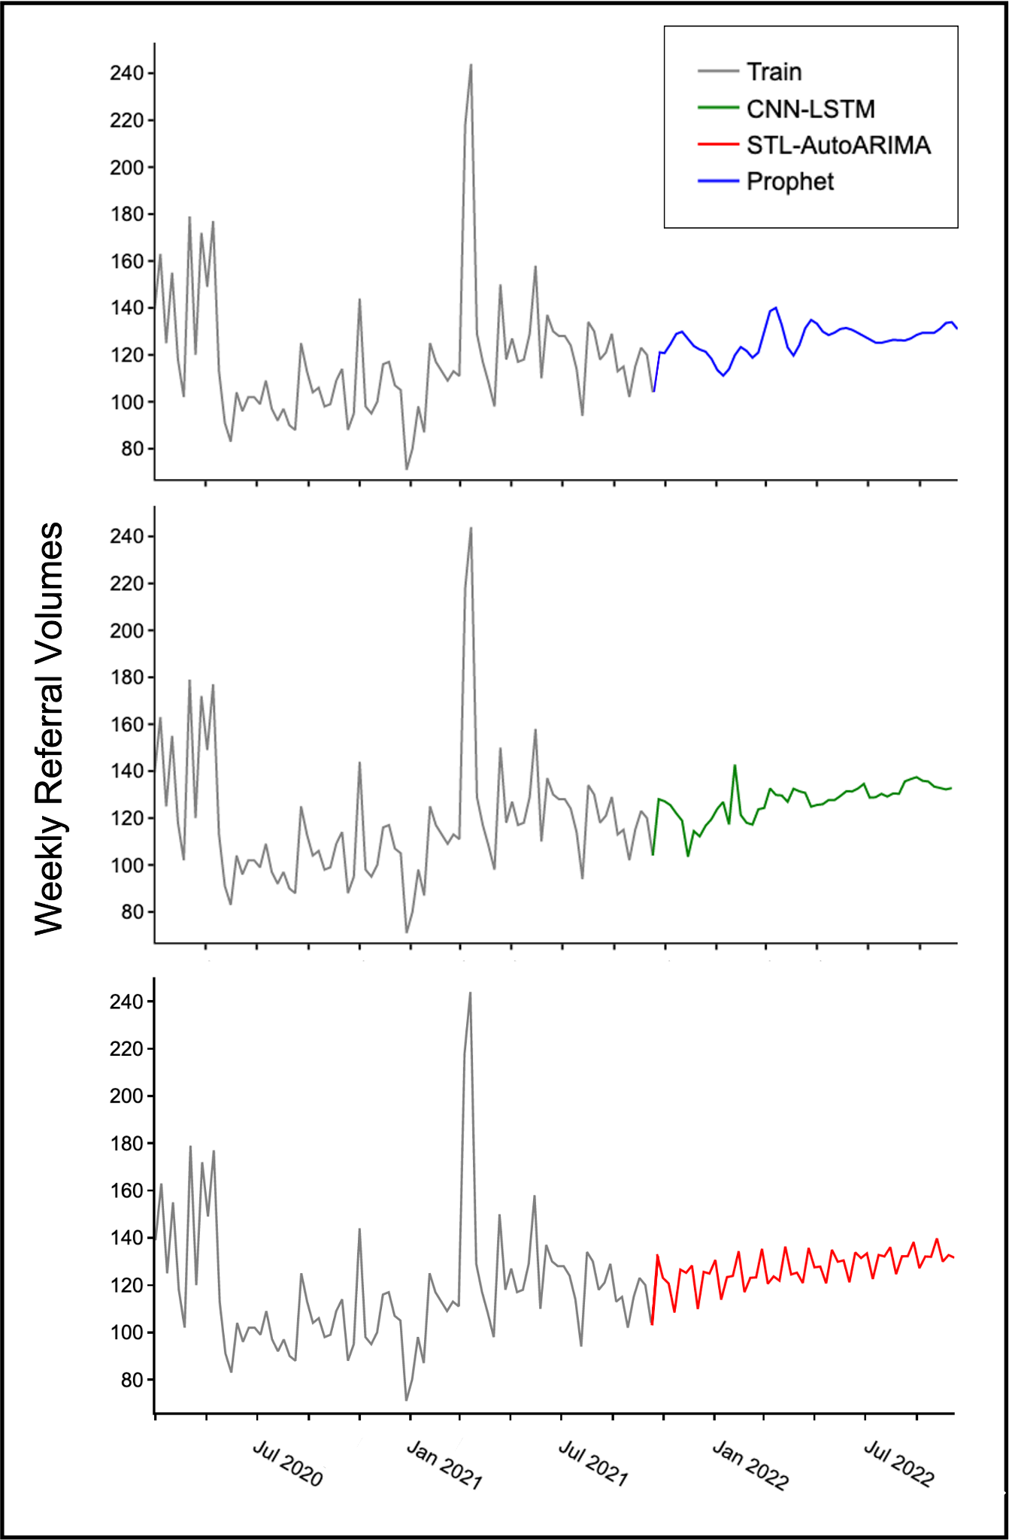

User experience and implementation

Analysis of coded user feedback explores possible reasons why the dashboard scored well (Supplementary Table 2). Many users highlighted the ‘clarity’, ‘usefulness’ and ‘variety’ of graphs and figures [M1, C3, C4, R1, R6, R7, R10, R12]. Others commented on dashboard interactivity [R6, R8], in particular the use of drill-down features as being particularly positive. Some users found that the dashboard would help with auditing and research. In particular they found that it gave important insights ‘into previously inaccessible big-data’ [R1], that it highlighted ‘areas of improvement for staff allocation’ [C3], suggested ‘directions for more focused audit and research’ [C5] and that it demonstrated ‘why we need to liaise with local referring sites’ [R3]. A few users commented on the AI implementation and time-series forecasting functions stating that it would be ‘useful in anticipating demand’ [R1], and that it ‘could be implemented easily’ [R8] but ‘unsure how it would be applied day-to-day’ [R12]. Some users did express concerns about dashboard access in the department [C1, C2], whereas others thought there should be additional functionality to ‘export data’ or review it in more detail [R2, R11].

Supplementary Table 2. User feedback and interview responses

Role | Code | Which aspects or features of the dashboard did you find most useful? (Italics = verbal feedback during think-aloud protocol) | Do you have any suggestions for improving the dashboard? (Italics = verbal feedback during think-aloud protocol)
Management and Administration | M1 | Useful graphs, gives important insights into acute neurosurgical data | /
Management and Administration | M2 | Will be useful in helping understand acute patient flow such as for MSCC (Metastatic spinal cord compression) | /
Management and Administration | M3 | More audit work should be done like this. Easy to use | /
Neurosurgery Consultant | C1 | Will be very useful to understand the [acute neurosurgical] service | Need to know when it can be accessed by whole department
Neurosurgery Consultant | C2 | Comprehensive. [Time-series] is interesting. Very useful | Needs better access
Neurosurgery Consultant | C3 | Heatmaps highlight areas of improvement for staff allocation/resources. Will help make on-call burden easier
Neurosurgery Consultant | C4 | Beautiful figures | No
Neurosurgery Consultant | C5 | Useful at suggesting directions for more focused audit and research | /
Neurosurgery Registrar | R1 | Useful figures, can give insight into previously inaccessible big data. Forecasting will be useful at anticipating demand | /
Neurosurgery Registrar | R2 | Really useful | More granular outcome data needs to be available
Neurosurgery Registrar | R3 | Shows why we need to liaise with local referring sites [in reference to geospatial figure] | /
Neurosurgery Registrar | R4 |  | /
Neurosurgery Registrar | R5 | The new AI tool was really user friendly and I’m excited to see its practical use in research. | /
Neurosurgery Registrar | R6 | Nice varied visuals and interaction | /
Neurosurgery Registrar | R7 | Very clear figures | /
Neurosurgery Registrar | R8 | Instant drill-down and interactivity. Impressive that AI could be implemented and used so easily [in reference to forecasting] | Some functionality (date/time changers) was a bit slow
Neurosurgery Registrar | R9 | [in reference to geospatial figure] could help improve in determining which sites send poor referrals and how patient transfers could be improved | /
Neurosurgery Registrar | R10 | Nice graphs | Pending information is ambiguous
Neurosurgery Registrar | R11 | Excellent dashboard! | Needs ability to download or export data
Neurosurgery Registrar | R12 | Highly visual. You get a good idea of where referrals are coming from. Saves time in looking at spreadsheets | Unsure where the AI will be used on a day to day level

Supplementary References

1. Box, G. E. P., Jenkins, G. M., Reinsel, G. C. & Ljung, G. M. Time Series Analysis Forecasting and Control. (John Wiley & Sons, Inc., Hoboken, New Jersey, 2016).
2. Taylor, S. J. & Letham, B. Forecasting at Scale. Am Statistician 72, 37–45 (2018).
3. Weiner, B. J. et al. Psychometric assessment of three newly developed implementation outcome measures. Implement Sci 12, 108 (2017).

Supplementary Appendix

Appendix 1. Diagnostic classification.
Specialist working diagnoses typically made by on-call neurosurgical registrar, aggregated into diagnostic classes for further analysis. Where a working diagnosis was fitting more than one class, the most likely class was used.
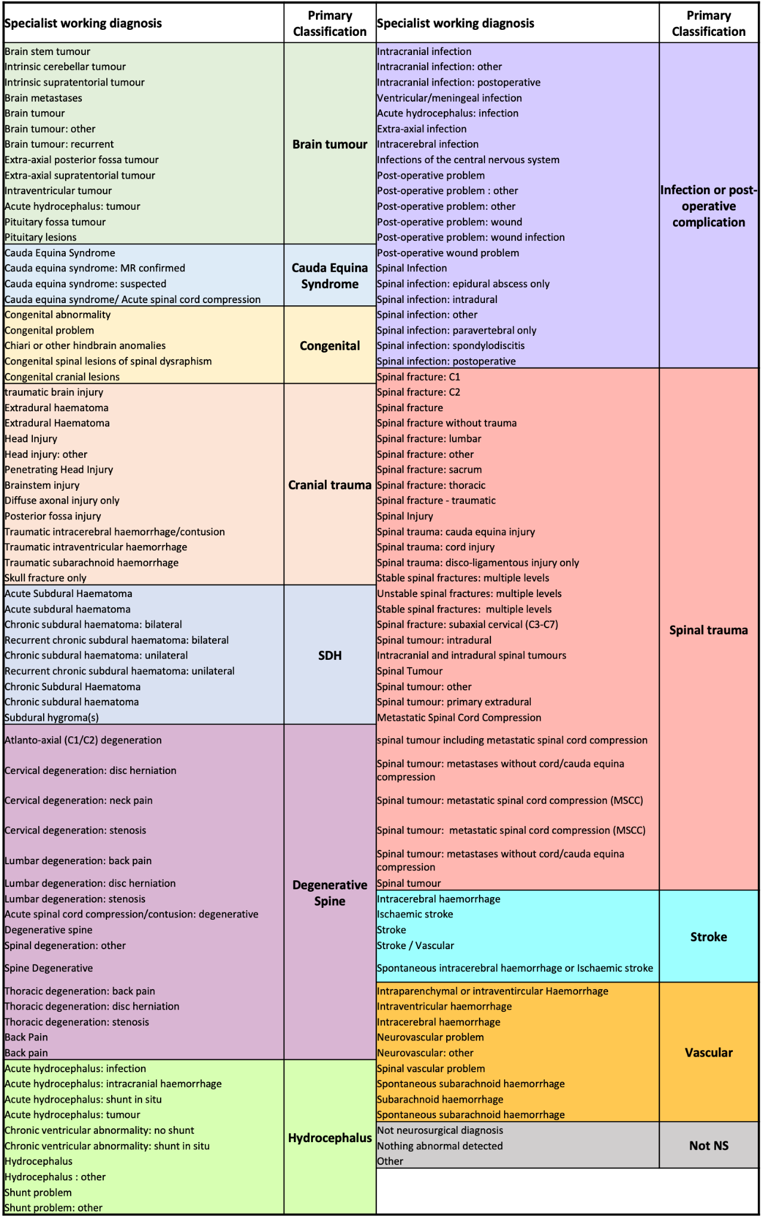

Appendix 2. User feedback questionnaire with usability, acceptability and feasibility assessment.
Instrument | Stem | Item
Acceptability | Please rate the following statements according to the scale:  - Completely agree  - Somewhat disagree  - Neither agree nor disagree  - Somewhat agree  - Completely agree | The neurosurgical referral dashboard meets my approval
 |  | The neurosurgical referral dashboard is appealing to me
 |  | I like the neurosurgical dashboard
 |  | I welcome the neurosurgical referral dashboard
Feasibility | Please rate the following statements according to the scale:  - Completely agree  - Somewhat disagree  - Neither agree nor disagree  - Somewhat agree  - Completely agree | The neurosurgical referral dashboard seems implementable
 |  | Using the neurosurgical referral dashboard seems doable
 |  | Using the neurosurgical referral dashboard seems possible
 |  | The neurosurgical referral dashboard seems easy to use
Usability | Please rate the following statements according to the scale:  - Strongly disagree  - Somewhat disagree  - Neither agree nor disagree  - Somewhat agree  - Strongly agree | I think that I would like to use this dashboard frequently
 |  | I found the dashboard unnecessarily complex
 |  | I thought the dashboard was easy to use
 |  | I think that I would need the support of a technical person to be able to use this dashboard
 |  | I found the various functions in this dashboard were well integrated
 |  | I thought there was too much inconsistency in this dashboard
 |  | I would imagine that most people would learn to use this dashboard very quickly
 |  | I found the dashboard very cumbersome to use
 |  | I felt very confident using the dashboard
 |  | I needed to learn a lot of things before I could get going with this dashboard
General | Which aspects or features of the dashboard did you find most useful?
 | Do you have any suggestions for improving the dashboard?
Which role would best describe you?
- Neurosurgical Registrar
- Neurosurgical Consultant
- Management and Administration

