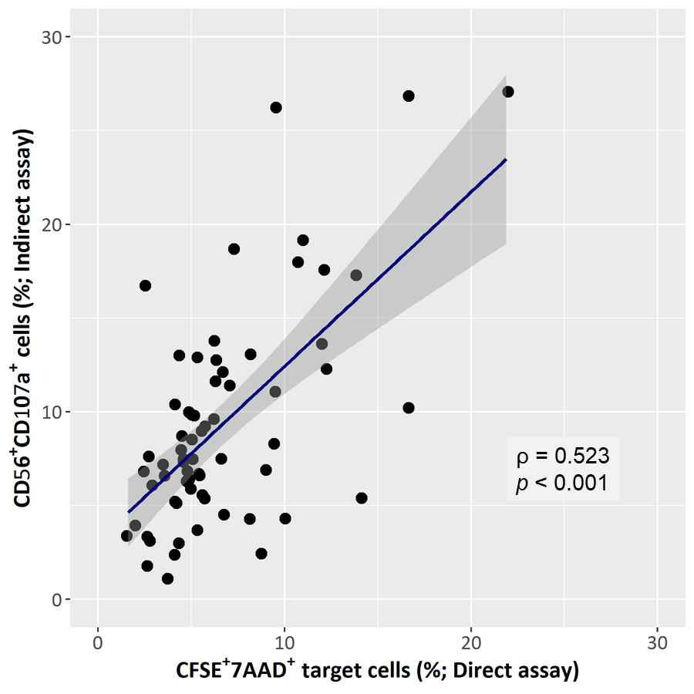
Figure S1. Relationship of the results between assays to evaluate NK cell activity. Correlation of 67 blood samples between the direct assay (CFSE-based NK cell cytotoxic activity) and indirect assay (degranulation potential of NK cells). Linear regression curve with 95% CI was plotted, and Spearman’s Rank correlation coefficient (ρ) and p-value were calculated.

