Supplementary Information
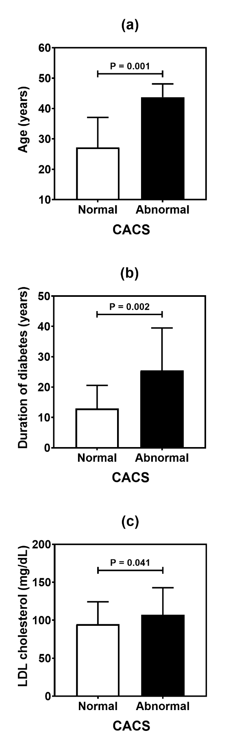
Additional file 1: Fig. S1. Comparative analysis of age (a), duration of diabetes (b), and LDL (low-density lipoprotein) cholesterol level (c) in type 1 diabetes patients according to CACS (coronary artery calcium score).
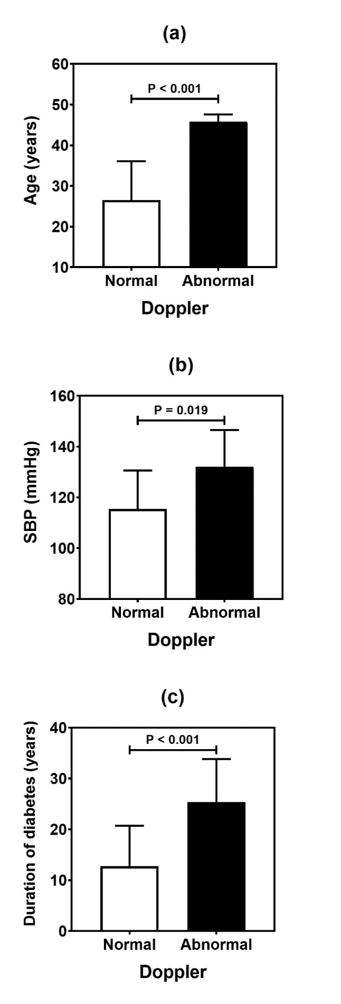
Additional file 1: Fig. S2. Comparative analysis (mean and standard deviation) of age (a), SBP (Systolic blood pressure) (b), and duration of diabetes (c) in type 1 diabetes patients according to carotid Doppler sonography.
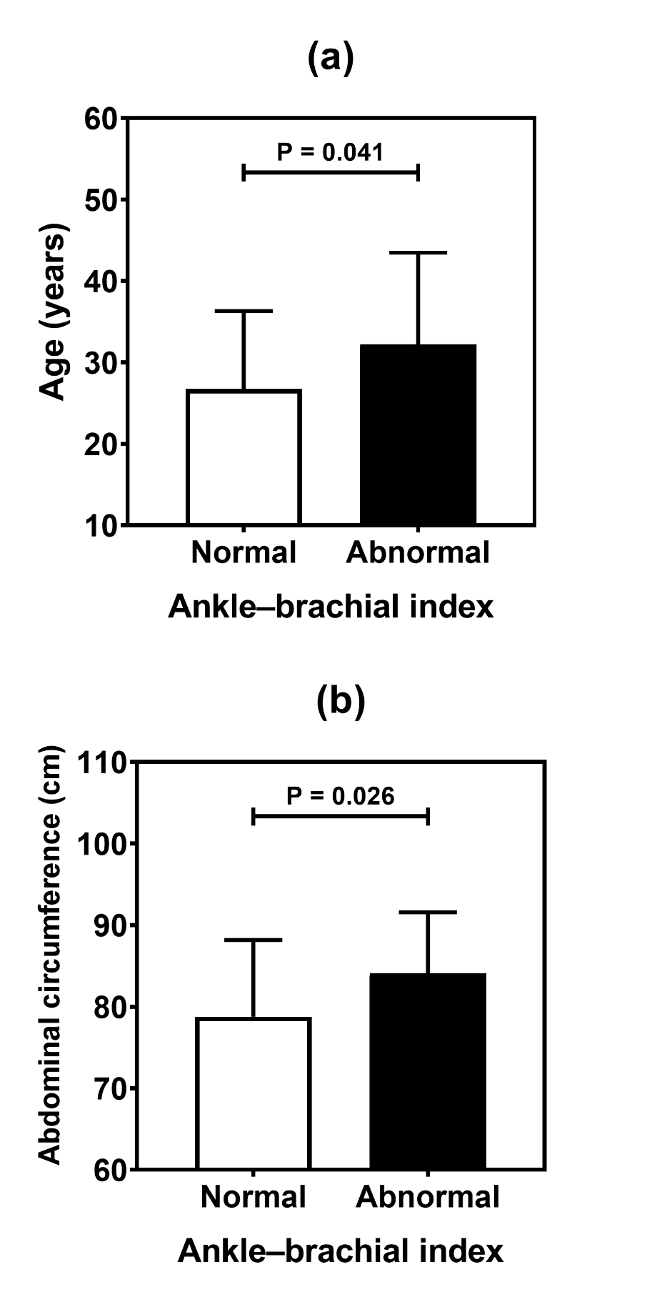
Additional file 1: Fig. S3. Comparative analysis (mean and standard deviation) of age (a), and abdominal circumference (b) in type 1 diabetes patients according to ankle-brachial index.

Additional file 1: Table S1 Results of comparison tests (p values) of autosomal ancestry data in individuals with type 1 diabetes according to cardiovascular evaluation.
Variables | Cardiovascular abnormalities
 | CACS | Doppler | ABI
 | p value | p value | p value
Autosomal ancestry
Amerindian | 0.222 | 0.795 | 0.765
European | 0.383 | 0.481 | 0.234
African | 0.688 | 0.801 | 0.636
CACS Coronary artery calcium score (Normal versus Abnormal). Doppler Carotid Doppler sonography (Normal versus Abnormal). ABI Ankle–brachial index (Normal versus Abnormal).

