Supplementary Information

Laser-Ablative Aqueous Synthesis and Characterization of Elemental Boron Nanoparticles for Biomedical Applications

Andrei I. Pastukhov¹, Iaroslav B. Belyaev^{2,3}, Julia C. Bulmahn⁴, Ivan V. Zelepukin^{2,3}, Anton A. Popov², Irina N. Zavestovskaya^{2,5}, Sergei M. Klimentov², Sergey M. Deyev^{2,3}, Paras N. Prasad^{2,4}* and Andrei V. Kabashin^{1,2}*
1Aix Marseille University, CNRS, LP3, Campus de Luminy, Case 917, 13288, Marseille, France
2MEPHI, Institute of Engineering Physics for Biomedicine (PhysBio), 115409 Moscow, Russia
3Shemyakin–Ovchinnikov Institute of Bioorganic Chemistry, Russian Academy of Sciences, 16/10 Miklukho-Maklaya St, Moscow, 117997, Russia
4University at Buffalo, The State University of New York, Department of Chemistry and the Institute for Lasers, Photonics, and Biophotonics, Buffalo, New York 14260, United States
5P. N. Lebedev Physical Institute of the Russian Acad. Sci., Leninskiy Pr. 53, 119991 Moscow, Russia
*pnprasad@buffalo.edu, andrei.kabashin@univ-amu.fr
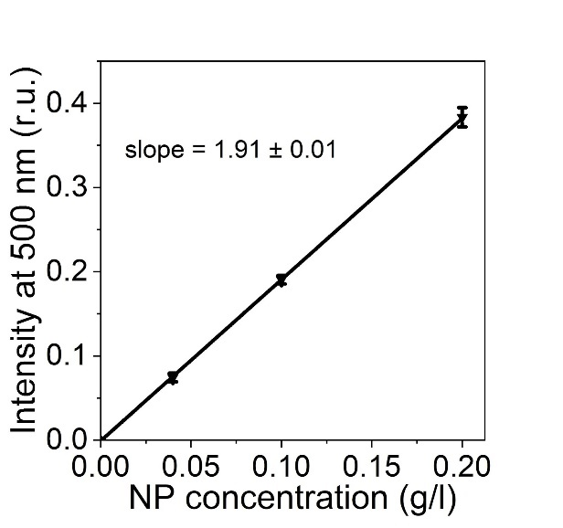
Figure S1. Calibration curve of the absorbance intensity of boron NPs at 500 nm in water versus concentration (n=3).

