**Table S1: List of primers used in this study.**



PM Xapt + aTc

PM Xapt - aTc

WT+ aTc

WT - aTc

D266G+ aTc

D266G - aTc

**Supplementary Fig. 1. A wild type (WT) but not a catalytic dead (D266G) form of second copy PM X could rescue the growth defect due to knockdown of endogenous PM X.** PM Xapt parasites complemented with a second copy of the PM X gene, wild type (WT) or catalytic mutant (D266G) were grown in presence or absence of aTc. Parasitemia were determined at indicated times. Mean values from three independent experiments are shown and error bars represent standard deviations.



**Supplementary Fig. 2. *In vitro* substrate cleavage activity of the wild type (WT) rPM X under different pH conditions.** As substrate, a fluorogenic synthetic peptide that corresponds to the PM X cleavage site in Rh2N was used. 1 uM substrate peptide was incubated with 10 ng of rPM X at 37°C. The increase in relative fluorescence intensity (RFU) over time due to cleavage by PM X was measured. To inhibit PM X activity, 1 uM CWHM-117 was added to samples at pH 5.5. Neg: no rPM X added. Rh2N-mut: a mutated form that is not cleaved by PM X. Mean values from three independent experiments are shown and error bars represent standard deviations.

pH 5.5+CWHM-117



***

***

**Supplementary Fig. 3. *In vitro* activity of prodomain (PD) mutant forms of parasite-derived PM X.** Second copy PM X tagged with GFP was purified from schizonts using anti-GFPantibody. Isolated enzyme was then incubated with substrate as in fig. 3. Reaction was carried out for 1 h at 37°C. Mean values from three independent experiments are shown and error bars represent standard deviations. ***: p<0.001.

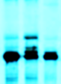

**Supplementary Fig. 4. PM X processing is brefeldin A (BFA)-sensitive.** 40-43 h schizonts expressing PM X-3xHA were pulse labelled with [35S]methionine-cysteine for 5 min followed by chasing in unlabeled medium in the presence of cycloheximide (10 µg/ml). To one sample BFA (5 µg/ml) was added during chase. After 1 h, PM X was pulled down using anti-HA beads followed by autoradiography. The precursor and the processed forms of PM X are indicated.

BFA

No drug

0 min

1 h

unprocessed

processed

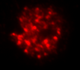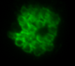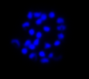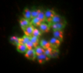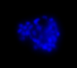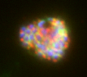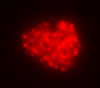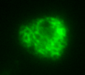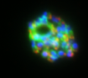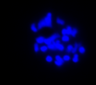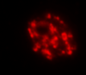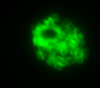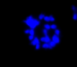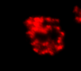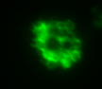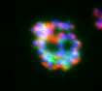

AMA1

MSP1

DAPI

Combined

-aTc+CWHM-117

+aTc+C1

2𝛍m

**Supplementary Fig. 5. Unprocessed AMA1 accumulates in terminal organelles in**

***P. falciparum* schizonts*.*** Synchronized schizonts (44 h old) from PM Xapt parasites were treated with C1 in presence of aTc. To knock down PM X and suppress residual activity, an aliquot of the culture was grown in absence of aTc from invasion and at 24 h post invasion, 0.5 uM CWHM-117 was added. Samples were fixed and stained with indicated antibodies followed by IFA.

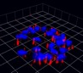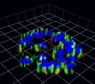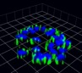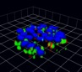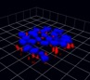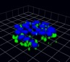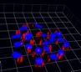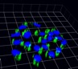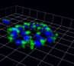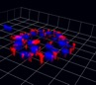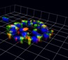

HA + DAPI

AMA1 + DAPI

Combined

HA + DAPI

EBA175 + DAPI

Combined

PM X

SUB1

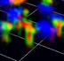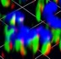

**a**

**b**

**c**

PM X

SUB1

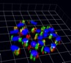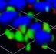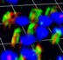

**Supplementary Fig. 6. Both PM X and SUB1 partially colocalize with the microneme markers AMA1 and EBA175. a** and **b** 3D reconstruction of Airyscan confocal images from the samples in fig 8c. Insets show regions of interest: either complete overlap or very close proximity of the two signals. Each unit of grid is 1.61 µm. **c** SR-SIM microscopy: 2D images of parasites expressing PM X-3xHA and labeled with the indicated antibodies.

AMA1

HA

Combined

with DAPI

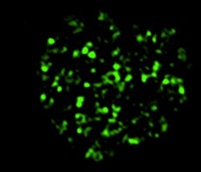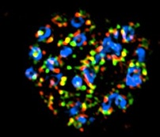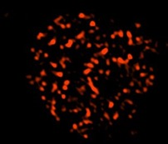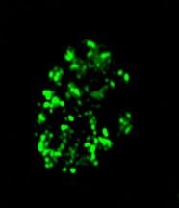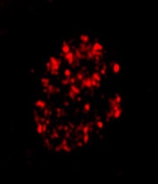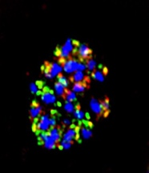

5 μm

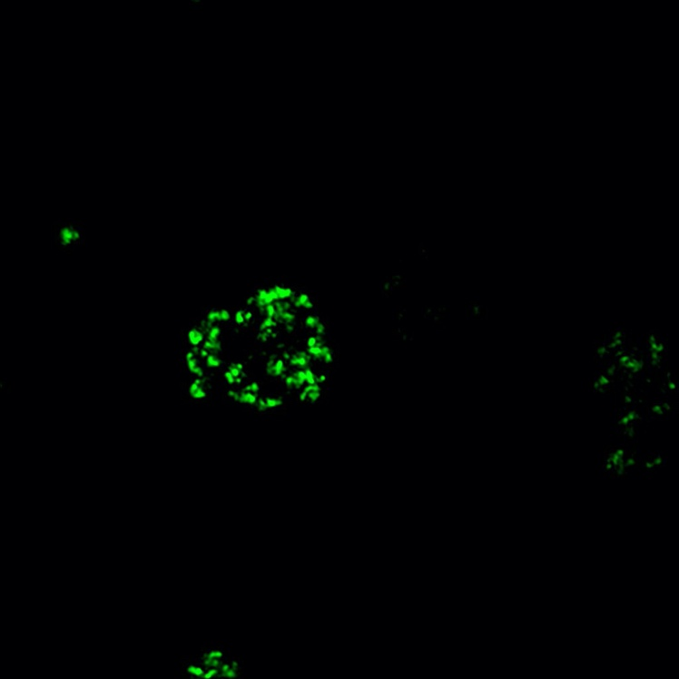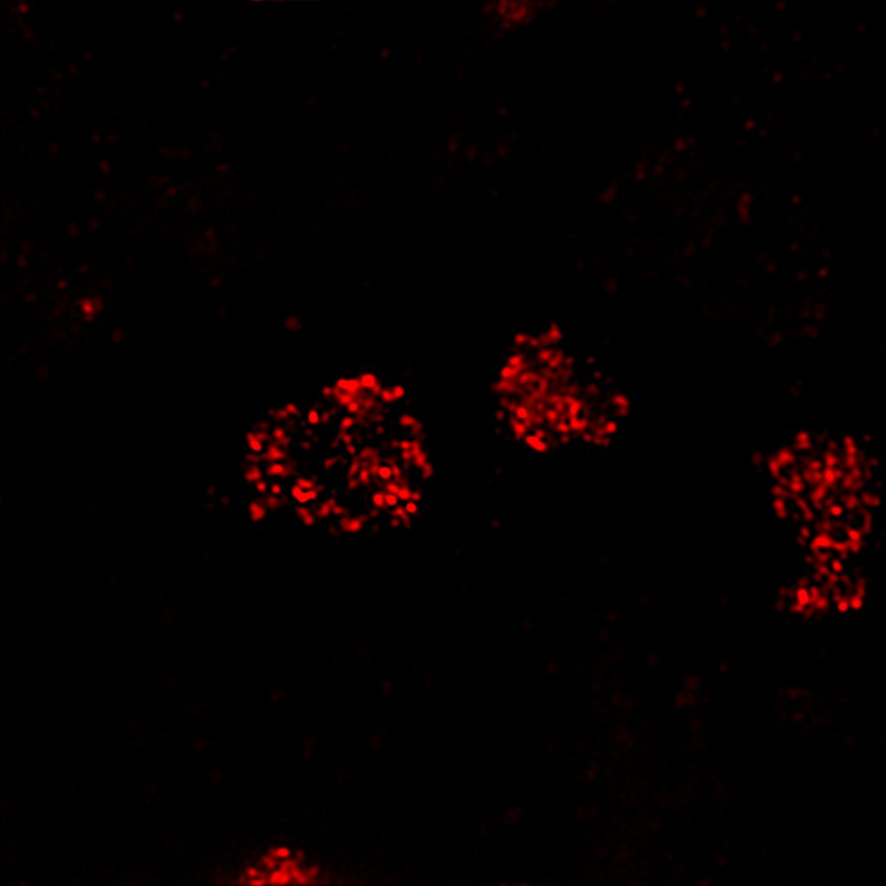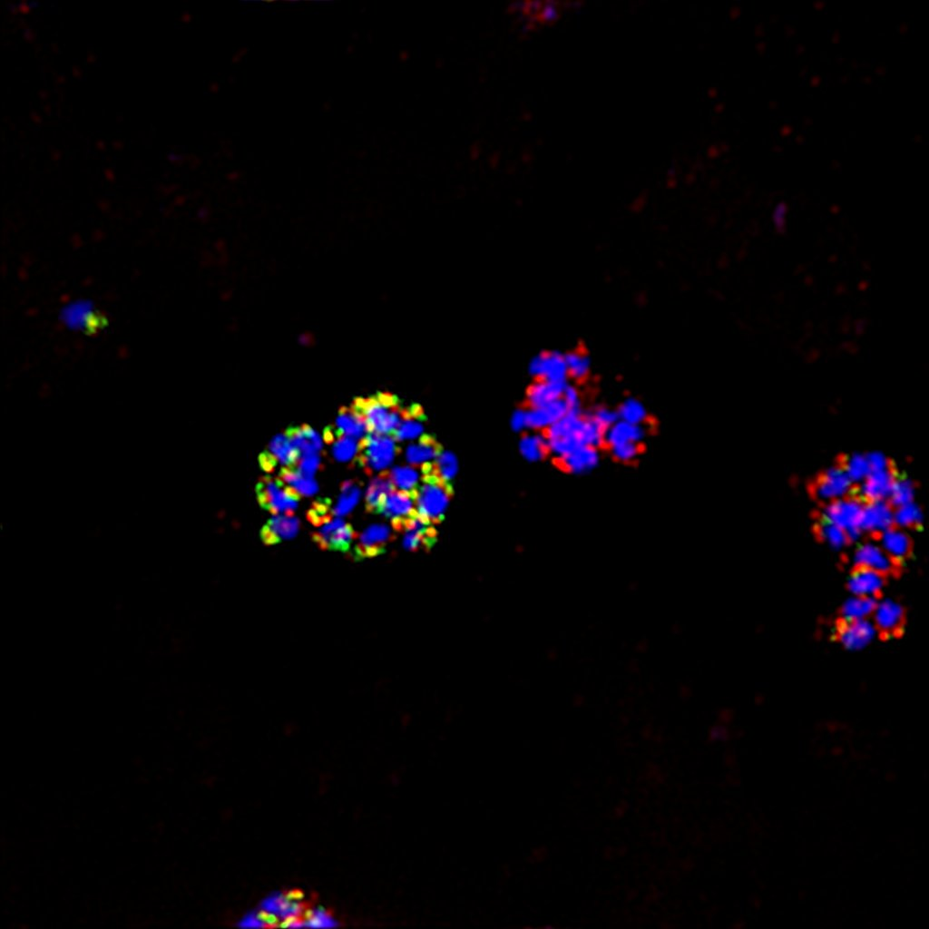

EBA175

HA

Combined

with DAPI

