Supplementary Figures
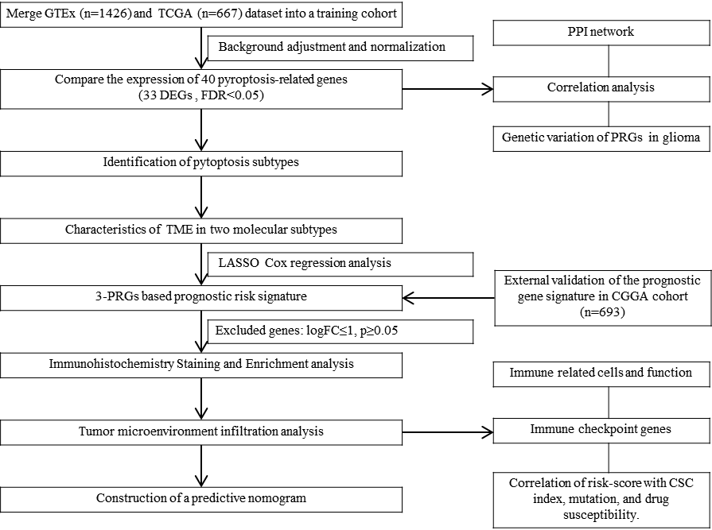

Figure S1 The workflow chart about each analytical process of the study.

FIGURE S2 Correlation networks of pyroptosis-related genes in gliomas and their potential interactions. (A) Correlations between 40 pyroptosis-related genes. The stronger the correlation, the darker the color. (B) The interactions of the 33 DEGs in the PPI network (interaction confidence score = 0.9). (C) The correlation network of the 33 DEGs (red line: positive correlation; blue line: negative correlation).

