A uterus-inspired 3D niche drives embryo development beyond implantation

Zhen Gu^{2,4,7}, Jia Guo^{1,3,5,7}, Jinglei Zhai^{1,3,5,7}, Guihai Feng^{1,3,5,7}, Xianning Wang¹, Zili Gao^{1,3}, Liyuan Jiang^{1,6}, Yongqiang Wen², Liu Wang^{1,3,5}, Jie Hao^{1,3,5}, Wei Li^{1,3,5}, Shutao Wang^{4,5*}, Hongmei Wang^{1,3,5*}and Qi Gu^{1,3,5*}

¹State Key Laboratory of Membrane Biology, The State Key Laboratory of Stem Cell and Reproductive Biology, Institute of Zoology, Chinese Academy of Sciences, Beijing 100101, P. R. China. ²Department of Chemistry and Biological Engineering, University of Science and Technology Beijing, Beijing 100083, P. R. China. ³Institute for Stem Cell and Regeneration, Chinese Academy of Sciences, Beijing 100101, P. R. China. ⁴CAS Key Laboratory of Bio-inspired Materials and Interfacial Science, Technical Institute of Physics and Chemistry, Chinese Academy of Sciences, Beijing, 100190, P. R. China. ⁵University of Chinese Academy of Sciences, Beijing 100049, P. R. China. ⁶School of Life Sciences, Northeast Agricultural University, Harbin, 150030, P. R. China. ⁷These authors contributed equally to the work. *e-mail: stwang@mail.ipc.ac.cn; wanghm@ioz.ac.cn; qgu@ioz.ac.cn.

Supplementary information for

A uterus-inspired 3D niche drives embryo development beyond implantation
Zhen Gu^{2,4,7}, Jia Guo^{1,3,5,7}, Jinglei Zhai^{1,3,5,7}, Guihai Feng^{1,3,5,7}, Xianning Wang¹, Zili Gao^{1,3}, Liyuan Jiang^{1,6}, Yongqiang Wen², Liu Wang^{1,3,5}, Jie Hao^{1,3,5}, Wei Li^{1,3,5}, Shutao Wang^{4,5}*, Hongmei Wang^{1,3,5}* and Qi Gu^{1,3,5}*

¹State Key Laboratory of Membrane Biology, The State Key Laboratory of Stem Cell and Reproductive Biology, Institute of Zoology, Chinese Academy of Sciences, Beijing 100101, P. R. China
²Department of Chemistry and Biological Engineering, University of Science and Technology Beijing, Beijing 100083, P. R. China
³Institute for Stem Cell and Regeneration, Chinese Academy of Sciences, Beijing 100101, P. R. China
⁴CAS Key Laboratory of Bio-inspired Materials and Interfacial Science, Technical Institute of Physics and Chemistry, Chinese Academy of Sciences, Beijing, 100190, P. R. China.
⁵University of Chinese Academy of Sciences, Beijing 100049, P. R. China.
⁶School of Life Sciences, Northeast Agricultural University, Harbin, 150030, P. R. China.
⁷These authors contributed equally to the work.
*e-mail: stwang@mail.ipc.ac.cn; wanghm@ioz.ac.cn; qgu@ioz.ac.cn.

Table of Contents:
Supplementary notes
Supplementary Figures 1 to 11 with legends
Supplementary Tables 1 to 2
Legend to Supplementary Movies 1 to 3
Supplementary references

Supplementary notes
Previous studies on embryo culture and embryo-material interactions
The first mouse blastocyst cultured in vitro was injected into the fiber network of the bovine eye¹. Currently, the typical dishes used for embryo culture are made of polystyrene, silicone or specialized plastic polymer-coated by collagen, laminin, fibrinogen or some other matrix²⁻⁶.
Cell microenvironment, a complicated and dynamic biochemical and physical environment, is able to control cell behaviors and development and determine cell fates⁷. An embryo, the well-organized cell cluster, is also sensitive to the surrounding condition^{8,9}.
3D biomaterial system has provided a paradigm shift in cell culture in vitro and considerable research efforts have been devoted to material properties including macro/nano-structure, elastic, stuffiness, micro/nano-patterns influencing cell states¹⁰⁻¹⁴ through chemical pathways¹⁵⁻²⁰.
Our U3N platform was established according to the well understanding of the structure of the uterus and developmental biology. Developing of appropriate culture method in vitro is crucial to explore the black-box of embryo development, and stem cell based embryo assembly, which have attracted much attention²¹⁻³⁰. To the best of our knowledge, U3N system not only extends the embryo culture period to heartbeat stage from initial blastocyst, but also uncovers molecular regulators between materials and embryos, which governs YAP pathways, to regulate embryo spreading and developmental potential³¹⁻³⁶.

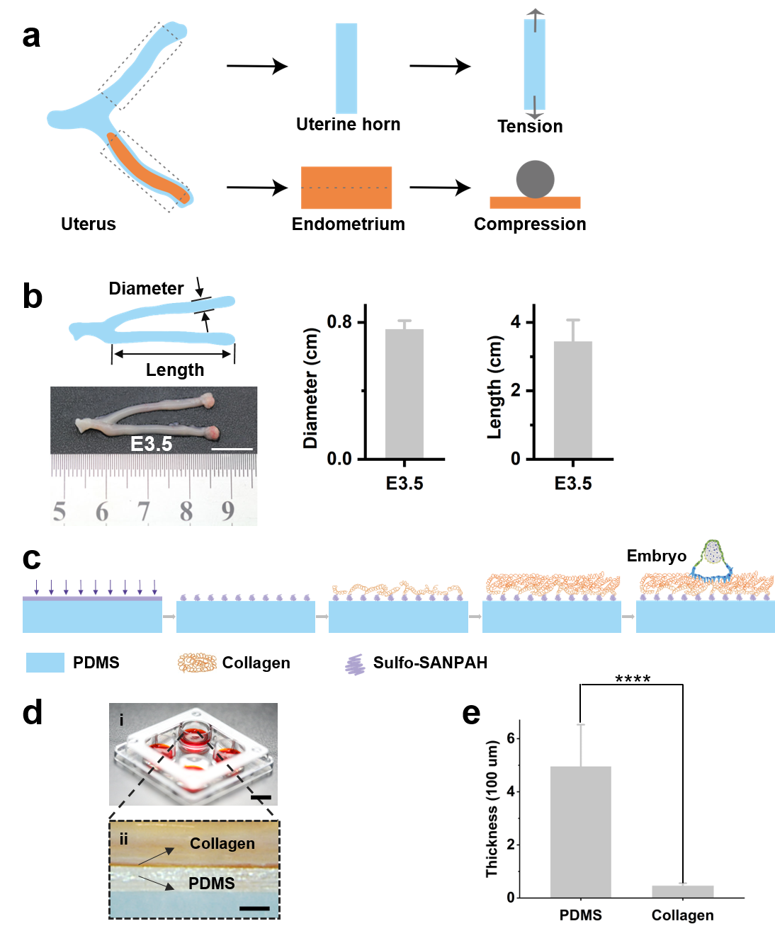
Supplementary Figure 1 Uterus and uterus-inspired 3D niche construction. a, Schematic diagram of uterine modulus measurement. b, Digital morphology picture of E3.5 mouse uterus with uterine schematic in the left, statistics of diameter and length of uterine horn in the middle and right. Scale bar, 1 cm. c, Preparation process of uterus-inspired 3D niche. d, Digital image (top panel) of the in vitro culture environment for the embryo on the uterus-inspired 3D niche. Scale bar, 3 mm. Magnified view of cross section of culture substrate is shown at the bottom panel. (i) scale bar, 1 cm; (ii) Scale bar, 500 μm. e, The thickness of PDMS and collagen in the major area of embryo development in the dotted box (d). ***P < 0.001.

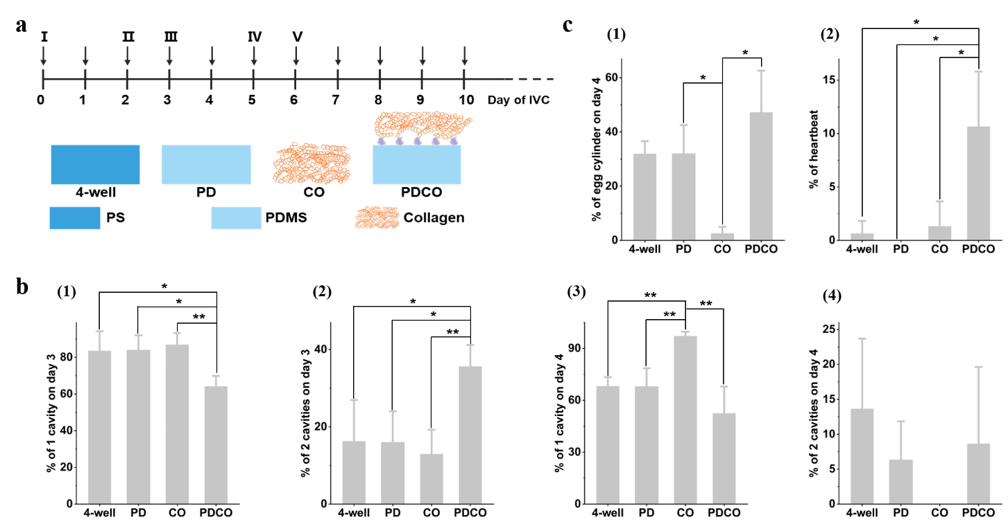
Supplementary Figure 2 Embryo development in conventional and uterus-inspired niche. a, Schematic representation of conventional and uterus-inspired niche. b, c, Developmental status of embryos in conventional and uterus-inspired niche. I, II, III, IV and V represent the medium added at the corresponding time points of in vitro culture: І, the medium for embryos on day 0-1 of IVC, Ⅱ, the medium for embryos on day 2 of IVC, Ⅲ, the medium for embryos on day 3-4 of IVC, Ⅳ, the medium on day 5 of IVC, Ⅴ, the medium for embryos on day 6-10 of IVC. *P < 0.05, **P < 0.01.

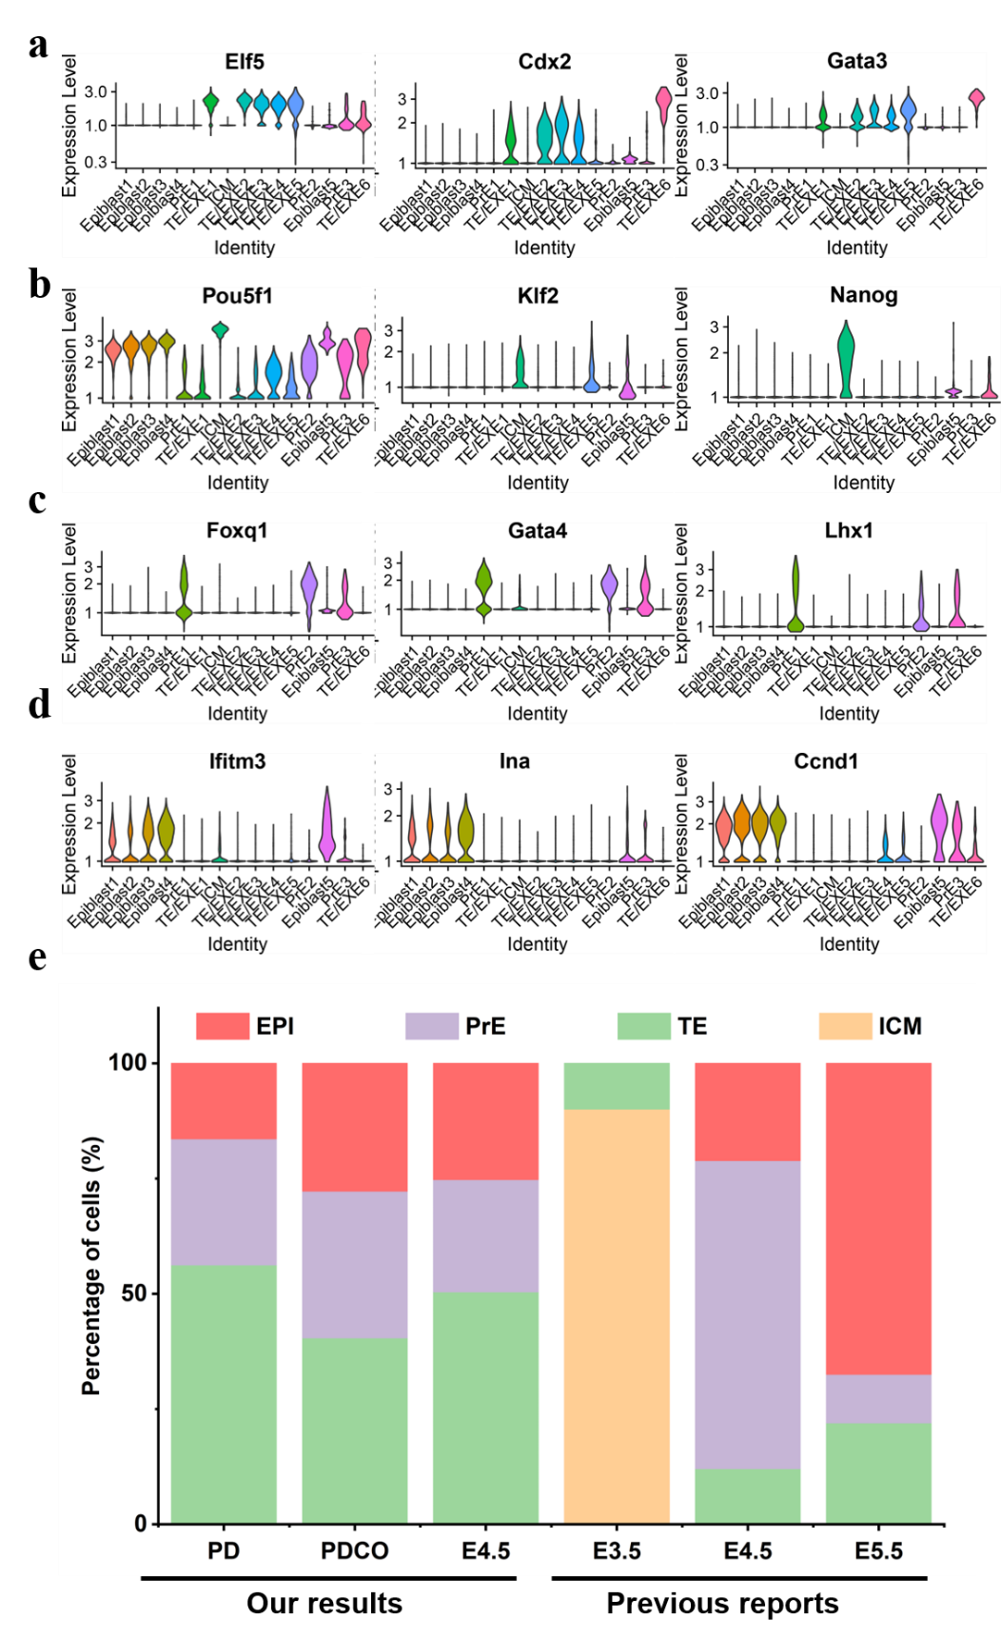
Supplementary Figure 3 Results of single-cell RNA sequencing. a-d, Expression of clustering maker genes for TE (a), ICM (b), PrE (c), EPI (d). e, Proportion of EPI, PrE, TE, and ICM cells of embryos on PD and PDCO on day 2 of IVC and embryos of E3.5, E4.5 and E5.5 in previous publications. Epiblast (EPI), primitive endoderm (PrE), trophoblast (TE)and inner cell mass (ICM).

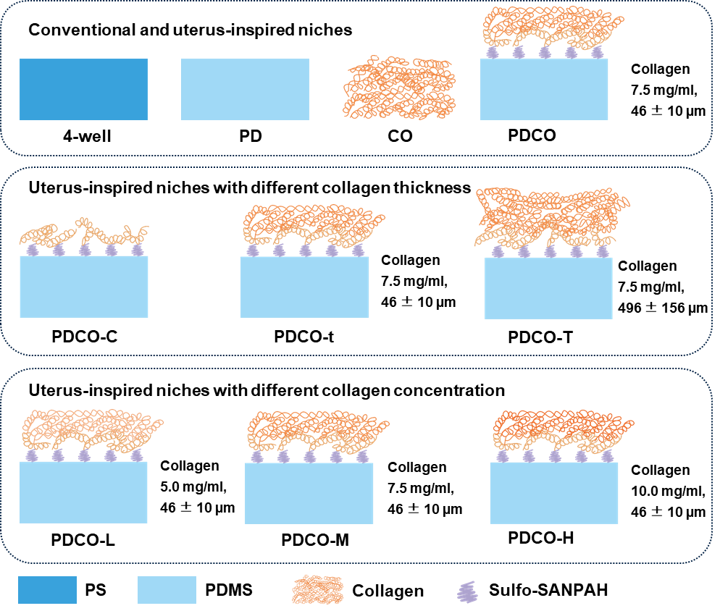
Supplementary Figure 4 Schematic diagram and abbreviations of major terms of the niche for embryo culture in vitro. Up panel, the conventional (4-well and PD) and uterus-inspired niches (PDCO).4-well: Nunc 4-well dish. PD: PDMS with a thickness of 496 ± 156 µm. CO: Collagen with a concentration of 7.5 mg/ml and a thickness of 46 ± 10 µm. PDCO: The bottom layer is PDMS (496 ± 156µm in thickness) and the up layer is collagen (7.5 mg/ml, 46 ± 10 µm in thickness). Middle panel, different thickness of collagen gel for the uterus-inspired niche. PDCO-C: PDMS (496 ± 156µm in thickness) is coated with collagen. PDCO-t: The bottom layer is PDMS (496 ± 156µm in thickness) and the up layer is collagen (7.5 mg/ml, 46 ± 10µm in thickness). PDCO-T: The bottom layer is PDMS (496 ± 156µm in thickness) and the up layer is collagen (7.5 mg/ml, 417 ± 137µm in thickness). Bottom panel, different concentrations of collagen gel for the uterus-inspired niche. PDCO-L: The bottom layer is PDMS (496 ± 156µm in thickness) and the up layer is collagen (5.0 mg/ml, 46 ± 10µm in thickness). PDCO-M: The bottom layer is PDMS (496 ± 156µm in thickness) and the up layer is collagen (7.5 mg/ml, 46 ± 10µm in thickness). PDCO-H: The bottom layer is PDMS (496 ± 156µm in thickness) and the up layer is collagen (10.0 mg/ml, 46 ± 10 µm in thickness).

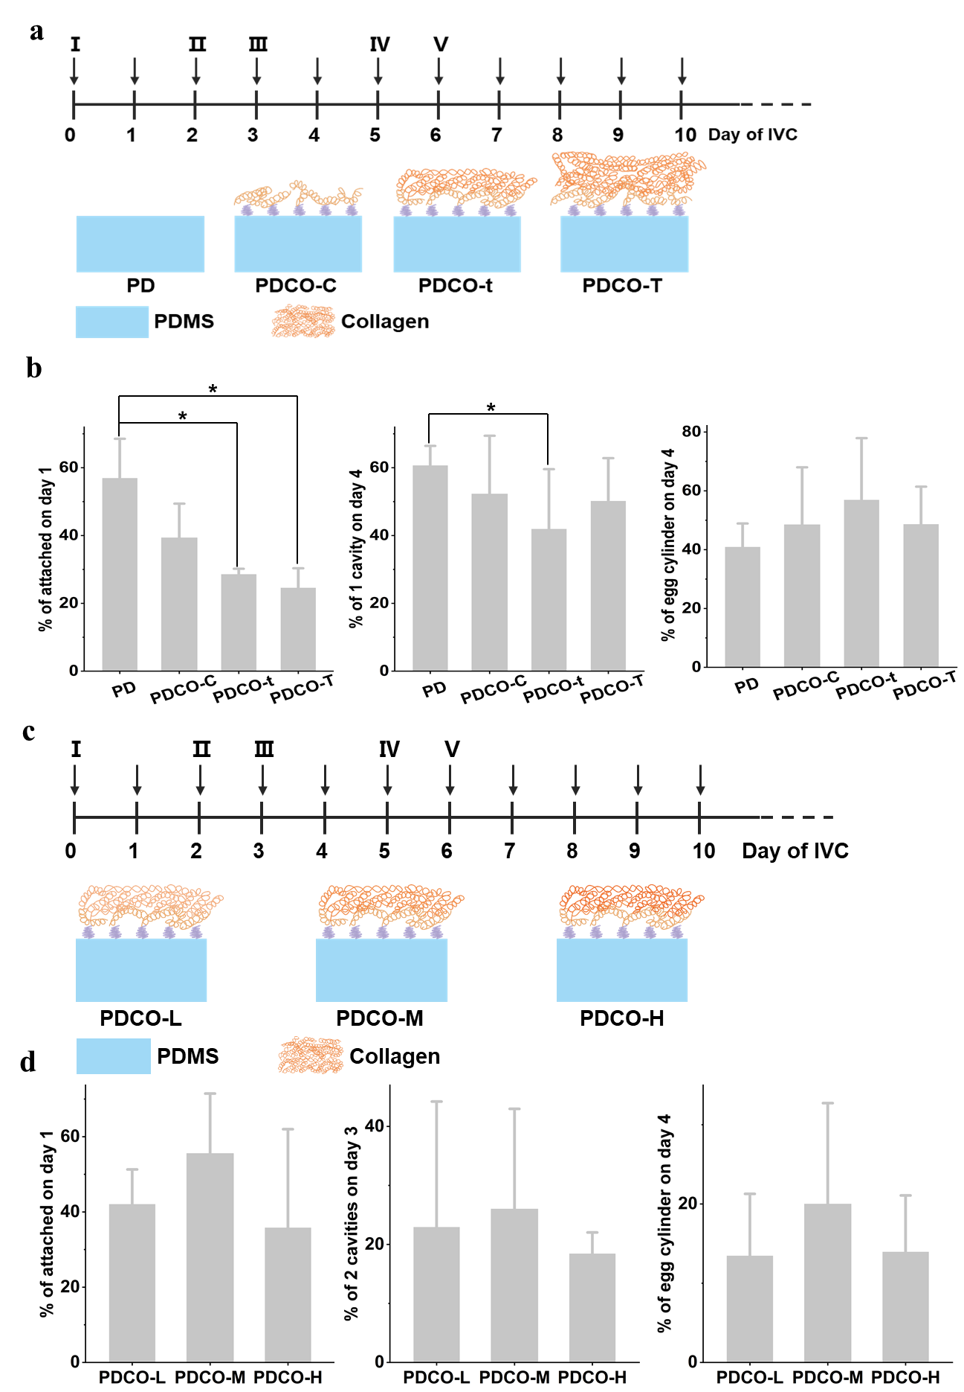
Supplementary Figure 5 Optimization of the uterus-inspired niche to promote embryo development. a, b, The embryo development in the uterus-inspired niche with different collagen thickness. c, d, The embryo development in the uterus-inspired niche with different collagen concentration. I, II, III, IV and V represent the medium added at the corresponding time points of in vitro culture: І, the medium for embryos on day 0-1 of IVC, Ⅱ, the medium for embryos on day 2 of IVC, Ⅲ, the medium for embryos on day 3-4 of IVC, Ⅳ, the medium on day 5 of IVC, Ⅴ, the medium for embryos on day 6-10 of IVC. *P < 0.05.

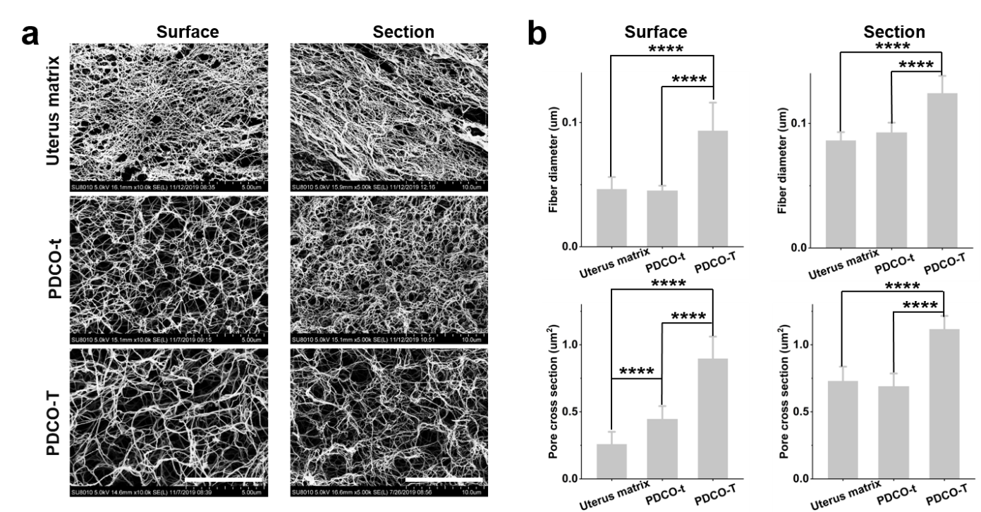
Supplementary Figure 6 Developmental status of embryos in the uterus-inspired niche with different collagen thickness. a, Scanning electron microscopy images of the surface and cross sections of uterus matrix and indicated culture matrix. Scale bars, 5 μm (left panel). Scale bars, 10 μm (right panel). b, The fiber diameter and pore cross sections of surface (right panel) and cross sections (left panel) of uterus matrix and indicated culture matrix. ****P < 0.0001.
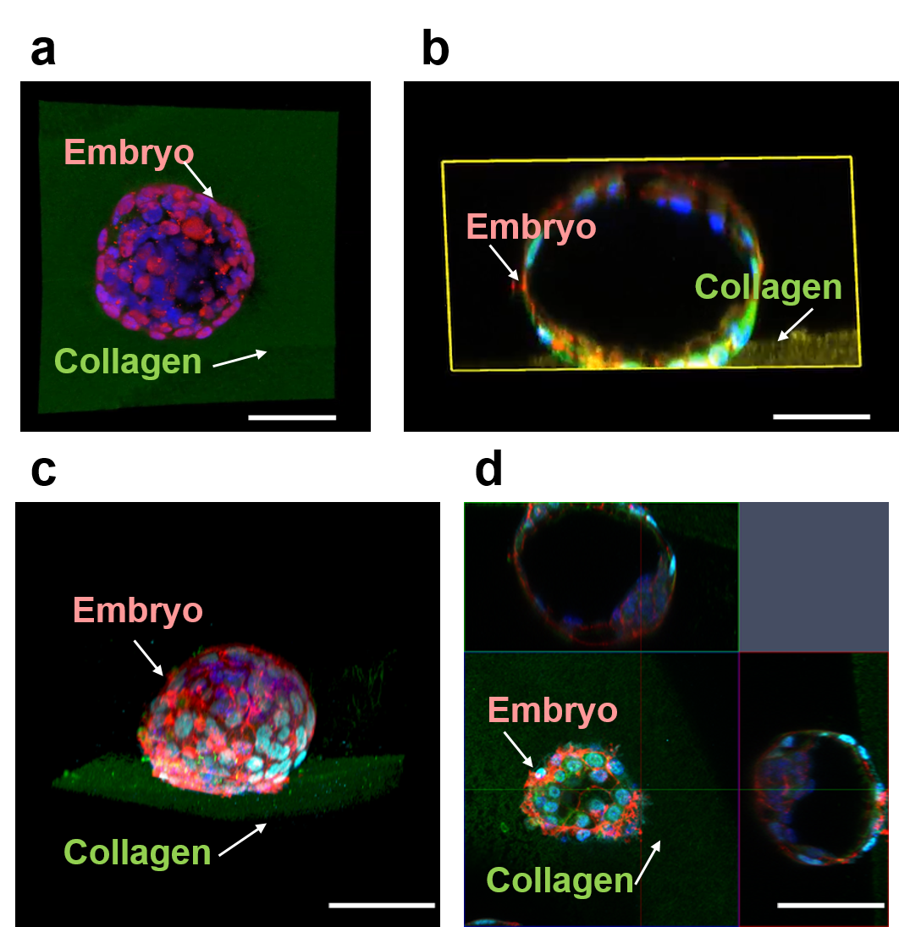
Supplementary Figure 7 Embryo invasion into collagen fibers. a, b, Screenshots of 3D video of the E3.5 embryo cultured on the PDCO for one day and the cross section perpendicular to collagen substrate. n = 3. Scale bar, 100 μm. a, CDX2, red (trophoblast), and Collagen I, green (material), DAPI, blue (nucleus), b, CDX2, cyan (trophoblast), Collagen I, yellow (material), Phalloidin, red (cytoskeleton), DAPI, blue (nucleus). c, d, 3D images of embryos on PDCO of day 2 for IVC. CDX2, cyan (trophoblast), Collagen I, green (material), Phalloidin, red (cytoskeleton), DAPI, blue (nucleus). The above and right images are cross-sectional views along the corresponding color indicator lines n = 5. Scale bars, 100 μm.
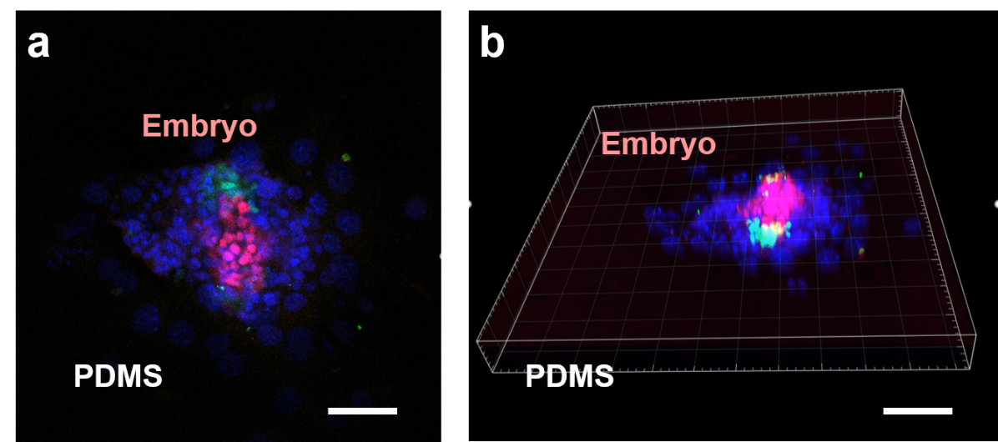
Supplementary Figure 8 3D imaging of the embryos cultured on PD. The video screenshots of the embryos at E3.5 cultured on the PD for one day that are displayed dynamically from top to bottom (a) and by rotating from multiple angles (b). OCT4, green (epiblast), CDX2, red (trophoblast), and DAPI, blue (nucleus). Scale bars, 100 μm.

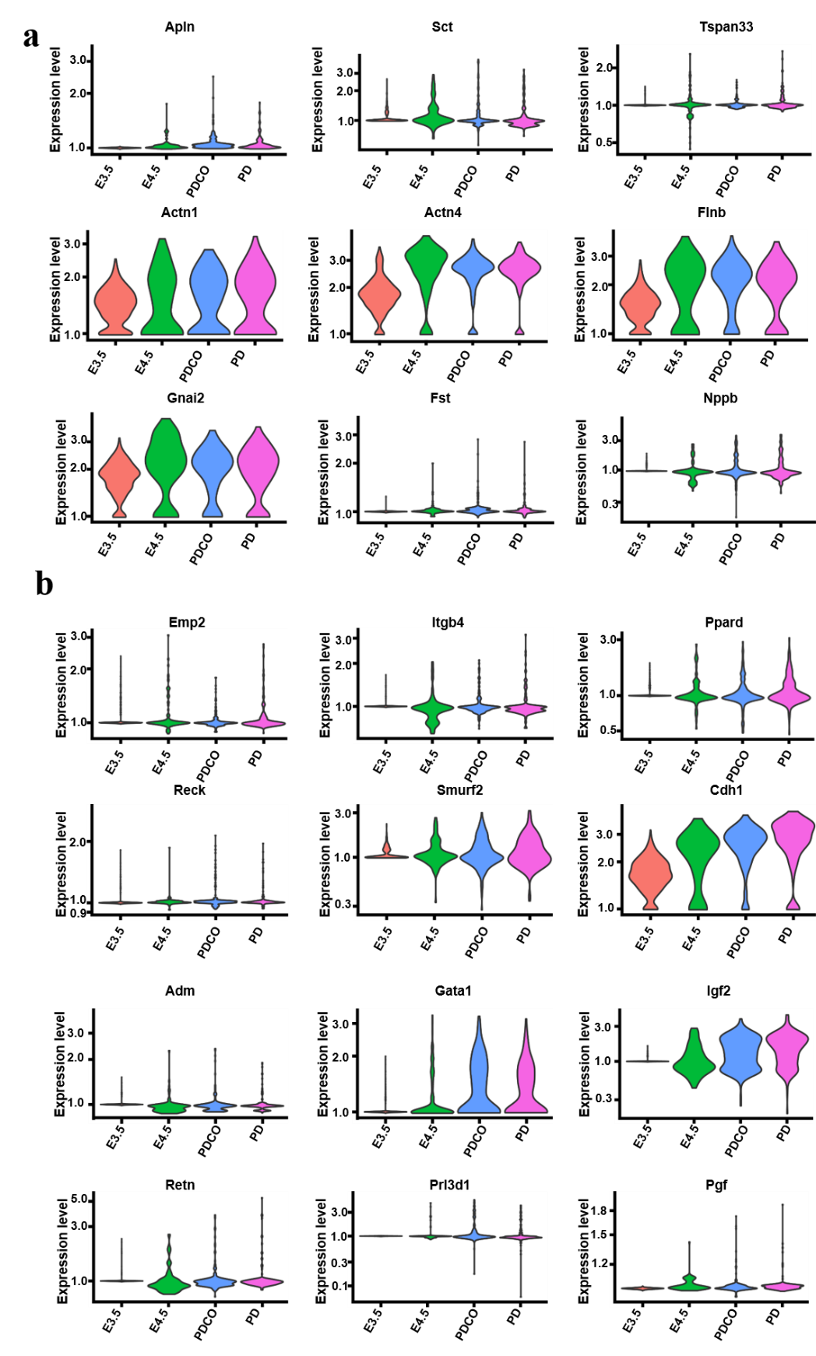
Supplementary Figure 9 Detection of embryo hormones and implantation genes in vitro and in vivo. RNA analysis markers for hormones (a) and implantation-related (b) of the embryos of 2 days of IVC on PD and PDCO and normal embryos of E3.5 and E4.5.
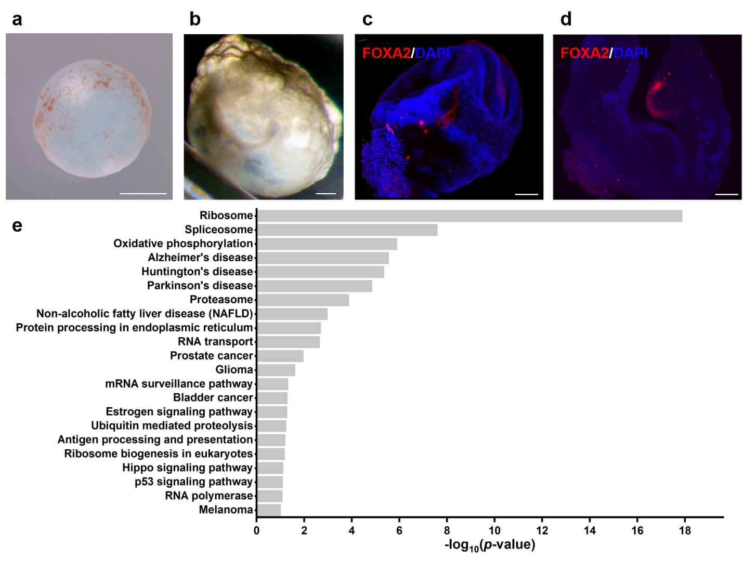
Supplementary Figure 10 Progressive development of embryos at post-gastrulation in uterus-like microenvironment. (a) Morphological observation of the yolk sacs of embryo culture on PDCO at day 8. Scale bars, 1 mm. (b) Video screenshot of embryo culture on PDCO for 10 days with early cardiac formation and pulsation. Scale bar, 200 μm. c, E8.5 embryos were stained late embryonic brain with antibody for FOXA2 (red). Scale bar, 200 μm. d, Mouse blastocysts were cultured on PDCO until day 8, and stained late embryonic brain with antibody for FOXA2 (red)).. Scale bar, 200 μm. (e) Compared to embryos cultured on the PDMS, KEGG of upregulated genes of embryos cultured on the PDCO for 10 days.
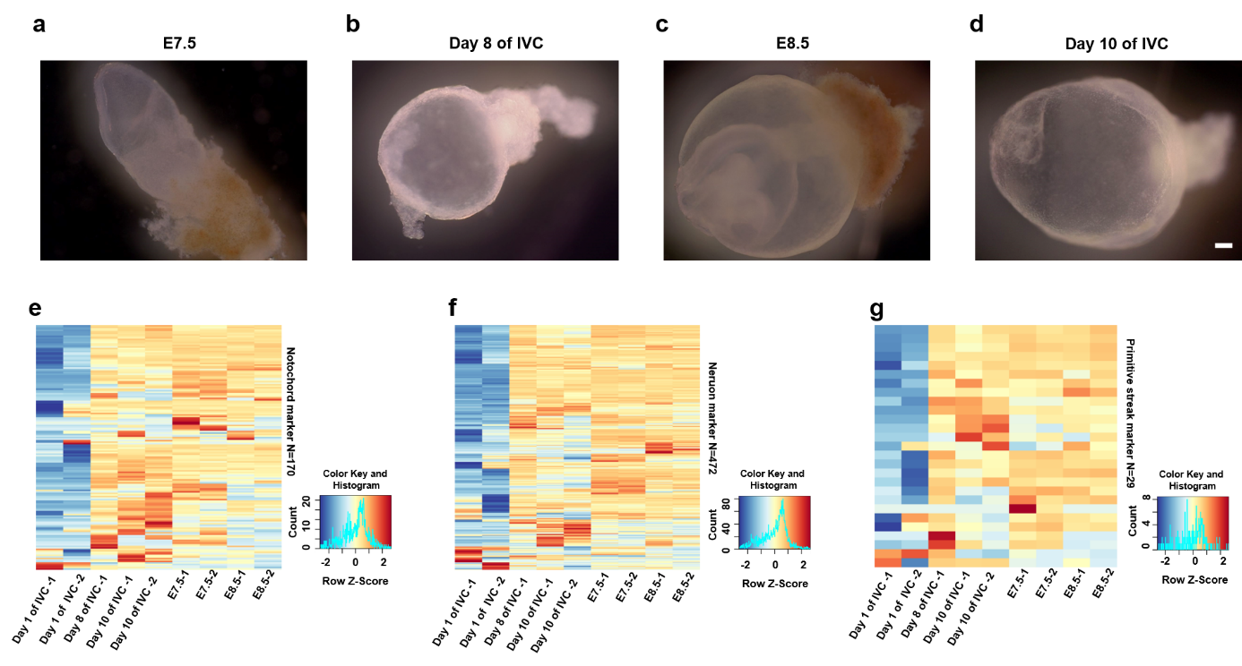
Supplementary Figure 11 Characterization of embryos cultured at post-implantation. (a-d) Bright images of embryos on day 8 and day 10 of IVC on PDCO and normal embryos of E7.5 and E8.5. Scale bars, 200 μm. (e-g) RNA sequencing of the embryos mentioned above and analysis for the markers of neural tissue, primitive strips, and chordae.
Supplementary Table 1
Compared to the embryos cultured on the PDMS, GO terms of upregulated genes in embryos on day 2 cultured on the PDCO.
Terms | Genes
oxidation-reduction process | ALDH18A1, NDUFB7, PYROXD1, CHCHD4, FTH1, NDUFB2, UQCR11, HIF1AN, HMOX1, PNPO, AKR7A5, CAT, ETFB, GPD2, NDUFA4, SEPW1, GDI2, PTGR1, NDUFB10, AIFM1, NDUFA7, NDUFC1, SOD1, TET1, NDUFA1, NDUFA12, NDUFA11, AKR1B8, ADI1, NDUFV3, TXNDC12, PYCR2, KDM2A, RRM2, JMJD1C
negative regulation of intrinsic apoptotic signaling pathway | G2E3, HDAC2, PARL, NDUFA13, HELLS, NOC2L
cell proliferation | MORF4L1, PTGES3, USPL1, MKI67, MAP2K1, NASP, HLCS, GRHL2, TACC2, LARP1, PURA, SRRT, DKC1, GNG2, H3F3B
ATP metabolic process | ATP5J2, ATP5O, ATP5G1, HSPA8, ATP5K, ATP5J
cellular response to retinoic acid | WNT7B, HDAC2, HTRA2, NDUFA13, SNRNP70, ABL2, PHC1
progesterone receptor signaling pathway | NEDD4, PHB, UBR5
cell migration | CORO1B, CCDC88A, S1PR1, GSK3A, EFNB2, LAMC1, ARPC5, CD63, MDK, PTEN, ABL2, LCP1
in utero embryonic development | FGFR2, MYO1E, TRIM28, GJB3, CDH1, PRKCSH, RBBP6, GRHL2, GPI1, YBX1, WNT7B, SALL4, KDM2A, ANKRD11, MEG3, SYF2
multicellular organism growth | FGFR2, GPD2, KDM2A, KMT2C, ANKRD11, MEG3, H3F3B, RBBP6, GRHL2
positive regulation of gene expression | FGFR2, PTGES3, HMGB2, MAP2K1, PHB, LEF1, CALR, HNRNPU, RPS3, DROSHA, WNT7B, ID2, KDM2A, UBR5, MDM2, HSPA4, TCF3, DNMT3B, HSPA8
embryonic organ development | FGFR2, WNT7B, SYF2, RBBP6, GRHL2
positive regulation of cell cycle | FGFR2, ID2, MDM2, CALR, TCF3
embryo implantation | GRN, FKBP4, TRIM28, CDH1, H3F3B, SOD1
epithelial cell morphogenesis | CDH1, JMJD1C, GRHL2, IFT88

Supplementary Table 2
Compared to embryos cultured on the PDMS, KEGG of upregulated genes in embryos on day 2 cultured on the PDCO
Terms | Genes
Ribosome | RPL17, RPL19, MRPS14, RPL14, RPL13, RPLP2, RPL37, RPL38, RPS3, RPS25, MRPL11, RPS27, RPS29, RPL8, RPL3, FAU, RPL10A, RPL7A, MRPL33, RPS27A, RPL26, RPS5, RPS18, MRPS18C, RPS19, RPL41, RPL18A, MRPL27, RPL13A, RPS14, RPL21, RPS15, RPS12, RPS11
Spliceosome | BCAS2, EFTUD2, PPIL1, LSM7, DDX39B, SNRPD2, SF3A1, HNRNPU, HNRNPM, PPIH, SRSF9, SYF2, DHX16, SLU7, ACIN1, SNRNP70, SNRNP27, THOC2, PRPF38B, HSPA8, DDX42
Oxidative phosphorylation | NDUFA4, ATP5J2, NDUFB10, NDUFB7, NDUFA7, COX7C, COX4I1, NDUFA13, ATP5G1, NDUFC1, NDUFA1, NDUFA12, NDUFB2, NDUFA11, NDUFV3, UQCR11, ATP5O, ATP5K, ATP5J
Alzheimer's disease | NDUFA4, NDUFB10, NDUFB7, NDUFA7, COX7C, COX4I1, NDUFA13, ATP5G1, NDUFC1, NDUFA1, NDUFA12, NDUFB2, CAPN1, NDUFA11, NDUFV3, UQCR11, BACE1, CALM3, ATP5O, CALM1, ATP5J
Huntington's disease | NDUFA4, POLR2F, NDUFB10, NDUFB7, POLR2J, NDUFA7, COX7C, COX4I1, NDUFA13, ATP5G1, NDUFC1, REST, SOD1, NDUFA1, NDUFA12, NDUFB2, NDUFA11, NDUFV3, UQCR11, HDAC2, ATP5O, ATP5J
Parkinson's disease | NDUFA4, NDUFB10, NDUFB7, NDUFA7, COX7C, COX4I1, NDUFA13, ATP5G1, NDUFC1, NDUFA1, NDUFA12, NDUFB2, NDUFA11, NDUFV3, UQCR11, HTRA2, ATP5O, ATP5J
Proteasome | PSMB6, PSME1, PSME2, PSMA4, PSMB3, PSMC1, PSMB2, POMP, PSME4
Non-alcoholic fatty liver disease (NAFLD) | NDUFA4, NDUFB10, NDUFB7, NDUFA7, COX7C, COX4I1, NDUFA13, NDUFC1, NDUFA1, NDUFA12, NDUFB2, NDUFA11, NDUFV3, UQCR11, GSK3A
Protein processing in endoplasmic reticulum | HSP90AB1, GANAB, PDIA3, RRBP1, UBE4B, PDIA4, CALR, PRKCSH, SSR1, RBX1, CAPN1, HSP90B1, ATF6B, DNAJA1, HSPA8
RNA transport | EEF1A1, XPO1, EIF2S3Y, DDX39B, EIF5B, RANGAP1, EIF4G1, EIF3A, EIF4EBP1, UPF3B, RAE1, EIF1, PABPC1, ACIN1, THOC2
Prostate cancer | HSP90AB1, FGFR2, CCNE2, HSP90B1, MAP2K1, PDGFA, MDM2, LEF1, PTEN
Glioma | MAP2K1, PDGFA, CALM3, MDM2, CDK4, PTEN, CALM1
mRNA surveillance pathway | PPP1CA, UPF3B, GSPT1, DDX39B, PABPC1, ACIN1, PPP2R2D, CPSF1
Bladder cancer | MAP2K1, RASSF1, MDM2, CDH1, CDK4
Estrogen signaling pathway | HSP90AB1, HSP90B1, MAP2K1, FKBP4, ATF6B, CALM3, HSPA8, CALM1
Ubiquitin mediated proteolysis | NEDD4, UBE3A, UBE2K, UBR5, UBE4B, UBE2M, MDM2, SAE1, UBE3C, RBX1
Antigen processing and presentation | HSP90AB1, PSME1, PDIA3, PSME2, HSPA4, CALR, HSPA8
Ribosome biogenesis in eukaryotes | DROSHA, NOL6, XPO1, DKC1, NOP58, GNL3L, NOP56
Hippo signaling pathway | AJUBA, ACTB, WNT7B, PPP1CA, FRMD6, ID2, RASSF1, LEF1, CDH1, PPP2R2D
p53 signaling pathway | CCNE2, RRM2, MDM2, CDK4, PERP, PTEN
RNA polymerase | POLR2F, POLR3K, POLR2J, POLR3D
Melanoma | MAP2K1, PDGFA, MDM2, CDH1, CDK4, PTEN

Supplementary movie legends
Supplementary movie 1
The embryo was viewed using confocal microscope and 3D-reconstruction of Imaris 9.0.2 software.
Three embryos from three independent experiments displayed similar results, penetration of the E3.5 embryo cultured on PDCO for one day through the collagen fibers. a, c, d CDX2, red (trophoblast), and Collagen I, green (material), DAPI, blue (nucleus), b, CDX2, cyan (trophoblast), Collagen I, yellow (material), Phalloidin, red (cytoskeleton), DAPI, blue (nucleus). Scale bars, 100 μm.
Supplementary movie 2
The embryo was viewed using confocal microscope and 3D-reconstruction of Imaris 9.0.2 software.
Three embryos from three independent experiments displayed similar results. The video of the E3.5 embryos cultured on the PD for one day. OCT4, green (epiblast), CDX2, red (trophoblast), and DAPI, blue (nucleus). Scale bar, 100 μm.
Supplementary movie 3
Original heart was developed on Day 8 of in vitro culture, and began to beat more than 2 days.
Supplementary references
1. Jenkinson, E. J. & Wilson, I. B. In vitro support system for the study of blastocyst differentiation in the mouse. Nature 228, 776-778 (1970).
2. Wu, T. C., Wan, Y. J. & Damjanov, I. Positioning of inner cell mass determines the development of mouse blastocysts in vitro. J. Embryol. Exp. Morphol. 65, 105-117 (1981).
3. Carson, D. D., Tang, J. P. & Gay, S. Collagens support embryo attachment and outgrowth in vitro: effects of the Arg-Gly-Asp sequence. Dev. Biol. 127, 368-375 (1988).
4. Hsu, Y. C. Differentiation in vitro of mouse embryos to the stage of early somite. Dev. Biol. 33, 403-411 (1973).
5. Morris, S. A. et al. Dynamics of anterior-posterior axis formation in the developing mouse embryo. Nat. Commun. 3, 673 (2012).
6. Bedzhov, I., Leung, C. Y., Bialecka, M. & Zernicka-Goetz, M. In vitro culture of mouse blastocysts beyond the implantation stages. Nat. Protoc. 9, 2732-2739 (2014).
7. Huang, G. Y. et al. Functional and Biomimetic Materials for Engineering of the Three-Dimensional Cell Microenvironment. Chem. Rev. 117, 12764-12850 (2017).
8. Xiang, L. et al. A developmental landscape of 3D-cultured human pre-gastrulation embryos. Nature 577, 537-542 (2019).
9. Kolahi, K. S. et al. Effect of Substrate Stiffness on Early Mouse Embryo Development. PLoS One 7, e41717 (2012).
10. Engler, A. J., Sen, S., Sweeney, H. L. & Discher, D. E. Matrix elasticity directs stem cell lineage specification. Cell 126, 677-689 (2006).
11. Saha, K. et al. Substrate Modulus Directs Neural Stem Cell Behavior. Biophys. J. 95, 4426-4438 (2008).
12. Meehan, S. & Nain, A. S. Role of Suspended Fiber Structural Stiffness and Curvature on Single-Cell Migration, Nucleus Shape, and Focal-Adhesion-Cluster Length. Biophys. J. 107, 2604-2611 (2014).
13. Sheets, K., Wunsch, S., Ng, C. & Nain, A. S. Shape-dependent cell migration and focal adhesion organization on suspended and aligned nanofiber scaffolds. Acta Biomater. 9, 7169-7177 (2013).
14. Winograd-Katz, S. E., Fassler, R., Geiger, B. & Legate, K. R. The integrin adhesome: from genes and proteins to human disease. Nat. Rev. Mol. Cell Biol. 15, 273-288 (2014).
15. Aragona, M. et al. A Mechanical Checkpoint Controls Multicellular Growth through YAP/TAZ Regulation by Actin-Processing Factors. Cell 154, 1047-1059 (2013).
16. Guimarães, C. F., Gasperini, L., Marques, A. P. & Reis, R. L. The stiffness of living tissues and its implications for tissue engineering. Nat. Rev. Mater. 5, 351-370 (2020).
17. Yamada, K. M. & Sixt, M. Mechanisms of 3D cell migration. Nat. Rev. Mol. Cell Biol. 20, 738-752 (2019).
18. Chronopoulos, A. et al. Syndecan-4 tunes cell mechanics by activating the kindlin-integrin-RhoA pathway. Nat. Mater. 19, 669-678 (2020).
19. Romani, P. et al. Extracellular matrix mechanical cues regulate lipid metabolism through Lipin-1 and SREBP. Nature Cell Biology 21, 338-347 (2019).
20. Rafiq, N. B. M. et al. A mechano-signalling network linking microtubules, myosin IIA filaments and integrin-based adhesions. Nat. Mater. 18, 638-649 (2019).
21. Zheng, Y. et al. Controlled modelling of human epiblast and amnion development using stem cells. Nature 573, 421-425 (2019).
22. Zhang, S. et al. Implantation initiation of self-assembled embryo-like structures generated using three types of mouse blastocyst-derived stem cells. Nat. Commun. 10, 496 (2019).
23. Manfrin, A. et al. Engineered signaling centers for the spatially controlled patterning of human pluripotent stem cells. Nat. Methods 16, 640-648 (2019).
24. Li, R. et al. Generation of Blastocyst-like Structures from Mouse Embryonic and Adult Cell Cultures. Cell 179, 687-702 (2019).
25. Xiang, L. et al. A developmental landscape of 3D-cultured human pre-gastrulation embryos. Nature 577, 537-542 (2020).
26. Bedzhov, I., Leung, C. Y., Bialecka, M. & Zernicka-Goetz, M. In vitro culture of mouse blastocysts beyond the implantation stages. Nat. Protoc. 9, 2732-2739 (2014).
27. Rossant, J. & Tam, P. P. L. New Insights into Early Human Development: Lessons for Stem Cell Derivation and Differentiation. Cell Stem Cell 20, 18-28 (2017).
28. Morris, S. A. Human embryos cultured in vitro to 14 days. Open Biol. 7, 170003 (2017).
29. Rossant, J. Human embryology: Implantation barrier overcome. Nature 533, 182-183 (2016).
30. Reardon, S. Human embryos grown in lab for longer than ever before. Nature 533, 15-16 (2016).
31. Piccolo, S., Dupont, S. & Cordenonsi, M. The Biology of Yap/Taz: Hippo Signaling and Beyond. Physiol. Rev. 94, 1287-1312 (2014).
32. Dupont, S. Role of YAP/TAZ in cell-matrix adhesion-mediated signalling and mechanotransduction. Exp. Cell Res. 343, 42-53 (2016).
33. Peng, G. et al. Molecular architecture of lineage allocation and tissue organization in early mouse embryo. Nature 572, 528-532 (2019).
34. Kono, K., Tamashiro, D. A. A. & Alarcon, V. B. Inhibition of RHO-ROCK signaling enhances ICM and suppresses TE characteristics through activation of Hippo signaling in the mouse blastocyst. Dev. Biol. 394, 142-155 (2014).
35. Perez-Gonzalez, N. A. et al. YAP and TAZ regulate cell volume. J. Cell Biol. 218, 3472-3488 (2019).
36. Logsdon, D. M. et al. Egg cylinder development during in vitro extended embryo culture predicts the post transfer developmental potential of mouse blastocysts. J. Assist. Reprod. Genet. 37, 747-752 (2020).

