Additional file 2: Flow Charts for Inclusion and Exclusion of Literature

Flow chart for guidelines
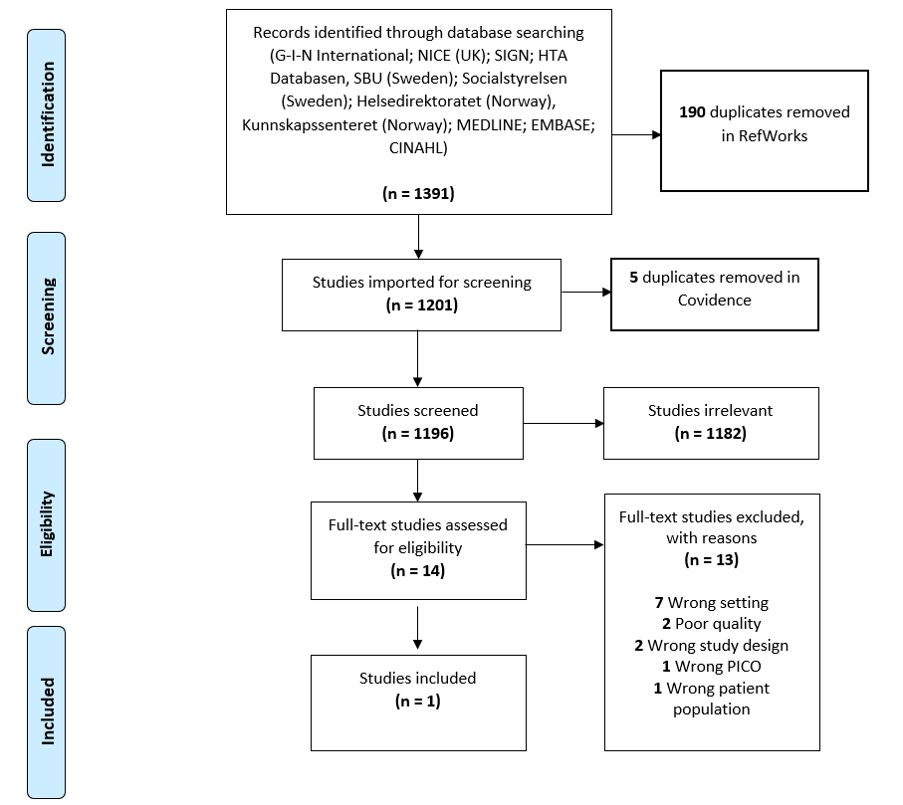

Flow chart for reviews
