Supporting Information

Practical quinone-based organic supercapacitor > 6 V

Yuto Katsuyama,^{1,2} Takayuki Takehi,^{2,3} Shu Sokabe,⁴ Mai Tanaka,⁵ Mizuki Ishizawa,⁵ Hiroya Abe,² Masaru Watanabe,⁴ Itaru Honma⁶ and Yuta Nakayasu*^{2,4}
1Department of chemistry and Biochemistry, University of California Los Angeles, Los Angeles, 90095, USA
2Frontier Research Institute for Interdisciplinary Sciences (FRIS), Tohoku University, Sendai, 980-8578, Japan
3Division of General Education, National Institute of Technology Nagaoka College, Niigata, 640-8532, Japan
4Research Center of Supercritical Fluid Technology, Tohoku University, Sendai, 980-8579, Japan
5School of Engineering, Tohoku University, Sendai, 980-8579, Japan
6Institute of Multidisciplinary Research for Advanced Materials (IMRAM), Tohoku University, Sendai, 980-8577, Japan
*nakayasu@tohoku.ac.jp

S1. SUS vs. Au
Figure S1 (a) shows the charge and discharge curves of the DCAQ electrodes when Au and SUS316 were used as the current collectors. The charge and discharge curves at different C rates (1 and 0.5 C) are shown in Fig. S1 (b). A discussion is provided in the main manuscript.
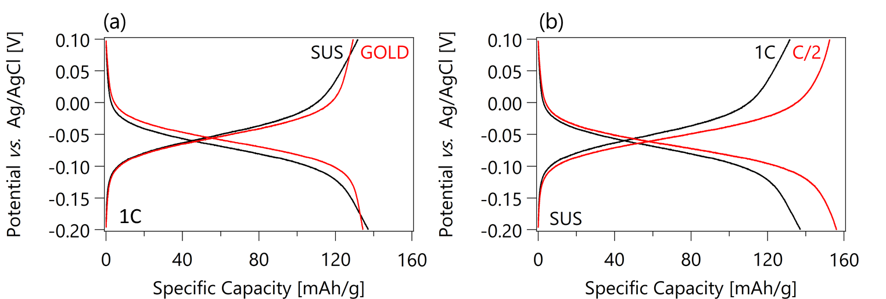
Figure S1. (a) Charge and discharge curves of DCAQ electrodes when Au and SUS316 are used as current collectors at a 1 C rate. (b) Charge and discharge curves of DCAQ electrodes when SUS316 mesh is used as current collector at different C rates (1 and 0.5 C)

S2. Calculation of redox capacity
The capacity obtained by redox reactions of quinones is calculated as follows:
1. Draw a linear trend line in the voltage region that is completely dominated by the formation/destruction of the electric double layers (EDL).
2. The intersection of the trend line and termination voltage must be the capacity obtained by the EDL (20.4 mAh g^{–1}).
3. By subtracting the EDL capacity from the total capacity, the redox capacity can be calculated (181.3 – 20.4 = 160.9 mAh g^{–1}).
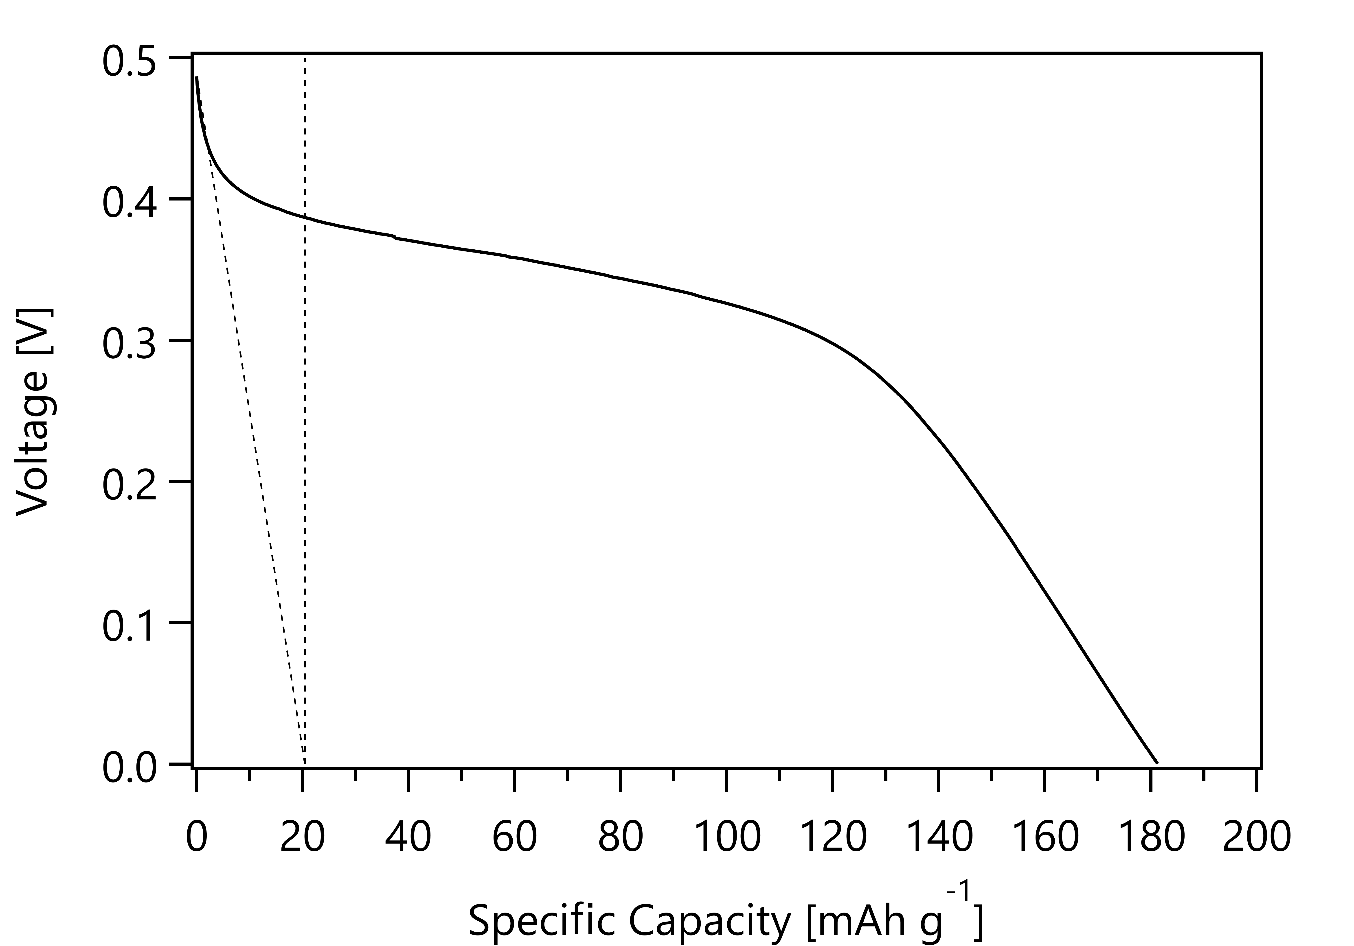
Figure S2. Discharge curve of a chloranil electrode with a thickness of 0.5 mm at a 1 C rate.

S3. Rate performance of thick electrodes
Figure S3 is another expression of Figure 2 (d), representing the capacity retention rates of single cells with different electrode thicknesses at high C rates based on the capacities at a 1 C rate. As the electrode became thicker, the capacity decreased faster at higher C rates.
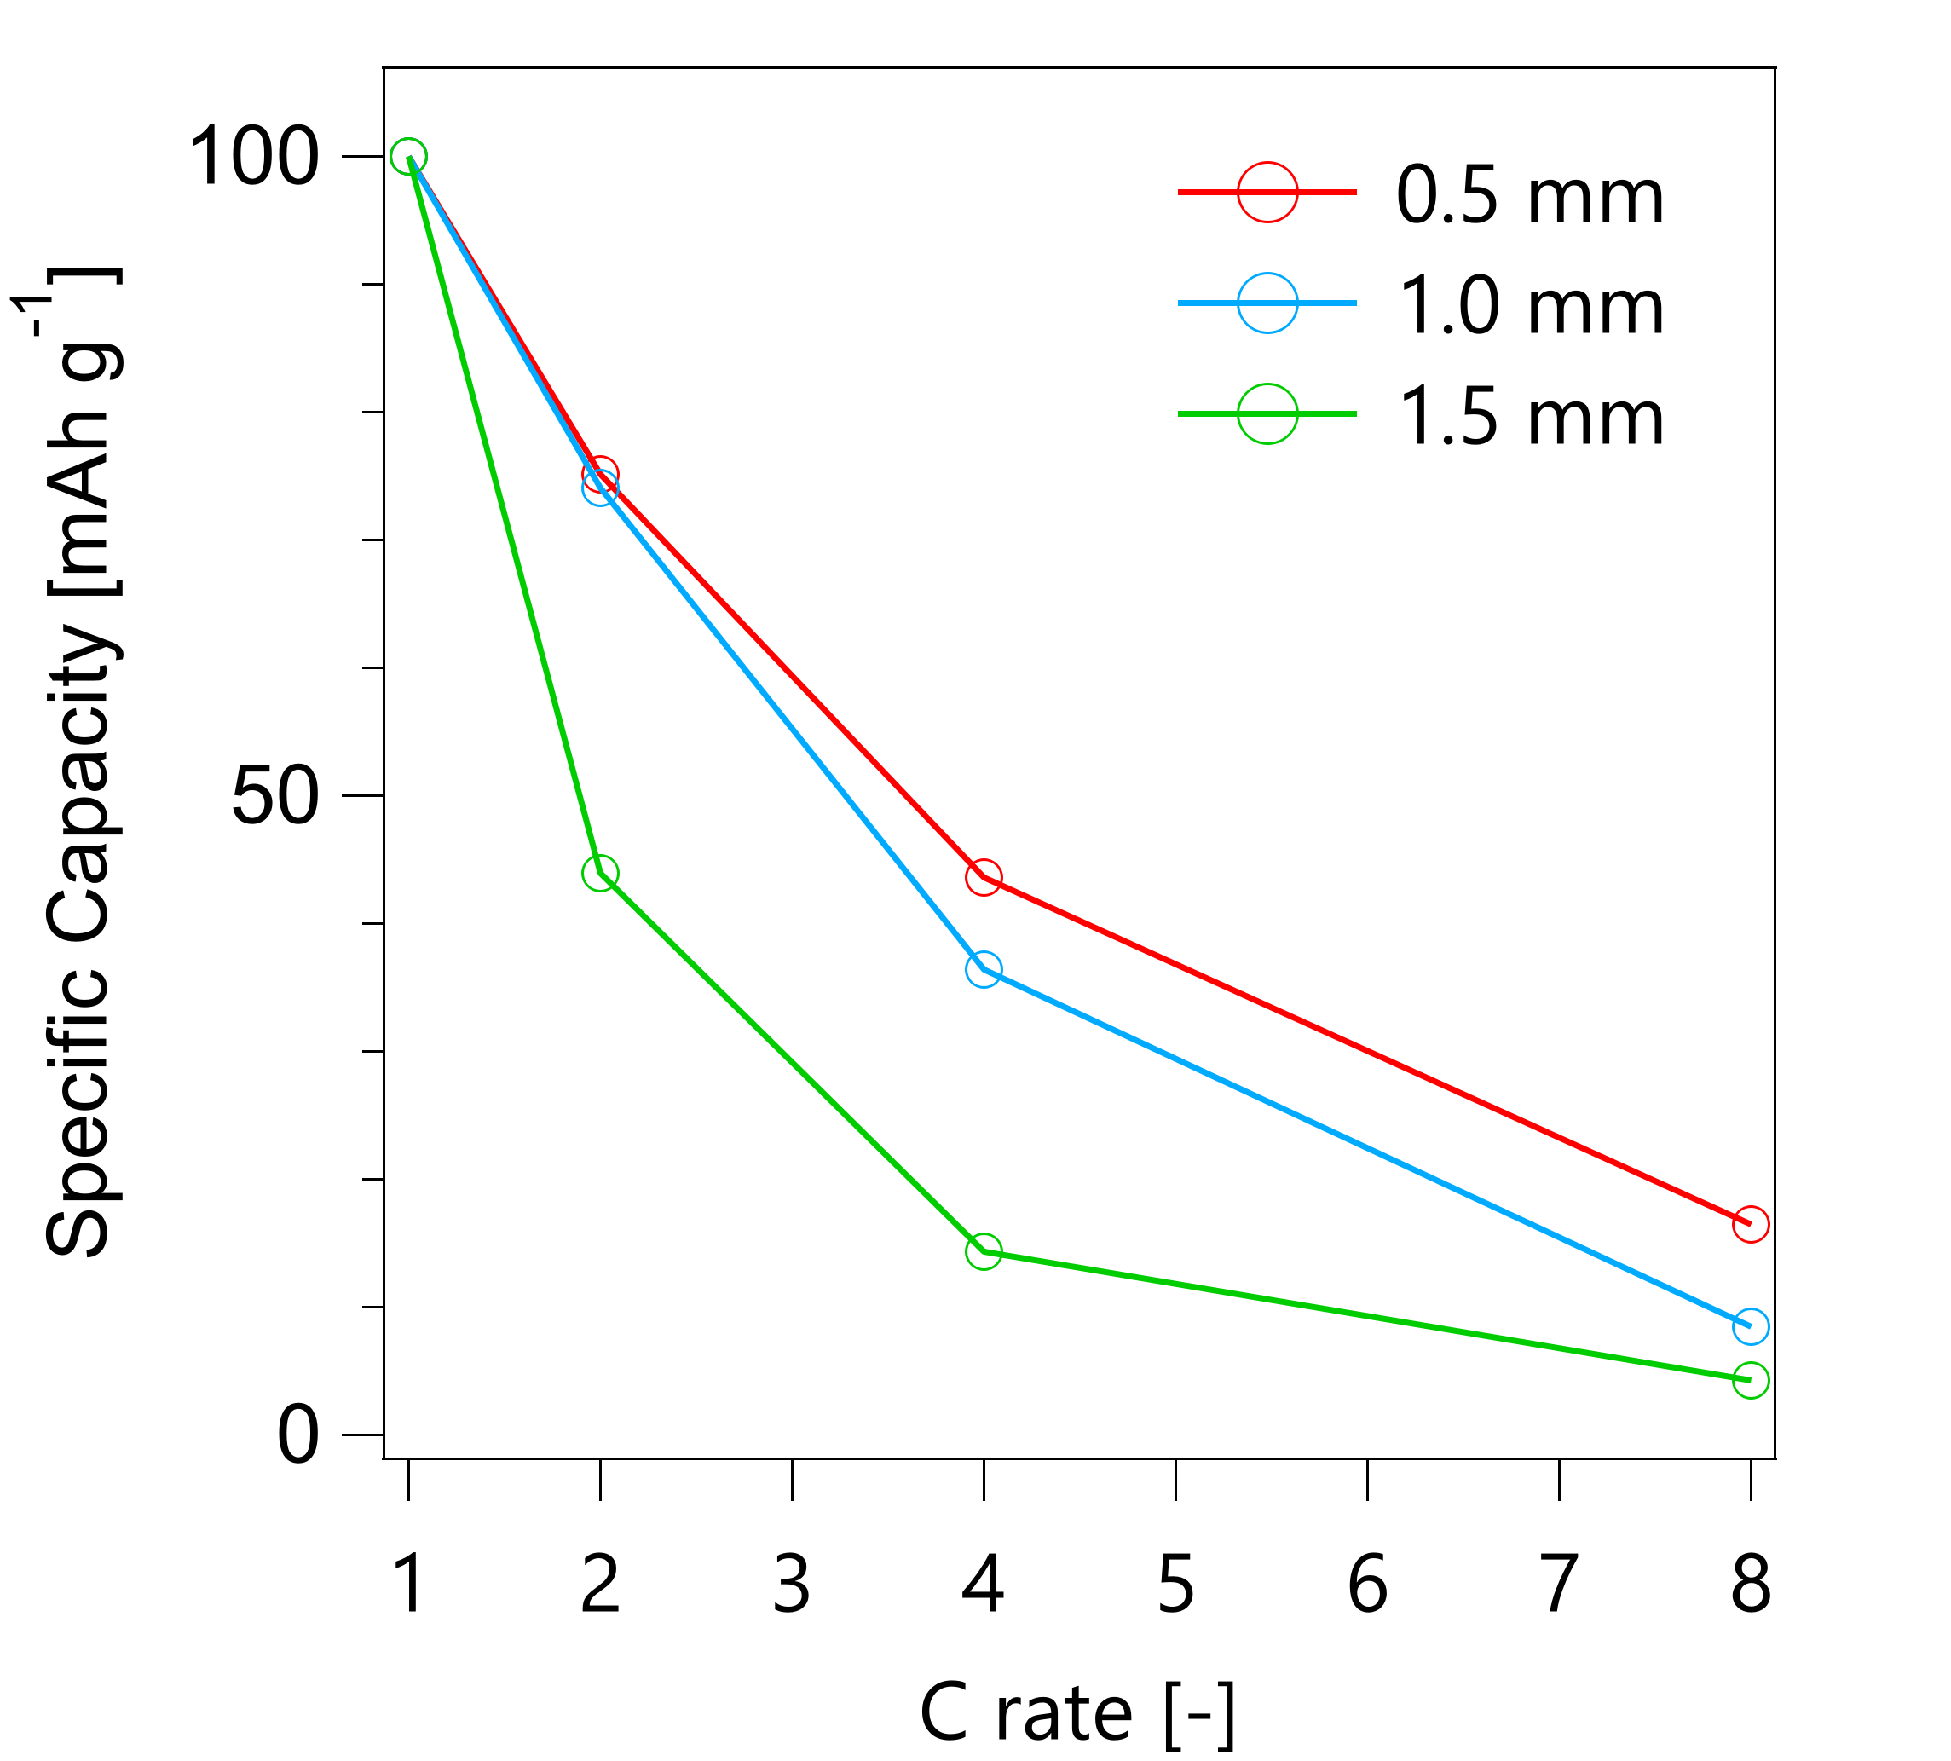
Figure S3. Capacity retention rates of single cells with different electrode thicknesses (0.5, 1.0, and 1.5 mm) at high C rates based on the capacities at a 1 C rate.

S4. pH dependency
From the standpoint of safety, it is better to use a neutral electrolyte than an acidic electrolyte when the device is practically used. Cyclic voltammetry curves of the chloranil and DCAQ electrodes in H₂SO₄ aqueous electrolyte at various pH values (0, 3, and 4) are shown in Figure S4. Both the chloranil and DCAQ electrodes exhibit sharp redox peaks only at pH=0, suggesting that the supercapacitor works well only under strongly acidic conditions.
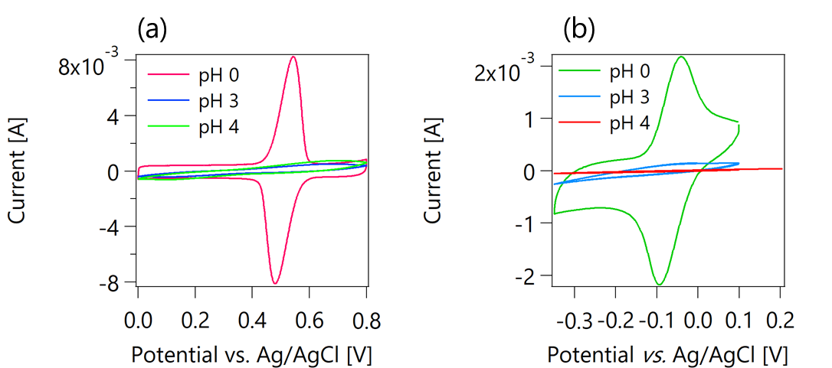
Figure S4. Cyclic voltammetry curves of (a) chloranil and (b) DCAQ electrodes in H₂SO₄ aqueous electrolytes with various pH values (0, 3, and 4).

