Supplementary Table 1: Ground samples used from multiple site networks in the North American boreal domain. All sample locations were combined into one large dataset for model training and validation.
Sites | Location | Number of samples
Canadian permanent sample plots | Canada | 26,831
Northwest Territories chronosequence data | Northwest Territories, Canada | 263
Canada National Forest Inventory | Canada | 195
Cooperative Alaska Forest Inventory | Alaska, USA | 142
Bonanza Creek LTER | Alaska, USA | 63
Total |  | 27,494

Supplementary Table 2: Image composites for early spring, mid-summer, and fall seasons used to identify key differences in deciduous and evergreen green-up amplitudes. Nominal 1992 Landsat data did not have complete coverage for Alaska.
Year range | Julian dates | Season | Data | Region
1987 – 1997  (nominal 1992) | 55 - 165 | Spring | Landsat 5 | Canada
 | 180 - 240 | Summer
 | 255 - 330 | Fall
1998 – 2002  (nominal 2000) | 55 - 165 | Spring | Landsat 5 & 7 | Canada, Alaska
 | 180 - 240 | Summer
 | 255 - 330 | Fall
2003 – 2007  (nominal 2005) | 55 - 165 | Spring | Landsat 5 & 7 | Canada, Alaska
 | 180 - 240 | Summer
 | 255 - 330 | Fall
2008 – 2012  (nominal 2010) | 55 - 165 | Spring | Landsat 5 & 7 | Canada, Alaska
 | 180 - 240 | Summer
 | 255 - 330 | Fall
2013 – 2018  (nominal 2015) | 55 - 165 | Spring | Landsat 7 & 8 | Canada, Alaska
 | 180 - 240 | Summer
 | 255 - 330 | Fall

Supplementary Table 3: Random Forest model parameters for deciduous fraction and tree canopy cover used in multi-dimensional grid search for optimal parameters. The RMSE values of deciduous fraction and tree cover models are for output values in the range of 0 – 1 and 0 – 100, respectively.
Parameter | Deciduous fraction |  |  |  |  |  | Tree canopy cover
 | Western Boreal |  | Eastern Boreal
 | 3-season  model | 1-season  model | 3-season  model | 1-season  model |  | 3-season  model |  | 1-season  model
N estimators | 800 | 800 | 1200 | 1200 |  | 2000 |  | 1200
Max features | 4 | 2 | 4 | 2 |  | 12 |  | 8
Min sample split | 2 | 2 | 2 | 2 |  | 4 |  | 12
Min sample leaf | 1 | 1 | 1 | 1 |  | 2 |  | 4
Max depth | None | None | None | None |  | 24 |  | 16
R-squared | 0.71 | 0.56 | 0.54 | 0.48 |  | 0.61 |  | 0.52
RMSE | 0.19 | 0.09 | 0.21 | 0.24 |  | 21 |  | 23

Supplementary Table 4: Random Forest model parameters for spring, summer and fall blue-sky albedo models using deciduous fraction and tree canopy cover as inputs.
Parameter | Albedo
 | Spring | Summer | Fall
N estimators | 2000 | 1800 | 1800
Max features | 2 | 2 | 2
Min sample split | 6 | 4 | 4
Min sample leaf | 1 | 1 | 1
Max depth | None | None | None

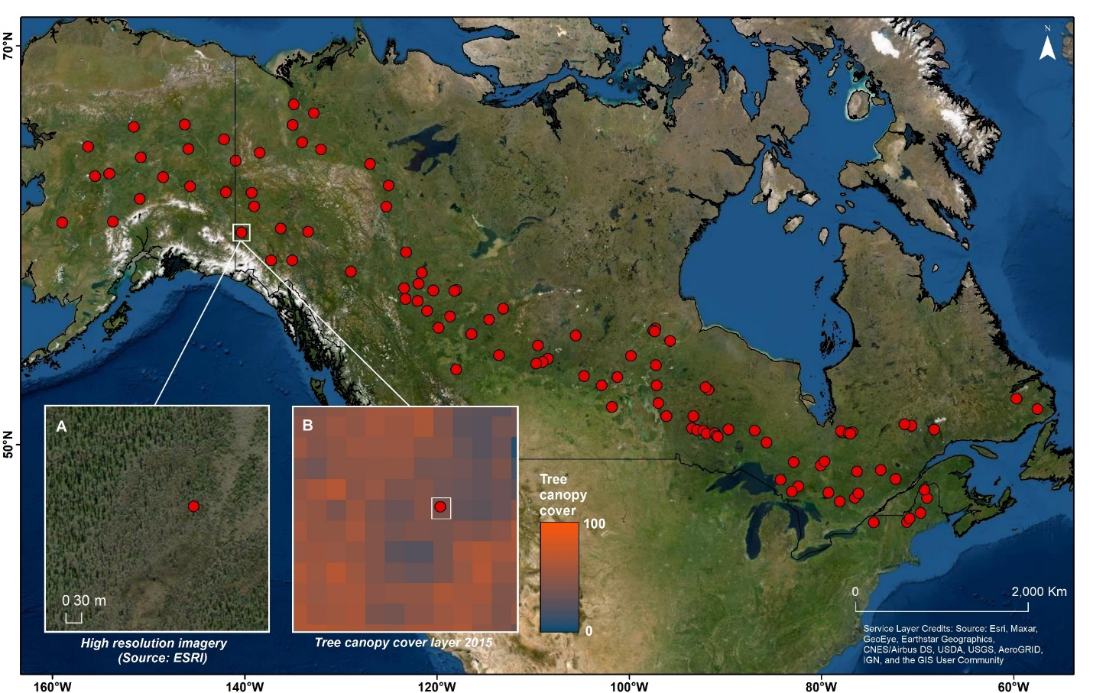Supplementary Figure 1: Visual assessment locations (n = 110) between high-resolution imagery (A) and tree canopy cover (B) for the same nominal year across the boreal domain to determine per pixel tree cover threshold of 25%. The pixel marked in panel (B) has a tree canopy cover value of 25.

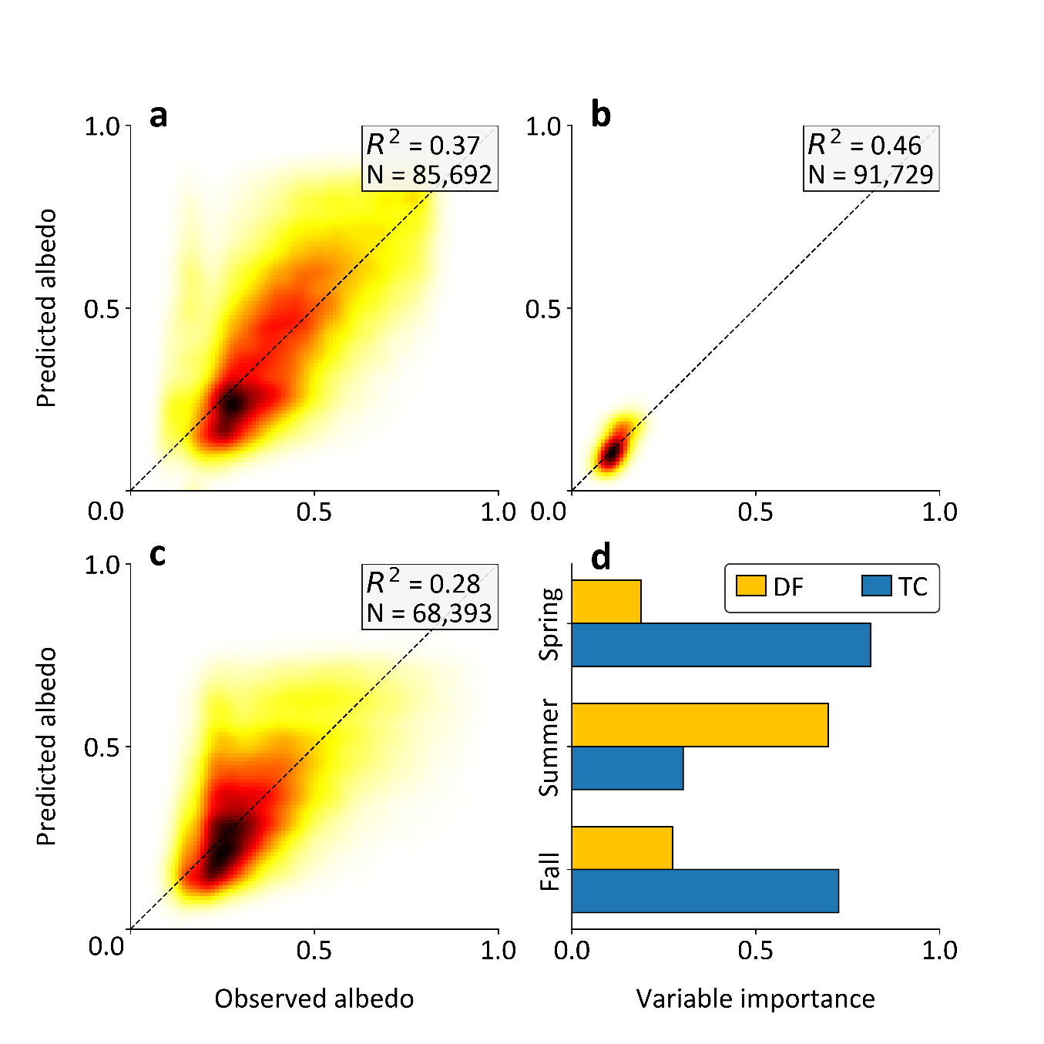Supplementary Figure 2: Performance of (a) spring, (b) summer, and (c) fall random forest models and (d) variable importance plot for surface albedo using deciduous fraction (DF) and tree cover (TC) as input layers. Evualtion performed using cross-validation.

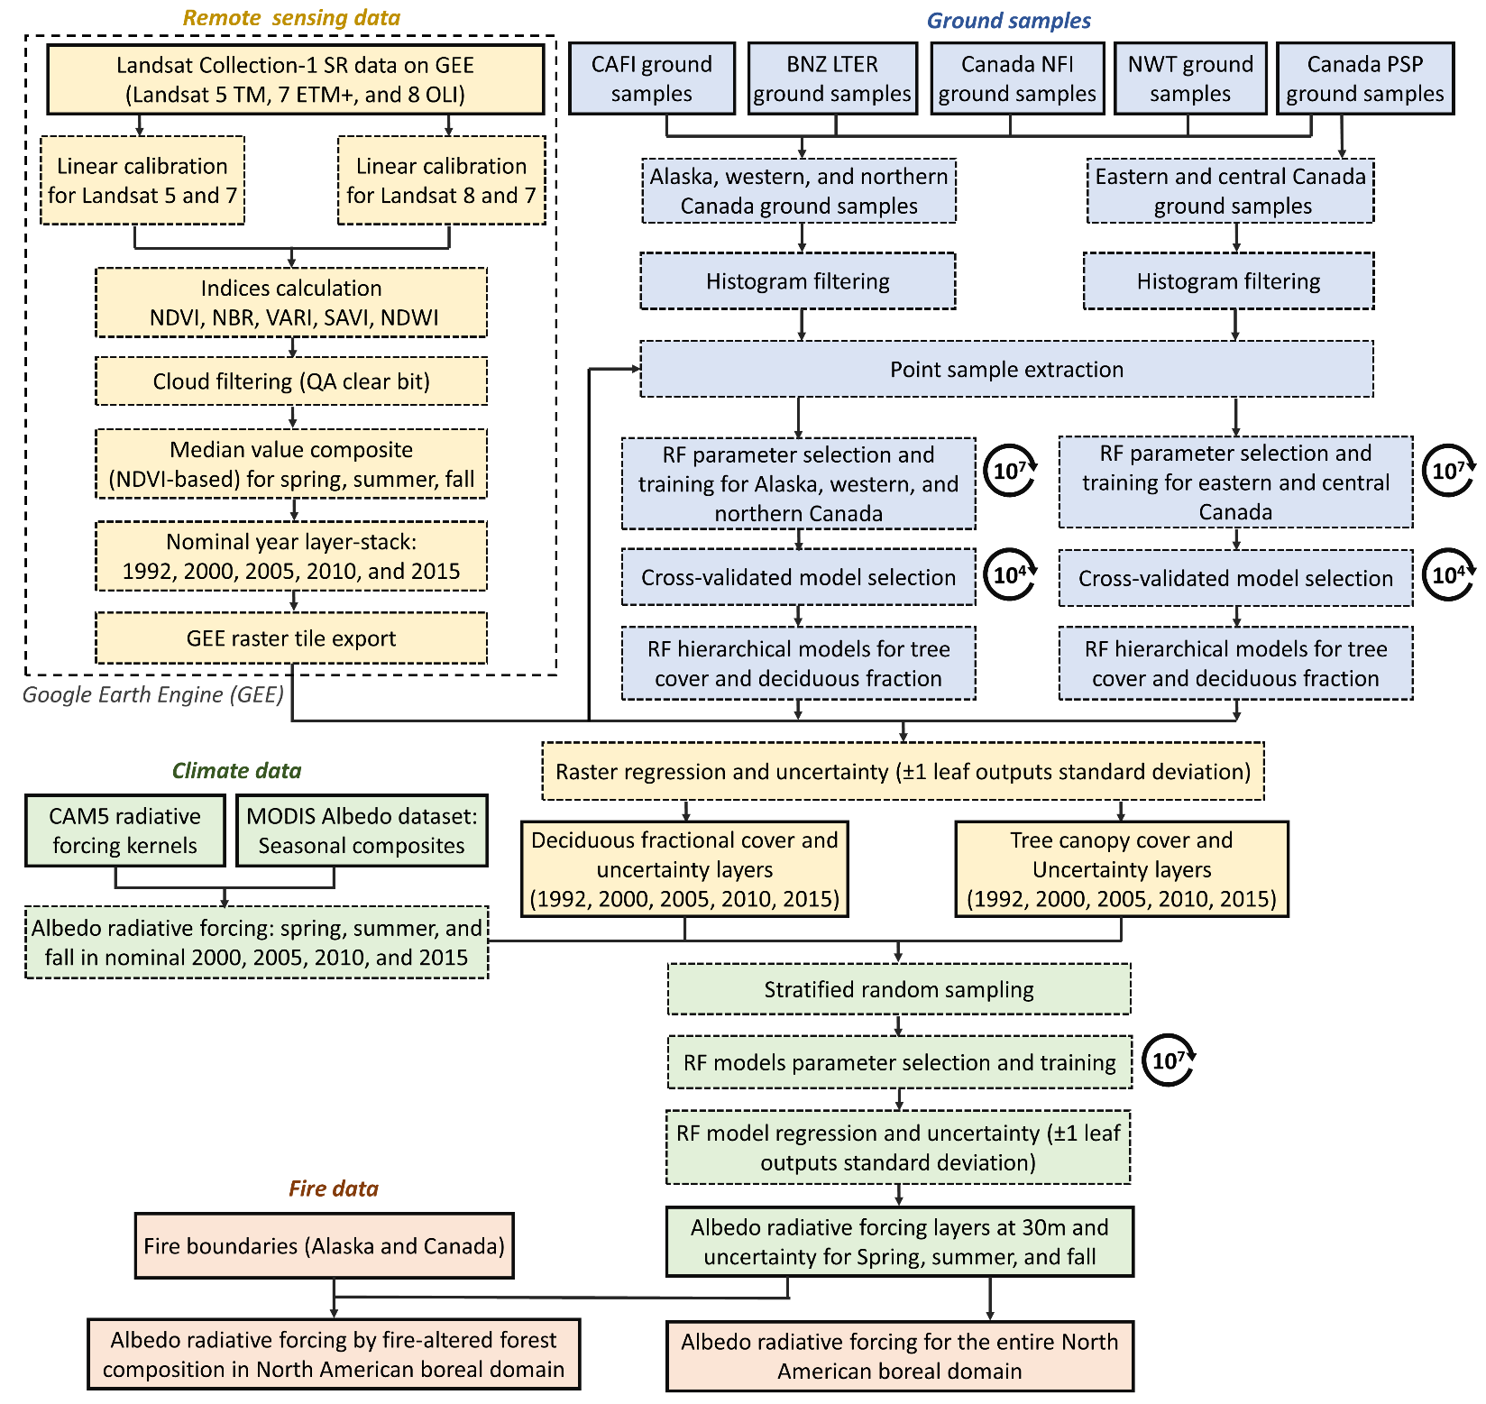
Supplementary Figure 3: Overall workflow for preparing deciduous fraction layers, tree canopy cover layers, and surface albedo layers for nominal years 1992, 2000, 2005, 2010, and 2015 across boreal North America. Here sold line blocks indicate input or output layers. Dashed line blocks are intermediate layers.

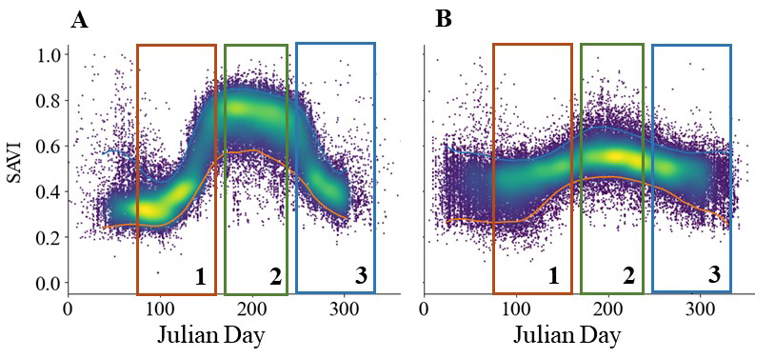Supplementary Figure 4: Seasonal soil adjusted vegetation index (SAVI) for (A) deciduous and (B) evergreen field samples sites for nominal years 1992, 2000, 2005, 2010, and 2015. Sample categories were defined here using deciduous fraction thresholds of greater than 0.75 for deciduous and less than 0.25 for evergreen. Windows shows spring (1), summer (2), and fall (3).

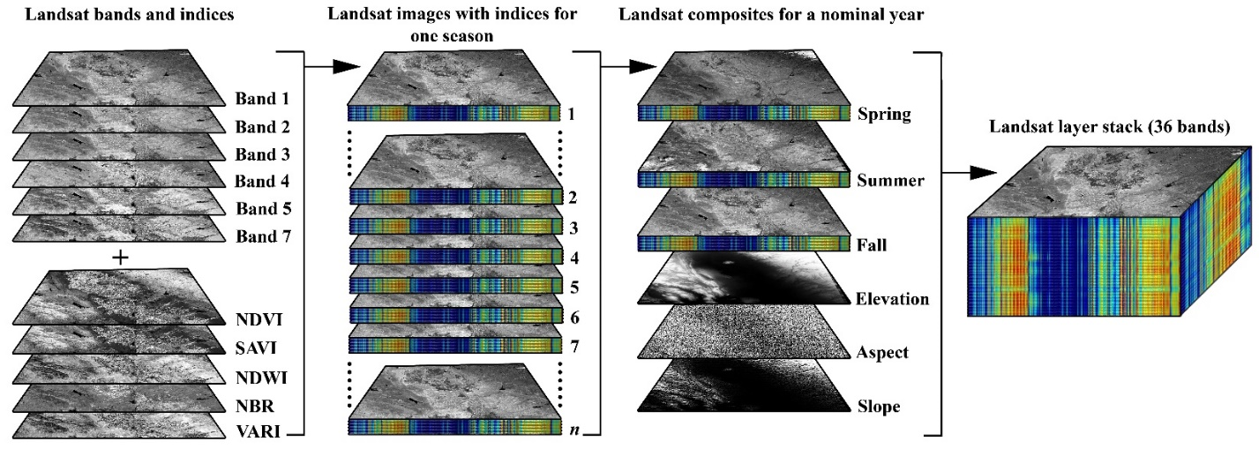Supplementary Figure 5: Landsat image stack used for modeling. Landsat image composites prepared using visible and NIR bands, as well as derived indices for spring, summer, and fall. Topographical layers were also added to the seasonal composites to produce a 36-band layer-stack.

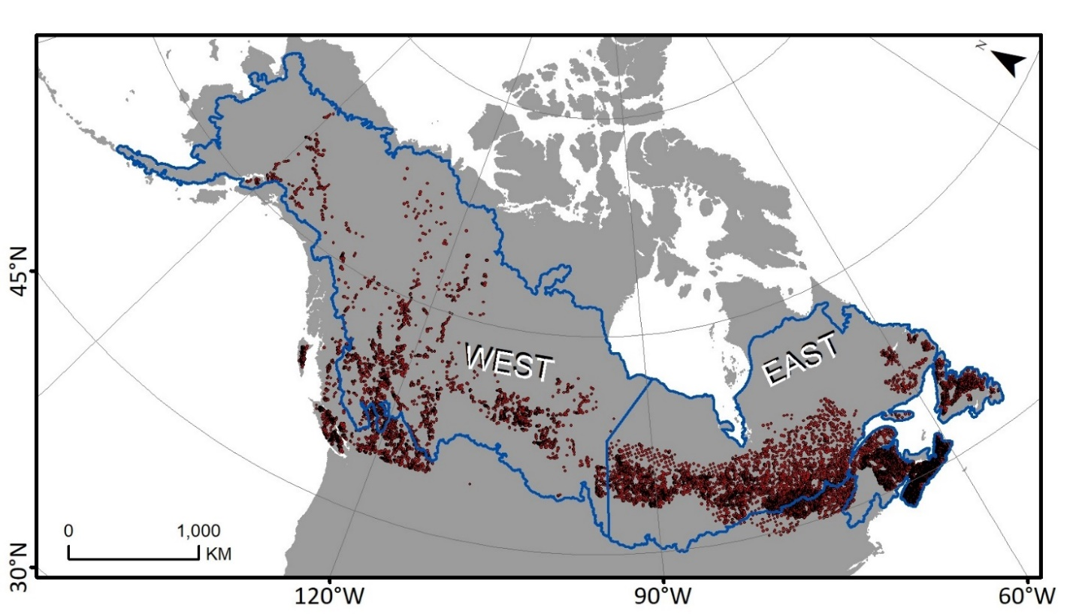
Supplementary Figure 6: Ground samples used in deciduous fraction analysis divided into east and west regions.

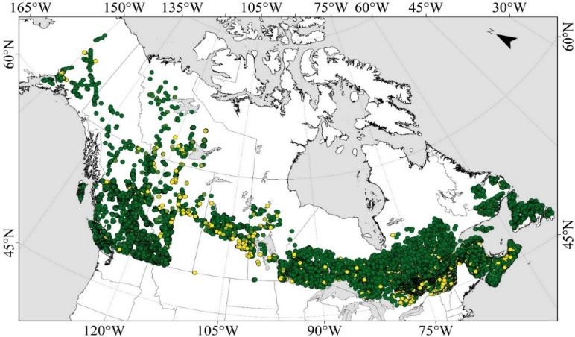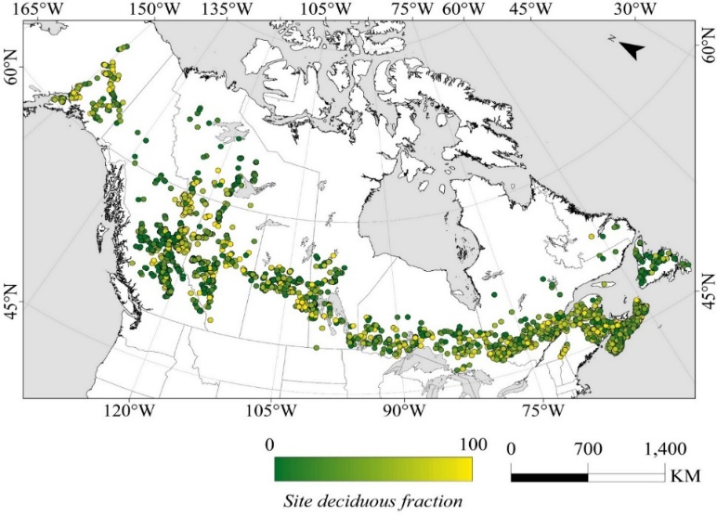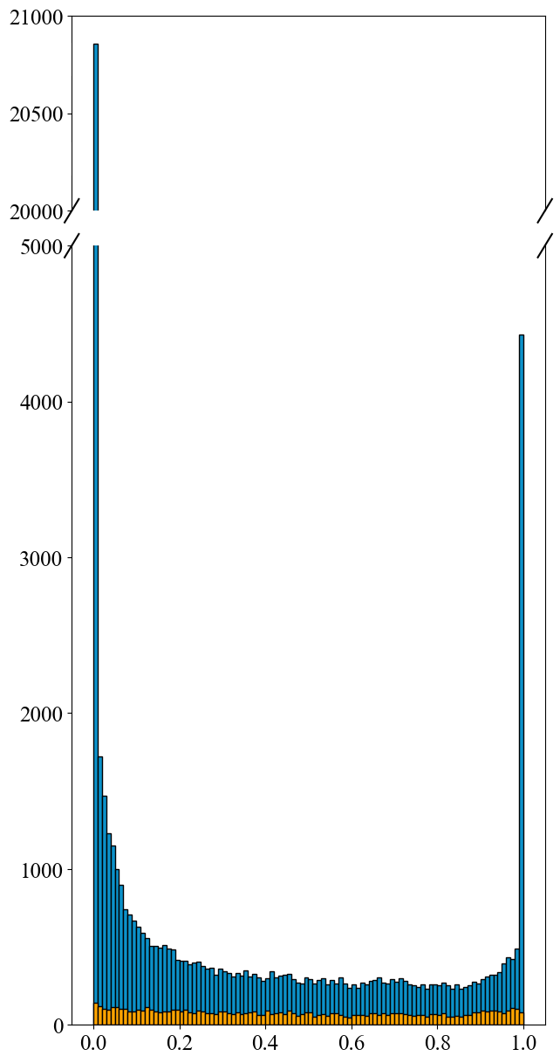Supplementary Figure 7: Resampling of ground samples by (A) binned under-sampling to create a near uniform distribution of deciduous fraction and reduction of sample size from (B) to C.
A
C
B
Selected samples
Deciduous fraction
Sample count
Available samples
500
-
250
-

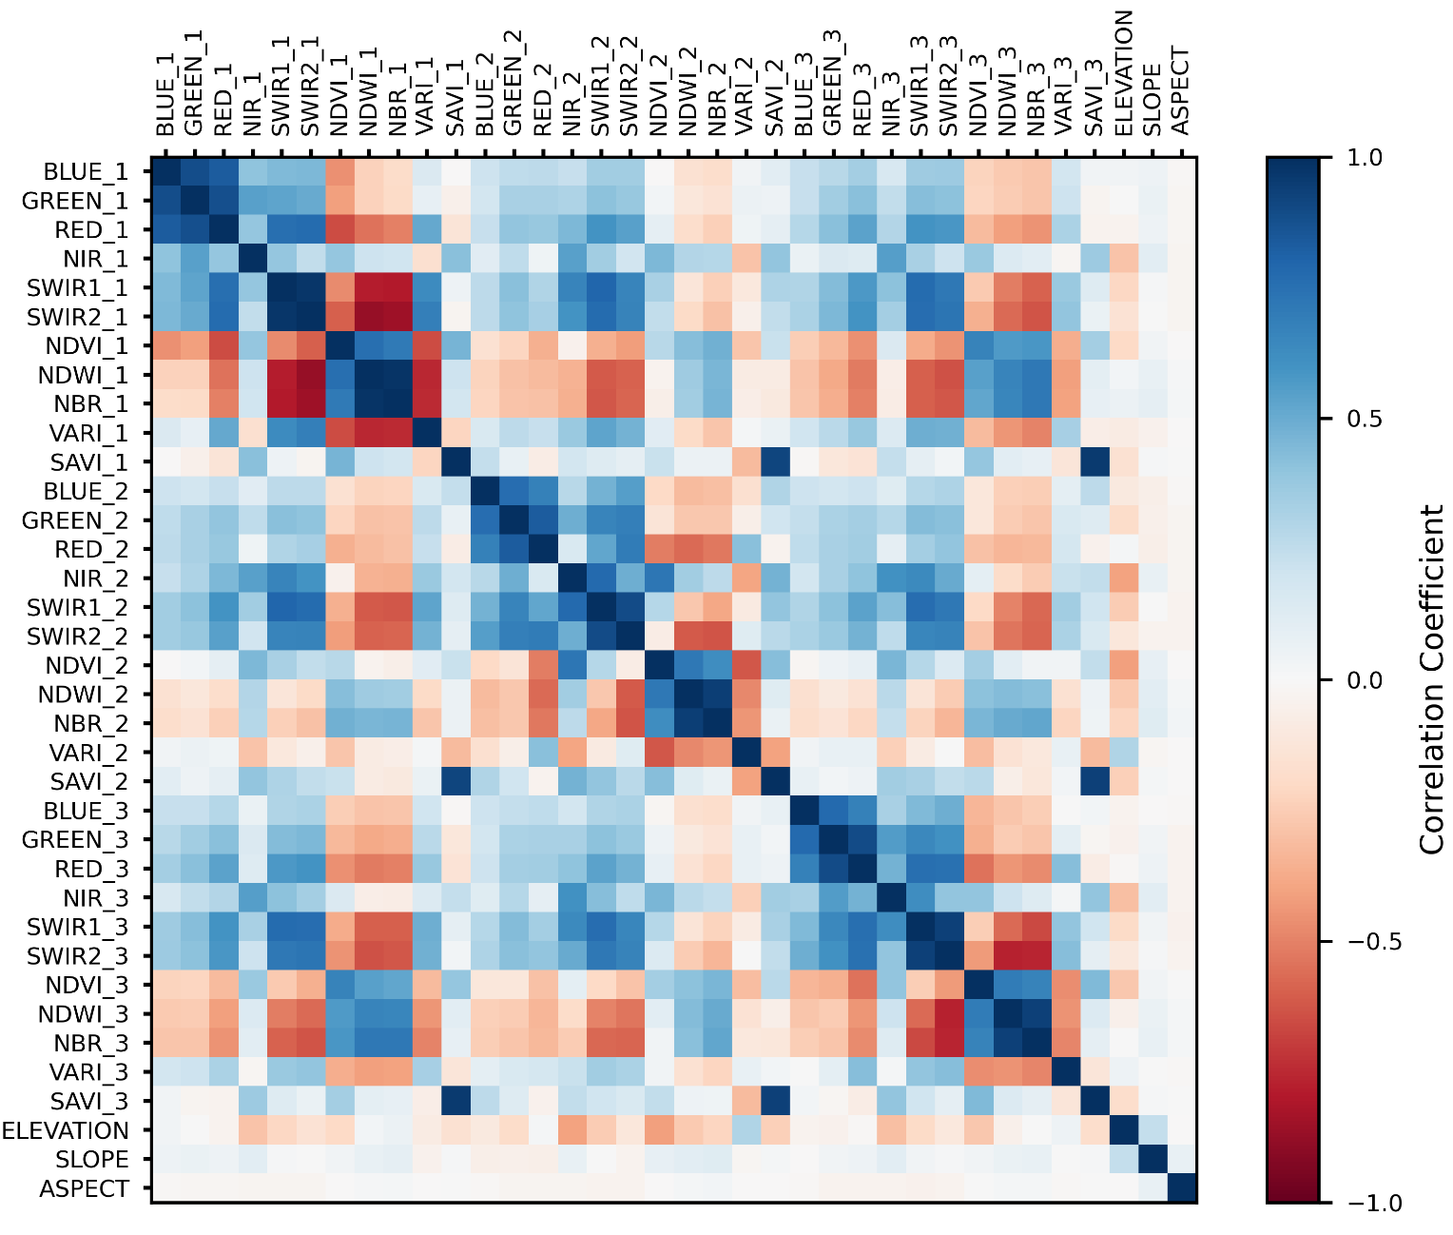
Supplementary Figure 8: Correlation matrix between all Landsat bands and spectral indices derived using all the extracted samples across nominal years 1992, 2000, 2005, 2010, and 2015. Seasons include spring (1), summer (2), and fall (3).

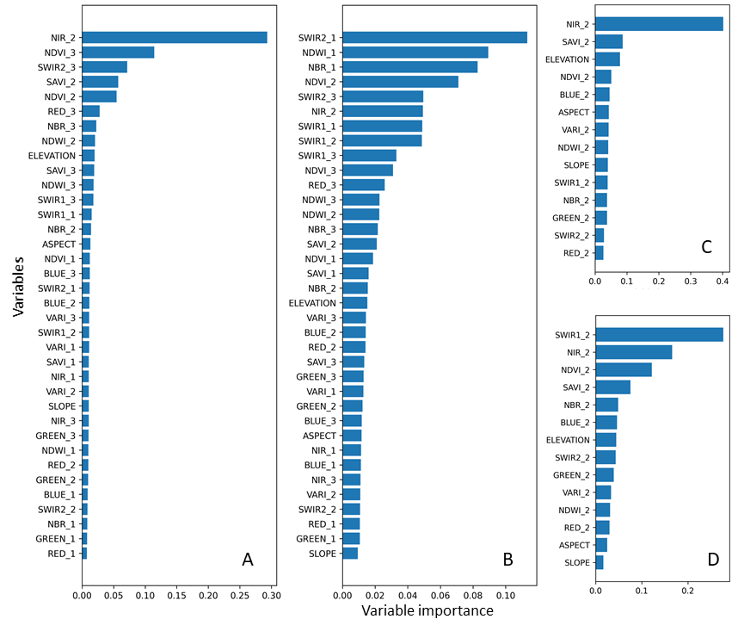
Supplementary Figure 9: Deciduous fraction variable importance plots. (A) 3-season model for western zone, (B) 3-season model for eastern zone, (C) 1-season model for western zone, and (D) 1-season model for eastern zone.

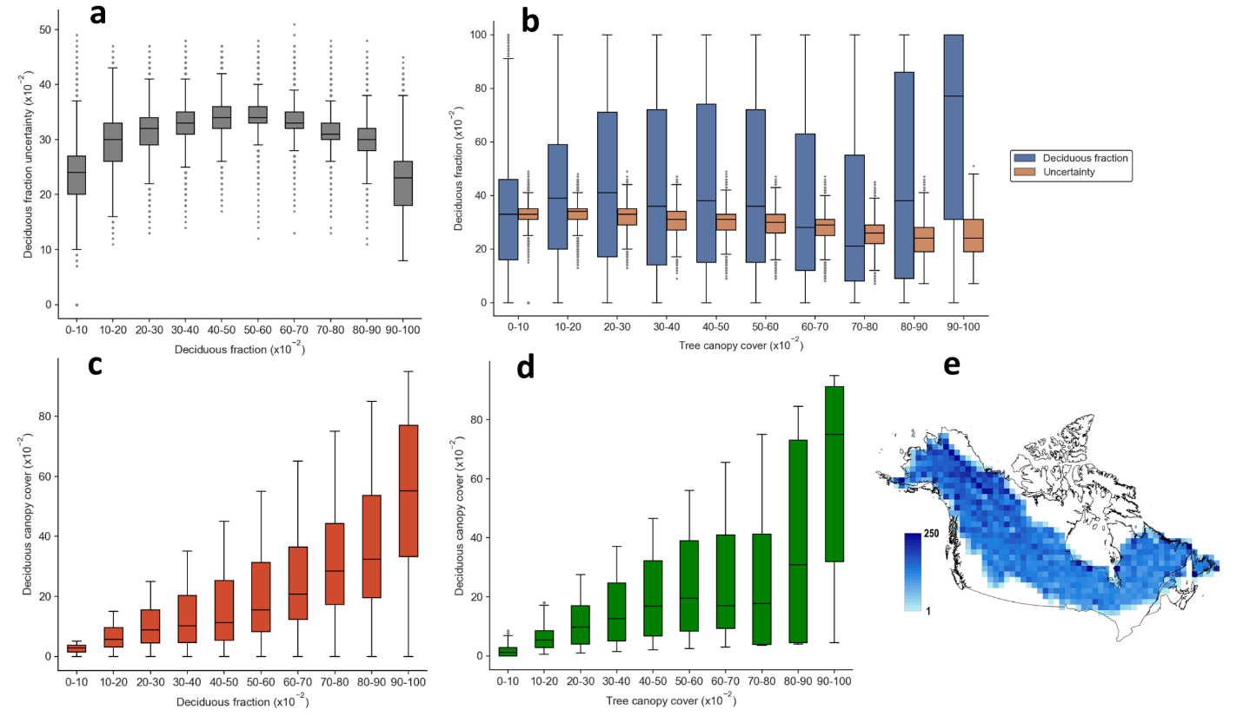Supplementary Figure 10: (a) Relationships between per-pixel deciduous fraction and its uncertainty, (b) per-pixel tree canopy cover and deciduous fraction, (c) deciduous canopy cover and deciduous fraction, and (d) deciduous canopy cover and tree canopy cover using randomly distributed samples (e) across boreal North America. The scale in (e) shows number of randomly distributed samples per 1° x 1° grid cell.

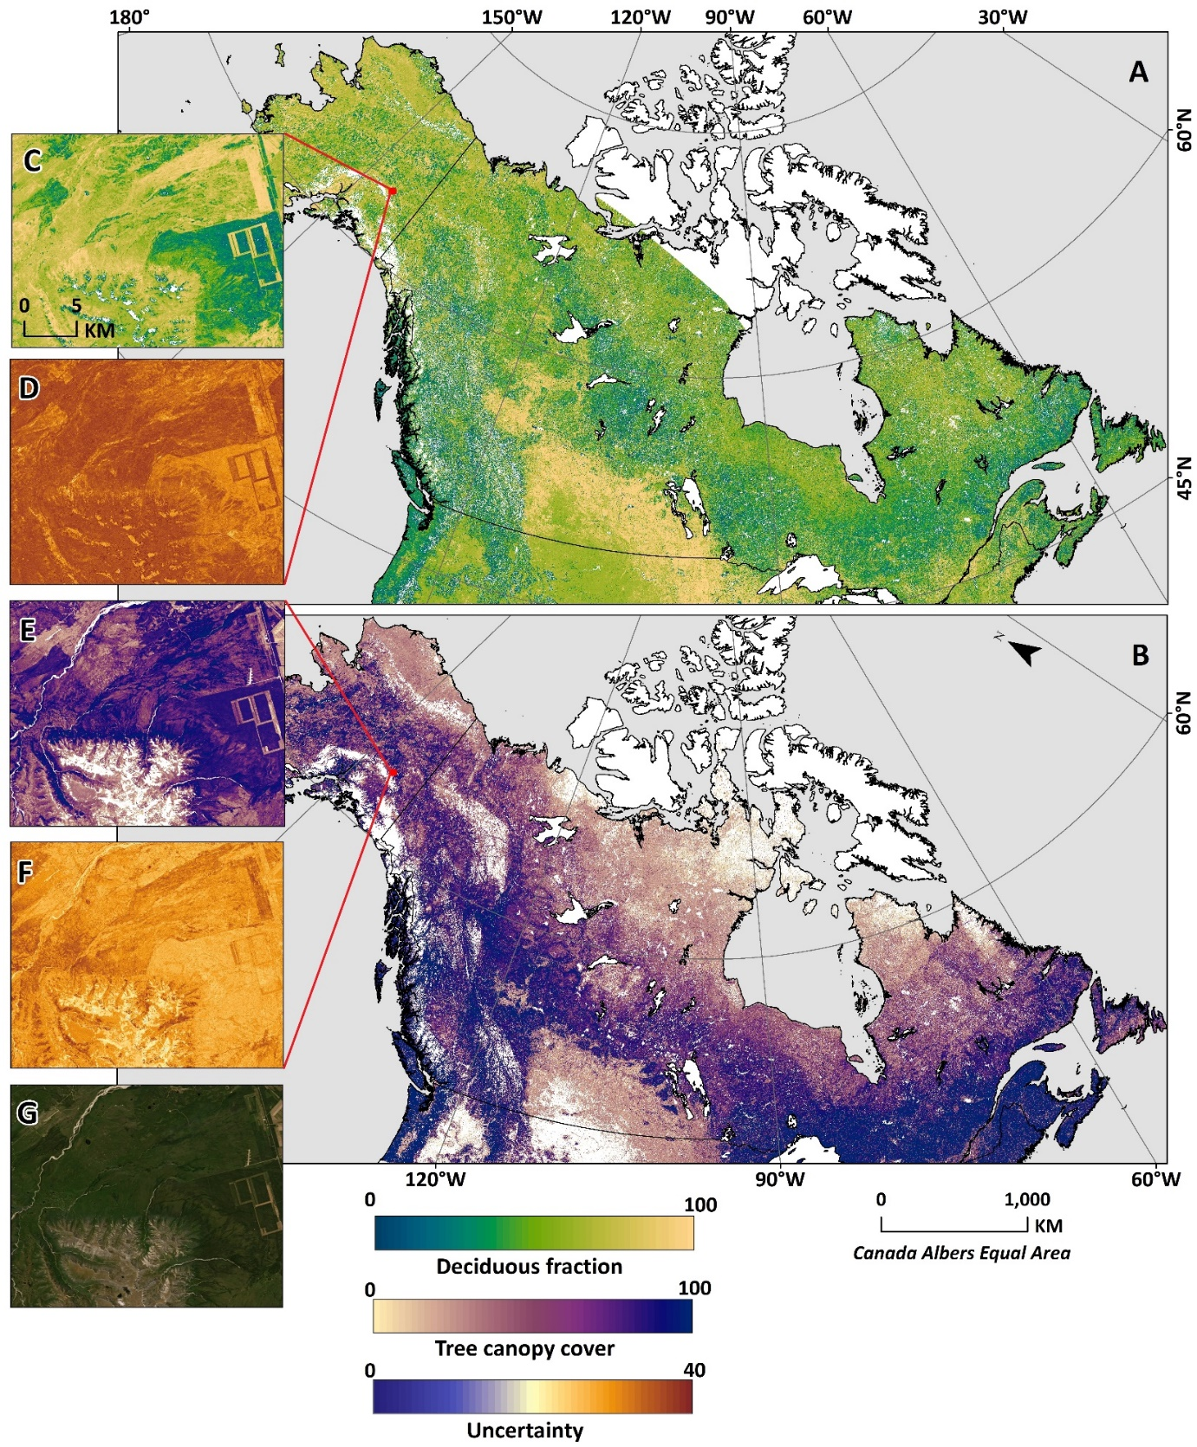
Supplementary Figure 11: (A) Deciduous fraction and (B) tree canopy cover layer in 2015 for boreal North America. (D) The uncertainty map for deciduous fraction shows the absolute value of per-pixel uncertainty in deciduous fraction. Similarly, (E) tree canopy cover and (F) it’s uncertainty. (G) High resolution imagery from Google Earth Engine is provided as reference.

