Supplementary Tables and Figures

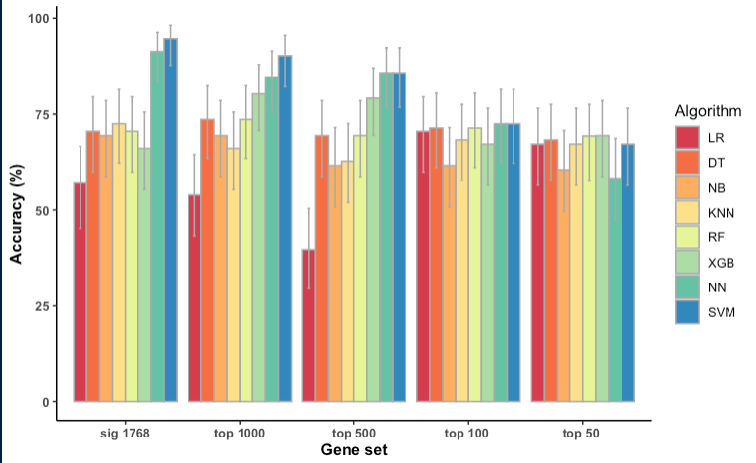
Figure S1. Classification accuracies of the eight machine learning algorithms trained using the full Cox PH set of 1,768 genes and the top 1000, 500, 100 and 50 genes with the lowest p values from this set. Logistic regression (LR); Decision trees (DT); Naïve bayes (NB); K nearest neighbours (KNN) ; Random forest (RF); XGBoost (XGB); Neural Networks (NN); Support Vector Machine (SVM)

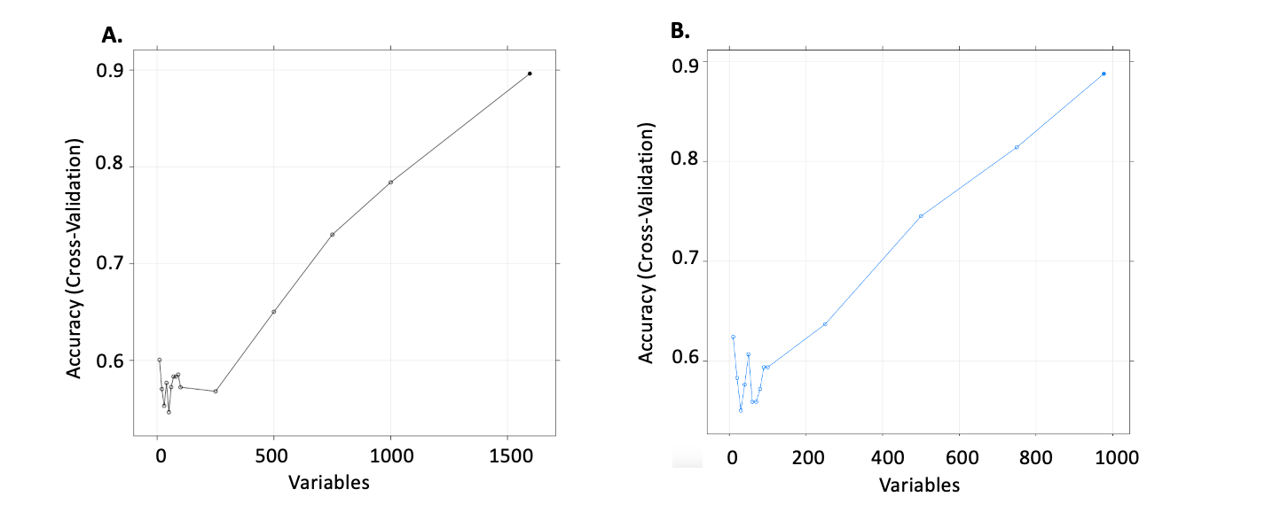
Figure S2. Classification accuracies when subsets of the A) Wilcoxon set of 1,596 genes and B) the Wilcoxon-Cox set of 977 gene sets selected using recursive feature elimination were used to train a Support Vector Machine algorithm.
On the x axis is the number of genes in the subset used for training. On the y axis is the corresponding accuracy of the Support Vector Machine model

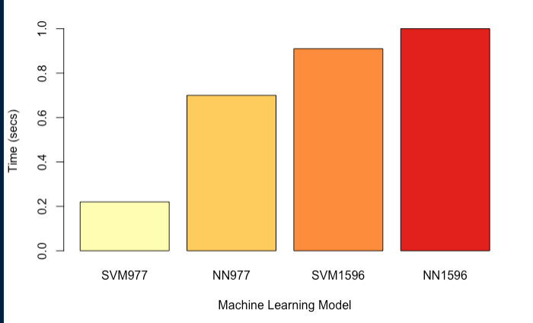
Figure S3. Computational time taken for each of the top four ML models to predict relapse status on a test set of 90 patients. These models use the Wilcoxon set of 1596 genes or the Wilcoxon-Cox set of 977 genes with a Support Vector Machine (SVM) or Neural Networks (NN) algorithm

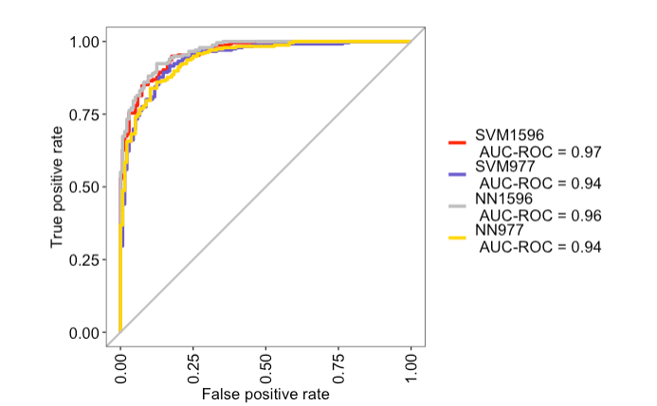

Figure S4. Area Under Receiver Operating Characteristics Curve (AUROC) for the top four ML models: SVM1596, NN1596, SVM1596, NN977.
These models use the Wilcoxon set of 1596 genes or the Wilcoxon-Cox set of 977 genes with a Support Vector Machine (SVM) or Neural Networks (NN) algorithm.

Table S1. Sensitivity and specificity of the top four ML models: SVM1596, NN1596, SVM1596, NN977. These models use the Wilcoxon set of 1596 genes or the Wilcoxon-Cox set of 977 genes with a Support Vector Machine (SVM) or Neural Network (NN) algorithm
Model | Sensitivity | Specificity
SVM1596 | 81.55% | 92.79%
NN1596 | 89.23% | 86.27%
SVM977 | 91.09% | 78.95%
NN977 | 85.29% | 86.77%

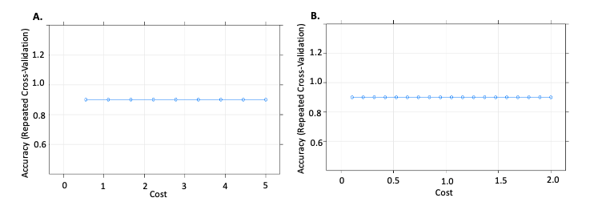
Figure S5. Accuracy comparison of SVM models using the Wilcoxon-Cox set of 977 genes with varying values of the cost hyperparameter selected through a manual grid search for A) cost values between 0 and 5 in 0.5 increments and B) cost values between 0 and 2 in 0.1 increments

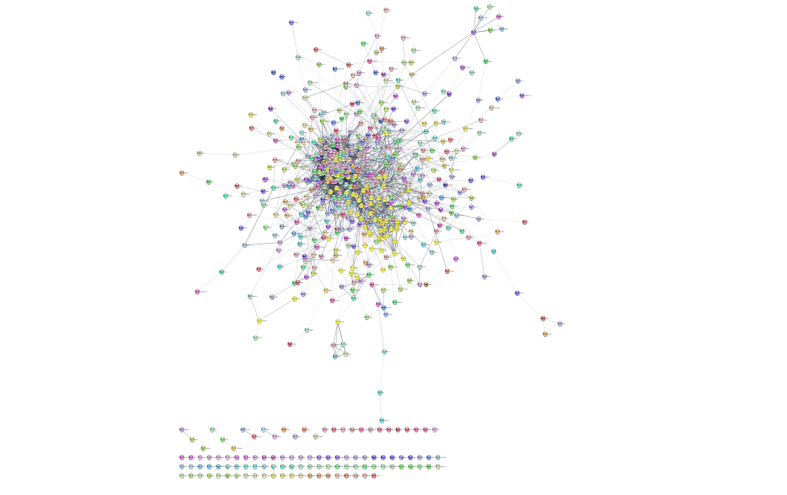
Figure S5. Protein-protein interactions of the Wilcoxon-Cox set of 977 genes visualized by Cytoscape.

Table S2. List of radiogenes
Gene Symbol | Reference
AR | Eschrich et al. CCR 2012
ABL1 | Eschrich et al. CCR 2012
CDK1 | Eschrich et al. CCR 2012
JUN | Eschrich et al. CCR 2012
HDAC1 | Eschrich et al. CCR 2012
IRF1 | Eschrich et al. CCR 2012
PRKCB | Eschrich et al. CCR 2012
RELA | Eschrich et al. CCR 2012
STAT1 | Eschrich et al. CCR 2012
SUMO1 | Eschrich et al. CCR 2012
ASF1B | Speers et al. CCR 2015
ATM | Speers et al. CCR 2015
BATF | Speers et al. CCR 2015
BCAR3 | Speers et al. CCR 2015
BIN1 | Speers et al. CCR 2015
BLM | Speers et al. CCR 2015
BTG2 | Speers et al. CCR 2015
BUB1B | Speers et al. CCR 2015
C4orf19 | Speers et al. CCR 2015
CDT1 | Speers et al. CCR 2015
COBL | Speers et al. CCR 2015
CPE | Speers et al. CCR 2015
DNAJB4 | Speers et al. CCR 2015
DNMT3B | Speers et al. CCR 2015
DTL | Speers et al. CCR 2015
EMP3 | Speers et al. CCR 2015
FZD2 | Speers et al. CCR 2015
GALC | Speers et al. CCR 2015
GINS2 | Speers et al. CCR 2015
HELLS | Speers et al. CCR 2015
HOOK1 | Speers et al. CCR 2015
HOXC13 | Speers et al. CCR 2015
ITPR1 | Speers et al. CCR 2015
KRT86 | Speers et al. CCR 2015
LAMP2 | Speers et al. CCR 2015
MCM10 | Speers et al. CCR 2015
MKI67 | Speers et al. CCR 2015
MSRA | Speers et al. CCR 2015
MTRF1 | Speers et al. CCR 2015
MYO5C | Speers et al. CCR 2015
NFIL3 | Speers et al. CCR 2015
OSMR | Speers et al. CCR 2015
PBX3 | Speers et al. CCR 2015
PDCD4 | Speers et al. CCR 2015
PRC1 | Speers et al. CCR 2015
PRKCA | Speers et al. CCR 2015
PXMP4 | Speers et al. CCR 2015
RAB15 | Speers et al. CCR 2015
RAB25 | Speers et al. CCR 2015
RAD51 | Speers et al. CCR 2015
RBPMS | Speers et al. CCR 2015
SARS | Speers et al. CCR 2015
SDHD | Speers et al. CCR 2015
SERPINE2 | Speers et al. CCR 2015
SLC39A14 | Speers et al. CCR 2015
SPC25 | Speers et al. CCR 2015
VAMP7 | Speers et al. CCR 2015
TK1 | Speers et al. CCR 2015
TSPAN13 | Speers et al. CCR 2015
ZPR1 | Speers et al. CCR 2015
LTN1 | Speers et al. CCR 2015
ADH1B | Tramm et al. CCR 2014
DNALI1 | Tramm et al. CCR 2014
hCG2023290 | Tramm et al. CCR 2014
HLA-DQA1 | Tramm et al. CCR 2014
IGKC | Tramm et al. CCR 2014
OR8G2 | Tramm et al. CCR 2014
RGS1 | Tramm et al. CCR 2014

Table S3. List of 16 radiogenes found in the 977 gene set and their aliases. All genes are protein coding
Symbol | Gene name | Aliases
MKI67 | Marker Of Proliferation Ki-67 | KIA, MIB- , MIB-1, PPP1R105, MKI67
CDK1 | Cyclin Dependent Kinase 1 | CDC2, CDC28A, P34CDC2, CDK1
SPC25 | SPC25 Component Of NDC80 Kinetochore Complex | AD024, SPBC25,HSpc25
PRC1 | Protein Regulator Of Cytokinesis 1 | ASE1, PRC1
BLM | BLM RecQ Like Helicase | BS, MGRISCE1, RECQ2, RECQL2, RECQL3,BLM
SLC39A14 | Solute Carrier Family 39 Member 14 | HCIN, HMNDYT2, LZT-Hs4, NET34, ZIP14, cig19, SLC39A14
ASF1B | Anti-Silencing Function 1B Histone Chaperone | CIA-II
PDCD4 | Programmed Cell Death 4 | H731, PDCD4
DNMT3B | DNA Methyltransferase 3 Beta | ICF, ICF1, M.HsaIIIB, DNMT3B
PRKCA | Protein Kinase C Alpha | PRKACA
RELA | RELA Proto-Oncogene, NF-KB Subunit | CMCU, NFKB3, p65, RELA
DTL | Denticleless E3 Ubiquitin Protein Ligase Homolog | CDT2, DCAF2, L2DTL, RAMP, DTL
GINS2 | GINS Complex Subunit 2 | HSPC037, PSF2, Pfs2, GINS2
MSRA | Methionine Sulfoxide Reductase A | PMSR, MSRA
HELLS | Helicase, Lymphoid Specific | ICF4, LSH, Nbla10143, PASG, SMARCA6, HELLS
MCM10 | Minichromosome Maintenance 10 Replication Initiation Factor | CNA43, DNA43, PRO2249, MCM10

