Supplementary materials
Supplementary Table 1. Characteristics of collection sites: soil type (org.= organic, min.= mineral), soil moisture, average concentration of HM ions [mg∙kg⁻¹] (* data according Terelak, 2007), type and intensity of soil usage (h.= high, m= medium, l.= low).
Region (code) | Ecotype number | Soil type | Soil moisture | HM concentration in soil [mg kg⁻¹] * |  |  | Type and intensity of soil usage
 |  |  |  | Cd²⁺ | Cu²⁺ | Pb²⁺
Podlaskie (POD) | 50 | organic | high | 0.21 | 5.6 | 10.2 | mainly cut, m.
Mazowieckie (MAZ) | 873 | min.- org. | medium | 0.15 | 3.5 | 9.2 | mainly grazed, h.
 | 801 | min.- org. | medium | 0.17 | 3.7 | 9.3 | mainly grazed, m.
 | 131 | min.- org. | medium | 0.17 | 4.0 | 9.8 | mainly cut, h.
 | 685 | min.- org. | high | 0.14 | 3.7 | 9.4 | none, l.
 | 730 | organic | medium | 0.15 | 3.6 | 9.3 | mainly grazed, m.
average |  |  |  | 0.16 | 3.7 | 9.4
Lubelskie (LUB) | 45 | mineral | low | 0.17 | 6.0 | 9.9 | none, l.
Świętokrzyskie (SWK) | 273 | mineral | low | 0.36 | 6.2 | 20.7 | none, l.
 | 160 | mineral | low | 0.36 | 6.2 | 20.7 | other, l.
 | 129 | organic | medium | 0.36 | 5.9 | 15.1 | mainly cut, m.
 | 227 | organic | medium | 0.30 | 9.8 | 15.3 | mainly cut, m.
 | 87 | organic | medium | 0.47 | 10.1 | 17.2 | none, l.
average |  |  |  | 0.37 | 7.6 | 17.8

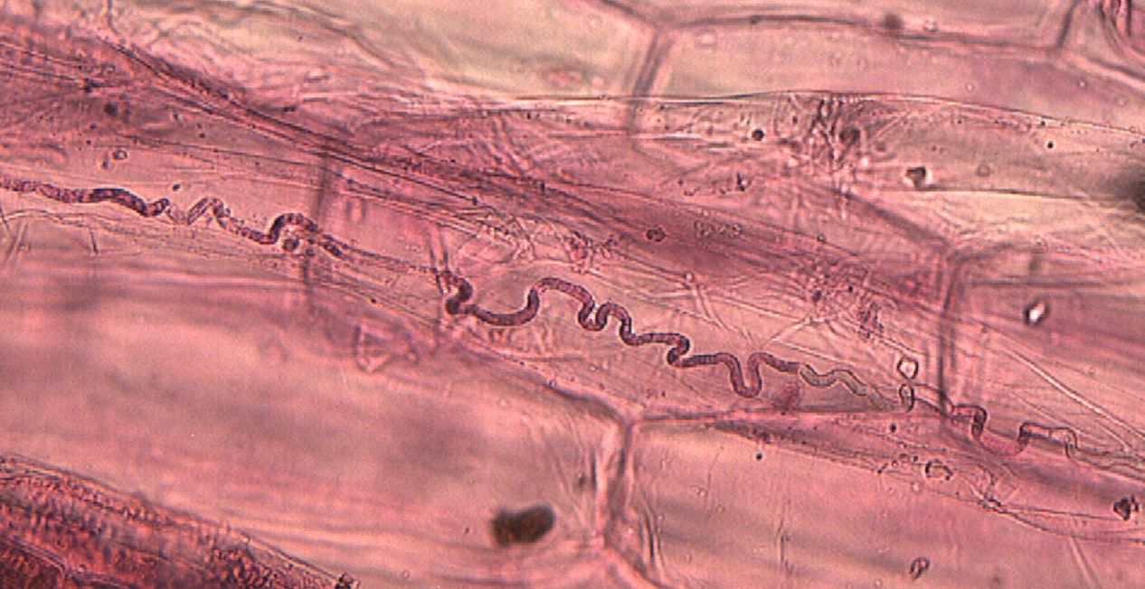
Suppl. Fig. 1. Characteristic hyphae in the leaf intercellular spaces of perennial ryegrass.
1a.
1 b.

Suppl. Fig. 2. Dry mass of perennial ryegrass (E-, 1a) plants and Epichloe-perennial ryegrass symbionts (E+, 1b.) grown in control conditions (left bar for each ecotype number) and in the presence of HM ions (right bar for each ecotype number). Ecotypes are listed in decreasing order of collection sites latitude.
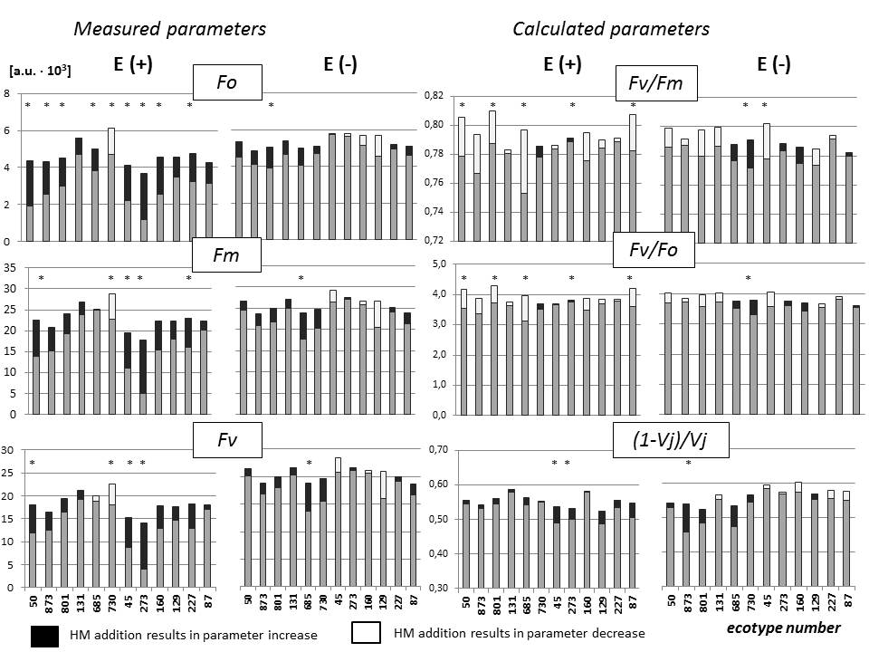

Suppl. Fig. 3. Stacked column chart of changes in Chl a fluorescence parameters (measured and calculated) in response of perennial ryegrass – Epichloë symbionts (E(+) and control (E(-) to HM ions aplied to the soil. The total height of bar corresponds to values in leaves of ecotypes treated by HM, black fragments marks increase of the parameter in response to HM as compared to control (not HM treated plants), whereas white (empty) bars ilustrates the decrease of the parameter in response to HM treatment. Charts were drown for parameters found as statisticaly important on bases of Anova analysis. Ecotypes are listed in decreasing order of collection sites latitude. Intersection with a vertical axes on charts Fv/Fm and (1-Vj)/Vj is at points > 0. Significane of difference between HM treated and not treated plants was marked with asterisks (*) for α ≤ 0.05

Supplementary Table 2. Eigenvector values of three factors calculated with Principal Component Analysis (PCA) performed on Chl a fluorescence parameters.

Chl a fluorescence | Factor #
parameters | #1 | #2
Fo | -0.983 | 0.141
Fm | -0.979 | -0.148
Fv | -0.951 | -0.231
Fv/Fm | 0.305 | -0.716
Tfm | 0.061 | 0.078
Area | -0.711 | -0.279
RC_ABS | -0.219 | -0.844
FvFo | 0.332 | -0.729
Vj | -0.460 | -0.613
PI | -0.128 | -0.951
variation explained (%) | 56.8 | 22.3

