Two Nucleoporin98 homologous genes jointly participate in the regulation of starch degradation to repress senescence in Arabidopsis
Long Xiao^{1, §}, Shanshan Jiang^{2, §}, Penghui Huang^{2, §}, Fulu Chen², Xu Wang², Zhiyuan Cheng², Yuchen Miao³, Liangyu Liu⁴, Iain Searle⁵, Chunyan Liu¹, Xiao-Xia Wu¹, Yong-Fu Fu^{2, *, ¶}, Qingshan Chen^{1, *}, Xiao-Mei Zhang^{2, *}

Additional files

Supplementary Table 1. Primers used in this study.
Primer Name | Gene ID | Nucleotide Sequence (5’-3’) | Purpose
At4g34270-F | At4g34270  Reference gene | gtgaaaactgttggagagaagcaa | qRT-PCR
At4g34270-R |  | tcaactggataccctttcgca | qRT-PCR
AGL15-F | AT5G13790 | ttccttctaccttcttctc | qRT-PCR
AGL15-R |  | agtgacttgtctgctatt | qRT-PCR
AMY1-F | At4g25000 | cttggctatgattgatgat | qRT-PCR
AMY1-R |  | ttatgcgttacttcttctc | qRT-PCR
AMY2-F | At1g76130 | ctcggttggagaatgttg | qRT-PCR
AMY2-R |  | ctgattatacgctgtctatgg | qRT-PCR
AMY3-F | At1g69830 | tgagatattatgccaaggt | qRT-PCR
AMY3-R |  | gaacagtgaatccaagtg | qRT-PCR
ARF2-F | At5g62000 | gatgatgataaggttgac | qRT-PCR
ARF2-R |  | aatctgtgtaagtaggtt | qRT-PCR
ARP4-F | AT1G18450 | gtctgagtatgaggaaca | qRT-PCR
ARP4-R |  | ctaataatcttcaaggaacaac | qRT-PCR
BAM1-F | At3g23920 | accattgaagaacagagaa | qRT-PCR
BAM1-R |  | tcatcacaaacacaggaa | qRT-PCR
BAM2-F | At4g00490 | agattcaggttgttatgt | qRT-PCR
BAM2-R |  | aagtagatgtcaggattg | qRT-PCR
BAM3-F | At4g17090 | ggaatagcgagtatggaa | qRT-PCR
BAM3-R |  | ctgaagataggagttggt | qRT-PCR
BAM4-F | At5g55700 | tgatgatgccgattgatac | qRT-PCR
BAM4-R |  | gctaacttgagtgccttaa | qRT-PCR
BAM5-F | At4g15210 | aagataccgacaatacag | qRT-PCR
BAM5-R |  | gcaacttctataccttct | qRT-PCR
BAM6-F | At2g32290 | gtcatcacgaacgataacg | qRT-PCR
BAM6-R |  | accatcactccatctacttg | qRT-PCR
BAM7-F | At2g45880 | tggatgtgaaggaagaag | qRT-PCR
BAM7-R |  | actcgtcattactactactg | qRT-PCR
BAM8-F | At5g45300 | cagagatggttgtatgagat | qRT-PCR
BAM8-R |  | aggagaaggttgacgata | qRT-PCR
BAM9-F | At5g18670 | cttccgttagacacagtt | qRT-PCR
BAM9-R |  | ctcaataccttctacaccaa | qRT-PCR
CAT1 | At1g20630 | tattcttcgtccgtgatg | qRT-PCR
CAT1 |  | cagtatcctccagttctc | qRT-PCR
COI1-F | AT2G39940 | atggcggtgtatgtctcag | qRT-PCR
COI1-R |  | gcggaagtcacagaggtt | qRT-PCR
DPE1-F | At5g64860 | gcaaggagttgatataatgg | qRT-PCR
DPE1-R |  | cgctaacaagaagaggaa | qRT-PCR
DPE2-F | At2g40840 | ggacttagactcaactatg | qRT-PCR
DPE2-R |  | gattaccaccagattcaa | qRT-PCR
EBP1 | At3g51800 | ccaatcgctcctccttaa | qRT-PCR
EBP1 |  | gaactcatctctgataactctc | qRT-PCR
GWD1/SEX1-F | At1g10760 | aagttggcaggttattagt | qRT-PCR
GWD1/SEX1-R |  | ttgtaggtctatcgtaggt | qRT-PCR
GWD2-F | At4g24450 | agtgtgataatggatgaag | qRT-PCR
GWD2-R |  | caatcgctgagaatagac | qRT-PCR
GWD3/PWD-F | At5g26570 | gacacatcaggagaatcaa | qRT-PCR
GWD3/PWD-R |  | cagtatcaggagcatcatt | qRT-PCR
HXK1-F | AT4G29130 | ctacagaatgcgaagact | qRT-PCR
HXK1-R |  | taccagaggacagagaag | qRT-PCR
ISA3-F | At4g09020 | tggcatagacaacaaggt | qRT-PCR
ISA3-R |  | tggatggttacagttcagt | qRT-PCR
KIN10-F | At3g01090 | cagatggtatgctcagtaac | qRT-PCR
KIN10-R |  | tgcttcgttctctattatgc | qRT-PCR
KIN11-F | At3g29160 | gtttactttgccgggttac | qRT-PCR
KIN11-R |  | ccatcaaaaagaagaaagga | qRT-PCR
LDA-F | At5g04360 | aatgatgagactgttgag | qRT-PCR
LDA-R |  | aatgttggaagaagatgta | qRT-PCR
LHCA1-F | At3g54890 | tctcttcttccaagtctaa | qRT-PCR
LHCA1-R |  | attctgatacgaccaaca | qRT-PCR
LHCA2-F | At3g61470 | aataatggcatcatctctt | qRT-PCR
LHCA2-R |  | cagtcaacttcttcttca | qRT-PCR
LHCB1.1-F | At1g29920 | tgagccaagttctatctgt | qRT-PCR
LHCB1.1-R |  | ctctaccatccaccacaa | qRT-PCR
LHCB1.4-F | At2g34430 | gagtgaagttcggagaag | qRT-PCR
LHCB1.4-R |  | ccaagtagtccaatcctc | qRT-PCR
LSF1-F | At3g01510 | ggcattcagcaacttcac | qRT-PCR
LSF1-R |  | agcaacatcaccaactaca | qRT-PCR
LSF2-F | At3g10940 | gagaacgatgagtgtgatt | qRT-PCR
LSF2-R |  | agaagtgaagcaagaagatt | qRT-PCR
NAC1-F | AT1G56010 | aggagttatatgtagagac | qRT-PCR
NAC1-R |  | tgatgatgtagtgatgat | qRT-PCR
NAP-F | AT1G69490 | gaagaagagataatgatgatg | qRT-PCR
NAP-R |  | caggttgatgaagatgat | qRT-PCR
NPR1-F | AT1G64280 | attgccaaggattacgaagt | qRT-PCR
NPR1-R |  | tctcactctgctgctgta | qRT-PCR
ORE1/NAC2-F | At5g39610 | tacgaggcatcaagaatc | qRT-PCR
ORE1/NAC2-R |  | aggtagtgagttatgagttc | qRT-PCR
PHS1-F | At3g29320 | ggattggtggagaagacat | qRT-PCR
PHS1-R |  | gagccgcagattgatagt | qRT-PCR
PHS2-F | At3g46970 | agagattgacaagaggtt | qRT-PCR
PHS2-R |  | acacataagttagccattc | qRT-PCR
RPS6A | At4g31700 | agaagccaagaatgagag | qRT-PCR
RPS6A |  | ggtaagtgttgacataggt | qRT-PCR
SAG12-F | AT5G45890 | caagcactgatgaaggcagt | qRT-PCR
SAG12-R |  | tgcactctccagtgaacaca | qRT-PCR
SAG13 | AT2G29350 | gacaacataaggacgaactctg | qRT-PCR
SAG13 |  | tacgcaccgcttctttct | qRT-PCR
SAG2-F | AT5G60360 | tcttcttcttcttcttcttct | qRT-PCR
SAG2-R |  | aactactgatgataggattgt | qRT-PCR
SAUR36 | AT2g45210 | atgtctcgtctcactctc | qRT-PCR
SAUR36 |  | atcttcctcatcttcttatagc | qRT-PCR
SEN1-F | At4g35770 | gcttggacagagaatgag | qRT-PCR
SEN1-R |  | tgattgatacttgcgttga | qRT-PCR
SEX4-F | At3g52180 | tcttcttcttcttcttct | qRT-PCR
SEX4-R |  | gtcttggctatattcatc | qRT-PCR
TPS1-F | AT1G78580 | catcaggagaccgaagac | qRT-PCR
TPS1-R |  | tgttgttgttgttagagttagag | qRT-PCR
WRKY53-F | At4g23810 | catcatcgccaagattacat | qRT-PCR
WRKY53-R |  | ggtccttctaagcctctc | qRT-PCR
WRKY6-F | At1g62300 | ttctccttcgttaatctc | qRT-PCR
WRKY6-R |  | atcatcttcttcgtcaat | qRT-PCR
WRKY70-F | At3g56400 | aatgaaggaagaagacaa | qRT-PCR
WRKY70-R |  | gcctgatgatgataatct | qRT-PCR
RT98a-F | At1g10390 | atccgttgtcaaactacagagg | RT-PCR
RT98a-R |  | ggagacgagccaaaactaaagg | RT-PCR
RT98b-F | At1g59660 | ccaactcctgttacaaacccat | RT-PCR
RT98b-R |  | gtccaatctctcgccttccatc | RT-PCR
DRM1-qRT-F | At1g28330 | AGGAAGGAACATGTGGCACT | qRT-PCR
DRM1-qRT-R |  | GAGTCACCGCTGTACAACCA | qRT-PCR
DIN6-qRT-F | AT3G47340 | TCTCGACCCTGAATCCAAGATGAT | qRT-PCR
DIN6-qRT-R |  | GTCGTCAAAGGCTCTCCTTAGA | qRT-PCR
ATG8a-qRT-F | AT4G21980 | CAATTTGTATACGTGGTTCGT | qRT-PCR
ATG8a-qRT-R |  | AGCAACGGTAAGAGATCCAA | qRT-PCR
ATG8E-qRT-F | AT2G45170 | TCTTTAAGATGGACAACGATTTC | qRT-PCR
ATG8E-qRT-R |  | CTCAGCCTTTTCCACAATCA | qRT-PCR
SAG12-qRT-F1 | At5g45890 | TATTACAGGTTATGAGGATGTCCC | qRT-PCR
SAG12-qRT-R1 |  | ACCACATAGTCCTTGTTTATCC | qRT-PCR
WRKY53-qRT-F1 | AT4G23810 | CTTCTGCTAAACTGGTCATCC | qRT-PCR
WRKY53-qRT-R1 |  | CTCTCTCTGGGCTTATTCTCA | qRT-PCR
ACT2-F | At5g09810 | CTCATGAAGATTCTCACTGAG | RT-PCR
ACT2-R |  | ACAACAGATAGTTCAATTCCCA | RT-PCR
TIP41-F | At4g34270 | GTGAAAACTGTTGGAGAGAAGCAA | qRT-PCR
TIP41-R |  | TCAACTGGATACCCTTTCGCA | qRT-PCR

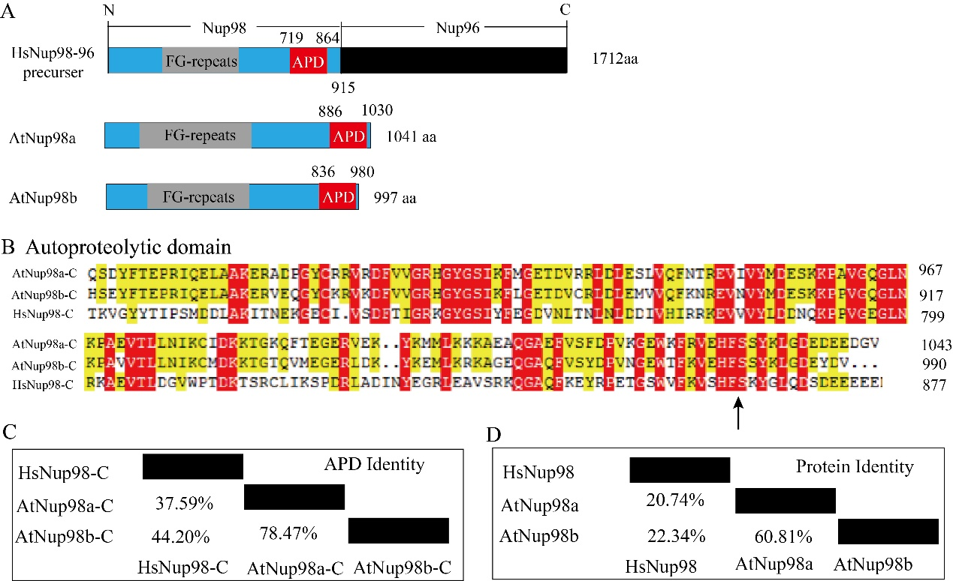

Figure S1. Protein domains in Nup98a and Nup98b of Arabidopsis thaliana. A, Sketches of Nup98-96 proteins from Homo sapiens HsNup98-96 (NM_016320.4) and two homologs from Arabidopsis thaliana Nup98a (At1g10390) and Nup98b (At1g59660). APD, autoproteolytic domains. FG, phenylalanine and glycine repeats. B, Alignment of the autoproteolytic domains of HsNup98-96, At Nup98a and At Nup98b. The arrow indicates the conserved HFS cleavage site. C, Overall identity of the autoproteolytic domains of HsNup98-96, At Nup98a and At Nup98b. D, Overall identity of the proteins of HsNup98-96, At Nup98a and At Nup98b.

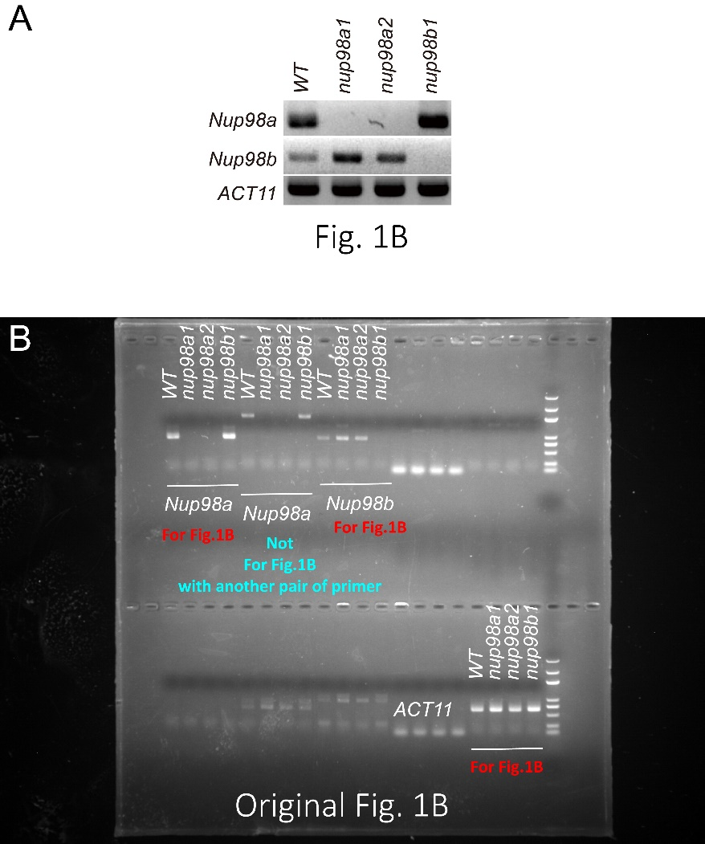
Figure S2. The original photograph of the gel in Figure 1B. A, Fig.1B; B, The original photo.

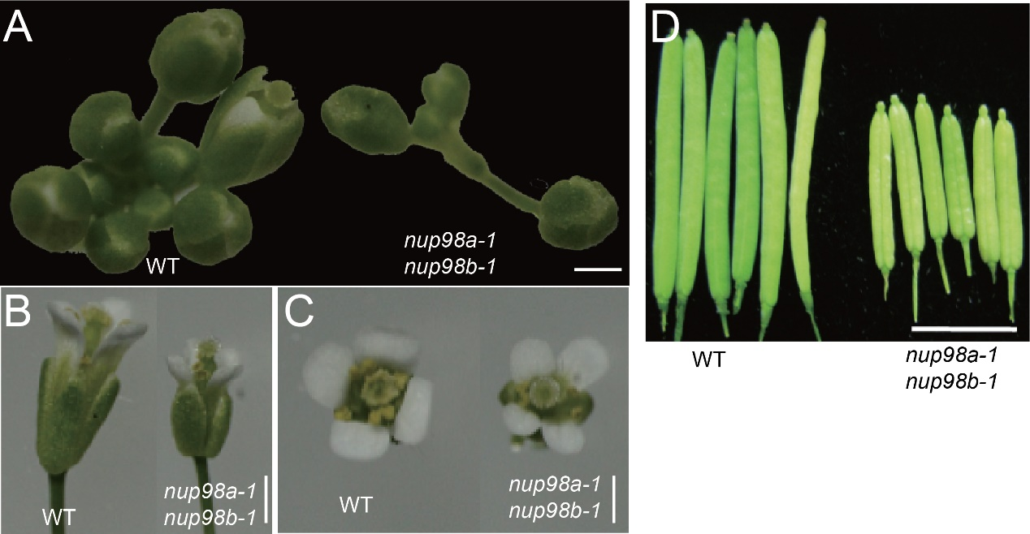
Figure S3. The nup98a1, nup98b1 double mutant showed pleiotropic phenotypes in various organs. The seeds of mutant and WT were sown in soil after low temperature treatment for 3 days on wet filter paper and grew in long day conditions. A, A top view of Inflorescence; B, A side view of flowers; C, A top view of flowers; D, Siliques. Scale bars = 2 mm. All the images are our own data.

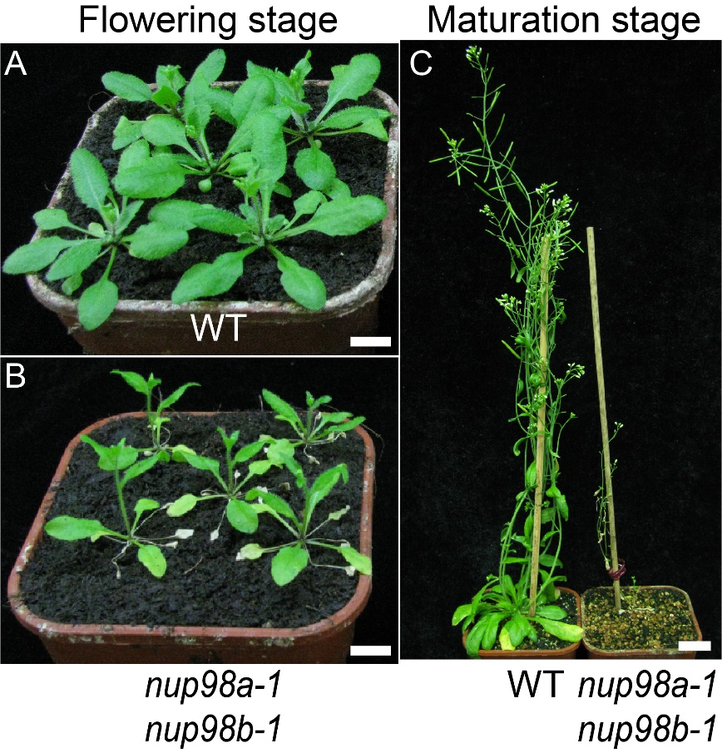
Figure S4. The nup98a1, nup98b1 double mutant showed a senescent and sterile phenotype. The seeds of mutant and WT were sown in soil after low temperature treatment for 3 days on wet filter paper and grew in long day conditions. A and B, Plants at early stage of flowering. Plants grew in dishes supplemented with MS and sucrose for one week, and then transplanted in soil. C, Plants at mature stage. All the images are our own data.

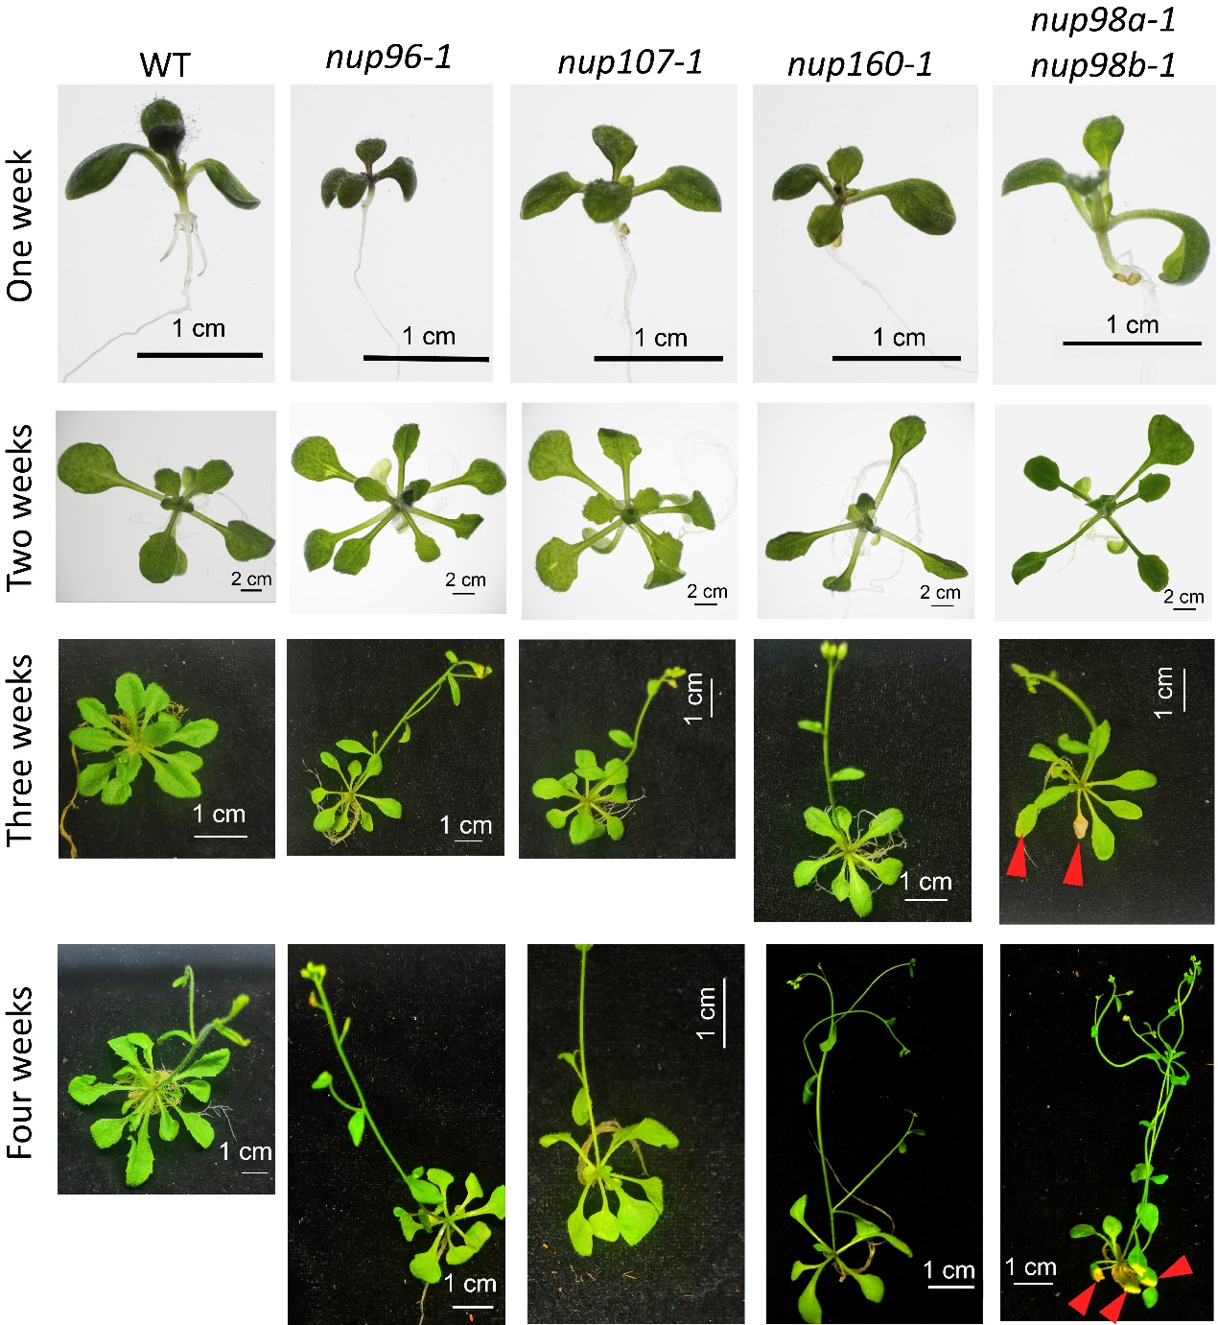
Figure S5. Senescent phenotypes were specific to the nup98a1, nup98b1 double mutant compared with mutants of other nucleoporins. The data showed that the mutants of nucleoporin genes, Nup96, Nup107, and Nup160, did not exhibit senescence characteristics even though plants were in bloom, while the nup98a-1 nup98b-1 mutant appeared senescence symptom (yellow leaves, red arrows) from three weeks after germination. All plants grew in long day conditions. All the images are our own data.

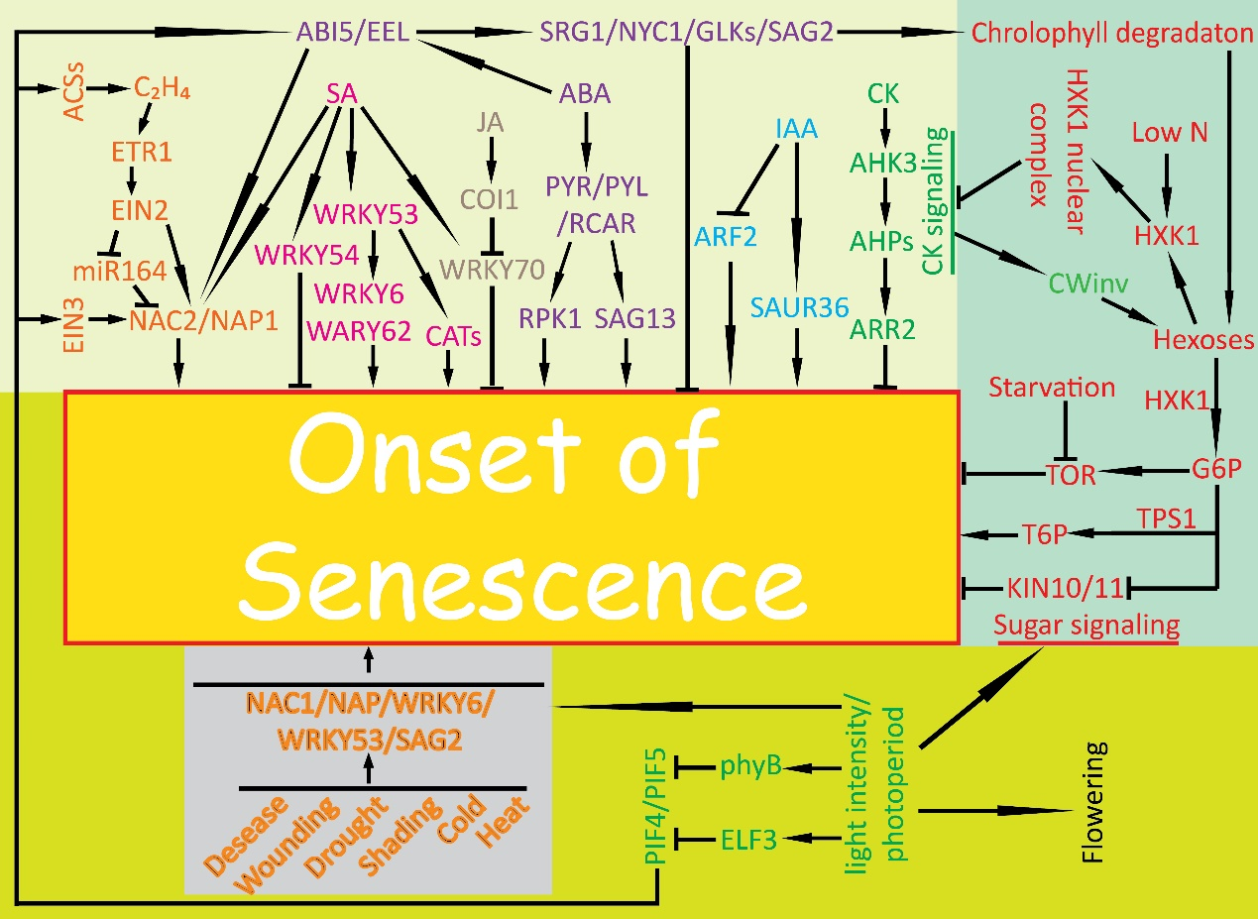
Figure S6. Molecular network of senescence initiation in plants. The summary is based on previous publications ¹⁻¹², but not limited these publications. Generally, initiation of senescence includes the hormone (light yellow background), sugar metabolism (light green background), and light and photoperiod pathway (green-yellow background), and stress pathways (grey background). These pathways can induce senescence at different developmental stages (yellow background). Genes and metabolites in the same pathway are indicated by the same color. Due to space limitations, this summary model does not include all genes identified to date. Abbreviations: ABA, abscisic acid; ABI, ABA INSENSITIVE; AHK, ARABIDOPSIS HISTIDINE KINASE; ACS, AMINOCYCLOPROPANE-1-CARBOXYLATE (ACC) SYNTHASE; AHP, ARABIDOPSIS THALIANA HISTIDINE PHOSPHOTRANSFER PROTEINS; ARF, AUXIN RESPONSE FACTOR; ARR, ARABIDOPSIS RESPONSE REGULATOR; C₂H₄, ethylene ; CAT, CATALASE; CK, cytokinin; COI1, CORONATINE INSENSITIVE 1; CWINV, CELL WALL INVERTASE; EEL, ENHANCED EM LEVEL; EIN, ETHYLENE INSENSITIVE; ELF, EARLY FLOWERING; ETR, ETHYLENE RESPONSIVE; G6P，6-phosphoric acid glucose; GLK, Golden 2-like Transcription factor; HXK1, HEXOKINASE 1; KIN, PROTEIN KINASE10; N, nitrogen; NAC，NAM, ATAF, AND CUC; NAP, NAC-LIKE PROTEIN; NYC, NONYELLOW COLORING; ORE, ORESARA; PHYB, phytochrome B; PIF, PHYTOCHROME INTERACTING FACTOR; PYR/PYL/RCAR, PYRABACTIN RESISTANCE/PYR1-LIKE ORREGULATORY COMPONENT OF ABA RECEPTOR; SAG, SENESCENCE-ASSOCIATED GENE; SAUR, SMALL AUXIN UPREGULATED; SGR, STAYGREEN; T6P, TREHALOSE-6-PHOSPHATE; TOR, TARGET OF RAPAMYCIN; TPS1, TREHALOSE-6-PHOSPHATE SYNTHASE 1; WRKY, WRKY DNA-BINDING PROTEIN. Arrowheads indicate promoting effect while short bars indicate inhibiting effect on senescence. All the images are our own data.

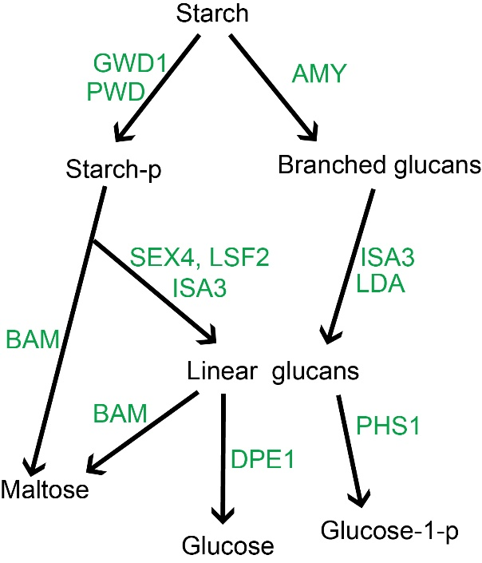
Figure S7. A simplefied pathway of starch degradation in chloroplasts. Starch is degraded into maltose, glucose, or glucose -1-phospholate in chloroplast, and these three monosaccharides are exported from chloroplast into cytoplasm to provide energy source for cells. Black words indicate saccharides, while green words represent enzymes degrading starch (only main enzymes showed). GWD, α-glucan, water dikinase; PWD, phosphoglucan, water dikinase; AMY, α-amylase; BAM, β-amylase; SEX4, STARCH EXCESS 4 (phosphoglucan phosphatase); LSF2, LIKE SEX FOUR2 (phosphoglucan phosphatase); DPE, disproportionating enzyme; ISA3, iso-amylase3; LDA, limit-dextrinase; PHS, α-glucan phosphorylase. These degradation steps happen in chloroplasts, and the products of maltose, glucose and glucose-1-p would be exported from chloroplasts into cytoplasm.

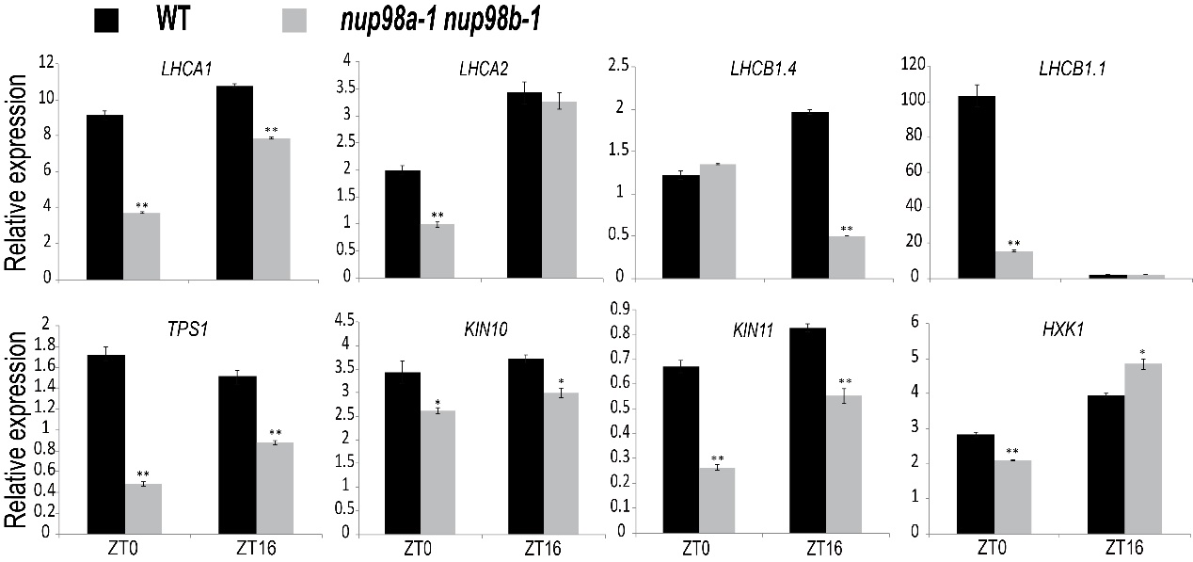
Figure S8. Expression analysis of genes related to photosynthesis and sugar metabolism in the nup98a1, nup98b1 double mutant. The nup98a-1 nup98b-1 double mutant and WT plants were grown in petri dishes in long day conditions for 14 days, and then harvested at ZT0 and ZT16 for gene expression analysis. All qPCR measurements were repeated at least three times, in triplicate. Gene expression measurements were normalized to the control At4g34270 and expressed as a relative expression value. Student’s t test was used to statistically analyze the data. An * indicates measurements that were significantly (*P < 0.05; **P <0.01) different from the control. Error bars indicate ± SD of the mean.

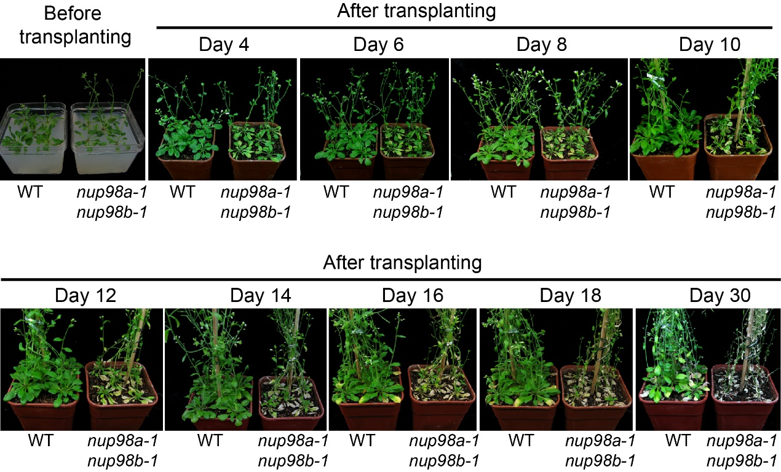
Figure S9. Exogenous sucrose reduces early senescence in the nup98a1, nup98b1 double mutant plants. Medium is MS (Murashige & Skoog) basal nutrients and 3% sucrose. The seeds of WT and the nup98a-1 nup98b-1 double mutant were sown on MS medium with sucrose. After stratification, plants were grown under long day conditions. After inflorescences emerged, plants were transplanted to soil. Senescence symptoms appeared 4 days later in the double mutant leaves, about 12 days earlier than the wild type control. All the images are our own data.

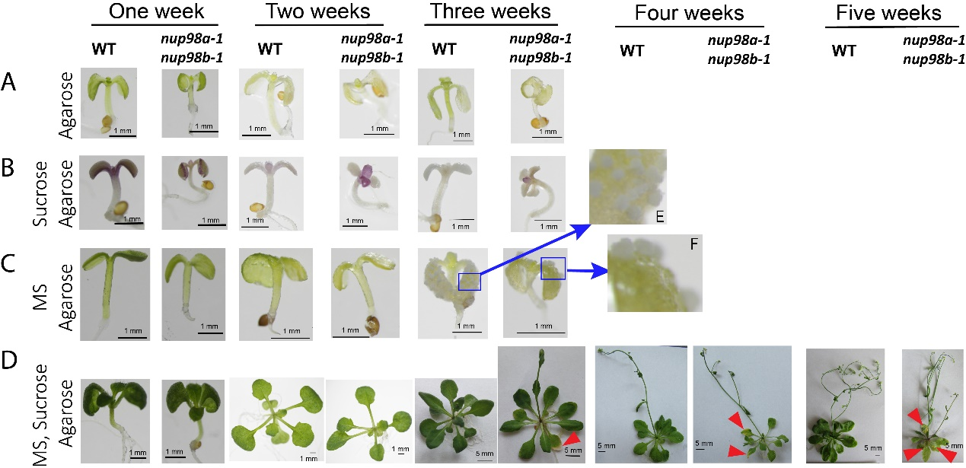
Figure S10. Phenotype analysis of the nup98a1, nup98b1 double mutant compared with WT grown on different mediums. Medium is MS (Murashige & Skoog) basal nutrients and 3% sucrose. Row A, agarose medium. Row B, agarose plus sucrose. Row C, agarose plus MS basal nutrients. Row D, agarose plus sucrose and MS basal nutrients. Plants cannot fulfil the life cycle and die in about three weeks after germination in medium A, B, and C, whereas plants in medium D can go through the life cycle. There were white callus-like structures found on the leaf surfaces of three week-seedlings on medium C (blue arrow, E and F). The nup98a-1 nup98b-1 double mutant displayed senescence leaves (red arrow heads) early than WT (from week three) as Figure 5 showed. We also observed that the seedlings of 25% of WT or 8% of the nup98a-1 nup98b-1 double mutant on medium C can grow normal more or less until three weeks after germination. All experiments were repeated at least twice, and one representative photo each was showed here. All the images are our own data.

Reference:
1 Lim, P. O., Kim, H. J. & Nam, H. G. Leaf senescence. Annu Rev Plant Biol 58, 115-136, doi:10.1146/annurev.arplant.57.032905.105316 (2007).
2 Khan, M., Rozhon, W. & Poppenberger, B. The role of hormones in the aging of plants - a mini-review. Gerontology 60, 49-55, doi:10.1159/000354334 (2014).
3 Guo, Y. Towards systems biological understanding of leaf senescence. Plant Mol Biol 82, 519-528, doi:10.1007/s11103-012-9974-2 (2013).
4 Guiboileau, A., Sormani, R., Meyer, C. & Masclaux-Daubresse, C. Senescence and death of plant organs: nutrient recycling and developmental regulation. C R Biol 333, 382-391, doi:10.1016/j.crvi.2010.01.016 (2010).
5 Zhang, H. & Zhou, C. Signal transduction in leaf senescence. Plant Mol Biol 82, 539-545, doi:10.1007/s11103-012-9980-4 (2013).
6 Thomas, H. Senescence, ageing and death of the whole plant. New Phytol 197, 696-711, doi:10.1111/nph.12047 (2013).
7 Jibran, R., Hunter, D. A. & Dijkwel, P. P. Hormonal regulation of leaf senescence through integration of developmental and stress signals. Plant Mol Biol 82, 547-561 (2013).
8 Bakshi, M. & Oelmuller, R. WRKY transcription factors: Jack of many trades in plants. Plant signaling & behavior 9, e27700 (2014).
9 Sheen, J. Master Regulators in Plant Glucose Signaling Networks. 57, 67-79, doi:10.1007/s12374-014-0902-7 (2014).
10 Koyama, T. The roles of ethylene and transcription factors in the regulation of onset of leaf senescence. Frontiers in plant science 5, 650, doi:10.3389/fpls.2014.00650 (2014).
11 Hinderhofer, K. & Zentgraf, U. Identification of a transcription factor specifically expressed at the onset of leaf senescence. Planta 213, 469-473 (2001).
12 Miao, Y., Laun, T., Zimmermann, P. & Zentgraf, U. Targets of the WRKY53 transcription factor and its role during leaf senescence in Arabidopsis. Plant Mol Biol 55, 853-867, doi:10.1007/s11103-004-2142-6 (2004).

