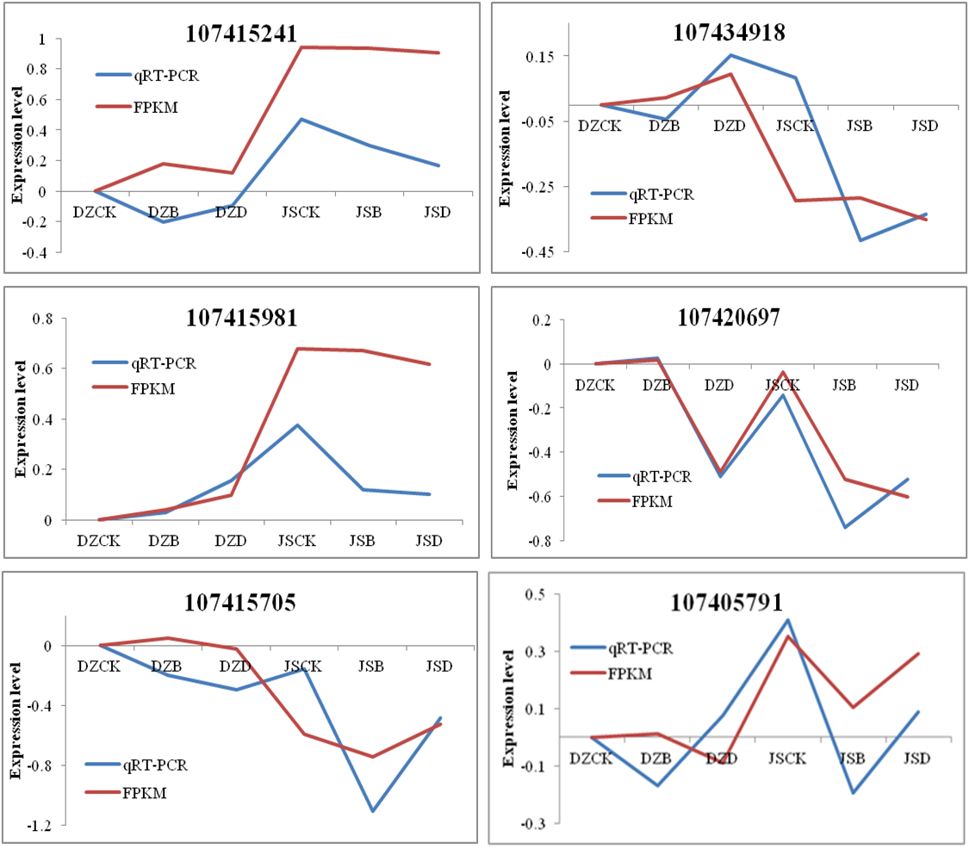
Figure S1 Validation by qRT-PCR of DEGs isolated from the different samples in ‘Dongzao’ and ‘Jinsixiaozao’.
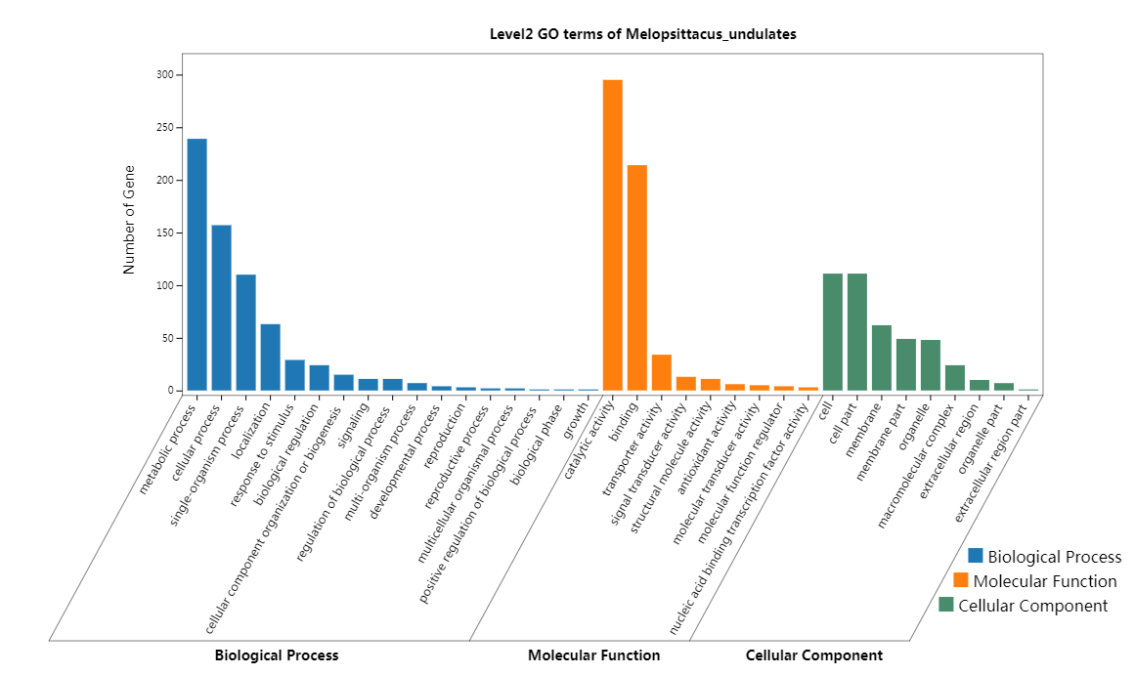
Figure S2 GO analysis of DEGs under different degree cold stress in ‘Dongzao’.
The X and Y axes correspond to GO terms and the number of DEGs.
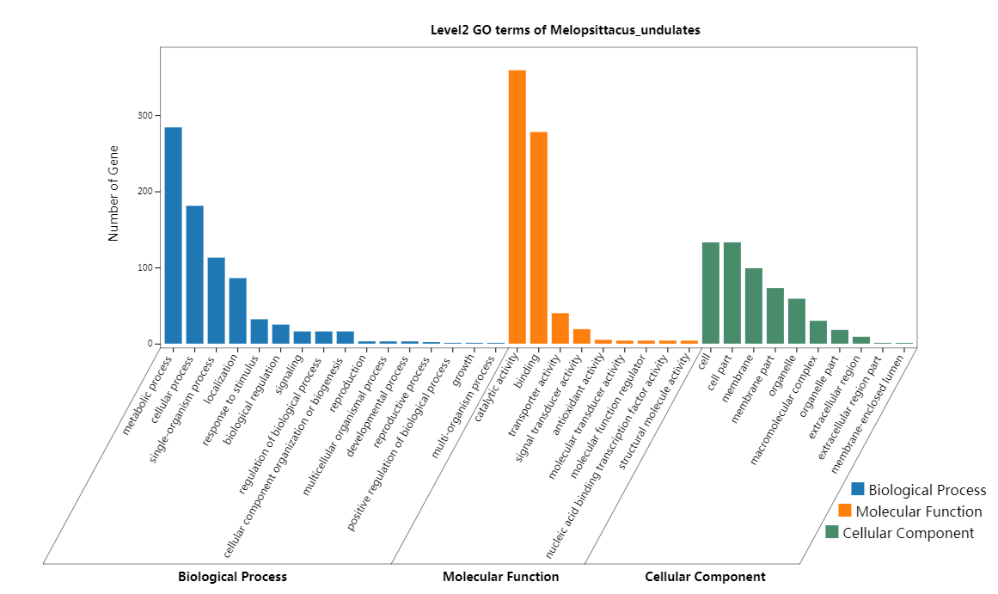
Figure S3 GO analysis of DEGs under different degree cold stress in ‘Jinsixiaozao’.
The X and Y axes correspond to GO terms and the number of DEGs.

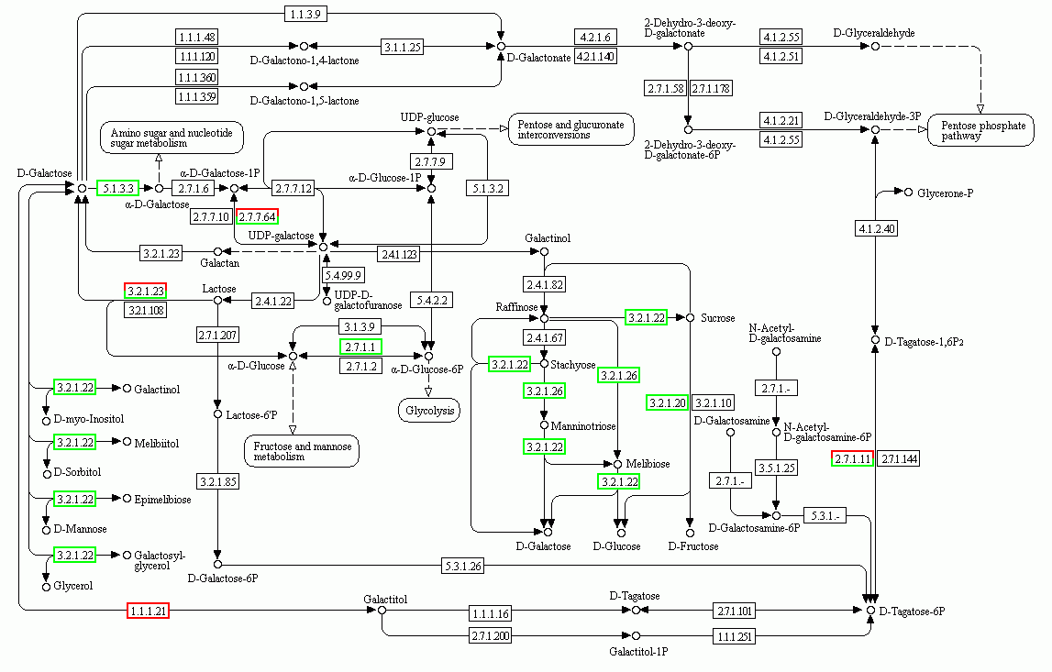
Figure S4 DEGs in galactose metabolism.
Different boxes represent different genes in galactose metabolism. The red boxes represent up-regulated genes, and the green boxes represents down-regulated genes

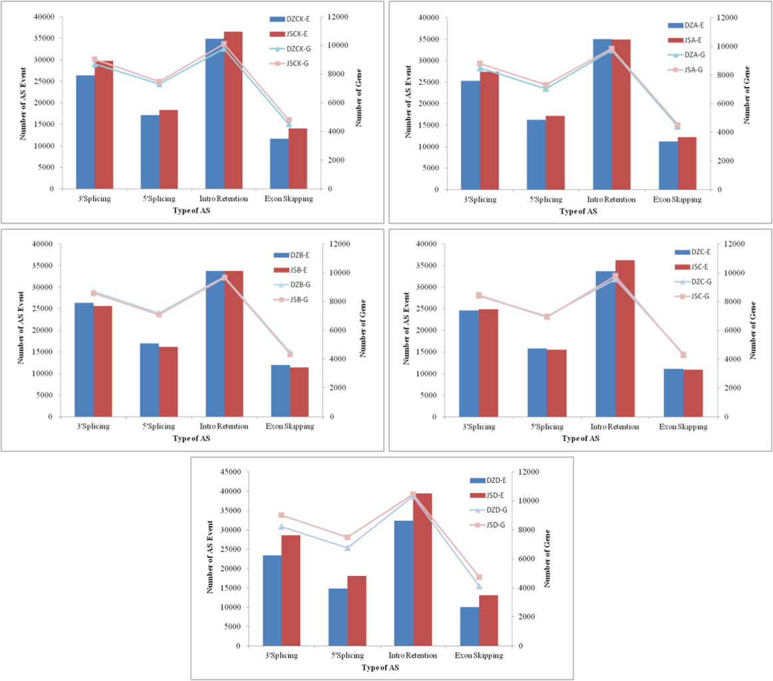
Figure S5. Alternative Splicing Event and gene number at the same degree cold stress between two cultivars.

Table S1 Primers for qRT-PCR
Gene ID | Primer Sequence 5'→3'
107415241 | F:CAGACTCAGTGGTGGTATTGTG R:TGCTCATTCTCATCGGTAGGT
107415981 | F:ATACACTAACCAAATCGCAACCA R:ACAGGACCAACAGAGGAAGAA
107434918 | F:AACAACAACAACACTGGAGGTT R:TGGCACTGATTGAGAGGAAGA
107420697 | F:CAGTCGTGATGGTGGTGAG R:TGGTGATGGTCCTGGTCTT
107415705 | F:TCGTGCTATTGCTGCTAAGATAAC R:AACAAGTCACAGATGCCAACTC
107405791 | F:AAGTCCAACACCGCCATTC R:GAGCAATTCACCGAGAGTCAA

Table S2 DEGs involved in galactose metabolism pathways
Gene ID | Gene description | Pathway
107426117 | stachyose synthetase | Galactose metabolism;Metabolic pathways
107415484 107417578 107418294 | raffinose synthase | Galactose metabolism;Metabolic pathways
107411641 | inositol 3-alpha-galactosyltransferase | Galactose metabolism;Metabolic pathways
107435337 107435723 | hexokinase | Glycolysis / Gluconeogenesis;Fructose and mannose metabolism; Galactose metabolism;Starch and sucrose metabolism; Amino sugar and nucleotide sugar metabolism; Streptomycin biosynthesis; Neomycin, kanamycin and gentamicin biosynthesis; Metabolic pathways; Biosynthesis of secondary metabolites;Microbial metabolism in diverse environments; Biosynthesis of antibiotics; Carbon metabolism; HIF-1 signaling pathway;Insulin signaling pathway;Type II diabetes mellitus;Carbohydrate digestion and absorption;Central carbon metabolism in cancer
107408372 107406885 107411414 107408074 107407291 107408806 107407193 | 6-phosphofructokinase 1 | Glycolysis / Gluconeogenesis;Pentose phosphate pathway;Fructose and mannose metabolism; Galactose metabolism;Methane metabolism; Metabolic pathways; Biosynthesis of secondary metabolites; Microbial metabolism in diverse environments; Biosynthesis of antibiotics; Carbon metabolism; Biosynthesis of amino acids; RNA degradation; AMPK signaling pathway; Central carbon metabolism in cancer
107409871 | UDPglucose--hexose-1-phosphate uridylyltransferase | Galactose metabolism;Amino sugar and nucleotide sugar metabolism;Metabolic pathways; Prolactin signaling pathway
107421374 107418905 107404162 | UDP-sugar pyrophosphorylase | Pentose and glucuronate interconversions;Galactose metabolism  Ascorbate and aldarate metabolism  Amino sugar and nucleotide sugar metabolism  Metabolic pathways  Biosynthesis of antibiotics
107430988 107418946 | maltase-glucoamylase | Galactose metabolism;Starch and sucrose metabolism;Metabolic pathways;Carbohydrate digestion and absorption
107414011 107428511 | alpha-galactosidase | Galactose metabolism;Glycerolipid metabolism;Sphingolipid metabolism;Glycosphingolipid biosynthesis - globo and isoglobo series;Metabolic pathways;Lysosome
107424008 107417196 107426293 107420256 107409426 107403993 107428314 107425187 107425355 107425261 | beta-galactosidase | Galactose metabolism;Other glycan degradation;Sphingolipid metabolism; Metabolic pathways
107425264 107430302 | beta-fructofuranosidase | Galactose metabolism;Starch and sucrose metabolism;Metabolic pathways
107419312 | aldose 1-epimerase | Glycolysis / Gluconeogenesis;Galactose metabolism; Metabolic pathways; Biosynthesis of secondary metabolites; Microbial metabolism in diverse environments;Biosynthesis of antibiotics

