METABOLIC IMPACT OF INFANT FORMULAS IN YOUNG INFANTS. AN OUTLOOK FROM THE URINE METABOLOME.

Angie Marcela Calvo Barbosa¹, Stefany Casallas Cortes¹, Ninna Pulido^{1,2}, Martha Yaneth Parra¹, Alexander Rodríguez-López^{1,3}, Johana Guevara-Morales ^{1, *}, Olga Yaneth Echeverri-Peña^{1, *}
1 Instituto de Errores Innatos del Metabolismo. Facultad de Ciencias. Pontificia Universidad Javeriana, Carrera 7 # 43-82. Ed. 54, Bogotá, Colombia
2 Grupo de ciencias de laboratorio Clínico. Hospital Universitaria San Ignacio, Bogotá, Colombia.
3 Fundación Instituto de Inmunología de Colombia (FIDIC), Bogotá, Colombia; School of Medicine and Health Sciences, Universidad del Rosario, Bogotá, Colombia.

Table S1: Correlation between urine organic acids levels in infants receiving infant formula.
Metabolite (Acid) | R* | P value**
Lactic | -0,507 | 0,023
2 OH butyric | 0,365 | 0,113
Glicolic | -0,264 | 0,26
3 OH isobutiric | -0,130 | 0,586
Oxalic | 0,168 | 0,478
Pyruvic | -0,097 | 0,684
2 methyl 3 OH butyric | 0,597 | 0,005
Methylmalonic | 0,069 | 0,773
3 OH isovaleric | -0,192 | 0,417
Urea | 0,027 | 0,911
Octanoic | -0,022 | 0,927
Ethylmalonic | 0,175 | 0,462
Phosphoric | 0,314 | 0,178
Succinic | -0,087 | 0,717
Methylsuccinic | 0,451 | 0,046
Fumaric | -0,122 | 0,609
4-Deoxytetronic | 0,590 | 0,006
Phenoxyacetic | 0,292 | 0,212
Glutaric | 0,332 | 0,153
3 Methylglutaric | 0,526 | 0,017
3 OH Adipate Lactone | 0,181 | 0,444
3 methylglutaconic | 0,092 | 0,698
3,4 Dihydroxybutyric | -0,240 | 0,309
Citramalic | 0,402 | 0,079
Adipic | 0,497 | 0,026
3 methyl adipic | 0,654 | 0,002
Heptenedioic | 0,095 | 0,691
2 OH glutaric | 0,037 | 0,876
3 OH 3 Methylglutaric | -0,091 | 0,704
2 Ketoglutaric | 0,301 | 0,197
4 OH Benzoic | 0,116 | 0,626
4 OH phenylacetic | 0,046 | 0,846
Lauric | 0,155 | 0,515
Suberic | 0,159 | 0,502
Aconitic | 0,159 | 0,848
HVA | -0,004 | 0,987
Hipuric | -0,097 | 0,683
2-methyl 3- ketovaleric | -0,188 | 0,427
Citric | -0,93 | 0,698
VMA | -0,054 | 0,821
4 OH phenylactic | 0,158 | 0,507
D-Glucitol | -0,214 | 0,365
Palmitic | -0,383 | 0,095
3 OH Sebacic | 0,102 | 0,669
4 OH hippuric | 0,291 | 0,213
Stearic | -0,362 | 0,117
PAG | 0,511 | 0,021
* Spearman's Rho (correlation coefficient)
** Statistical significance was considered with P<0.05

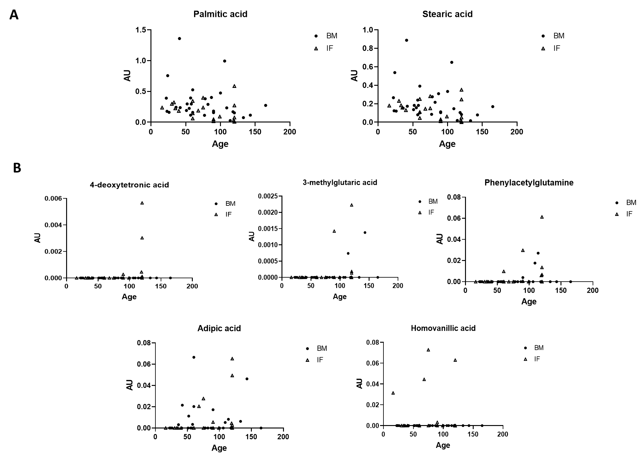
Figure S1: Metabolites that showed statistically significant Spearman's correlation with age in the total population (both groups). A. Metabolites that show tendency to decrease with age. B. Metabolites that show tendency to increase with age.

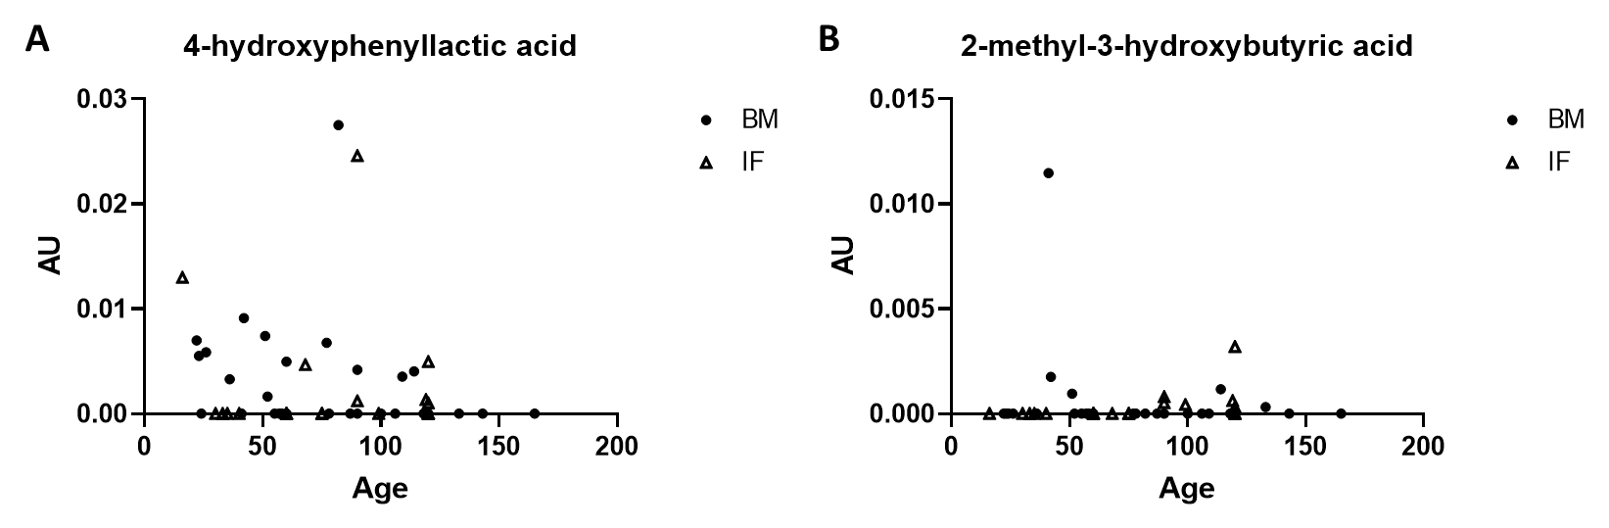
Figure S2: Metabolites that showed statistically significant Spearman's correlation with only one population A. Metabolites associated with age in breast milk group. B. Metabolites associated with age in infant formula group.

