**Supplementary Information**

“Ultrafast interfacial carrier dynamics and persistent topological surface states in VSe2/Bi2Se3 van der Waals heterojunctions”

Tae Gwan Park1, Jae Ho Jeon2, Seung-Hyun Chun2, Sunghun Lee2,*, Fabian Rotermund1,*

1Department of Physics, Korea Advanced Institute of Science and Technology (KAIST), Daejeon 34141, Republic of Korea

2Department of Physics and Astronomy, Sejong University, Seoul 05006, Korea

*Correspondence to: kshlee@sejong.ac.kr (S.L.) and rotermund@kaist.ac.kr (F.R.)

**Note S1: Hall resistance of 10 QL Bi2Se3**



**Figure S1.** **Hall resistance as a function of magnetic field of 10 QL Bi2Se3 thin film at room temperature.** The slope indicates *n*-type semiconductor and the estimated three-dimensional carrier density is 3.13×1020 cm-3.

**Note S2: Coherent phonon dynamics in VSe2/Bi2Se3 heterostructures (VBHs)**

As shown in Figure S2, a significant echo signal was observed in VSe2/Bi2Se3 heterostructures (VBHs). The prominent coherent acoustic signal was obtained from the pump-probe data by extracting bi-exponential decays, representing the carrier dynamics as shown in Figure S2a.

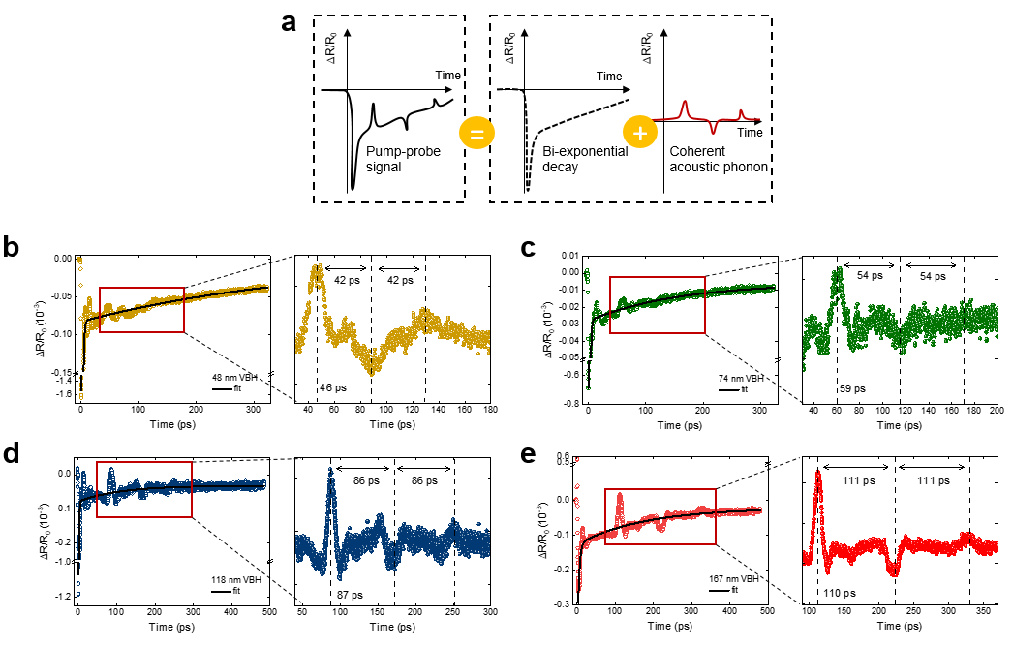

**Figure S2.** **Coherent phonon dynamics in VSe2/Bi2Se3 heterostructures (VBHs).** (**a**) Schematic illustration of coherent phonon propagation signals containing in pump-probe data. (**b**)-(**e**) Pump-probe data and the abstracted coherent phonon signals at heterostructures of 48, 74, 118, and 167 nm VSe2 and Bi2Se3, respectively. The black curves indicate the fitting results with bi-exponential decay. The red boxes indicate the interested region and plotted with magnification in each right panel.

**Note 3: Transient reflectance (TR) and absorption (TA) spectra in Bi2Se3**

In the transient reflectance (TR) measurements in Bi2Se3, we observed the photobleaching, which leads to a decrease in optical reflectance and absorption at near zero-delay as shown in Figure S3a and S3b. The derivative-like features in Bi2Se3 begun to exhibit at 2 ps as indicated by the vertical white lines. This spectral feature showed the dynamics of the blue shift from 0.9 to 0.96 eV over time as indicated by the curved black arrows in Figure S3a and S3b. For the 1.5 eV pump excitation, the energy of excited electrons is higher than the optical transition energy. Consequently, the optical transition was possible at lower energy than that of equilibrium. The excited carriers relaxed toward the conduction band minimum (CBM) for electrons and the valence band maximum (VBM) for holes by efficient electron-phonon coupling during a few ps. Subsequently, the optical transition energy showed the dynamics of blue shift during 5 ps. After this time, the stable derivative-like features were observed by electrons in CBM and holes in VBM for several tens of ps as shown in Figure S3a.

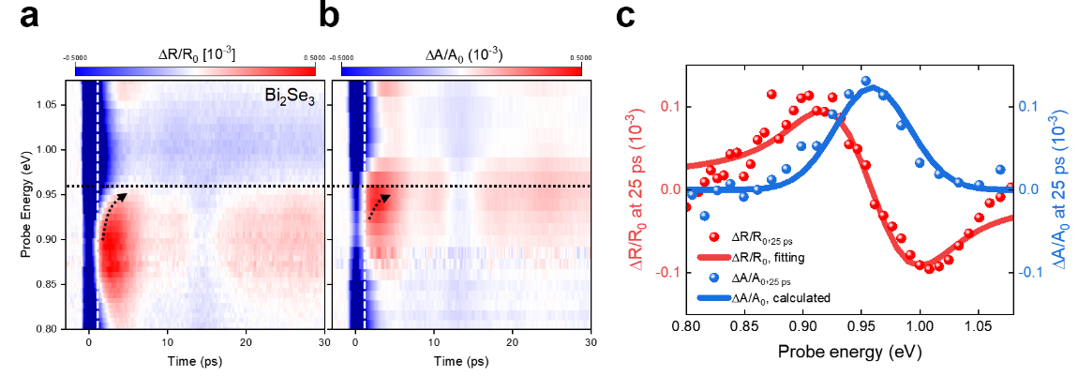

**Figure S3.** **Transient reflectance/absorption (TR/TA) response in Bi2Se3. (a)** TR response in Bi2Se3. (**b**) TA response in Bi2Se3. (**c**) TR/TA spectra at 25-ps delay time (vertical dashed lines in **a**). The red line indicates the model fit to the experimental data and the blue line indicates the corresponding calculated absorption change.

**Note S4: TR spectroscopy in bare VSe2**

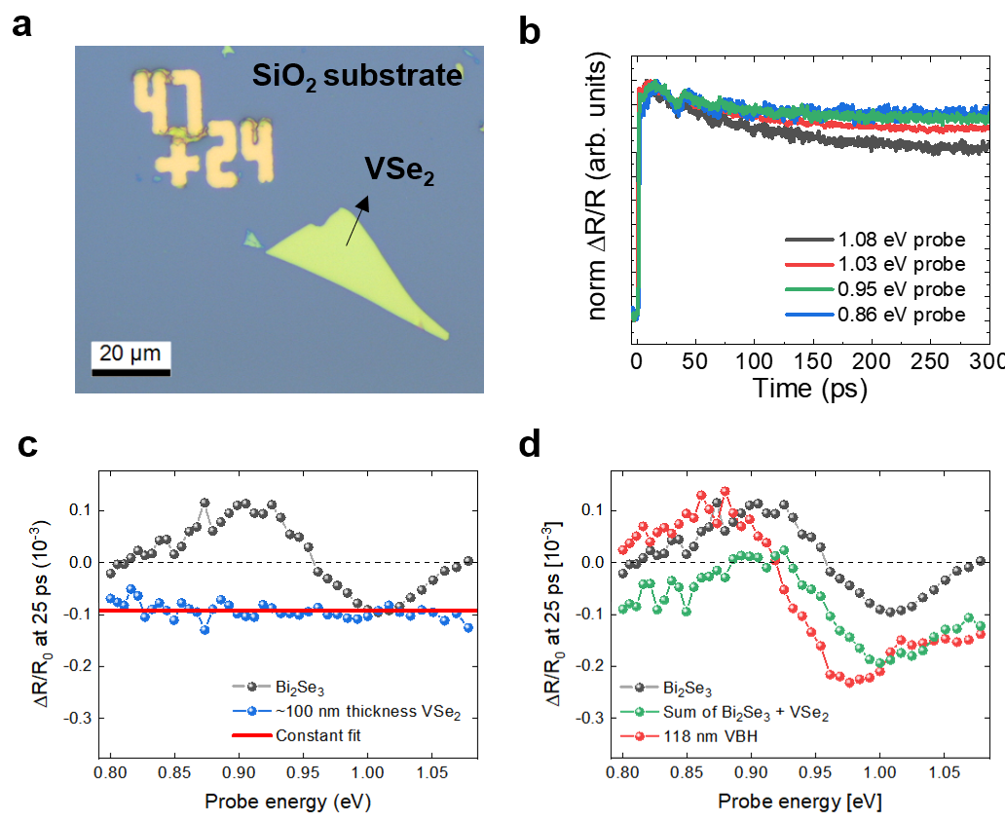

**Figure S4.** **TR response in bare VSe2.** (**a**)Optical image of bare VSe2 on SiO2 with thickness of ~100 nm. (**b**) Decay kinetics in bare VSe2 on SiO2.The normalized differential reflectance measured in bare VSe2 at various probe energy.. (**c**) The TR spectra at 25 ps delay time in Bi2Se3 and VSe2. The horizontal red line indicates the constant fit result on VSe2. (**d**) Comparison of TR spectra at 25 ps between 118-nm VBH (red), simple TR sum (green) of Bi2Se3, and ~100-nm thick bare VSe2.

To confirm whether the observed redshift of the transition energy in VBHs is an interfacial effect or a simple sum of the TR signals of VSe2 and Bi2Se3, the TR measurement was performed in bare VSe2. We prepared the bare VSe2 sample by mechanical exfoliation and transferred it onto the SiO2 substrate (Figure S4a). The expected thickness of the prepared bare VSe2 was about 100 nm. As shown in Figure S4b, the observed decay characteristics in bare VSe2 on SiO2 were significantly slow compared to Bi2Se3. It can be seen that the excited electrons in VSe2 recover relatively quickly at large probe energies, but in our available delay range, the decay constant was difficult to obtain due to the slow decay (~only 10-25% recovery). From this, we concluded that the observed shortened decay times in VBH (Figure 4f) were not originated from decay characteristics in bare VSe2. The TR response of bare VSe2 shows a negative signal of decreased reflectance in overall probe energy (Figure S4c). The TR spectra at 25 ps exhibited almost constant differential reflectance $(\frac{∆R}{R_{0}}=-0.9×{10}^{-3})$ as shown in Figure S4c. The comparison between 118-nm VBH and simple summation of Bi2Se3 and VSe2 unambiguously shows that the observed redshift of optical transition in VBH is originated not only from the TR response in VSe2 but also the interfacial effect as shown in Figure S4d.

**Note S5: Decay times in Bi2Se3, and VBHs**

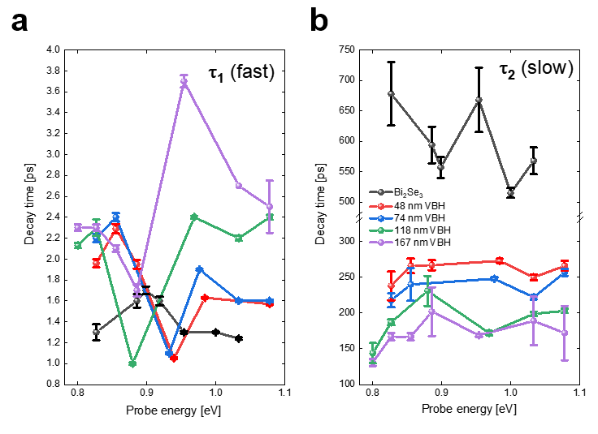

**Figure S5. Decay constants in Bi2Se3 and VBHs obtained by fitting with bi-exponential decay.** (**a**) Fast decay constant ($τ_{1}$) indicating the hot carrier cooling. (**b**) Slow decay constant ($τ_{2}$) indicating the carrier recombination time.