Supplementary Table S1
Association of NodCa and ShCa area proportions with the categorical baseline characteristics.

Category | (n) NodCa | (n) ShCa | NodCa | ShCa | Category | (n)  NodCa | (n) ShCa | NodCa | ShCa | p NodCa | p  ShCa
Age ≥ 70.5 years | 22 | 22 | 22.6 ± 12.3 | 14.2 ± 11.9 | Age < 70.5 | 27 | 26 | 22.2 ± 12.5 | 14.8. ± 12.0 | 0.747 | 0.852
Males | 28 | 26 | 23.9 ± 11.8 | 13.1 ± 10.0 | Females | 21 | 22 | 20.6 ± 12.9 | 16.2 ± 13.7 | 0.315 | 0.983
BMI > 25 Kg/m² | 28 | 26 | 24.7 ± 9.8 | 10.5 ± 6.9 | BMI (18.5-25) | 19 | 20 | 19.3 ± 15.4 | 20.0 ± 15.1 | 0.190 | < 0.05
Previous, current smokers | 45 | 44 | 22.3 ± 12.1 | 13.6 ± 11.3 | Never smokers | 2 | 2 | 17.4 ± 17.5 | 24.8 ± 24.1 | 0.578 | 0.495
Diabetes type I or II | 14 | 13 | 26.4 ± 8.8 | 10.4 ± 5.5 | No | 33 | 33 | 20.6 ± 13.4 | 16.3 ± 13.5 | 0.085 | 0.400
Hypertension | 41 | 41 | 22.4 ± 12.0 | 14.7 ± 11.6 | No | 8 | 7 | 22.3 ± 14.5 | 13.2 ± 13.7 | 0.971 | 0.492
Dyslipidemia | 45 | 43 | 22.6 ± 12.1 | 13.7 ± 10.7 | No | 5 | 4 | 18.7 ± 14.5 | 25.1 ± 20.1 | 0.503 | 0.307
Coronary artery disease | 12 | 12 | 26.2 ± 11.4 | 14.6 ± 12.0 | No | 35 | 34 | 20.8 ± 12.9 | 14.1 ± 12.1 | 0.305 | 0.755
Cerebro-vascular accident | 3 | 3 | 28.6 ± 11.6 | 19.1 ± 9.2 | No | 44 | 43 | 22.5 ± 12.2 | 13.7 ± 11.7 | 0.406 | 0.208
Increased hs-CRPª | 13 | 12 | 26.9 ± 10.2 | 13.4 ± 11.5 | No | 36 | 36 | 20.8 ± 12.7 | 14.9 ± 12.0 | 0.121 | 0.775
Impaired GFR^{b} | 9 | 9 | 28.5 ± 10.8 | 12.7 ± 11.8 | No | 39 | 38 | 21.6 ± 12.0 | 14.3 ± 11.5 | 0.119 | 0.604
Leukocytosis^{c} | 19 | 19 | 24.0 ± 11.5 | 13.6 ± 11.4 | No | 27 | 26 | 10.5 ± 13.1 | 16.0 ± 12.6 | 0.357 | 0.513
Anaemic^{d} | 7 | 12 | 23.8 ± 13.0 | 14.6 ± 12.0 | No | 41 | 34 | 22.0 ± 12.3 | 14.1 ± 12.1 | 0.728 | 0.608
Statin users | 37 | 35 | 23.6 ± 11.7 | 14.9 ± 10.8 | No | 12 | 13 | 18.6 ± 13.6 | 13.6 ± 14.8 | 0.224 | 0.232

Association of NodCa and ShCa area proportions with the categorical baseline characteristics.
Data presented as mean ± SD; analysis of NodCa data by independent T-test; analysis of ShCa data by Mann-Whitney U test
Abbreviations: NodCa, nodular calcification; ShCa, sheet calcification; LEAD, lower extremity arterial disease; BMI, body mass index; hs-CRP, high sensitive chain reactive protein; GFR, glomerular filtration rate. No, absence of the category.
a Females’ values > 2.5 mg/L and males’ values > 3 mg/L.
b Values < 77 for patients aged (50-59)years, < 69 for patients aged (60-69), < 59 for patients aged 70 years and over.
c Values > 8.2 E9/L.
d Females’ Hb readings <117 g/L and males’ readings < 134 g/L.

SupplementaryTable S2
Correlation of NodCa and ShCa area proportions with the continuous patients’ characteristics.

 | NodCa |  |  | ShCa
 | rho | N | p | rho | N | p
Age (years) | 0.130 | 49 | 0.373 | 0.066 | 49 | 0.655
BMI (kg/m²) | 0.094 | 47 | 0.531 | -0.181 | 46 | 0.23
Leukocytes (10E9/L) | 0.002 | 48 | 0.989 | 0.042 | 47 | 0.777
Hemoglobin (g/L) | -0.195 | 48 | 0.185 | 0.234 | 47 | 0.114
Thrombocytes count (10E9/L) | -0.163 | 48 | 0.267 | -0.216 | 47 | 0.144
hs-CRP (mg/L) | 0.200 | 49 | 0.168 | -0.099 | 48 | 0.505
GFR (mL/min/1.73 m²) | -0.149 | 48 | 0.314 | 0.083 | 47 | 0.58
Total-cholestrol (mmol/L) | 0.013 | 49 | 0.930 | -0.065 | 48 | 0.658
LDL-cholesterol (mmol/L) | -0.017 | 48 | 0.907 | -0.346* | 47 | < 0.05
HDL-cholestrol (mmol/L) | -0.078 | 49 | 0.594 | 0.419** | 48 | < 0.005
Triglyceride (mmol/L) | 0.036 | 49 | 0.804 | -0.371** | 48 | < 0.01

NodCa data analysed by Pearson, ShCa data analysed by Spearman rank, rho is the correlation coefficient.

Abbreviations: NodCa, nodular calcification; ShCa, sheet calcification; BMI, body mass index; hs-CRP, high sensitive chain reactive protein; GFR, glomerular filtration rate.

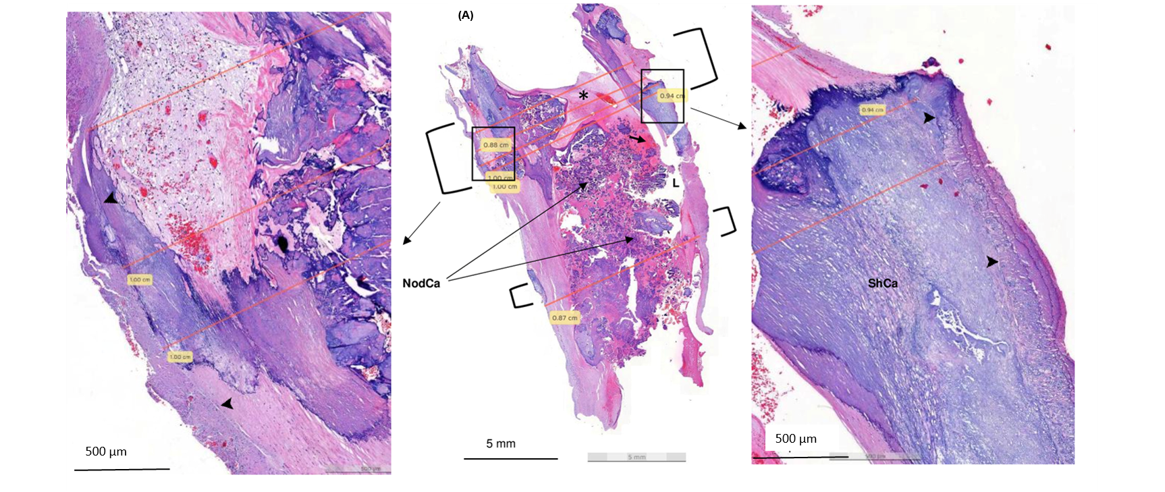
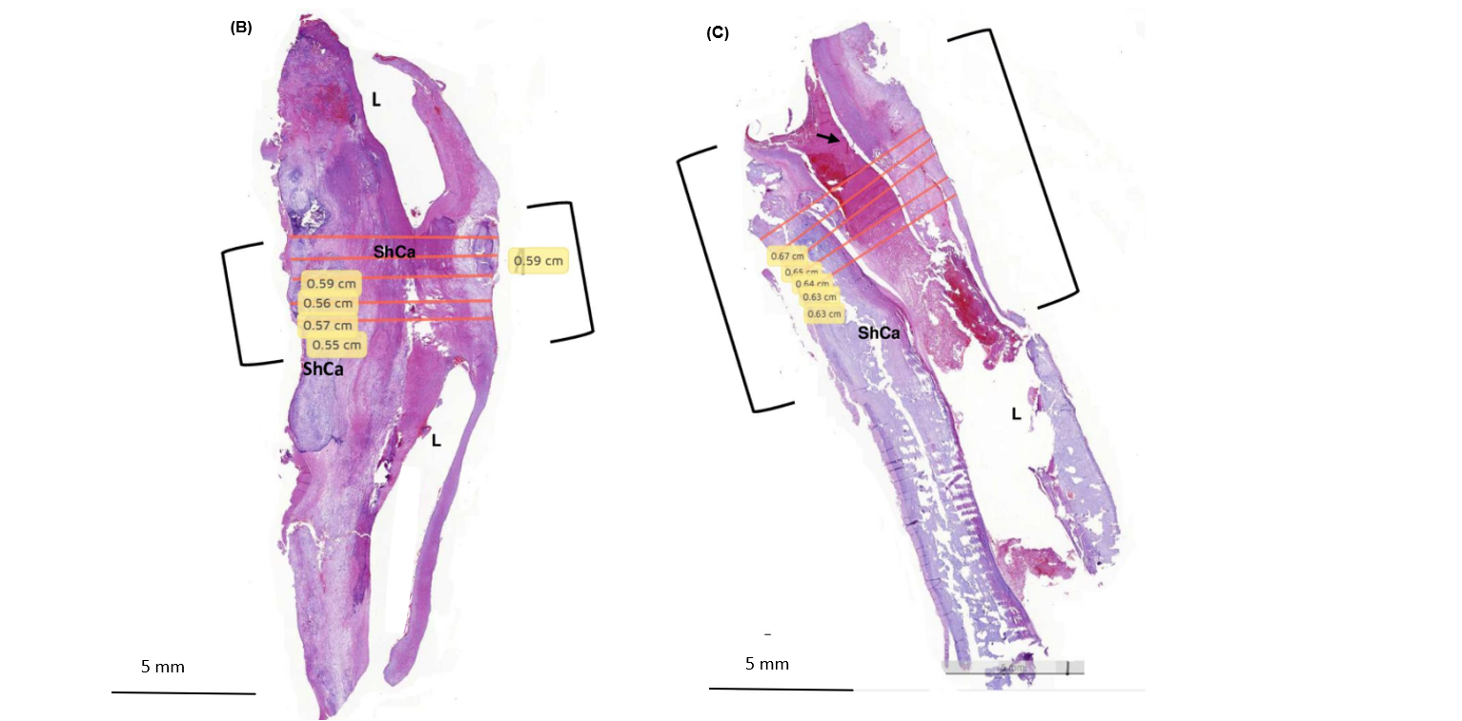
Supplementary Figure S1. Three examples of obstructed femoral plaques (A), (B) and (C) for illustration of the vessel diameter measurement. Maximum internal elastic vessel diameter at the obstruction site (surrounded by squared brackets) was measured. L indicates vessel lumen. Arrowhead refers to internal elastic lamina in the magnified subsections of plaque section (A). Section (A), has mainly nodular calcification (NodCa), 26% of the plaque tissue section, whereas (B) and (C) are dominated by sheet calcification (ShCa, 40% and 41% respectively. Section (A) has a larger measured vessel diameter(10mm) compared to section (B), 5.9mm and section (C), 6.7mm. Small arrow on (C) refers to fibrin, asterisk on (A) refers to the organized thrombus.

