Appendix
Figure A.1 shows the conversion curves of the RBE-conversion model for 16-fraction CIRT, the black curve is based on 10 patients, and the red curve is based on 30 patients. Two conversion curves are matched with each other. Based on the median value, the difference between these from 10 patients and these from 30 patients were -0.62% (-3.02% to 2.49%).
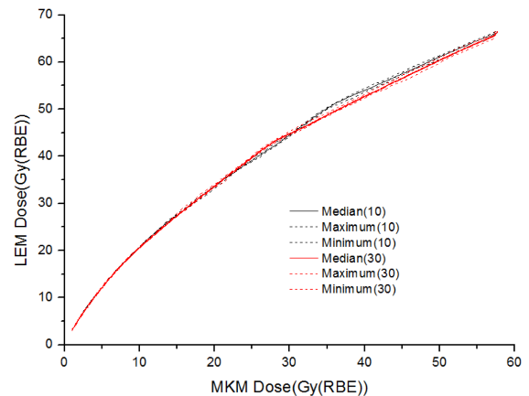
Fig. A.1 The conversion curves for 16-fraction, the black curve is based on 10 patients and the red curve is based on 30 patients.

